Part 1 | ITEM NO.

REPORT OF STRATEGIC DIRECTOR FOR SUSTAINABLE REGENERATION

TO THE LEAD MEMBER FOR PLANNING ON 2 FEBRUARY 2010
AND
LEAD MEMBER FOR ENVIRONMENT ON 1 FEBRUARY 2010

TITLE: CRESCENT MEADOWS – PHASE 1 FOOTPATH WORKS

RECOMMENDATION:

That the Lead Member for Planning is recommended to:

- Approve that Salford City Council enter into a Grant Funding Agreement with Community Forests North West Ltd for £175,750 funding from the Setting the Scene for Growth fund, to be expended by 31 March 2011;
- Approve the Phase 1 proposals for the laying of footpaths at the Crescent Meadows, costing approximately £55,000 to be implemented between February and April 2010;
- Note that a further report will be submitted in Spring 2010 for the Phase 2 proposals at the Crescent Meadows, which will consist of fencing at the Meadow Road entrance, meadow and woodland planting, wetland creation and a footpath link to Peel Park; and
- Approve that Urban Vision enter into negotiations with Salford City Council’s appropriate partner contractor to obtain a target cost for constructing the works on site.

That the Lead Member for Environment is recommended to:

- Approve the Phase 1 proposals for the laying of footpaths at the Crescent Meadows, on land owned by Salford City Council and managed by the Environment Directorate.

EXECUTIVE SUMMARY:

The Crescent Meadows is a key project in the Central Salford Urban Regeneration Company Business and Investment Plan 2009-2010. The Phase 1 proposals are for the laying of a footpath around the perimeter of the site. The Phase 2 works will consist of fencing at the Meadow Road entrance, meadow and woodland planting, wetland creation and a footpath link to Peel Park. The proposals will improve the accessibility, biodiversity and attractiveness of the site. Approval is sought for the implementation of the Phase 1 proposals between February and April 2010, costing approximately £55,000 of the total £175,750 approved Community Forests North West Setting the Scene for Growth fund.

BACKGROUND DOCUMENTS:
(Available for public inspection)

None.

KEY DECISION: YES

DETAILS:

1.0 | Background
1.1 | The Crescent Meadows is a key project in the Central Salford Urban Regeneration Company Business and Investment Plan 2009-2010.
1.2 | The site represents a rare opportunity to significantly improve a large existing public open space at the northern anchor of Irwell River Park and the southern end of the Irwell Sculpture Trail. The approved funding will allow the implementation of the first stage of the long term vision for the site. It will provide an immediate resource for local communities in Broughton and Irwell Riverside, and will generate confidence in the future of the site and Irwell River Park as a whole.
1.3 | Setting the Scene for Growth is a fund managed by Community Forests North West Ltd on behalf of the Northwest Regional Development Agency and the Forestry Commission.
1.4 | Approval of Setting the Scene for Growth funding was granted on 30 November 2009, and subject to Salford City Council approvals, the Phase 1 works will be on site in February and March 2010.
2.0 | Details
2.1 | The attached plan at Annex 1 shows the Phase 1 footpath proposals. The footpath will be 1.8m wide, and approximately 850m long. It will be constructed of recycled crushed stone. Planning permission is not required. The proposed footpath will lead into the site from Meadow Road and form a circuit around the perimeter of the central field. The proposed link to Peel Park via the existing footbridge will be constructed in Phase 2 of the works.
2.2 | A planning application will be submitted in Spring 2010 for Phase 2 including the proposed fencing, meadow and woodland planting, wetland creation and footpath link to Peel Park (see Annex 2).
2.3 | If implemented, the Phase 1 and 2 proposals together will:  - Secure the site with attractive, accessible and sustainable perimeter treatments;  - Improve accessibility and increase usage by creating a network of surfaced and unsurfaced paths; and  - Increase the attractiveness and interest of the site by improving the existing woodland habitat on site, diversifying the grassland and creating new woodland and wetland habitats.
2.4 | An Environment Agency bund is present on site which potentially contains contaminated material. The bund consists of material dredged from the river bed, which is a potential health and safety hazard. It is considered by Salford City Council that the material was put on Salford City Council land without permission. Therefore Urban Vision are seeking to open discussions with the Environment Agency to have this removed. The footpath has been designed to avoid the bund, so that the bund can be removed in future by the Environment Agency with minimal impact upon these proposals.
2.5 | Existing local community groups in Lower Broughton will be consulted on the Phase 2 proposals at a later date once the funding has been confirmed. The consultation approach will be agreed with (amongst others) Countryside Properties who have entered into a Development Agreement with Salford City Council covering the Crescent Meadows site.
3.0 | Future Management and Maintenance
3.1 | Grounds Maintenance Section, Environment Directorate have confirmed the existing annual cost of maintaining the site at £4,400 per annum. The proposed footpaths can be maintained within this figure.
3.2 | The approved funding includes £14,000 Establishment Costs to contribute towards the uplift in maintenance costs for five years following practical completion of Phase 2 of the works.
3.3 | Management and Maintenance Arrangements for the Phase 2 works will be confirmed when a further Lead Member Report is submitted for approval in Spring 2010.
3.4 | The project will complement the Crescent Meadows Woodland Management Plan which is currently on site and is two years into a five year programme of planned maintenance works to the trees and landscaping to improve biodiversity and develop different types of ecosystems.
4.0 | Procurement
4.1 | Following Lead Member approval, Urban Vision will enter into negotiations with Salford City Council’s appropriate partner contractors to obtain a target cost for constructing the works on site.
5.0 | Financial
5.1 | The Grant Funding Agreement needs to be signed by the end of January 2010. The Agreement will be between Salford City Council and Community Forests North West Ltd. Community Forests North West are funded by the North West Development Agency and Forestry Commission as part of the Newlands programme.
5.2 | The Grant Funding Agreement is for £161,750, with £14,000 set aside for Establishment Costs to contribute towards future maintenance.
5.3 | The funding for Phase 2 is anticipated to be confirmed in April or May 2010. Once the Phase 2 funding has been confirmed, work will commence on detailed designs, proposals for public consultation and a planning application.
5.4 | Funding will be drawn down by Salford City Council expending up to the value of the Agreement, and providing evidence of defrayal to Community Forests North West Ltd to claim this value back.
6.0 | Recommendation
6.1 | That the Lead Member for Planning is recommended to:  - Approve that Salford City Council enter into a Grant Funding Agreement with Community Forests North West Ltd for £175,750 funding from the Setting the Scene for Growth fund, to be expended by 31 March 2011;  - Approve the Phase 1 proposals for the laying of footpaths at the Crescent Meadows, costing approximately £55,000 to be implemented between February and April 2010;  - Note that a further report will be submitted in Spring 2010 for the Phase 2 proposals at the Crescent Meadows, which will consist of fencing at the Meadow Road entrance, meadow and woodland planting, wetland creation and a footpath link to Peel Park; and  - Approve that Urban Vision enter into negotiations with Salford City Council’s appropriate partner contractor to obtain a target cost for constructing the works on site.
6.2 | That Lead Member for Environment is recommended to:  - Approve the Phase 1 proposals for the laying of footpaths at the Crescent Meadows, on land owned by Salford City Council and managed by the Environment Directorate.

KEY COUNCIL POLICIES:
- Salford City Council Unitary Development Plan (adopted 21 June 2006); and
- Irwell City Park Planning Guidance (adopted by Salford City Council March 2008).

EQUALITY IMPACT ASSESSMENT AND IMPLICATIONS:
The Phase 1 proposals will improve the accessibility of the site for the benefit of all members of the local community.

ASSESSMENT OF RISK:
Medium. The payment of funding by CFNW is dependent upon it receiving the requisite funding from the Forestry Commission. Therefore if the City Council is expending monies in advance, then at the current time there is no guarantee (even with the benefit of a completed GFA) that it will be able to recover such expenditure.

SOURCE OF FUNDING:
Setting the Scene for Growth is a partnership between Northwest Development Agency and the Forestry Commission. It should be noted that the payment of funding by CFNW is dependent upon it receiving the requisite funding from the Forestry Commission, and therefore if the City Council is expending monies in advance , then at the current time there is no guarantee (even with the benefit of a completed GFA) that it will be able to recover such expenditure.

LEGAL IMPLICATIONS
Supplied by: Ian Sheard x 3084
Date Consulted: 18/1/2010
Comments: The City Solicitor will be responsible for agreeing the wording of the Grant Funding Agreement. It is noted that the payment of funding by CFNW is dependent upon it receiving the requisite funding from the Forestry Commission, and therefore if the City Council is expending monies in advance , then at the current time there is no guarantee (even with the benefit of a completed GFA) that it will be able to recover such expenditure.

FINANCIAL IMPLICATIONS
Supplied by: Alison Swinnerton x7423
Date Consulted: 15/01/2010
Comments: Crescent Meadows forms part of the approved Central Salford Urban Regeneration Company’s Business and Investment Plan. The project will be funded by a grant from Setting the Scene for Growth; expenditure will occur during the financial years 2009/10 and 2010/11. The maintenance costs have been identified and can be met from within the current maintenance arrangements. However, there is a phrase within the GFA which states that “CFNW shall have no liability to make any payment to the Applicant if the related sums are not received by it from the (Forestry) Commission for any reason”. Therefore there is no guarantee that Salford City Council would be able to recover the expenditure.

OTHER DIRECTORATES CONSULTED:
The Environment Directorate is supportive of the Phase 1 proposals.

CONTACT OFFICER: TIM HEWITT TEL. NO. 0161 686 7416

WARD(S) TO WHICH REPORT RELATE(S): Broughton


ANNEX 1 – PHASE 1 PROPOSALS
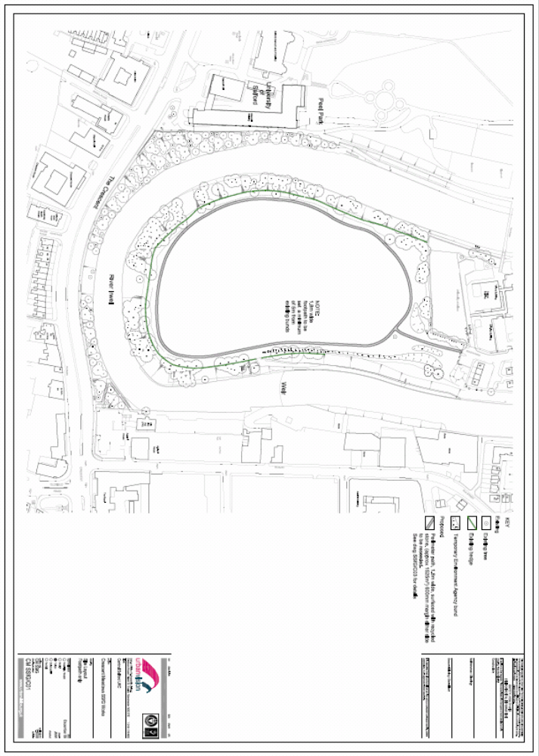
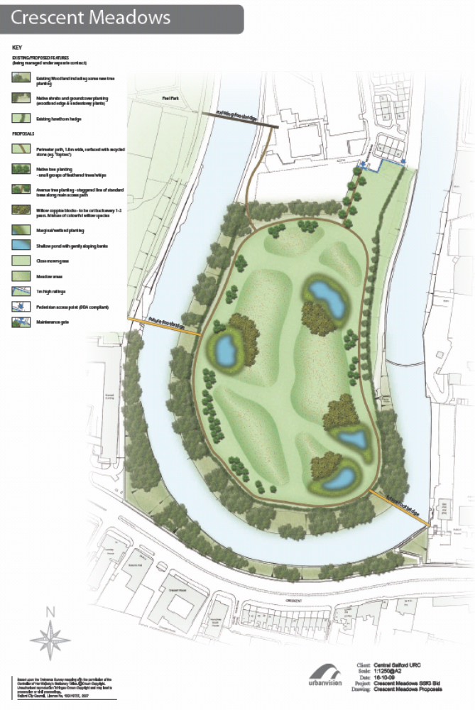
ANNEX 2 – PHASE 2 PROPOSALS


