 |  | PART 1  (OPEN TO THE PUBLIC) | ITEM NO.
REPORT OF THE STRATEGIC DIRECTOR FOR SUSTAINABLE REGENERATION

TO THE LEAD MEMBER FOR PLANNING ON 2 MARCH 2010

TITLE: IRLAM POOL, PRINCES PARK.

RECOMMENDATIONS:

The Lead Member for Planning:
1. Approves the allocation of £265,000 of Section 106 monies received from development schemes in Cadishead to provide changing facilities and improved parking provision to serve the outdoor pitches at Princes Park, and contribute towards the provision of squash facilities and a sports hall at Irlam Pool.
2. Approves the allocation of £112,332 of Section 106 monies received from development schemes in Cadishead to provide improvements to Princes Park, in line with the parks master plan.

EXECUTIVE SUMMARY:

The priorities for investment within Princes Park have recently been reviewed by the Irlam and Cadishead Neighbourhood Partnership Board, with investment into Fit City Irlam recognised as a main priority for the local community.

In considering how to satisfy the requirements of Section 106 agreements from developments in the vicinity of Irlam Pool / Princes Park, officers have concluded that the proposals being developed by the Neighbourhood Partnership Board constitute an appropriate way of meeting some of these requirements, and it is proposed that Section 106 monies, as set out in the report, could contribute to the costs of these works. These include the construction of outdoor changing facilities and additional leisure facilities at Irlam Pool in addition to improvements to the open space facilities on offer within Princes Park.

It is proposed to utilise £175,000 in Section 106 contributions for the construction of changing facilities that would form part of the wider improvements to Irlam Pool and would serve the outdoor pitches at Princes Park. It is also proposed that a further £90,000 would contribute towards the provision of squash / dry sports facilities at Irlam Pool.

Further proposals include the recommendation to utilise £112,332 in Section 106 contributions for the delivery of the key local priorities for open space that have been identified within the Princes Park master plan.

The spending of Section 106 contributions on improvements to the extension of Irlam Pool and investment into Princes Park are within the parameters of the legal agreement and in line with the five tests set out in Circular 05/2005.

BACKGROUND DOCUMENTS: None

KEY DECISION: YES

DETAILS

1.0 | Background
1.1 | This report relates to the proposed use of Section 106 contributions for improvements to the leisure facilities on offer at Irlam Pool, including the provision of new squash courts, sports hall, and the construction of changing facilities attached to Irlam Pool that would serve the outdoor pitches at Princes Park. The report also details the proposed use of Section 106 contributions for the delivery of improvements to Princes Park in accordance with the Princes Park master plan.
1.2 | Approval was given by the Lead Member for Environment on 4th November 2008 for the implementation of the Princes Park Master Plan. Consultation undertaken by the Environment Directorate as part of the Master Planning Process identified an Amphitheatre as being a desired facility for the local community. This was to be funded fully through Section 106 contributions from agreements including those listed in Annex 1. Works on the Amphitheatre included ground re-modelling rather than any built works resulting in a natural bowl and an electric supply which would allow for lighting and sound to enable events to be held.
1.3 | However, rising construction and long-term management costs have led to a re-evaluation of the project.
1.4 | Following a review of the master plan for Princes Park, the Irlam and Cadishead Neighbourhood Partnership Board recognised investment into extensions at Irlam Pool (Fit City Irlam) as a main priority for the local community. These extensions would provide outdoor changing facilities and additional leisure facilities at Irlam Pool, in addition to improvements to the open space facilities on offer within Princes Park.
2.0 | Proposed New Facilities at Irlam Pool
2.1 | A proposal has been developed by the City Council, Salford Community Leisure and the Hamilton Davis Trust. This would see the investment of £2.7 million into the facilities on offer at Irlam Pool. The project will include the provision of a new two storey extension, which on the ground floor, includes a redesigned entrance and reception, office accommodation, staff room and changing rooms, which will service the dryside activities, two squash courts and an associated viewing area. Alterations to the existing dry changing
 | facilities will also be included to provide more disabled changing with access to swimming pools. (see Annex 3).
2.2 | There is a recognised need for increased leisure facilities within the Irlam area and for improved changing facilities for the outdoor pitches at Princes Park. Teams that utilise the playing fields currently have to make use of portakabins for changing. Therefore one of the key objectives of the improvements to Irlam Pool is to provide modern changing facilities for the existing outdoor football pitches plus appropriate referee’s changing rooms. Externally it is proposed to renovate the existing car park and provide additional car parking for users of the outdoor pitches in the park. The proposed new changing facilities would be available for use outside pool opening times. The project also includes the provision of two squash courts with movable walls to allow for flexibility of use with an associated viewing area and a four court sports hall.
2.3 | Because of the terms of the agreements, Section 106 contributions can only be utilised to fund the works to Irlam Pool that are related to the provision of open space, environmental improvements and recreation facilities in accordance with planning policy. Therefore it is proposed to utilise Section 106 contributions secured for the purposes of environmental improvements for the construction of the external changing facilities and also contribute towards the car parking provision associated with such changing rooms. Section 106 contributions totalling £90,000 that have been negotiated for the provision of replacement recreational facilities are proposed to be applied towards the provision of squash facilities and a multi-functional recreational sports hall.
3.0 | Proposed Investment into the Princes Park
3.1 | From the contributions that are available (see Annex 1), £52,332 could not be utilised for investment at Irlam Pool due to the legal restrictions contained with the Section 106 agreements. These monies, in addition to a further £60,000 from other developments in the area requiring the provision of open space, will be combined to provide investment of £112,332 to Princes Park.
3.2 | It is proposed that further consultation will be undertaken with the local Community to ascertain the types of improvements that are deemed a priority within Princes Park.
4.0 | Section 106 Contributions
4.1 | The Section 106 contributions proposed for the funding of improvements to Irlam Pool have been received from two developments (see Annex 1), both within the locality of Irlam Pool (see map at Annex 2). Open space and recreational facilities could not be provided on the sites of the developments that have paid Section 106 contributions.
4.2 | The Section 106 contributions proposed for the funding of the delivery of open space improvements identified within the Princes Park master plan have been received from four developments (see Annex 1), all of which are within the locality of Princes Park (see map at Annex 2). Open space and children's play space could not be provided on the sites of the developments that have paid Section 106 contributions.
5.0 | A Justification for the Use of Section 106 Contributions at Irlam Pool
5.1 | It is important to note the restrictive wording of both Section 106 agreements (see Annex 1). It is essential that any scheme funded through Section 106 contributions is clearly justified and adheres to the legal agreements.
5.2 | The contributions received in relation to Agreement 163 totalling £90,000 (see Annex 1) requires them to be expended in line with Polices R1 and R2 of the UDP 1995 and requires the replacement of recreational facilities that are lost due to development, seeking to ensure that all residents of Salford have access to a broad range of recreational facilities. The proposed investment into the additional squash courts and sports hall at Irlam Pool would be consistent with the requirements of polices R1 and R2.
5.3 | The contributions received in relation to Agreement 135 (Land at former Kwik Save site, Fairhills Road) have been secured through a Section 106 agreement that enables a proportion of such contributions to be applied for the purposes of environmental improvements. The proposed improvements to Irlam pool would address environmental deficiencies within Princes Park by replacing the unsightly portakabins that are currently used as changing facilities for the outdoor pitches with new facilities. The proposed increase in provision of parking for users of the changing facilities will also address the environmental matter of indiscriminate parking by users of both Princes Park and Irlam Pool.
6.0 | Financial Information
6.1 | The total cost of the improvements to Irlam Pool is estimated at over £2.7 million. It is proposed to make available £265,000 from Section 106 contributions towards the cost of these works. The anticipated funding breakdown is as follows:  City Council: £1,000,000  Hamilton Davis Trust: £1,000,000  Salford Community Leisure: £200,000  Section 106: £265,000  Sports England*: £300,000
6.2 | *Salford Community Leisure are currently awaiting the decision on an application to Sports England for a further £300,000. If successful, such funding will have to be expended by March 2011.
7.0 | Recommendations

The Lead Member for Planning:

1. Approves the allocation of £265,000 of Section 106 monies received
from development schemes in Cadishead to provide changing facilities and improved parking provision to serve the outdoor pitches at Princes Park, and contribute towards the provision of squash facilities and a sports hall at Irlam Pool.
- Approves the allocation of £112,332 of Section 106 monies received from development schemes in Cadishead to provide improvements to Princes Park, in line with the parks master plan

Paul Walker
Strategic Director for Sustainable Regeneration

EQUALITY IMPACT ASSESSMENT AND IMPLICATIONS:
The revised process for the allocation of section 106 contributions is aligned with the city’s approach for impact in relation to equality.

ASSESSMENT OF RISK: Medium –

- If funding cannot be secured from Section 106 contributions, this may put the implementation of the project in jeopardy

- Developers can seek to legally challenge the city council to claim back section 106 monies under the following circumstances:

- If not used on a scheme that mitigates the impacts of that development
- If not spent in line with the requirements of the Section 106 agreement
- If not spent within the agreed timescale

The proposals satisfy these tests.
SOURCE OF FUNDING:
- Section 106 contributions from development schemes within the locality of Irlam Pool and Prince’s Park.

LEGAL ADVICE OBTAINED:
Contact Officer and Extension No: Richard Lester 793 2129
Date Consulted: 1st February 2010
Comments: No adverse legal implications. (Please see Assessment of Risk).

FINANCIAL ADVICE OBTAINED:
Contact Officer and Extension No: Mags Miller-Cobham – 2504
Date Consulted: 03.02.10
Comments: Section 106 monies have been received and £265,000 is available to fund the above scheme

OTHER DIRECTORATES CONSULTED: Salford Community Leisure and the Chief Executive’s Directorate have been consulted and are supportive of regeneration improvements to Irlam Pool.

CONTACT OFFICER:
Tony Melia - Section 106 Officer TEL. NO. x2063

WARD (S) TO WHICH REPORT RELATE (S): Cadishead

KEY COUNCIL POLICIES:
Planning Obligations Supplementary Planning Document 2007
Unitary Development Plan

Annex 1: Section 106 Agreement Breakdown

ID | Application Number | Developer | Location | Summary of Section 106 Agreements | Current Section 106 Balance | Further Payments Expected | Contributions for Irlam Pool | Contributions for opnespace improvements to Princes Park
135 | 05/51128/REM | Westbury Homes | Land at former Kwik Save site, Fairhills Road | For the purposes of open space, children's play space and environmental improvements in accordance with planning policies H8 & H11 of the adopted UDP, H8 of the revised deposit draft UDP and Supplementary Planning Guidance 7 | £188,766 | £0 | £175,000 | £13,766
163 | 06/53186/REM | Miller Homes Limited | Land To The Rear Of The Ship Public House, Liverpool Road. | £61,804 - Open Space provision and recreational provision in accordance with Policies H6 & H11 of the UDP 1995, H8 of the revised deposit draft 2003 and Supplementary Planning Guidance 7, Provision of Open space and Recreation space associated with new residential.  £90,000 – Recreational Contribution for the purposes of adequate replacement recreational provision in accordance with polices R1 and R2 of the UDP 1995 and R1 of the Revised Deposit Draft Replacement Plan 2003. (Approximately half of the site was last used as a bowling green for the public house and the remainder of the site is open space associated with the public house) | £128,566 | £0 | £90,000 | £38,566
138 | 04/49716/FUL | McInerney Homes Limited | Land at Irlam Locks, Cadishead Way | For the purposes of open space and children's play space in accordance with planning policies H8 & H11 of the adopted UDP, H8 of the revised deposit draft UDP and Supplementary Planning Guidance 7 | £50,000 | £0 | £0 | £50,000
61 | 02/44340/FUL | Persimmon Homes Limited | Land to west of Cadishead Way, | Full and final satisfaction of the provision of play space and associated equipment | £10,000 | £0 | £0 | £10,000
 |  |  |  | TOTAL | £377,332 | £0 | £265,000 | £112,332

Annex 2: Location of Section 106 Developments

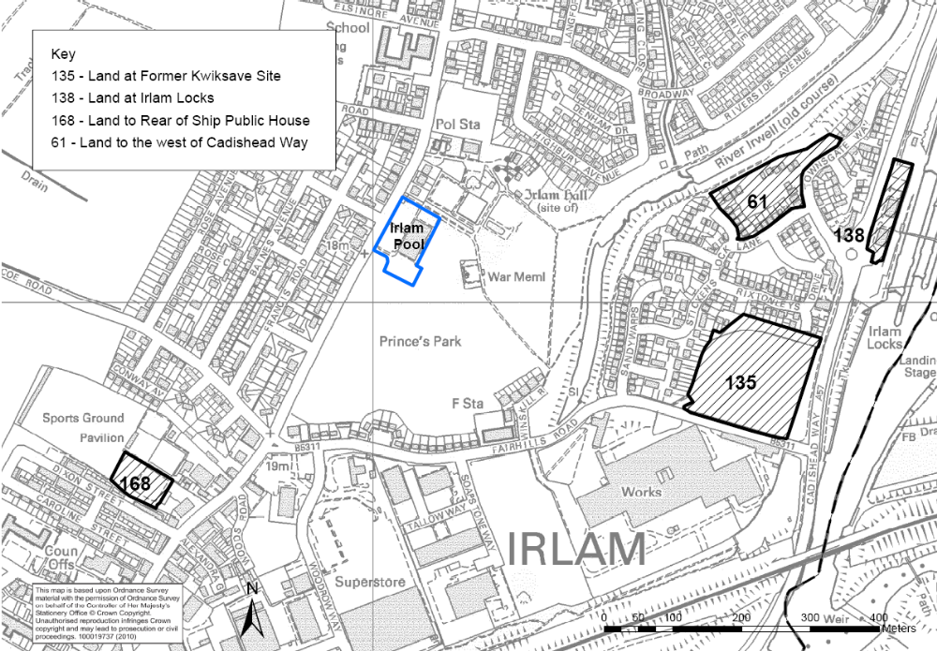

Annex 3: Plan of proposals for improvements to Irlam Pool





