Part 1 | ITEM NO.

REPORT OF THE STRATEGIC DIRECTOR FOR SUSTAINABLE REGENERATION

TO THE LEAD MEMBER FOR PLANNING
5th October 2010

TITLE: IRWELL RIVER PARK - SOAPWORKS GREEN FINGER, ORDSALL

RECOMMENDATIONS:

That Lead Member for Planning:

- Approve a maximum capital contribution of £145,000 (50% of construction costs) towards the new Green Finger. This contribution is to be funded from the Irwell River Park capital allocation amounting to £143,226 with the balance of £1,774 from the Central Salford URC budget. The site developers, Nikal/Abstract Securities, will provide the remaining 50% contribution to the cost of works as part of their Section 106 Obligations.

- Note that the developers of the Soapworks development – Nikal/Abstract Securities will take on all future maintenance liabilities and responsibilities for the site at no expense to the City Council. This agreement also forms part of the signed Section 106 agreement.

EXECUTIVE SUMMARY:

This report seeks approval to construct a new Soapworks Green Finger link between the River Irwell and Ordsall Lane, and has been jointly developed between the URC and owner developers Nikal/Abstract Securities. The City Council is asked to provide a 50% contribution to the construction of this new link route, which is being brought forward from the future planned phases of the former Colgate site.

This new link containing a pocket park will provide a welcoming, well lit and safe route from the riverside the heart of the Ordsall neighbourhood providing enhanced accessibility and connectivity to the riverside.

Nikal/Abstract Securities will deliver the link in 2010/11, alongside the refurbishment of the existing boiler house which will form the marketing suite for the redevelopment of the wider site. They will take on all future maintenance liabilities for the link which will be publicly accessible.

BACKGROUND DOCUMENTS:
Appendix A – Design Proposals Plan

KEY DECISION: YES

DETAILS:

- Background

1.1 The Soapworks Green Finger proposal has been jointly developed between the URC and developers Nikal/Abstract Securities to provide a welcoming, well lit and safe route from the riverside to the junction of Colgate Lane and Ordsall Lane. Developers Nikal/Abstract Securities aim to deliver the link in 2010/11, alongside the refurbishment of the existing boiler house which will form the marketing suite for the redevelopment of the wider site and provide available space to let.

1.2 The link will provide an important part of the vision for Irwell River Park, to create an 8km sustainable transport corridor connecting Salford Quays and Crescent Meadows.. The Soapworks Green Finger was endorsed by the Irwell River Park Strategic Steering Group on 11th March 2010. The principle of improving linkages between the waterfront and Ordsall neighbourhood have been supported by the local community through the Irwell City Park Planning Guidance and the Ordsall Waterfront Planning Guidance. In addition the site’s developer held public consultation events at Ordsall Community Café, at which improved linkages were supported as part of the planning application for the site.

1.3 The Section 106 Agreement requires that development shall not commence until details of the Green Finger are submitted to the Council, and that not more than 50% of the floorspace of Phase 1 will be occupied until the Finger has been laid out (and is retained thereafter). The Agreement also states that the Landowner shall make the Green Finger available for public use at all times and not close the Green Finger at any time save for repairs or emergency. In the event the Landowner opts to maintain the Green Finger (which has now been agreed) then the area shall be repaired, maintained and cleaned for a period of ten years.

  - There are clear benefits to bringing forward this link as early as possible to complement the City Council funded works to improve the riverside routeway and links to Irwell River Park, particularly within the Ordsall Neighbourhood. These benefits are:

- The new link complements and adds value to the City Council’s recent approval of £614,000 towards the Routeway Improvement Plan as part of Irwell River Park’s delivery phase commencing 2010/11;

- Bringing forward this new link gives greater certainty in terms of delivery, and provides a better opportunity to create a much higher quality routeway with green infrastructure benefits, than relying on the developer alone, in perhaps 4 to 5 years time;

- The timing of this opportunity is optimised by the significant complementary developments in the Ordsall Neighbourhood, with significant investment already underway at Ordsall Hall, in surrounding streets to the Hall, and at Monmouth Park. New signage and wayfinding can also be incorporated into the proposal with the developer contributing a 50% share to this, which would otherwise be lost if the development occurred later;

- As the developer is already progressing the wider redevelopment of the site, there are potential significant economies of scale that will benefit this project by constructing the link now.

  - In view of the above, the project team have driven the development of this early link with the developers and their professional consultant team, who also wish to grasp the opportunity to enhance the design and environmental quality of the new link route.

  - The link itself will provide a welcoming, safe, well-lit route between the junction of Colgate Lane and the Manchester Ship Canal. The link will open up the site and the waterfront to the Ordsall neighbourhood by providing direct pedestrian access through a former industrial site. The accompanying plan at Annex 1 shows the Colgate Green Finger in its wider context, as it adds value to and enhances City Council and other public sector investment.

- Design Proposals

  - The Soapworks Green Finger (shown in detail at Annex 2) is a landscaped route connecting Ordsall Lane with the waterfront. The design includes areas of soft and hard landscaping, with primary pedestrian and cycle lanes through the site. The route is delineated by a series of powder coated planters, incorporating low level lighting.

  - Adjacent to the waterfront is a new area of public realm forming a 'Pocket Park' with textured concrete paved areas, broken by textured granite setts and surrounded by timber perimeter seating. Various levels of planting are incorporated with all soft landscape specifications to include a series of trees and low level cover suitable for the location. Signage will be provided at each end of the route in line with the current Central Salford wayfinding and signage proposals.

  - A thorough cost estimate of £290,000 has been prepared, including preliminaries, overheads, contingencies and fees. Originally this was prepared by Davis Langdon as part the of Irwell River Park Pre-Implementation Phase, and has been reviewed by Nikal/Abstract’s cost consultants EC Harris and contractor Bowman Kirkland. Any minor final design amendments to the scheme will be undertaken within the maximum budget available, without affecting the integrity of the proposal and will be endorsed between the two parties.

3.0 Accessibility and Maintenance

3.1 As owners of the former Colgate site, Nikal/Abstract Securities will take on full maintenance responsibilities and liabilities, with no maintenance implications for Salford City Council. This is underpinned by clauses in the Section 106 agreement as stated below:

- Clause 4.2 of the Section 106 Agreement states that the Landowner shall make available the Green Finger for public use at all times and not close the Green Finger at any time save for repairs or emergency.

- Clause 4.3 states that in the event the Landowner opts to maintain the Green Finger (which has now been agreed) then the area shall be repaired, maintained and cleaned for a period of ten years.

KEY COUNCIL POLICIES:

- Salford City Council Unitary Development Plan (adopted 21st June 2006);
- Irwell City Park Planning Guidance (adopted by Salford City Council March 2008); and
- Ordsall Riverside Planning Guidance (adopted July 2007).

EQUALITY IMPACT ASSESSMENT AND IMPLICATIONS:

The scheme will provide enhanced pedestrian and cycling facilities through the former Colgate/Palmolive site. It will form part of the Irwell River Park route will be open for use, paved lit and well maintained between the waterfront and Colgate Lane. The link will add value to complementary projects in the area, which together will provide a continuous, safe and attractive route to effectively link communities, economic drivers and cultural attractions.

ASSESSMENT OF RISK:

Medium: There is a risk that if a Lead Member decision is delayed or funding cuts are made then the required funding and timescales may not allow the delivery of the Soapworks Green Link with the funding for Irwell River Park available only in 2010/11.

In terms of delivery, the signed Section 106 agreement between the City Council and developers places full responsibility on the construction and future maintenance liabilities on the developer. The City Council will contribute to the cost of completed works procured and delivered by the developer, which minimises any financial risk to the City Council.

SOURCE OF FUNDING:

The Irwell River Park contribution (£143,226) will be made from the capital programme allocation of £750,000 was approved by Council on 17th February 2010 for capital works associated with the routeway and public realm improvements. A minimal requirement of £1,774 has been secured through the Central Salford URC budget to make the full public sector contribution of £145,000.

LEGAL IMPLICATIONS: Supplied by: Norman Perry x 2325

A risk assessment of the developer has not been produced so its’ financial strength in the current market is unknown.

While the Council will only be exposed to 50% of the cost of building the link projects such as this could overrun and the cost increase. In the current economic climate the Council would be hard pressed to find any extra funding.

In the event of the developer getting into financial difficulty, what fund does the Council have to enable it to complete the project with another developer?

FINANCIAL IMPLICATIONS: Supplied by: Alison Swinnerton x 2585

The contribution to the Soapworks Green Finger Link is part of the Irwell River Park agreed Capital Project and will be funded from the Capital resources available to the scheme. A small amount of contribution is coming from the Central Salford Urban Regeneration Company’s approved Business and Investment Plan 2010/11 which is also funded from the Salford City Council Capital funds as part of the allocation to the Central Salford Urban Regeneration Company 2010/11.

There are no revenue implications for the first 10 years as the developer has agreed to meet these costs as part of the S106 agreement.

OTHER DIRECTORATES CONSULTED:

None

CONTACT OFFICERS:

- Tim Hewitt, Central Salford URC (0161 686 7416)
- Dave Evans (0161 793 3443)

WARD TO WHICH REPORT RELATES:

Ordsall

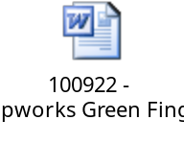
ANNEX 1: CONTEXT PLAN
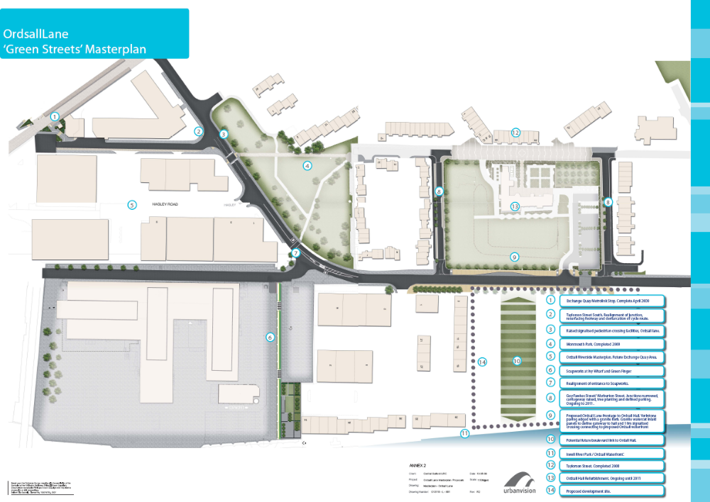
ANNEX 2: DESIGN PROPOSALS


