Part 1 | ITEM NO.

REPORT OF THE STRATEGIC DIRECTOR FOR SUSTAINABLE REGENERATION

TO THE LEAD MEMBER FOR PLANNING ON 7 SEPTEMBER 2010

TITLE: BRIDGEWATER WAY 2010 – 11 TOWPATH IMPROVEMENTS

RECOMMENDATIONS:

That the Lead Member:

- Note the contents of this report.
- Approve phase 5 of the Bridgewater Way (the Granary to Barton Road bridge, Worsley) to progress in 2010/11.
- Approve the Bridgewater Canal Trust to obtain and let the tender / run the contract; subject to
- Delegation of authority to the Strategic Director for Sustainable Regeneration to approve the tender / expenditure of Salford City Council money.

EXECUTIVE SUMMARY:

This report presents 2 options for the next phase of towpath improvements along the Bridgewater Way. The Bridgewater Way forms part of the wider Bridgewater Canal Corridor project which aims to improve the Bridgewater Canal in Salford as a heritage, tourism, recreational and learning resource. Match funding of £160,000 has already been secured from Salford West, the Local Transport Plan (LTP) and the Bridgewater Canal Trust. This report requests approval of phase 5 as the preferred scheme for 2010/11.

BACKGROUND DOCUMENTS: None
(Available for public inspection)

KEY DECISION: NO

DETAILS:

1.0 Background

1.1 In June 2009 Salford City Council commissioned a masterplan for the Bridgewater Canal in Salford. This aims to improve the Bridgewater Canal as a heritage, tourism, recreational and learning resource. One element of this programme is to upgrade and improve the towpath along the canal.

1.2 The Bridgewater Way project, managed by the Bridgewater Canal Trust, is the organisation taking forward towpath improvement works. The Bridgewater Way project aims to upgrade the towpath along the route of the Bridgewater Canal and install new furniture and orientation to improve the user experience of the canal. The aim of the scheme is to provide multi-user access for pedestrians, cyclists and people with buggies.

1.3 To date 2.2km of towpath have been improved in Salford, between Liverpool Road and Monton (see Annex A). This is recognised as part of the national walking and cycling network, Regional Route number 82, connects with Salford's greenways and National Route N55

2.0 2010 – 11 towpath improvement scheme

2.1 There are two potential towpath improvement schemes in 2010/11 (see
Annex A). These are as follows:

- Phase 4 – Alder Park to the Granary, Worsley
- Phase 5 – the Granary to Barton Road bridge

2.2 The total cost of implementing both schemes is £360,000. Phase 4 will cost 200,000 and phase 5 will cost £160,000. To date £160,000 has been secured from the Local Transport Plan (£75,000), Salford West (£60,000) and the Bridgewater Canal Trust (£25,000). No other potential source of funding has been identified this financial year. Given this shortfall a decision is needed as to which of the two schemes to progress with in 2010/11. Should the preferred option be phase 4 the scheme will be reduced in length slightly to fall within the available budget.

3.0 Phase 4, Alder Park to the Granary, Worsley

3.1 Phase 4 aims to upgrade the surface and widen the towpath between Alder Park in Winton and the Granary in Worsley. Completing this section would maintain a continuous route of improvements of 2.7km and a continuous cycling route from Patricroft Bridge to the Granary in Worsley. Completing this section would also provide a school commuter route connected to Alder Park school, though further funding would need to be identified to formalise access from the canal to the school as it is currently unsafe.

3.2 This area is however a major area of change within the Bridgewater Canal masterplan. A new 250 berth marina is proposed on the opposite side to the towpath, which is likely to proceed within the next few years subject to obtaining the necessary planning permissions. Should the marina receive planning approval there is an aspiration to construct a new pedestrian footbridge across the canal to connect residents in Westwood Park and Alder Park to the new marina and Worsley Greenway (see Annex B). During construction of the footbridge there is the potential for damage to be caused to the towpath, which would require part of it to be re-surfaced. This phase may also be better conceived as part of a wider, more comprehensive scheme comprising access from Westwood Park and Alder Park to the canal, improvements to the towpath and a new footbridge providing access to the new marina and Worsley Greenway, as set out in the masterplan.

3.3 Should this scheme not proceed in 2010/11 our intention is to include phase 4 within the bid to the Heritage Lottery Fund (HLF) as part of the comprehensive redevelopment of this area.

4. Phase 5, the Granary to Barton Road bridge

4.1 Phase 5 aims to upgrade the surface and widen the towpath between the Granary in Worsley and Barton Road bridge in Worsley Village. This constitutes a further 0.54km of towpath improvements, which will bring the total completed stretch of towpath in Salford to 2.74km out of a total of 7.9km.

4.2 The key benefit of undertaking phase 5 in 2010/11 is in preparation for the 250th anniversary of the canal in 2011. A number of major celebration events are planned along the canal in 2011. Worsley Village has been identified as one of the key events spaces for the 250th anniversary. Improving this section of towpath will not only uplift the area visually for the anticipated large number of visitors at key events. It will also contribute to improved health and safety at events and reduce the risk of claims through having a properly constituted towpath. No major events will take place along phase 4 due to the lack of events space along this section.

4.3 The Bridgewater Canal masterplan contains no other major works in the vicinity of the towpath in Worsley and so there is no likelihood of works undertaken this year having to be re-visited in a couple of years time.

4.4 Should this scheme not proceed in 2010/11 our intention is to include phase 5 within the bid to the Heritage Lottery Fund (HLF).

5.0 Timescales

5.1 Neither scheme requires planning permission as it is a simple upgrade of the existing towpath route. (Development Control within Urban Vision have confirmed this). It is anticipated that the scheme will commence by autumn 2010 and construction works will take approximately 6 – 8 weeks. This will necessitate the closure of the towpath during this period in order for construction works to be undertaken. All necessary notifications will be issued by the Bridgewater Canal Trust.

6.0 Procurement

6.1 Salford City Council will contract with the Bridgewater Canal Trust to deliver the towpath improvements. This contract will be issued by Legal Services along with a copy of the council’s contract terms and conditions.

6.2 The Bridgewater Canal Trust have appointed an independent Quantity Surveyor to provide estimate costs for the works, which are contained within this report. It is proposed that the Bridgewater Canal Trust will obtain and let the tender / run the contract. A minimum of three tenders will be sought to ensure value for money and procurement regulations are adhered to. The tenders will then be scored with the independent Quantity Surveyor to determine who to appoint.

6.3 Salford City Council will confirm appointment of the contractor following advice and recommendations from the Bridgewater Canal Trust. To expedite the process permission is being sought from Lead Member for Planning to delegate authority to the Strategic Director for Sustainable Regeneration to approve the tender and expenditure of Salford City Council money.

KEY COUNCIL POLICIES:

Salford West Strategic Regeneration Framework and Action Plan

EQUALITY IMPACT ASSESSMENT AND IMPLICATIONS:-

The towpath is currently not accessible for a range of users, including cyclists, wheelchair users and families with buggies. The towpath improvement works will upgrade the towpath to make it fully accessible to enable multi-functional usage.

ASSESSMENT OF RISK:

Low – funding has been secured to implement either phase 4 (part) or phase 5. Whichever scheme does not proceed will be included as part of the bid to the Heritage Lottery Fund (HLF) expected to be submitted later this year.

SOURCE OF FUNDING:

Salford West - £60,000 – secured
Local Transport Plan - £75,000 – secured
Bridgewater Canal Trust - £25,000 - secured

LEGAL IMPLICATIONS:

Contact Officer and Extension No: Richard Lester Ext 2129
Date Consulted: 17th June 2010
Comments: There are no legal implications at this stage. Subject to acceptance of the recommendations in this report, ultimately a contract will be completed, but the legal issues relating thereto will be considered when a report is submitted proposing the acceptance of a quotation.

FINANCIAL IMPLICATIONS:

Contact Officer and Extension No: Frank O’Brien Ext 2585
Date Consulted: 17th June 2010
Comments: The contribution from Salford West of £60,000 can be met from the 2010-11 approved Salford West capital budget. Local Transport Plan funding of £75,000 was approved in March 2010. £25,000 from the Bridgewater Canal Trust was confirmed in June 2010.

OTHER DIRECTORATES CONSULTED:

Directorate – Environment
Contact name and tel no. Annie Surtees
Date consulted: 18 June 2010
Comments: There are no concerns from our side regarding access across land managed by Environment as long as there is plenty of public notification etc and that land is restored following construction work.

CONTACT OFFICER: Paul Gill TEL. NO. Ext 2207

WARD(S) TO WHICH REPORT RELATE(S): Winton, Worsley

Annex A – Map of phasing

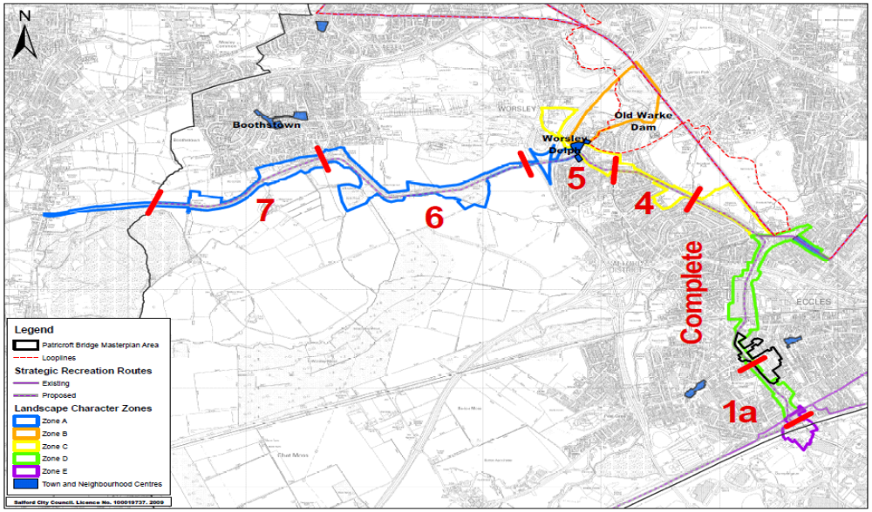
Annex B – Bridgewater Canal masterplan – Monton



