ITEM NO.

REPORT OF THE HEAD OF HOUSING

TO THE LEAD MEMBER FOR HOUSING
ON 9TH OF JUNE 2005
TO THE LEAD MEMBER FOR PLANNING
ON THE 13TH JUNE 2005

TITLE : Private Sector Stock Modelling

RECOMMENDATIONS :

- That the findings of the BRE modelling exercise be noted.
- That the BRE study is utilised to target intervention
- That the market support team continues to monitor the condition of private sector stock
- The BRE’s report is placed on the N Drive to make it easily accessible to Housing Staff
- The report is publicised to staff through “Talking Homes”
- That the Stock Condition Model is used to target any joint stock condition survey with Manchester City Council. (Initial meeting on 16th June. We intend to appoint a contractor to carry out the survey by the end of July 2005 )
- That the joint stock condition survey is used to validate the stock condition model.

EXECUTIVE SUMMARY :

Housing Services commissioned a model of private sector housing stock conditions including energy efficiency matters and a socio-economic profile of private sector households. The BRE (Building Research Establishment) carried out a desktop modelling exercise which provides
- A robust baseline at a geographical level not financially viable by traditional survey.
- A level of detail that has never before been available.
- A picture of housing conditions at the level of the City, Old Ward and Census Output Area
- Maps which will facilitate more targeted sampling of a traditional survey is required.
- Good correlation between the model and the 2001 survey. The authority can therefore have confidence in the data provided.

Key Results for Salford

- Vulnerable occupiers in a non-decent home 15%
- Households experiencing Fuel Poverty 8%
- Dwellings that fail the decent homes standard because of unfitness 4%
- Dwellings that fail the decent homes standard due to disrepair 10%

Implications

The PSA 7 Target is less than 25 % of Vulnerable occupiers in a non-decent private sector home by 2010 based on the modelling exercise we appear to be ahead of schedule. We must note that this figure will change as people become vulnerable and homes deteriorate over time. Consequently we must continue to monitor the situation

Because the survey gives us unprecedented detail Housing Services will be able to target interventions and survey samples more effectively.

BACKGROUND DOCUMENTS :

Salford City Council: Housing Stock Projections
The Draft Brief of the Private Sector Stock Condition Survey

Housing Services Service Plan 2004-2005

ASSESSMENT OF RISK: Moderate – We need to ensure that our information requirements in terms of forward planning and responding to PSA7 are covered.

SOURCE OF FUNDING: Private Sector Regeneration Consultants Budget

COMMENTS OF THE STRATEGIC DIRECTOR OF CUSTOMER AND SUPPORT SERVICES (or his representative):

- LEGAL IMPLICATIONS Not applicable
- FINANCIAL IMPLICATIONS The model cost £10000. By comparison a traditional 5% sample survey would have cost approximately £144190. There will be further financial implications of a joint survey with Manchester.

CONTACT OFFICER : Michael Hemingway 922 8707

WARD(S) TO WHICH REPORT RELATE(S): ALL

KEY COUNCIL POLICIES: Housing Strategy
HMR Scheme Update

DETAILS:

1.0 | Background
 | Since Salford last commissioned a private sector stock condition survey, the information required of us has increased and the way that the private sector is monitored has also changed. For example the Decent Homes Standard is now applied to the private sector, this must now be measured including the proportion of vulnerable households living in a decent home.

The Modelling Option

The BRE model uses the Census and English House Condition Survey to model decency, fitness, vulnerability and 5 other indicators at census output area level (an extremely small geographical area not possible using traditional surveys ).

The BRE modelling will not completely replace a traditional survey but it will enhance our forward planning and strategic capability in the short to medium term and it will facilitate a more effective targeting of a survey sample.

The BRE have produced a series of housing stock projections describing housing conditions in Salford. The projections will provide information on key housing variables at the authority, statistical ward and census output area level. They are based on a combination of national data drawn from the English House Condition Survey 2001 (EHCS 2001) and nationally available small area datasets such as the census.

The model provides:

- Dwelling which fail the Decent Homes Standard
- Dwellings which fail the Decent Homes Standard due to:
- Unfitness
- Inadequate thermal comfort
- Disrepair
- Non-modern facilities and services
- Non decent homes occupied by a vulnerable household
- Dwellings with a SAP rating less than 30
- Dwellings whose occupiers are in Fuel Poverty

The results

Each model produces projections of the percentages for each variable at the level of the local authority, the statistical ward and the census output area. The results were provided at old ward level and these can be found in Appendix 1. We aggregated the BRE results at a best fit to the new wards (This can be found at appendix 2). We can also provide plans of the city showing the BRE results and the new wards.
The results at city level are summarised below

 | Proportions | Numbers
Non Decent | 37% | 37583
Non Decent due to :
Inadequate Thermal Comfort | 29% | 30058
Unfitness | 4% | 3835
Disrepair | 10% | 9763
Non Modern Facilities | 4% | 3802
Vulnerable Occupiers / Non-Decent Home | 15% | 15426
Sap Rating less than 30 | 20% | 20629
Fuel Poverty | 8% | 7992

The results around Vulnerable Occupiers / Non-Decent Homes are particularly encouraging as they indicate that we have already met the Government’s PSA 7 target. They would suggest that the Councils previous interventions to deal with problems leading to non-decency such as unfitness have been successful. The Council will need to continue to monitor the situation which will remain fluid as homes deteriorate and individuals personal circumstances change.

The BRE mapped the results and supplied maps with the final report.

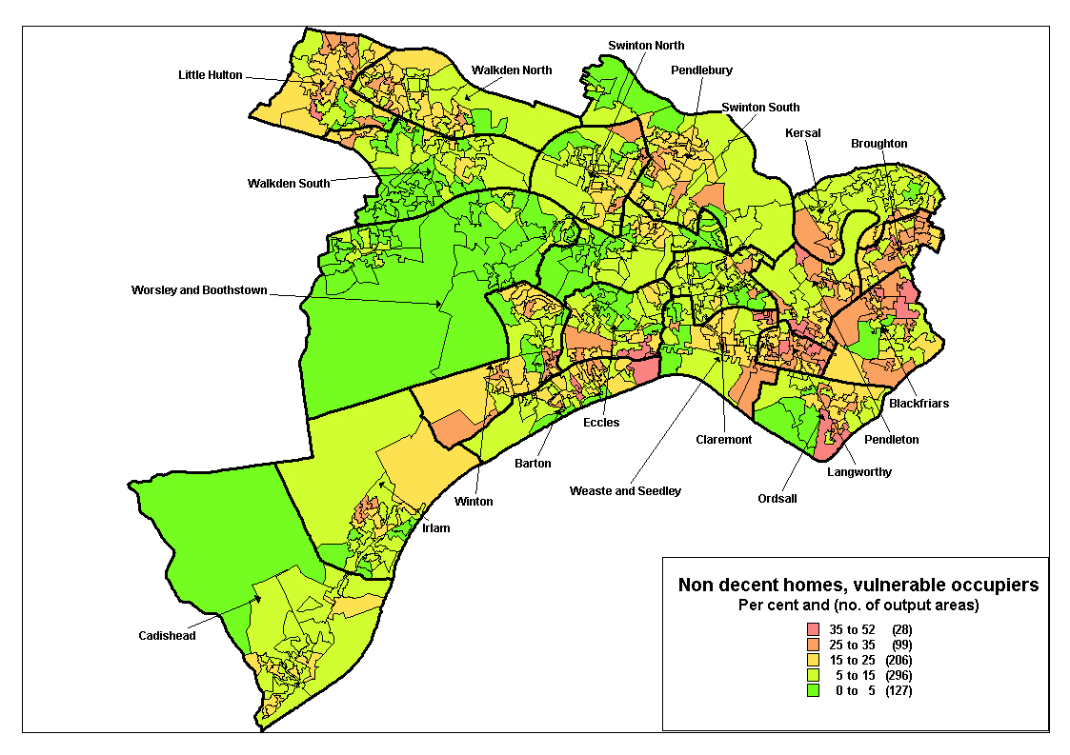
We have also mapped the results using the BRE data and the new wards we illustrate an example below. On our plans we have masked areas that are predominantly not residential. We believe this gives a more realistic picture.

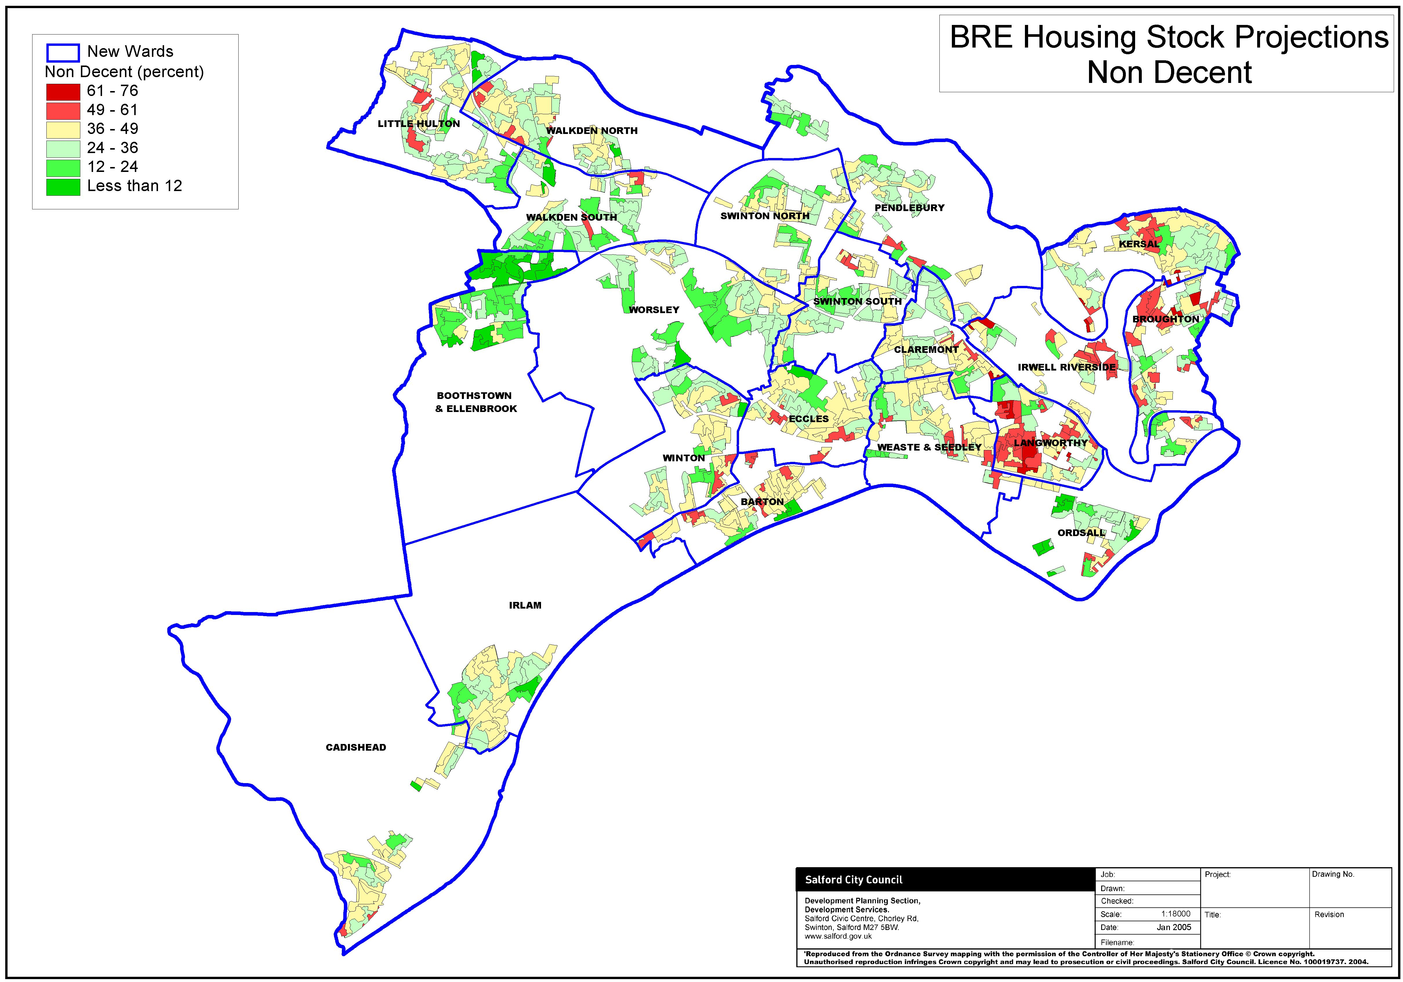

Comparison between the BRE model and Local House Condition Survey

The Council provided a local house condition survey database for comparison with the outputs of the models. Unfitness was selected for comparison as this is considered one of the most important pieces of information collected by house condition surveys. The BRE feel indications are very positive that the unfitness model can predict relative condition of output areas. It must again be emphasised that local factors are important and when considering the data the information on a specific output area should be looked at critically in the context of local knowledge. In general the relationships between the variables are similar to those found in other authorities with a strong correlation between each of the components of the decent home standard and the overall standard.

The BRE found the results of the comparison of the unfitness survey data with the modelled data is particularly encouraging.

The End of Traditional Surveys?

We do not believe that modelling will completely replace traditional surveys but we feel that the BRE model provides a robust indicator of conditions in the city and negates the need for a traditional survey in the short to medium term.

Next steps

- The BRE’s report has been placed on the N Drive to make it easily accessible to Housing Staff
- The report will be publicised through “Talking Homes”
- The report is utilised to target work (it’s findings have already been incorporated into the affordable warmth strategy and is being utilised in the Private Sector Housing Assistance Policy)
- The model should be used to target the sample for a joint stock condition survey that it is envisaged is to be conducted with Manchester. We aim to appoint a contractor by the end of July to conduct this survey and will report back further on this process.
- The model should be further validated by this survey.

Conclusion

This study provides a statistically robust baseline at a geographical level not financially viable by traditional survey. Because the survey gives us unprecedented detail the council will be able to target interventions more effectively. The model can also be used to target the sample for a traditional survey which it has been suggested The BRE found the results of the comparison of the unfitness survey data with the modelled data is particularly encouraging consequently the council can have confidence in the results of the model.

The PSA 7 Target is less than 25 % of Vulnerable occupiers in a non-decent private sector home by 2010 Salford has already achieved this.

Appendix 1

Modelled data (proportions)
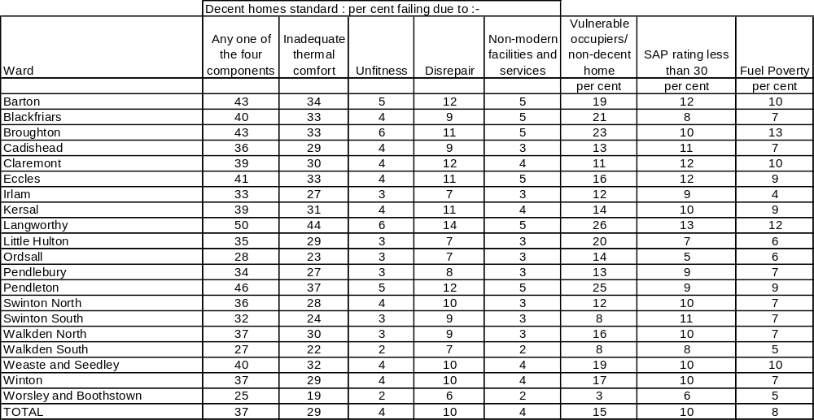
Modelled data (totals)
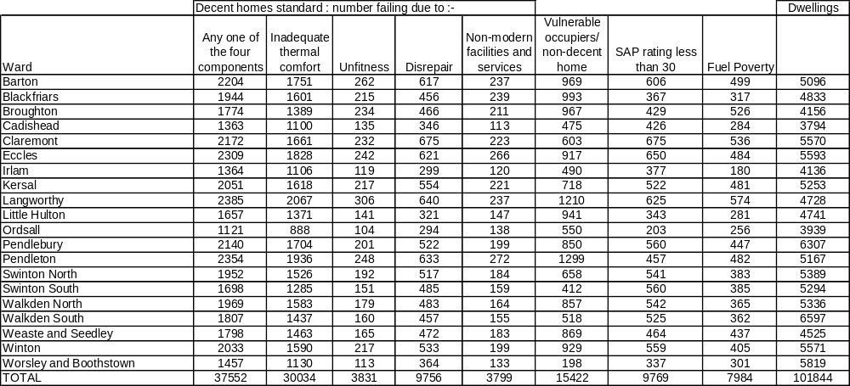

Appendix 2

 | NON DECENT | THERMAL COMFORT | UNFIT | DISREPAIR | NON MODERN | SAP<30 | FUEL POVERTY | NON DECENT VULNERABLE | DWELLINGS
BARTON | 2425 | 1933 | 295 | 693 | 260 | 669 | 558 | 1076 | 5541
BOOTHSTOWN & ELLENBROOK | 624 | 487 | 52 | 149 | 55 | 161 | 137 | 90 | 3546
BROUGHTON | 2582 | 2065 | 330 | 640 | 299 | 610 | 710 | 1480 | 6131
CADISHEAD | 1399 | 1128 | 138 | 355 | 115 | 439 | 290 | 481 | 3893
CLAREMONT | 1722 | 1302 | 179 | 549 | 174 | 546 | 412 | 369 | 4558
ECCLES | 2025 | 1599 | 202 | 528 | 236 | 568 | 414 | 793 | 4992
IRLAM | 1526 | 1243 | 133 | 324 | 136 | 404 | 194 | 586 | 4489
IRWELL RIVERSIDE | 2538 | 2010 | 289 | 760 | 301 | 559 | 567 | 1135 | 5964
KERSAL | 1859 | 1463 | 193 | 502 | 197 | 479 | 445 | 642 | 4901
LANGWORTHY | 3903 | 3362 | 433 | 961 | 421 | 912 | 759 | 2124 | 7983
LITTLE HULTON | 1987 | 1647 | 167 | 382 | 177 | 417 | 323 | 1103 | 5770
ORDSALL | 1599 | 1287 | 156 | 402 | 197 | 286 | 321 | 755 | 5040
PENDLEBURY | 1558 | 1256 | 131 | 345 | 139 | 395 | 282 | 672 | 4894
SWINTON NORTH | 1863 | 1460 | 183 | 492 | 175 | 505 | 363 | 638 | 5159
SWINTON SOUTH | 1633 | 1252 | 168 | 473 | 157 | 536 | 413 | 506 | 4617
WALKDEN NORTH | 1969 | 1583 | 179 | 483 | 164 | 542 | 365 | 857 | 5336
WALKDEN SOUTH | 1434 | 1128 | 131 | 384 | 120 | 433 | 289 | 354 | 4646
WEASTE & SEEDLEY | 1780 | 1417 | 175 | 495 | 172 | 474 | 482 | 760 | 4753
WINTON | 1900 | 1471 | 206 | 516 | 187 | 538 | 397 | 843 | 5275
WORSLEY | 1258 | 965 | 93 | 332 | 118 | 300 | 270 | 161 | 4495
SALFORD | 37583 | 30057 | 3833 | 9764 | 3801 | 9775 | 7991 | 15425 | 101983
 | NON DECENT | THERMAL COMFORT | UNFIT | DISREPAIR | NON MODERN | SAP<30 | FUEL POVERTY | NON DECENT VULNERABLE | DWELLINGS
BARTON | 43.76 | 34.89 | 5.32 | 12.50 | 4.69 | 12.08 | 10.07 | 19.42 | 5541
BOOTHSTOWN & ELLENBROOK | 17.60 | 13.72 | 1.47 | 4.21 | 1.55 | 4.55 | 3.86 | 2.53 | 3546
BROUGHTON | 42.11 | 33.68 | 5.39 | 10.44 | 4.87 | 9.96 | 11.59 | 24.15 | 6131
CADISHEAD | 35.92 | 28.97 | 3.54 | 9.11 | 2.97 | 11.28 | 7.45 | 12.35 | 3893
CLAREMONT | 37.78 | 28.57 | 3.92 | 12.03 | 3.83 | 11.98 | 9.04 | 8.10 | 4558
ECCLES | 40.56 | 32.03 | 4.05 | 10.59 | 4.74 | 11.38 | 8.29 | 15.88 | 4992
IRLAM | 34.00 | 27.69 | 2.95 | 7.21 | 3.03 | 9.00 | 4.33 | 13.06 | 4489
IRWELL RIVERSIDE | 42.56 | 33.69 | 4.84 | 12.74 | 5.04 | 9.37 | 9.51 | 19.03 | 5964
KERSAL | 37.93 | 29.86 | 3.94 | 10.24 | 4.02 | 9.78 | 9.09 | 13.10 | 4901
LANGWORTHY | 48.90 | 42.11 | 5.43 | 12.03 | 5.27 | 11.43 | 9.51 | 26.60 | 7983
LITTLE HULTON | 34.44 | 28.55 | 2.89 | 6.62 | 3.06 | 7.22 | 5.60 | 19.12 | 5770
ORDSALL | 31.72 | 25.53 | 3.09 | 7.99 | 3.90 | 5.68 | 6.37 | 14.99 | 5040
PENDLEBURY | 31.83 | 25.66 | 2.69 | 7.04 | 2.85 | 8.07 | 5.77 | 13.72 | 4894
SWINTON NORTH | 36.12 | 28.30 | 3.54 | 9.54 | 3.40 | 9.78 | 7.04 | 12.36 | 5159
SWINTON SOUTH | 35.36 | 27.11 | 3.65 | 10.25 | 3.41 | 11.61 | 8.94 | 10.95 | 4617
WALKDEN NORTH | 36.90 | 29.67 | 3.36 | 9.06 | 3.08 | 10.16 | 6.84 | 16.06 | 5336
WALKDEN SOUTH | 30.86 | 24.29 | 2.83 | 8.27 | 2.59 | 9.33 | 6.23 | 7.62 | 4646
WEASTE & SEEDLEY | 37.45 | 29.82 | 3.68 | 10.41 | 3.62 | 9.98 | 10.13 | 15.99 | 4753
WINTON | 36.01 | 27.89 | 3.90 | 9.77 | 3.54 | 10.20 | 7.52 | 15.97 | 5275
WORSLEY | 27.98 | 21.47 | 2.07 | 7.39 | 2.62 | 6.68 | 6.00 | 3.59 | 4495
SALFORD | 36.85 | 29.47 | 3.76 | 9.57 | 3.73 | 9.58 | 7.84 | 15.13 | 101983

