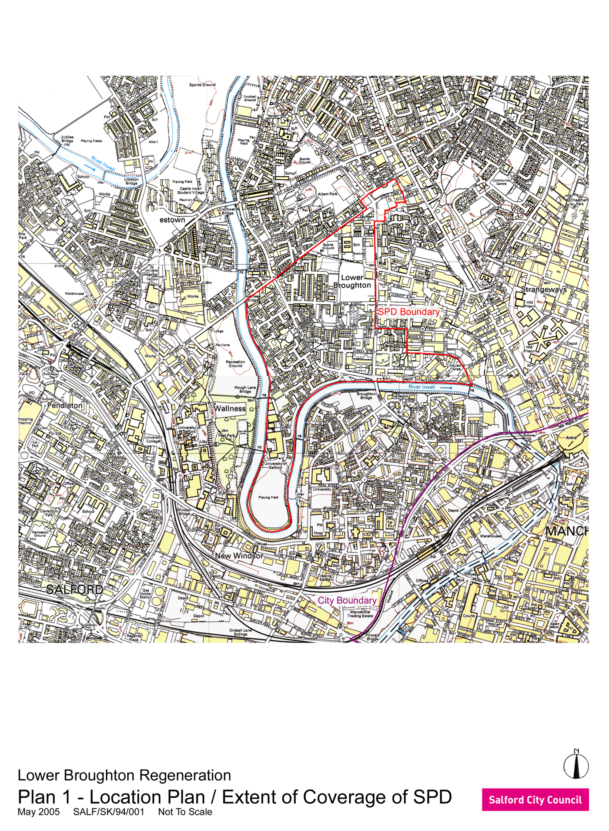

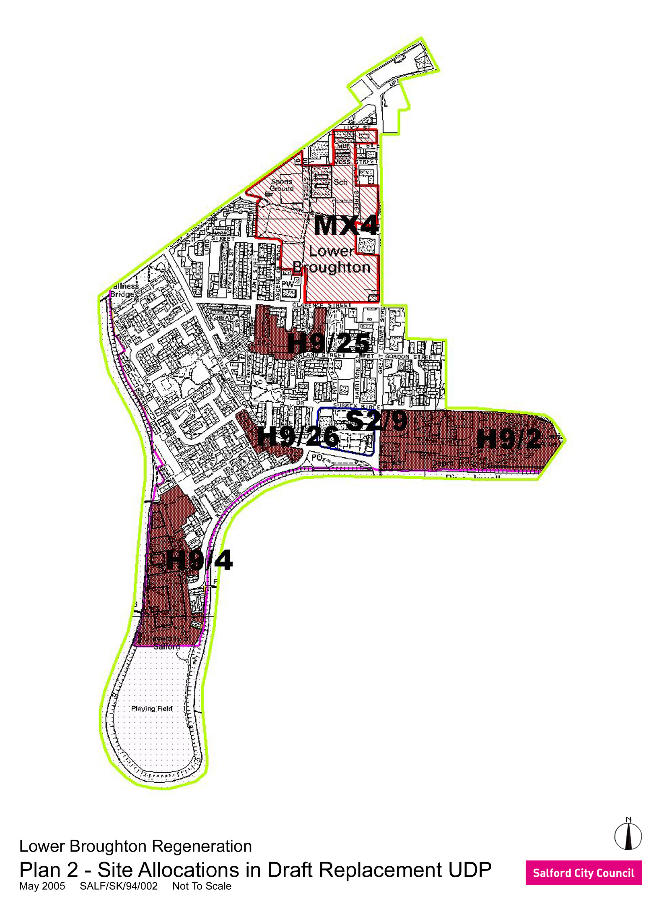

KEY
SITES FOR NEW HOUSING:
H9/2 CAMBRIDGE RIVERSIDE
H/9/4 MEADOW ROAD
H9/25 CUMBERLAND STREET
H9/26 LOWER BROUGHTON ROAD

NEIGHBOURHOOD CENTRE:
S2/9 MOCHA PARADE

SITE FOR MIXED USE DEVELOPMENT:
MX4 FORMER LOWRY HIGH SCHOOL



