Part 1

REPORT OF THE STRATEGIC DIRECTOR FOR SUSTAINABLE REGENERATION

TO THE LEAD MEMBER FOR PLANNING
FOR BRIEFING ON 6th October 2009
FOR DECISION ON 20th October 2009

TITLE: Chapel Street Highway and Public Realm Improvements

RECOMMENDATIONS:

That the Lead Member is recommended to:

- Approve the detailed design proposals for the Chapel Street Highway and Public Realm Improvements;
- Approve that Salford City Council enters into a funding agreement for £9.985 million with the North West Development Agency;
- Approve the expenditure of £405,000 as a commuted sum from Central Salford Urban Regeneration Company’s existing approved Green Streets budget to fund the management and maintenance of the project for a ten year period; and
- Approve that Urban Vision commence the procurement of contractors for the works.

EXECUTIVE SUMMARY:

The regeneration of the Chapel Street area is one of the most important projects in Central Salford. The revitalisation of the historic core of the City, linking the University of Salford to a new Corporate Centre around Salford Central Station, will create a new high quality environment for investing, living, working and visiting.

Chapel Street lies at the heart of this planned transformation. The challenge is now to create the conditions to enable successful regeneration in Chapel Street to occur over the next few years and to make sure that the area benefits from the current expansion of the Regional Centre. English Cities Fund is the lead developer partner with Central Salford, Salford City Council and other third party land owners and developers for this regeneration.

The vision for Chapel Street is to create a destination. This vision is underpinned by the plans to calm the A6 corridor, reduce traffic volume, support high quality public transport linkages and create a high quality environment. This will shape a new sustainable mixed use place with residential, commercial, leisure, hotel and retail developments alongside existing and new creative industries and established homes and businesses.

The Chapel Street Highway and Public Realm Improvements will achieve:

- The creation of a high quality environment to support £650Million private sector investment, 11,000 jobs and 1,700 new homes;

- A traffic calmed high street;

- Increased space for pedestrians of 89%;

- Much improved connections across Chapel Street for pedestrians;

- Bus and cycle priority; and

- High quality public realm with removal of street clutter, tree planting imaginative lighting and new street signage and furniture.

Subject to the approval of North West Development Agency funding, a start on site is anticipated in February 2010 with completion in May 2011.

BACKGROUND DOCUMENTS: None

KEY DECISION: Yes

DETAILS:

1.0 Background

1.1 | The regeneration of the Chapel Street area is one of the most important projects in Central Salford. The revitalisation of the historic core of the City, linking the University of Salford to a new Corporate Centre around Salford Central Station, will create a new high quality environment for investing, living, working and visiting. Chapel Street lies at the heart of this planned transformation. The challenge is now to create the conditions to enable successful regeneration in Chapel Street to occur over the next few years and to make sure that the area benefits from the current expansion of the Regional Centre. English Cities Fund is the lead developer partner with Central Salford Urban Regeneration Company (CSURC), Salford City Council and other third party land owners and developers for this regeneration. The vision for Chapel Street is to create a destination. This vision is underpinned by the plans to calm the A6 corridor, reduce traffic volume, support high quality public transport linkages and create a high quality environment. This will shape a new sustainable mixed use place with residential, commercial, leisure, hotel and retail developments alongside existing and new creative industries and established homes and businesses. Chapel Street is a priority project and is at the core of CSURC’s Vision and Regeneration Framework which was commissioned and approved by the Company’s three founder members in 2006.
1.2 | The Vision aspired to:  • reducing traffic on Chapel Street and encouraging the use of public transport;  • establishing a network of pedestrian friendly, tree lined boulevards; and  • creating an interconnected network of open spaces and pedestrian routes, to make walking, cycling and recreation everyday activities in Central Salford.
1.3 | Salford City Council and the CSURC have reinforced these objectives by producing Planning Guidance for Salford Central and a detailed Development Framework for Salford Central, both adopted by Salford City Council. These documents both have as a key objective the creation of a new Chapel Street that once more becomes a key destination within the wider Regional Centre and a place where people choose to live, work and spend their leisure time. The proposals for Chapel Street have been developed to give expression to this objective.
1.4 | In December 2006, the Chapel Street area between Oldfield Road and Trinity Way was included in a development agreement signed by Salford City Council, CSURC and the English Cities Fund, aimed at bringing about comprehensive improvements and new development reflecting the ‘vision’ for Central Salford. English Cities Fund appointed Glen Howells Architects to undertake a feasibility study of the potential for new commercial and residential development on the southern frontage of Chapel street and around St, Philip’s Church. The resultant development masterplan was produced in 2008.
1.5 | The strategic and local transport policy objectives are expressed in the Greater Manchester Local Transport Plan, the adopted Central Salford Integrated Transport Strategy and the draft Regional Centre Transport Strategy. The proposals are designed to encourage access by sustainable modes of transport and include provision of a bus lane along the street’s length reflecting the street’s role as a continuing major bus route which will form part of the route of the proposed Leigh-Salford-Manchester Busway that is being promoted by GMPTE.
1.6 | In February 2009 Salford City Council adopted a public realm design handbook for Central Salford, which sets out a series of design principles for the improvement of public spaces and streets within the area. These principles together with other city council design guidance have formed an important consideration in developing the design options set down in this report.
1.7 | The proposals have been developed to be consistent with the statutory and non – statutory land use and transport planning framework and other policies and guidance at national, regional, sub–regional and local levels summarised above. The following key principles, which have remained constant throughout the development of the ‘vision’ :  To reduce car traffic, and introduce:  - Wider footways; and  - Much greater pedestrian connectivity;  To provide bus and cycle priority along the corridor;  To reduce street clutter;  To introduce a very high quality public realm; and  Tree planting where services allow.
2.0 | Issues
2.1 | Traffic calming  Despite improving other routes into the Regional Centre, Chapel Street will remain a key transport corridor. With approximately 20,000 vehicle movements a day and 50 bus movements in each direction an hour, even after traffic calming, a dedicated bus lane and all purpose vehicle lane will be required in each direction.
2.2 | Limited space  The original visions show tree lined wide pedestrian footways, pedestrian refuges in the centre, cycle lanes, bus lanes and a general traffic lane in each direction. However Chapel Street has fixed dimensions with the historic assets, fundamental to place, forming the edges.  The limits of physical space have meant that in reality with a bus lane and general traffic lane in each direction there is a limit on the space leftover.
2.3 | Materials  Quality has been the key element of the different visions. However the materials all have to perform structurally and have had to pass a road safety audit; as well as enhancing the historic character of the street. The need to find suitable materials that can be used as a road surface has limited the selection available. The need to accommodate large volumes of heavy traffic restricted the choice to asphalt or deep granite. As natural stone performs differently to asphalt in the carriageway one of the challenges was to slow traffic down if quality materials in the highway were going to be used. Due to the skid resistance qualities of the higher quality materials it is necessary to reduce the speed limit to 20mph; a response usually implemented in residential or school zones.
2.4 | Environmental Sustainability  The limited space and the idiosyncrasies of a City High Street have prevented the selection of many types of sustainable urban drainage. After investigation: many of the solutions would have compromised the ambitions of creating an active and vital pedestrian environment. Material selection has also been a challenge with obviously competing qualities associated with certain materials; such as granite, which performs exceptionally well to deliver a quality appearance yet is an irreplaceable natural resource. The proposal aims to encourage people to choose more sustainable modes of transport particularly walking, cycling and increased bus usage. The calming of Chapel Street will significantly improve air quality in the corridor.
2.5 | Providing a full tree lined boulevard  The limited space and the amount of underground services that has been inherited along Chapel Street has prohibited the extent of tree coverage along the street.
2.6 | Reducing signage and street clutter  A key aim of previous visions has been the removal of excess signage and clutter including white lines on the highway. This is an area that is regulated and statutory traffic signage requirements mean that a minimum amount of signage must be provided. It has been a particular challenge to gain acceptance to remove excess white lining.
3.0 | Details
3.1 | Annex 1 is a plan of the proposed scheme. The project consists of:  A traffic calmed high street  Reducing traffic by a third along Chapel Street has been achieved by:  - Introducing 20mph zone, speed cushions upon entry to the area with sensors on traffic lights to slow and stop traffic moving too quickly;  - Traffic calming features included at every 100m;  - Visually narrower roads and the ramp up to Cathedral Square change drivers’ perceptions of the road as a highway; and  - East Ordsall Lane diversion straight on to Trinity Way provides alternative route.
3.2 | Increased space for pedestrians  - Wider pavements and removal of clutter increase useable pedestrian spaces from 4423m² to 8352m².
3.3 | Improved connections across Chapel Street for pedestrians  - New 10m wide straight line crossing connecting the two sides of the high street;  - Raised plateau at St John’s Place providing pedestrian friendly crossing point; and  - 2m wide central reservation provides refuge.
3.4 | Bus and cycle priority  - Extended bus and cycle lane from 3m to 4m allowing an increase of bus services from 41 per hour each way to 50 per hour.
3.5 | High quality public realm with removal of street clutter, provision of tree planting, imaginative lighting and new street signage and furniture  - New tree planting where possible along corridor;  - Architectural lighting included for key buildings, blue LED lighting provided in strips in paving, new street lighting and up-lighters for pedestrians; and  - High quality materials used for paving making use of natural stone where appropriate.
3.6 | New and improved squares and spaces - St. John’s Place  - New square opposite Cathedral that improves its setting;  - Raised Plateau creates a sense of a continuous space over both sides of the street; and  - Offers a centrepiece with new spaces for developments to spill out.  War Memorial  - Improved setting for the Grade II listed monument; and  - Re-design allows a greater flexibility of use and improvements to the way people can access and interpret the monument.  Islington Park Avenue  - Removal of through traffic allows a pedestrian friendly ‘shared surface’ to be incorporated improving connections and access to Islington Park.
3.7 | Summary  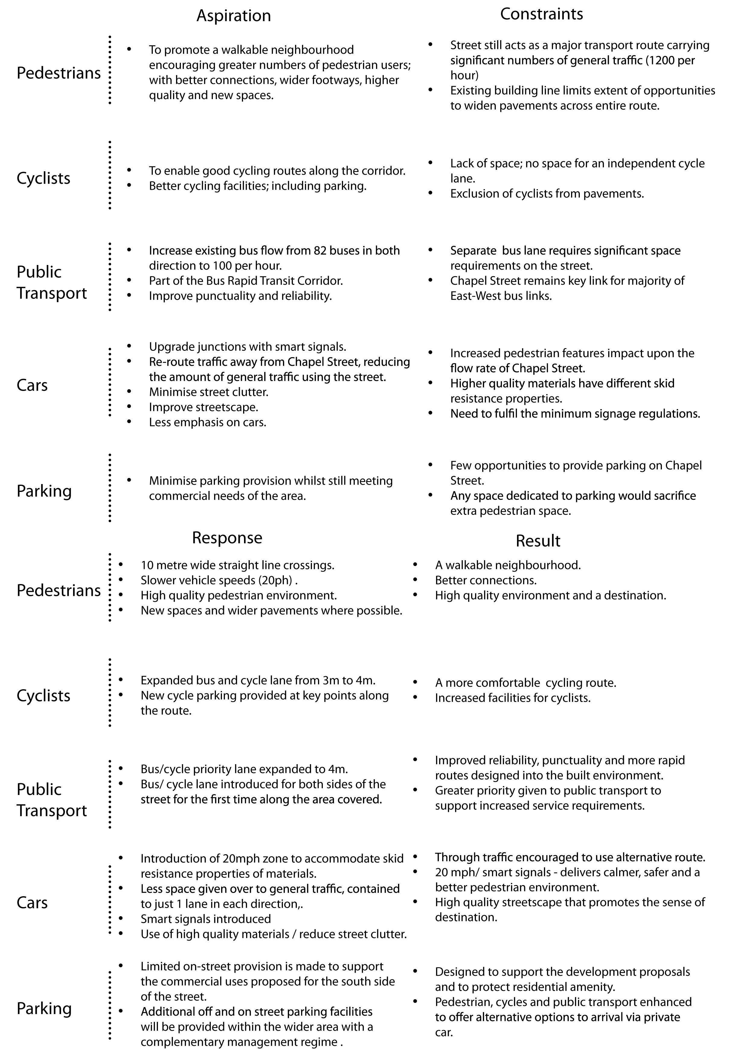
4.0 | Enabling Junction Improvement Works
4.1 | In order to achieve the above improvements to the Chapel Street Corridor, traffic still wishing to access Manchester City Centre must be directed along alternative routes. The Central Salford Integrated Transport Strategy has established that this can be achieved by undertaking relatively minor adjustments to the following junctions;  - Broad Street / Albion Way / The Crescent;  - Liverpool Street / Albion Way;  - The Crescent / Oldfield Road;  - Regent Road / Oldfield Road / Ordsall Lane.  Further details of these junction schemes will be brought forward for approval as designs are developed
5.0 | Implications for Salford City Council
5.1 | Road Safety and DDA
 | The new design for Chapel Street increases the opportunities to cross the road and could potentially increase the conflicts between other road users, particularly at St John’s Place.
5.2 | A road safety and DDA audit has been carried out and the new design conforms with the appropriate legislative standards.
5.4 | Maintenance and Management
The high quality materials and extra public space provision will result in an increase in management and maintenance responsibilities for the City Council. Existing and estimated future maintenance costs are set out below:

Cost for maintaining Chapel Street as existing over the next ten years | £462,500
Estimated cost for maintaining Chapel Street following the highway and public realm improvements over ten years | £868,000
Increase in maintenance cost over ten years | £405,500

It will be essential to make sure that the street and spaces are maintained to the same high standards that have been designed in to the original works. This will be a critical element in ensuring that the Chapel Street area becomes and remains a high quality destination within the City Centre as expressed in the Vision and supporting guidance documents. CSURC agrees to commit this additional maintenance figure of £405,000 as a commuted sum from the existing approved Green Streets programme (as included in the CSURC’s approved Business and Investment Plan 2009/2010) over the years 2009/2010, 2010/2011 and 2011/2012.
CSURC and the City Council are also working on proposals to address issues of longer term management and maintenance of all new public realm and highway improvements in Central Salford. These proposals will provide appropriate funding and delivery mechanisms after the ten year period.
6.0 | English Cities Fund Planning Application
6.1 | English Cities Fund submitted a Hybrid Planning Application for part of the Salford Central area on 28th July 2009. This includes the details of the Chapel Street Highway and Public Realm Improvements.
7.0 | Procurement Arrangements
7.1 | Tendering for the works will be undertaken in two parts:  - The enabling junction improvement works will be procured through a tender process with Salford City Council’s approved framework partner contractors.  - The main Chapel Street highway and public realm works will be procured through the OJEU process.
8.0 | Timetable
8.1 | A start on site is programmed for February 2010 with completion in May 2011.

KEY COUNCIL POLICIES:

Central Salford Integrated Transport Strategy: June 2009 (Section 4: Proposals By Corridor (Chapel Street))

EQUALITY IMPACT ASSESSMENT AND IMPLICATIONS:

The new design increases the opportunities to cross the road and could potentially increase the conflicts between other road users, particularly at St John’s Place.
A road safety and DDA audit has been carried out and the new design conforms with the appropriate legislative standards.

ASSESSMENT OF RISK: Low

SOURCE OF FUNDING:

Central Salford URC’s approved Business and Investment Plan 2009/2010 identifies the Chapel Street highway and public realm works within its Corporate Centre Programme (Project 2.2 : Chapel Street).

Funding of £9.985 million is being sought from the North West Development Agency. A Concept Application was approved by the North West Development Agency on 10th August 2009 and a Detailed Development and Appraisal Application is due to be submitted on 28th September. North West Development Agency Board approval is expected on 7th December 2009.

LEGAL IMPLICATIONS:

Contact Officer and Extension No: Richard Lester - 793 2129
Date Consulted: 21st September 2009
Comments:
The report explains the procurement arrangements which will lead to contractual relationships. The proposed traffic controls (eg speed limit, speed tables, bus and cycle lanes) will require traffic regulation orders to be made in accordance with statutory procedures

FINANCIAL IMPLICATIONS:

Contact Officer and Extension No: Alison Swinnerton (on behalf of Nigel Dickens) - 601 4887
Date Consulted: 21 September 2009
Comments:
The Chapel Street Highway and Public Realm Improvements will be met within CSURC’s Business and Investment Plan Capital Programme 2009/2010. Future maintenance will be provided by way of a commuted sum funded from CSURC’s Business and Investment Plan 2010/2011. There will be no additional resources needed from the City Council to fund this project as it forms part of the Salford City Council Capital funds allocation to CSURC.

The Chapel Street Highways and Public Realm Improvements is part of CSURC’s Business and Investment Plan Capital Programme 2009/2010.

Funding of £9.985 million has been applied for from the North West Development Agency which received Concept approval on 10 August 2009. A decision on the Detailed Application is expected by the end of December 2009.

The scheme will be dependent on obtaining sufficient funding from the North West Development Agency.

Indicative maintenance costs are currently estimated to be an additional £405,000 over ten years. There would be a commuted sum of £405,000 from CSURC’s Business and Investment Plan Capital Programme to meet this cost.

OTHER DIRECTORATES CONSULTED: Urban Vision (Highways)

CONTACT OFFICERS: Peter Baker Central Salford URC (0161 601 7728)
Perry Twigg Urban Vision (0161 779 6053)

WARDS TO WHICH REPORT RELATES: Irwell Riverside and Ordsall

Paul Walker
Strategic Director for Sustainable Regeneration
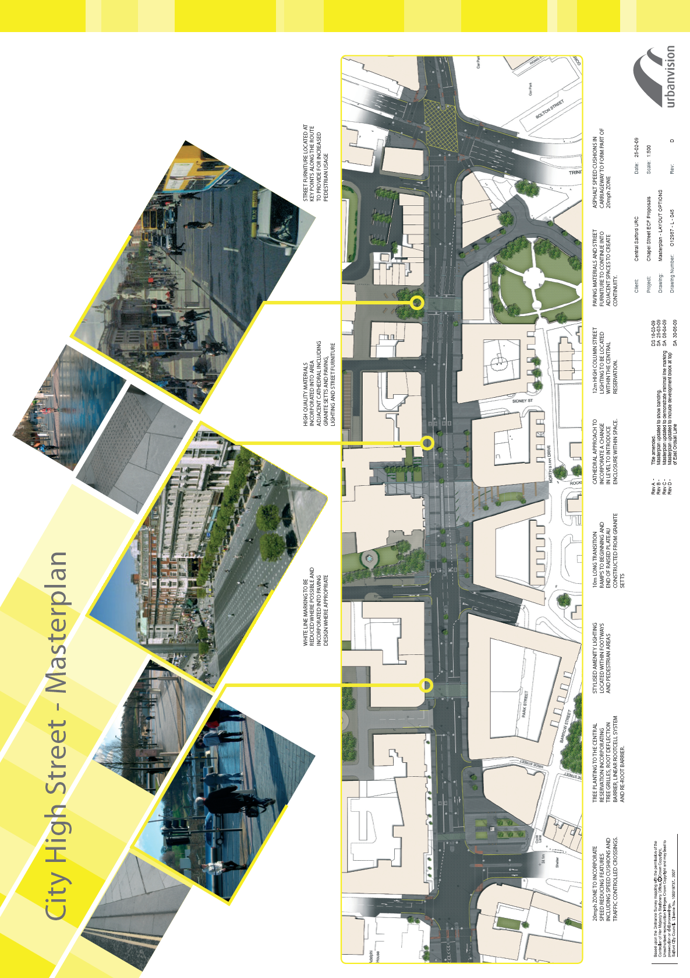
ANNEX 1

