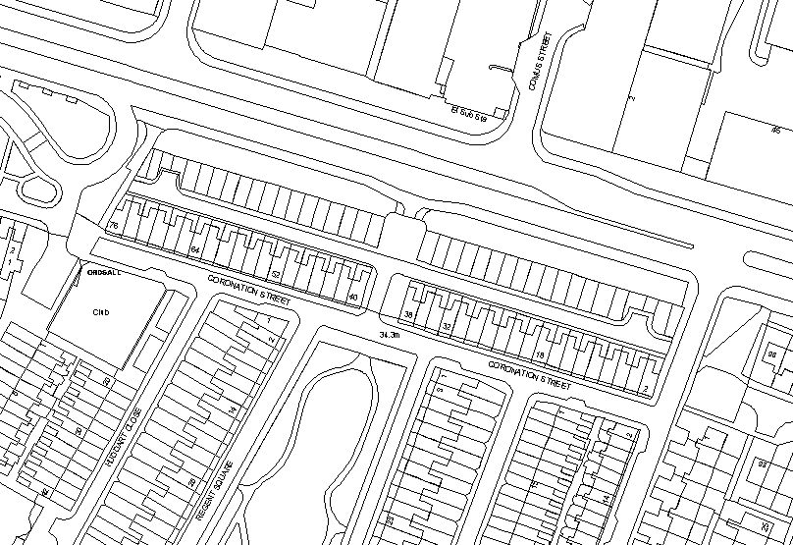
Coronation Street, Ordsall
Gate Position Plan
Scale: 1:1250

Gate 3

Gate 2

Gate 1
Existing sealed end of road by railings.

