PLANNING AND TRANSPORTATION REGULATORY PANEL |  | PART 1  (OPEN TO THE PUBLIC)
PLANNING AND TRANSPORTATION REGULATORY PANEL |  | ITEM NO
SUBJECT: HIGHWAYS ACT 1980, SECTION 129A  SALFORD CITY COUNCIL (MOUNT STREET - LONG STREET, SWINTON) GATING ORDER 2007 |  | OPERATIONAL MATTER
JOINT REPORT OF ASSISTANT DIRECTOR (LEGAL) AND  The Managing Director of Housing Connections Partnership. |  | FOR DECISION

1. Purpose of Report:

1.1 This report sets out details of the objections and evidence received in support of the proposed gating order, together with the comments of The Managing Director of Housing Connections Partnership.

1.2 The Panel are asked to consider whether the proposed Order meets the requirements of Section 129A of the Highways Act 1980 and if satisfied that it does, whether in light of the objections received, the Order should be introduced as originally proposed, amended or withdrawn.

1.3 It is our recommendation that the Order be introduced as originally proposed.

IF YOU HAVE ANY QUERIES PLEASE CONTACT  Louise Averill  0161 604 7720 | BACKGROUND DOCUMENTS (Available for public inspection)  - Plan outlining the proposals  - Draft Order  - Documentation in support  - Letters of Objection
QUALITY CONTROL | Report prepared by: Louise Averill  Reviewed by: Mike Wright
Customer and Support Services Directorate, Law and Administration Division, Salford Civic Centre, Chorley Road, Swinton M27 5DA

2. Implications:

2.1 Resources (Finance/Staffing): The scheme would be funded by the Housing Crime Reduction Team. All consultation and project management has been carried out by a Housing Crime Reduction Officer.

2.2 Strategy and Performance Review: The proposed scheme is consistent with relevant strategies these being the Crime & Disorder Reduction Strategy and Pledge 2 – Reducing Crime in Salford and Pledge 7 – Enhancing life in Salford.

2.3 Environmental: Environmental Services have been consulted on the scheme, there were no objections raised.

  - Equal Opportunities: No implications

3.0 Background

3.1 On the 4th May 2007, the Director of Engineering (Urban Vision) gave authorisation to advertise the intention to make the above-mentioned Gating Order under Section 129A of the Highways Act 1980.

3.2 Please refer to Appendix A for a map of the area. The Housing Crime Reduction Team were first presented with the alley gating of Mount Street – Long Street in June 2006 when they were contacted by local residents. They had concerns that the area was being used for anti social behaviour. Resident consultations were sent out on 13 November 2006 to the properties affected by the proposals. The results of these consultations were as follows:

- 16 out of the 39 (41%) domestic properties responded all of which were in favour of the scheme

Following the objections received from the Ramblers Association and the Joint Local Access Forum further consultation was carried out in order to gather information as to the frequency of the anti social behaviour suffered by the residents. Additional consultations were also sent to 51 – 57 Worsley Road as it was thought that these properties were not affected by the scheme but due to the gardens being extended on all of the properties they were.

The results of this consultation were as follows:

- 17 of the 43 (39%) properties responded, 1 objection was received.

It is worth noting that a high number of the properties are privately rented, it has been found on previous schemes that this demographic tend not to respond to consultations. On the initial consultation 34 out of the 39 (87%) properties consulted are privately rented. On the second consultation 34 of the 43 (79%) properties consulted are privately rented and 1 shop that is only open during the day.

4.0 Crime and / or Anti social behaviour

4.1 Of the residents that responded to the initial questionnaire 62.5% stated that crime or anti social behaviour occurred within the alley. Of the residents that responded to the second consultation 75% stated that crime or anti social behaviour occurred within the alley.

  - The responses from both resident consultation suggest that antisocial behaviour is facilitated by the alley way. These are attached in Appendix B for your perusal. The crimes that residents have highlighted in particular include youths drinking and congregating, used as an escape route from the police, drug dealing and arson attacks. Please refer to Appendix C for pictures evidencing the anti social behaviour being committed in the area.

5.0 Considerations and objections

5.1 Alternative route
Please refer to Appendix D & E. The alternative route would only affect a very small number of residents. If the route was restricted with the erection of gates there would be no impact on accessing any amenities or bus stops. There would be an additional route of 131.5 metres for a possible small number of School children.

5.2 Health Implications
As the alternative route would have a minimal effect on the extra distance required to access the School or access the side of the even properties on Mount Street to the even properties on Long Street and vice versa, there are no significant health implications to this gating order.

5.3 Impact on Disabled Users
There may be an impact on disabled users with regard to the additional distance. However, the alternative route is accessible for wheelchairs and suitable for older people.

5.4 Other Crime Reduction Measures considered
Due to the nature of the offences being suffered by the residents, alley gating is the only efficient way to resolve the existing problems of anti social behaviour.

5.5 Objections to the proposed Order have been received from the Ramblers Association and the Joint Local Access Forum.

Summary of Objections

That the Northern part of the route being the route between Beech Street and Stanwell Road is used as a through route.

2 residents objected to the proposed position of the gates.

Following the second consultation an objection was received by a local resident who had previously not responded. The objection stated that it was felt that the local residents are the source of the litter and that because the bins are left out this is the reason they are set on fire, also felt that by gating the alley way it would create a “ghetto”. It was also stated that the fire service should have easy access to the alley way.

Response to Objections

A copy of the summary of results was sent to the Ramblers Association and the Joint Local Access Forum with copies of the 2 alternative route maps.

A meeting was arranged with one of the resident objectors (the other was a neighbour) in the meeting it was clear that there had been confusion over the proposed positioning of one of the gates. The two residents were not objecting to the overall scheme but to the proposed position of one of the gates. It emerged that the properties on Worsley Road 51-57 have had the gardens extended, the map did not represent this and so it appeared that the properties would be excluded from the scheme. When the objector was informed that their properties would in fact benefit from the scheme, the resident who attended the meeting informed their neighbour and the objections were withdrawn.

The resident was advised that the fire service are consulted on all schemes, no concerns or objections had been received from the fire service. It was also confirmed that the fire service would simply forcibly remove the gates if they required emergency access. In other schemes carried out across the City it has been shown that the number of arson attacks have reduced following the erection of gates. If the bins were kept inside the gates it would be more difficult for them to be set on fire. Finally if the residents are the ones who are responsible for fly tipping, this can be reported to Environmental Services who are able to take enforcement action. If a gating order was granted then the status of the highway remains the same and as this is an adopted highway the Council would retain its responsibilities in its maintenance etc.

Although the points made by both the Ramblers Association and the Joint Local Access Forum are understood it is felt that by leaving the North end of the alley way open would not sufficiently resolve the issues and problems suffered by the residents. All but one of the residents who live adjacent to this part of the alley way have responded and are fully in support of the scheme, and if this part of the alley was left open it would leave a single point of congregation.

6.0 Legislation and procedure

6.1 The Council has complied with the procedures contained within Section 129C of the Highways Act 1980 in that it:-

- Notified occupiers of all adjacent or adjoining premises of the proposed Gating Order by letters dated 7th June 2007.

- Published a notice in the Salford Advertiser and on the Council’s website on 7th June 2007.

- Placed notices of the proposed Gating Order on the highway affected on 7th June 2007 and maintained the notices for a period of 28 days.

- Notified all statutory undertakers and any persons who requested to be notified of any proposed Gating Orders by letters dated 7th June 2007.

6.2 Section 129A of the Highways Act 1980 provides that the Council must be satisfied that:-

- Premises joining or adjacent are affected by crime or anti-social behaviour;
- The existence of the highway is facilitating the persistent commission of criminal offences or anti-social behaviour;
- It is in all the circumstances expedient to make the order for the purposes of reducing crime or anti-social behaviour.

6.3 We must also consider

- the likely effect of making the order on the occupiers of premises adjoining or adjacent to the highway;
- the likely effect of making the order on other persons in the locality; and
- in a case where the highway constitutes a through route, the availability of a reasonably convenient alternative route.

7.0 Summary

  - The procedures have been followed correctly as outlined in section 6.1

  - The evidence provided by residents clearly indicates the existence of persistent anti social behaviour, which is affecting their quality of life.

  - We are satisfied that despite the alternative route being slightly longer, the benefits of restricting access is greater than the minimal inconvenience to a small number of people.

  - On balance we are satisfied that it is in all circumstance expedient to make this order for the purposes of reducing crime and anti social behaviour.

David Galvin I. Sheard
Managing Director Assistant Director (Legal)
Housing Connections Partnership Salford City Council

Appendix A

Mount Street – Long Street – Gating Order Map

Scale 1:1250
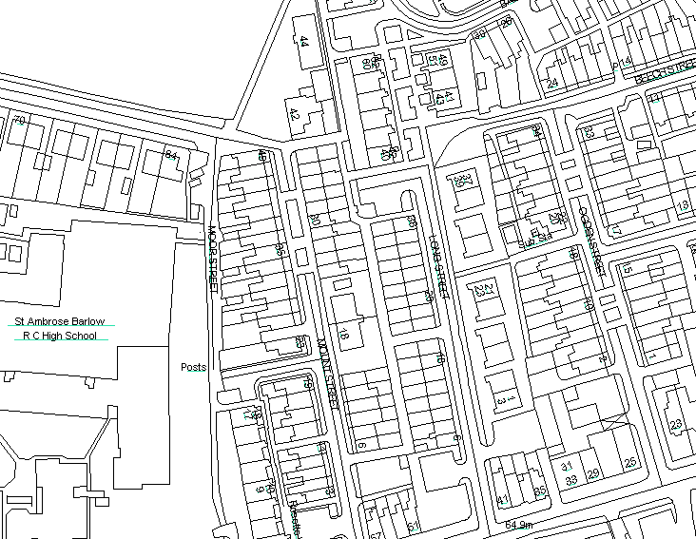
Gardens of 51 – 57 have all been extended

Appendix B – Comments from Residents

Comments
Drinking 10 or more youths; motorbikes; drug dealing. All school children before and after school use as a meeting place.
Shooting in Long Street.
Approx 12 months ago a stolen car was burnt out and abandoned near the alleyway to the rear of Mount Street. Minor anti –social behaviour x 4 within 12 months.
Escape routes for motorbikes being chased by police. Gangs of youths causing vandalism, setting fire to cars. Drug taking, gangs drinking, school fights, assaults, fly tipping in a result of rubbish being set alight by youths.
A gunman escaped through the alley way last year after shooting someone on the Street. School kids use the alley to access dealer and use drugs. Fly tipping is very common by residents and needs addressing seriously.
A neighbour got shot and the alley was used to gain access and as an escape route.
There was a shooting at a neighbour’s house and the gunman escaped through the alley.
Youths roam around at all times up and down most nights.
Drug dealing. Gangs hanging about burning bins, burning cars on car park, cars vandalised, throwing bricks over walls, trying to get into backs, driving motor bikes revving up load in night.
Gangs of youths at night time – very noisy and disturbing.

2nd Consultation
Comments
I cannot understand why objections have been raised. I must be surrounded by crooks and yobs. Lots of school children use the alley daily. They leave litter and often gather in groups in the alley day and night. It is used inappropriately. Plus it is very dark at night where intruders can roam freely, gates would be good here!!
Bins set on fire. Rubbish deposited
Youths hanging round and drinking in alley way. Stolen car burnt out and dumped near rear of alleyway.
Gangs of youths drinking. People dealing and taking drugs. Vandalism to many properties. Police chasing, arson, gangs fighting, verbal abuse weekly if your confront them.
Damage to property, bins being burnt out, cars broken into, teenagers drinking.
Gangs of youths sit on the walled garden behind my home, this can be very noisy and unnerving, graffiti is also on my wall. I fully support the gating. A property across the road was broken into recently via the rear door. The gating would make me feel a lot more secure in my home.
Youngsters drinking, fly tipping, escape route for people, wheelie bins set on fire, vandals on walls.
Vandals, fly tipping under age drinking, escape route, fires to bins.
Kids using it for under age drinking, hide out. Also tried to be broken into twice.
Bins set in fire regularly (fire engine here again now 3rd time this week), burglars using them to gain entry to rear of properties, kids not belonging to Street hanging about drinking.
I would like the gates on if only to help keep the place a little tidy. Hope this works but think we’re fighting a losing battle. Every Friday night about 10 upwards we get empty beer and alcohol bottle over the car park and bins turned upside down, litter on the road and bricks taken off the wall.
Gangs of young kids drinking and swearing, kicking balls at the side of the flat every night in Summer, can’t open window in Summer because of the kids.
Youths hang around at weekends to drink and hide.

2nd Consultation
Objection Comments
I am totally objecting to the alley gating scheme. In view of the anti social behaviour of the tenants I can’t imagine tenants adhering to rules regarding wheelie bins. Bins are left in the alley and streets constantly and regularly set on fire. I feel this scheme would create a ghetto with us trapped in. Mounds of discarded furniture etc and unemptied bins. It is essential that the fire service have easy access to the alley.
Fly tipping – littering by tenants.

Appendix C

Pictures to evidence anti social behaviour being carried out in the alley way
Remains of bin that had been set on fire
Litter that had been emptied from a wheelie bin

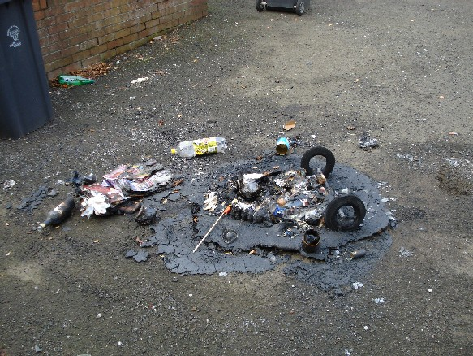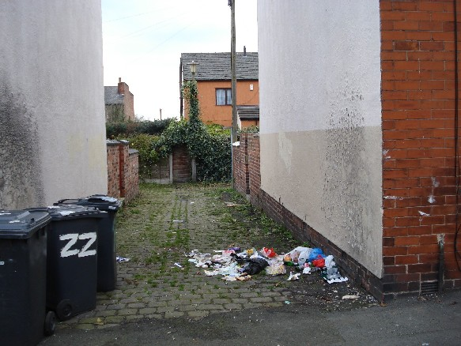

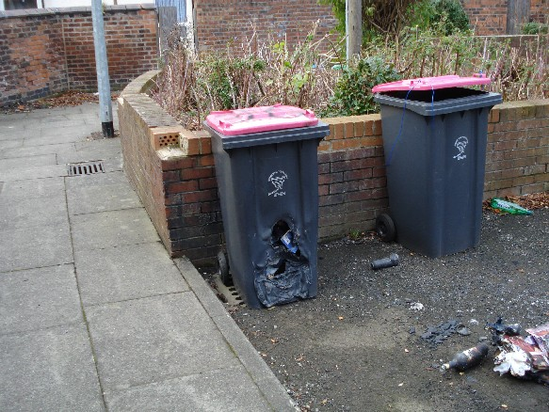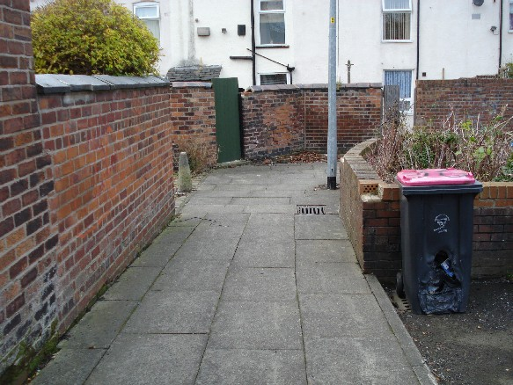

The three picture (one above and 2 to the side) are at the North end of the alley way where is has been stated that a number of youths gather. Burnt bin and litter, removed bricks from wall.
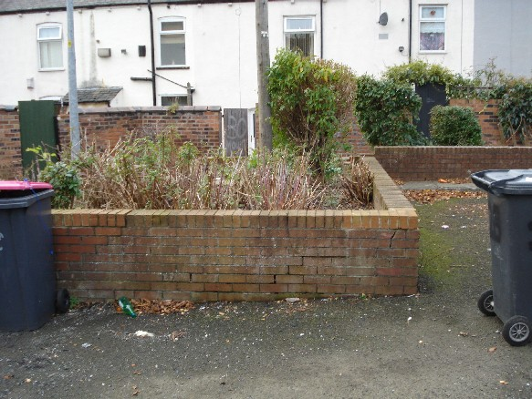
Graffiti on rear garden gate

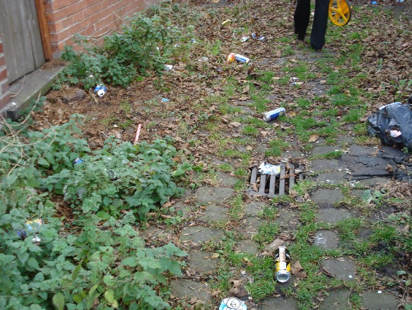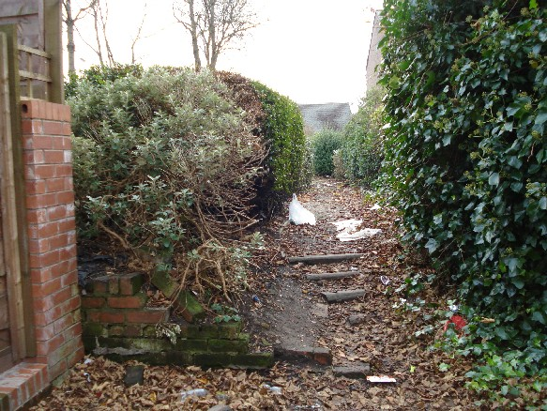

This is the point at which the Ramblers Association and the JLAF wish to remain open, this is the main point at which youths gather etc, if this were left open it would still allow a means of escape and it would be likely that the youths would continue to congregate.
This is a picture of the alley way to the rear of the affected properties, evidence of people drinking in the alley and discarding their rubbish in the alley.

Appendix D – Alternative Routes

Local amenities of shops and bus stops are located on Worsley Road and Chorley Road. Access to these local amenities would not be affected by the proposed Gating Order. A High School is located on Shaftesbury Road, there is an entrance on Moor Street. Please refer to Map 2 for route plans and distances.

The yellow line indicates the absolute maximum alternative route. This would however only affect residents from
- Moor Street and the odd side of Mount Street accessing the Long Street side of the estate.
- Odd side of Long Street accessing the Mount Street and Moor Street

If this route were to be gated access would only be restricted to domestic properties, it would have a minimum affect on access to any amenities or the School.
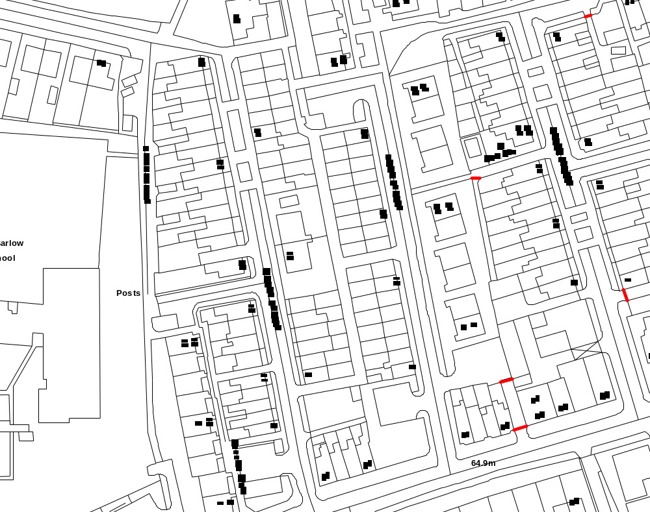
76.06m
140m
52.84m
304m

Route 1

Route using the alley to cut through

Alternative route using the pavement to the front of the affected properties.

Route 2

Route using the alley to cut through

Alternative route using the pavement to the front of the affected properties

Appendix E – Alternative Routes 2

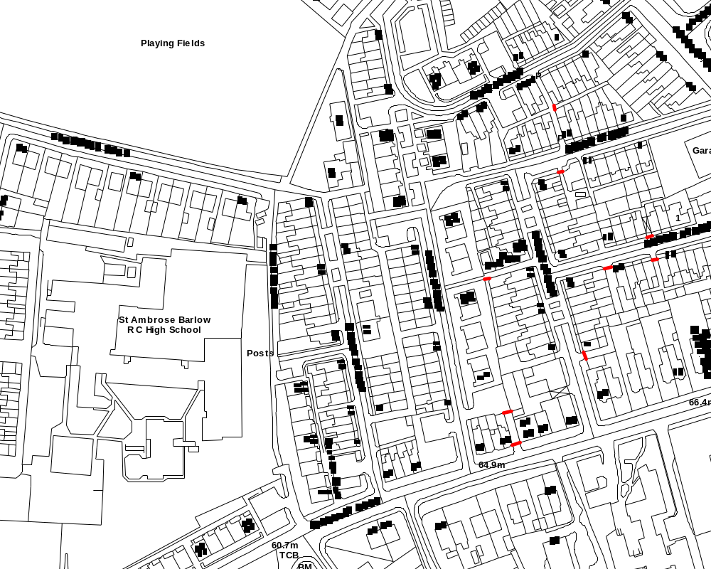
184 metres
53.5 metres
184
- 53.5
= 131.5 additional distance

