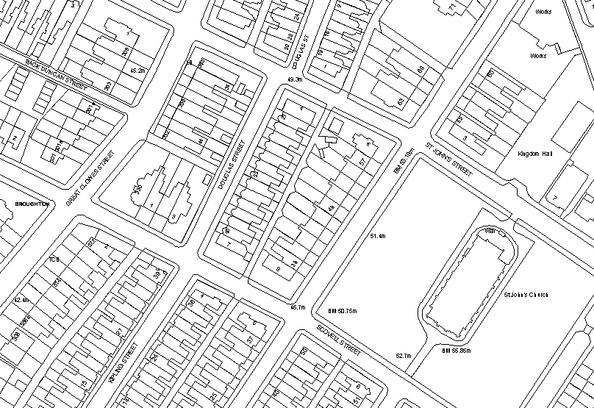
21 – 45 Douglas Street – 39 – 57 Wellington Street West – 4 – 6 Howe Street and 7 – 9 Scovell Street
Gate position plan
Scale: 1:1250
Proposed gate 1
Proposed gate 2

