REPORT BY

DAVID ROBINSON, ENVIRONMENTAL MAINTENANCE MANAGER

SUBJECT

GRAFFITI SERVICE

1.0 INTRODUCTION

1.1 In recent months, graffiti has been the cause of much greater concern than in the past. It is often described as a “cancer within society”. The Deputy Office of the Prime Minister considers graffiti to be one of the first steps of a downward spiral of the street scene within an area. Consequently, this has resulted in a recent Government White Paper entitled “Respect and Responsibility”, which takes a stand against anti-social behaviour and focuses on initially tackling the visible effects of anti-social behaviour in public places, and also introduces a new offence in the selling of spray paints to people under 18 years old.

1.2 If graffiti is not removed promptly, then this could result in an “epidemic” of further attacks within an area, which can in turn produce a “magnet” for further anti-social behaviour.

1.3 The public awareness has been heightened by graffiti attacks on prominent buildings and in particular, graffiti has been used by political / criminal activists who use it as a means to target members of the community (i.e. “Grass”, “Paedophile” etc), or, as in recent months, anti war slogans aimed at the Government.

1.4 The problem cannot be ignored, but with rapid and effective removal, combined with police assistance in investigating these “attacks”, we are nearer controlling a problem that is currently blighting not only our City, but also the whole country.

2.0 CURRENT SERVICE PROVISION

2.1 The Directorate presently has two graffiti teams who operate citywide. One team is funded solely by Environmental Services and the second team, introduced in January of this year, is partially funded from the Crime and Disorder budget. This funding has enabled the Directorate to obtain the operational resources (i.e. high power jet wash and chemical graffiti remover) required. However, the staffing costs are met from savings within the Directorate (see attached Service Costs – Appendix 2).

2.2 The Service has been in operation for approximately ten years and the performance of the teams has grown by experience, rather than by design. It is intended that Management Services be asked to monitor the performance of the teams (a task never before carried out), so that we can report / monitor their productivity. This will then enable us to establish Local Performance Indicators, and a thorough scrutiny of the effectiveness of the service.

2.3 Internal Audit was asked to review the service and its procedures, which was completed on the 1st April 2003. Their findings were: -

  - The Authority is vulnerable to risks of claims being made from any damage, which may be caused by the removal operation, and the introduction of a disclaimer would provide the necessary control.

  - The introduction of a clearly defined charging policy would help ensure that all parties are dealt with equally.

2.4 The demand for the service has steadily increased, reaching a peak in March 2003, with 120 reports being recorded, the highest monthly figure since the commencement of Flare(Computerised Recording System) was introduced. (See attached ward / monthly analysis for 2002 / 03 – Appendix 3).

2.5 All graffiti requests are recorded on the Flare system, via the Call Centre. Since the 1st January 2003, these reports are recorded by category, either as “Offensive / Racist Graffiti” or “Non-offensive Graffiti”.

2.6 Our current aim is to clear all Offensive / Racist Graffiti within forty-eight hours, and Non-Offensive Graffiti within five working days. However, 36% of all requests received are of an offensive / racist nature and as such, our priority is to respond to this category.

3.0 RECHARGING

3.1 At present, there is an inconsistent approach to re-charging for removal of graffiti. If service requests are received from other Directorates or owners of private buildings, the cost is recharged accordingly. However, all other requests do not incur this recharge. Therefore, in the case of Housing property, the Council tenants are being charged for the service, within their rent, whereas private householders do not incur such costs.

3.2 It is imperative that a future policy is decided on, from one of the following options: -

a) All requests are recharged to the land / property owner.

b) If the service is requested by the land / property owner, then the cost will be recharged. If the request is received by members of the public, elected members or officers, then no recharge is made.

c) A free service for all requests.

3.3 Suggested cost of the service would be as follows: -

Cost of removal of graffiti by use of hi-speed pressure wash and appropriate chemical | £44.00
Cost of “paint out” of graffiti, using the appropriate colour as necessary | £32.00
All costs would be based on an average removal time of half hour.

3.4 This report will be presented to the Environmental Services Lead Member for approval of one of the three options as stated in 3.2.

4.0 PROPERTY DAMAGE / DISCLAIMER

4.1 The present service did not seek permission, prior to removal of any graffiti. The equipment used, could, potentially, cause damage to property, e.g. rendering, pointing, brickwork etc.

4.2 All operatives of the two graffiti teams are fully trained in the use of the high pressure wash, and where appropriate, will actually manually “paint out” graffiti, rather than remove it. However, there could be an occasion when damage does occur, leaving the Authority liable for that damage and any resultant insurance claim.

4.3 Therefore, the Directorate has to introduce a Disclaimer/Consent Form, (see attached Disclaimer/Consent Form-Appendix 1)which has been approved by the Authority’s Legal Section.

4.4 Before any work commences, the consent form would need to be signed, indemnifying the Authority from any damage caused as a result of graffiti removal.

  - It should be noted, however, that now the disclaimer is introduced, this could impact on response time for the service to be carried out, as property / land searches would be required to locate the owner, and subsequent permission sought from them for this work to be completed. Permission may be refused on the grounds that this work would be chargeable or possible non return of the form, which could delay / prevent removal of any graffiti, leading to the problems highlighted earlier in this report with regard to the street scene appearance and its associated social problems.

  - It should be noted that at this present moment in time, there is no enforcement legislation to empower the removal of such graffiti. Racially inciting material may be a criminal offence, however this would be a matter for the police to deal with. Although there has been a recent press release(see Appendix 6)where MPs are demanding Government Ministers to empower Local Authorities to remove graffiti eyesores from property owned by statutory undertakers

There would also be the additional expense of any possible legal costs, if there were a need to pursue non-payment of invoices.

  - The introduction of a revised charging policy and also a disclaimer, would allow the Directorate to provide a more structured approach to the service, and combined with the Management Services Review of the graffiti removal operation, enable a more efficient and effective service for residents of the City.

SUMMARY OF APPENDICES

APPENDIX 1 | Disclaimer/Consent Form  (As approved by the Authority’s Legal Section)
APPENDIX 2 | Service Costs
APPENDIX 3 | 2002 / 2003 Graffiti Service Requests by Month
APPENDIX 4 | 2002 / 2003 Graffiti Service Requests by Electoral Ward and by Offensive / Non-Offensive Nature
APPENDIX 5 | Graffiti Requests Completed April to August 2003 and Outstanding as of 31st July 2003.
APPENDIX 5a | As above, but in Chart Analysis.
APPENDIX 6 | Press Cutting, “MPs Demand Graffiti Powers”

APPENDIX 1

DISCLAIMER / CONSENT FORM

Graffiti Removal

Name: _____________________

Address: _____________________
_____________________
_____________________
_____________________
_____________________

Flare Reference : _____________________

I hereby consent to the City of Salford carrying out all necessary work to remove graffiti from my property at ___________________________________________ and understand that the City of Salford will not be liable for any damage caused to my property as a result of the processes involved in the removal except where such damage is solely due to negligence on the part of the Council its servants or agents.

I also understand that I will receive an invoice form the City of Salford for the provision of this service.

Signed: __________________

Print name: __________________

Date: __________________

APPENDIX 2

SERVICE COST 2003 / 2004

TEAM 1
Pressure Wash (lease cost over 5 years) | £4,000
Labour | £32,000
Vehicle (including Fuel) | £15,500
Miscellaneous (i.e. personal protective equipment etc) | £1,000
Materials / Chemicals | £5,200
TOTAL | £57,700
TEAM 2
Labour | £32,000
Vehicle (including Fuel) | £15,500
Miscellaneous (i.e. personal protective equipment etc) | £1,000
Materials / Chemicals | £5,200
TOTAL | £53,700
TOTAL COST TO ENVIRONMENTAL SERVICES | £95,400
TOTAL COST TO CRIME AND DISORDER | £16,000
TOTAL SERVICE COST | £111,400

APPENDIX 3

NUMBER OF REQUESTS RECEIVED PER MONTH

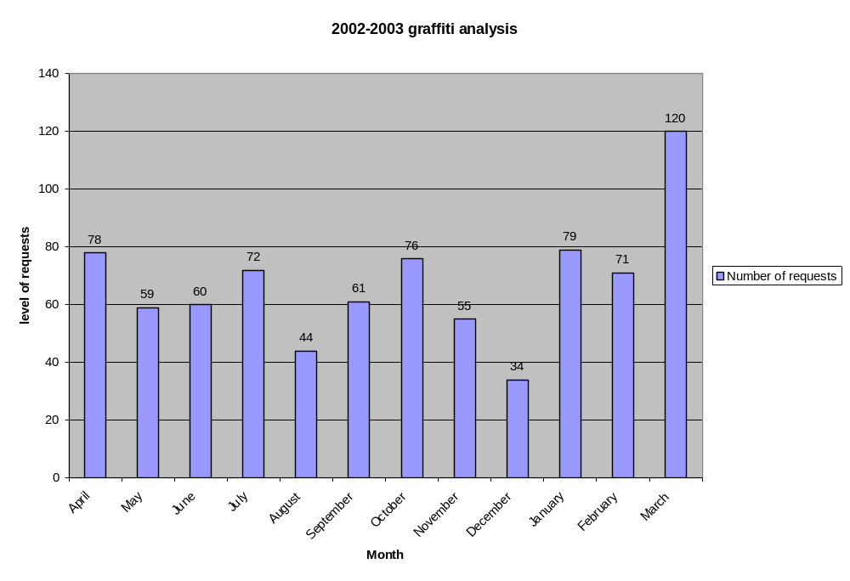

APPENDIX 4

TYPE OF REQUESTS RECEIVED BY ELECTORAL WARD

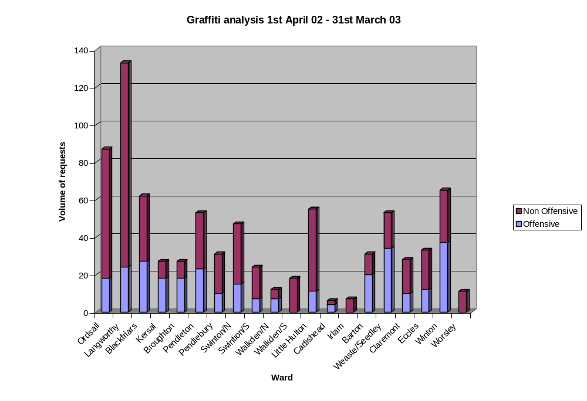

APPENDIX 5
Ward | Service Requests Completed | Offensive Outstanding | Non-Offensive Outstanding
Ordsall | 36 | 0 | 2
Langworthy | 88 | 0 | 3
Blackfriars | 17 | 0 | 0
Kersal | 9 | 0 | 0
Broughton | 28 | 0 | 1
Pendleton | 29 | 0 | 0
Pendlebury | 20 | 2 | 0
Swinton/N | 21 | 0 | 0
Swinton/S | 11 | 0 | 0
Walkden/N | 9 | 0 | 1
Walkden/S | 13 | 2 | 0
Little Hulton | 25 | 0 | 5
Cadishead | 2 | 0 | 0
Irlam | 2 | 0 | 0
Barton | 17 | 0 | 0
Weaste/Seedley | 31 | 0 | 1
Claremont | 7 | 0 | 0
Eccles | 12 | 0 | 0
Winton | 16 | 1 | 1
Worsley | 3 | 0 | 0
Total | 396 | 5 | 14
Graffiti Service Requests Offensive/Non Offensive Outstanding
31st August 2003
GRAFFITI SERVICE REQUESTS
2003 / 04
 | Total | Offensive | Non-Offensive
April 2003 | 97 | 34 | 62
May 2003 | 84 | 26 | 58
June 2003 | 84 | 37 | 47
July 2003 | 66 | 11 | 55
August 2003 | 65 | 24 | 41

APPENDIX 5A

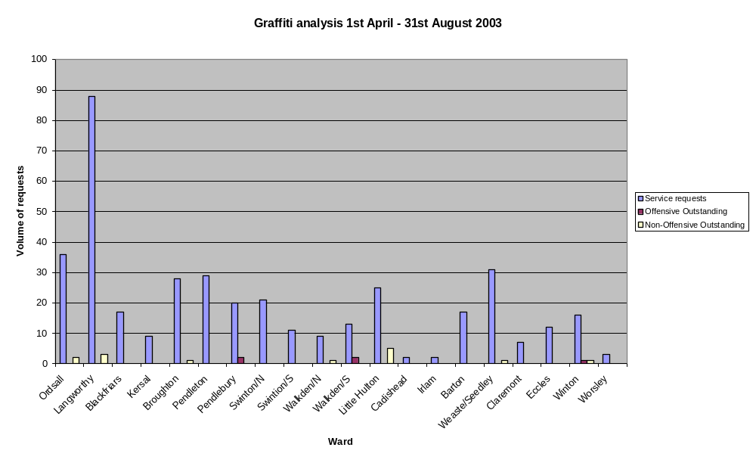

APPENDIX 6



