P.I. Ref. 7.3
Third Quarter 2002/03 Comparator Action Plan

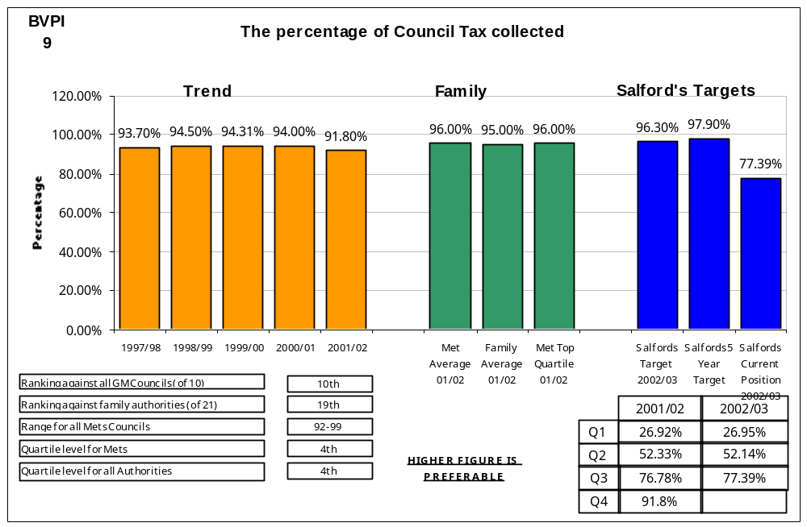

Performance Indicator Action Plan Date: 20/01/03

Comments on Current Performance:
Current Council Tax collections continue to improve with collections at the end of December 02, up 1.1% on previous years collections. It is envisaged that collection levels for 2002/03 will show a considerable improvement upon previous years levels and continue our recent record of continuous year on year improvements on performance.

Barriers to Improvement:
Current target levels are based upon top quartile performance levels of all Authorities nationally. As previously noted, it perhaps is timely that we revisit the basis of the assessment of these targets for 2003/04 examining more comparable authorities, for example members of our Audit Commission family groups or authorities which face similar deprivation issues to ourselves.

Current/Proposed Action:
Recovery action continues apace with action on Council Tax accounts during November resulting in 5,954 reminders and 3,422 summonses being issued with 1,102 Liability Orders being granted by the Court. A further 2,805 Liability Orders were granted in December. Other recent developments include;

- The targeting of high-level arrears cases which has resulted in the value of debt outstanding on the 50 highest value debts reducing by £110k to £220k.

- Plans to implement bankruptcy proceedings/the use of charging orders in cases where we are having difficulty collecting high value debts

- The use of the LOCTA tracing facility where through on-line contact with the council tax databases of all Authorities within the Greater Manchester area, we have been able to improve tracing performance and

- The planned introduction within the current quarter of the facility to make out-of-hours payments by telephone through use of our new interactive voice response technology. Evidently such technology will support our ability to take payments through our website where we continue to receive approximately £30K per month.

Top Quartile to be Achieved By (Date):  2004/05 | Lead Officer:  Martin Vickers - extn. 3364

P.I. Ref. 7.4
Third Quarter 2002/03 Comparator Action Plan

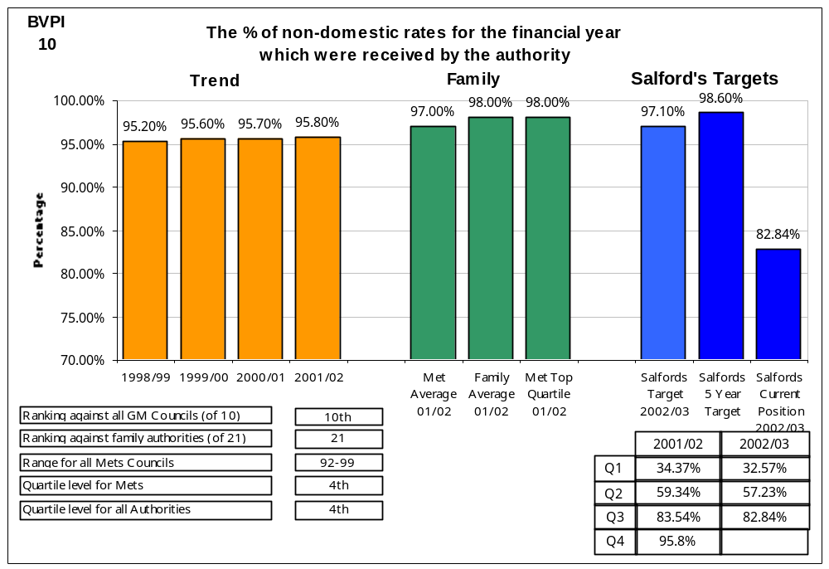

Performance Indicator Action Plan Date: 20/01/03

Comments on Current Performance:
I would remind Members of previous comments made in respect of the effects on the service of the conversion to the new Business Rates software package from April 2002.

Barriers to Improvement:
In the short-term implementation of the Pericles Business Rates computerised system will continue to create some “teething” problems as users familiarise themselves with new procedures and indeed new procedures/documentation are designed.

Current/Proposed Action:
The Business Rates recovery timetable is now being maintained with no backlogs in recovery action being taken. Business Rates collections still continue to show improvement although remaining below target levels with collections only marginally down on last years levels (NB. As at 27th January 2003, there was only a variance of 0.6% upon 2001/02 levels) Members will recall that due to the implementation of the Pericles system last year from December 2001 onwards, very little recovery action was undertaken between then and March 2002. It is anticipated that the gap will be significantly bridged between 2001/02 & 2002/03 performance levels, considering the planned recovery timetable for the same period this year.

Top Quartile to be Achieved By (Date):  2004/05 | Lead Officer:  Martin Vickers - extn. 3364

P.I. Ref. 7.17
Third Quarter 2002/03 Comparator Action Plan

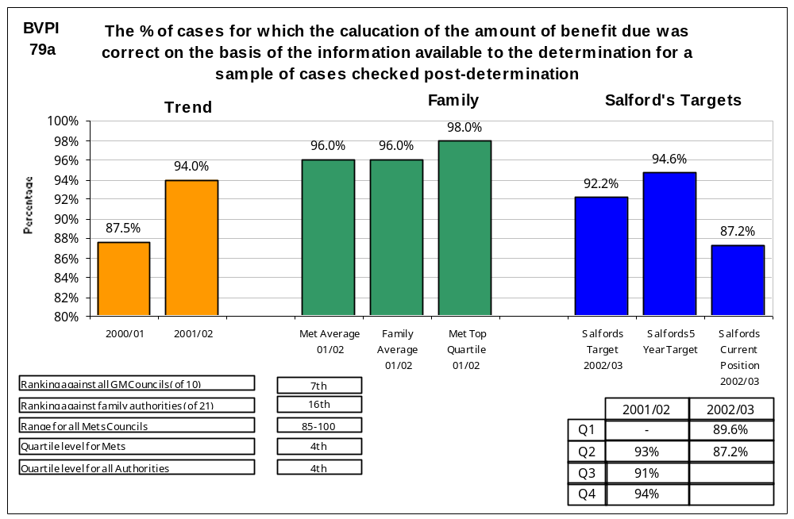

Performance Indicator Action Plan Date: 20/01/03

NB. The second quarter’s results have been utilised within this report as the definition requires the indicator to be calculated based on a quarterly statistical return to Department of Work and Pensions (DWP). The return to DWP is not due until 6 weeks after the quarter end date to allow the Authority sufficient time to undertake accuracy checks of 125 cases so this information is not yet available.

Comments on Current Performance:
Performance is slightly below target levels which may be as a result of several procedural changes within benefits administration from April 2002. Members will appreciate that from April 2002 the Verification Framework has been implemented which introduces far more stringent checks upon benefit claims when they are received. When such changes are viewed together with the major overhaul of procedures as a result of the recent Benefits Fraud Inspectorate’s (BFI) investigation, it can be appreciated that Benefits staff have been faced with major changes in working methods. Members will note that since June 2002 there has been a slight improvement in accuracy levels as the Service moves closer to 2002/03 target levels.

Barriers to Improvement:
The complex nature of Benefits administration and the continued changes in the legislative framework will ensure that the challenge of maintaining accuracy levels will remain a major test for the Benefits Service.

Current/Proposed Action:
Rigorous auditing systems continue to remain in place whereby 10% of all benefit payments are checked by dedicated quality audit staff prior to the payment being issued. It is expected that such work will ensure that staff training needs will clearly be identified and corrective action where appropriate taken more quickly. The ongoing effect of Verification Framework implementation should also ensure through more rigorous verification of claims at the gateway to the benefits process that accuracy levels will improve. Members will also note that during the last quarter, large amounts of specialised training have been provided to Salford Direct staff by external training providers as part of Greater Manchester’s successful bid to the Department of Work and Pensions for additional benefits training funding (£170K across all GM Authorities).
Top Quartile to be Achieved By (Date):  2004/05 | Lead Officer:  Martin Vickers - extn. 3364

P.I. Ref. 7.18
Third Quarter 2002/03 Comparator Action Plan

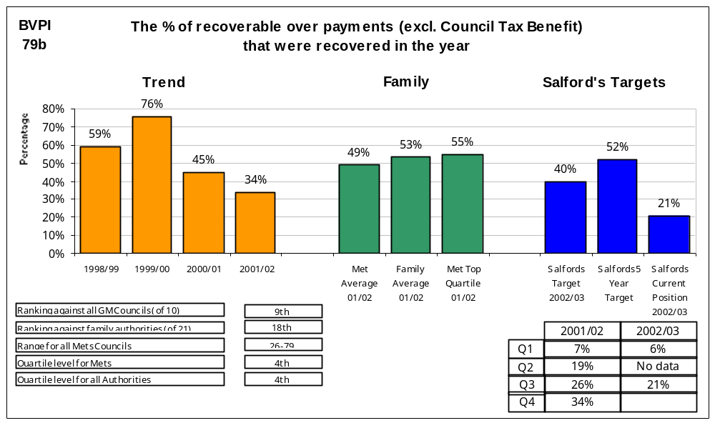

Performance Indicator Action Plan Date: 20/01/03

Comments on Current Performance:
I would remind Members that we need to revisit the target levels previously set as the target was based on a different assessment of how the overpayment recovery PI. NB. The calculation changed during February 2002.

Barriers to Improvement:
Whilst several new recovery initiatives have been introduced during 2002/03, the collection of benefit overpayments remains a challenging proposition when collecting relatively small amounts of debt from vulnerable groups within the community.
Current/Proposed Action:
Several new developments have been introduced, a summary of which is as follows;

- An overpayments recovery strategy has been developed for 2002/03 which enables recovery progress to be more closely monitored by Corporate Services Lead Members

- 3rd party deductions from ongoing payments to landlords have now been introduced whereby payments of a landlord’s former tenants are now being recovered from ongoing payments to landlords

- 1,000 cases are being referred to a specialised benefit overpayment debt collection agency between December 2002 and March 2003

- Significant reductions in arrears levels have been made through the write-off of considerable amounts of irrecoverable longer-term debt which has enabled the Service’s limited resources to focus on current year liabilities.

Top Quartile to be Achieved By (Date):  2004/05 | Lead Officer:  Martin Vickers - extn. 3364

P.I. Ref. 7.21
Third Quarter 2002/03 Comparator Action Plan

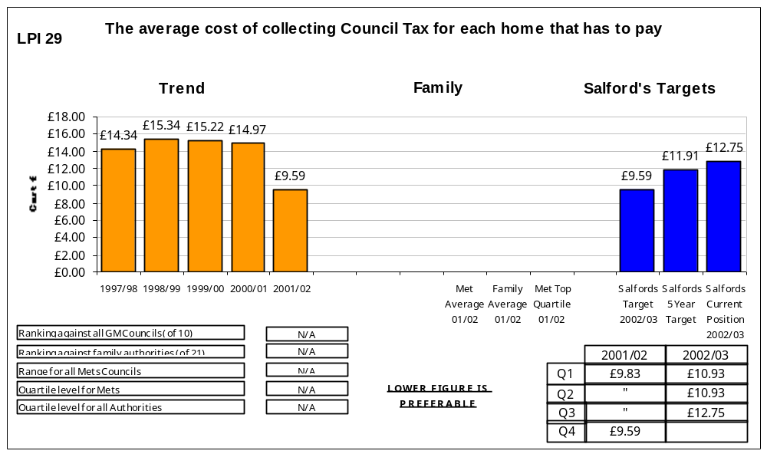

Performance Indicator Action Plan Date: 20/01/03

Comments on Current Performance:
Performance is not on target although at this stage within the financial year prior to budgets being closed and claimant numbers being clearly established, we are not clear whether current performance will be typical of the likely performance for the remainder of the year. The experiences of other Local Authorities implementing Verification Framework tell us that through tighter controls at the benefit gateway, claimant numbers do reduce. Whatever the total costs of benefits administration in real terms therefore, any decline in claimant numbers will adversely affect performance in this area. This situation will need to be monitored closely.

Barriers to Improvement:
The implementation of Verification Framework has led to increases in staffing resources within benefits to tackle the additional workload this entails. Whilst such investment has been supported by Government funding, as stated above it is anticipated that Verification Framework will reduce claimant numbers.

Current/Proposed Action:
There will be continued monitoring of costs levels/claimant numbers to ensure that the recent performance trends are maintained and costs continue to reduce.

Top Quartile to be Achieved By (Date): | Lead Officer:  Martin Vickers - extn. 3364

P.I. Ref. 7.26
Third Quarter 2002/03 Comparator Action Plan

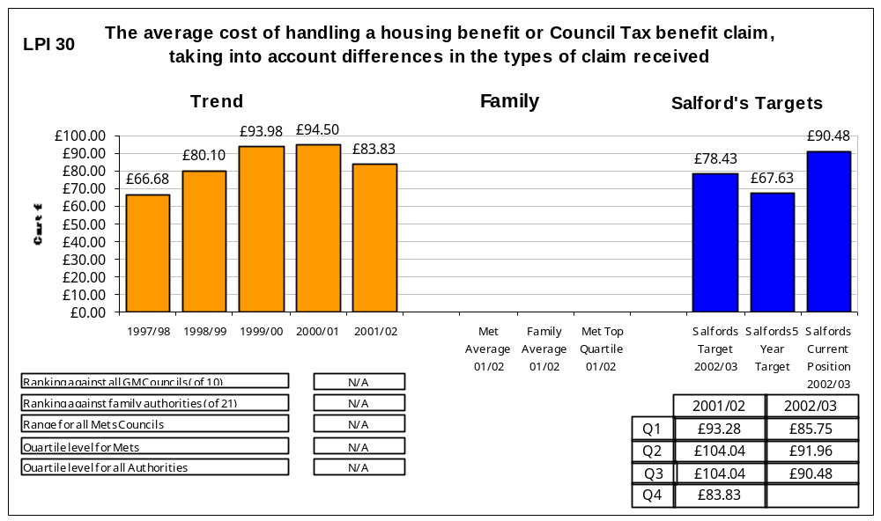

Performance Indicator Action Plan Date: 20/01/03

Comments on Current Performance:
Performance is not on target although at this stage within the financial year prior to budgets being closed and claimant numbers being clearly established, we are not clear whether current performance will be typical of the likely performance for the remainder of the year. The experiences of other Local Authorities implementing Verification Framework tell us that through tighter controls at the benefit gateway, claimant numbers do reduce. Whatever the total costs of benefits administration in real terms therefore, any decline in claimant numbers will adversely affect performance in this area. This situation will need to be monitored closely.

Barriers to Improvement:
The implementation of Verification Framework has led to increases in staffing resources within benefits to tackle the additional workload this entails. Whilst such investment has been supported by Government funding, as stated above it is anticipated that Verification Framework will reduce claimant numbers.

Current/Proposed Action:
There will be continued monitoring of costs levels/claimant numbers to ensure that the recent performance trends are maintained and costs continue to reduce.

Top Quartile to be Achieved By (Date):  2004/05 | Lead Officer:  Martin Vickers - extn. 3364

P.I. Ref. 7.2
Third Quarter 2002/03 Comparator Action Plan

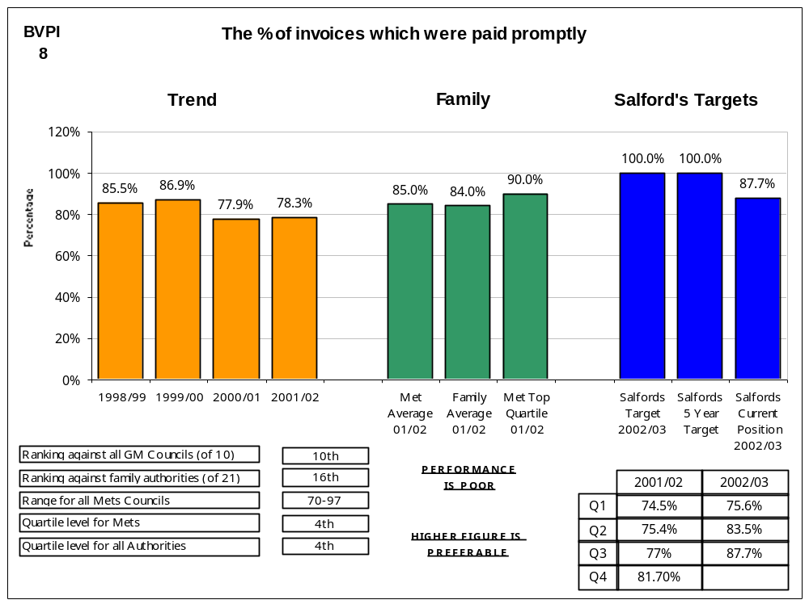

Performance Indicator Action Plan Date: 20/01/03

Comments on Current Performance:
With 87.7% of invoices being paid on time in the third quarter (compared with 77% in the same period last year), performance during the third quarter of 2002/03 improved, yet again, from the position in the second quarter due mainly to the appointment in late September to the two additional posts approved during the first quarter and the filling of other vacancies. During the third quarter, the new staff appointed in September have gradually become more conversant with their roles and will continue to do so during the next quarter.

The resolution of SAP goods receipting queries was re-absorbed into the Creditor Team from the Purchasing Section during the quarter, allowing improvements to be implemented. Whilst this has not resolved all problems, such queries are being dealt with more promptly and within the control of the Creditor Team.

Disputed invoices can now be identified and have been excluded from the calculation for the third quarter, thereby improving the reported performance and adhering more closely to the definition.

Much work was undertaken by the Creditor Team, during the third quarter, relating to the implementation of creditor processes for New Prospect Housing Ltd (NPHL) including procedures for processing invoices, determination of the payment programme and administration of the construction industry tax scheme. This diverted resources from Salford work and adversely affected performance. Salford’s performance figures correctly exclude NPHL for the third quarter although work on their behalf is still being carried out.

Payment within 30 days of invoices which do not have a computer generated order remained at 95% during the quarter (accounting for around 62% of all invoices paid). Payment within 30 days of invoices with a computer generated order improved to 78% (from 69% in the second quarter and from 55% in the first quarter).
Barriers to Improvement:
It is felt that although goods receipting continues to improve, much work remains to improve the process still further. A review of the procurement process, including this element, is planned to commence on 20th January 2003.

It is hoped that staffing resources are now adequate to cope with the workload. New staff are still inexperienced but improving constantly and formal SAP training is planned for mid-February 2003. Such training had originally been scheduled for mid-June 2002 but cancelled due to lack of resources on the e-Merge Team.

Work surrounding the creation of New Prospect Housing Limited (the Housing ALMO) diverted key resources from mainstream work during the third quarter. Issues still remain to be tackled during the fourth quarter but these should be more easily resolvable and should substantially reduce by the end of the financial year.

A multitude of staffing issues had to be addressed during the quarter (one leading to a dismissal in January 2003). Staffing issues continue to affect performance.

Current/Proposed Action:
Training to address complications of invoice verification processing has been re-scheduled for mid-February 2003. It is also intended to undertake continuous SAP and on-the-job training.

In mid-December 2002, the planned document imaging system was implemented and Anite Public Sector are in the process of imaging invoices from April 2002. As at 20th January 2003, invoices to mid-July 2002 have been scanned and images made available on the City of Salford’s server. All 2002/03 invoices should be scanned by the beginning of April 2003. Training will be provided to users to allow them to access these images during the fourth quarter of 2002/03. Document imaging will improve and streamline processes as original invoices will not need to be stored on the Creditor Team (thereby freeing space) and will not need to be filed; accountants, auditors, users of goods and services and budget holders will be able to view images of original invoices from their own PCs; and the possibility of mislaying invoices during transport between Directorates will be reduced.

Invoices are currently being imaged after payment. A future development would be scanning invoices in-house upon receipt, thereby speeding the goods receipting/payment process in some cases as originators and requisitioners would be able to view their invoices, where necessary, before receipting, thereby reducing payment delays caused by the transportation of original documentation. Initial discussions have taken place, during the quarter, with the in-house scanning team.

Continuing to build close working relationships with Directorates and suppliers to improve the procedures for processing. Meeting on 20th January 2003 to commence review of procurement to enable a more simplified process e.g. by the consideration of purchase orders that do not require goods receipting for certain services / goods provision.

Enquiries are in hand with providers of Customer Care training (including potential in-house providers) with a view to all FSG staff attending courses to improve their customer care skills. Telephone greetings have already been standardised, in which staff state their first name and area of work.

Continued SAP support to requisitioners and authorisers to improve the workflow processes to enable more efficient processing.

Longer term - the investigation of the potential for purchasing cards for certain goods/service provision. This could alleviate the pressures of processing high volume invoices such as provisions.

The sampling of invoices to verify payment timeliness, quality of input to general ledger, correct supplier details, and construction industry tax scheme, commenced during the quarter with ten invoices per week sampled for each element i.e. around forty invoices per week.

Investigate the methodology used by better-performing Local Authorities to produce their prompt payment statistics to establish whether it is the methodology or the fact which differs.

The Senior Creditor Officer continues to mentor the less experienced staff but all staff are now paying all categories of invoice.

Two staff have been nominated to deal predominantly with NPHL invoices in order to ensure that the early implementation period runs smoothly and to contain the impact upon mainstream work. This appears to have worked well.

The system, introduced last quarter, to identify disputed invoices for exclusion from counting within the calculation for this indicator, is now in full operation. However, this is not retrospective to the beginning of this financial year. Directorates have been asked to inform the Creditor Team of any disputed invoices and this appears to be working but will need regular re-enforcing.

The e-Merge Team has been asked to re-configure SAP to include only “commercial” payments within the calculation for this indicator. This is now unlikely to be effected until 2003/04.

An exercise commenced during December 2002 to mailshot suppliers paid by cheque with a view to changing their payment method to the more cost effective BACS method. Currently around 40% of suppliers are paid by BACS and the aim is to increase this substantially.
Top Quartile to be Achieved By (Date):  2004/05 | Lead Officer:  Karen Masheder - extn. 2552

P.I. Ref. 7.12
Third Quarter 2002/03 Comparator Action Plan

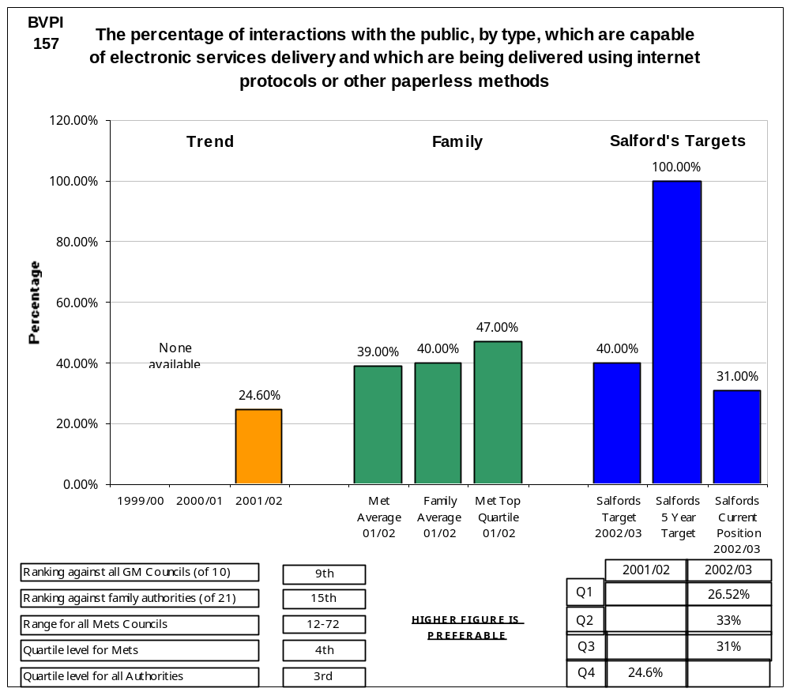

Performance Indicator Action Plan Date: 20/01/03
Comments on Current Performance:
In October 2002, we changed our method of collection and storage for this indicator to be in line with other authorities by collecting at interaction rather than transaction level and using the ESD Toolkit application to store and report on data (www-esd-toolkit.org). This has resulted in an apparent drop in performance. This is not the case. There are three reasons for this change:
- Collecting data at a transaction level can generate higher percentages than at an interaction level because the figures are more accurate. For example, a process may have two interactions associated with it eg Providing information and Application for a Service. Because the Application for Service interaction is not fully enabled, this would give us a percentage of 50% for this process. However, it may have ten transactions associated with it, of which seven are enabled. This would give a figure of 70%.
- Previous figures where based on incomplete data – we did not have a complete set of data for all directorates. Current data is complete.
- Interaction definitions were not clear and this has meant changing interactions types as they have become clearer. The definition of the citizen was also not clear and we have added extra interactions based on our new definition, eg schools.
In addition, we may not meet our 40% target in March 2003. This is due to a number of reasons:
- Over the last two months, we have spent our time putting in place a structure which will enable us to more accurately measure, monitor and meet our 2005 targets. These changes are outlined in the document. Because of this additional effort on this aspect, limited progress has been made in increasing our e-enablement percentages.
- We also have spent our time working with other authorities and the IDEA to assist in defining more comprehensive guidelines for the indicator.
- Funding or resources have not been available to deliver the projects on time which would contribute to our forecast figures.

Barriers to Improvement:
- Due to the severe budget constraints of the Council, crucial funding for necessary I.T equipment and facilities is not currently available. This is causing severe slippage on progressing key initiatives on such matters as web content management, the introduction of a local land and property gazateer and other initiatives contained in our agreed and published IEG statement,
- E-Government Programme is suffering from a lack of Corporate working where departmentalism in some areas continues to hamper shared use of corporate systems and approaches
- Competing claims on officers’ time arising from other strategic initiatives and day to day demands.

Current/Proposed Action:
- We now have a dedicated project manager in place for this indicator for the life of the project
- We have put in place measures to strengthen the e-government teams within the directorates and push responsibility and ownership and responsibility for targets and delivery to those directorates. We have put in place a communication place to ensure that people are kept informed about and involved in e-government from the top down.
- We have now identified the projects within the authority that support e-government targets. They have been pulled into the e-government programme and are consolidated by the Project Support Office using appropriate methodologies and controls
- We have put in place a maintenance and training plan to ensure that indicator data and targets are kept up to date and accurate.
- Forecasts and actuals will be redone and communicated on a constant basis so that senior management within directorates are aware of their performance
- We are taking an active partnership role with other authorities and the IDEA to contribute to methods and guidelines for the delivery of the indicator targets.
- We are taking an active partnership role within the Greater Manchester E-Government Partnership in the proposal and delivery of shared E-Gov systems and solutions.
Top Quartile to be Achieved By (Date):  2004/05 | Lead Officer:  M. Willetts - extn. 3956  M. Brooks - extn 3992

