REPORT OF THE DIRECTOR OF CORPORATE SERVICES

TO THE: QUALITY AND PERFORMANCE SCRUTINY COMMITTEE
ON: 22nd MAY 2002

TITLE: SUNDRY DEBTORS - ANALYSIS OF OUTSTANDING DEBT
SUMMARY:
This month has seen a substantial reduction in the overall debt position. There has been a reduction of £2,670,326, before adjustments for part payments, credit notes and land/property based charges. The reduction has been partly due to Directorates raising invoices within the last month of financial year 2001/2, which have been subsequently paid in April 2002.There has also been payment of a number of high value accounts, which are detailed within this report.

Also this month, as requested by Members at last month’s meeting, further analysis has been provided in relation to debt collection for each Directorate, performance against targets, and comparative data for other Greater Manchester Authorities.

Progress has been made this month notably, with commercial rents and schools. Regular meetings are taking place with staff from Valuation and Estates regarding commercial rents and experienced members of staff from the Debtors Team are making progress addressing the worst case debtors.

Schools have also been contacted with a view to settling arrears built up over a number of years and in recent weeks substantial payments have been received. A nominated officer is in regular liaison with schools to ensure that any problem debt areas are identified early and remedied.

It is also the intention to address issues with Social Services and regular meetings are taking place with Social Services and Legal Services staff.

Meetings have also taken place to discuss problem debt areas such as Environmental Services grounds maintenance, Education and Leisure library fines and Sports Development team swimming squad fees. As a result of these meetings, procedural changes have been implemented, and it is hoped that problems previously encountered will be reduced significantly.

It is anticipated that with all staff working on SAP debt collection that further progress will be made over the course of the next few months.

CONTACT OFFICER: Tony Hennessy - Creditors & Debtors Manager

1. | INTRODUCTION
1.1.  1.2.  1.3. | The Financial Support Group Debtors Section is responsible for the creation of customer master records, the creation of customer invoices and credit notes, and recovery action up to the point of referral to Legal Services.  The section includes the equivalent of 11.5 staff, under the management of the Debtors and Creditors Manager, as follows:  1 Debtors team leader  2 Senior billing and recovery officers  8.5 Billing and recovery officers  The nature of business that Salford City Council raises invoices for, includes:  - Development Services - Commercial and ground rents  - Environmental Services - Trade refuse and grounds maintenance  - Social Services - Accommodation Charges  - City Leisure - Hire of sporting facilities  - Housing - Housing property recharges & service charges  - Education - Library fines, schools service level agreements & swimming squad fees.  - Corporate Services - Supply of I.T. equipment and ex-employee charges  - Personnel - Provision of training courses

2.  2.1.  2.2.  2.3.  2.4.  2.5.  2.6. | AGED DEBT ANALYSIS  The aged debt report details the outstanding debt as at 30th April 2002 analysed into various age categories as follows:  - 0-30 days  - 31-59 days  - 60-89 days  - 90-119 days  - Over 120 days  The information is produced via SAP's reporting functionality and is utilised by staff within the Financial Support Group debtor section and senior officers within the respective Directorate to monitor outstanding debt.  Following on from a recent sundry debtors user group the reports are sent by the FSG to the respective Directorates on a monthly basis.  Detailed overleaf is the aged debt analysis for the period ending 30th April 2002. Also supplied is a comparison against the aged debt analysis reported last month. Overall the total value of outstanding debt has reduced from £15,528,837 at the end of March 2002 to £12,858,511 at the end of April 2002. This reduction is due mainly to the high value of invoices raised in March that have been subsequently paid in April 2002.  The report has been amended this month to include details of part payments against accounts, credit notes and accounts subject to blocked action as land charges / property based charges. Unfortunately, it is not possible to assign these credits against individual Directorate debt.  The reason for the increase of debt for Education and Leisure in the 60-89 day category is mainly due to an invoice for Salford Business Education Partnership in the value of £350,929.87. Assurances have been provided by the organisation that this account will be paid on 24th May 2002. Should this not be the case the organisation will be contacted with a view to immediate settlement.

AGED DEBT ANALYSIS BY DIRECTORATE AS AT 30TH APRIL 2002
Directorate | 0-30 days £ | 31-59 days £ | 60-89 days £ | 90-119 days £ | Over 120 days  £ | Total  £
Community & Social Services | 1,785,361 | 208,436 | 54,422 | 28,147 | 1,199,149 | 3,275,515
Environmental Services | 405,041 | 41,192 | 45,044 | 11,230 | 121,790 | 624,297
Chief Executives | 72,130 | 29 | 0 | 0 | 17,796 | 89,955
Development Services | 576,690 | 156,376 | 105,589 | 1,776 | 340,619 | 1,181,050
Commercial Rents | 130,418 | 335,748 | 32,349 | 33,769 | 705,143 | 1,237,427
Corporate Services | 215,686 | 152,691 | 24,615 | 18,144 | 30,614 | 441,750
Housing Services | 563,327 | 16,724 | 3,801 | 73 | 81,018 | 664,943
Personnel Services | 883 | 0 | 980 | 0 | 4,941 | 6,804
Education & Leisure | 1,169,467 | 686,566 | 458,218 | 34,974 | 333,951 | 2,683,176
Sub total - SAP raised | 4,919,003 | 1,597,762 | 725,018 | 128,113 | 2,835,021 | 10,204,917
Ex Radius debt |  |  |  |  | 2,653,594 | 2,653,594
Sub -Total | 4,919,003 | 1,597,762 | 725,018 | 128,113 | 5,488,615 | 12,858,511
Less part payments / credit notes |  |  |  |  |  | (1,086,709)  (264,494)
Less Land Charges / Property based charges |  |  |  |  |  | (779,454)
Outstanding debt total |  |  |  |  |  | 10,727,854

AGED DEBT ANALYSIS – GRAPHS

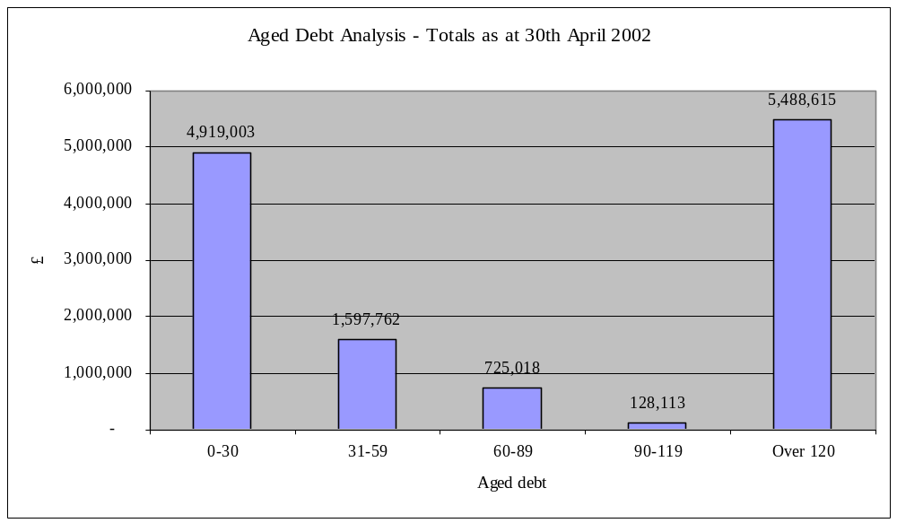

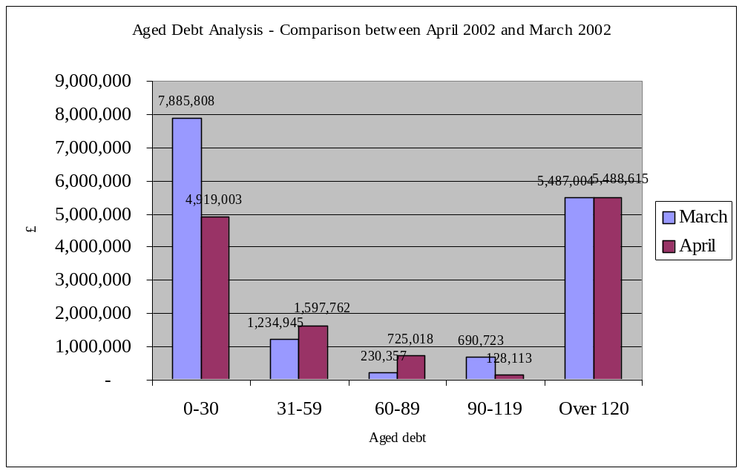

3.  3.1.  3.2. | DEBT COLLECTED AS A PERCENTAGE OF DEBT RAISED  Detailed below is the analysis as at 30th April 2002 showing the value of accounts raised for each debt category together with the amount collected in value and percentage terms.  Environmental Services currently have a number of accounts blocked for recovery action including £48,000 as land charges. Also included are annual accounts not yet due, value £263,000.Housing have one high value account land charged in the value of £139,590. Reports are to be provided to all Directorates detailing outstanding debt with a view to further improving collection.

DEBT COLLECTED AS A PERCENTAGE OF DEBT RAISED – DIRECTORATE ANALYSIS
(Analysis only details SAP debt raised from 4.9.2000)
Directorate | Debt raised £ | Amount collected £ | Outstanding Debt £ | % Debt collected | % Debt outstanding
Community & Social Services | 29,405,984 | 26,130,469 | 3,275,515 | 88.9% | 11.1%
Environmental Services | 1,911,468 | 1,287,171 | 624,297 | 67.3% | 32.7%
Chief Executives | 401,237 | 311,282 | 89,955 | 77.6% | 22.4%
Development Services | 16,468,770 | 15,287,720 | 1,181,050 | 92.8% | 7.2%
Commercial Rents | 7,717,123 | 6,479,696 | 1,237,427 | 84.0% | 16.0%
Corporate Services | 13,331,129 | 12,889,379 | 441,750 | 96.7% | 3.3%
Housing Services | 1,689,790 | 1,024,847 | 664,943 | 60.6% | 39.4%
Personnel Services | 91,576 | 84,772 | 6,804 | 92.6% | 7.4%
Education & Leisure | 22,148,233 | 19,465,057 | 2,683,176 | 87.9% | 12.1%
Total | 93,165,310 | 82,960,393 | 10,204,917 | 89.0% | 11.0%

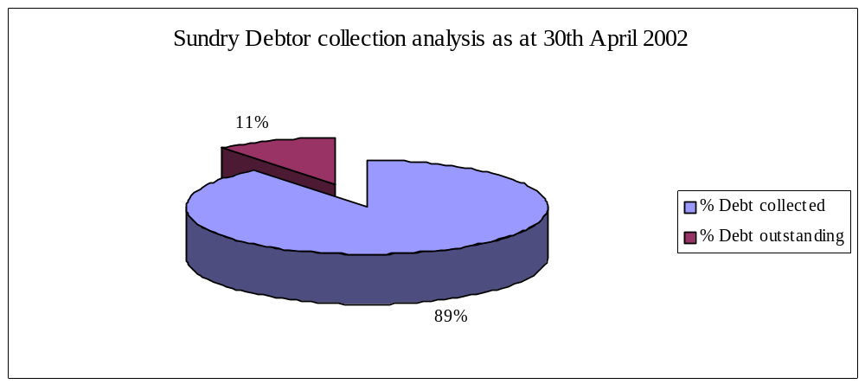

4.  4.1.  4.2.  4.3. | TRANSACTION ANALYSIS  The transaction analysis below details the number and value of outstanding sundry debtor accounts below and above the value of £200 as at 30th April 2002.  Directorates have been made aware that in future accounts below £200 will be subject only to one reminder letter before referral to a Debt Recovery Agency. It is anticipated that the first cases will be referred by the end of May 2002.  Directorates have also been encouraged wherever ever possible to obtain payments for goods or service provision by cash up front or by debit/credit card.

Directorate | Number of invoices raised under  £200 | Total value of invoices raised under £200  £ | Number of invoices raised over  £200 | Total value of invoices raised over £200  £ | Total  £
Community & Social Services | 906 | 73,930 | 1251 | 3,201,584 | 3,275,515
Environmental Services | 794 | 91,843 | 730 | 532,454 | 624,297
Chief Executives | 4 | 446 | 9 | 89,509 | 89,955
Development Services | 495 | 42,780 | 293 | 1,138,270 | 1,181,050
Commercial Rents | 793 | 35,684 | 839 | 1,201,743 | 1,237,427
Corporate Services | 95 | 9,509 | 126 | 432,241 | 441,750
Housing Services | 115 | 8,983 | 170 | 655,960 | 664,943
Personnel Services | 5 | 269 | 9 | 6,535 | 6,804
Education & Leisure | 3549 | 163,317 | 671 | 2,519,860 | 2,683,176
Sub - total SAP raised | 6756 | 426,761 | 4098 | 9,778,156 | 10,204,917
Ex Radius debt | 3148 | 163,700 | 1837 | 2,489,894 | 2,653,594
Total | 9904 | 590,461 | 5935 | 12,268,050 | 12,858,511
Less part payments / credit notes |  |  |  |  | (1,086,709)  (264,494)
Less Land Charges / Property based charges |  |  |  |  | (779,454)
Outstanding debt total |  |  |  |  | 10,727,854

5.  5.1.  5.2. | ANALYSIS OF DEBTS BY ACCOUNT GROUP  The information provided below details the outstanding debt as at 30th April 2002 by Account Group.  The Account Group subdivides the debt into four categories namely:  - Individuals  - Companies  - Schools  - Public bodies

Directorate | 0-30 days £ | 31-59 days £ | 60-89 days £ | 90-119 days £ | Over 120 days £ | Total £
Individuals | 1,293,887 | 318,601 | 432,131 | 73,261 | 1,224,667 | 3,342,547
Companies | 1,540,781 | 349,917 | 138,618 | 29,374 | 999,637 | 3,058,327
Schools | 713,746 | 639,058 | 124,710 | 25,478 | 181,727 | 1,684,719
Public Bodies | 1,370,589 | 290,186 | 29,559 | 0 | 428,990 | 2,119,324
Sub total SAP raised | 4,919,003 | 1,597,762 | 725,018 | 128,113 | 2,835,021 | 10,204,917
Ex radius debt |  |  |  |  | 2,653,594 | 2,653,594
Total | 4,919,003 | 1,597,762 | 725,018 | 128,113 | 5,488,615 | 12,858,511
Less part payments / credit notes |  |  |  |  |  | (1,086,709)  (264,494)
Less Land Charges / Property based charges |  |  |  |  |  | (779,454)
Outstanding debt total |  |  |  |  |  | 10,727,854

6.  6.1. | COMPARISON AGAINST PERFORMANCE INDICATOR - OUTSTANDING DEBT OVER 30 DAYS OLD  Detailed below is the comparison of the debt over 30 days old against the Best Value Performance Plan target of a 10% reduction in the value of outstanding debt as at 31st March 2003 compared to the position as at March 2001. This equates to a target of £7,916,417 by March 2003.

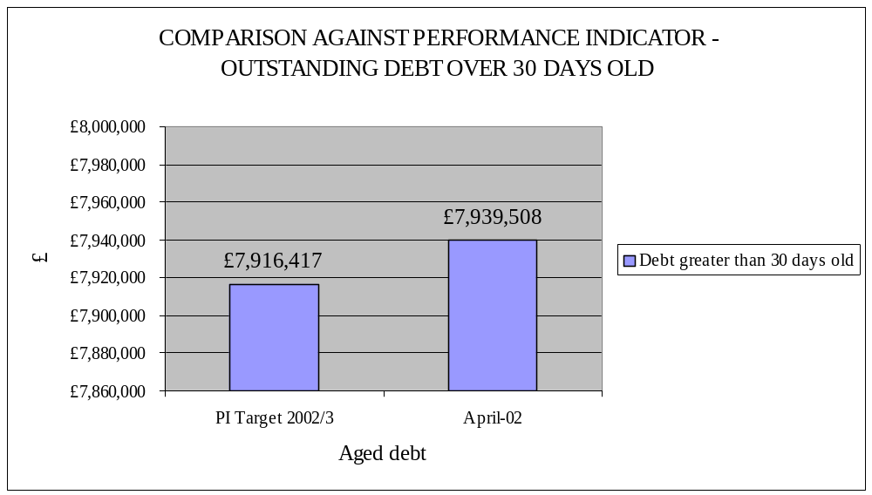

7.  7.1. | COMPARATIVE DATA WITH OTHER GM AUTHORITIES – COLLECTION RATES.  Detailed overleaf is the latest comparison with other Greater Manchester Authorities for financial year 2000/2001. No figures have as yet been released from GMAMT for 2001/2.  - The first column illustrates the cash collected as a % of the value of invoices raised within the year 2000/2001, plus any arrears brought forward from the previous financial year. Systems generally do not operate on a year on year accounting basis, but on a rolling debt, so any invoices raised in March would be collectable in April and beyond.  - The second column illustrates the cash collected within the year as a % of the value of the invoice raised in that year. Whilst it is quite a crude indicator, it is useful to see whether Authorities are “holding their own” i.e. collecting at least an amount equal to the value of invoices raised, and possibly even making inroads into the arrears accrued. It is also the case that the only BVPIs for Council Tax and Business Rates (nos 9 & 10) concentrate on % cash collected within the year.  - Debtor days is a mechanism to show on average how quickly a debt is collected across the Authority, and is a useful comparison across GM Authorities.

AUTHORITY | % cash collected | % cash collected  within the year | Debtor days

BLACKBURN
BLACKPOOL | 64.46 | 89.63
BOLTON | 71.84 | 89.20 | 71
BURY | 79.82 | 93.44 | 54
MANCHESTER | 77.46 | 93.97 | 100
OLDHAM | 92.75 | 106.62 | 26
ROCHDALE | 74.52 | 98.19 | 55
SALFORD | 75.37 | 112.64 | 84

STOCKPORT
TAMESIDE | 75.53 | 84.77 | 48

TRAFFORD
WARRINGTON | 78.87 | 92.95 | 64
WIGAN | 72.00 | 68.20 | 76

8.  8.1.  8.2. | MAJOR PAYMENTS RECEIVED THIS MONTH  Detailed below are major payments received within the month of April 2002.  A senior officer within the team monitors high value accounts regularly.

£994,790 | Salford Primary Care
£949,256 | GM Police
£394,541 | Citypark Realty
£319,108 | Cheshire Education & Finance
£187,500 | Wilson Bowden Development
£56,375 | Salford Community Service
£49,664 | National Probation Directorate
£41,080 | Salfordian Trust

9.  9.1.  9.2.  9.3. | OUTSTANDING ACCOUNTS OVER THE VALUE OF £25,000 GREATER THAN 120 DAYS OLD  Provided below are details of outstanding accounts over £25,000 greater than 120 days old as at 30th April 2002.  A number of these accounts are currently subject to disputes with Social Services Directorate. The team is in regular contact with Directorates with a view to resolving disputes as quickly as possible.  As part of new working procedures any accounts that are subject to disputes will only be left on the debtors system for one month from the date of notification. Thereafter, the account will be reversed, and the Directorate budget subsequently debited. Directorates have been informed of this arrangement and are in full agreement that this is the best way forward.

£ | CUSTOMER | NOTE
30,000.00 | United Utilities | Customer contacted to clear account. Assurances provided that this will be paid soon.
35,704.28 | Manchester City Council Social Services | In dispute with Social Services. Copy invoices provided to Manchester City Council.
42,005.36 | Housing and Social Care | In dispute with Social Services. A credit of £26,481.64 is due to be raised May 2002. The balance is due to be paid soon.
45,138.08 | Safeway Stores | Referred to Legal 21.1.2002.
150,000.00 | Salford and Trafford Health Authority | In dispute with Social Services.

