Community Plan 2005- 2015:

IN Salford
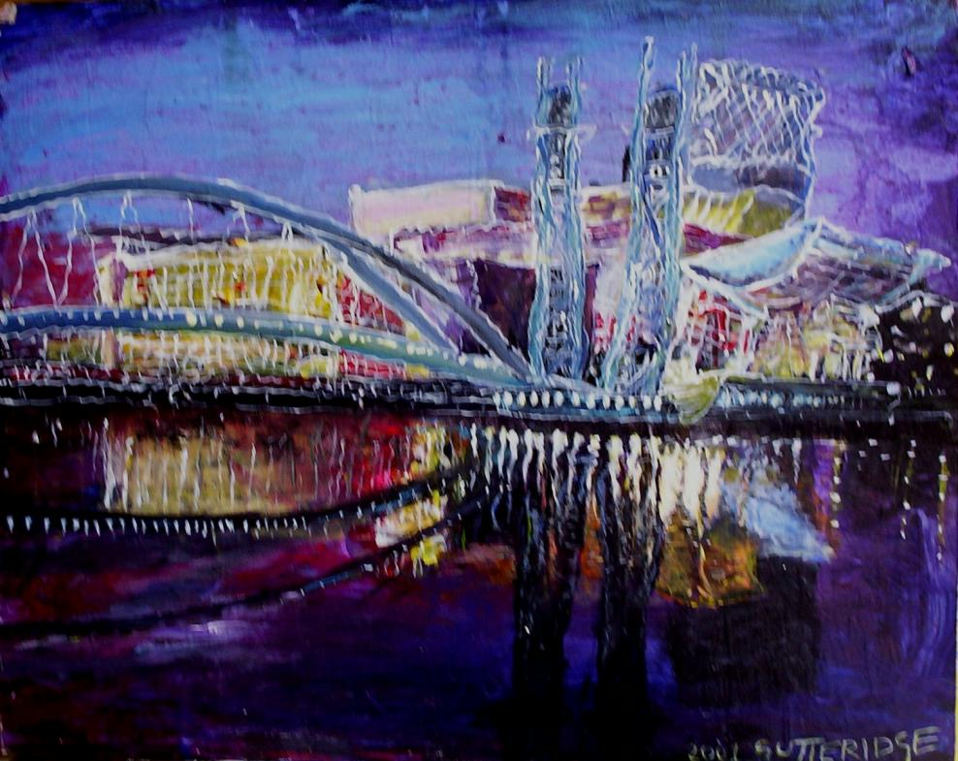

“In 2015, Salford will be a beautiful and welcoming city, driven by energetic and engaged communities, of highly skilled, healthy and motivated citizens, who have built a diverse and prosperous culture and economy which encourages and recognises the contribution of everyone, for everyone.”

FORWARD

  - Partners IN Salford

  - Fast Pace of Change

  - Citizens as partners

  - Conclusion

Signatures

PARTNERS IN SALFORD: SIGNED UP TO THE COMMUNITY PLAN

------------------------------------- ------------------------------------------
Angie Robinson Councillor John Merry
Chair, Partners In Salford Vice- Chair, Partners IN Salford
Chief Executive, Chamber of Commerce Leader of the Council, Salford City Council

Partners’ signatures

-------------------------------------- ------------------------------------------ --------------------------------------------

-------------------------------------- ------------------------------------------ --------------------------------------------

-------------------------------------- ------------------------------------------ ---------------------------------------------

-------------------------------------- ------------------------------------------- ----------------------------------------------

-------------------------------------- ------------------------------------------- ----------------------------------------------

-------------------------------------- --------------------------------------------- ----------------------------------------------

THE VISION FOR SALFORD
“In 2015, Salford will be a beautiful and welcoming city, driven by energetic and engaged communities, of highly skilled, healthy and motivated citizens, who have built a diverse and prosperous culture and economy which encourages and recognises the contribution of everyone, for everyone.”

SCENARIO PLANNING PROCESS
Process of engaging partners and the community in identifying a vision for Salford and a range of scenarios for how change might unfold in the city in the next 10 years, identifying the preferred scenario- Purple Patch, and 7 things that must happen in order to achieve the preferred scenario- the 7 Imperatives.
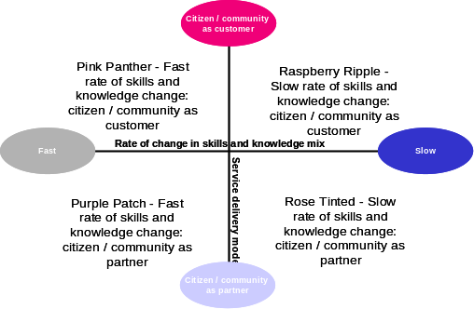
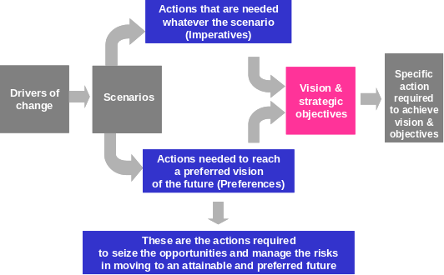
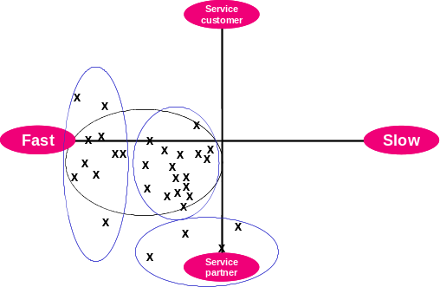

7 IMPERATIVES

A profile of the city in 2015

Population demographics- age, ethnicity, numbers
Key Employment Sectors
Increase in traffic?/ congestion? (LDF)
Amount of social housing/ affordable housing (LDF)
Key developments (LDF)
- Improving secondary school educational attainment
- Re-skilling the adult population
- Reducing polarisation and inequalities
- Raising aspirations / motivations
- Increasing community engagement
- Attracting newcomers
- Improving environmental sustainability

Summary of 7 themes
A HEALTHY CITY A SAFE CITY AN ECONOMICALLY PROSPEROUS CITY. A CITY THAT IS GOOD TO LIVE IN

AN INCLUSIVE CITY. A CITY WHERE YOUNG PEOPLE ARE VALUED. A LEARNING AND CREATIVE CITY.

How the themes will contribute to achieving the imperatives

THEME | IMPERATIVES
THEME | Educational attainment | Adult skills | Tackling inequalities | Raising aspirations | Community engagement | Attracting newcomers | Environmental sustainability
Healthy city | * | * | * | * | * | * | *
Safe city | * | * | * | * | * | * | *
Economically prosperous city | * | * | * | * | * | * | *
City that is good to live in | * | * | * | * | * | * | *
Inclusive city | * | * | * | * | * | * | *
City where young people are valued | * |  | * | * | * | * | *
Learning & creative city | * | * | * | * | * | * | *

Equalities Statement

Salford is a city where diversity is encouraged and valued…

A Healthy City

Strategic aims: from 2005 until 2015 we aim to improve the health an wellbeing of those who live and work in Salford, and tackle health inequalities in the neighbourhoods across the city
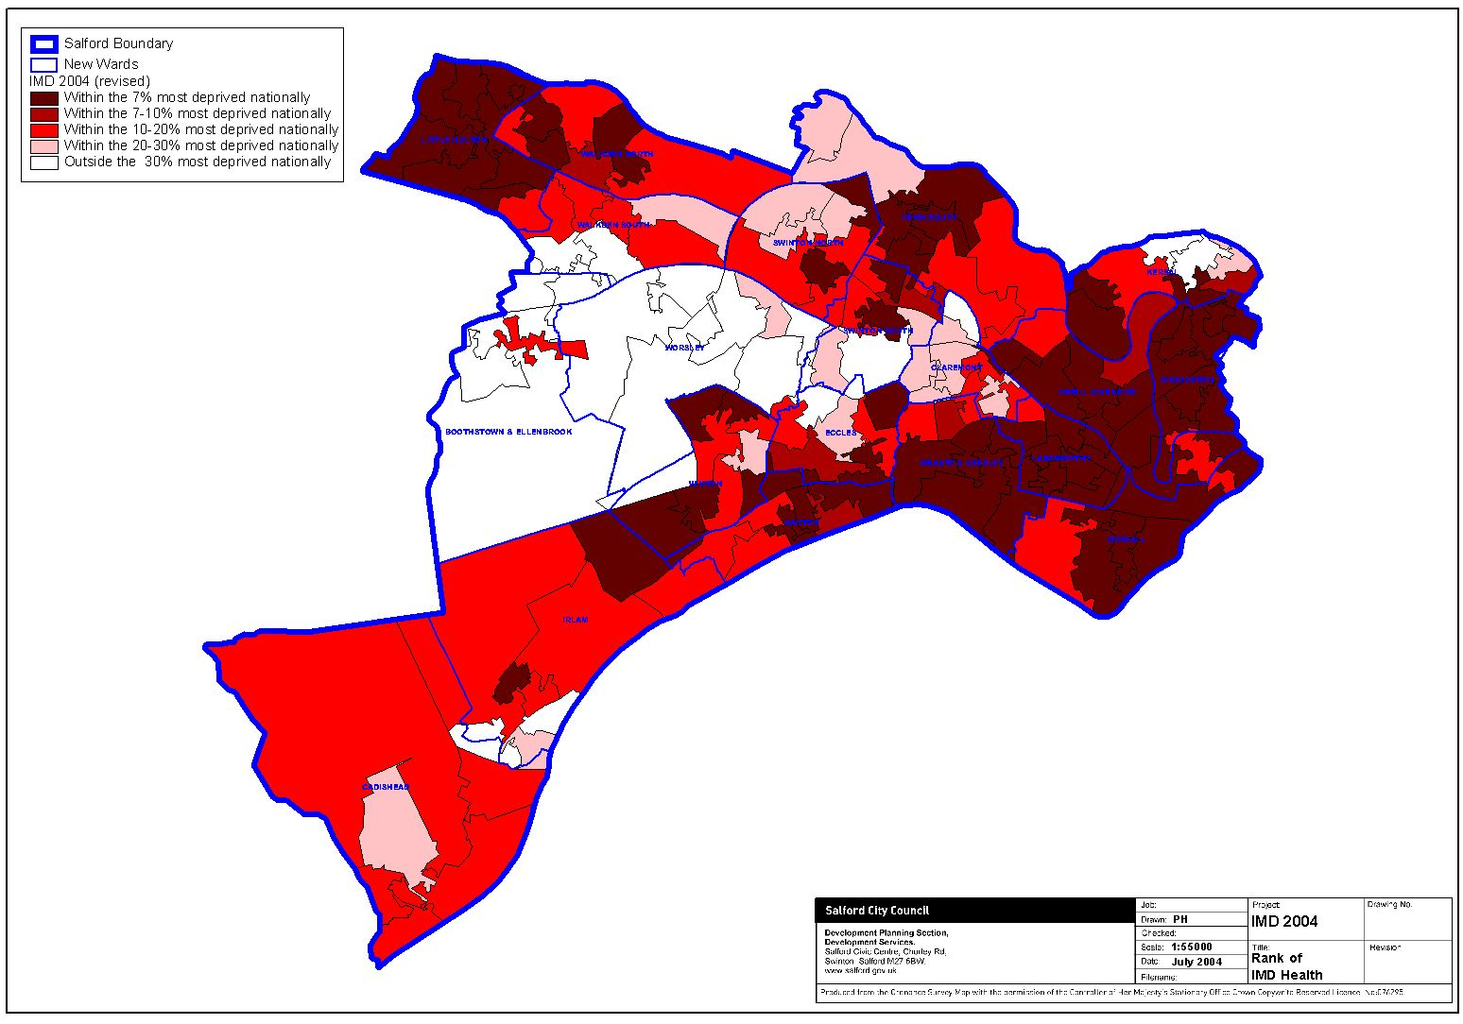
Life expectancy graph 1995-2015:

Priority outcomes | Current position | Interim 2010 target | Required activities to 2010 | 2015 target | How you will know we have achieved this priority
In order to achieve our strategic aim we will focus on… | This outcome is a priority because… | By 2010 the target is to… | In order to achieve this target we will have to… | By 2015 we aim to have achieved. … | In 2015 you will see that….
Improving health of Over 50s | The population is aging. By 2015…people will be over 50, …will be over 65 and …will be over 100. We must ensure that those who are over 50 can maintain independent, high quality lifestyles and full access to all their health and social support needs. | Reduce differences in the life expectancy of men and women such that all wards in Salford are equal to the highest ward.  Reduction in smoking rates of those over 40. | Improve access to primary health care facilities  Establish neighbourhood pharmacies and other health care services  Provide support and relief to carers.  Community and neighbourhood volunteering, physical activity, social and economic opportunities improved. | Life expectancy rates that are significantly closer to national levels for men and women. | Health services and facilities are available in your neighbourhood.  Older people are able to live at home independently for longer and enjoy better health.  That men and women are living longer.
Reducing smoking | Smoking is one of the biggest killers in Salford, causing 500 premature deaths from smoking related diseases a year. | Reduce the number of people who smoke by … % | Create no-smoking zones in public spaces  Provide free smoking cessation advice and support | A reduction in smoking of …% | You and your children will be safe to enjoy public spaces in Salford without the risks caused by passive smoking.
A Safe City
Strategic Aim: to reduce crime and disorder and to build safe, strong and confident communities

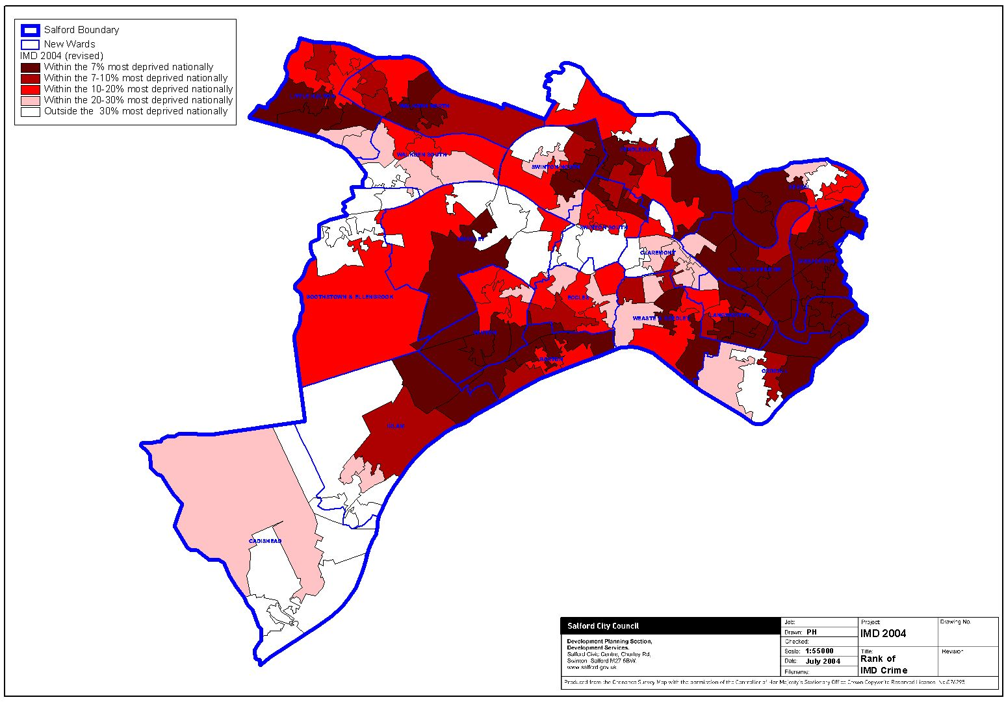
Key priority
                - Effective tackling of anti-social behaviour:
Key priorities: We will achieve this by:
                - Reducing crime
                - Working with communities to address issues of concern to them
                - Advising and protecting people who might become victims of burglary and repeat victims
                - Targeting the markets of stolen goods
                - Targeting prolific offenders to reduce re-offending
                - Improving car park locations and security
                - Improving the environment in local areas

Key Targets
- Reduce crime by …% by 2015
- Reduce juvenile nuisance incidents by …% by 2015
- Reduce arson related fires by …% by 2015
- Reduce the number of licensed premises selling alcohol to under 18s by 50% by 2015
- Reduce hate crime by …% by 2015
- Increase number of people who feel safe in their community to …% by 2015
Key priority:
- Reducing the harm caused by drug and alcohol misuse

We will achieve this by
- Reducing opportunities for arson to occur in properties, public spaces and vehicles
- Providing diversionary activities for young people
- Ensuring that empty and vulnerable properties are secured

Key priority:
- Helping all communities feel safer

We will achieve this by
- Encouraging the reporting of incidents and providing appropriate support and assistance
- Use police powers of arrest to apprehend perpetrators and bring them to justice
- Work with communities to change vulnerable locations

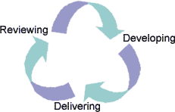
MONITORING, EVALUATION AND PLANNING CYCLE

PMF processes

3-Year Action Plan

Resources: NRF/ LPSA-2 reward/ pooled budgets

Partnership monitoring processes:
Data management- SPIN
Data reporting- LSP and SDPs

Evaluation plans
3 year review of progress as follow on from action plans
Community Plan review of document in 2010 to next 5 years
Final evaluation and development of 2025 Community Plan

Access to information

Further copies are available from:

www.salford.gov.uk/living/regeneration/communityplan or www.partnersinsalford.org.uk

If you need help in understanding this leaflet please contact the equalities team at Salford City Council on …..

In different languages….

