


Strategy Monitoring Report
4th Quarter
January - March 2005

SALFORD CRIME AND DISORDER PARTNERSHIP

CRIME & DISORDER REDUCTION STRATEGY
2002 – 2005
STRATEGY PERFORMANCE INDICATORS

Key:
.
Not on Target = Not on target for delivery and unlikely to be achieved in next quarter

.
Near to Target = Not on target for delivery, but may be achieved in next quarter

On Target = On or exceeding target for delivery

AGMA supply audited statistics for the crime type of robbery, vehicle crime and burglary other and dwelling. March statistics are not yet available so data for the last quarter has been obtained via the Greater Manchester Police Intranet Site. They will be adjusted accordingly when the AGMA statistics are available.

OBJECTIVE 1. RESPONDING EFFECTIVELY TO NUISANCE AND DISORDER

TARGET:- Reduce the number of Juvenile Nuisance incidents citywide by 6% to 9,704 by 2005.

Comments On Actions | On  Target
- Community Sector Teams continue to take early intervention action to tackle youth disorder through ASBO warning letters and interviews and through the Youth Inclusion Support Panel (YISP) (for 8-13 year olds at risk of committing anti-social behaviour)
- This quarter, the Nuisance Link Team received a total of 364 complaints of anti-social behaviour. From the 364 complaints, 196 have been successfully investigated through to closure. The remaining 168 cases continue to be investigated.
- The single telephone number for reporting anti-social behaviour, as part of the Together Action area, was launched on the 28th February 2005. Between the 28th February 2005 and the 31st March 2005 the Nuisance Link Team received 229 complaints through the national reporting number.
- The City Council and NPHL are developing a single anti-social behaviour unit.
  - The post of children’s Champion will go to advert soon. This post will be based in Community and Social Services and will focus on the implementation of the Youth Strategy.

Due to code changes in juvenile nuisance statistics the data for March cannot yet be obtained.
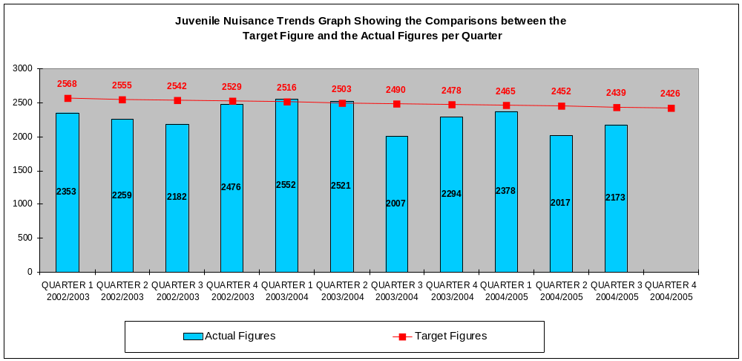
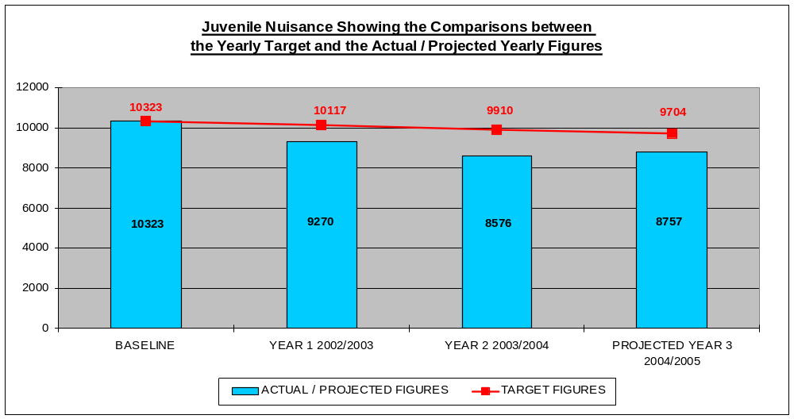

OBJECTIVE 1. RESPONDING EFFECTIVELY TO NUISANCE AND DISORDER

TARGET:- Reduce the number of Malicious Calls to Greater Manchester County Fire Service
By 10% to 537 by 2005.

Comments On Actions | On  Target
- The current hotspot areas are Little Hulton, Langworthy and Walkden North.
- The Fire and Rescue Service, particularly its Community Fire Safety Section, continue to actively work in schools and Youth Organisations engaging children in projects such as the ‘Learn not to Burn’ scheme. The Crucial Crew Scheme has again received full support from Education, with all Key Stage 2 children attending.
- Mobile phone operators continue to provide support through the barring of phones that are used to make malicious calls.
- A possible prosecution of a mobile phone offender in the Walkden area is currently being pursued.

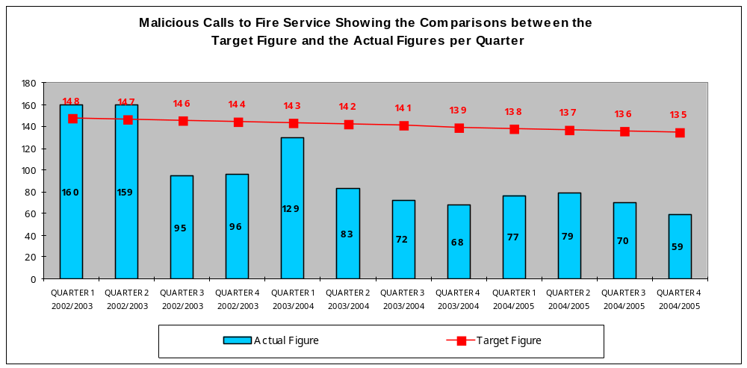

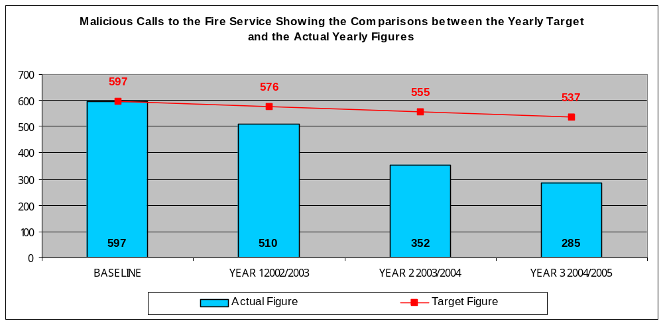

- The survey to measure the LPSA target has been arranged for May 2005 and will be in conjunction with Sheffield University.

- Salford Community Leisure has mainstreamed the post of Equity Officer, whose role is to increase participation in sporting activity for women and minority ethnic groups.
- An annual work programme has been developed for the Equity Officer that’s feeds into Salfords Community Leisure’s annual delivery plan.
- The SAYO (Sport, Arts and Youth in Ordsall) project continues to work closely with the Lads Club to encourage greater participation from young people and is currently working with the Lads Club to submit a Heritage Lottery Bid.
- We are awaiting the results from Sheffield University on sports participation for 5-16 year olds. Initial results point to a very significant rise in participation in sport in the city.
- Pilot work in two areas by the Raid Response Teams (Sports Development) has resulted in significant drops in juvenile nuisance (e.g. 25% reduction in Eccles). Reports, evaluations and funding applications for the pilot work to continue have been submitted however no funding beyond summer 2005 has been received.
- The Duke of Edinburgh activity scheme ceased in March 2005 due to funding from PAYP not continuing into 2005/2006.
- Watersport attendances and income figures have exceeded targets. New larger programmes with additional staffing resources are being organised for 2005/2006.

OBJECTIVE 1: INCREASE PARTICIPATION IN SPORTING ACTIVITY

TARGET: Increase the participation of young people in sporting activities by 25% from 56.3 to 70.3% by 2005

OBJECTIVE 2. TACKLING VIOLENT CRIME

TARGET:- Reduce the number of Violent Crimes by 12% to 4,576 by 2005.

Comments On Actions | Not on  Target
- Trading Standards, through test purchasing, covert observations and the provision of training schemes for Licensees, have significantly reduced under-age sales of alcohol in targeted premises.
- A multi-agency Alcohol Reference Group has been established. Much of its focus is alcohol related violence, including domestic violence. A new coordinator has recently been appointed.
- The Local Authority and the Police have recently established a stakeholder steering group to establish working practices and enforcement issues with respect to the new legislation relating to licensed premises.
- Operation Etna continues to provide a high visible police presence in Eccles Town Centre at the weekends.
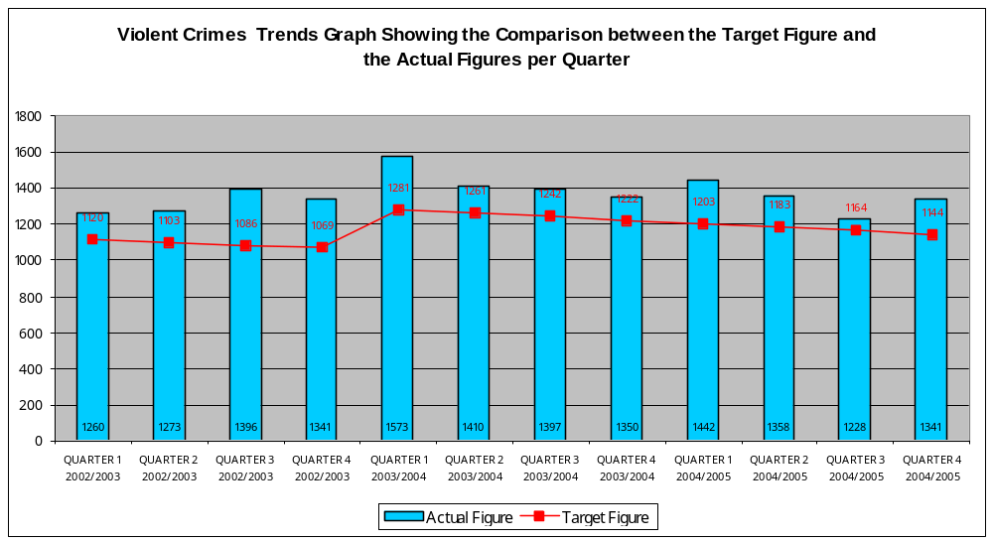

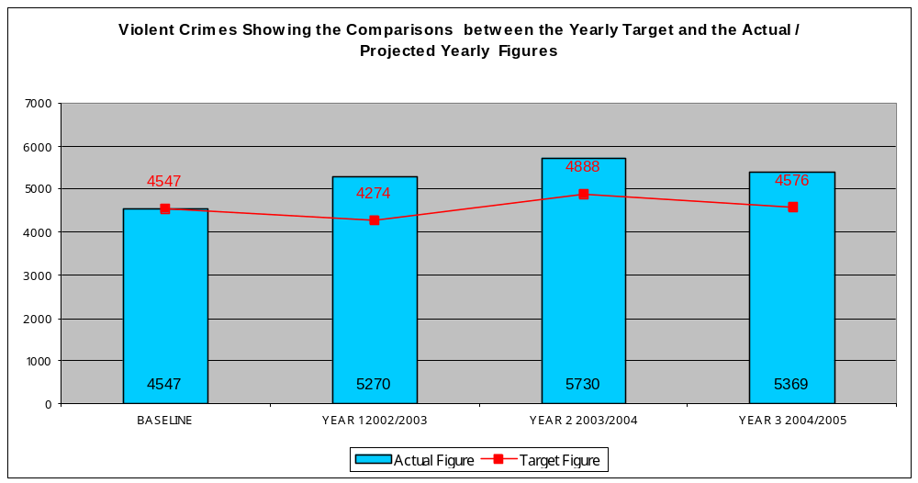

OBJECTIVE 2. TACKLING VIOLENT CRIME

TARGET:- Reduce the number of Robberies by 38% to 699 by 2005.

Comments On Actions | Not On  Target
- Following a rise in violent crimes and robbery in the Irlams o’th Height area, Operation ‘Solak’ was instigated, a highly visible presence in the area. This resulted in a number of offenders being arrested and a reversal of the trend.
- Operation Marne has established ‘safe routes’ in the vicinity of Salford University and also provided personal safety advice to the student population, particularly ‘freshers’. A similar operation is planned for the next intake.
- Under the Prolific & Other Priority Offenders initiative (PPO’s) the CDRP has complied a list of its top 50 offenders. These are now being actively pursued.

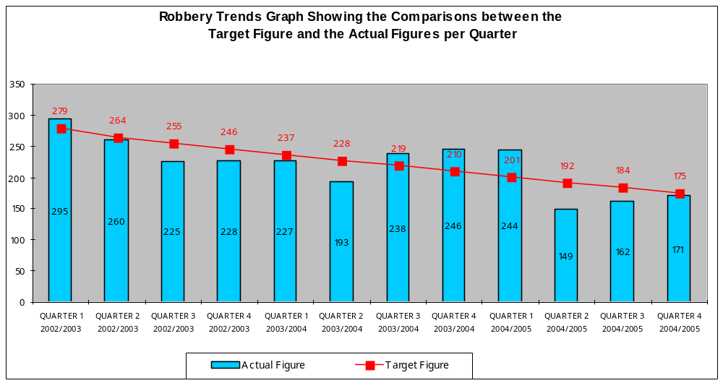

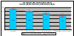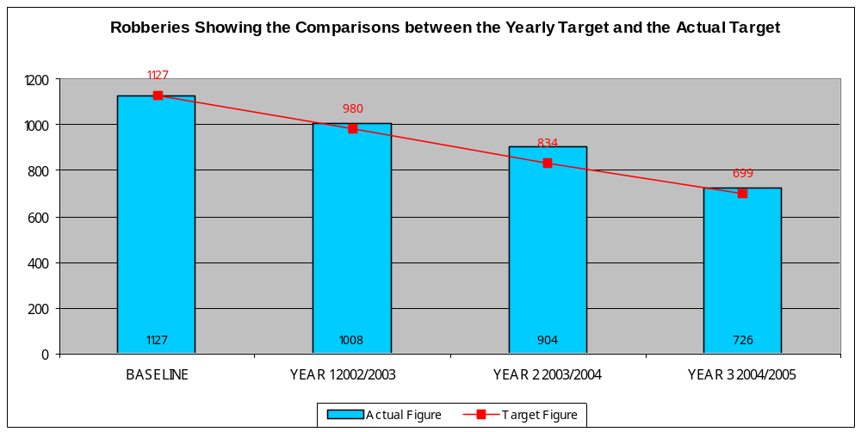
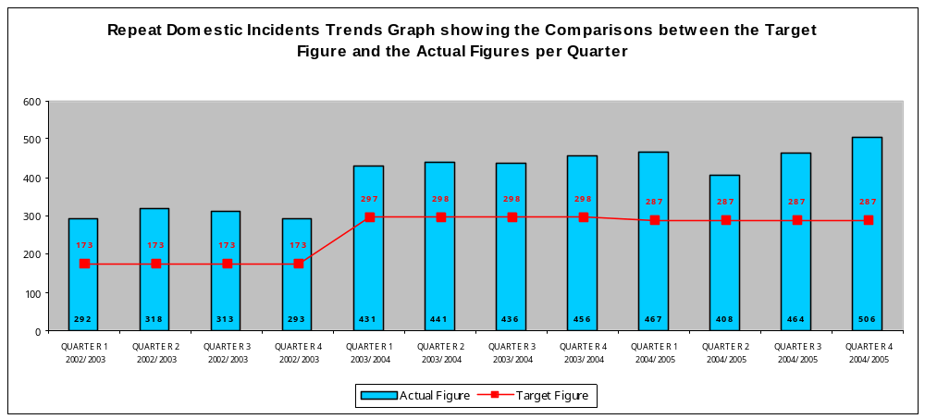
OBJECTIVE 2. TACKLING VIOLENT CRIME

TARGET:- Reduce the number of Repeat Domestic Abuse Incidents by 7% to 1,148 by 2005.
Comments On Actions | Not on  Target
- Domestic abuse contact numbers were printed on local bus tickets, from January 3rd – 11th 2005. Feedback was received that this was an effective way of raising domestic abuse awareness amongst the general public and of bringing support services to the attention of victims and survivors. Up to 499,000 tickets were issued.
- A five day training programme has been identified for those interested in setting up effective ways of working with unconvicted DA perpetrators and places have been booked for 2 social workers. This is a significant step forward in addressing preventative strategies.
- Domestic abuse presentations have been given as part of the ACPC Training Programme and at a Supporting People Consultation Event.
- The second round of 6 multi-agency domestic abuse training sessions has been arranged for delivery throughout April. A full summary of numbers attending etc. will be given in the next quarter.
- There has been considerable input into the setting of a pilot specialist DV court at Salford Magistrates’ Court scheduled to begin in July.
- A "Week-to-Count" DA incidents being plannned for July 17th - 24th, when all partnership agencies will be expected to focus on gathering DA data, especially around arrests, prosecutions & convictions.
- Publicity campaigns carrying DA information on supermarket till receipts and car park tickets at designated sites are ready to be launched in late April/early May.

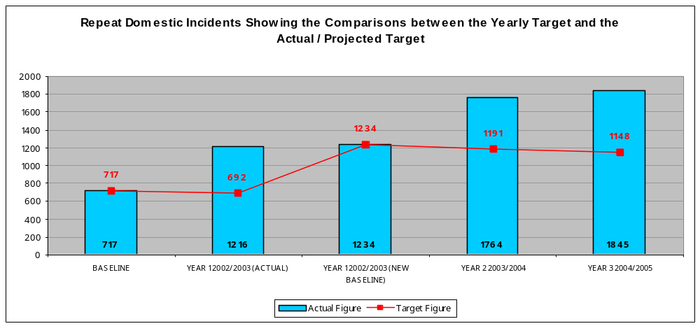

OBJECTIVE 3. REDUCING VEHICLE CRIME

TARGET:- Reduce the number of Vehicle Crimes (both theft of and theft from) by 20% to 6,278 by 2005.

Comments On Actions | On  Target
- The CDRP responding to attacks on buses in Broughton put into place a package of measures, which resulted in the elimination of the problem.
- The TOGETHER Action initiative is to embark on a number of ‘beat sweep’ operations throughout the city, part of the focus will be to remove older abandoned or uninsured vehicles which are statistically more likely to be stolen.
- The `First Step Trust` is to build a motor salvage yard in Salford. This will assist in the reduction of motor vehicles being stolen and taken to unscrupulous dealers for scrap metal.
- Trading Standards and the local police are making enquiries into the suitability of a number of people to own or manage MOT for salvage yards.
- The `Gears Project` has now been established, with offices found and staff being recruited.
- The parking survey in relation to Trinity has now been completed and is to be forwarded to highways so restrictions can be considered within the area.

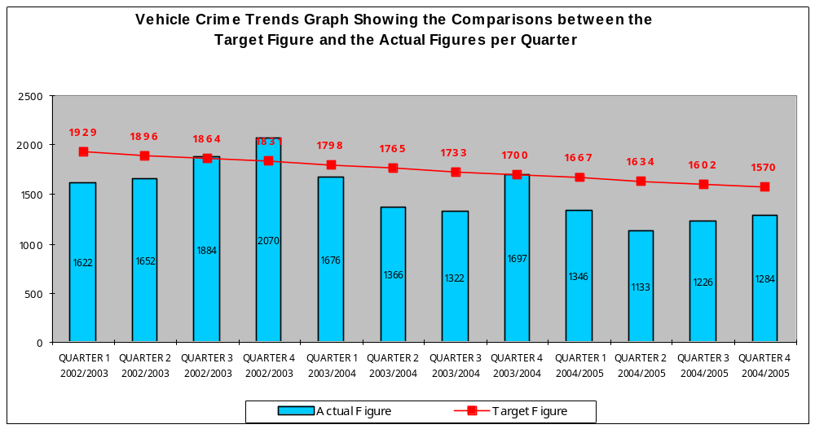

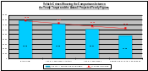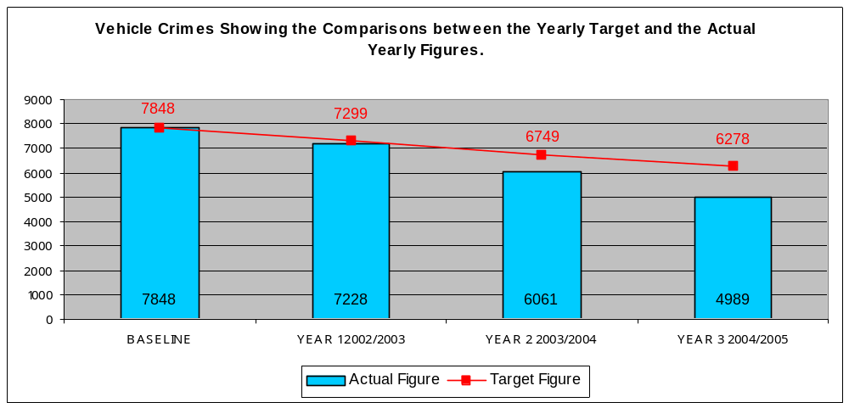

OBJECTIVE 3. REDUCING VEHICLE CRIME

TARGET:- Increase Detection Rate in relation to Vehicle Crimes by 10% to 5.72% by 2005.

Comments On Actions | Not on  Target
- The police are conducting overt and covert operations in the Trinity and Ordsall areas (operation Tokyo)

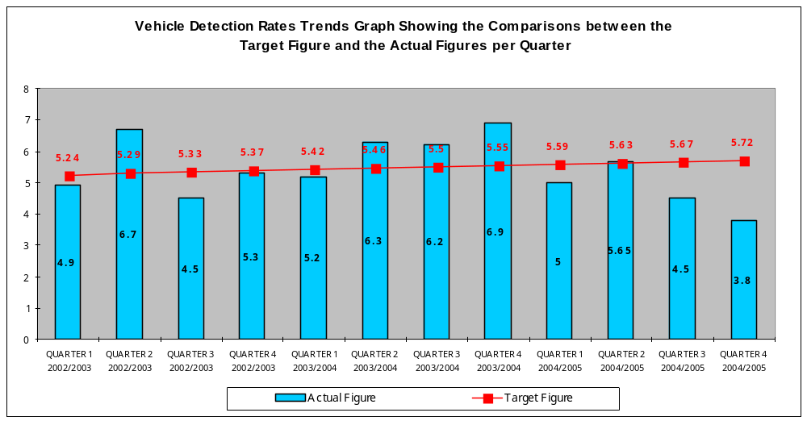

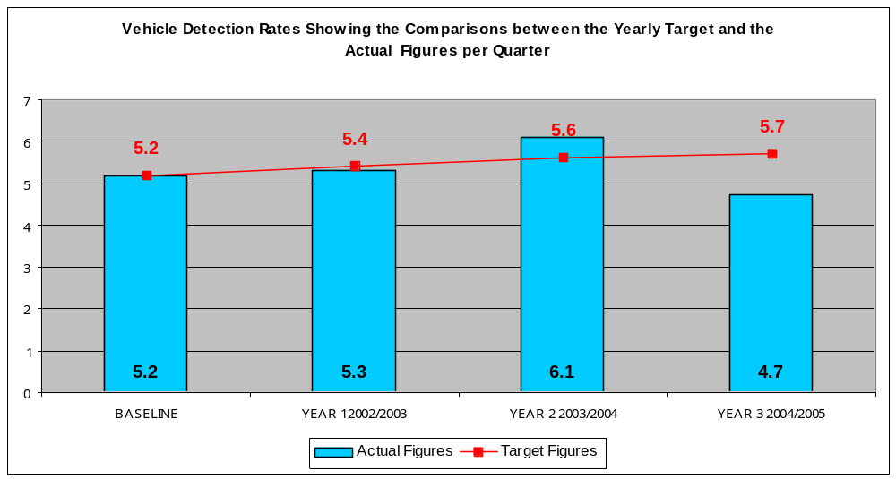

OBJECTIVE 3. REDUCING VEHICLE CRIME

TARGET:- Reduce the number of Malicious Vehicle Fires by 20% to 940 by 2005.

Comments On Actions | On  Target
- The hot spot areas at present are Irwell Riverside, Little Hulton and Ordsall.
- The multi agency ‘Beat Sweep’ initiative undertaken during October 2004 is being repeated in Lower Broughton, Blackfriars and Kersal, week commencing 23 May 2005.
- Funding from the Arson Control Forum is supporting the ‘Fast Track’ scheme which continues to be operated throughout the area.
- Boulders are to be provided on the Overdale Estate, Swinton to stop vehicles being burned out in vulnerable locations.

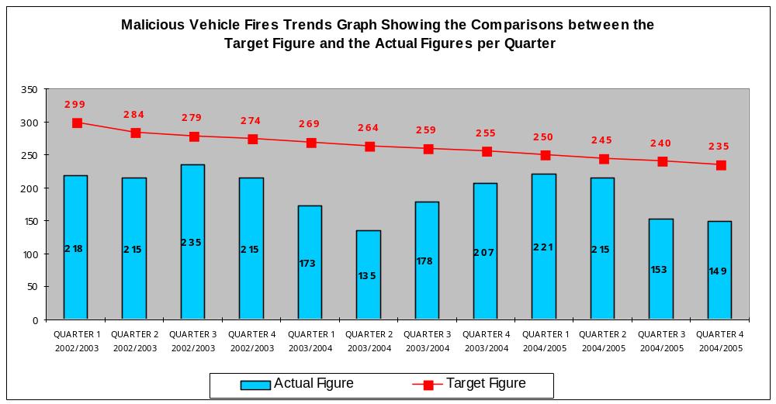

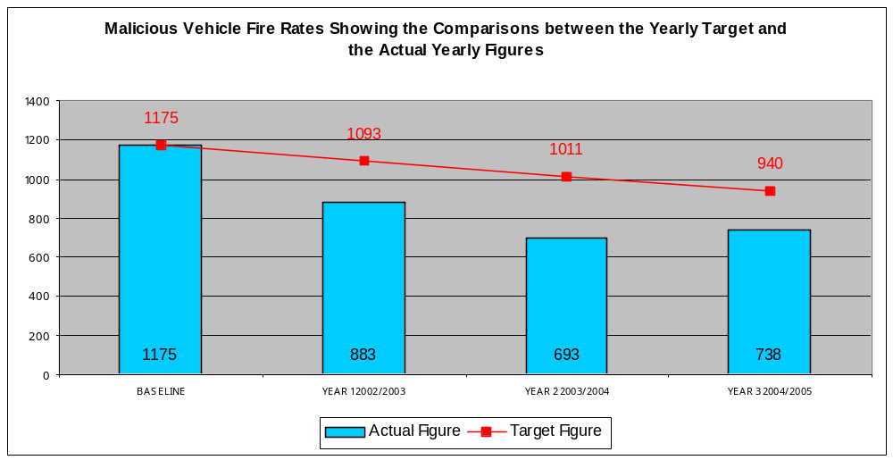

OBJECTIVE 4. REDUCING BURGLARY DWELLING AND BURGLARY OTHER

TARGET:- Reduce the number of Burglary Dwellings by 21% to 3,479 by 2005.

Comments On Actions | On  Target
- The Burglary Reduction Initiative secured more than 400 homes in the last quarter. This included providing 70 Identislot packages to elderly residents of Salford.
- 11 closures were completed covering 31 alleyways and work has started in the Charlestown area on a first phase of an alley gating scheme covering more than 1000 properties.
- Salford is to pilot a scheme in relation to doorstep crime. This is an attempt to get offenders and the criminal fraternity to report people who are committing this type of offence.
- Greater Manchester Police Authority is to lead a campaign on the reporting by vulnerable people of doorstep crime offences.

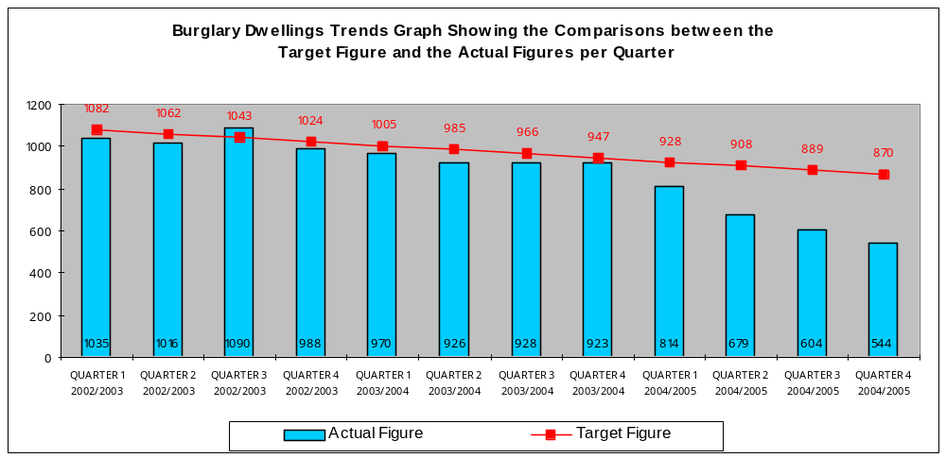

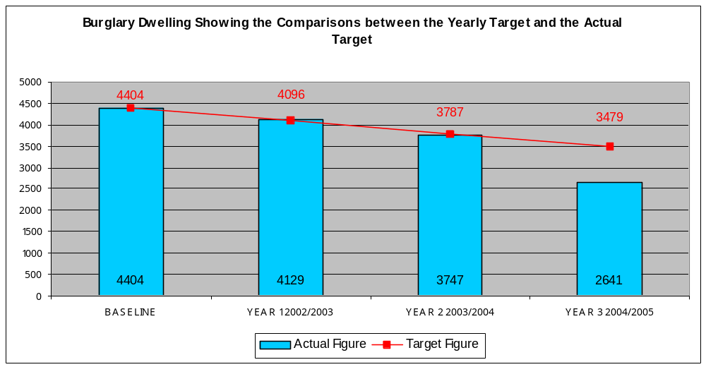

OBJECTIVE 4. REDUCING BURGLARY DWELLING AND BURGLARY OTHER

TARGET:- Reduce the number of Burglary Other by 15% to 2,989 by 2005.

Comments On Actions | On  Target
- Burglary other includes garages/shed thefts as well as crime committed against businesses. In the new strategy we recognise the importance of tackling business crime and sustaining and developing a buoyant business economy.
- We are participating in a pilot scheme (commenced on 1st April) involving Greater Manchester Police. This involves recording business crime in line with the following definition- ‘Any crime against business or against any person as a result of their employment’. The pilot scheme will run six months to the end of September 2005. It will be the subject of an evaluation and report by December 2005. After that time we should be in a stronger position to measure the levels of business crime and consider appropriate interventions.

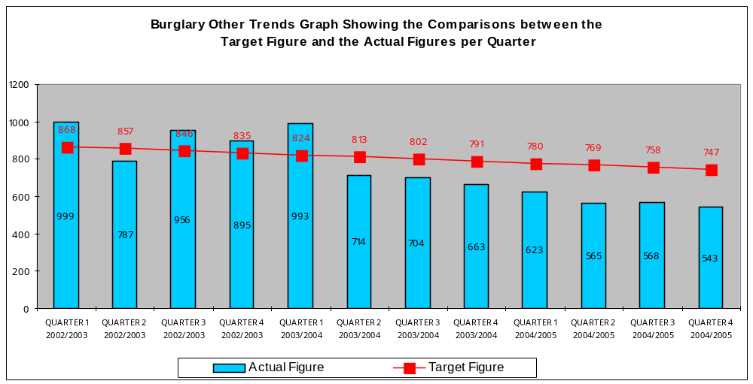

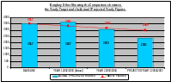
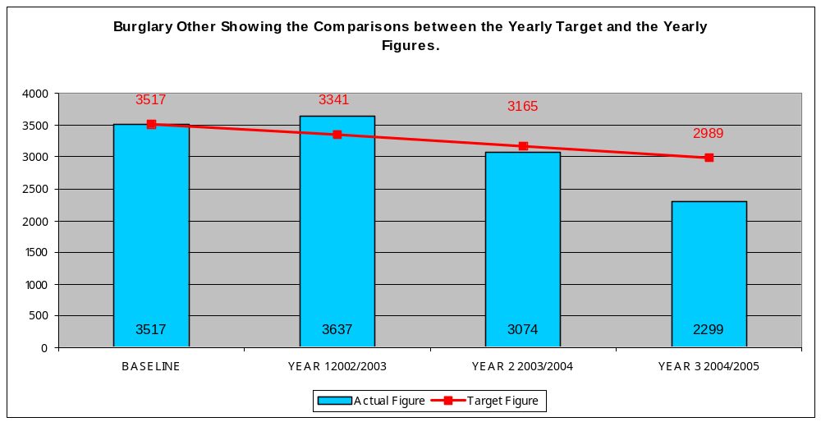

OBJECTIVE 5. EFFECTIVELY RESPOND TO HATE CRIME

TARGET:- Implement an effective third party reporting network for Hate Crimes by March 2004.

Comments On Actions

- The majority of reported hate crimes in the City are race related. Issues around having an effective reporting network for refugees and people seeking asylum were discussed recently at the newly formed Multi Agency Forum. This forum can provide a platform for co-ordinating reporting mechanisms.

OBJECTIVE 5. EFFECTIVELY RESPOND TO HATE CRIME

TARGET:- Increase the number of reported Hate Crimes by 30% to 398 by 2005.

Comments On Actions | On  Target
- There has been a steady rise in the number of hate incidents reported by way of the Salford multi agency reporting form.
- All GMP staff have been issued with the Race Equality Scheme Workbook of which completion is mandatory.
- Salford division recently held the inaugural meeting of the Salford Independent Advisory Group, the creation of which is one of the recommendations of the Stephen Lawrence Inquiry report.
- The Community Race Relations Officer has continued to contact victims of hate crime to offer support/advice.
- The Community Affairs Unit is working closely with NASS and the Immigration Service to assist with matters involving asylum seeking communities on the division.

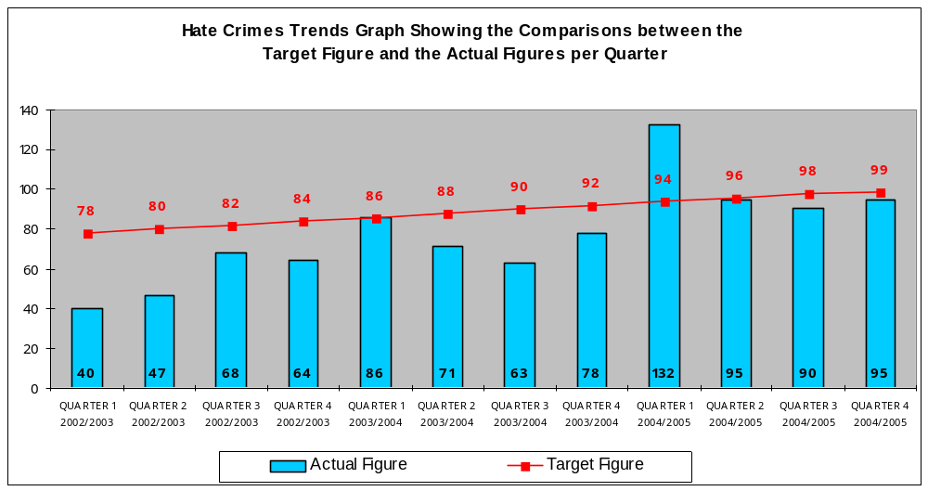

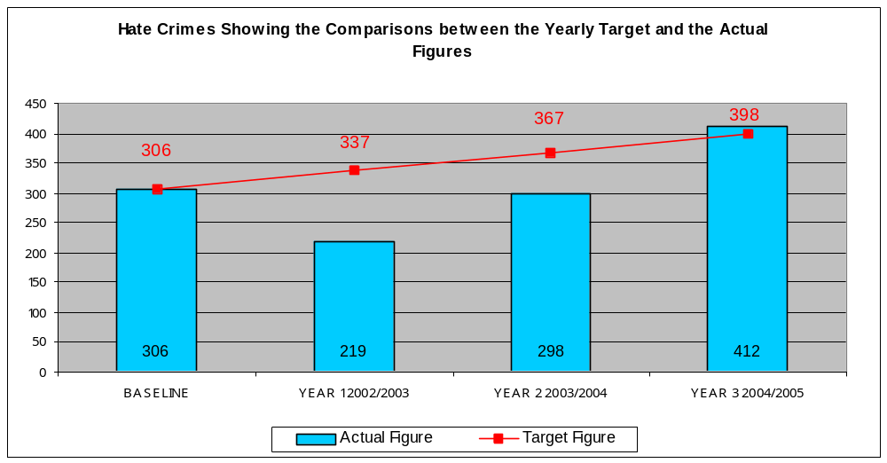

Public Service Agreements
Monitoring Report

4th Quarter January to March 2005

Completion date - March 2005

Target | On target for Delivery | Actual figures / rate |  |  |  |  | Target figures / rate
Target | On target for Delivery |  | 2001/2002 | 2002/2003 | 2003/2004 | 2004/2005 | 2004/2005
- Reduce Burglary Dwelling by 29%  Target to be reached by March 2005. Figure of 4,049 burglary dwellings. Rate of 42.13 offences per 1,000 households.  Baseline: 1998/1999 figure of 5,703 Burglary Dwellings.  Rate of 59.34 offences per 1,000 households. | On  Target | Number of offences | 4,404 | 4,129 | 3,747 | 2,641 | 4,049
 | On  Target | Rate per 1,000 households | 45.83 | 42.97 | 38.99 | 27.48 | 42.13
- Reduce Vehicle Crime by 36.5% by March 2005.  Target to be reached by March 2005. Figure of 6,852 vehicle crime. Rate of 30.33 offences per 1,000 population.  Baseline: 1998/1999 figure of 10,791 Vehicle Crimes.  Rate of 47.77 offences per 1,000 population. | On  Target | Number of offences | 7,848 | 7,228 | 6,061 | 4,989 | 6,852
 | On  Target | Rate per 1,000 population | 34.74 | 32.00 | 26.83 | 22.08 | 30.33

Household Count of 96,100 Population Count of 225,900
(Based on mid 1998 estimates)

