


Strategy Monitoring Report
3rd Quarter
October to December 2004

SALFORD CRIME AND DISORDER PARTNERSHIP

CRIME & DISORDER REDUCTION STRATEGY
2002 – 2005
STRATEGY PERFORMANCE INDICATORS

Key:
.
Not on Target = Not on target for delivery and unlikely to be achieved in next quarter

.
Near to Target = Not on target for delivery, but may be achieved in next quarter

On Target = On or exceeding target for delivery

OBJECTIVE 1. RESPONDING EFFECTIVELY TO NUISANCE AND DISORDER

TARGET:- Reduce the number of Juvenile Nuisance incidents citywide by 6% to 9,704 by 2005.

Comments On Actions | On  Target
- The six school based police officers had a number of successes dealing with a range of problems, in particular youths causing annoyance, bullying, violence and intimidation to pupils and staff, damage to school buildings, drug related incidents and hate crime
- Between commencement of operations in July 2004 and the end of December 2004, the Nuisance Link team have carried out investigations into 250 complaints of Anti-Social Behaviour. Of the 250 cases, 145 have been successfully investigated through to closure. The remaining cases continue to be investigated.
- Community Sector Teams continue to take early intervention action to tackle youth disorder through ASBO warning letters and interviews and through the Youth Inclusion Support Panel (YISP) (for 8-13 year olds at risk of committing anti-social behaviour)
- The single telephone number for reporting anti-social behaviour as part of the action area will be launched on 28th February 2005
- The City Council and NPHL are developing a single anti-social behaviour unit.
- The Council's budget strategy group has recently identified funding to establish the post of Young People's Champion for Salford in 2005-06. This post will be based in Community and Social Services and will focus on the implementation of the Youth Strategy.

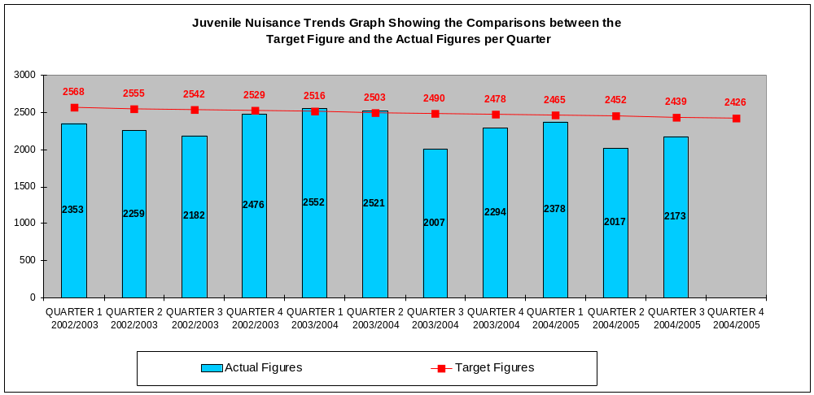
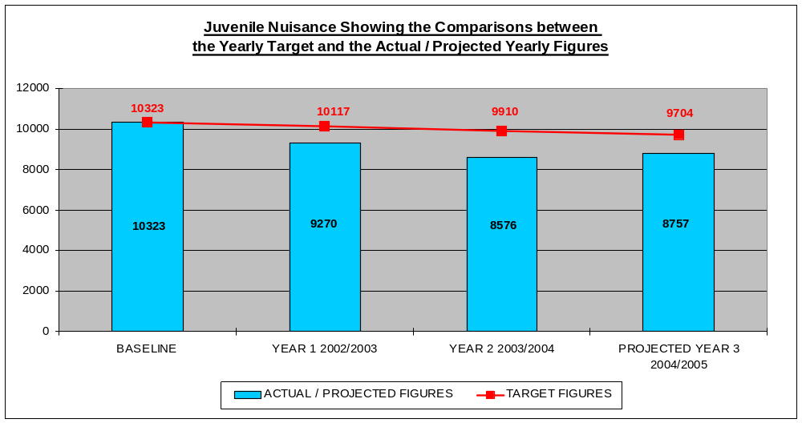

OBJECTIVE 1. RESPONDING EFFECTIVELY TO NUISANCE AND DISORDER

TARGET:- Reduce the number of Malicious Calls to Greater Manchester County Fire Service
By 10% to 537 by 2005.

Comments On Actions | On  Target
- The Fire and Rescue Service, particularly its Community Fire Safety section, continue to actively work in schools and Youth organisations engaging children in projects such as the ‘Learn not to burn’ scheme.
- Mobile phone operators continue to provide support through the barring of phones that are used to make malicious calls.
- The call challenge initiative continues to be applied whereby Fire Service Control operators question suspicious calls to determine whether they are genuine. This has identified 197 malicious calls, which would previously have resulted in a fire appliance responding under ‘blue light‘ condition.

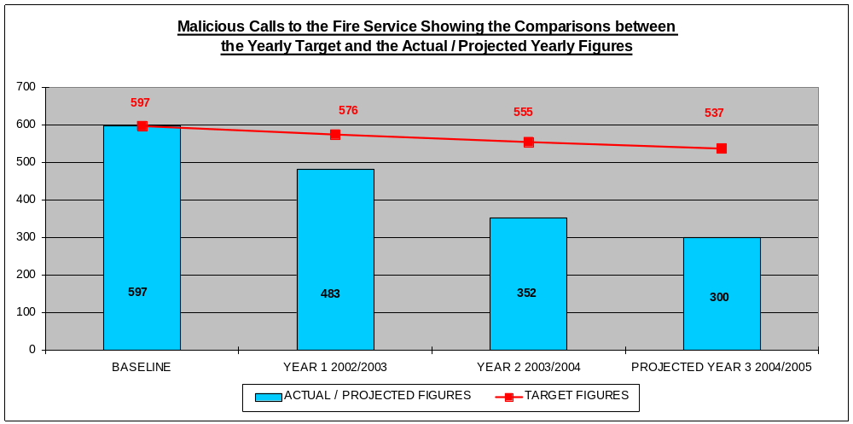
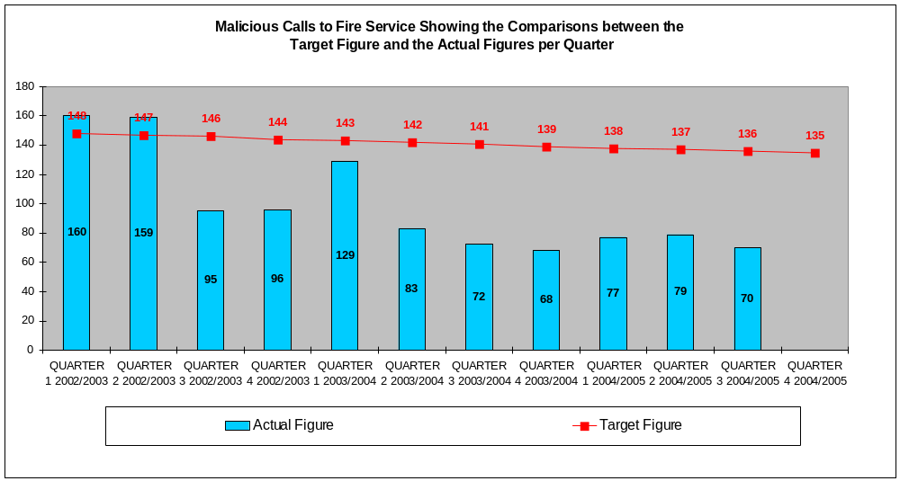

- The survey to measure the LPSA target has been arranged for April 2005 and will be in conjunction with Sheffield University.

- The post of Equity Officer, whose role is to increase participation in sporting activity for women and minority ethnic groups, is being mainstreamed.
- An annual work programme has been developed for the Equity Officer.
- The SAYO (Sport, Arts and Youth in Ordsall) project continues to work closely with the Lads Club to encourage greater participation from young people and is currently working with the Lads Club to submit a Heritage Lottery Bid.
- A weekend activity programme is continuing on Friday and Saturday evenings to encourage young people into sporting activities and there is a more extensive activity programme across the city.
- Weekend activity programmes operate at various localities in the city. In addition, pilot work in two areas by the Raid Response Teams (Sports Development) has resulted in significant drops in juvenile nuisance (e.g. 25% reduction in Eccles).
- Over 400 young people have participated in Duke of Edinburgh activities so far in 2004/5.
- Attendances for the Watersports Centre for the year of 2004 are 22,545.

OBJECTIVE 1: INCREASE PARTICIPTAION IN SPORTING ACTIVITY

TARGET: Increase the participation of young people in sporting activities by 25% from 56.3 to 70.3% by 2005

OBJECTIVE 2. TACKLING VIOLENT CRIME

TARGET:- Reduce the number of Violent Crimes by 12% to 4,576 by 2005.

Comments On Actions | Not on  Target
- Operation Etna has provided a highly visible police presence aimed at reducing violent crime in and around Eccles Town Centre at weekends.
- Trading Standards, through test purchasing, covert observations and the provision of training schemes for Licensees, have reduced under-age sales of alcohol in targeted premises from 50%-60% to 4%.
- A multi-agency Alcohol Reference Group has been established. Much of its focus is alcohol related violence, including domestic violence
- Operation Orlando was a policing operation initiated after a violent incident in Swinton Town Centre resulted in the death of a man. It involved a high profile police presence and intrusive supervision of licensed premises.
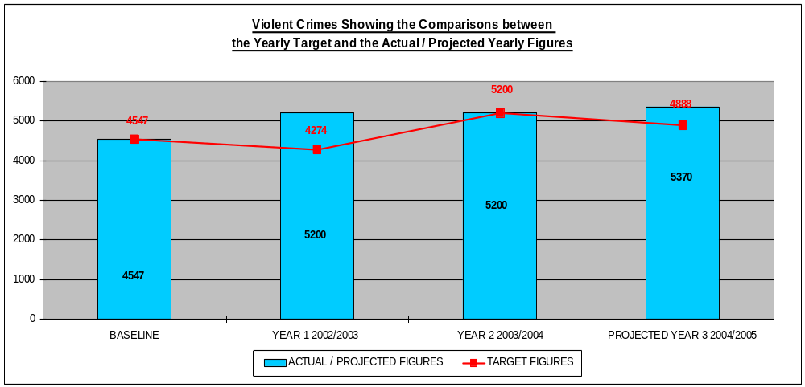
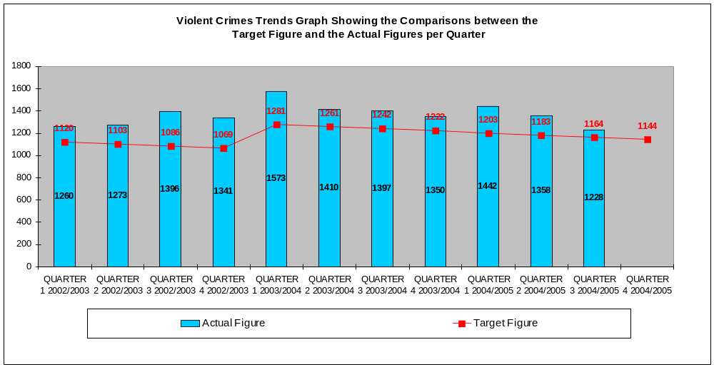

OBJECTIVE 2. TACKLING VIOLENT CRIME

TARGET:- Reduce the number of Robberies by 38% to 699 by 2005.

Comments On Actions | Not On  Target
- Operation Marne has established ‘safe routes’ in the vicinity of Salford University and also provided personal safety advice to the student population, particularly ‘freshers’.
- A similar operation to Marne is being established around Eccles College.
- Operation Elias is a multi-agency approach to the active supervision of known ‘street robbers’, the operation has included the provision of access to health & education services as an over all strategy of diverting individuals from committing crime.
- Under the Prolific & Other Priority Offenders initiative (PPO’s) the CDRP has complied a list of its top 50 offenders. These are now being actively pursued.
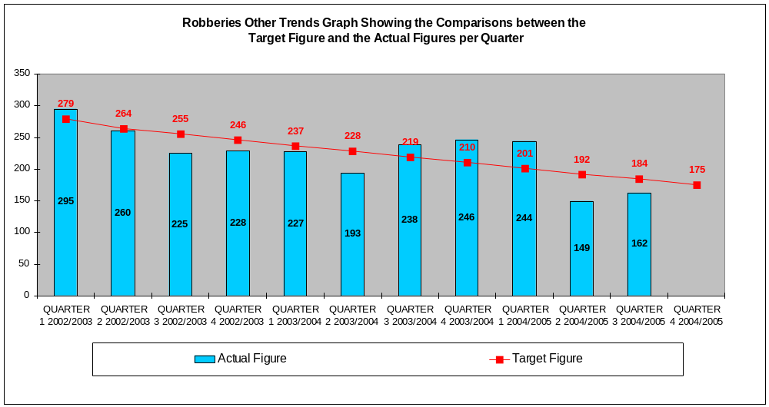

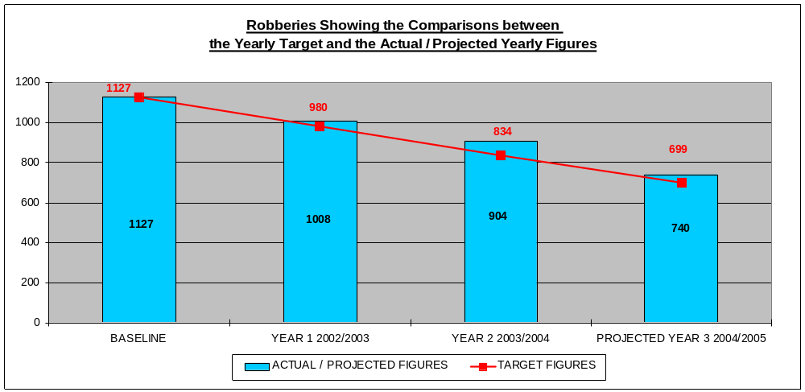
OBJECTIVE 2. TACKLING VIOLENT CRIME

TARGET:- Reduce the number of Repeat Domestic Violence Incidents by 7% to 1,148 by 2005.

Comments On Actions | Not on  Target
- The DV Forum for frontline workers and supported survivors was successfully launched in December 2004. Red Cinema hosted the event. Over 80 people from 33 voluntary and statutory agencies attended and the Forum will meet twice in its first year, building up to quarterly meetings thereafter. The Forum will serve to review policies and practices and it will facilitate consultation, networking and the sharing of information and good practice.
- The first series of multi-agency DV training sessions was successfully delivered in October & November 2004. There is already a waiting list for places on the next series, planned for the period after Easter.
- Public awareness raising and the dissemination of information about DV continue via new publicity campaigns. DV contact numbers are now displayed on the Plasma Screen in the Treasury Building and they were printed on local bus tickets, from January 3rd – 11th 2005. Permanent displays have been paid for at Hope Hospital.

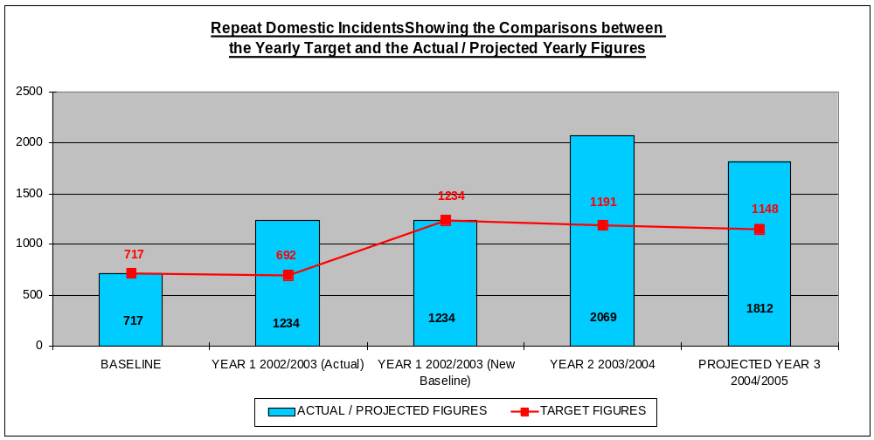
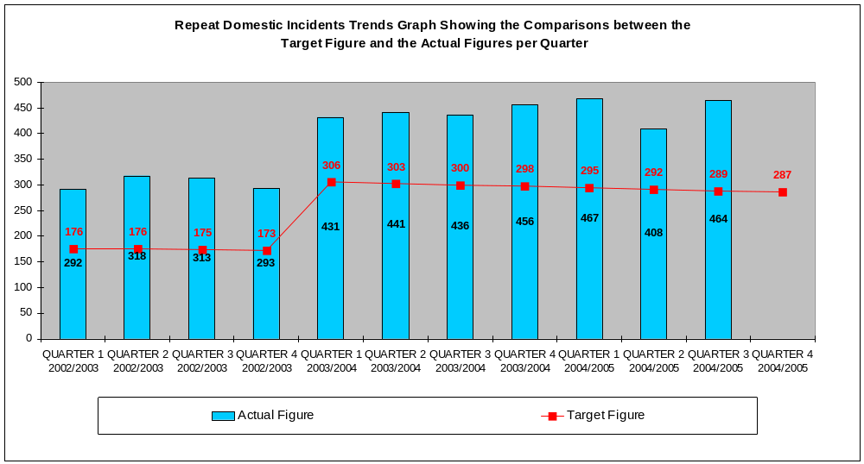

OBJECTIVE 3. REDUCING VEHICLE CRIME

TARGET:- Reduce the number of Vehicle Crimes (both theft of and theft from) by 20% to 6,278 by 2005.

Comments On Actions | On  Target
- The `First Step Trust` is to build a motor salvage yard in Salford. This will assist in the reduction of motor vehicles being stolen and taken to unscrupulous dealers for scrap metal.
- Trading Standards and the local police are making enquiries into the suitability of a number of people to own or manage motor salvage yards.
- Operation Tokyo, based in Trinity and NRF funded, is now in its final stage.
- The `Gears Project` has now been established, with offices found and staff being recruited.
- ANPR is being utilised within Eccles to reduce vehicle crime and other offences
- Boulders are to be provided on the Overdale Estate to stop vehicles being burned out in vulnerable locations.
- The parking survey in relation to Trinity has now been completed and is to be forwarded to highways so restrictions can be considered within the area.
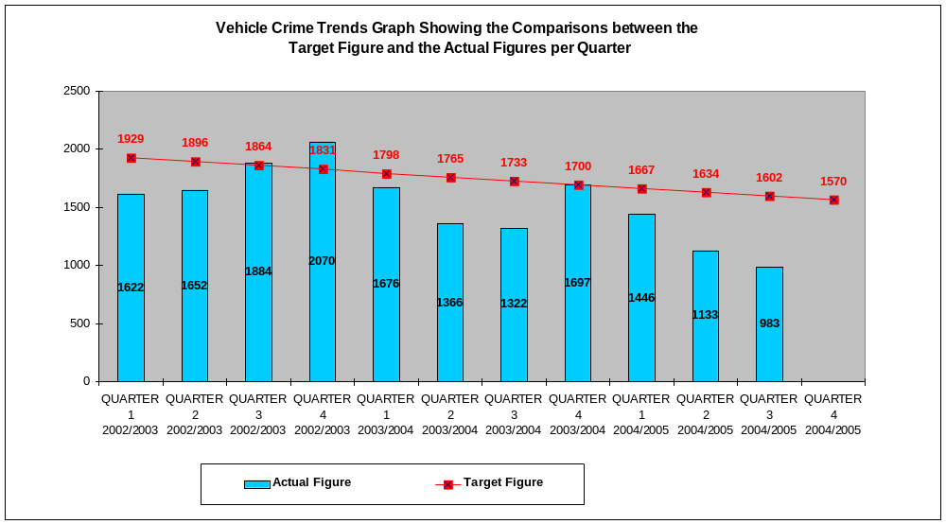

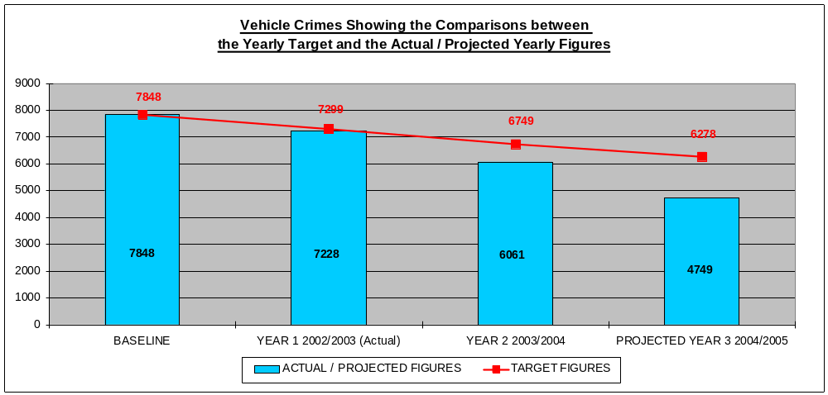

OBJECTIVE 3. REDUCING VEHICLE CRIME

TARGET:- Increase Detection Rate in relation to Vehicle Crimes by 10% to 5.72% by 2005.

Comments On Actions

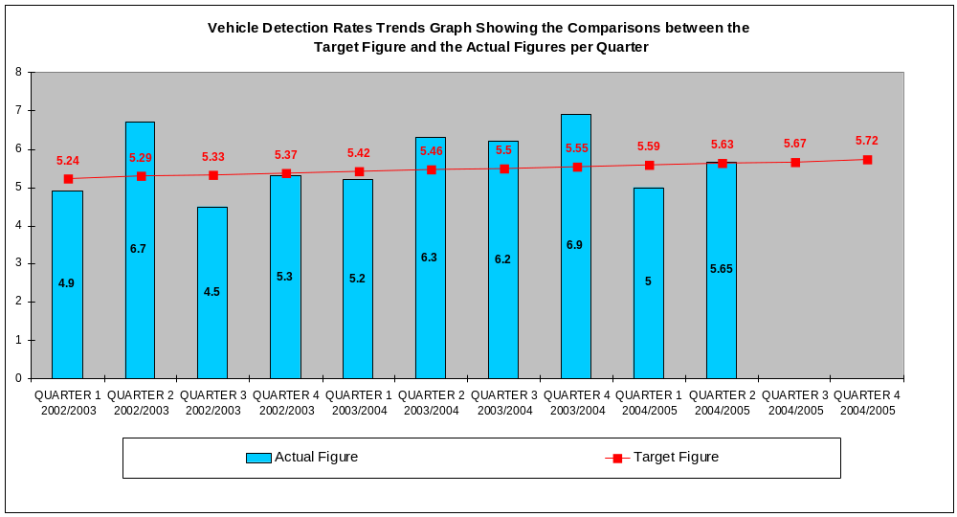
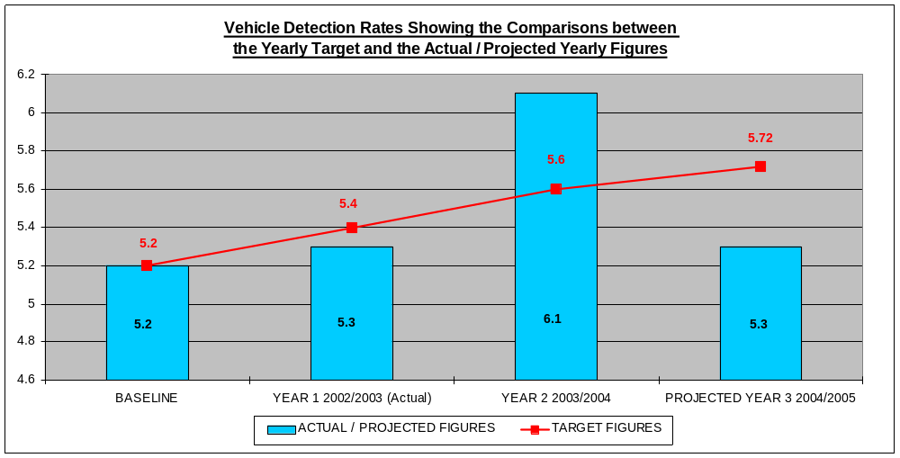

OBJECTIVE 3. REDUCING VEHICLE CRIME

TARGET:- Reduce the number of Malicious Vehicle Fires by 20% to 940 by 2005.

Comments On Actions | On  Target
- The hot spot areas at present are Blackfriars, Little Hulton and Pendlebury
- The multi agency ‘beat sweep’ initiative was undertaken during October 2004 in Little Hulton resulting in intelligence on over 70 vehicles being obtained and 40 being removed. Additionally 10 of these vehicles were identified as a priority for the Police. Additional issues such as benefits fraud and insurance documents were also identified during this activity.
- Funding from the Arson Control Forum is supporting the ‘Fast Track’ scheme.

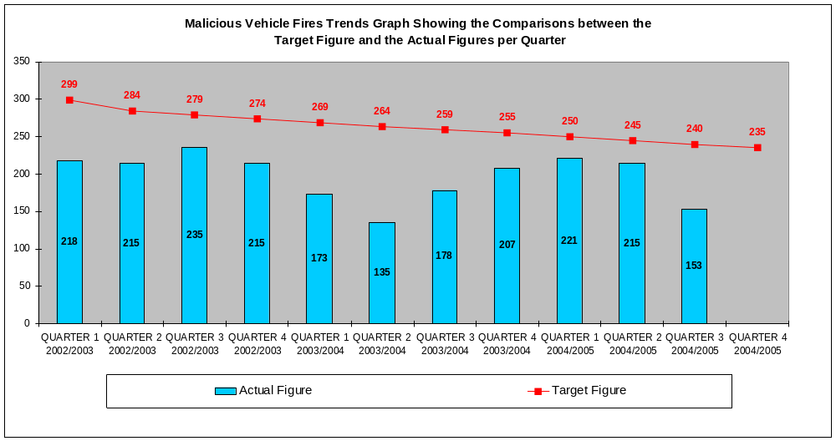

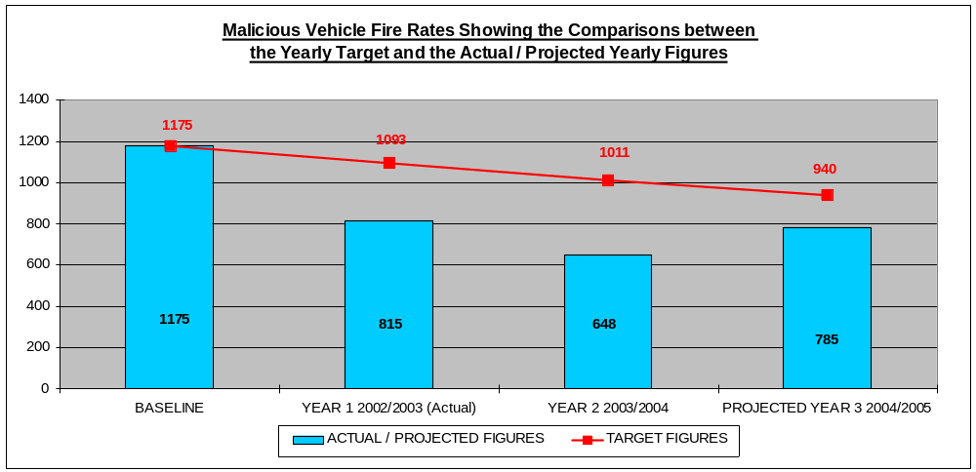

OBJECTIVE 4. REDUCING BURGLARY DWELLING AND BURGLARY OTHER

TARGET:- Reduce the number of Burglary Dwellings by 21% to 3,479 by 2005.

Comments On Actions | On  Target
- The Burglary Reduction Initiative is continuing to target harden premises within Salford.
- 53 alley closures are currently being processed and a further 23 are to be submitted.
- Salford is to pilot a scheme in relation to doorstep crime. This is in an attempt to get offenders, and the criminal fraternity to report people who are committing this type of offence.
- Greater Manchester Police Authority is to lead a campaign on the reporting by vulnerable people of doorstep crime offences.
- Operations Tahiti and Aquila are currently in progress.
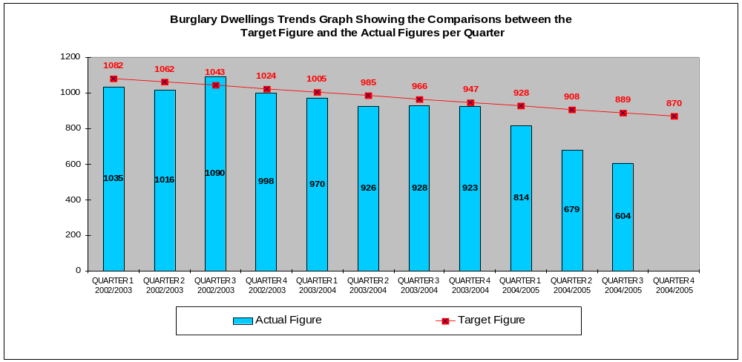
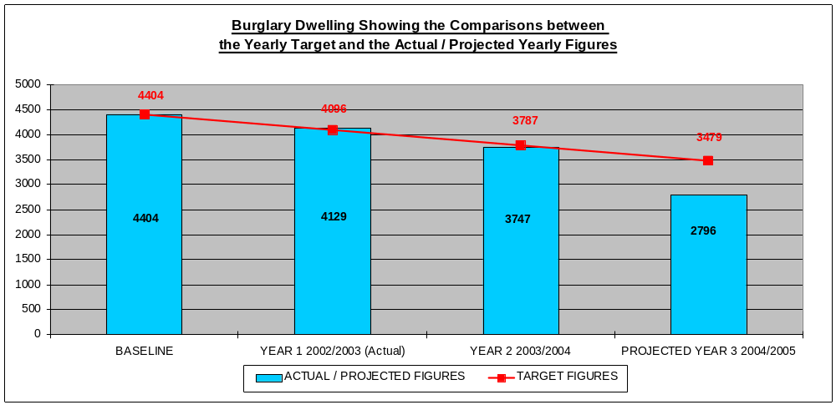

OBJECTIVE 4. REDUCING BURGLARY DWELLING AND BURGLARY OTHER

TARGET: Reduce Burglary Dwellings so that no area of Salford has more than 3 times the National Average Rate of 55.8 Burglary Dwellings per 1,000 households

Burglary of Dwelling by Ward for 2004 with calendar year totals and ratio per 1,000 households
 |  | 2004
Wards | House holds | Jan | Feb | Mar | Apr | May | June | July | Aug | Sept | Oct | Nov | Dec | Total | Ratio per 1,000 HH
BARTON | 5956 | 13 | 23 | 13 | 18 | 19 | 11 | 21 | 17 | 14 | 19 | 9 | 8 | 185 | 31.06
BOOTHSTOWN ELLENBROOK | 3900 | 10 | 23 | 13 | 16 | 6 | 7 | 12 | 11 | 19 | 10 | 13 | 7 | 147 | 37.69
BROUGHTON | 5787 | 14 | 23 | 18 | 15 | 12 | 32 | 14 | 7 | 15 | 15 | 18 | 17 | 200 | 34.56
CADISHEAD | 4048 | 4 | 5 | 4 | 4 | 4 | 4 | 7 | 8 | 5 | 2 | 3 | 6 | 56 | 13.83
CLAREMONT | 4401 | 11 | 9 | 10 | 6 | 7 | 13 | 10 | 8 | 4 | 11 | 5 | 12 | 106 | 24.09
ECCLES | 4940 | 22 | 17 | 20 | 9 | 26 | 21 | 12 | 7 | 10 | 7 | 6 | 7 | 164 | 33.20
IRLAM | 4115 | 9 | 14 | 9 | 8 | 8 | 2 | 4 | 6 | 3 | 3 | 8 | 3 | 77 | 18.71
IRWELL RIVERSIDE | 5186 | 10 | 12 | 13 | 20 | 31 | 34 | 14 | 12 | 18 | 9 | 8 | 7 | 188 | 36.25
KERSAL | 4644 | 11 | 19 | 25 | 4 | 8 | 19 | 10 | 8 | 5 | 7 | 3 | 27 | 146 | 31.44
LANGWORTHY | 7043 | 13 | 20 | 21 | 16 | 9 | 10 | 15 | 20 | 11 | 12 | 9 | 16 | 172 | 24.42
LITTLE HULTON | 6012 | 27 | 25 | 23 | 19 | 24 | 18 | 21 | 13 | 21 | 13 | 16 | 6 | 226 | 37.59
ORDSALL | 3718 | 5 | 7 | 5 | 8 | 14 | 5 | 7 | 3 | 7 | 3 | 5 | 12 | 81 | 21.79
PENDLEBURY | 5005 | 11 | 20 | 13 | 8 | 7 | 8 | 8 | 6 | 10 | 5 | 9 | 5 | 110 | 21.98
SWINTON NORTH | 4925 | 16 | 10 | 8 | 4 | 12 | 5 | 6 | 11 | 7 | 6 | 6 | 8 | 99 | 20.10
SWINTON SOUTH | 4672 | 17 | 13 | 7 | 8 | 10 | 14 | 10 | 6 | 7 | 5 | 13 | 11 | 121 | 25.90
WALKDEN NORTH | 5374 | 28 | 20 | 22 | 28 | 15 | 23 | 15 | 12 | 7 | 14 | 8 | 7 | 199 | 37.03
WALKDEN_SOUTH | 4385 | 17 | 16 | 12 | 11 | 8 | 12 | 15 | 12 | 15 | 13 | 5 | 3 | 139 | 31.70
WEASTE SEEDLEY | 5045 | 12 | 16 | 15 | 14 | 8 | 9 | 12 | 11 | 11 | 14 | 10 | 12 | 144 | 28.54
WINTON | 5377 | 26 | 21 | 17 | 16 | 25 | 15 | 18 | 14 | 12 | 10 | 8 | 13 | 195 | 36.27
WORSLEY | 4253 | 26 | 22 | 10 | 6 | 10 | 22 | 13 | 11 | 14 | 10 | 13 | 10 | 167 | 39.27
Total | 98786 | 302 | 335 | 278 | 238 | 263 | 284 | 244 | 203 | 215 | 188 | 175 | 197 | 2922

Household figures based on the 2001 Census re based on the new Ward boundaries.

Household figures taken from Key Statistic table 016. Figures include vacant properties and holiday homes.

OBJECTIVE 4. REDUCING BURGLARY DWELLING AND BURGLARY OTHER

TARGET:- Reduce the number of Burglary Other by 15% to 2,989 by 2005.

Comments On Actions | On  Target
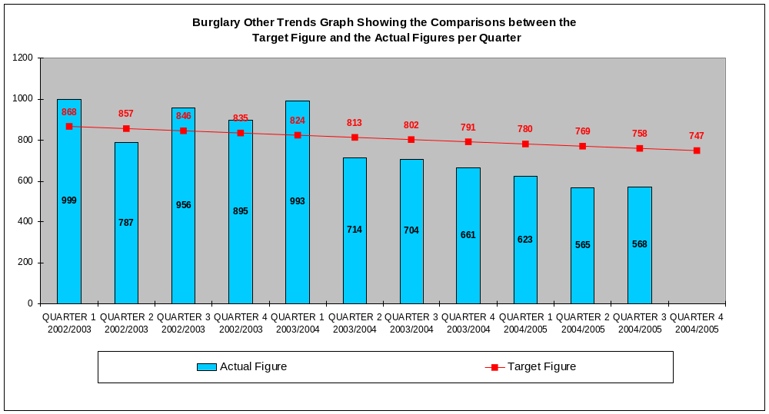

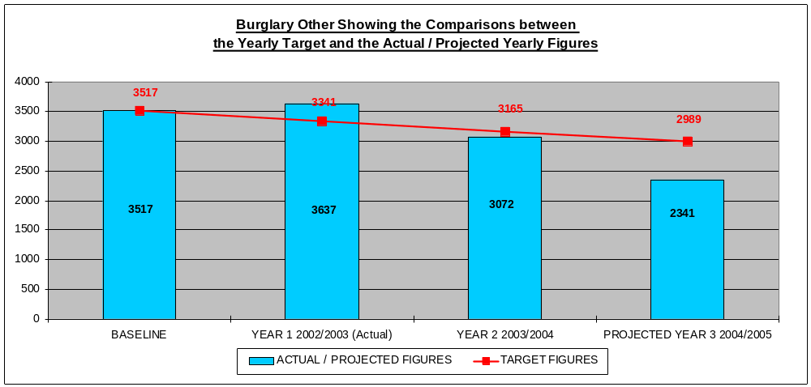

OBJECTIVE 5. EFFECTIVELY RESPOND TO HATE CRIME

TARGET:- Implement an effective third party reporting network for Hate Crimes by March 2004.

Comments On Actions

- The majority of reported hate crimes in the City are race related. Issues around having an effective reporting network for refugees and people seeking asylum were discussed recently at the newly formed Multi Agency Forum. This forum can provide a platform for co-ordinating reporting mechanisms.

OBJECTIVE 5. EFFECTIVELY RESPOND TO HATE CRIME

TARGET:- Increase the number of reported Hate Crimes by 30% to 398 by 2005.

Comments On Actions | On  Target
- The Police Community Affairs Unit has increased capacity by one officer who will be specifically monitoring hate crime reports on the police system
- The introduction of new reporting methods and the amended 730D is expected to increase the number of reported hate crimes further.
- GMP has been working closely with the PCT to develop the hate crime reporting procedures.
- The Community Race Relations officer within GMP has been visiting local Drop In centers offering support, advice and encouraging reporting of hate crime.
- GMP has established a reporting station for hate crime at Salford University.
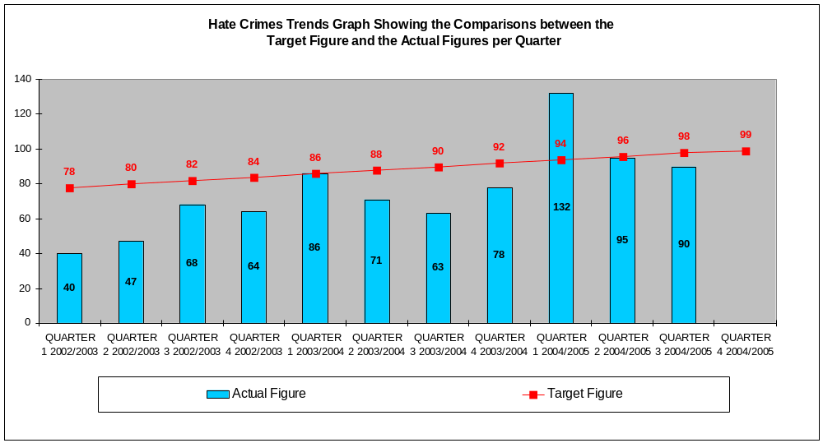

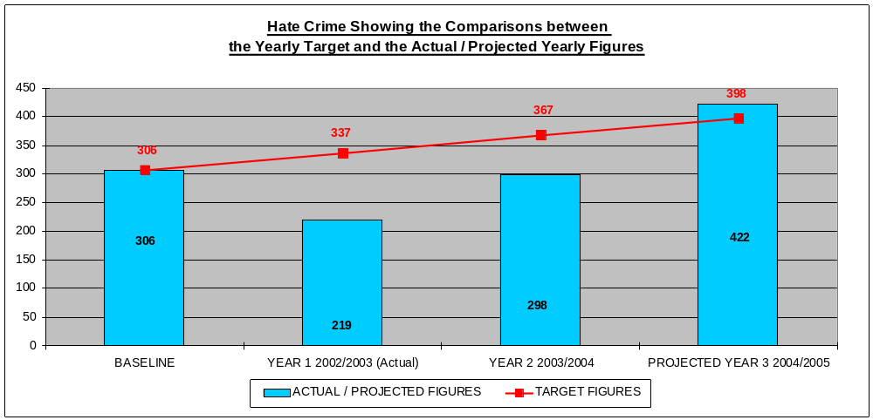

Public Service Agreements
Monitoring Report

3rd Quarter October to December 2004

Completion date - March 2005

Public Service Agreements (P.S.A’s)

Target | On target for Delivery | Actual figures / rate |  |  |  | Quarterly figures 2004/2005 |  |  |  | Target figures / rate
Target | On target for Delivery |  | 2001/2002 | 2002/2003 | 2003/2004 | 1st  Qtr | 2nd  Qtr | 3rd  Qtr | 4th  Qtr | 2004/2005
- Reduce Burglary Dwelling by 29%  Target to be reached by March 2005. Figure of 4,049 burglary dwellings. Rate of 42.13 offences per 1,000 households.  Baseline: 1998/1999 figure of 5,703 Burglary Dwellings.  Rate of 59.34 offences per 1,000 households. | On  Target | Number of offences | 4,404 | 4,129 | 3,747 | 814 | 679 | 604 |  | 4,049
 | On  Target | Rate per 1,000 households | 45.83 | 42.97 | 38.99 | 33.88 | 31.07 | 29.09 |  | 42.13
- Reduce Vehicle Crime by 36.5% by March 2005.  Target to be reached by March 2005. Figure of 6,852 vehicle crime. Rate of 30.33 offences per 1,000 population.  Baseline: 1998/1999 figure of 10,791 Vehicle Crimes.  Rate of 47.77 offences per 1,000 population. | On  Target | Number of offences | 7,848 | 7,228 | 6,061 | 1,446 | 1,133 | 983 |  | 6,852
 | On  Target | Rate per 1,000 population | 34.74 | 32.00 | 26.83 | 25.60 | 22.83 | 21.02 |  | 30.33

Household Count of 96,100 Population Count of 225,900
(Based on mid 1998 estimates)

