|  |
| --- |
|  |
| UV IT Annual Statement  Financial year 1st April 2010 to 31st March 2011 |
|  |
|  |

Contents Page

1. Executive Summary 2

2. The Urban Vision IT Team 3

3. Business Continuity 5

4. Ordnance Survey responsibilities 7

5. Graphical Information Systems (GIS) 10

6. AutoCAD 12

7. ESRI – A GIS software package used by Salford 14

8. GGP - What is it and what are our responsibilities 16

9. Planning 18

10. Highway records (CONFIRM system) 21

11. Property records 23

12. Customer complaints 25

13. Freedom of information 27

14. Investment 29

15. Efficiencies and improvement 31

16. Future Developments 33

# Executive Summary

* 1. The purpose of this report is to provide an overview of the ICT support provided by Urban Vision and to describe the relationships between Urban Vision, Salford City Council and Capita Symonds from an ICT perspective.
  2. The IT team manage a number of critical systems on behalf of the Council and these are detailed in this report. These systems support a number of key services including Planning, Highways and Property management.
  3. Prior to the formation of Urban Vision, the ‘Development Services’ Directorate was an integral part of Salford City Council. The computer systems for that Directorate, and the IT team that supported them, were situated at the Civic Centre campus. There was no dedicated server room for the Directorate and the servers were generally located in uncontrolled areas such as on floors and under desks.
  4. With the inception of Urban Vision Partnership in January 2005, plans were developed to move the seconded staff. The moves were planned in stages over a period of a month, with IT providing the installs over consecutive weekends.
  5. The server’s were moved to a dedicated new server-room at Emerson House and placed in a secure environment in purpose built racks.
  6. Areas of responsibilities- The work of the Urban Vision ICT team can be categorised into four main areas:

* Infrastructure/security/e-mail/telephony (Urban Vision staff only)

* Help desk and support.

* System support involving upgrades and data management
* Support for third party clients such as Salix Homes, The Urban Regeneration Company, City West and the Emergency Planning Team.
  1. Since the inception of Urban Vision, Capita Symonds has invested considerable resource and expenditure in order to develop both the IT infrastructure, and the portfolio of services it offers.
  2. Urban Vision has had some challenges around the provision of its IT network, notably for providing access to both Salford City Council employees and Capita Symonds employees. To facilitate this the IT team, in conjunction with Salford City Council and Capita, have designed and implemented a new infrastructure that uses the resources and potential of both Salford City Council and Capita to bring about a mutually beneficial structure that is able to support Urban Vision whilst being fully interoperable with Salford City Council, Capita and other 3rd parties.

# The Urban Vision IT Team

* 1. Urban Vision has an IT Team of six staff with a diverse range of experience and knowledge. The team provide support for Urban Vision users based at Emerson House, Swinton Hall Road Depot, Salford Civic Centre and out stationed personnel.
  2. The Urban Vision IT team support a number of users and Directors across the City including colleagues in the Sustainable Regeneration Directorate.
  3. In addition, the team provide support to external clients such as Salix Homes, City West Housing Trust, and before 31st March, 2011, The Central Salford Urban Regeneration Company.
  4. There are around 420 users based at Emerson House, including 30 or so Capita Staff, for whom we also provide localised support to for hardware and software.
  5. Since April 2010 users are able to log support calls via Capita Firstpoint Helpdesk ( by phone, by email or online).
  6. In terms of support this comes in the form of managing the users Operating Systems, Hardware and Software and the software supported includes the following :-
* Microsoft Operating Systems ( Windows XP, Windows Vista, Windows 7)
* Microsoft Office Application Suite ( Office 2000, Office 2003, Office 2007, Office 2010)
* Autocad 2008, 2009, 2010, 2011 & Autocad Add-ons
* Autodesk Revit Architecture, Autodesk 3d Studio Max
* GGP GIS
* ESRI GIS
* Confirm Highways System
* Bespoke In-house Systems support
* Uniform Planning System
* SAP System Support
* Ebydos System Support
* Capita Desktop
* Specialist Design Packages such as In Design, Dreamweaver CS4, Photoshop, Adobe Bridge, Adobe Illustrator, Adobe Acrobat Professional, Adobe Creative Suite.
* Cotag Badge System ( Badge Security System for controlling Salford Sites access and monitoring).
  1. There are a total of 23 servers located in Urban Vision ( 17 windows servers and 6 linux based servers), these servers house the majority of the systems which are used by Urban Vision and some by Salford Council, including :-
* Uniform Planning System
* Highways Confirm System
* Highways Geoworks System
* Public Access System linking to Uniform Planning System
* Legacy bespoke In-house systems ( Salford Assets, GMP Assets, City West Assets, RTB System etc)
* Group and Department servers housing shared company data
* Realise System
* Mastec System
* Print Servers managing users print job to networked printers
* Engineering Projects folders for current and archived Projects.
* Internet Proxy Server for Urban Vision allowing users to access internet via Capita Symonds.
  1. The Urban Vision IT team is also responsible for the following activities:

* Maintenance of hardware (file servers) – daily house-keeping, updates, backups, restores, log-checks
* Configuration of hardware (file servers and workstations)
  + Setting up shares
  + Setting up and managing local security groups
  + Maintaining records of users
  + Managing user space
  + Setting up PDA devices for mobile working
* Installation of software
* Upgrade of software
* Configuration of software
* Providing technical information to aid the purchase and upgrade of hardware and software.
* Various levels of training in the use of software used within the company.

# Business Continuity

* 1. Urban Vision is committed to ensuring business continuity through pro-active infrastructure design and testing.
  2. As part of this commitment, Urban Vision IT is in the process of implementing and testing data recovery infrastructure and procedures over the next few months. This is being done with considerable investment from Capita Symonds and by using the skills and experience of the local IT team, and involves the use of a pre-configured, mobile data centre.
  3. Additionally, Urban Vision have developed a mirrored, fully-resilient, tape-less storage solution, split across two remote sites, that provides both backup & restore capability as well as ‘hot’ DR restore point, should it become necessary.
  4. The IT infrastructure has been fluid and dynamic since 2005, and developments, improvements and changes continue, in order to provide the best possible service whilst realising efficiencies and expanding its potential. Since moving away from Salford City Council, many best-practice policies have been employed by Urban Vision from Capita including; Change Control, Licence pooling, laptop encryption, client & server monitoring, asset management & inventory control, hardware standardisation, build-documentation control, removable storage encryption.
  5. New Server room dedicated for the placement of UV Servers in tailor-made server cabinets :-
  + Access controlled room via Cotag Badge Reader, restricted to IT Personnel only.
  + Dedicated Uninterruptable Power Supplies for each cabinet.
  + The power supplied to the cabinets was also a dedicated 3 phase supply from the main building.
  + Circuit Breaker Box located in Server Room.
  + Each phase power would supply to 2 cabinets each. With a total of 6 cabinets.
  + Fully air conditioned with 2 dedicated air cooler units, providing resilience and fail-over
  + Proper IT Installation Workbenches within server room, to allow for pc equipment builds, upgrades and repairs
  1. At least 2, dual-fed, 48 port switches for all network sockets on each floor, allowing for failures an any given switch and still have network connectivity to the floor.
  2. The added benefit of 2 Cisco Wireless Access Points per floor, allowing laptop users the freedom of wireless networking, both at Emerson House and the depot. Again any single failure would not affect the wireless operation.
  3. Filtered Mains sockets supplying power to each set of 6 desks, protecting .from mains spikes and minor interruptions
  4. A Number of new consolidation servers were purchased in 2007, to alleviate space issues / out of warranty servers. These new servers allowed the movement of data from a number of older servers, thus allowing the decommissioning of many older servers that were out of support and warranty and represented risks in both reliability and security.
  5. Implementation of Robotic Storage Devices on these 2 servers, to allow the automated backup of large amounts of data quickly to allow for adequate, regular off-site storage via he implementation of a full backup strategy allowing daily tape rotation and Weekly/Monthly off-site storage (located at Burrows House).
  6. With the continuing trend of buying additional IT infrastructure for Urban Vision, another 2 consolidation servers were purchased in 2011, allowing the migration of data/systems from a number of other older servers, providing increased performance and reliability and resilience as well as additional storage. - (still in progress)
  7. In July 2010, a major change was made to the network infrastructure at Urban Vision- Emerson House and the Swinton Hall Rd Depot, this involved making them into a more resilient MPLS (Multi Protocol Layered Switching) network configuration. This allowed us to implement our own Network Addressing for Emerson House and the Depot. Giving us greater reliability, more control over our own network and access to our network switches. This change also meant that UV was less susceptible to outages and IT issues at the civic centre, of which there have been many.
  8. We also now have a dedicated Firewall (with redundant, hot-swap backup) which provides security between UV – SCC , UV – CAPITA and UV – External (For our webhosting servers).
  9. Many improvements have been made on the network side (with the use of an OU (Organisational Unit), Sub tree of Salford’s COS Domain), which allows Urban Vision to execute login scripts on our PC’s when logging into the Salford Domain. Software rollouts can be automated, as well as automated scripts for fixes that can be centrally maintained. We also have an inventory management system (designed in-house) which allows us to maintain/audit/support our PC’s. This is both internal and external - for home workers (via VPN across Salford’s Network).
  10. Moving forward, we plan to continue migrating the few remaining old servers data to the recently purchased consolidation servers. This will also allow us enough capacity to grow for the medium-to-long term.
  11. Urban Vision is committed to ensuring business continuity through pro-active infrastructure design and testing.
  12. Additionally, Urban Vision have developed a mirrored, fully-resilient, tape-less storage solution, split across two remote sites, that provides both backup & restore capability as well as ‘hot’ DR restore point, should it become necessary.

# Ordnance Survey responsibilities

* 1. **Introduction**

A vast quantity of information held by Urban Vision on behalf of Salford City Council is map based, examples are the highway adoption records and the land ownership records held on the Councils terrier database. A number of systems used by Urban Vision and Salford City Council are dependent on up to date maps and these are discussed in a separate section of this report.

All Council’s are dependent on Ordnance Survey to provide up to date maps to enable the Council Directorates to maintain accurate records and its Urban Vision responsibility, on behalf of Salford, to receive and update the Council’s maps on a regular basis.

The maps are received from Ordnance Survey in a single format, these need to be translated into information that the various map based systems (GIS) across the Directorates can interpret.

It is the role of officers within Urban Vision to undertake this Ordnance Survey liaison role and ensure that the entire map based information is current and accessible to all the mapping software across the City. Access right to the information needs to be protected and Urban Vision mange the access rights to this sensitive data.

* 1. **Background and history**

In 2005 the city council entered into the Mapping Services Agreement (MSA) that allows the authority to use the various mapping products as defined in the MSA. The fee includes copyright/royalty payments for the use of the data in reports, publications and use on the intranet/internet etc.

The MSA is managed by Urban Vision on behalf of the City Council by Keith Walker who is the Authority Liaison Officer and Nigel Snell who is a Senior IT officer.

The authority is required to have an Authority Liaison Officer whose role and responsibilities are defined below.

* 1. **Existing commitment 2010/11.**

|  |  |  |  |
| --- | --- | --- | --- |
| Provider | Description | Cost | Cost centre |
| Local Government Information House | Mapping Service Agreement - The LGIH/ IDeA covers costs to supply InterMap and Intelligent Addressing | £10,518.68 | **D5006** |
| Ordnance Survey | Royal Mail PAF Royalities for Web Charge | £3,750.00 | **D5006** |
| Ordnance Survey | Mapping Service Agreement Fee | £51,131.83 | **D5006** |
| Ordnance Survey | OSMM Imagery Layer Data | £570.00 | **D5006** |
| Total |  | 65,970.51 |  |

* 1. **Role and responsibilities of the Authority Liaison Officer.**

The Authority shall be required to appoint, following consultation with LGIH, an Authority Liaison Officer who shall be the principal point of contact in the Authority for the Service Provider and shall be responsible for specifying to the Service Provider the requirements of the Authority. The Service Provider shall not be obliged to deliver Mapping and/or Data Products and/or Services unless an Authority Liaison Officer has been appointed by the Authority.

The Authority Liaison Officer shall have the responsibility for completing the Order Form and, where appropriate, agreeing the format and media of the Mappings and/or Data Products and/or Services to be delivered to the Authority. They shall also, using reasonable endeavours, be responsible for the Authority’s compliance with the terms of this Service Provider Agreement. An Authority Liaison Officer (ALO) shall be responsible for requesting either Standard or Additional Services.

* 1. **Other duties carried out by the Authority Liaison Officer.**

The MSA also requires the authority to maintain a Local Street Gazetteer (LSG) and Local Land and Property Gazetteer (LLPG) and to upload them to the National Street Gazetteer and National Street Gazetteer hubs.

As the council is using LLPG data on their website for address searches this incurs additional Royal Mail royalty charges for the use of the Post Office Address File (PAF). The ALO must complete an annual return via the Ordnance Survey for the assessment and payment of the PAF royalties and ensure payment of the annual licence fee to Landmark for the use of historical mapping data.

* 1. **Management of contractor licenses.**

When a contractor is required to use the Salford Ordnance survey data a contractor licences must be issued to comply with the OS licence agreement, this process is managed by Keith and Nigel. In 2010/11 19 contractor licenses were prepared on behalf of various Directorates and this took on average of one day per licence to arrange and release the map information.

* 1. **Distribution and management of data throughout the Authority**

MSA data is available to all directorates of the council and is used by most of them.

Urban Vision maintains a server that holds all the MSA data products in the format supplied by the service providers and can be accessed by anyone who wishes to use it by contacting Nigel Snell who looks after the security of the map server. Access is restricted but needs to be managed, access granted / removed etc. People from most areas of Salford City Council and Urban Vision access data directly.

All products except Mastermap Topography and ITN are supplied automatically on DVD/CD and are copied to the server as they are received.

Mastermap has to be ordered online using the Ordnance Survey website. The data is then supplied on DVD/CD.

Most GIS/CAD systems cannot use the MSA data in the supplied format and needs to be translated into the appropriate format.

Keith Walker translates the data into AutoCAD (a design tool used by engineers and architects) format for use by all the AutoCAD systems used throughout the authority and also creates index drawings showing the areas covered by the various products.

Nigel Snell translates the data for use in GGP and ESRI GIS systems and also issues data to Red Rose Forest and Salix Homes and some users require a site visit to load / update their data.

More types of OS data are now available which takes longer to load. Keith and Nigel also provide advice on using MSA products to other staff members and contractors working on behalf of the council.

* 1. **MSA products**

Below is a list of the products, formats and update cycles of the data supplied under the MSA contract.

**Ordnance Survey**

Mastermap Topography data GML format Quarterly update

Mastermap ITN data GML format Quarterly update

1:10,000 B&W raster TIFF format Continuous update

1:50,000 raster TIFF format Annual update

1:250,000 raster TIFF format Annual update

Streetview raster JPG format Six monthly update

Boundary Line Shapefile Annual update

Address Point CSV format Quarterly update

Code Point CSV format Six monthly update

**Intermap Technologies**

DTM height data GML format No updates

DSM height data GML format No updates

**Non MSA Products**

Landmark Historical OS maps TIFF format No updates

OS Aerial Imagery JPG format Infrequent updates

In summary the map information provides the bedrock of all the Council’s mapping systems and it is essential that these are managed in a professional manner, the following sections provide greater detail on how the maps are used in conjunction with some of the major graphical information systems used across the Council Directorates.

# Graphical Information Systems (GIS)

* 1. **What is a GIS system**

A graphical Information System (GIS) is a system used to capture, store and manage data that can be represented spatially on a map. Salford City Council and Urban Vision Partnership Limited use software from a number of software providers as part of their GIS systems. The software is sourced from ESRI (An ArcGIS product), Pitney Bowes (MapInfo) and GGP Systems (GGP). The choice of software system would have been made on technical grounds, in order to maintain compatibility with other systems that interface with the GIS software however; all systems have the ability to share data by means of data conversions options within the software. Data is regularly converted and transferred between systems both inside Salford City Council / Urban Vision and also with outside contractors.

* 1. **Salford Interactive maps**

Salford City Council has developed an online mapping service which is hosted on the Salford City Council web site. This service is based upon the council's corporate geographic information system (GIS). It provides interactive mapping that allows the user to access a variety of information such as Ordnance Survey base maps and map layers held by Salford City Council.

Many of the data sets available to view via the corporate system are actually maintained in GIS systems by Urban Vision. Urban Vision IT, working in collaboration with the Council IT staff, manages the transfer of various data sets into the interactive mapping system.

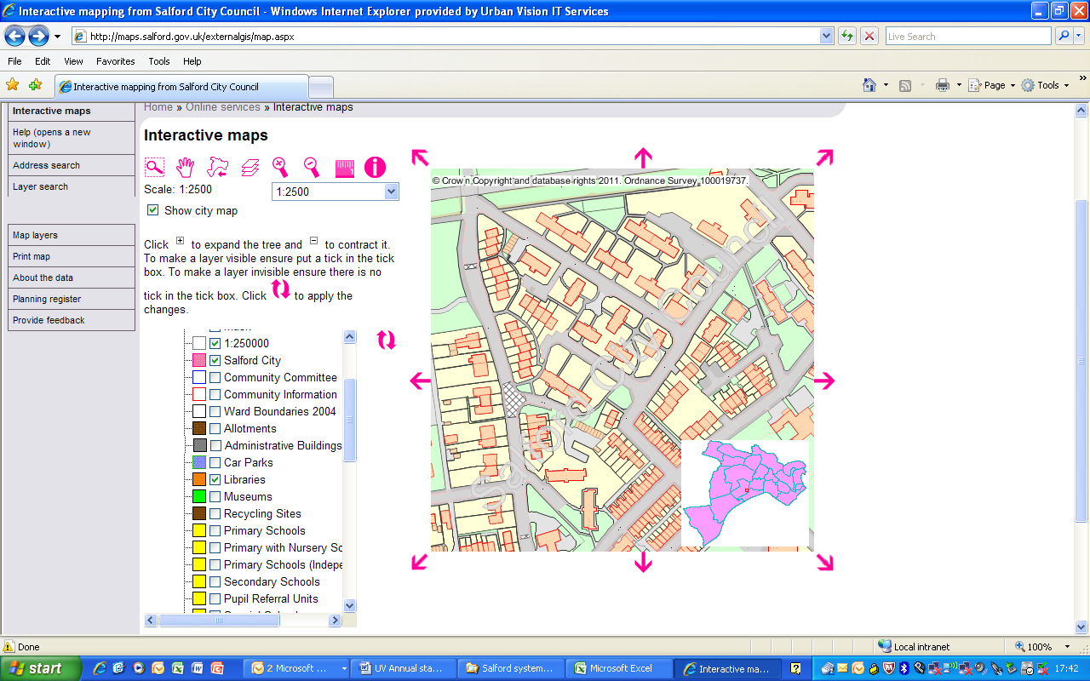

* 1. **Urban Vision currently supports GIS for the following customers;**
* City West Housing Trust
* Salford City Council
* Salix Homes
* Urban Vision Partnership Limited
* Northgate Public Services
  1. **The technical support provided includes;**
* Maintenance of hardware (file servers) – daily house-keeping, updates, backups, restores, log-checks etc…
* Configuration of hardware (file servers and workstations)
* Setting up shares
* Setting up and managing local security groups
* Maintaining records of users
* Managing user space
* Setting up PDA devices for mobile working
* Installation of software
* Upgrade of software
* Configuration of software
* Providing technical information to aid the purchase and upgrade of hardware and software.
  1. **Training**

The It team provide a number of different levels of training for its clients and the team is currently working with Salix Homes to develop an information store to graphically capture information relating to their housing responsibilities. The training provided by the IT team includes the following;

* Creation and editing of basic layers
* Creation of print templates
* The use of OS MasterMap products
  1. **GIS software support**

The Urban Vision IT team provide software support for the following packages;

* AutoCAD
* AutoCAD Map 3D
* ESRI ArcGIS Desktop
* ESRI ArcGIS Server
* GGP Systems
* MapInfo Professional
* Various design packages
* SearchNET (Land Charges)

# AutoCAD

* 1. **AutoCAD: An Overview**

AutoCAD is a 2D and 3D computer-aided drafting software application used in architecture, construction and manufacturing to assist in the preparation of blueprints and other engineering plans. This AutoCAD software is used extensively within Urban Vision by Architects, Surveyors, Planners, Road Safety teams, Engineers and structural professionals. In all 120 members of staff within Urban Vision have access to this software.

From an Urban Vision IT support role there are a number of factors to consider in supporting this software which can be challenging, the important point is that our staff rely on this technology to carry out their projects on behalf of Salford, therefore it is imperative that they are using the correct versions of the software, on machines that are capable of supporting the software and that the data is held in a secure environment.

* 1. **Management of licenses**

Twelve months ago Urban Vision managed their own licence pool for the AutoCAD software, this meant that 30 licenses were in circulation that could be used by all the staff. From experience it was found that this ratio was sufficient for our needs, however a number of stand a lone licences were in circulation for staff who used AutoCAD on a regular basis.

The challenge from an IT perspective was to ensure that all the different versions of AutoCAD were compatible and that all staff had access to a license as and when required. In addition it was important to set standards across Urban Vision to ensure that drawings could be passed from one team to another without any difficulties arising. All licenses were subject to an annual fee and this increased with later versions of the software.

During 2010 Capita developed a unique arrangement with the software provider, instead of paying thousands of pounds for an upgrade, all Capita staff including all seconded staff based in Urban Vision were granted access to a common pool of licenses, this in reality has meant that Urban Vision staff now have access to a pool of 500 licenses.

The benefit of this arrangement is that a license will always be available and that the latest version of the software will be available at all times. A payment mechanism has been arranged where Urban Vision only pay for the time they use on the software, this equated to £0.25p per hour. This arrangement has generated a great deal of savings while providing greater access to the software.

The role of the IT section is to ensure that these licenses are available to all staff within Urban Vision and to ensure that the latest versions are installed on the license server.

* 1. **Management of data**

The role of the IT section is to ensure that all the drawings and their associated photographs are stored in a safe environment. A dedicated server has been provided to store these documents and a robust backup regime is in place. This store has been tested in recent months when a great deal of data was inadvertently deleted, however within a matter of hours all the data was restored.

* 1. **Hardware**

It is the role of the IT team within Urban Vision to provide the specification for new computers, one of the considerations in performing this role is the likely requirement of new software. It is important when investing in a computer refresh programme that a certain degree of future proofing is built into the computers specification. The replacement computer needs to be able to support existing AutoCAD software but there will be the requirement to undertake a degree of research to determine the level or capacity that may be required in the future.

* 1. **New build/Ghosting**

The IT team have the responsibility for preparing new computers for Urban Vision staff and this will involve loading the relevant software onto the Computer. Different teams within Urban Vision will have different requirements, therefore, “images”, of the disk have been prepared in advance to enable a standardised computer, for each business within Urban Vision, to be built. It may be that the Engineers will require the AutoCAD software in a slightly different format to that of an Architect and the ghosting technology delivers a consistency of approach.

* 1. **AutoCAD user group**

An AutoCAD user group exists to develop common practices across Urban Vision and share ideas. Subjects discussed at the group include a consistent way of managing the different layers within AutoCAD, which helps when drawings are shared across disciplines.

Training requirements are also discussed at the group and a number of Architects have just completed a REVIT AutoCAD course to enable them to have the skills to use this new version of the software.

# ESRI – A GIS software package used by Salford

* 1. **Background**

ESRI is a software company providing Geographic Information System (GIS) software.

The software is used to capture, store and manage data that can be represented spatially on a map.

The ESRI product used by Salford City Council, Urban Vision Partnership Limited and Salix Homes is ArcGIS.

* ArcGIS is a suite of windows based software running on computer workstations and file servers:
* ArcView is the basic module used to create, edit and view data on a map.
* ArcEdit has more advanced features and extra functionality.
* ArcSDE is the file server based software that allows users to connect to spatial data held in a database. The Salford City Council data is held in an Oracle database.

ESRI is used for managing asset and planning data. This includes managing housing stock and the UDP (Unitary Development Plan). It also displays highway information, with regard to road status and classifications, road closures, the positioning of street lighting columns, identifying accident black spots, and monitoring accident claims data.

* 1. **How is the software accessed?**

Access to most of the workstation software is controlled by a Licence Manager. This offers increased flexibility by allowing the software to be installed on any number of (suitable) workstations but only allowing access to a fixed number of users matching the number of licences held.

* 1. **Where is this software used?**

The ArcGIS software is used across a wide range of Directorates and sections within Salford City Council:

|  |  |
| --- | --- |
| **Salford City Council:**  Burglary Reduction  Design and Heritage  Economic Development  Environment  Info and Research  LLPG  Local Plans  Planning Regeneration  Private Sector Housing  Salix Homes  Strategic Planning  Strategy and Partnership  Transportation  Urban Renewal | **Urban Vision:**  Engineering Design  Highway Information  Network Management  Traffic and Transportation |

* 1. **Urban Vision support**

All users have access to core (Ordnance Survey) data held in the spatial database. This includes the Master Map data that forms the base data to all maps, Raster data sets of different scales and dates going back to 1887 and Digital imagery (aerial photographs) from various years going back to the 1940’s.

Individual set of users also have access to their own unique data held in the spatial database.

Urban Vision I.T. is responsible for the installation, update and configuration of software on workstations at Salford City Council, Salix Homes and Urban Vision. It is also responsible for the maintenance and management of (most of) the file servers used for GIS work, management of GIS users and the updating of the core (Ordnance Survey) data.

Urban Vision I.T. provides operational and strategic technical support to GIS users and managers. Urban Vision I.T also maintains contact with ESRI Technical Support to help resolve issues, problems and faults and ensure that the system is operational at all times.

Urban Vision I.T. is working with Salford ICT section on the Enterprise II software project. This involves working towards the goal of delivering software to users and / or workstations on demand, to realise the potential of agile working within Salford City Council.

# GGP - What is it and what are our responsibilities

* 1. GGP is a software company providing Geographic Information System (GIS) software, GGP stands for Geo Graphic Processing. It is a windows based application that runs from a central server and is used by a user from their workstations.
  2. The software is used to capture, store and manage data that can be represented spatially on a map. The GGP product is used by Salford City Council & Urban Vision Partnership Limited.
  3. GGP software is deployed across a wide range of sections within the Council and Urban Vision:
* Salford City Council:

Emergency Planning, LLPG, Planning Regeneration, Strategic Planning.

* Urban Vision:

Engineering Design, Highway Information, Network Management, Traffic and Transportation, and Property Services.

* 1. All users have access to core (Ordnance Survey) data held in the spatial database. This includes the Master Map data that forms the base data to all maps, Raster data sets of different scales and dates going back to 1887 and Digital imagery (aerial photographs) from various years going back to the 1940’s.

Individual set of users also have access to their own unique data held in the spatial database.

* 1. Urban Vision I.T. is responsible for the installation, update and configuration of software on workstations in Salford City Council and Urban Vision. It is also responsible for the maintenance and management of (most of) the file servers used for GIS work, management of GIS users and the updating of the core (Ordnance Survey) data.
  2. Urban Vision I.T. provides operational and strategic technical support to GIS users and managers. Urban Vision I.T also maintains contact with GGP Technical Support to help resolve issues, problems and faults and ensure that the system is operational at all times.

GGP Main Application showing a standard overview of the City of Salford and its ward boundaries.

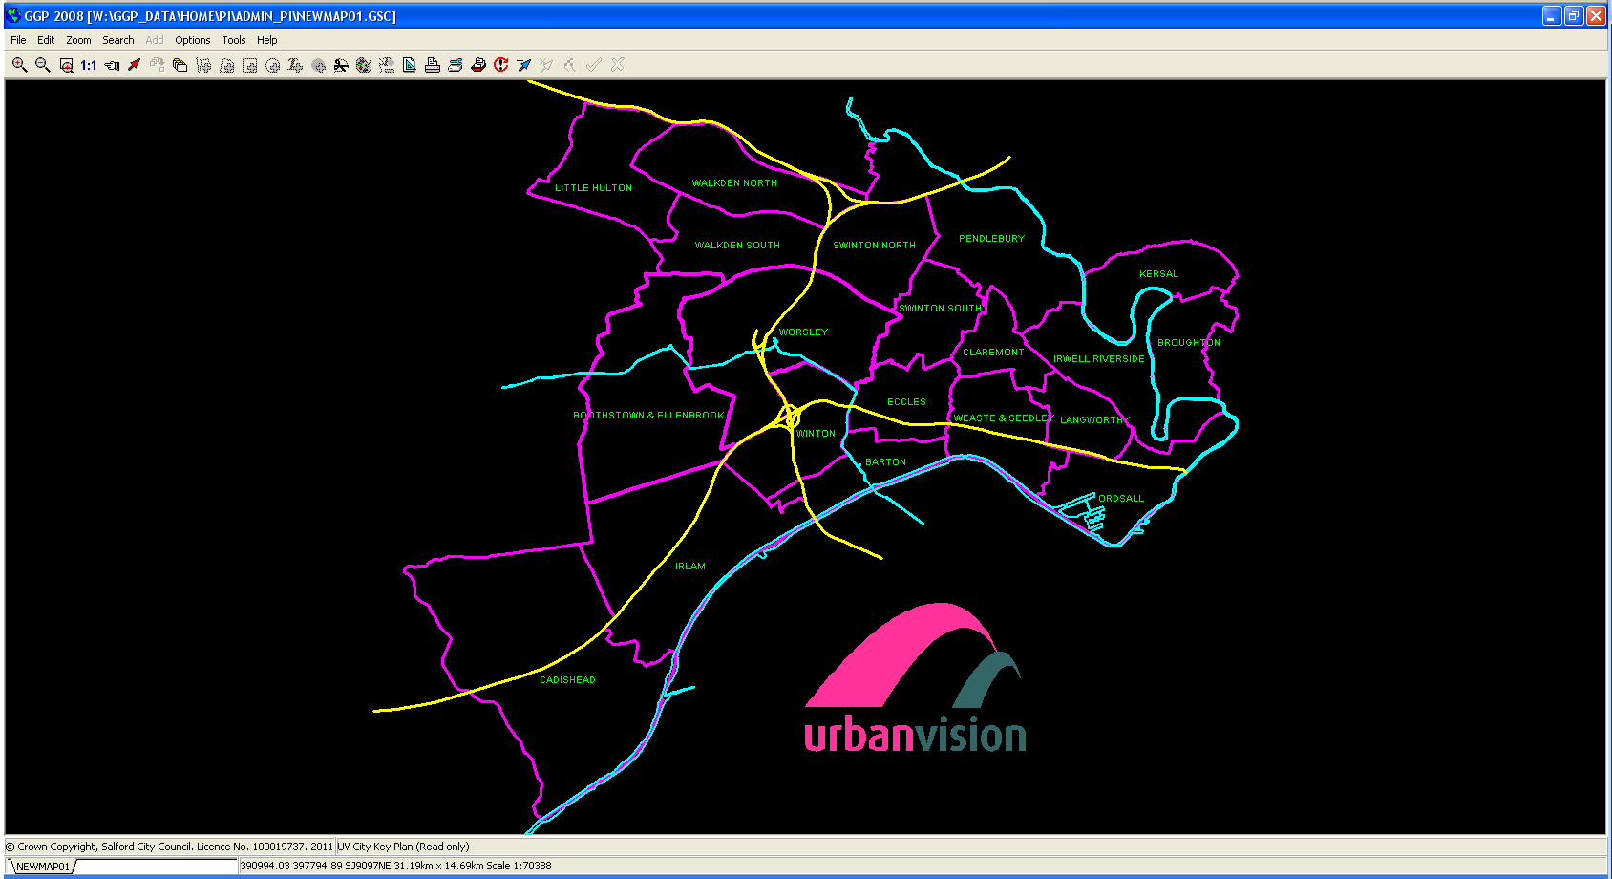

GGP Main Application showing a standard overview of the City of Salford and its ward boundaries.

In this instance, overlays have been switched on to show Salford Assets, which are colour coded to the individual directorates.

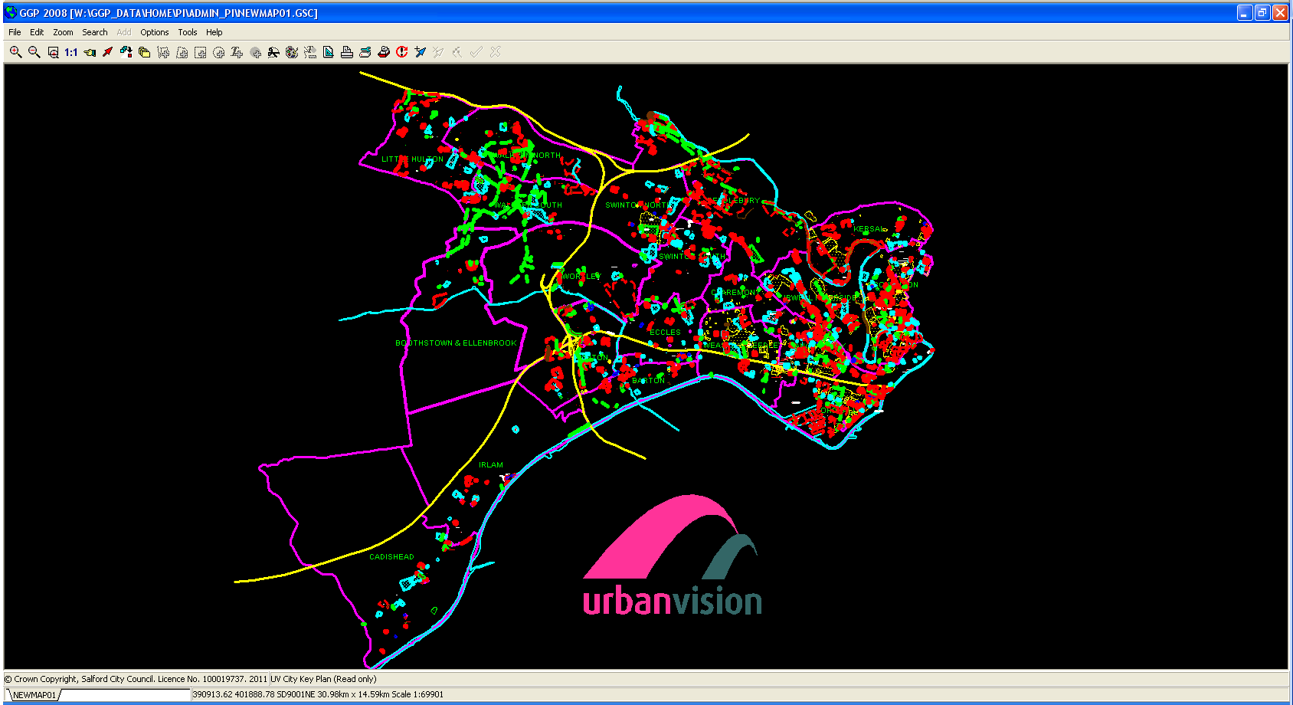

GGP stores data in what is known as Overlays. These overlays you could consider as being separate pieces of tracing paper with each piece of paper holding information for each directorate. As the overlays are switched on, its like multiple sheets of tracing paper are placed on top of each other, showing the bigger picture of all the combined assets.

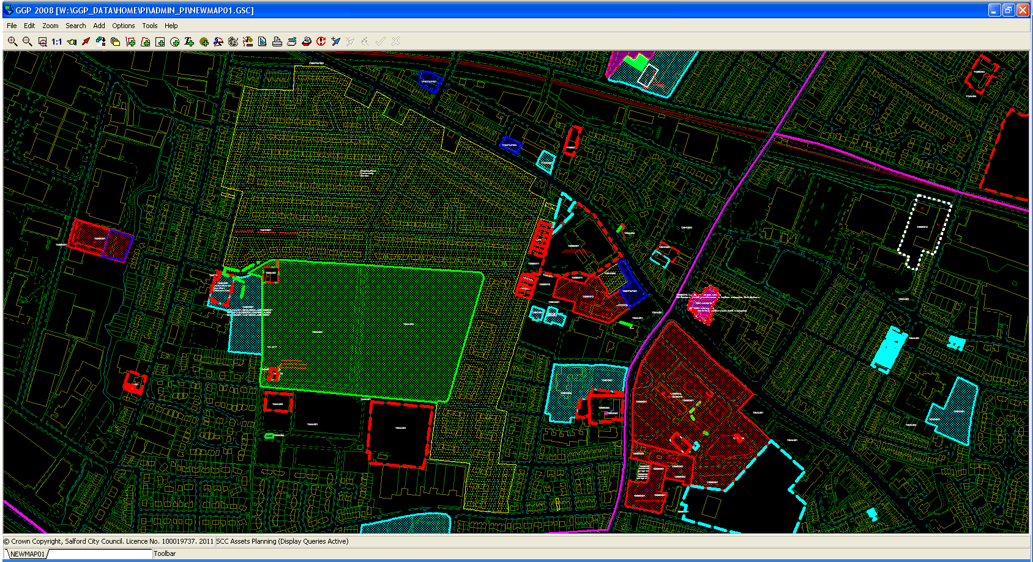

GGP is a powerful application that allows designated users to manage data relating to the councils assets.

The colour coding is used to distinguish the ownership of the individual assets between the council directorates.

This combined with linking to the Legacy Asset Register allows detailed information to be easily available about each council asset, this being Land and Buildings Assets.

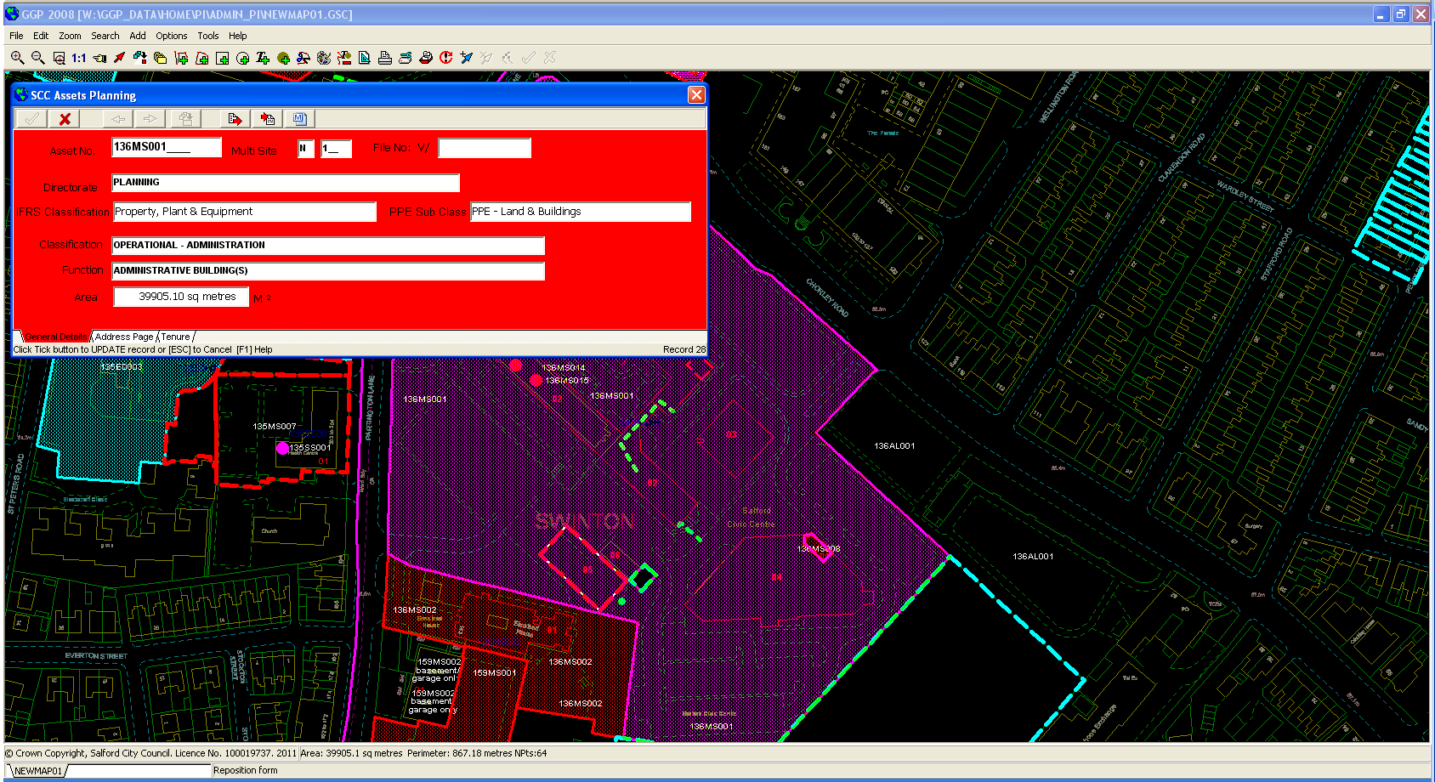

From this screen shot, we can see that an overlay item has been clicked on (the purple area) and this brings up a POP UP box showing information about the individual asset.

# Planning

* 1. The Urban Vision planning and building control officers support the Council by determining and enforcing planning decisions. The planners within Urban Vision have a proven track record of processing planning applications, on behalf of the Authority, within the Governments national performance targets of 8 weeks for minor planning applications and 13 weeks for major planning applications.
  2. To support the planning process the Urban Vision IT team work closely with the planning team and the software provider IDOX to ensure that the planning computer system is continuingly up and running and effective, any down time or disruption would effects the Council planning performance.
  3. The planning system links in with the Council’s public access system, public access enables the general public to view planning applications and maps on line and it is critical that this link it maintained to enable a proper and thorough consultation process to take place, failure of public access will have a severe impact on the teams ability to consult and process planning applications.
  4. UNIFORM Planning consists of ten modules; each dedicated to a separate area of planning activity and designed to meet the exact requirements of that activity. All ten modules work together seamlessly to enhance the management of the entire planning process.
  5. The component parts of UNIFORM are as follows:
* Development Control-for more efficient application processing.
* Appeals — for meeting the complex legal requirements of any appeals procedure.
* Enforcements — for control of complaints information, from investigations through to formal notices and the issuing of compliance requirements.
* Local Development Framework (LDF) — for structured support through all stages of LDF production.
* Development Monitoring — for facilitating and ensuring compliance with planning permission conditions.
* Listed Buildings — for accurate recording of listed-building details and monitoring of actions taken on listed properties.
* Tree Preservation Orders — for better management of information about protected trees.
* Highways — for simplifying the processes of monitoring, maintaining and planning the construction of local roads.
* Development Planning — for keeping planning applications up to date with additional detail, and recording housing gains and losses.
* High Hedges — for effective management of the legislative process, complaint through to decision and possible appeal.
  1. The Urban Vision IT team work hand in hand with the Salford IT team to ensure that scanned planning documents captured in the Councils document management system, Eclipse, are available within the public access system.
  2. Regular meetings take place between the Urban Vision IT team and the Assistant Director for Corporate ICT to ensure that all parties understand their responsibilities in ensuring that this critical Council system is maintained. A recent development has been the creation of a system manual which details the critical paths and linkages within the planning system, it needs to be understood that the planning system is driven by the UNIFORM system but does rely on eclipse and public access for capturing and then publishing the planning applications.
  3. All planning applications are scanned in at Emerson House and the Urban Vision IT team work closely with the printing staff to ensure that the network and scanning stations are working at all times, any failure in this performance will affect the planning process.
  4. The Urban Vision IT team are responsible for all the UNIFORM and public access upgrades. To ensure that there is no disruption to service a test UNIFORM database is run concurrently with the live database to ensure that the migration to a high version goes as planned. Once this upgrade has been tested thoroughly the planning system is switched to the new version of the software.
  5. The Uniform System comprises of 3 servers at Emerson House and 1 virtual server used to access the Planning website. One server holds the Oracle software; this includes databases for the live, test, train and trial systems and the ‘Compuserve’ software licence manager. Another server holds the files required by the client application that runs on users PCs, for the day to day processing by the teams in Building Control, Planning and Local Land and Property Gazetteer LLPG. The final server of the three pulls out the spatial information and the data for request made by the public access site.
  6. The web server is held in the Demilitarised Zone at the Civic Centre and allows the public to search, view and make comments about all Planning Applications within in Salford, whilst also protecting the servers from intrusion and unauthorised access.

* 1. For the Client software there is a concurrent user licence of 50 seats, the application holds the user details of staff both past and present that have had access and for the purpose of preserving the names of the Planning Officers assigned to past achieved planning applications up to 1993. Access to the database can only be made internally through the software and via a secure Username and Password (which is changed once a user leaves).
  2. In summary, the Urban Vision IT team have a crucial role in supporting the planning team and ultimately Salford City Council’s planning performance.
  3. An example of a public access search:

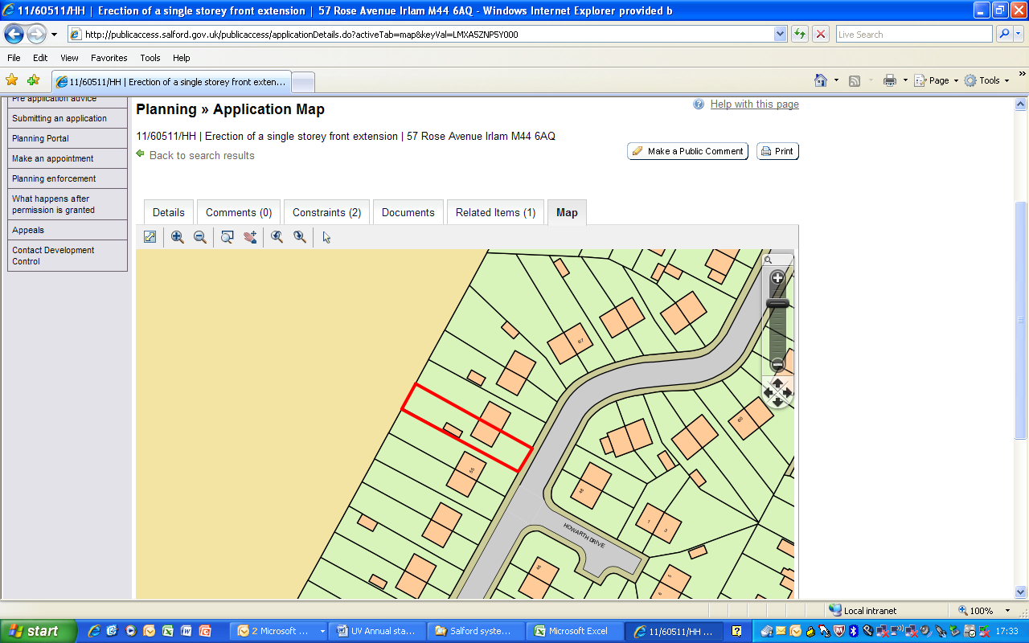

# Highway records (CONFIRM system)

* 1. The Confirm Highway Management System is used for a number of functions within Network Management and Highway Services. The Highway Inspectors use handheld devices to record details of carriageway, footway and kerb defects. When Highway Services have repaired the defects, they update the system accordingly. Confirm also receives data from the council’s Customer Relationship Management system. This interface means that the Contact Centre staff at Orbit House are able to track issues as they are logged, assigned and resolved, and can respond in real time, to queries from the public.
  2. The UK Pavement Management module enables staff to analyse condition data, and to produce the required national and local performance indicators.
  3. The Street Works module is used to manage works carried out by utility companies. It automates the issuing and receipt of essential notifications in order to determine when works are to be started, their progression, and completion. These details can also be viewed as a layer on the council’s intranet and internet based corporate mapping system.
  4. Urban Vision IT Services provide administrative support and maintenance on Confirm. This includes:
* Installation and configuration of the software on workstations and servers.
* Installation and configuration of the mobile software on PDAs.
* Creating users and groups with the relevant security permissions.
* Creation of customised reports.
  1. There are now three servers with elements of Confirm installed on them. One is the Oracle server, which holds the databases for both the live and test systems along with the software licence manager. Another server runs Confirm System Agent, which is used as part of the process for transferring street works notices electronically. There is a web server that receives notices sent under the EToN4 and EToN5 standards, as well as an FTP server that currently still receives EToN3 notices.

* 1. Since the formation of Urban Vision, the number of staff who access the system has expanded beyond the Network Management and Highway Services sections. Two users from the Business Support and Information team run reports when they receive Freedom of Information requests. The reports that they run, which have been customised by Urban Vision IT Services, provide details of when highway inspections were carried out and any defects that were recorded; calls that have been received from the public either by the Customer Contact centre at Orbit House or made directly to Highway Services; and when repairs to defects were carried out. The software is installed on one PC, which both staff access using their own user names and passwords.
  2. Staff from the Audit and Risk Management section also generate reports in order to provide data for the defence of accident claims. There are currently five machines in the section with Confirm installed.
  3. Recently, seven staff in the Customer Contact Centre have been granted access to the system in order to view enquiry details from the public, including which member of the Network Management or Highway Services staff has been assigned to the call, and the progress of the job. The software is installed on one PC, which the staff access using their own user names and passwords.
  4. The inspectors use PDA (portable hand helds) devices to record the condition of carriageways and footways, and to record details of any defects that they discover. We are in the process of installing and configuring mapping on to the PDAs. The GPS module within the software will show where the inspector is located. When they tap on the map to create a job, the eastings and northings will be recorded within it. This will save the inspectors time when they return to the office to upload their jobs into the main Confirm system, because they will not need to manually enter the details.
  5. There is an annual upgrade applied to the system, as well as any required maintenance updates, such as those to the Rules and Parameters databases, which are part of the Confirm UK Pavement Management System. Version 9.00c.AM is currently in use. The upgrade to version 10 will take place later in the year and will be carried out by the Urban Vision IT team.
  6. Urban Vision IT Services are working with Salford City Council’s ICT section to implement the installation of Confirm as part of the Enterprise II project. This will enable the software to be automatically rolled out to any machines owned by SCC that require it, rather than having to manually install the necessary components manually. The process will first be tested on virtual PCs before it is made available to users.

# Property records

* 1. The City Council has a substantial portfolio of land and property interests (excluding Council dwellings) with a book value of approximately £420m. The Asset Management Plan sets out the ways in which this property portfolio needs to support the objectives and service requirements of the City Council to deliver better outcomes for the people of Salford.
  2. A fundamental component of asset management activity is the need for accurate and up to date property data. The Council’s property terrier **records** all of the core data, including a CIPFA asset categorisation and a description of the function of the property.
  3. Urban Vision maintains these records on behalf of the Council. The current system comprises of multiple databases that were developed by the Urban Vision IT team in a database language called Dataease and are still managed by the in house IT team.
  4. The work areas that the databases cover include: -
* Property management
* Asset management
* Acquisition & Disposals
* Right to Buy valuations
  1. This very broadly covers a large percentage of the work undertaken by Property Services on behalf of Salford City Council and Greater Manchester Police Authority, and as such the systems are a critical part of the day-to-day operation of the Property team.
  2. Urban Visions IT responsibilities and the work areas that the Databases cover include: -

**Salford Assets & Periodic Rents System**

* Asset Register
* Multi-Occupancy Records.
* Property Management
* Managed Estate Terrier Records
* Management of Transactions for Acquisitions, Disposals, Revaluations
* Category Transfers between CIPFA Categories (Operational, Non-Operational & Community Asset States)., IFRS Categories ( Assets Held for Sale, Investment Property, Property Plant & Equipment Assets).
* The Management of the 5 yearly revaluation programme of assets.
* Payable and Receivable Rents – Scc Managed Estate
* Periodic Rents which covers the raising of Invoices for the rental of Salford’s Commercial Portfolio.

**Right to Buy System ( for Salford ( Salix ) and City West )**

* Right to Buy System handles Salix and City West RTB Valuations and Tenant Purchases under the Right to Buy Scheme.

**GM Police Asset Register, Terrier and Managed Estate Records**

* This covers the similar aspects as that of the Salford System.
* Payable Rent Records

**City West Asset Register and Managed Estate Records**

* Which covers the similar aspects as that of the Salford System.
* Payable and Receivable Rent Records, including raising of invoices for the commercial portfolio.

**Salford City Council Land & Property Instruction Sheets System**

* Acquisitions, Disposals and Management Cases.

**GM Police Land & Property Instruction Sheets System**

* Acquisitions, Disposals and Management Cases.
  1. The Salford Asset Register, GMP Asset Register, City West Asset Registers all have links into Urban Vision’s off the shelf GIS product called GGP.
  2. The GIS System which is a Geographical Information System holds overlays of data in graphical format to aid in the management of these assets. In addition to Ordnance Survey data which is present within the GIS product and updated regularly, it provides a powerful management overview of the Councils portfolio.

# Customer complaints

* 1. **Customer complaints**

This section sets out a summary of the complaints received by Urban Vision Partnership Ltd in the year (April - March 2011),

Urban Vision follows Salford City Council’s Corporate Complaints Procedure with respect to handling complaints regarding services provided by Urban Vision on behalf of the City Council.

There are four stages to the Urban Vision Complaints Procedure:

▪ Level 1: Informal Complaint and/or Request for Service

▪ Level 2: Formal Complaint

▪ Level 3: Panel Review

▪ Level 4: Local Government Ombudsman

All complaints are logged on the Councils CRM system, Citizen from instigation through to the complaints resolution. Urban Vision is monitored on their performance and the following key performance indicators are used on a monthly basis.

* 1. **Percentage (%) of complaints acknowledged within 3 working days of receipt**

|  |  |  |  |  |
| --- | --- | --- | --- | --- |
| **Month** | **<3 days** | **Received** | **Cumulative %** | **Target %** |
| Apr-10 | 4 | 4 | 100.0% | 95% |
| May-10 | 11 | 11 | 100.0% | 95% |
| Jun-10 | 10 | 10 | 100.0% | 95% |
| Jul-10 | 6 | 6 | 100.0% | 95% |
| Aug-10 | 14 | 15 | 97.8% | 95% |
| Sep-10 | 29 | 30 | 97.4% | 95% |
| Oct-10 | 13 | 13 | 97.8% | 95% |
| Nov-10 | 12 | 12 | 98.0% | 95% |
| Dec-10 | 8 | 8 | 98.2% | 95% |
| Jan-11 | 11 | 12 | 97.5% | 95% |
| Feb-11 | 17 | 17 | 97.8% | 95% |
| Mar-11 | 81 | 81 | 98.6% | 95% |
|  |  |  |  |  |
| **Total** | **216** | **219** | 98.6% | **95%** |

* 1. **Percentage (%) of complaints responded to within 10 working days of receipt**

|  |  |  |  |  |
| --- | --- | --- | --- | --- |
| **Month** | **<10 days** | **Received** | **Cumulative %** | **Target %** |
| Apr-10 | 4 | 4 | 100.0% | 95% |
| May-10 | 11 | 11 | 100.0% | 95% |
| Jun-10 | 10 | 10 | 100.0% | 95% |
| Jul-10 | 5 | 6 | 96.8% | 95% |
| Aug-10 | 13 | 15 | 93.5% | 95% |
| Sep-10 | 29 | 30 | 94.7% | 95% |
| Oct-10 | 13 | 13 | 95.5% | 95% |
| Nov-10 | 11 | 12 | 95.0% | 95% |
| Dec-10 | 7 | 8 | 94.5% | 95% |
| Jan-11 | 12 | 12 | 95.0% | 95% |
| Feb-11 | 17 | 17 | 95.7% | 95% |
| Mar-11 | 80 | 81 | 96.8% | 95% |
|  |  |  |  |  |
| **Total** | **202** | **219** | **92.23%** | **95%** |

# Freedom of information

* 1. **What is it Freedom of Information?**

The Freedom of Information Act deals with access to official information. In addition there are also regulations which provide access to environmental information. These are known as the Environmental Information Regulations.

The Freedom of Information Act applies to most public authorities. It also applies to companies which are wholly owned by public authorities.

The Act gives the public a general right of access to information held by public authorities. The Act also requires public authorities to have an approved publication scheme, which is a means of providing access to information which an authority proactively publishes.

When responding to requests, there are procedural requirements set out in the Act which an authority must follow. There are also valid reasons for withholding information, which are known as exemptions from the right to know.

* 1. **The Environmental Information Regulations**

The environmental information regulations allow the public to request environmental information from public authorities.

The information covered can be divided into the following six main areas:

* The state of the elements of the environment, such as air, water, soil, land, fauna (including human beings)
* Emissions and discharges, noise, energy, radiation, waste and other such substances.
* Measures and activities such as policies, plans, and agreements affecting or likely to affect the state of the elements of the environment.
* Reports, cost-benefit and economic analyses.
* The state of human health and safety, contamination of the food chain.
* Cultural sites and built structures (to the extent they may be affected by the state of the elements of the environment)

If the Authority receives a request from a member of the public for environmental information on any of the areas mentioned above, they are legally obliged to provide it, usually within 20 working days. There are a number of exceptions to this rule and if an Authority withholds the information, they must explain why and give the public interest reasons for refusal.

* 1. **What is the impact on Urban Vision?**

As you are aware Urban Vision delivers and number of services on behalf of Salford City Council and by virtue of this relationship the company is bound by the freedom of information legislation (FOI). The Council has the responsibility for replying to FOI requests within 20 working days and the Council’s performance is monitored by the office of the Information Commissioner.

* Alan Westwood, the Director of Corporate Services has insisted that responses are provided to him within 15 working days to enable the Council to meet these deadlines.
* Urban Vision have been asked to provided an initial response to the FOI team by day 4, the FOI team will then draft a reply and send the draft reply to the relevant Urban Vision Assistant Director for approval.
* The Assistant director is requested to reply back to the FOI team with comments by day 7. If further time is required to collate the information then the FOI team will request an extension of time to deal with the request.
* If its is estimated that the request is going to take more than 18 hours the FOI team will write back to the person requesting the information to ask them to be more specific in their request or to inform them that a charge would be levied for officer time in preparing the information.
  1. **Salford City Council – Total number of requests received (2005 to 2010)**

## 

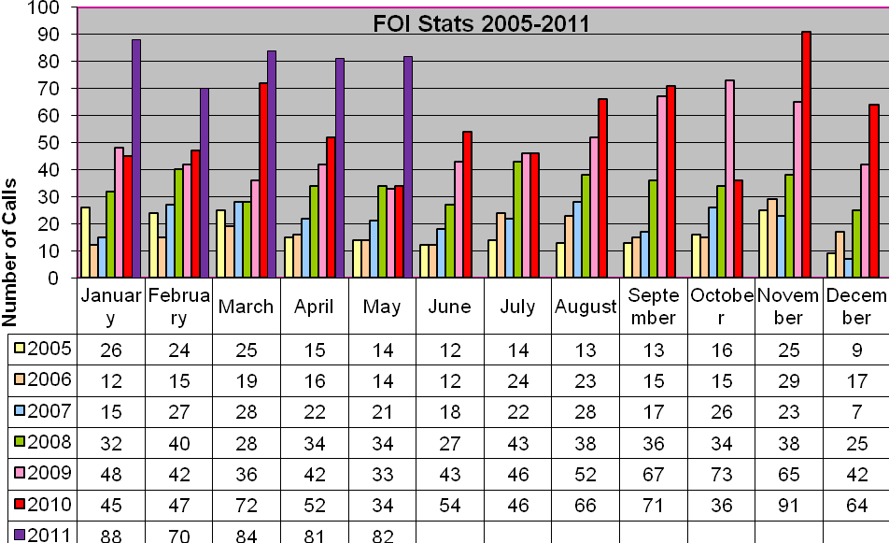

* 1. **Total Number of requests received by UV in the year**

|  |  |  |  |  |  |
| --- | --- | --- | --- | --- | --- |
| Total Number of requests: | QTR 1 | QTR 2 | QTR 3 | QTR 4 | Total |
| Freedom of information requests | 27 | 21 | 20 | 26 | 94 |
| Environmental requests | 5 | 0 | 0 | 2 | 7 |
| **Total requests in the period.** | **32** | **21** | **20** | **28** | **101** |

|  |  |  |  |  |  |
| --- | --- | --- | --- | --- | --- |
| **Total for the Council in period** | **164** | **140** | **183** | **191** | **678** |

# Investment

* 1. **Licenses managed by Urban Vision-appendix 1**

Appendix 1 provides a detailed audit of the current software managed by Urban Vision, it needs to be recognised that not all of the software listed within the appendix relate to Salford City Council. For reference a summary of the main licenses is contained in the table below.

|  |  |  |  |  |  |  |
| --- | --- | --- | --- | --- | --- | --- |
|  | Notes | Product | Responsibility | SCC  Number | UV  Number | Total |
| 1 | Pitney Bowes Business Insight -  'Confirm' | Confirm | SCC | 39 | 0 | 39 |
| 2 | Standalone licenses | AutoCAD-LT | UV | 0 | 93 | 93 |
| 3 | Capita have pooled all AutoCAD licenses, therefore UV have access to unlimited Full AutoCAD on a pay as you go arrangement once the existing license pool has been exhausted. | AutoCAD-Full | UV | 0 | 23 | 23 |
| 4 | Capita have pooled all REVIT licenses, therefore UV have access to unlimited AutoCAD REVIT on a pay as you go arrangement once the existing license pool has been exhausted. | AutoCAD-Revit | UV | 0 | 5 | 5 |
| 5 | Standalone licenses | AutoCAD-ADT | UV | 0 | 5 | 5 |
| 6 | Planning system | Uniform | SCC | 50 | 0 | 50 |
| 7 | GIS | GGP | JOINT | 4 | 23 | 27 |
| 8 | GIS | Arcview | JOINT | 5 | 5 | 10 |
| 9 | GIS | ArcEdit | JOINT | 10 | 5 | 15 |

* 1. **Urban Vision Partnership Ltd-investment in ICT.**

Urban Vision Partnership Ltd was created in February 2005 and since this date there has been an investment of £791,849 in IT. The following bullet points provide an illustration of the type of IT investment that has been delivered.

* 1. **Annual PC refresh programme**

Each year a third of all desktops and laptops within Urban Vision are considered for replacement as part of a rolling programme. The 2010 programme includes the replacement of 56 computers totalling £59,000. This investment is capitalised and recharged to business units over a three year period.

The table below illustrates the PC refresh programme for 2010.

|  |  |  |  |  |
| --- | --- | --- | --- | --- |
| **2010** | **High End PC's** | **Standard PC's** | **Laptops** | **Total £** |
| ZUVI | 14 | 8 | 1 | 28,139 |
| ZUVB | 17 | 1 |  | 17,082 |
| ZUVA | 7 | 1 |  | 7,179 |
| ZUVX |  | 1 | 1 | 1,600 |
| ZUVE | 2 | 3 |  | 5,075 |
|  |  |  |  |  |
| **Totals** | **40** | **14** | **2** | **£59,075.00** |

* 1. **AutoCAD licenses**

The design teams within Urban Vision rely heavily on the Autodesk suite of products including ADT, Revit, LT and AutoCAD. Urban Vision have traditionally held a number of these licenses however Capita have introduced a license pool strategy that enables Urban Vision to tap into an almost limitless number of up to date licenses on a pay as you go basis. Urban Vision’s license pools are ring fenced; however our staff can now access additional licenses if required. This strategy has enabled the design teams to work with the latest releases of the application to deliver a number of BSF projects.

* 1. **GGP licenses**

Urban Vision have twenty three GGP licenses. GGP is software that enables staff to work with spatial information, maps in a GIS format. The primary use for this software is to hold map information for highway adoptions and land and property information on behalf of the council.

* 1. **Mobile working**

Urban Vision has recently invested in new PDA equipment to replace the out of date XDA’s provided within the O2 mobile phone contract. Since migrating to Vodafone in November 2009, Urban Vision has purchased 15 HTC touch Pro 2’s and 105 new mobile phones.

* 1. **Software**

Urban Vision is constantly reviewing its software requirements and investing in new software such as CS4 creative design.

# Efficiencies and improvement

* 1. Following the investment from Capita, Urban Vision has been able to make improvements and efficiencies across the whole IT spectrum including;
  2. New Server room dedicated for the placement of UV Servers in tailor-made server cabinets :-
  + Access controlled room via Cotag Badge Reader, restricted to IT Personnel only.
  + Dedicated Uninterruptable Power Supplies for each cabinet.
  + The power supplied to the cabinets was also a dedicated 3 phase supply from the main building.
  + Circuit Breaker Box located in Server Room.
  + Each phase power would supply to 2 cabinets each. With a total of 6 cabinets.
  + Fully air conditioned with 2 dedicated air cooler units, providing resilience and fail-over
  + Proper IT Installation Workbenches within server room, to allow for pc equipment builds, upgrades and repairs
  1. Communications cabinets are provided on each floor that provide network connectivity via at least 2 number 48 port switches for all network sockets on each floor, allowing for PC connectivity as well as telephone moves.
  2. The switches in the floor communications cabinet also supply power to the new Cisco IP Phone’s that are present on all desks. Giving the benefits of IP Telephony and further utilising the existing network infrastructure and linking to Salford’s Cisco Call Manager system
  3. The added benefit of 2 Cisco Wireless Access Points per floor, allowing laptop users the freedom of wireless networking, both at Emerson House and the depot.
  4. Filtered Mains sockets supplying power to each set of 6 desks.
  5. Dedicated Meeting rooms on the 7th floor, with network connectivity both wireless and via wall sockets.
  6. 2 large screen monitors for use in meeting rooms for presentations, one of which has video conferencing availability.
  7. The implementation of Print Logging system on the print servers which control the photocopiers on each floor, thereby logging all printing jobs for the accountability/financial usage calculations.
  8. A Number of new consolidation servers were purchased in 2007, to alleviate space issues / out of warranty servers. These new servers allowed the movement of data from a number of older servers, thus allowing the decommissioning of many older servers that were out of support and warranty and represented risks in both reliability and security
  9. Implementation of Robotic Storage Devices on these 2 servers, to allow the automated backup of large amounts of data.
  10. The implementation of a full backup strategy allowing daily tape rotation and Weekly/Monthly off-site storage (located at Burrows House).
  11. The continuing modernisation of the shared user/group areas, bringing together centralised storage capability and better group data sharing.
  12. Greater implementation / Usage of PDA’s (Pocket Digital Assistants/mobile phones) within Urban Vision. Thus enabling key people to have email on the move. These connect to Salford Email System via data-enabling of the phone simm cards.
  13. With the continuing trend of buying additional IT infrastructure for Urban Vision, another 2 consolidation servers were purchased in 2011, allowing the migration of data/systems from a number of other older servers, providing increased performance and reliability and resilience as well as additional storage. - (still in progress)
  14. There are now a total of 23 servers located in Urban Vision ( 17 windows servers & 6 linux based servers). This is up from 7 windows servers when based at the Civic centre.
  15. In July 2010, a major change was made to the network infrastructure at Urban Vision- Emerson House and the Swinton Hall Rd Depot, this involved making them into an MPLS (MultiProtocolLayeredSwitching) network configuration. This allowed us to implement our own Network Addressing for Emerson House and the Depot. Giving us greater reliability, more control over our own network and access to our network switches.
  16. We also now have a dedicated Firewall (with redundant, hot-swap backup) which provides security between UV – SCC , UV – CAPITA and UV – External (For our webhosting servers).
  17. We have a a number Linux Based servers, one of which is a webserver which now hosts our GMGU sites (gmwastedpd & gmmineralsplan) on our servers instead of Manchester University Servers. This gives us greater flexibility and resilience in supporting these sites for our Geological Section, Urban Vision IT also maintain these sites.
  18. We also have a windows-based web-server, which hosts a number of externally facing websites which have been designed in-house, for the benefit of Urban Vision and a number of external clients.
  19. Many improvements have been made on the network side (with the use of an OU (Organisational Unit), Subtree of Salford’s COS Domain), which allows Urban Vision to execute login scripts on our PC’s when logging into the Salford Domain. Software rollouts can be automated, as well as automated scripts for fixes that can be centrally maintained. We also have an inventory management system (designed in-house) which allows us to maintain/audit/support our PC’s. This is both internal and external - for home workers (via VPN across Salford’s Network).
  20. Adoption of Capita’s ‘First Point’ help desk solution. In 2010, Urban Vision began to use Capita’s help-desk & call-logging system (Firstpoint) which allows both Urban Vision users and SCC CLO’s and helpdesk staff to log calls with Capita’s state-of-the-art, permanently manned support desk. Calls can be logged via telephone, mail or web-access are immediately filtered down the UV support team at Emerson House. This has saved the local IT valuable man-hours taking and logging calls as well as providing for improved reporting against SLA’s and KPI’s

# Future Developments

* 1. Moving forward, we plan to continue migrating the few remaining old server data to the recently purchased consolidation servers. This will also allow us enough capacity to grow for the medium-to-long term.
  2. The implementation is pending of our mirrored, split-location NAS/SAN servers which will provide enhanced backup facilities to our network, and thus reduce the reliance upon conventional tape based systems. Increase backup performance, allow for faster restores, eliminate tapes and provide a hot-standby, DR unit that can be up-and-running within seconds in the event of a disaster or failure
  3. Urban Vision have recently moved from using Salford’s proxy server for internet access to a server built by Urban Vision IT, which links to the proxies used by Capita Symonds allowing faster, more secure internet access for all Urban Vision staff, whilst also reducing the load on the SCC internet feed.
  4. Urban Vision has plans to continue the separation of its IT hardware and OS infrastructure to enable the company to fall into line with its unique remit as a company. Continued network separation will increase the manageability and performance of its own network whilst retaining the links with SCC & Capita necessary to operate effectively.
  5. Additional network monitoring will be deployed to provide pro-active alerting and fault diagnosis as well as performance and 'up-time' figures
  6. The data recovery solution, (part of Capita Symonds solution) will be implemented and tested for Urban Vision.
  7. Older, less reliable servers will be replaced or virtualised.
  8. Anti-malware protection will be stepped-up to fall in line with that of Capita Symonds
  9. Urban Vision IT will continue to develop software applications that increase its own efficiency, such as the ones already developed that allow us perform our support function with much fewer staff than the industry standard. As well as being marketable and potentially profitable revenue streams.
  10. PC refresh - every 3 years will continue and regular upgrades will be performed.
  11. Through the Capita licensing-pool agreement Urban Vision staff will continue gain access to the latest versions of an ever-increasing portfolio of software, at a fraction of the cost it would normally be.