


2010 Annual Health and Safety Report to Salford City Council
08/02/2011
completed by Mike Collier
Urban Vision
Emerson House
Albert Street
Eccles
Salford M30 OTE

0161 779 4800
www.urbanvision.org.uk

Contents Page

1. Executive Summary 2
2. How Health and Safety is Managed 3
3. Health and Safety Information 9
4. Strategy 13
5. Monitoring 14
Appendix A Statement of Intent 15
Appendix B Accident Breakdown [12 Month Rolling Period] 16
Appendix C Yearly Accident Statistics 17
Appendix D Strategic Health and Safety Objectives 2010 and 2011 18

Executive Summary

Acccidents
8 accidents were reported in 2010, none of which were RIDDOR reportable. This compares with 15 in 2009 (of which 5 were RIDDOR reportable). See diagrams in paragraph 3.3.
The overall accident frequency ratio (AFR) for 2010 was zero, compared with 0.48 in 2009. See diagram in paragraph 3.3.

Strategy
Urban Vision’s strategy during 2010 was to focus on the continued improvement in the awareness of the risks associated with lifting and handling and of slips and falls. This approach proved very successful and Urban Vision exceeded its targets set for 2010.
However, Urban Vision has reached a point where further reduction in the number of accidents will be increasingly difficult to achieve, having dramatically reduced the number of accidents in the period 2005 to 2010. The number reported in 2010 (compared to 2009) has reduced by 7 (from 15 to 8).
Urban Vision has identified the maintaining of the latest improvements in its health and safety performance as its priority for 2011. On this basis the maintaining of awareness of the risks of lifting and handling operations together with slips and fall has been adopted as a priority during 2011, following on from the successful campaign in 2010.
The strategic objectives and targets identified for 2011 are set out in Appendix D.

Monitoring
Urban Vision monitors its performance against its strategic objectives and action plan. It also audits compliance with company objectives, company operating procedures and local procedures both internally and through BSI.
The company has successfully retained its certification to ISO9001, 14001 and 18001.

How Health and Safety is Managed

A Joint Venture Company
Urban Vision is a joint venture company involving Salford City Council, Capita Symonds and Morrison Highway Maintenance. The company does not employ any personnel directly, all being seconded by one or other of the 3 partners. A close working relationship is therefore required between the partners and Urban Vision to safeguard the health and safety of those working within Urban Vision. The following help to achieve this:
- All partners are represented on Urban Vision’s Strategic Safety, Health and Environment Management Group. Morgan Foster, the Strategic Regeneration Directorate’s safety officer, represents the Council.
- All partners have at least one member on the Urban Vision Board. John Spink is the Council’s Board Member. The Board receives a monthly health and safety report.
- An annual health and safety report is submitted to the Council and submitted to the Partnership Forum, chaired by Councillor Antrobus.

The Company’s Health and Safety Policy & Objectives
A copy of Urban Vision’s company policy is attached at Appendix A.
As the Policy states ultimate responsibility for health and safety within Urban Vision rests with the Operations Director and the Board of Directors.
Urban Vision Partnership Ltd operates a health and safety system designed to achieve high standards for the well being of its workforce, other stakeholders, customers and the community at large. It promotes a culture that encourages ownership of occupational health and safety (including safety in construction) by all its employees and partners.
The Board has appointed a director responsible for health and safety (Jim Carew of Morrison Highway Maintenance). Day-to-day responsibility for the management of health and safety within Urban Vision rests with the Operations Director (Jonathan Ellis) and his management team, supported by a Health and Safety Advisor (Steve Marlor), an Associate Director (Mike Collier) and the Business Quality Manager (Richard Preston). The Operations Board has appointed one of its directors (Steven Lee) to chair a Strategic Safety, Health and Environment Management Group.
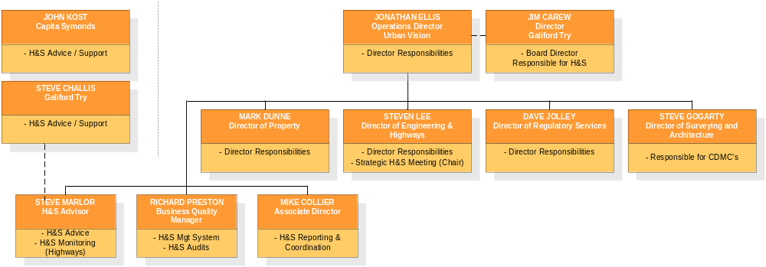
Our vision is to become incident, accident and injury free and to work with other duty holders under the Construction (Design and Management) Regulations to secure a similar vision for all our construction sites. This can only be achieved with the full involvement of all managers and staff, committed to doing everything they can to prevent injury to fellow workers, workers on construction sites, members of the public and others affected by our undertaking and to assist at all levels with the development of robust health and safety management systems.
The company’s commitment to its policy, and its implementation, is communicated to all employees through induction training, toolbox talks and the issuing of an employees handbook. The policy is displayed in all locations and on the company’s Integrated Management System (IMS) intranet site.

Management and Communication

Health and safety in Urban Vision is managed and communicated through a series of forums including:
- The Urban Vision Board – with health and safety as a standard agenda item. The Board meets monthly and a health and safety report is submitted to each meeting. The duties and responsibilities of the Board are set out in the Safety, Health, Environment and Quality (SHEQ) Policy / Manual (Section 3 – Organisation) which forms the basis of our Integrated Management System (IMS). A representative of the Council (John Spink) is a member of the Board.
- A Strategic Safety, Health and Environmental Management Group which meets on a quarterly basis to address issues (including those raised by business unit managers and that arise from accident data) and provide strategic guidance. It is attended by all business unit managers and Urban Vision’s Health and Safety Advisor, Steve Marlor. Partner health and safety officers / advisors are also invited. Morgan Foster attends on behalf of the City Council. Each year it prepares strategic objectives and targets for the following year.
- A monthly Operational Board Meeting attended by operational directors of the Company. A comprehensive health and safety report is prepared for all senior managers, a summary of which (similar to the one submitted to the Board) is submitted to the Operation Board. The Board considers health and safety issues on an exception basis. It is this board’s responsibility to monitor the day-to-day management of health and safety in Urban Vision.
- Individual team meetings within business units. Regular meetings take place at which health and safety is a standard item and where feedback from staff is encouraged. Business unit managers are responsible for the management of health and safety in their units.

Minutes of the management and board meetings can be viewed on the intranet and can be made available if required.

The detailed monthly report to managers includes details of accidents that occurred during the month in question and provides comparative data / assessments / trends.

Actions required to achieve Urban Vision’s health and safety objectives are included in an action plan, which is reviewed each month by the Urban Vision Operations Board.

The methods used to achieve a safe and healthy workplace and workforce, together with safe construction / demolition sites are detailed in our Integrated Management System, which addresses the following matters:
      - Ensuring all employees understand their responsibilities.
      - Providing adequate information, instruction and training to ensure the competence of our employees (including all designers and CDM co-ordinators), and to ensure that protection is granted to all our employees and those affected by our undertakings in relation to safety, health, environmental and quality issues..
      - Providing and maintaining suitable and sufficient risk assessment and safe working procedures for all work activities (these are included in the Integrated Management System and can be viewed on the intranet).
      - Providing and maintaining safe plant, machinery, equipment and work places.
      - Providing adequate resources to monitor and control the implementation of the health and safety policy.

As part of this process Urban Vision maintains a series of H&S Standard Operating Procedures (SOPs) which can be accessed via the IMS. These SOP’s are regularly reviewed along with other associated forms, including risk assessments, in line with the internal audit programme.

Urban Vision has identified vulnerable individuals who may have difficulty evacuating Urban Vision occupied buildings in the normal way. Personal Emergency Evacuation Plans have been prepared for those employees. Evacuation chairs are provided at Emerson House

All of the SOP’s are currently being reviewed and are due for completion by May 2011.

The purpose of Urban Vision’s IMS, which is based on the SHEQ Policy / Manual, is to set the standards and procedures by which Urban Vision manages Safety, Health, Environmental and Quality (SHEQ) issues throughout all operations, and to document operational procedures for each business unit. The Standard Operating Procedures (previously Company Standards), together with risk assessments and safe working procedures form a significant part of the IMS. The IMS is externally certified by BSI, who carry out a 3rd party assessment of Urban Vision against the requirements of ISO9001 [Quality], ISO14001 [Environment] and ISO18001 [Health and Safety].

Competent Advice
General health and safety advice is provided to Urban Vision by its own advisor (Steve Marlor), with support from health and safety teams within its partner organisations, Capita Symonds Ltd and Morrison Construction Ltd (Galliford Try), as well as the Urban Vision Business Quality Team.
Construction related advice is provided to Urban Vision as follows:
- In respect of its role as contractor / principal contractor (Highway Services) by its advisor (Steve Marlor), with support from the Galliford Try health and safety team.
- In respect of its roles as designer and CDM co-ordinator by Urban Vision’s own CDM Co-ordination Team and other Capita Symonds’ designers and CDM co-ordinators, with support from Capita Symond’s Health and Safety Team.
The main purpose of Urban Vision’s Health and Safety Advisor’s role is to promote and monitor the health and safety of personnel seconded to Urban Vision. The role covers both office based personnel throughout Urban Vision and operational personnel based at the Highways Depot. However, the intention from the start has been for the advisor to focus a majority of his time on the higher risk activities based at the highways depot (spending around 80% of his time on those activities). However, initially, considerably more than 20% of his time was spent at Emerson House establishing effective management procedures. Now that those procedures are well established and working effectively he has been able to revert to the original intention. The advisor’s role now, as far as office based personnel are concerned, is to monitor accidents, incidents and near misses, the outcome of monthly floor inspections and advise managers on health and safety matters.

Training and Information

Induction
Induction for new staff in Urban Vision involves the following:
- A presentation from the Company’s Health and Safety Advisor.
- The issuing of a health and safety booklet.
- More specific induction relevant to their job and working environment by their line manager.

Continued Professional Development (CPD)
All employees who are members of professional organisations undertake continuing professional development in order to meet their organisations’ membership requirements. The company encourages such development and bears the cost of some of the training undertaken.

Health and Safety Training (including CDM2007)
A training needs assessment is undertaken for all employees at least once a year, as part of a staff appraisal process. The company provides the necessary training identified by those assessments. It is the responsibility of each manager, with the assistance of the Health and Safety Advisor, to source all relevant training requirements and to maintain training records. Examples of these records can be provided if required.
In line with Capita Symonds’ policy all personnel seconded to Urban Vision and undertaking the role of designer as defined in the CDM Regulations are provided with awareness training which is refreshed every 3 years.
Staff whose responsibilities include regular visits to construction sites possess an appropriate CSCS Card.

Staff Wellbeing
The performance and productivity of our staff is vital to ensure our business is successful and by introducing wellbeing into the workplace we can ensure the workforce is motivated, which then enables the business to grow and achieve its goals.
The wellbeing framework is in part aimed at reducing stress and improving levels of sickness absence
We are committed to improving the health and wellbeing of all our staff and believe that the success of our business and the working lives of our staff can be improved by focusing on health and wellbeing in the workplace.
To ensure that we are addressing significant issues such as identifying health needs, ensuring a positive working culture is maintained, making sure we recognise an appropriate work-life balance and providing a supportive management structure, we are working with the Investors in People standard to improve the working lives of our staff.
We attempt to actively work towards reducing stress-related illnesses in the workplace and are committed to helping our employees to manage stress effectively, as excessive stress can have an impact on performance, health and relationships.
Our annual Staff Survey, carried out in Autumn 2010 demonstrated that 95% of respondents feel that our organisation takes their personal safety seriously, whilst 87% feel that they could approach their line manager to talk openly about flexible working, which demonstrates an improvement on last year's results.
Our Wellbeing Strategy focuses on ensuring that:
- The working environment is a comfortable and stimulating place
- Our diverse range of people are acknowledged and respected
- Opportunity, access, participation and contribution is fair and inclusive
- A positive working culture is maintained
- An appropriate work-life balance is recognised
The Wellbeing Strategy is split into 4 focus areas
Health and Nutrition
      - In the Workplace:
      - Free fruit delivered every week
      - Free Fair Trade tea/ coffee (skimmed milk available) and ‘Wateraid’ mineral water available on all floors
      - Nutritional Tips published on Intranet regularly (for example eating patterns, food groups and maintaining a balanced diet)
      - Eyecare vouchers for free eye tests and £45 off glasses for VDU use
        - Health Initiatives
        - Blood Donor sessions in conjunction with the National Blood Service
        - Flu vaccinations
        - Linking in with national initiatives e.g. Women’s Health Month / Men's Health Month

Work/ Life Balance
          - Flexi-time available to SCC staff and flexible working available to Capita staff
          - Carers / compassionate leave policies
          - Social activities are encouraged and promoted
          - Christmas Parties are subsidised by the company
          - Break out area and kitchen provided

Emotional Wellbeing
    - Access to Counselling services
    - Stress Awareness Sessions run in conjunction with National Stress Awareness Day
    - Employee of the Month Award : £100 Trafford Centre gift card prize
    - Prayer/ Reflection Room available

Fitness and Exercise
- Discounted Fit City membership for all staff
- Cycle To Work scheme: available for all staff
- Provision of showers, lockers and bike racks
- Bupa 10k Run: Urban Vision paid the entry fee for 22 staff with proceeds going to our "Charity of the Year" St Ann’s Hospice (over the past 24 months we have raised over £14,000)
- Pedometer Challenge in conjunction with Walk to Work week

Staff have the opportunity to input into the strategy through the Staff Representatives Group and the Staff Suggestion Scheme. Wellbeing is promoted through:
- Dedicated Intranet page with tips and campaigns
- Literature in break out area
- Poster campaigns
The Health and Wellbeing calendar for 2010 is set out below:

Month | Activity
February | Weight Watchers at Work pilot sessions
April | Blood Donation Sessions  Pedometer Challenge & Walk to Work Week
May | Bupa 10k Run
June | Men’s Health Month: promotion and provision of information
August | Blood Donation Sessions
October | Women’s Health Week Month: promotion and provision of information
November | Stress Awareness Sessions run in conjunction with National Stress Awareness Day
December | Blood Donation Sessions

Health and Safety Information

Accident / Incidents
There were 8 accidents reported in 2010.
Information in respect of all accidents (including RIDDOR reportable accidents) to employees seconded to Urban Vision over the last 12 months is set out in the two tables below and Appendices B and C:
Type of Accident [12 month periods]
 | Fatality | Major injury | Over 3-day injury [RIDDOR] | Minor injury (Lost Time Not Reportable) | Minor Injury (No Lost Time) | Injuries to Members of the Public | Total Number of Accidents
2010 | 0 | 0 | 0 | 0 | 8 | 0 | 8
2009 | 0 | 0 | 5 | 4 | 6 | 0 | 15
2008 | 0 | 1 | 2 | 1 | 13 | 0 | 17
2007 | 0 | 1 | 7 | 1 | 17 | 0 | 26
2006 | 0 | 0 | 9 | 1 | 31 | 0 | 41

Accident Frequency Ratios
Accident Frequency Ratios [AFRs], which only relate to those accidents involving absences of more than 3 days, are calculated using the following Health and Safety Executive formula:
Number of reportable accidents x 100,000
Number of hours worked in year
The Urban Vision AFRs for the 12 months to the end of December 2010 are as follows:
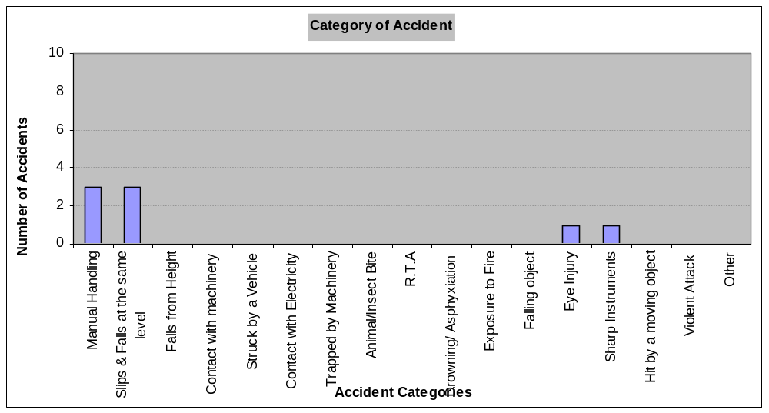
Urban Vision as a Whole
0 x 100,000 = AFR 0.00 (Previous month AFR = 0.10)
930,300
Highways Depot
0 x 100,000 = AFR 0.00 (Previous month AFR = 0.31)
301,362
Emerson House & Civic Centre
0 x 100,000 = AFR 0.00 (Previous month AFR = 0.00) 628,938
The above AFRs are based on the best available data at the time this report was compiled.

Accident Trends

RIDDOR Reportable Accidents
No RIDDOR reportable accidents occurred during 2010. This compares with 5 in 2009.

All Accidents
Urban vision is reaching a point where further reduction in the number of accidents will be increasingly difficult to achieve, having dramatically reduced the number of accidents in the period 2005 to 209 and maintained that reduction in 2010. The number reported in 2010 (compared to 2009) has reduced by 7 (from 15 to 8).
Urban Vision had identified the maintaining of the latest improvements in its health and safety performance as its priority for 2011. On this basis the maintaining of awareness of the risks of lifting and handling operations together with slips and fall has been adopted by Urban Vision as a priority during 2011, following on from the successful campaign in 2010.
The table below shows the number of accidents each month in 2010:
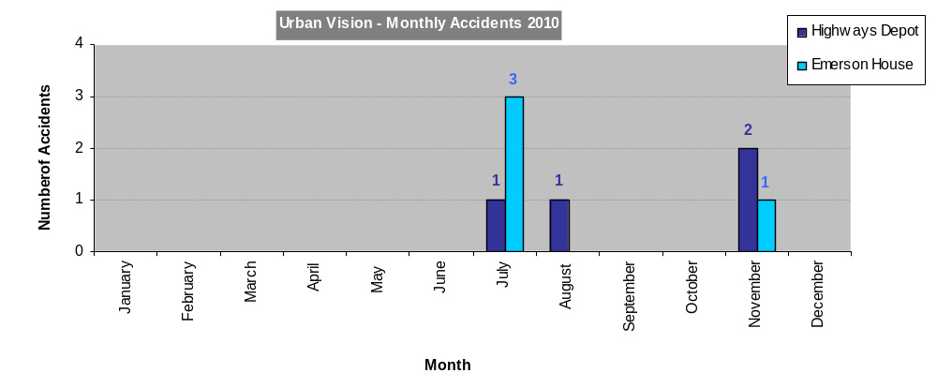
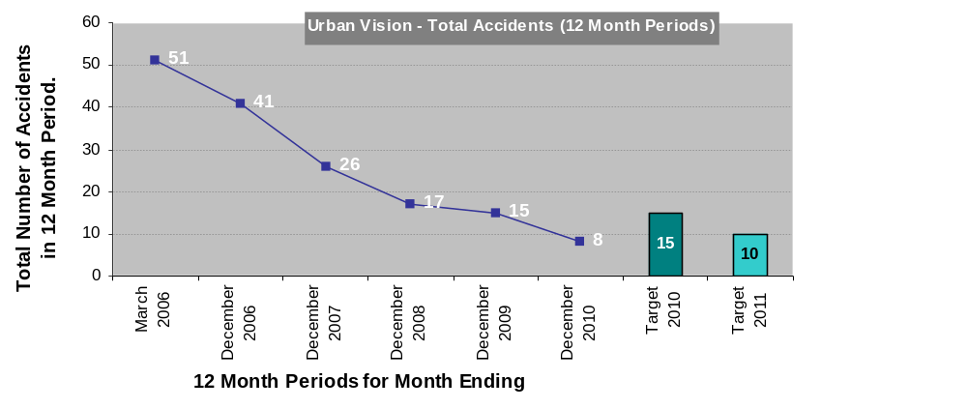
A breakdown of 12-month figures during 2010 is given below:

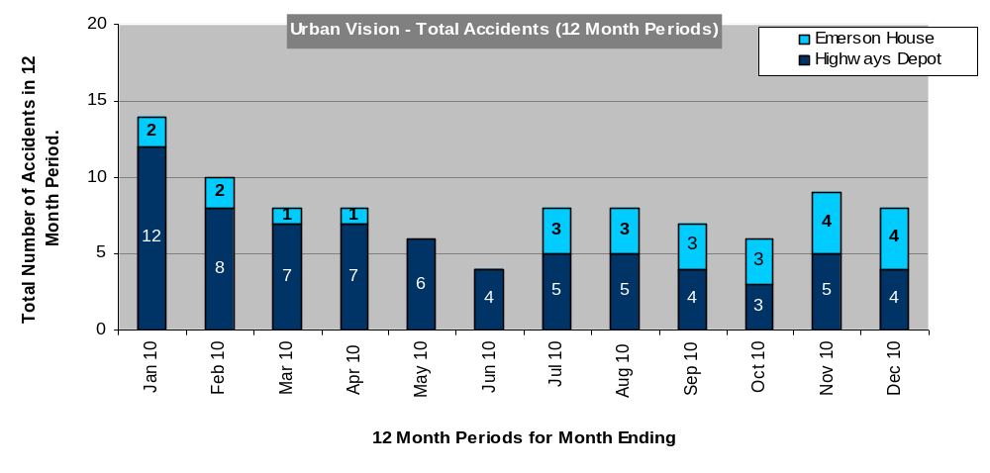

In December 2009 the company set itself a target accident frequency ratio (AFR) of 0.29 in 2010. The table below shows a comparison of overall Urban Vision AFRs achieved in the calendar years since 2006, with the targets for 2010 and 2011. It also shows the target for 2010 (this target has been approved by the main Board). The table also shows the original 5 year target (which aimed at reducing the AFR by 10% each year), together with an alternative 20% per year improvement line.
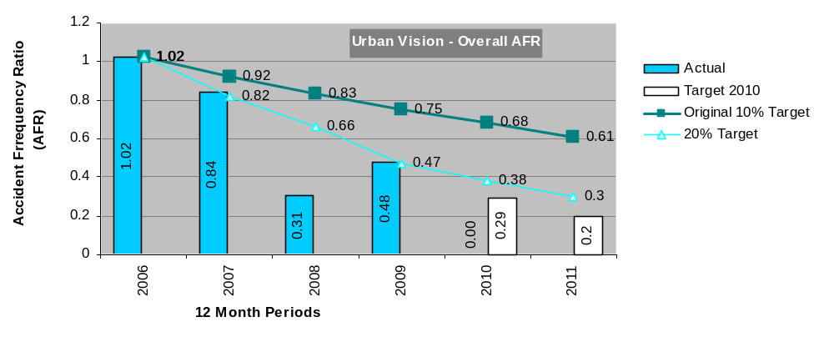

Strategy

2010
Urban Vision identified its priorities for 2010 as being to continue to consolidate the progress it had been making since 2005 in reducing the number of accidents to its personnel. The Strategic Safety, Health and Environmental Management Group had stressed that it would become increasingly difficult to make further reductions. Consequently the following targets were set:
- To avoid any deterioration in the total number of accident from that achieved in 2009. In the event the number of accidents was reduced from the 2009 figure of 15 to 8.
- To reduce the number of lifting & handling accidents from 8 in 2009 to 4. A reduction to 3 such accidents was achieved.
- To reduce the number of slips and falls from 5 in 2009 to 4. A reduction to 3 such accidents was achieved.
- To improve the accident frequency ratio from 0.48 to 0.29. In the event a zero ratio was achieved.
In other words Urban Vision met and exceeded all its targets.
2010 has therefore been an exceptional year in the company’s campaign to make the company a safer place to work.

2011
Urban Vision has identified the maintaining of the latest improvements in its health and safety performance as its priority for 2011. On this basis the maintaining of awareness of the risks of lifting and handling operations together with slips and fall has been adopted as a priority during 2011, building on the successful campaign in 2010.
The targets set for 2011 are set out in Appendix D.

Monitoring
Urban Vision’s managers regularly monitor the company’s performance against its health and safety objectives and targets. They receive a comprehensive monthly safety, health and environment report which includes accident reports, data and trends, together with assessing progress against the annual strategic objectives and the Health and Safety Action Plan. A summary report is submitted to the main Board and the Operations Board. Copies of all these documents can be viewed on the intranet under the Integrated Management System.
The Company also provides monthly reports to Capita Symonds and Galliford Try.

Strategic Objectives 2010

Objectives
Urban Vision identified its priorities for 2010 as being to make Urban Vision an even safer place to work and to reduce accidents. To achieve this objective we set a number of targets, focussing particularly on manual handling and slips, trips and falls.

Outcome
We have achieved and exceeded all our targets in what has been an exceptional year for the company in terms of health and safety performance.
During 2010 Urban Vision continued to focus its attention on improving awareness of the causation factors associated with accidents involving manual handling and slips, trips and falls. This successfully reduced the number of both types of accident.
Particular initiatives in 2010 included:
- Continued targeting of training on higher risk areas, including:
- Manual Handling (all operatives at the Highways Depot and 282 other staff have attended).
- Slips, Trips and Falls (all operatives at the Highways Depot and 282 other staff have attended).
- CDM awareness training, including refresher training.
- Ongoing monthly induction for new starters.
- Strengthening the safety culture via staff / management meetings.
- Continued certification to ISO18001.
Urban Vision’s performance against its 2010 Strategic Objectives is set out in more detail in Appendix D.

Action Plan
Key actions identified at any of the meetings referred to in 2.6 of this report are included in a Health and Safety Action Plan. The Plan is updated on a monthly basis. Progress in implementing actions in the plan is monitored by managers and at the Operations Board Meeting, also on a monthly basis.
All the high priority actions identified during 2010 have been completed.

- Statement of Intent
HEALTH AND SAFETY STATEMENT

At Urban Vision we are committed to the implementation of this policy, and achieving our vision to become incident, accident and injury free, and to the prevention of ill health.

Our policy is to provide a safe and healthy workplace for our employees and other stakeholders including those who may be affected by our undertaking. We consider all people working under the control and management of Urban Vision (either seconded or on a temporary basis) as our employees for the purpose of health and safety, including ill health, irrespective of who their actual employer is within the partnership.

Urban Vision aims to deliver excellent, sustainable solutions for the built environment through innovation, continuous improvement, learning and meeting & beating all government targets. This will be achieved by the following strategic objectives, which are continually monitored and reported at both an Operation and Board level:

  - To reduce accidents
  - To maintain a high standard of CDM Designer awareness

The methods used to achieve a safe and healthy workplace and workforce are detailed in our IMS, (SHEQ Policy / Manual) which address the following matters:

- Ensuring compliance with applicable legislation, regulation and other requirements.
- Ensuring all employees understand their responsibilities.
- Provide adequate information, instruction and training to ensure their competence.
- Provide and maintain suitable and sufficient risk assessments and safe working procedures for all work activities.
- Provide and maintain safe plant, machinery, equipment and work places.
- Ensure adequate resources are provided to monitor and control the implementation of the IMS policy.
- Setting of key performance indicator targets for our IMS performance.

This Policy will be communicated to all employees through induction training, toolbox talks and the issue of an employee handbook, which will be monitored, reviewed and updated as required. The Policy will be displayed on all office locations health and safety noticeboards and on the IMS Intranet site.

The ultimate responsibility for the Health & Safety Policy lies with the Operations Director who will ensure safety and health are a given priority within our business objectives. The Policy and its implementation will be reviewed at least annually by the Board of Directors to meet new business, legal and other requirements, as well as identifying areas in need of improvement. It will be revised and updated as necessary.

Urban Vision understands its legal responsibilities and is committed to ensuring compliance with applicable legal and other requirements.

This Health & Safety Statement of Intent will be reproduced by the Business Quality Team and displayed on the SHEQ Notice boards located on each floor within Emerson House. The Statement of intent will also be displayed at the Highway Services Depot.

Signed: | Jonathan Ellis
Date: | January 2011
Position: | Operations Director – Urban Vision Partnership Ltd

- Accident Breakdown [12 Month Rolling Period]
Month | Manual Handling | Slips & Falls at the same level | Falls | Contact with machinery | Struck by a Vehicle | Contact with Electricity | Trapped by Machinery | Animal/Insect Bite | R.T.A | Drowning / Asphyxiation | Exposure to Fire | Falling object | Eye Injury | Sharp Instruments | Hit by a moving object | Violent Attack | Other | Total
January |  |  |  |  |  |  |  |  |  |  |  |  |  |  |  |  |  | 0
February |  |  |  |  |  |  |  |  |  |  |  |  |  |  |  |  |  | 0
March |  |  |  |  |  |  |  |  |  |  |  |  |  |  |  |  |  | 0
April |  |  |  |  |  |  |  |  |  |  |  |  |  |  |  |  |  | 0
May |  |  |  |  |  |  |  |  |  |  |  |  |  |  |  |  |  | 0
June |  |  |  |  |  |  |  |  |  |  |  |  |  |  |  |  |  | 0
July |  | 2 |  |  |  |  |  |  |  |  |  |  | 1 | 1 |  |  |  | 4
August | 1 |  |  |  |  |  |  |  |  |  |  |  |  |  |  |  |  | 1
September |  |  |  |  |  |  |  |  |  |  |  |  |  |  |  |  |  | 0
October |  |  |  |  |  |  |  |  |  |  |  |  |  |  |  |  |  | 0
November | 2 | 1 |  |  |  |  |  |  |  |  |  |  |  |  |  |  |  | 3
December |  |  |  |  |  |  |  |  |  |  |  |  |  |  |  |  |  | 0
Total 2010 | 3 | 3 | 0 | 0 | 0 | 0 | 0 | 0 | 0 | 0 | 0 | 0 | 1 | 1 | 0 | 0 | 0 | 8
Total 2009 | 8 | 4 | 1 | 0 | 0 | 0 | 0 | 0 | 0 | 0 | 0 | 0 | 0 | 0 | 0 | 0 | 2 | 15
Total 2008 | 6 | 5 | 1 | 0 | 0 | 0 | 0 | 0 | 0 | 0 | 0 | 0 | 2 | 1 | 1 | 0 | 1 | 17

- Yearly Accident Statistics
 | Fatality | Major Injury | 3 Day Injury | Total RIDDOR |  | Minor Accidents |  | Overall Total
Highway Services
2005 [9 months only] | 0 | 0 | 8 | 8 |  | 28 |  | 36
2006 | 0 | 0 | 7 | 7 |  | 25 |  | 32
2007 | 0 | 1 | 7 | 8 |  | 13 |  | 21
2008 | 0 | 1 | 2 | 3 |  | 9 |  | 12
2009 | 0 | 0 | 4 | 4 |  | 8 |  | 12
2010 | 0 | 0 | 0 | 0 |  | 4 |  | 4
Emerson House (& Civic Centre)
2005 [9 months only] | 0 | 0 | 0 | 0 |  | 0 |  | 0
2006 | 0 | 0 | 2 | 2 |  | 7 |  | 9
2007 | 0 | 0 | 0 | 0 |  | 5 |  | 5
2008 | 0 | 0 | 1 | 1 |  | 4 |  | 5
2009 | 0 | 0 | 0 | 0 |  | 2 |  | 2
2010 | 0 | 0 | 0 | 0 |  | 5 |  | 4

Urban Vision as a Whole
2005 [9 months only] | 0 | 0 | 8 | 8 |  | 28 |  | 36
2006 | 0 | 0 | 9 | 9 |  | 32 |  | 41
2007 | 0 | 1 | 7 | 8 |  | 18 |  | 26
2008 | 0 | 1 | 3 | 4 |  | 13 |  | 17
2009 | 0 | 0 | 5 | 5 |  | 10 |  | 15
2010 | 0 | 0 | 0 | 0 |  | 9 |  | 8

- Strategic Health and Safety Objectives 2010 and 2011
2010
 | Target | Status | Progress / Comments
1 | To Make Urban Vision an even safer place to work
1.1 | Reduce Accidents
1.1.1 | To achieve an accident frequency ratio for Urban Vision as a whole of no more than 0.00 (0.48 in 2009) | G | Achieved
1.1.2 | To have no more than 3 RIDDOR reportable accidents involving personnel at Highway Services (5 in 2009). | G | Achieved (no RIDDOR reportable accidents)
1.1.3 | To ensure that the total number of accidents does not exceed 15 (15 in 2009). | G | Achieved (8 accidents)
1.1.4 | To ensure that the number of manual handling accidents does not exceed 4 (8 in 2009). | G | Achieved (3 accidents)
1.1.5 | To ensure that the number of slips, trips and falls (all types) does not exceed 4 (5 in 2009). | G | Achieved (3 accidents)

2011
1 | To Make Urban Vision an even safer place to work
1.1 | To reduce accidents
H1 | An accident frequency ratio for Urban Vision as a whole of no more than 0.20.
H2 | No more than 10 accidents overall.
H3 | No more than 3 manual handling accidents.
H4 | No more than 3 slips, trips and falls (all types).
1.2 | To maintain a High Standard of CDM Designer Awareness
H5 | 100% of all new personnel undertaking duties under the CDM Regulations are provided with awareness training within 6 months of commencing work with Urban Vision.

