_____________________________________________________

Key Council Policies:- Best Value
_____________________________________________________

REPORT DETAILS

1 | Background

The Council is required to produce a Best Value Performance Plan by the 30th June every year.

The Plan has to conform to certain requirements laid down by the Audit Commission to ensure that it is a balanced record of the Council’s performance.

This year there have been fewer requirements than in previous years, and the Audit Commission has advised that the Plan should be primarily designed for an audience of Members, employees and partner organisations, rather than the public.

However the Plan is still required to set down a large amount of statistical data on our performance in 2003/4 and our plans for the future.

The Plan was provided to reception areas and libraries and made available on the internet in time to meet the statutory requirements.

2 | The 2004/5 Strategic and Best Value Performance Plan
2.1 | Attached is the Plan as made publicly available (although in a format without graphic enhancement).  It is intended that, subject to approval, a further version of the Plan will be published and supplied widely throughout the Council, to all Members and to partner organisations. This version will also include a new foreword detailing the 2004/5 Cabinet Workplan.
2.2 | The structure of the Plan is designed to focus attention on the 7 Pledges as the key building blocks of the Council’s activity. It demonstrates the linkages between the shared priorities with government, the Community Plan, the Pledges, the Cabinet Workplan, service plans and individual performance.
2.3 | The Plan uses similar graphics to the Summary Best Value and Performance Plan already produced and circulated to all households in Salford and all employees of the Council.
2.4 | To encourage Members and employees to have a greater understanding of performance management in the Council and to encourage increased engagement in improvement activities a ‘Guide to Performance Management’ written in a deliberately “easy-to-read” style is annexed to the document.
3 | Recommendation  THAT, with inclusion of the new foreword, the Strategic and Best Value Performance Plan 2004/5 be approved.

Strategic and Best Value

Performance Plan 2004 / 2005

Improving People’s Lives in Salford

CONTENTS

INTRODUCTION  From the Leader of Salford City Council and the Chief Executive | PAGE NO:
Section 1 - The Strategic Plan

1.0 The Strategic Plan
1.1 Profile of the city
1.2 The Vision ofSalford
1.3 How it all fits Together
1.4 Structures
1.5 Resources
  - Corporate Governance
  - Managing Risk

Section 2 - Best Value and Continuous Improvement

- Best Value and continuous improvement
2.1 Introduction
  - Best Value in Salford
  - Comprehensive Performance Assessment (CPA)
  - Performance management

Section 3 – Analysis of our performance

3.0 What we have achieved and our plans for the future
3.1 Awards and external recognition
  - BVPI user satisfaction survey
  - Local Public Service Agreement targets
  - Our performance in 2003/2004 and our future plans – overview
Pledge 1
Pledge 2
Pledge 3
Pledge 4
Pledge 5
Pledge 6
Pledge 7

Section 4 – Responsibility statement

  - Language service
  - For your comments

Annex – An employees guide to performance management in Salford

Strategic and Best Value Performance Plan, June 2004

INTRODUCTION

From the Leader of Salford City Council and the Chief Executive

This plan is our key document for setting out our aspirations for the City and immediate targets for the council. It also demonstrates our accountability for how we have performed.

A summary of the plan has already been circulated to all households in Salford and made widely available through council offices and libraries. The summary has also been distributed to all employees.

The plan is now structured to show how all our services and activities are focused towards the achievement of the council’s seven pledges. The pledges have been aligned to establish a clear link between national government priorities, the priorities for the city as identified with our local partners and the work of the council.

In section 2, we also set out how our best value processes are driving improvements. Best Value reviews and the inspections and support from outside bodies like the Audit Commission are opportunities for us to provide better services for the people of Salford.

Section 3 provides a detailed commentary on our longer term aspirations, our targets for the coming year and how we have performed last year.

The key audiences for this years plan are those people closely involved with delivering services in the city – councillors, partner organisations and employees. Consequently, the plan is designed to provide a valuable source of information to help us all plan and manage in the coming year. With this in mind the plan provides a comprehensive overview of all of the key processes and structures which contribute to our overall performance and shows how everyone’s contribution fits in. To help make this connection we have included “ A Guide to Performance Management” as an annex.

We hope that you find the plan format and structure useful and that you can use it to make a practical difference to “create the best possible quality of life for the people of Salford”.



Councillor John Merry John Willis
Leader of the City Council Chief Executive
SECTION 1

1.0 The Strategic Plan

This Section sets out and explains our objectives and priorities. It shows the key contexts that shape those objectives. This starts with some key facts about the city and goes on to explain how the council works within a national and local partnership arrangement.

We then show how all this fits together.

The section goes on to outline other key factors such as the allocation of the budget and how the efforts of the people who deliver our services are aligned to support our pledges. Finally we look at some issues of governance – the way we organise our services as a democratically accountable organisation.

  - Profile of the city

Salford City Council is a large organisation with the 2004/05 budget set at £280.403million, an increase of 4.3% from 2003/04. This year, the increase we received in Revenue Support Grant from the government of 3.8% was again less than the average increase for all authorities of 4.9%. Despite this, the city council managed to set a below-average council tax increase of 3.5%. To supplement our budget we also have an established track record in securing external funding. Over the last five years more than £200million has been secured from a range of external sources to support regeneration activity across the City, including Single Regeneration Budget, European funding, New Deal for Communities, Housing Market Renewal Fund and the National Lottery.

Lifestyle-related health problems and health inequalities within the local community are key issues for Salford. On average people in Salford have poorer health than in the rest of the country. The council has established an effective partnership with local agencies, in particular the PCT, which has led to significant progress in a number of areas. For example, since 1991, life expectancy has increased by 2.4 years for men and 1.6 years for women.

The number of burglaries and vehicle crimes has shown a steady decline across Salford between 1998-99 and 2001-02. The most recent crime figure for domestic burglary is 37.01 per 1000 households. Vehicle crime stands at 28.03 per 1,000 population. We are developing innovative responses, combining the latest Anti-Social Behaviour legislation and a comprehensive prevention programme, to reduce the number of juvenile nuisance reports. However, despite these recent reductions, crime rates in Salford are still in excess of the national average and we will continue our efforts to improve.

We recently received a positive OfSTED report, highlighting the rate of change and improvements within our Education Service. The number of pupils achieving 5 A*-C grades at GCSE level is steadily increasing, as is the proportion of school leavers progressing into further education. These improvements are encouraging although the council recognises that GCSE attainment and staying on rates are below the national average. Over 3,000 new childcare places have been created since April 1999, and free nursery education for 3 and 4 year olds is available in a range of early years settings.

The city has experienced significant structural change in its economy. The new and knowledge-based jobs, particularly in the Quays and neighbouring Manchester and Trafford Park, have lessened the dependency on employment sectors in decline. The business services sector continues to grow and at 18.7% is now larger than the regional average of 12.8%.

Salford now has one of the fastest growing economies in the North West, creating an additional 19,000 jobs between 1991 and 2001, a rise of 22%. Unemployment has reduced and is at a 17 year low of 3.7%, close to the national average of 3%, although there are significantly higher unemployment rates in Central Salford wards, for example 11.3% in Broughton.

Recently, in partnership with Manchester, we became the first Housing Market Renewal initiative to be agreed by the ODPM securing £125m to tackle market decline. In the last twelve months over 1,100 new houses have been completed, an increase of 79% on the previous 12 months. Also over the last 12 months, house values in Salford have increased by 27.7%, the greatest increase in Greater Manchester. This trend is set to continue.

Over the past year we have made great progress in addressing the challenges faced in the city and seen real results in service improvements; which are identified in detail in this plan.

1.2 The vision for Salford

1.2.1 Shared priorities for central and local government

Central and local government have agreed 7 areas in which it is most important to deliver improvements over the next 3 years.

These are areas on which it is essential that government, councils and others work together in order to bring about improvements. They have been adopted as priorities because they matter to communities.

The 7 shared priorities are :-

- promoting healthier communities

- creating safer and stronger communities

- raising standards across our schools

- improving the quality of life of children, young people, families at risk and older people

- promoting the economic vitality of localities

- meeting local transport needs more effectively

- transforming our local environment

In Salford we’ve taken these 7 shared priorities and have considered them in conjunction with our pledges. The shared priorities also align with the themes within the City’s Community Plan. Details of the Community Plan themes and our pledges are included at sections 1.2.4 and 1.2.7. For a more detailed analysis of how the shared priorities, the Community Plan themes and our pledges align together, please see figure 1 in section 1.2.7.

    - Partners IN Salford

Partnership working is well established in Salford and has involved all key agencies within the city since 1994. The Local Strategic Partnership, now called Partners IN Salford celebrated it’s 10th anniversary in April this year.

Partners IN Salford consists of the following 14 organisations :-

- Salford City Council
- Greater Manchester Police
- Salford Primary Care Trust
- University of Salford
- Manchester Enterprises
- The faith sector
- JobcentrePlus
- 2 representatives from the city’s nine community committees
- 3 representatives from the city’s Community Network
- Salford Lifelong Learning Partnership
- North West Development Agency
- Learning and Skills Council
- Government Office for the North West
- Manchester Chamber of Commerce and Industry.

As well as those mentioned above, a wide range of other public, private and voluntary organisations actively contribute to the work of Partners IN Salford and its wider family of partnerships.

The Partners IN Salford organisation aims to:

- Provide a common voice for the area, with agreed aims, objectives and priorities
- Work to improve key mainstream public services to make them more responsive to local communities
- Agree strategies to tackle deprivation and promote sustainable development
- Develop similar partnership structures for programmes and initiatives.

The partnership has undergone significant change since the launch of the Neighbourhood Renewal agenda in 2001. For the last three years it has been successfully accredited by the Office of the Deputy Prime Minister’s (ODPM) Neighbourhood Renewal Unit (NRU).

Delivering the work of the main partnership, we have 7 Service Delivery Partnerships (SDP’s), one for each of the seven themes of the Community Plan (see section 1.2.4).

For the council’s part being a member of Partners IN Salford enables us to link better into the wider needs and priorities of the citizens and communities in our city. Joint working is increasingly the way to do things and includes increasing pooling of budgets, joint posts and joint working. This approach will be further developed through the implementation of our Neighbourhood Management initiative across the city later this year (see section 1.2.9 for more information)

Vision for the city

The City has an overall vision, developed by Partners IN Salford.

“Our vision for Salford is to create a city where people choose to live and work. We aim to improve the quality of life of all of our citizens by creating an economically prosperous city with a buoyant and competitive economy; creating and maintaining strong, safe, healthy and sustainable communities where all citizens can participate to the fullest extent in decisions which affect their communities, providing a better education for all, to enable children and young people to thrive and fulfil their potential; creating a city that is good to live in by providing quality homes and a clean and healthy environment.”

Local Priorities - The Community Plan

Partners IN Salford’s vision, priorities and targets were set down in Salford’s first Community Plan which was published in November 2001. The plan helps partners delivering services across the city to focus on our agenda for change in Salford. This will be achieved by focusing on the seven themes listed below that reflect the priorities given to us by local people:-

- A healthy city – we will achieve this by improving health outcomes and reducing health inequalities
- A safe city – we will achieve this by reducing crime and disorder and improving the sense of community safety
- A learning and creative city – we will achieve this by raising education and skill levels, and developing and promoting opportunities for cultural and leisure enhancement
- A city where children and young people are valued – we will achieve this by investing and focusing our resources and efforts into services, activities and opportunities that will support children and young people and help them achieve their full potential.
- An inclusive city with stronger communities – we will achieve this by tackling poverty and social inequalities, maximising the opportunities for children and young people and increasing the involvement of local people and communities in shaping the future of the city.
- An economically prosperous city – we will achieve this by providing jobs with good prospects, and supporting our local economy by encouraging local enterprise and business development
- A city that’s good to live in – we will achieve this by protecting and improving the environment and providing access to decent, affordable homes which meet the needs of local people

When the Community Plan was published, the partnership made a commitment to report back on progress so that everyone could see how we are doing in achieving the key priorities. A Community Plan Annual Report was produced in 2003 detailing progress made. Several of our key achievements and results are shown below:-

- 2000 new childcare places established
- New Job Shop Plus Centre opened in Eccles offering help to unemployed people
- 699 new jobs created
- Kerbside recycling scheme launched
- Six new health and social care “LIFT” centres to be built
- Street crime initiative undertaken
- Vehicle crime down to 33.48 incidents per thousand population for 2002/03 from 42.9 in 2000/01
- Convictions of young people for burglary down 55%
- Long term unemployment down 2.2% between October 2001 and January 2003

Want to find out more?

For a copy of the Community Plan or Annual Report 2003 please contact Gemma Singleton on 0161-793-3442 or see the council’s website at www.salford.gov.uk/communityplan.

    - The Neighbourhood Renewal Strategy

The Neighbourhood Renewal Strategy (NRS) is an overarching strategy that fits alongside the Community Plan. Where the Community Plan details “what needs to be done in Salford”, the NRS details “where to do it”.

The NRS was developed in 2002 and sets out Salford’s priorities for the city on a neighbourhood by neighbourhood basis. It is written in line with the Government targets that concentrate on improving performance in :

- Health
- Housing
- Employment
- Education
- Crime Reduction
- Road Safety

Implementation of the NRS is assisted by two workplans. The first focuses on Central Salford and ties in with the application for Urban Regeneration Company status, the second focuses on Salford West.

These two areas of the city have very different requirements; Central Salford displays many symptoms of deprivation; poor housing, low educational aspirations, high worklessness, whereas Salford West is much more stable but with pockets of deprivation. In Central Salford far-reaching improvement is required across the physical and social spectrum. In Salford West the emphasis is on supporting the stable areas and providing early intervention to the areas that show symptoms of deprivation.

The introduction of our Neighbourhood Management initiative across the city later this year will be key to the implementation of the NRS strategy at a local level.

Want to find out more?

For more information in relation to the Neighbourhood Renewal Strategy please contact Paul McKenna on 0161-793-3421 or by e-mail at paul.mckenna@salford.gov.uk

Salford City Council’s mission

Salford City Council’s mission is

“To create the best possible quality of life for the people of Salford”.

To achieve our mission, we have developed our seven pledges as shown below.

Local priorities – City Council Pledges (The magnificent seven)

These pledges identify the council’s priorities and give a better understanding of the good work that is carried out throughout the authority.

The council’s seven pledges each have a number of sub pledges which indicate how the pledges will be achieved. These are set out as follows:-

Pledge 1 Improving health in Salford

We will improve the health, well-being and social care of the people in Salford

This will be achieved by:

- Promoting a healthy lifestyle and tackling health inequalities
- Working with partners to improve life chances and promote good health for individuals and communities
- Improving and redesigning service to maximise access and meet need

Pledge 2 Reducing crime in Salford

We will reduce crime and disorder and improve community safety

This will be achieved by:

- Reducing the fear of crime and targeting the crimes causing most concern to the people of Salford
- Helping victims and witnesses
- Tackling offenders
- Implementing crime reduction and prevention measures

Pledge 3 Encouraging learning, leisure and creativity in Salford

We will raise education and skill levels and further enhance cultural and leisure opportunities

This will be achieved by:

- Raising the educational attainment of children, young people and adults in the city
- Providing better quality schools and leisure facilities
- Promoting independence for people through education, training and employment
- Encouraging more people to participate in a range of sport, culture and learning activities
- Promoting the city for major cultural, sporting and leisure events

Pledge 4 Investing in young people in Salford

We will focus on services, activities and opportunities to support children and young people in achieving their full potential

This will be achieved by:

- Encouraging greater engagement with young people on issues that affect their lives
- Providing services and facilities to meet the needs of young people
- Improving the life chances of young people by supporting them and their families

Pledge 5 Promoting inclusion in Salford

We will tackle poverty and social inequalities and increase the involvement of local communities in shaping the future of the city

This will be achieved by:

- Building strong, confident communities
- Celebrating and supporting our cultural diversity
- Improving access to services and support mechanisms for vulnerable members of our community

Pledge 6 Creating prosperity in Salford

We will ensure an economically prosperous city with good jobs and a thriving
economy

This will be achieved by:

- Promoting the city as a location of choice for people and investment
- Supporting businesses and maximising employment opportunities
- Maximising public and private investment to regenerate the city
- Helping people to overcome the barriers to employment and improving basic skills
- Maintaining a high quality workforce to drive the prosperity of the city

Pledge 7 Enhancing life in Salford

We will ensure that Salford is a city that’s good to live in with a quality environment and decent, affordable homes which meet the needs of local people.

This will be achieved by:

- Ensuring the cleanliness and maintenance of the city
- Giving residents in the city a choice of quality housing to meet their needs
- Promoting sustainability through appropriate development, conservation and improvement of the city’s environment
- Providing an accessible and sustainable recycling service
- Improving the city’s highway and transportation network

To ensure that we deliver on our pledges each directorate of the council is required to show how it will contribute to the implementation of them. Consequently, the work to be done is set out in Service Plans which show details of what is to be achieved throughout the coming year.

Details on how we are performing in achieving our pledges are contained in Section 3.

How we achieve the shared priorities for central and local government is shown in Figure 1.

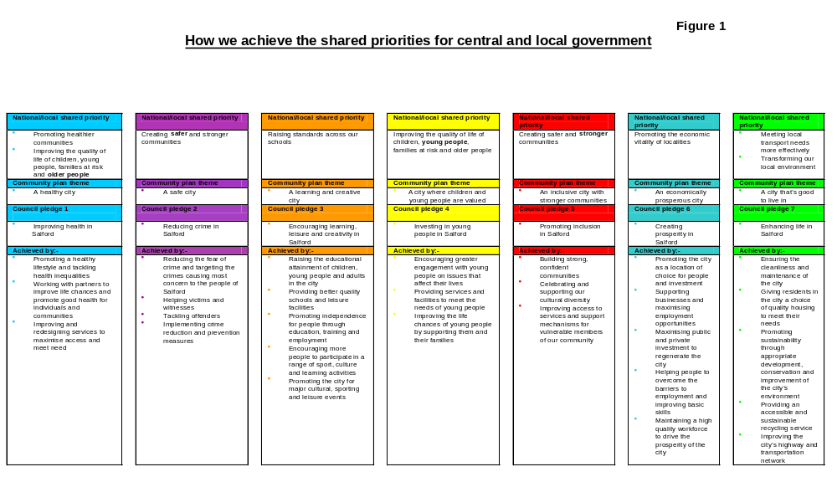

    - Cabinet Workplan

The cabinet has produced a workplan and priorities for 2004/5 which underpins the pledges. The workplan sets out exactly what local people can expect to see the cabinet working on and highlights the following main themes for the council in the coming year:-

- Making services better reflect the needs of the people of Salford
- Increasing member and public participation
- Raising the profile of the city
- Neighbourhood Management

Targets have been set in the workplan to ensure that the cabinet delivers the necessary changes to tackle the city’s challenges head-on and also celebrate our achievements. The workplan is underpinned by a budget strategy which ensures that resources are allocated to reflect our priorities.

Want to find out more?

A full copy of the Cabinet Workplan can be obtained from the council’s website at www.salford.gov.uk/council/councillors/cabinet/cabinetworkplan or by contacting Charlotte Cunnah on 0161 793 3416.

1.2.9 Neighbourhood Management

We have previously referred to a new way of working with the geographical communities of Salford which is being introduced this year, called Neighbourhood Management. This initiative is designed to ensure integrated and responsive service delivery to communities through the creation of neighbourhood teams which will be overseen by local Partnership Boards.

This initiative opens up our Community Strategy as a means of delivering not only council services, but our partner’s services too.

It will provide the means for the implementation of neighbourhood plans, developed in consultation with local communities, which bring together strategic plans for the area and priorities identified locally.

Neighbourhood Management makes clear the connection between service delivery on the ground, the Community Plan, Neighbourhood Renewal Strategy and the various forums that support them.

At the core of the initiative is the creation of an identifiable multi-agency neighbourhood team, led by a Neighbourhood Manager, who will be responsible for the delivery of key services in each Community Committee area.

Also we will create local Partnership Boards in every Community Committee Area which will drive the agenda on behalf of local communities and formally recognise the role of key partners, such as the Police and the PCT, in Community Committee structures.

Want to find out more?

For further information on Neighbourhood Management please contact Tom McDonald on 0161-793-2287 or by e-mail at tom.mcdonald@salford.gov.uk

1.3 How it all fits together

To help us understand how “to create the best possible quality of life for the people of Salford” we have created a number of documents that break down our plans into meaningful areas of work for everyone to relate to. Figure 2 below explains how this all fits together.

All the plans align with each other and are written with a specific audience in mind.

This Strategic and Best Value Performance Plan is the lynchpin. It provides a comprehensive and detailed view of all of our performance targets and systems at a council-wide level.

More detail can be found in each directorate’s Service Plan, which is produced annually. Most sections also have more specific and detailed plans and each employee is appraised every year on their individual contribution.

Alongside each plan is a set of targets and a performance management system (see section 2.4) which ensure plans lead to better services.

Community Plan Vision
and seven themes

Our Strategic and Best Value Performance Plan
Audience
Purpose
People and Partners In Salford

Outlines the vision and mechanisms for joint working
Demonstrates how Salford City Council is contributing to the seven themes of the Community Plan
Pulls together in detail all the city council’s work with key targets and all the PI’s related to the pledges
Detailed work programmes at directorate level
People who live and work in Salford
Primarily Councillors and staff
Directorate Service Plans
Staff within directorates

Section Business Plans and individual appraisal
To guide and support staff at a local level
Staff

Our seven pledges and Cabinet Workplan
Central and Local Government

Shared Government Priorities

Priority areas in which Government, Council’s and others work together to bring about improvements
Our plans and how they fit together
Figure 2

  - Structures

1.4.1 Democratic Structures

In June 2001 the citizens of Salford confirmed that they wished the Council to operate with a Leader and Cabinet. These arrangements came into force in October 2001 and we are now structured as shown in Figure 3 below.

Figure 3

CITY OF SALFORD – DEMOCRATIC STRUCTURE

COUNCIL

STANDARDS
COMMITTEE

SCRUTINY
COMMITTEES
(6)

CABINET
COMMUNITY COMMITTEES
(9)

REGULATORY
PANELS
(2)
NON REGULATORY
PANELS (18)

Employers’ Forum

Equal Opportunities Forum

Corporate Complaints Panel

Housing Appeals Panel

Discretionary Housing Payments Appeal Panel

Transport Appeals Panel

Social Services Panel

Adoption Panel

Children’s Review Panel

Complaints & Representations Panel

Exceptions Panel

Fostering Panel

Fostering Appeals Panel

Inspection & Registration Unit Advisory Panels

Rota Visits Panels:

- Children’s Residential Homes
- Other Establishments
- Rota Visits Reviewing Panel

Secure Accommodation Review Panel

Responsible for:

Codes of Conduct

Probity and Ethics Issues
6 committees scrutinising:

Economic & Community Safety

Environmental

Health & Social Care

Lifelong Learning & Leisure

Quality & Performance

Budget
10 Members with responsibility for:

Leader – Chief Executive; Strategic Overview; Regeneration; Policy, Performance and Best Value; Communications; Boundary Commission

Deputy Leader – Chief Executive; Targets and Pledges; Crime and Disorder; Customer Focus; Waste Disposal; Electoral Matters; Property

Arts & Leisure

Community and Social Services

Asylum Issues

Community Strategy

Corporate Services

Development Services

Education

Environmental Services

Youth

Tourism

Housing Services

Personnel Services

Covering the following areas in the City:

Blackfriars & Broughton*

Claremont & Weaste

Eccles

Irlam & Cadishead

Little Hulton & Walkden

Kersal, Pendleton & Charlestown*

Ordsall & Langworthy

Swinton

Worsley & Boothstown

* Blackfriars and Broughton and Kersal, Pendleton and Charlestown Community Committees are to merge. This Community Committee will have a new name which has yet to be decided.
Responsible for:

Licensing & Safety

Planning & Transportation

1.4.2 Cabinet

The cabinet consists of the Leader of the council, the Deputy Leader and eight councillors who have each been allocated a Lead Member portfolio with responsibility for particular services. Some cabinet members also have a special portfolio of responsibility covering cross cutting themes which involve more than one service such as crime, communications and tourism. The cabinet portfolios for Lead Members currently cover the following areas:-

Development Services
Housing
Corporate Services
Environmental Services
Education
Personnel
Community and Social Services
Arts and Leisure

The cabinet meets in public on alternate Wednesdays, and considers matters of strategy and policy. In addition each Lead Member holds a weekly briefing with their respective Director.

    - Scrutiny Committees

Jargon Buster!

What is a Scrutiny Committee?

Scrutiny Committees look at the effectiveness of the council’s policies and practices as well as enquiring into matters of local concern. The committees submit reports to and advise the cabinet on its policies, budgets and service provision. They may also be consulted by the cabinet on forthcoming decisions as well as the development of policy

Scrutiny Committees support the work of the cabinet and the council. The council originally had five scrutiny committees but this was increased to six in 2002. Their strategic responsibilities include:

- Advising the cabinet and council on policies, practices, budget and service delivery
- Monitoring decisions of the cabinet - scrutiny committees can “call-in” a decision that has been made by the cabinet but not yet implemented.

The six committees are:-

Economic and Community Safety Scrutiny Committee

- works closely with the Chief Executive Directorate and others in order to make Salford a safer place to live and work and also builds stronger communities by developing the local economy.

Lifelong Learning and Leisure Scrutiny Committee

– works closely with the Education and Leisure Directorate in overseeing service delivery and supporting young people.

Quality and Performance Scrutiny Committee

– works to ensure that public money is wisely spent and council taxpayers receive value for money. Also involved in promoting efficiency and performance management.

Health and Social Care Scrutiny Committee

– works closely with Community and Social Services Directorate and NHS organisations to help make the city a healthier place to live.

Environmental Scrutiny Committee

– works with Environmental Services, Development Services and Housing Services to ensure that the city is clean, and well planned with quality homes for everyone.

Budget Scrutiny Committee

– oversees our budget process, monitors spending against the budget and monitors and comments on budget strategies.

Our Overview and Scrutiny Annual report for 2002/2003 is available on the council’s website at www.salford.gov.uk/council/scrutiny or telephone 0161-793-2513. Also available are copies of each Scrutiny Committee’s workplan with details of committee meeting dates.

In December 2003, an external expert - Professor Steven Leach from De Montford University carried out a review of our overview and scrutiny arrangements. Key comments made in his report included:-

“The current operation of Overview and Scrutiny in Salford incorporates a number of strengths. Although there are – as in all authorities – also a number of weaknesses and problems in the operation of the function, there is certainly not in Salford the sense of overview and scrutiny as a “disaster area”, which is the perception (and indeed sometimes the reality) in a significant number of authorities. Salford deserved better in its CPA assessment of the scrutiny function. There is a lot of as yet unrealised potential in the way in which overview and scrutiny is working, but at least it starts from a relatively strong base currently, compared with many other authorities. The challenge in Salford is not to radically change the existing approach, but to build on its existing strengths and strive to overcome the weaknesses.”

Want to find out more?

For further information on Overview and Scrutiny in Salford please contact Peter Kidd on 0161-793-3322 or by e-mail at peter.kidd@salford.gov.uk.

    - Community Committees

Salford City Council consults with and involves local people through a network of local Community Committees which cover the following areas:-

- Claremont and Weaste
- Eccles
- Irlam and Cadishead
- Little Hulton and Walkden
- Kersal, Pendleton and Charlestown
- Ordsall and Langworthy
- Swinton
- Worsley and Boothstown

Following the recent ward boundary changes Blackfriars and Broughton and Kersal, Pendleton and Charlestown Community Committees have merged. This Community Committee will have a new name which they have yet to decide.

The three major functions of our Community Committees are:-

- To develop, implement, monitor and evaluate local Community Action Plans
- To manage budgets delegated to them
- To scrutinise local services

Each Community Committee produces a local Community Action Plan which identifies the key issues and priorities of the local area. Funding is delegated to local communities for them to make decisions on how this is best spent to address these local priorities.

The Community Committees play a key role in the new Neighbourhood Management arrangements we have outlined earlier (see section 1.2.9)

Want to find out more?

For further information in relation to Community Committees please contact Tom McDonald on 0161-793-2287 or by e-mail at tom.mcdonald@salford.gov.uk

    - Internal Structure of the Council

John Willis, the Chief Executive is responsible for the corporate management of the council. He is the leader of a team of directors who are responsible for co-ordinating the council’s services. Each director is responsible to the council through the Chief Executive for the efficient running of the services his/her directorate provides. All directors meet on a fortnightly basis. Details of the council’s directorates and a summary of the services they are responsible for are illustrated below in Figure 4.

In September 2002 a new body – New Prospect Housing Limited was launched to manage council homes within Salford. Similarly we have also set up a new organisation in October 2003 to manage leisure facilities across Salford: Salford Community Leisure was set up as a community benefit society – it is owned and controlled by the local community in order to provide direct service benefits to the community.
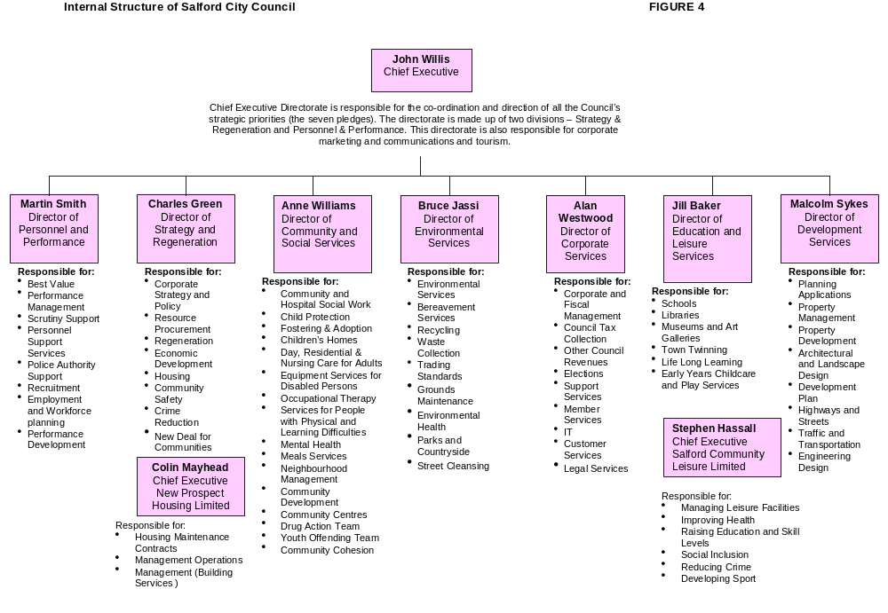

1.5 Resources

1.5.1 The financial context

This section provides a summary of the issues that influenced the setting of our revenue budget for 2004/05. These issues include the level of council tax, the standard of service provision, public consultation, legislative requirements or proposals and the financial settlement provided by the government.

The various sections give a summary of the main reasons for the changes from the 2003/04 revenue budget and show how these changes have affected service budget allocations.

Jargon Buster!

What is a Revenue Budget?

Revenue expenditure is costs incurred in the day to day running of the council; it primarily comprises employee expenses, capital financing charges and general running costs. The Revenue Budget is our plan for revenue expenditure in the forthcoming year, which determines the level of Council Tax that will be charged. During the year, accountants monitor actual spending against the budget

We operate a medium-term financial strategy that is designed to take into account future major issues facing the city such as the predicted change in the number and profile of people in the city.

The budget for 2004/05 forms part of the medium-term financial strategy covering 2004/05 to 2006/07. This financial strategy ensures that there is a close link between the allocation of resources to services so that we can achieve specific service results.

Best value principles also require that the strategy takes into account the key messages emerging from the various independent reviews of the services that the council provides. In particular the Comprehensive Performance Assessment, Best Value reviews and service inspections, and targets as set out in the council’s Local Public Service Agreement, together with the key messages from our consultation with the public last December and January, have also been taken into account.

Jargon Buster!

What is a LPSA?

LPSA’s are agreements between individual councils and the government. The agreement is our commitment to work to achieve a number of targets which can either be targets which we have developed ourselves and agreed with government because we feel that they are priorities for Salford or targets selected from ones which have been developed nationally by the government.

LPSA targets must be achieved in a certain timescale, and, if we achieve them, we receive additional money to assist us to improve in the chosen service areas.

    - At a glance summary – Where the council spends its budget

Our net expenditure, or “ budget requirement” as it is referred to is the cost of services after taking into account the income generated from charges made to service users, and various grants including those received from the government to fund specific services or initiatives. Figure 5 below shows in broad terms the services that make up our council’s budget requirement:

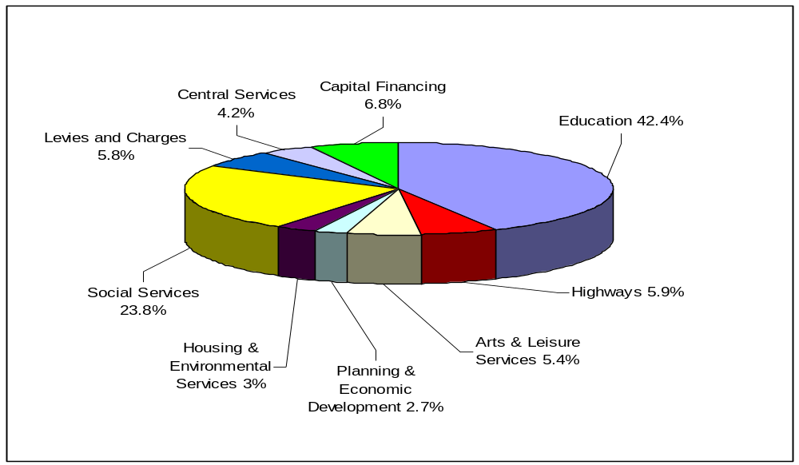Where the council spends its budget – 2004/05 Figure 5

    - At a Glance Summary – How the council’s budget is funded

Our budget requirement is funded from two main sources - 1) the government via its revenue support grant and the redistribution of income collected from business rates and 2) council tax payers via the council tax charge levied by the council. Figure 6 shows the value of these income sources in 2004/05:

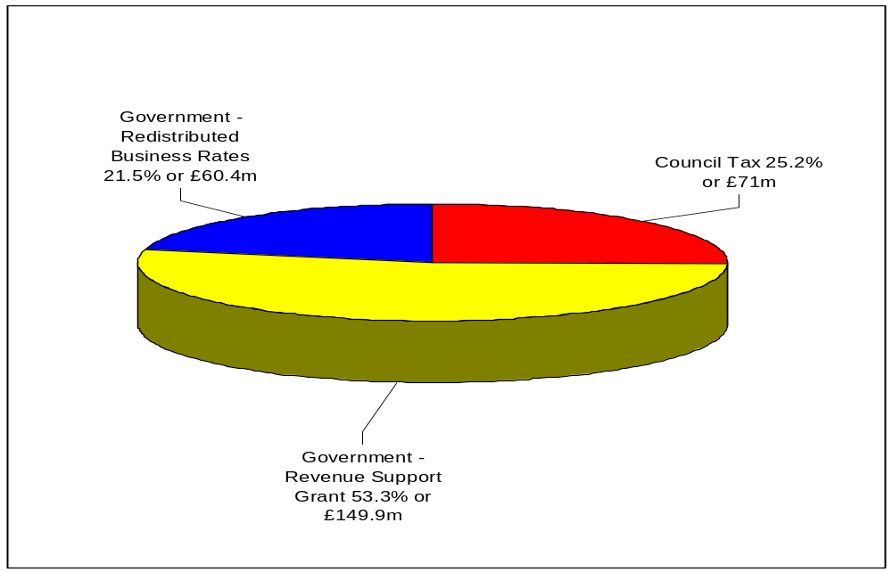Where the money comes from to fund the Figure 6
the council’s net budget – 2004/05

    - The City Council’s Spending Plans 2004/2005

The 2004/05 budget process

Forecasts of our spending requirements for 2004/05 began in March 2003 and formed part of our financial strategy. The strategy was developed during the year and adjusted to take into account the issues arising from various services and changes announced by the government relating to the way that it funds local authority expenditure.

Formal budget submissions for 2004/05 were made by each service, timed to coincide with the receipt of details of the government’s provisional funding settlement in November/December2003. This provisional settlement and service submissions made it necessary to revise the budget planning level to take into account: -

- The relatively low level of the revenue support grant (RSG) increase. For Salford this represents a 3.8% increase after adjustment for function and grant funding changes. This is once again less than the average increase of 4.9% for all local authorities.

- The impact of certain transfers between specific grants and RSG.

- The calculations for passporting the government’s expected increases in funding to education and social services.

- The impact on costs of the increased service demands, particularly for social services, identified during the detailed scrutiny of services.

- The clear expectation from the government of a low increase in council tax.

Jargon Buster!

What is a Revenue Support Grant (RSG) ?

This is a general grant paid by Central Government to each local authority to help to finance local revenue expenditure. The way RSG is calculated is supposed to equalise the differences in spending needs and resources between authorities, in order to allow each authority to support a standard level of spending and set a standard Band D Council Tax.

The implications of these funding issues on service costs and outcomes were considered during December and January with the budget of £280.403m approved in February.

The approved budget is designed to deliver continued improvement in service delivery and meet council and national priorities and address other issues coming from the key messages contained in the findings of the various independent reviews we have had. In summary the budget has been approved within the following financial framework: -

- Council Tax rises to be below the national average.
- Reserves to achieve the target of £8m or a lower level supported by a thorough risk assessment.
- To continue to passport government anticipated spending increases for schools and social services.
- To provide growth in priority services of £1m per annum.
- To de-capitalise revenue expenditure currently funded from capital in a phased manner over the next three years.
- To seek to eliminate the dependence on surpluses achieved by direct service organisations to support the budget.
- To make appropriate allowance for expected pay and price inflation and other anticipated commitments based on a budget risk exercise

The approved budget of £280.403m will enable all aspects of the financial framework to be met, or progressed and ensure that all directorates maintain a "positive direction of travel" in delivering the council's pledges and priorities, national priorities and improving performance.

What it means for services

The 2004/05 approved budget aims to continue the implementation of the council’s seven pledges. To achieve this it is necessary to have clear links between the key outcomes expected and the resources made available. The key outcomes expected from the revenue budget are summarised overleaf.

Education

An outturn budget of £132.475m will aim to secure the following key outcomes :-

Jargon Buster!

What is an Outturn Budget ?

The Revenue Budget goes through several stages prior to and during the financial year. The original plan is known as the Base, and is formed from the previous year’s experience. This is modified into the Estimate , which takes into account expectations for the current year. Later versions of the budget reflecting developments in the year are known as the Approximate and finally Outturn, which then become the base budget for the next year.

- Improvement in results at key stage 2 and GCSE.
- Removal of surplus places in primary and secondary schools.
- Increase in the rates of school attendance.
- Ensuring more excluded pupils continue their education.
- Improve the educational attainment of children leaving care at 16 (with Community and Social Services ).
- Increase the number of 16 to 19 year olds in employment, training or education.
- To work in partnership with Community and Social Services and other agencies towards the development of a children's trust.
- To target support to schools with serious weaknesses and in special measures.

Arts and Leisure

An outturn budget of £16.841m will aim to secure the following key outcomes :-

- Increasing the usage of museums and libraries.
- Providing leisure facilities that meet customer demand.
- Promoting cultural, leisure and recreational events for the benefit of Salford residents.
- Increase the participation of young people in sport.
- Improve the condition of the city's parks.

Community and Social Services

An outturn budget of £74.321m will aim to secure the following key outcomes :-

- Lead the development of a children's trust.
- Meet the demand for childcare placements, promoting foster care and adoption, and reducing the dependence upon outside placements.
- Ensure children looked after get the best chance in life.
- Avoid hospital bed blocking.
- Integrate services in learning difficulties for adults with the primary care trust.
- Assist disadvantaged people into employment (with Chief Executive).
- Enable adults who need social care to lead as full a life as possible in their own homes.
- Develop day care services.
- Develop the use of information and communications technology to improve efficiency of operations.
- Improve the transport service for clients.

Environmental Services

An outturn budget of £8.726m will aim to secure the following key outcomes :-

- Continue to improve the cleanliness of the city
- Increase the recycling of household waste
- Improve air quality
- Ensure a safe environment in the city's cemeteries
- Ensure the public is protected from unfit food, counterfeiting, under age alcohol sales, doorstep crime.

Housing (General Fund)

An outturn budget of £0.502m will aim to secure the following key outcomes :-

- Reduce the number of unfit homes and the duration of empty homes
- Reduce the number of homeless people, the use of bed and breakfast accommodation and length of stay in hostels
- Increase the number of accredited private landlords
- Ensure asylum seekers and other vulnerable and disadvantaged people secure appropriate accommodation and support services
- Encourage the provision of choice in lettings from all housing providers
- Support the regeneration of key areas of the city
- Increase the accreditation of private landlords.

Highways, Planning & Economic Development

An outturn budget of £27.196m will aim to secure the following key outcomes :-

- Reduce the number of people killed or seriously injured in road accidents
- Halt the deterioration in, and maintain the condition of, the city's highways and footpaths
- Develop the unitary development plan
- Implement major development proposals and support regeneration activity
- Process planning applications promptly
- Reduce office accommodation costs.

Central Services

An outturn budget of £12.980m will aim to secure the following key outcomes :-

- Drive the delivery of the community plan and pledges
- Seek to improve performance and service delivery
- Ensure a safer city by reducing crime
- Develop stronger communities
- Implement regeneration programmes
- Assist disadvantaged people into employment (with Community and Social Services)
- Support the achievement of key corporate personnel policies and targets
- Sustain the improvement in the financial health of the council
- Improve council tax and business rates collection
- Improve benefit application processing times
- Pay undisputed invoices quicker
- Increase the volume of electronic transactions with the council
- Ensure land searches are conducted promptly
- Work with the PCT to provide joint services in LIFT centres
- Improve customer contact with the council
- Ensure the cost effectiveness of the council.

1.5.5 At a glance summary – Capital Investment

In addition to the money the council spends on day to day services as reflected in the revenue budget, we also invest for the future in our buildings and infrastructure. A capital programme of works costing approximately £114.6m has been drawn up which is expected to attract government grants and other external funding in the region of £78.7m. The balance of costs will be met from income of approximately £13m generated from the disposal of surplus assets (capital receipts) with the balance to be met from borrowing. The capital financing requirement included in our revenue budget provides for the cost of this borrowing. A summary of the type of schemes included in this year’s programme and the proposed funding is shown below:

Jargon Buster!

What is the Capital Programme ?

Capital expenditure is money spent on the acquisition of a fixed asset; or expenditure which adds to the value of an existing fixed asset. The Capital Programme is the Council’s plan for capital expenditure in the forthcoming year.

Capital Investment Plans 2004/05 Figure 7
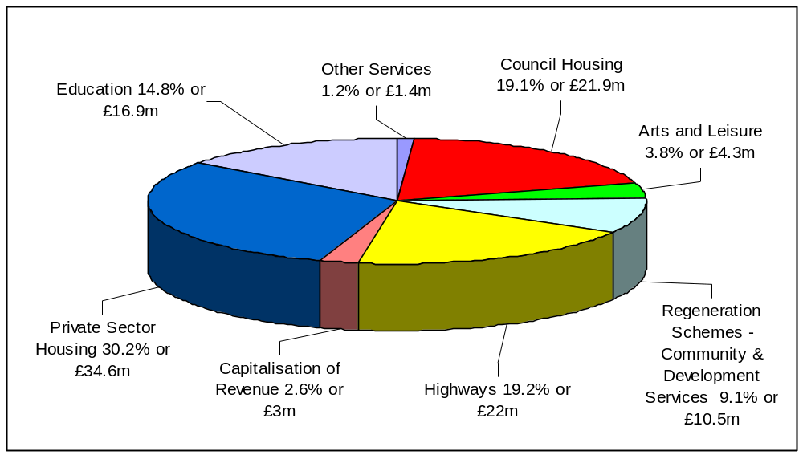

Want to find out more?

For more detailed information on our finances, please see the document entitled: “Revenue Estimates and Capital Programme 2004/5” which can be obtained by contacting Phil Prady on 0161 793 3245 or see the council’s website at www.salford.gov.uk/council/finance/budget/budget-reports.

    - Human Resources Strategy

Crucial to our ability to continuously improve everything we do is ensuring we have effective employees who are appropriately supported and encouraged.

Currently we have a complex mix of occupations and working practices. Some key workforce data shows that:-

- Women make up 67% of our overall workforce. Of those approximately two thirds are concentrated in the traditionally female roles e.g. care, cleaning, catering and clerical
- However, women make up less than 40% of top earners
- The vast majority of the workforce is white – nearly 98%
- Approximately less than 2% of the workforce has declared they meet the Disability Discrimination Act disability definition
- 10% of the workforce is under 25, the majority of employees being between 36 and 50
- Approximately 30% of the workforce work less than full-time hours
- The average length of service is 9 years. A significant proportion – 30% have less than 2 years service
- The number of working days lost to sickness absence is approximately 11.52 days per employee, per year

Our Human Resource Strategy provides a framework or policies, practices and systems which determines the kind of employer the City Council wants to be and sets out how we aim to achieve this. It is designed:-

- To attract, develop and retain the people we require
- To ensure we have the present and future skills, knowledge and competences we require
- To support individual performance at all levels
- To enable timely and effective communications and consultation
- To promote a culture that is receptive to change and responsive to the key influences and challenges we face

The strategy has three key improvement areas

Leadership at all levels
enabling all employees to demonstrate leadership and progress within a performance management and improvement regime

Customer Care
providing improved service to our citizens and other customers

Diversity and inclusion
increasing the diversity of the workforce and ensuring that all employees understand, promote and value the increasing diversity of the City in all that they do.

In addition, Action Plans are being implemented to ensure these improvement programmes are achieved.

The government has published a Code of Practice on Workforce Matters in Local Authority Service Contracts. This requires from March 2003 that all service contracts involving a transfer of staff comply with the Code. In Salford, we are committed to the principles of the Code and its application. However in the year 2003/2004 no employees of the council were transferred who fell within the code of practice.

Want to find out more?

For more detailed information on our Human Resources Strategy please contact Mike Bleese on 0161-793-3502 or by e-mail at mike.bleese@salford.gov.uk

1.5.7 Procurement

Jargon Buster!

What does Procurement mean?

Procurement means “ the acquisition of goods, works and services from third parties” and is a key feature of the way modern local government provides services to its citizens.

Developments in Procurement at a National Level

There have been a number of national developments in procurement:

The Byatt Report - “Delivering Better Services for Citizens” recommend that councils review the state of their procurement skills in the light of the requirements of best value.

The Report made 39 recommendations under 16 themes and we have reviewed our arrangements in the light of these.

The Egan Report - “Rethinking Construction” advocated a fundamental shift away from the traditional contract approach based on lowest price towards the development of a long-term partnership approach for construction.

This was followed by the publication of: “Towards a National Strategy for Local Government Procurement” published by the ODPM (Office of the Deputy Prime Minister) and the LGA ( Local Government Association), which endorsed Byatt’s 39 recommendations and confirmed the view that procurement must be set in the broader context of best value.

This report recommended local authorities to establish a corporate procurement team led by a professional head of procurement function, in order to create a centre of expertise in procurement and a focus on the strategic management of procurement and partnership across the organisation.

The findings of these three reports were built upon by CIPFA (Chartered Institute of Public Finance and Accountancy) in its document “How to Develop a Procurement Strategy” which sets out the stages involved in developing a documented procurement strategy within an organisation.

Major developments in procurement in Salford

The council has made significant progress since the publication of the above reports, which is summarised below:-

Community and Social Services have moved from a major provider to a major commissioner of services involving domiciliary care, dispersed housing, day care and residential care for both adults and children.

A Trust has been agreed for the provision of residential care for the elderly and a Children’s Trust is being developed with the Education and Leisure Service and the PCT.

In addition there is significant joint working with the PCT including joint budgets for services for people with learning disabilities.

Other joint working initiatives are being developed to maximise the impact of the LIFT (Local Improvement Finance Trust) outlets proposed for Swinton, Walkden, Eccles, Pendleton, Charlestown and Lower Kersal.

Development Services are in the latter stages of consideration of a joint venture company for a wide range of their services.

An independent company known as an Arms Length Management Operation has been set up for the Housing Service (NPHL Ltd) and housing, together with Community and Social Services have implemented the government’s Supporting People initiative.

Another independent organisation, Salford Community Leisure has been created to manage the council’s sport and leisure facilities.

Environmental Services are responsible for the procurement of all the council’s transport fleet.

The Central Purchasing Unit, in addition to co-ordinating the general provision of goods and some services undertakes the procurement of several major contracts such as DERV and all energy contracts.

Education and Leisure Services have delivered one Private Finance Initiative (PFI) for three special high schools and are now developing proposals for a further PFI for three high schools. In addition it is likely that a bid will be made for a further PFI for nine high schools and Development Services are seeking a PFI for street lighting.

Corporate Services have implemented an integrated computer system - SAP, which should provide a sound base for co-ordinated purchasing of goods and services and development around electronic procurement. Proposals are also being developed for joint delivery of services with the PCT and others in the LIFT centres.

Personnel and Performance have implemented joint procurement of recruitment advertising with other Greater Manchester Authorities.

This experience shows that we have the skills and willingness to implement new methods of service delivery and procurement. Our procurement policies and skills are extensive and are being developed.

The above list is not exhaustive and there will undoubtedly be more opportunities for both joint working and joint procurement in the future. To avoid fragmentation and encourage the dissemination of best practice and adherence to our policies, we have developed a procurement strategy along the lines indicated below.

Development of a procurement strategy

Objective : Procurement will support our key strategies and goals and will be used to support wider council objectives such as equal opportunities, local economic regeneration and sustainability

Continuous improvement : A commitment to continuous improvement and best value is a key component in our procurement decision making processes. Decisions about procurement will consider the full range of options available including partnerships, joint purchasing, internal and external provision, and views of local citizens and quality and risk will be judged fairly along with cost

Fairness and consistency : All procurement activities will be carried out in a fair and equitable manner and decisions will be transparent with due regard to the need for public accountability. We will comply with relevant codes such as the Commission for Racial Equality Code of Practice.

Buying power : We will make best use of our buying power to make full use of consortia and corporate procurement opportunities to obtain economies of scale and secure best value.

Employment : We will seek to encourage good employment practice and seek to sustain the city’s economic development by effective procurement decisions.

Environment : Procurement decisions will be taken with due consideration to the environmental impact of the goods or services in question

Total costs : Administrative costs of procurement will be taken into account in decision making processes. Total life costs of products and services need to be considered so that the best overall value for money can be judged

Monitoring and benchmarking : Contractual arrangements and procurement processes will be monitored on a regular basis to ensure that best value is being achieved, with the focus on outputs. Benchmarking will be undertaken to help identify the success or otherwise of the procurement route that has been taken

Electronic procurement : We will embrace electronic procurement opportunities to drive down costs and increase efficiency of our procurement processes

Impact of procurement : A regular analysis will be made of the impact of our procurement activities on the economic, social and environmental well-being of the City.

Next steps

We have created and recently appointed to a post of Procurement Co-ordinator to bring together the procurement specialists in each directorate and drive forward our Procurement Strategy and ensure best practice and our policies are delivered.

Our next step is to bring together a Procurement Board - consisting of appropriate representatives of each directorate to oversee the implementation and development of the Procurement Strategy during the coming year. We will also be moving forward in the development of e-procurement across the organisation.

  - CORPORATE GOVERNANCE

Jargon Buster!

What is Corporate Governance?

Corporate Governance is ensuring that we have systems and processes in
place for proper accountability and openness in how we conduct our business.
In particular, it relates to using resources efficiently. In simple terms, Corporate Governance is the corporate “culture” – leadership, direction and control.

The principles of good governance are integrity, openness and accountability. The public sector recognises that good governance contributes to high-quality, appropriate services and greater community cohesion, health, safety and economic well-being. Fundamentally the quality of governance affects the trust people have in public services.

In Salford we place great emphasis in demonstrating these qualities. We have robust systems, for example for performance management, risk management and financial management which are dealt with in detail in this Plan. We also have systems in place to ensure high standards of behaviour from our councillors and employees, and we have established Codes of Conduct that regulate their behaviour.

Want to find out more?

Copies of the Code of Conduct can be obtained from Bev Hinks, Performance Development Team on 0161 793 3419 or by e-mail at bev.hinks@salford.gov.uk

Our scrutiny arrangements contribute to good governance and, as we said earlier, (see section 1.4.3) they have been positively reviewed by an external expert.

Our website and other communications demonstrate our commitment to open government by providing public access to decisions and the decision making process. Nearly all of our meetings are open to the public and encourage public participation.

Our Neighbourhood Management initiative is designed to reinforce and develop the role of geographical communities in engaging with our decision making. Recently Partners IN Salford have established a “Diversity Leadership Forum” to further engage with our ethnic minority communities.

Our community engagement process has just been inspected by the Audit Commission and was deemed to be good with promising prospects for improvement. As a result, we are currently implementing an ambitious plan to increase openness and participation, including establishing a “citizens panel” to support our decision-making.

  - MANAGING RISK

Jargon Buster!

What is Risk Management?

All organisations are faced with a wide range of events and threats that may influence their ability to achieve their objectives. e.g. how would we cope if our main IT system failed? We have to plan in advance for these events. Risk Management is about handling the outcomes of these events, and also about seizing the opportunities that are presented to us. The Council has a Corporate Risk Register which identifies the major risks which we face.

The Audit Commission undertook a review of our corporate governance arrangements in late 2003 and concluded that we are making “good progress”, particularly in the area of risk management. All the elements of our agreed action plan have been delivered and the next key challenge for us is ensuring that the risk management process becomes truly “embedded” as part of the culture of the organisation.

We have identified the key strategic and operational risks facing us and these are now contained in a variety of risk registers. Steps are also in place to ensure that there are adequate controls in place to manage the key risks identified.

A key element of our approach is to ensure there are clear linkages between our performance management framework, service plans, strategic and operational risk registers and the overarching corporate decision-making process. Our service planning process is being developed to reflect the importance of risk management techniques both in identifying priorities and in assessing the best ways in which objectives can be achieved.

Want to find out more?

For further information in relation to Risk Management please contact Don Simpson on 0161-793-3290 or by e-mail at don.simpson@salford.gov.uk

SECTION 2

2.0 Best value and continuous improvement

Improving and striving for the best for our citizens is at the heart of our council.

This section explains the way the council is judged nationally through the government’s best value systems and in particular the Comprehensive Performance Assessment (CPA) and how we organise ourselves to improve our performance.

The sub-sections are as follows:-

  - Introduction
  - Best value in Salford
  - Comprehensive Performance Assessment
2.4 Performance management

2.1 Introduction

Jargon Buster!

What is the Audit Commission?

The Audit Commission is a government organisation which looks closely at how councils are being run to ensure that they are:-

- Providing high quality services
- Providing value for money
- Accountable to our citizens
- Treating people fairly and being a good employer.

The Commission assesses councils against the above areas through regular audits and inspections.

In its annual audit and inspection letter the Audit Commission commented early this year that;

“Over the last year some of Salford City Council’s services have not delivered improvements, for example the management of council houses remains a cause for concern. More positively, the Council has been short listed for national recognition for its housing benefits and support services to vulnerable people. The council’s relationships with partners have increased its ability to provide services, for example, successful community safety and regeneration partnerships. The council is committed to improving service and there is progress in a number of areas. For example the council has put plans in place to improve education services and we expect to see measurable improvements in the next twelve months. Salford City Council now needs to focus on increasing the level of support and leadership provided to service areas to ensure more consistent improvement. The council has put plans in place to do this and we will be monitoring progress over the coming year.”

Since that was written we have received an improved inspection score for area housing delivery and gained Beacon status for our housing benefits and supporting people services. We are determined to continue to improve and win recognition for our efforts.

2.2 Best value in Salford

Jargon Buster!

What is Best Value?

The Local Government Act 1999 established a duty of Best Value for all councils. This requires councils to seek to achieve continuous improvement by having regard to the efficiency, effectiveness and economy of their service delivery.

In order to measure whether councils are achieving best value the government has set measures of performance in key service delivery areas. These measures come in a number of inter-related forms such as - Best Value Performance Indicators (supplemented by some service-specific indicators), Best Value Inspections and the Comprehensive Performance Assessment (CPA).

Salford City Council’s policy in respect of best value is

“to provide quality, value for money services which meet the community’s needs and aspirations at a price they are prepared to pay.”

This means that we need to review our activities in line with best value principles and ensure that we have action plans in place to ensure improvements are made and that services are meeting the needs of local communities. These plans are reflected in our annual best value programme of reviews as outlined in Figure 8.

    - Best Value Performance Plans

The Government requires that every local authority produces a Best Value Performance Plan by 30th June each year. A summary performance plan must also be produced annually by 31st March. Our 2004/2005 Summary Strategic and Best Value Performance Plan was published in the council’s Life IN Salford magazine and distributed to all homes in the city in order to report on progress. Copies have also been made available at local council offices, libraries and on the council’s website at www.salford.gov.uk/bestvalue.

This document is the council’s full plan and aims to reflect our achievements over the last year and our plans for improvement over the next three years. The plan is structured in line with the council’s seven pledges and provides an overview of how we are performing against our Best Value Performance Indicators and our key targets for the forthcoming years.

    - Audit of Strategic and Best Value Performance Plan 2003/2004 (BVPP)

This Strategic and Best Value Performance Plan will be audited by the Audit Commission, who will produce a written report before the end of December 2004. The plan is audited to make sure that it represents a balanced and accurate picture of the council’s performance.

Jargon Buster!

What is an audit?

An audit is a formal inspection of a process that is carried out within the council. We have our own internal audit department which carries out inspections of our internal processes, schools etc. We also work in close conjunction with the Audit Commission’s local District Audit service.

The District Auditor’s report on last year’s performance plan (2003/2004) confirmed that the plan complied in all respects with legislation and the accuracy of the performance indicators included within the Best Value Performance Plan was satisfactory. The District Auditor confirmed “We are pleased to report that this year we will be issuing an unqualified opinion on your BVPP. The council has made significant efforts to ensure that the performance indicators included within the BVPP are accurate.”

It is worth noting that following the audit of the plan in 2002/2003 District Audit made five recommendations as to how the plan may be improved : these were all acted upon in 2003/2004 and no other recommendations were necessary.

2.2.3 Our Programme of Best Value reviews

Our programme of Best Value reviews is designed to take into account national and local priorities and also to contribute to the delivery of the council’s pledges and the improvements from our CPA assessments. Monitoring progress on all current Best Value reviews is part of our performance management system (see Section 2.4). Our programme of best value reviews for the current year 2004/2005 is shown below.

Our programme of Best Value reviews Figure 8
Year 5 : 2004/2005

Review | Responsible Director | Review Team Leader | Contribution to pledges | Duration / Completion date
Public Protection | Bruce Jassi | Nigel Powell | Pledge 1 – Improving Health in Salford | April 2004 – March 2005
Safeguarding Children | Anne Williams | Paul Woltman | Pledge 2 – Reducing Crime in Salford  Pledge 4 – Investing in Young People in Salford | October 2004 – June 2005
Services to People with Physical and Sensory Impairments | Anne Williams | Julia Clark | Pledge 5 – Promoting Inclusion in Salford | July 2004 – May 2005
IT NET/Salford Advance | Alan Westwood | Mike Willetts | Pledge 6 – Creating Prosperity in Salford | April 2004 – March 2005
SAP | Alan Westwood | Geoff Topping | Pledge 6 – Creating Prosperity in Salford | June 2004 – May 2005

In the last year we have undertaken the following Best Value reviews:-

Housing Planned Maintenance
Education Inspection and Advisory Services
Bereavement Services
Residential Care for Children
Tenant Participation
Grounds Maintenance Service
Youth Service
Culture, Arts and Heritage
Construction and Design

All these reviews have been completed. We have also carried out two further Best Value Reviews which have been inspected by the Audit Commission – Community Engagement and Planning Services. Both these services were rated by the Audit Commission inspectors as good, two star services with promising prospects for improvement.

In addition to these Best Value Reviews, a number of management reviews are also being carried out during 2004/2005. For example, a review of the Early Years Service is being undertaken jointly by Community and Social Services, Education and Leisure Services and the Primary Care Trust.

Jargon Buster!

What is an inspection?

The Audit Commission may decide to inspect the service that has been reviewed. Inspectors visit us, look at our key documents and interview key officers, service users, councillors and partners and then give the service a rating of between 1 and 4 stars (4 stars being excellent). They also provide recommendations and comment on the service’s prospects for improvement.

Our programme of inspections

Year 5 : 2004/2005

We will have the following inspections in 2004/05: Figure 9

Inspection | Dates
Waste | Week commencing 7th June 2004
Pilot for new CPA Corporate Assessment | Week commencing 19th July 2004
Commission for Social Care Inspection – Learning Difficulties | September 2004
Sport and Leisure | Week commencing 19th July 2004

2.3 Comprehensive Performance Assessment (CPA)

Jargon Buster!

What is a CPA?

CPA was introduced by the Audit Commission in 2002. It is a process that brings together evidence of how well a council is performing from a range of sources. It provides an overall categorisation for councils: poor, weak, fair, good or excellent. This categorisation is produced by combining the scores for two specific aspects:-

- how the council is run overall i.e. the corporate assessment
- how the council’s main services perform i.e. the service assessment

The Audit Commission produce the overall corporate assessment with some of the service assessments being made by other inspectorates e.g. OFSTED (education) and CSCI (social services).

Salford’s overall classification in both 2002 and 2003 was “weak”. We have been disappointed with the rating we have been given. However we have in place detailed plans for improvement which are shown elsewhere in this Plan (see Section 3). Salford is a city in the midst of colossal change and we know only too well that we have to continue to work hard to make sure people see and understand the changes and improvements we are making.

Salford’s overall categorisation in 2003 and the elements of the Audit Commission’s findings are shown at Figure 10.

In 2003, the Audit Commission introduced a “direction of travel” statement into the CPA scorecard under heading 1 – “How is Salford City Council run and what progress has the council made in the last year?” More detail on what the Audit Commission have said and the full Audit and Inspection Letter can be found on the council’s website at www.salford.gov.uk/council/perform/cpa.

    - CPA in 2004/05

As to the future of CPA, the approach to scoring CPA in December 2004 is the same as in 2003. Consequently the issues in demonstrating our improved performance in 2004 will remain similar to 2003 i.e. the majority of the model will not be re-scored, but will have scores carried forward. However, we are committed to continuous improvement in all that we do and we have every intention of ensuring that this is reflected in our 2004 CPA assessment and direction of travel statement.

    - CPA 2005 and beyond

The Audit Commission are reviewing the approach to CPA scoring from 2005 because the government has acknowledged that it needs to be reviewed and updated. The proposed approach maintains the overall classification (poor, weak, fair, good, excellent) which is produced by combining service assessment and corporate assessment scores. However a number of amendments are proposed to both individual service assessments and the corporate assessment, and further consultation is proposed in these areas through 2004.

A group of councils will help conduct the review as a pilot exercise, which was outlined in the consultation document “The Way Ahead”, published by the Audit Commission earlier this year. This will be undertaken during summer 2004, but the outcome score will not contribute to CPA in December 2004.

Salford City Council has been chosen as a pilot authority for this review which we believe shows that the Audit Commission acknowledges we can help improve the existing system.

Want to find out more?

If you want to know more about CPA, then telephone Stan Frost on 0161 793 2563 or contact stan.frost@salford.gov.uk

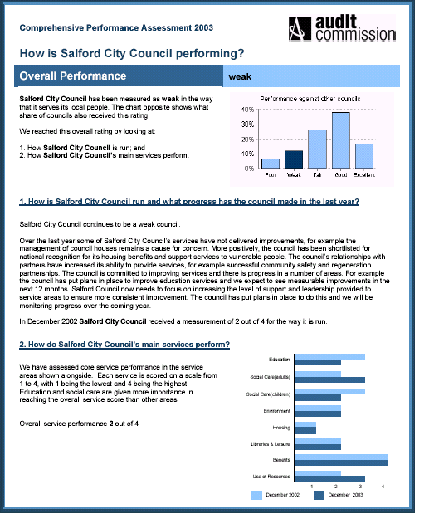

The Audit Commission’s assessment of Figure 10

2.4 Performance management

As explained in the earlier sections, councils are at the centre of a wide-ranging inspection and review framework.

To ensure that we continue to improve we need to make sure that these external monitoring arrangements are matched by internal systems that identify opportunities for improvement and make the changes that are needed. These systems are our Performance Management arrangements.

In Section 1 we identified how our plans and structures fitted together. Performance management runs in parallel to those structures by providing targets for the future and feedback on how we are actually getting on. This operates at all levels in the council from the individual employee, through their section and directorate to a corporate level. We also join together performance in geographical localities with performance across the city as a whole. (see Figure 11)

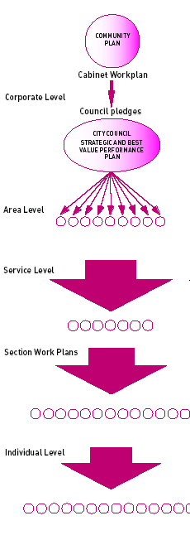
Figure 11

How the corporate planning and performance management model works

Corporate level

Within our Strategic and Best Value Performance Plan, our performance and that of our key partners, is measured against a set of performance indicators which have been set for all council’s by the government. These are called Best Value Performance Indicators. In the plan, we have also set out a number of performance indicators which have been produced by the council. These are called Local Performance Indicators.

Our Community Plan has been produced by the council and its key partners and sets out the priorities for the city for the coming years. The plan contains a number of targets against which we and our partners measure ourselves to determine whether we are achieving those priorities.

We have aligned our pledges to the themes of the Community Plan so that we focus on how we, as a council, can help to achieve the priorities set out in the Community Plan. We monitor our performance against the achievement of the pledges on a quarterly basis.

The Cabinet have developed an annual workplan which takes into account the key priorities within the Community Plan and the national and local shared priorities. Again, we monitor our progress in achieving the objectives within the workplan on a quarterly basis.

Area level

Each of the community committees has produced a Local Action Plan containing targets for the achievement of priorities for each of those local areas and for the achievement of the priorities contained within the Community Plan and the pledges.

Service level

Each directorate produces an annual service plan which sets the targets to be achieved for the priority areas for the year ahead. These targets are based on the priorities contained within the local action plans produced by each community committee, the achievement of pledges and priorities contained within the Community Plan and the Strategic and Best Value Performance Plan.

Section level

An annual work plan is developed for your section which sets out the targets to be achieved. These targets are based on the priorities to be achieved by your directorate in the coming year.

Individual level

At your annual appraisal meeting, targets are agreed for your job for the year ahead. These targets are to be based on the key priorities to be achieved by your section in the coming year. The Employee Appraisal Scheme has recently been revised and all employees will receive an annual appraisal.

Overall

This means that everybody can understand where he or she fits in and what we all need to achieve based on good quality performance data. This plan provides a comprehensive guide to a lot of that data: the Annex – A Guide to Performance Management – shows how we use that data within the council.

However, performance management is more than just systems, although they are a critical part of it. Improvement depends on everyone being committed to making a difference and being enabled to do so. This is known as having a “performance culture”. In Salford building on that culture is a priority. The Guide to Performance Management is available to all employees. Also the comprehensive training programmes identified within our Human Resource Strategy are directed to support this issue.

SECTION 2

2.0 Best value and continuous improvement

Improving and striving for the best for our citizens is at the heart of our council.

This section explains the way the council is judged nationally through the government’s best value systems and in particular the Comprehensive Performance Assessment (CPA) and how we organise ourselves to improve our performance.

The sub-sections are as follows:-

  - Introduction
  - Best value in Salford
  - Comprehensive Performance Assessment
2.4 Performance management

2.1 Introduction

Jargon Buster!

What is the Audit Commission?

The Audit Commission is a government organisation which looks closely at how councils are being run to ensure that they are:-

- Providing high quality services
- Providing value for money
- Accountable to our citizens
- Treating people fairly and being a good employer.

The Commission assesses councils against the above areas through regular audits and inspections.

In its annual audit and inspection letter the Audit Commission commented early this year that;

“Over the last year some of Salford City Council’s services have not delivered improvements, for example the management of council houses remains a cause for concern. More positively, the Council has been short listed for national recognition for its housing benefits and support services to vulnerable people. The council’s relationships with partners have increased its ability to provide services, for example, successful community safety and regeneration partnerships. The council is committed to improving service and there is progress in a number of areas. For example the council has put plans in place to improve education services and we expect to see measurable improvements in the next twelve months. Salford City Council now needs to focus on increasing the level of support and leadership provided to service areas to ensure more consistent improvement. The council has put plans in place to do this and we will be monitoring progress over the coming year.”

Since that was written we have received an improved inspection score for area housing delivery and gained Beacon status for our housing benefits and supporting people services. We are determined to continue to improve and win recognition for our efforts.

2.2 Best value in Salford

Jargon Buster!

What is Best Value?

The Local Government Act 1999 established a duty of Best Value for all councils. This requires councils to seek to achieve continuous improvement by having regard to the efficiency, effectiveness and economy of their service delivery.

In order to measure whether councils are achieving best value the government has set measures of performance in key service delivery areas. These measures come in a number of inter-related forms such as - Best Value Performance Indicators (supplemented by some service-specific indicators), Best Value Inspections and the Comprehensive Performance Assessment (CPA).

Salford City Council’s policy in respect of best value is

“to provide quality, value for money services which meet the community’s needs and aspirations at a price they are prepared to pay.”

This means that we need to review our activities in line with best value principles and ensure that we have action plans in place to ensure improvements are made and that services are meeting the needs of local communities. These plans are reflected in our annual best value programme of reviews as outlined in Figure 8.

    - Best Value Performance Plans

The Government requires that every local authority produces a Best Value Performance Plan by 30th June each year. A summary performance plan must also be produced annually by 31st March. Our 2004/2005 Summary Strategic and Best Value Performance Plan was published in the council’s Life IN Salford magazine and distributed to all homes in the city in order to report on progress. Copies have also been made available at local council offices, libraries and on the council’s website at www.salford.gov.uk/bestvalue.

This document is the council’s full plan and aims to reflect our achievements over the last year and our plans for improvement over the next three years. The plan is structured in line with the council’s seven pledges and provides an overview of how we are performing against our Best Value Performance Indicators and our key targets for the forthcoming years.

    - Audit of Strategic and Best Value Performance Plan 2003/2004 (BVPP)

This Strategic and Best Value Performance Plan will be audited by the Audit Commission, who will produce a written report before the end of December 2004. The plan is audited to make sure that it represents a balanced and accurate picture of the council’s performance.

Jargon Buster!

What is an audit?

An audit is a formal inspection of a process that is carried out within the council. We have our own internal audit department which carries out inspections of our internal processes, schools etc. We also work in close conjunction with the Audit Commission’s local District Audit service.

The District Auditor’s report on last year’s performance plan (2003/2004) confirmed that the plan complied in all respects with legislation and the accuracy of the performance indicators included within the Best Value Performance Plan was satisfactory. The District Auditor confirmed “We are pleased to report that this year we will be issuing an unqualified opinion on your BVPP. The council has made significant efforts to ensure that the performance indicators included within the BVPP are accurate.”

It is worth noting that following the audit of the plan in 2002/2003 District Audit made five recommendations as to how the plan may be improved : these were all acted upon in 2003/2004 and no other recommendations were necessary.

2.2.3 Our Programme of Best Value reviews

Our programme of Best Value reviews is designed to take into account national and local priorities and also to contribute to the delivery of the council’s pledges and the improvements from our CPA assessments. Monitoring progress on all current Best Value reviews is part of our performance management system (see Section 2.4). Our programme of best value reviews for the current year 2004/2005 is shown below.

Our programme of Best Value reviews Figure 8
Year 5 : 2004/2005

Review | Responsible Director | Review Team Leader | Contribution to pledges | Duration / Completion date
Public Protection | Bruce Jassi | Nigel Powell | Pledge 1 – Improving Health in Salford | April 2004 – March 2005
Safeguarding Children | Anne Williams | Paul Woltman | Pledge 2 – Reducing Crime in Salford  Pledge 4 – Investing in Young People in Salford | October 2004 – June 2005
Services to People with Physical and Sensory Impairments | Anne Williams | Julia Clark | Pledge 5 – Promoting Inclusion in Salford | July 2004 – May 2005
IT NET/Salford Advance | Alan Westwood | Mike Willetts | Pledge 6 – Creating Prosperity in Salford | April 2004 – March 2005
SAP | Alan Westwood | Geoff Topping | Pledge 6 – Creating Prosperity in Salford | June 2004 – May 2005

In the last year we have undertaken the following Best Value reviews:-

Housing Planned Maintenance
Education Inspection and Advisory Services
Bereavement Services
Residential Care for Children
Tenant Participation
Grounds Maintenance Service
Youth Service
Culture, Arts and Heritage
Construction and Design

All these reviews have been completed. We have also carried out two further Best Value Reviews which have been inspected by the Audit Commission – Community Engagement and Planning Services. Both these services were rated by the Audit Commission inspectors as good, two star services with promising prospects for improvement.

In addition to these Best Value Reviews, a number of management reviews are also being carried out during 2004/2005. For example, a review of the Early Years Service is being undertaken jointly by Community and Social Services, Education and Leisure Services and the Primary Care Trust.

Jargon Buster!

What is an inspection?

The Audit Commission may decide to inspect the service that has been reviewed. Inspectors visit us, look at our key documents and interview key officers, service users, councillors and partners and then give the service a rating of between 1 and 4 stars (4 stars being excellent). They also provide recommendations and comment on the service’s prospects for improvement.

Our programme of inspections

Year 5 : 2004/2005

We will have the following inspections in 2004/05: Figure 9

Inspection | Dates
Waste | Week commencing 7th June 2004
Pilot for new CPA Corporate Assessment | Week commencing 19th July 2004
Commission for Social Care Inspection – Learning Difficulties | September 2004
Sport and Leisure | Week commencing 19th July 2004

2.3 Comprehensive Performance Assessment (CPA)

Jargon Buster!

What is a CPA?

CPA was introduced by the Audit Commission in 2002. It is a process that brings together evidence of how well a council is performing from a range of sources. It provides an overall categorisation for councils: poor, weak, fair, good or excellent. This categorisation is produced by combining the scores for two specific aspects:-

- how the council is run overall i.e. the corporate assessment
- how the council’s main services perform i.e. the service assessment

The Audit Commission produce the overall corporate assessment with some of the service assessments being made by other inspectorates e.g. OFSTED (education) and CSCI (social services).

Salford’s overall classification in both 2002 and 2003 was “weak”. We have been disappointed with the rating we have been given. However we have in place detailed plans for improvement which are shown elsewhere in this Plan (see Section 3). Salford is a city in the midst of colossal change and we know only too well that we have to continue to work hard to make sure people see and understand the changes and improvements we are making.

Salford’s overall categorisation in 2003 and the elements of the Audit Commission’s findings are shown at Figure 10.

In 2003, the Audit Commission introduced a “direction of travel” statement into the CPA scorecard under heading 1 – “How is Salford City Council run and what progress has the council made in the last year?” More detail on what the Audit Commission have said and the full Audit and Inspection Letter can be found on the council’s website at www.salford.gov.uk/council/perform/cpa.

    - CPA in 2004/05

As to the future of CPA, the approach to scoring CPA in December 2004 is the same as in 2003. Consequently the issues in demonstrating our improved performance in 2004 will remain similar to 2003 i.e. the majority of the model will not be re-scored, but will have scores carried forward. However, we are committed to continuous improvement in all that we do and we have every intention of ensuring that this is reflected in our 2004 CPA assessment and direction of travel statement.

    - CPA 2005 and beyond

The Audit Commission are reviewing the approach to CPA scoring from 2005 because the government has acknowledged that it needs to be reviewed and updated. The proposed approach maintains the overall classification (poor, weak, fair, good, excellent) which is produced by combining service assessment and corporate assessment scores. However a number of amendments are proposed to both individual service assessments and the corporate assessment, and further consultation is proposed in these areas through 2004.

A group of councils will help conduct the review as a pilot exercise, which was outlined in the consultation document “The Way Ahead”, published by the Audit Commission earlier this year. This will be undertaken during summer 2004, but the outcome score will not contribute to CPA in December 2004.

Salford City Council has been chosen as a pilot authority for this review which we believe shows that the Audit Commission acknowledges we can help improve the existing system.

Want to find out more?

If you want to know more about CPA, then telephone Stan Frost on 0161 793 2563 or contact stan.frost@salford.gov.uk

The Audit Commission’s assessment of Figure 10

2.4 Performance management

As explained in the earlier sections, councils are at the centre of a wide-ranging inspection and review framework.

To ensure that we continue to improve we need to make sure that these external monitoring arrangements are matched by internal systems that identify opportunities for improvement and make the changes that are needed. These systems are our Performance Management arrangements.

In Section 1 we identified how our plans and structures fitted together. Performance management runs in parallel to those structures by providing targets for the future and feedback on how we are actually getting on. This operates at all levels in the council from the individual employee, through their section and directorate to a corporate level. We also join together performance in geographical localities with performance across the city as a whole. (see Figure 11)

Figure 11

How the corporate planning and performance management model works

Corporate level

Within our Strategic and Best Value Performance Plan, our performance and that of our key partners, is measured against a set of performance indicators which have been set for all council’s by the government. These are called Best Value Performance Indicators. In the plan, we have also set out a number of performance indicators which have been produced by the council. These are called Local Performance Indicators.

Our Community Plan has been produced by the council and its key partners and sets out the priorities for the city for the coming years. The plan contains a number of targets against which we and our partners measure ourselves to determine whether we are achieving those priorities.

We have aligned our pledges to the themes of the Community Plan so that we focus on how we, as a council, can help to achieve the priorities set out in the Community Plan. We monitor our performance against the achievement of the pledges on a quarterly basis.

The Cabinet have developed an annual workplan which takes into account the key priorities within the Community Plan and the national and local shared priorities. Again, we monitor our progress in achieving the objectives within the workplan on a quarterly basis.

Area level

Each of the community committees has produced a Local Action Plan containing targets for the achievement of priorities for each of those local areas and for the achievement of the priorities contained within the Community Plan and the pledges.

Service level

Each directorate produces an annual service plan which sets the targets to be achieved for the priority areas for the year ahead. These targets are based on the priorities contained within the local action plans produced by each community committee, the achievement of pledges and priorities contained within the Community Plan and the Strategic and Best Value Performance Plan.

Section level

An annual work plan is developed for your section which sets out the targets to be achieved. These targets are based on the priorities to be achieved by your directorate in the coming year.

Individual level

At your annual appraisal meeting, targets are agreed for your job for the year ahead. These targets are to be based on the key priorities to be achieved by your section in the coming year. The Employee Appraisal Scheme has recently been revised and all employees will receive an annual appraisal.

Overall

This means that everybody can understand where he or she fits in and what we all need to achieve based on good quality performance data. This plan provides a comprehensive guide to a lot of that data: the Annex – A Guide to Performance Management – shows how we use that data within the council.

However, performance management is more than just systems, although they are a critical part of it. Improvement depends on everyone being committed to making a difference and being enabled to do so. This is known as having a “performance culture”. In Salford building on that culture is a priority. The Guide to Performance Management is available to all employees. Also the comprehensive training programmes identified within our Human Resource Strategy are directed to support this issue.

