PART 1  (OPEN TO THE PUBLIC) | ITEM NO.

REPORT OF THE STRATEGIC DIRECTOR OF AND LEAD MEMBER FOR
CUSTOMER AND SUPPORT SERVICES

TO THE CITY COUNCIL ON WEDNESDAY, 1ST MARCH, 2006

Subject : 2006/07 REVENUE BUDGET AND CAPITAL PROGRAMME

RECOMMENDATIONS : Members are requested to:

- Approve a revenue budget of £189.190m for 2006/07 ;

- Approve the Council Tax levy in accordance with the formal resolutions contained in Appendix 11 ;

- Approve the HRA budget for 2006/07 as set out in Part 2 ;

- Request each Lead Member and Strategic Director to monitor rigorously the implementation of the accepted savings and expenditure against budget on a regular basis, to identify and report to Budget and Audit Scrutiny Committee any alternative savings which may be necessary to compensate for any savings not achievable in full and to ensure that overall net expenditure is contained within budget, and for the Lead Member and Strategic Director of Customer and Support Services to report monthly to Budget and Audit Scrutiny Committee on progress with the budget on a corporate basis ;

- Approve a capital programme of £107.325m as set out in Part 3 and detailed in Appendix 19.

- Agree to the list of assets for disposal in 2006/07 as set out in Appendix 18 to allow the Strategic Director of Housing and Planning, in conjunction with Urban Vision Partnership Ltd, to proceed to market those sites where a commitment to dispose has not already been made.

- Approve the prudential indicators for 2006/07 to 2008/09 as set out in Part 4.

EXECUTIVE SUMMARY :

Context

This report sets out the specific proposals for the 2006/07 Revenue Budget and Council Tax, HRA Revenue Budget, Capital Programme and Prudential Limits.

The proposals match the available resources from Government and local tax and rent payers with spending needs through inflationary and other pressures and Council priorities, taking into account matters raised in consultation with the public and tenants.

The budget process is driven by the Council’s strategic planning framework and aims to provide the means by which the Council’s priorities as reflected in its vision for the City, its 7 pledges and sub-pledges and the Cabinet’s cross-cutting priorities, and its contribution towards achieving the aims of the Community Plan and the Local Strategic Partnership, are delivered.

Through Budget and Efficiency Group, a sub-group of Cabinet, the budget strategy has been developed and aligned with the strategic priorities. Whilst the tightness of the Revenue Support Grant (RSG) settlement this year has not enabled resources to be reallocated to priorities, the budget strategy has aimed to avoid cuts in service so that priority services can be maintained, whilst also maintaining the financial health of the Council and improving value for money from its services.

This report is produced in 6 parts :-

- 2006/07 Revenue Budget and Council Tax

- Identifies that the approximate outturn expenditure for 2005/06 is expected to show an underspend of £2.4m against the budget plan, and consequently the balances held in reserve at 31st March, 2006 will be £9.2m.

- Sets out the key factors taken into consideration in determining the budget and Council Tax, the prime financial driver being the delivery of a low Council Tax increase of no more than 3% for Salford’s services.

- Sets out the details of the RSG settlement for 2006/07 and 2007/08 for Salford, which allows for a 2.9% and 4.3% increase respectively in Formula Grant, a better outcome relative to recent years.

- Identifies that, taking into account a 3% Council Tax increase and Government resources from Formula Grant, total resources of £189.190m are available to deliver the desired outcomes for 2006/07.

  - Continues to improve value for money through the identification of efficiencies in services amounting to £2.7m and improvements in productivity and performance.

  - Proposes to use £2m of reserves to support revenue expenditure.

  - Continues to maintain the financial health of the Council by reducing the dependence upon capitalisations and retaining a sufficient level of reserves that is supported by a risk assessment.

- The Greater Manchester Police Authority and the Fire and Civil Defence Authority precepts will increase by 4.99% and 3.7% respectively.

- The overall Council Tax will be £913.87 at Band A and £1,370.81 at Band D, an increase of 3.2%. Single person households will pay 25% less.

  - 2006/07 HRA Revenue Budget

- Identifies that the approximate outturn expenditure for 2005/06 is expected to require a contribution from reserves of £0.663m towards funding gross expenditure of £86.4m, and consequently the balances held in reserve at 31st March, 2006 are estimated to be £3.557m or 4.1% of the gross budget.

- Identifies that a balanced HRA revenue budget can be achieved for 2006/07 that will maintain the Council’s investment in the management and maintenance of Council dwellings.

- Identifies that the HRA will utilise £1.193m of reserves in funding stock options appraisal costs leaving an estimated level of reserves at 31st March 2007 of £2.364m or 2.6%, which is around the minimum level needed to meet foreseeable risks.

- 2006/07 Capital Programme

  - Identifies that funding is available for a capital programme of £107.325m in 2006/07.

  - Identifies the contractual commitments and the priority new starts to be met from that available funding.

    - Prudential Indicators for 2006/07 to 2008/09

      - Identifies the prudential limits for the next three years required to be set in accordance with the Local Government Act 2003 and the Prudential Code for Capital Finance produced by CIPFA to indicate the affordability of the Council’s capital expenditure and borrowing plans from the revenue budget and housing rents, together with the limits that will be adopted in the management of the Council’s borrowing and investments.

        - Efficiency Statement

          - Identifies a provisional schedule of efficiencies the Council will deliver in response to the Gershon efficiency review and the Government’s requirement to produce an annual efficiency plan from 2006/07.

            - Future Prospects

              - Identifies the key issues for future consideration in rolling forward the medium-term financial strategy.

BACKGROUND DOCUMENTS :

- Letters from the ODPM dated 5th December 2005 and 31st January, 2006 entitled "Local Authority Finance (England) : Revenue Support Grant for 2006/07 and 2007/08 and Related Matters”
- Reports to Budget Scrutiny Committee dated 11th January and 9th February 2006 re 2006/07 Budget Consultation, RSG Settlement and Revenue Budget.
- Reports to joint meeting of Housing and Customer and Support Services Lead Members, 6th February 2006 re housing rents and service charges, and the proposed NPHL management fee.

ASSESSMENT OF RISK :

Paragraph 9 in Part 1 of this report contains an assessment by the Strategic Director of Customer and Support Services of the risks associated with the 2006/07 revenue budget and Appendix 4 contains a risk assessment of the adequacy of reserves held at 31st March 2006. Similarly, Part 2 and Appendix 14 set out similar details for the HRA.

SOURCE OF FUNDING : Revenue Budget, HRA Revenue Budget and Capital Programme.

COMMENTS OF THE STRATEGIC DIRECTOR OF CUSTOMER AND SUPPORT SERVICES (or his representative):

1. LEGAL IMPLICATIONS The Head of Law and Administration has been consulted in the preparation of this report and is satisfied that the proposals set out in this report satisfy all legal requirements.

2. FINANCIAL IMPLICATIONS This report has been prepared by the Head of Finance and Principal Group Accountant (Housing, Planning and Chief Executive) in consultation with the Strategic Director of Customer and Support Services and other Strategic Directors and Heads of Function.

3. PROPERTY The proposals for generating capital receipts from the disposal of assets have originated from Urban Vision Ltd in consultation with the Strategic Director of Housing and Planning.

4. HUMAN RESOURCES The efficiency savings proposals involve the loss of a modest number of posts, mostly through the non-filling of vacant posts, but also through some voluntary early retirements.

CONTACT OFFICER : John Spink Tel No : 793 3230 E-mail : john.spink@salford.gov.uk
Nigel Dickens : 793 2585 : nigel.dickens@salford.gov.uk

WARD(S) TO WHICH REPORT RELATES : All wards

KEY COUNCIL POLICIES : Budget Strategy, Pledges, Sub-Pledges, Cabinet Priorities, Service and Performance Plans
INTRODUCTION

This report is presented in 6 main parts and is designed to pull together the key components of the Council’s budget into a single document.

It is also presented in this format in order to ensure that inter-related decisions between the revenue budget and the capital programme, and between the General Fund and HRA revenue budgets, are taken at the same time and can be seen to be consistent between the different funding sources.

Finally, it also allows the requirement for the Council to set 3-year forward prudential indicators under the Local Government Act 2003 and CIPFA’s Prudential Code for Capital Finance to be integrated with the budget setting process, as required by the Code.

Parts 1 to 4 seek the approval of members of the Council to the following :-

Page
Part 1 - The proposed revenue budget and Council Tax levy 2006/07 (Pink) 6

Part 2 - The proposed HRA revenue budget 2006/07 (Green) 29

Part 3 - The proposed capital programme 2006/07 (Yellow) 37

Part 4 - The proposed prudential limits 2006/07 to 2008/09. (White) 45

Parts 5 and 6 inform the Council of the following :-

Part 5 – The provisional Efficiency Statement and value for money (White) 50

Part 6 – The future prospects (White) 57

A summary of the recommendations is contained in Part 7. 61

Appendices to each of the parts follow Part 7 and have the same colour coding. 63

PART 1

THE REVENUE BUDGET AND COUNCIL TAX LEVY FOR 2006/07

- THE STRATEGIC PLANNING AND BUDGET FRAMEWORK AND PROCESS

- The revenue budget forms part of the Council’s overall strategic planning framework. It provides the means whereby the Council’s overarching vision and priorities, as reflected in its 7 pledges, its sub-pledges and the Cabinet’s priorities, and its contribution towards achieving the aims of the Community Plan and the Local Strategic Partnership, are delivered and which, in turn, are supported by each directorate’s service and performance plans.

- This strategic planning framework informs proposals for the realignment of the Council’s resources in order to put additional resource into its key priority services and draw them from areas of lesser priority or where efficiencies can be delivered.

- The Budget and Efficiency Group, a sub-group of Cabinet, and comprising the Leader, Deputy Leader, Lead and Executive Support Members for Customer and Support Services, Chief Executive, Strategic Director of Customer and Support Services and Head of Finance, lead on the budget process to ensure the alignment of the strategic and budget planning processes.

- How the strategic and budget planning processes are aligned can be illustrated by the diagram on the following page.

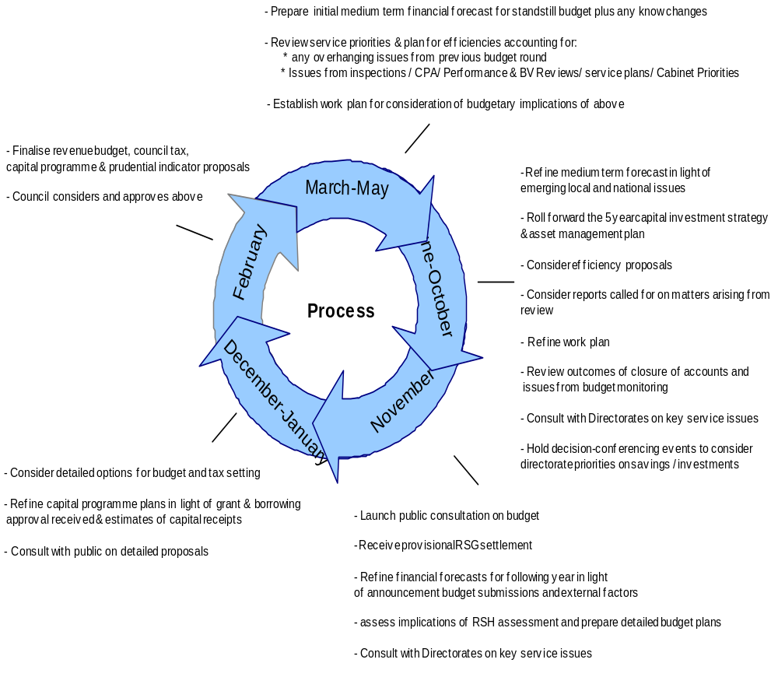

- REVIEW OF 2005/06 PERFORMANCE

- On 2nd March 2005, the Council set a budget of £294.772m in the expectation that reserves at 31st March 2005 would be £7.5m and by 31st March 2006 would be £6.853m, consistent with the minimum risk assessment, after taking account of a planned contribution of £0.643m to be made from reserves to support the 2005/06 revenue budget.

- The final outturn for 2004/05, which was determined after the 2005/06 revenue budget was set, resulted in reserves at 31st March 2005 being £7.9m, which included £0.422m of underspendings by directorates that were allowed to be carried forward, thereby giving unearmarked reserves in line with the budget expectation of £7.478m.

- The forecast outturn for 2005/06 is to underspend by £2.448m, giving a revised expected level of unearmarked reserves at 31st March 2006 of £9.283m

- The main reasons for the underspend have been :- £000s
Capital financing – debt rescheduling savings and increased interest on investments 1,103
Rate refunds on leisure centres (reduced 1990 rateable values) 790 Additional dividends from Manchester Airport and Modesole 406
Other net variations 149

- These matters have been reported to Budget and Audit Scrutiny Committee during the year. Other spending pressures, notably in Social Care and Childrens’ Services, have also been considered by the Budget and Audit Scrutiny Committee where the directorates have been requested to meet them from within their existing resources.

- All other directorates are indicating that they will contain expenditure within their budget, or will make good any overspending that cannot be avoided from future years’ budgets via the carry forward scheme.

- The main achievements that services have made during the year are detailed in Appendix 1.

- Of particular highlight in terms of financial achievement has been the 3 star rating obtained for the use of resources under the CPA assessment.

- DETERMINING THE MEDIUM-TERM FINANCIAL STRATEGY 2006/07 TO 2008/09

  - Through Budget and Efficiency Group the medium-term financial strategy for the next 3 years has been developed to ensure alignment between the strategic and budget planning processes.

  - The key priorities that the Group has identified for the Council for its financial strategy have been to develop a budget which :-

              - reflects the strategic priorities of the Council
              - maintains the financial health of the Council
              - maintains a policy of low Council Tax increases,
              - continues to seek increased efficiency from existing services,
              - delivers services which represent value for money, and
              - takes into account the results of public consultation.

- The financial objectives consistent with the key priorities had initially been identified as :-

  - Council Tax rises to be no more than 3% per annum for Salford’s services
  - Reserves to be supported by a detailed risk assessment
  - Eliminating the capitalisation of revenue expenditure by 2006/07
  - Providing for growth in priority services of £1m per annum
  - Making appropriate allowance for expected pay and price inflation and other expected commitments over the next three years.

- The tightness of the RSG settlement this year has meant that financial provision for service growth has not been possible and it has been necessary to amend the objectives to ensure that service priorities have at least been maintained without compromising the financial health of the Council and maintaining a positive “direction of travel”.

- The Group has also sought and considered efficiency savings from services in order to maintain low Council Tax increases.

- The Group has purposefully sought to avoid cuts in any area of service.

- The feedback from the public consultation has also been taken into account in determining the revenue budget and Council Tax.

- Details of the priorities for each directorate for 2006/07 analysed against the Council’s pledges and the Cabinet’s priorities are shown in Appendix 1.

- A detailed analysis of the responses to the public consultation is contained in Appendix 2.

- LEVEL OF GENERAL RESERVES

- The level of general reserves as at 31st March, 2006 is estimated to be as follows :-
£m
Actual Balance of Unearmarked Reserves at 1st April, 2005 7.478
Less : Budgeted contribution from reserves 2005/06 - 0.643
-------
Original Budgeted Balances at 31st March 2006 6.835
Add : Forecast underspend 2005/06 (as per paragraph 2.3 above) 2.448
-------
Forecast balance at 31st March, 2006 9.283

- This level of reserves is equivalent to 3.1% of the 2005/06 net revenue budget.

- Section 25(1)(b) of the Local Government Act 2003, which came into effect for the 2004/05 revenue budget, requires the chief financial officer to report to the authority on the adequacy of the proposed financial reserves and guidance from CIPFA is that local authorities, on the advice of their chief finance officers, should make their own judgement on a minimum level of reserves. CIPFA states that a well-managed authority with a prudent approach to budgeting should be able to operate with a relatively low level of general reserves and that chief financial officers should take account of the strategic, operational and financial risks facing the authority.

- A risk assessment has therefore been undertaken to establish what should be a minimum level of general reserves for Salford. The details are provided at Appendix 4. Whilst the assessment is not an exact science, and views may differ on what constitute key financial risks and their evaluation, it indicates that the minimum level of general reserves during 2006/07 should be in the region of £6.2m.

- This position appears likely to be exceeded in 2005/06 based upon the scenario set out above, and thus offers the scope for support to the 2006/07 revenue budget, if required.

- THE 2006/07 REVENUE SUPPORT GRANT (RSG) SETTLEMENT

Background to the RSG Settlement

- The Government has needed to consider a number of issues which have arisen in the lead-up to the 2006/07 RSG settlement, as follows :-

Formula Grant Changes

- The Government has previously updated key data such as population from being based on the 1991 Census to the 2001 Census.

- Their intention for 2006/07 has been to update the remaining data still based upon the 1991 Census, eg density and sparsity factors, certain deprivation indicators, ethnicity, in-commuters and day visitors.

- However, they have also taken the opportunity to review certain elements of the RSG formula where they believe them to also require updating. They have also consulted on the disbandment of Formula Spending Shares and moving to a grant determination system based on 4 formula blocks.

- Taken together, these planned changes have led to great uncertainty and unpredictability over the likely grant settlement at an individual local authority level to the extent that the ability to predict the likely level of grant settlement has been impossible, particularly with other changes and announcements, and hence budget planning has been more complex and uncertain than in recent years.

Schools Funding Changes

- The Government will make a major change to the way in which schools are funded from 2006/07. Schools will be wholly funded by a specific grant, the Dedicated Schools Grant (DSG), in future rather than as part of the Education Formula Spending Share (FSS) and RSG.

- However, whilst the DfES has been continually releasing information during the summer about how it expects the new schools grant system to operate, there has been continuing uncertainty around the precise nature of the grant transfer between RSG and DSG.

- Where such grant transfers are made it is normally the rule that the Government withdraw from FSS the appropriate amount provided in the formula. However, in this instance the DfES intend to withdraw from FSS the appropriate amount of local authority expenditure on schools in order not to financially disadvantage schools from the funding change and no doubt to avoid the national exchequer picking up a cost.

- Transitional arrangements are intended to operate to ensure no local authority or school loses out, but the details of such a scheme had not been announced in sufficient detail as to predict the impact prior to the announcement of the provisional RSG settlement.

Sufficiency of Funding for Local Government

- There has been concern in local government this year of an extremely tight grant settlement and consequently considerable lobbying has been taking place by the Local Government Association (LGA) in particular to ensure that the Government makes sufficient funding available to meet the continuing spending pressures upon local government arising from increased responsibilities, increased demands for certain services and inflationary pressures in others. The LGA has identified the need for an additional £2.2bn of funding for local government in 2006/07 to meet these pressures.

- The Government has announced their intention to cap any local authority to Council Tax increases of no more than 5%, following on from their success in the last 2 years in using the threat of capping to bring down the average national increase.

- However, this capping level has seemed inconsistent with data they have produced which originates from the 2004 Comprehensive Spending Review indicating that RSG may only rise by 1.5% next year after allowing for the schools grant transfer and other adjustments and resulting in a 7.5% council tax increase.

3-Year Revenue and Capital Settlements

- The Government intend to phase in the introduction of 3-year settlements for both revenue and capital from 2006/07 by initially introducing 2-year settlements covering 2006/07 and 2007/08, before introducing fully rolling 3-year settlements by 2008/09 which will dovetail with Comprehensive Spending Review announcements, the next one being due in 2007 to begin from 2008/09.

- Under this proposal, the first year grant will be fixed with the 2nd and 3rd years being provisional, although only changing with the annual updating of certain key data, eg population, taxbase. This therefore offers the opportunity for greater certainty and predictability in future budget setting beyond 2006/07.

The National Grant Settlement Details

- The Government has disbanded the use of Formula Spending Shares and moved to a system of determining the cash grant (Formula Grant) available to local authorities.

- Formula Grant will in future be determined by 4 blocks of funding :-
- Relative needs – the “Relative Needs Amount”
- Relative ability to raise Council Tax – the “Relative Resources Amount”
- Grant per head of population – the “Central Allocation”
- Grant floor to give a minimum grant increase – “Floor Damping”

- As previously, Formula Grant will continue to be paid in 2 components parts : business rates (NNDR) redistributed on a population count and the remainder as Revenue Support Grant.

- The government has also updated the grant distribution to :-

- reflect the 2001 Census data
- introduce new formulae for Personal Social Services for children and adults
- increase the resource equalisation
- introduce free off peak bus travel for over 60s and the disabled from 1/4/06
- other minor formula changes

- The settlement announces Formula Grant for authorities for both 2006/07 and 2007/08. The grant for 2007/08 will remain provisional until it is updated for data changes this time next year.

- Grant floor increases have also been introduced, as follows :-

 | 2006/07 | 2007/08
 | % | %
For education and social services authorities (ie like Salford) | 2.0 | 2.7
For police authorities | 3.1 | 3.6
For fire authorities | 1.5 | 2.7
For shire districts | 3.0 | 2.7

- Those authorities whose grant increase is above the floor will have their grant increase scaled back to pay for those protected by the floor. Education and social services authorities whose grant increase is above the floor only get to keep 15.5% of any cash increase above the floor in 2006/07 and 30.6% in 2007/08.

- The Government has also carried out its intention to fund schools directly by a specific grant known as the Dedicated Schools Grant.

- The headline national impact of the grant distribution is as follows :-

 | 2006/07 |  | 2007/08
 | £bn | % | £bn | %
Business Rates (NNDR) | 17.500 | - 2.8 | 17.500 | 0.0
Revenue Support Grant (RSG) | 3.443 | + 52.6 | 4.163 | + 24.8
Net Aggregate External Finance | 20.943 | + 3.4 | 21.663 | + 4.0
Specific Grants | 14.608 |  | 15.262 | + 4.5
Dedicated Schools Grant | 26.576 |  | 28.171 | + 6.0
Total Aggregate External Finance | 62.127 | + 4.5 | 65.096 | + 5.0

- Within these headline grant figures Formula Grant payable to local authorities comprises the following components :-

Business Rates (NNDR) | 17.500 | - 2.8 | 17.500 | 0.0
Revenue Support Grant (RSG) | 3.378 | + 54.1 | 4.105 | + 25.5
Police Grant | 3.936 | + 1.1 | 4.028 | + 2.3
Total Formula Grant | 24.814 | + 3.0 | 25.633 | + 3.7

(NB. All comparisons for 2006/07 are made with adjusted 2005/06 grant figures taking account of function changes and grant transfers, the major one being the Dedicated Schools Grant adjustment).

- The major features of the provisional RSG settlement have been :-

- Formula Grant for local authorities (Revenue Support Grant plus NNDR plus Police Grant) will increase by 3.0% in 2006/07 and by 3.7% in 2007/08.

- On average, Formula Grant for metropolitan areas increases by 2.6% and 3.6% in 2006/07 and 2007/08 respectively, for London 2.7% and 3.5%, and shire areas increase by 3.3% and 4.0%.

- Regionally, Formula Grant in 2006/07 for the North West increases by 2.9% with increases ranging between 2.7% and 3.7%. In 2007/08, the North West increases by 3.8%, with increases ranging between 3.4% and 4.5%.

- The distribution of Formula Grant according to the 4 block model is as follows :-

 | Proportion | 2006/07 | 2007/08
 | of Total | £bn | £bn
Relative Needs Amount | 71.0% | 14.821 | 15.350
Relative Resources Amount | -24.6% | -5.129 | -5.309
Central Allocation | 53.6% | 11.186 | 11.564
Floor Damping | 0% | 0 | 0
Total Formula Grant (excl Police Grant) | 100% | 20.878 | 21.605

- Overall, the Government’s grant settlement has fallen far short of what local government was seeking. Whilst they have publicised the fact that they have provided an extra £305m in 2006/07 and £508m in 2007/08 over and above their previous plans, this nevertheless falls at least £1bn short of what local government was seeking for 2006/07.

- The business rates multipliers are also updated through the RSG settlement and for 2006/07 these will be :-

  - Standard multiplier for most business premises 43.3p (2005/06 – 42.2p)
  - Small business multiplier 42.6p (2005/06 – 41.5p)

These multipliers represent an increase of 2.6%.

- Details of the national grant settlement are contained in Appendix 5.

Impact of the National Grant Settlement on Salford

- Salford’s Formula Grant can be summarised as follows :-

 | Formula Grant | Increase
 | £m | %
2005/06 Formula Grant | 221.487
Adjustment for Dedicated Schools Grant | - 116.797
Other Function and Grant Transfer Adjustments | -3.978
2005/06 Adjusted Formula Grant | 108.668
2006/07 Formula Grant | 111.847 | + 2.9
Function and Grant Transfer Adjustments | - 0.985
2006/07 Adjusted Formula Grant | 110.862
2007/08 Formula Grant | 115.652 | + 4.3

- Salford’s increase in Formula Grant for 2006/07 at 2.9% compares favourably with the metropolitan district average of 2.6% and with other Greater Manchester districts, with only Manchester at 3.9% and GM Police at 3.5% getting a higher increase.

- For 2007/08, Salford’s increase at 4.3% again exceeds the metropolitan district average of 3.6% and is only exceeded locally by Manchester at 4.7% and Oldham at 4.4%.

- Salford’s Formula Grant is analysed between the 4 blocks as follows :-

 | 2006/07 | Proportion | 2007/08 | Proportion
 | £bn | of Total | £bn | of Total
Relative Needs Amount | 89.361 | 79.9% | 92.092 | 79.6%
Relative Resources Amount | -8.616 | -7.7% | - 9.173 | -7.9%
Central Allocation | 36.020 | 32.2% | 36.790 | 31.8%
Floor Damping | -4.919 | -4.4% | - 4.019 | -3.5%
Total Formula Grant) | 111.847 | 100% | 115.652 | 100%

- The above table illustrates that Salford has received a higher proportion of grant to reflect its needs than the national average and a significantly lower resources deduction, which suggests that, in some respects, this settlement is more skewed to those authorities with high needs and low resource. However, a counter argument is the fact that shire districts have generally fared the best from this settlement in terms of their year-on-year increases.

- Because Salford is one of the authorities with a grant increase above the floor it has had its grant scaled down to pay for those authorities supported by the floor, to the tune of nearly £5m in 2006/07 and £4m in 2007/08. This damping adjustment is the 2nd highest in Greater Manchester in both years. Without damping, Salford would have had grant increases of 8% in both 2006/07 and 2007/08.

- A comparison of the Formula Grant settlement with all Greater Manchester authorities is set out in Appendix 6.

- 2006/07 AVAILABLE RESOURCES

Estimate of Available Resources

- The RSG settlement and the resource assumptions in the financial strategy, particularly over the level of Council Tax increase, can now be brought together to determine the available resources for revenue expenditure in 2006/07.
- The total resources available to fund Salford’s services, based upon a Council Tax increase of 3% are as follows :-

Council Tax for Salford’s services
- Levy at + 3% (2005/06 £1,178.40) £1,213.76

£m
- Council Tax income (for taxbase of 63,722 dw) 77.343
Add :

Formula Grant : NNDR 93.750

RSG 18.097
---------- 111.847
----------
Total Resource Available 189.190
======
- This represents an increase in resources of 5% on an adjusted like-for-like basis.

  - It should be noted that the estimated Council Tax base of 63,722 for 2006/07 has increased by 1,504 band D dwellings (or 2.4%) from 62,218 in 2005/06, which reflects the increase in new dwellings currently under construction and expected to be built and ready for occupation during 2006/07.

Collection Fund

- The Collection Fund is the account in which all financial transactions relating to the collection of Council Tax are kept.

- A local authority is required to determine, by no later than 15th January preceding the financial year for which the budget is being considered, whether its Collection Fund will be in surplus or deficit on 31st March prior to the financial year in question, and to share out such surplus or deficit with the precepting authorities in proportion to the composition of the Council Tax bill.

- On 9th January, 2006, the Lead Member for Customer and Support Services approved a recommendation to declare a break-even position on the Collection Fund at 31st March, 2006.

- An analysis of the amounts of Council Tax raised and collected since its inception in 1993/94 is attached at Appendix 7.

- 2006/07 REVENUE BUDGET

Development of the Forecast of Medium-Term Spending Requirements

- Forecasts of 3-year spending requirements began in March last year as a rolling review of medium-term spending requirements and have been refined as developments have unfolded during the year, particularly as the financial strategy was developed during the autumn, as details of the RSG settlement were announced in December, as submissions were received from directorates during December and implications for services and outcomes considered during December and January.

- The medium-term financial strategy has addressed the major challenges facing the City in order to fulfil the Council’s vision for the City, its 7 pledges and sub-pledges and the Cabinet’s cross-cutting priorities, and its contribution towards achieving the aims of the Community Plan and the Local Strategic Partnership, as referred to in paragraph 1 above. Accordingly, clear links have been developed between the key outcomes expected and the resources made available.

Consequently, the Budget and Efficiency Group reviewed the medium-term financial strategy and established the following framework for determining its expenditure requirements :-

Key spending priorities

- maintaining priority services
              - delivering services which represent value for money
              - continuing to seek increased efficiency from services
              - avoiding cuts in any area of service
              - maintaining the financial health of the Council
              - maintaining a policy of low Council Tax increases, with Council Tax rises to be no more than 3% per annum for Salford’s services
              - reducing the capitalisation of revenue expenditure
  - making appropriate allowance for expected pay and price inflation and other expected commitments over the next three years
  - reserves to be supported by a detailed risk assessment
              - taking into account the results of public consultation.

- As a result, and based upon total available resources of £189.190m, as per paragraph 6.2, a revenue budget can be set at this amount that fulfils the key strategic and spending priorities.
- An analysis of the increase in spending requirements is provided in the following table :-
£m %
Pay 5.392 + 3.0
Prices 4.374 + 2.4
Funding for time-expired grant funded schemes 2.680 + 1.5
New responsibilities (concessionary fares) 1.882 + 1.0
Capital financing costs 1.338 + 0.7
Efficiency savings - 2.902 - 1.6
Contribution from reserves - 2.000 - 1.1
Other adjustments - 1.710 - 0.9
Total 9.054 + 5.0
===== ====
- The following chart shows the increase in budget for each directorate in 2006/07 by comparison with 2005/06. It particularly emphasises the funding increases going into Social Care and lower spending increases for most services than 2005/06 due to the tightness of the RSG settlement :-

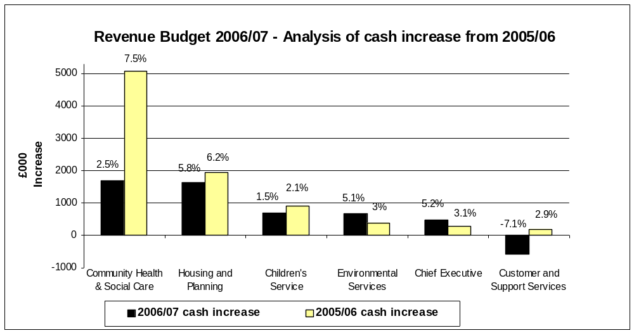
whilst the following chart illustrates efficiency savings by service in comparison with 2005/06 :-

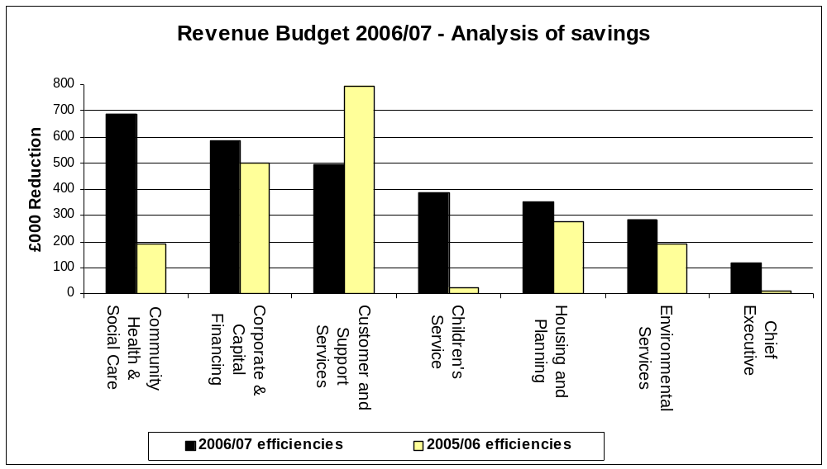

- There has not been the same flexibility in the ability to reallocate resources for service expansion in the budget this year as there has been in previous years because of the tightness of the RSG settlement.

- However, it should be noted that resource of £2.6m has been put into the budget to allow for time-expired projects previously funded from SRB, HMRF and NRF to continue to be provided from mainstream funds, whilst some £3m of NRF grant has been redirected to support the Local Strategic Partnership’s priorities in dealing with health, crime and disorder, environment and community engagement issues.

- The priority for the budget has been to maintain existing services and avoid cuts. Whilst new efficiencies of £2.7m have been identified, which has helped to keep expenditure within the resources available, cuts in service have been successfully avoided.

- It has also been necessary to consider a strategy for the use of reserves to keep expenditure to within the resources available.

Strategy for the Use of Reserves

- The risk assessment of the level of reserves required in 2006/07 has been previously referred to, which illustrates a minimum requirement of £6.2m. Also previously referred to has been the outturn for 2005/06, which is projecting an underspend of £2.4m and thus giving an expected level of reserves at 31st March 2006 of £9.2m

- Taken together, this position would suggest a balance of £3m could be available to support the budget.

- To commit to using reserves at this level in a single year is a one-off measure that runs the risk of being unsustainable beyond the immediate financial year. Any use of reserves, once committed in support of the budget, becomes a spending commitment within future years’ base budgets and therefore requires a strategy to recover them through savings in the following year. The greater the use of reserves, the greater the level of commensurate savings required and the greater the risk of cuts in service to deliver them.

- However, where additional revenue can be confidently expected in later years, eg from buoyancy in the taxbase, it would be an appropriate strategy to draw down reserves in anticipation of that additional revenue coming in to replenish reserves in later years. The planning system is indicating a significant upturn in the number of new dwelling starts (net of demolitions and voids) which will provide increased revenue from Council Tax over the next few years. In 2006/07, increased revenue of £1m is expected based upon a half-year’s income from an additional 1,500 band D dwellings (approx 2,500 total dwellings). By 2007/08, further Council Tax of £1m would be produced from the full year effect of these new dwellings. (Note : It is highly likely that further revenue will be available from more new starts in 2007/08).

- Therefore a strategy could be adopted which combines a controlled release of surplus reserves, ie additional to the risk assessment level, but at a level which does not provide a drain upon future budgets, with an anticipation of additional revenue from Council Tax without over-committing the use of reserves in support of the revenue budget. In this way, a maximum of £2m could be used from reserves in 2006/07, of which £1m would come from the level of general reserves and £1m from anticipated additional Council Tax revenue in 2007/08.

- The following table illustrates the flow of reserves in coming years adopting this approach, and assuming all other things being equal :-

2006/07 2007/08 2008/09
£m £m £m
Balance at 1st April 9.2 7.2 7.2
Less :
Use of reserves
- above risk assessed minimum -1.0 -1.0 -1.0
- from future revenue -1.0
Add :
Reserves replenished from add’n revenue 1.0

Balance at 31st March 7.2 7.2 6.2

Risk assessed minimum 6.2 6.2 6.2

- This approach would :-

- Maintain reserves at no less than the current minimum required until 2009/10
- Maintain a position over 3 years which would avoid the need for savings until 2009/10 to replace the use of reserves
- Still allow for revenue growth from Council Tax on new dwellings in 2007/08 and beyond
- Result in reserves at 31st March 2007 being no less than planned at 31st March 2006 in the 2005/06 revenue budget, and in fact marginally higher.

- There would always be risks to this approach that any budget overspend needing to be funded from reserves, or that any new future risks that required an increase in the minimum reserves level, could require this strategy to be revisited.

- However, taking all factors into consideration, it would be possible to contribute up to £2m from reserves to the revenue budget in 2006/07 without taking undue risk.

- In summary, therefore, a budget of £189.190m would enable all aspects of the financial framework to be met, and ensure that all directorates maintain a "positive direction of travel" in delivering the Council's pledges and priorities, national priorities and improving performance.

- This strategy is based upon the presumption that directorates contain current expenditure within budget. Whilst 2005/06 outturn is expected to be within budget, issues arising from budget monitoring during 2005/06 have identified demand pressures for 2006/07 in the learning difficulties service in Community, Health and Social Care and with children in care in Children’s Services and those directorates will need to ensure rigorous monitoring is in place to identify any emerging trends of increasing demand pressures and have contingency plans in place to take effective remedial action.

- Also, it should be noted that the Government has announced the Supporting People Grant allocations for 2006/07 and 2007/08. Grant will reduce by £233k in 2006/07 and a further £658k in 2007/08. The budget projection for 2006/07 provides for clawback of the £500k contingency allowed for implementing grant reductions to providers in 2006/07. No allowance has been made for the loss of grant in both years on the basis that the financial strategy for the service should be to achieve the accumulated grant reduction of £891k for the 2007/08 baseline, and in so doing should be capable of achieving part year reductions of £233k in 2006/07.

- Also, the budget projection now assumes no funding available for service expansion other than previous commitments entered into and that, consequently, any expansion will need to be funded from within directorate allocations.

- Details of the 2006/07 outturn budgets for each service compared to 2005/06 are contained in Appendix 8.

- Details of the efficiency savings accepted are contained in Appendix 9.

- THE 2006/07 COUNCIL TAX LEVY

- If a revenue budget is set at £189.190m then this would lead to a Council Tax requirement calculated as follows :-
£m
Total Net Budget 189.190

Less : Revenue Support Grant - 93.750
Business Rates (NNDR) - 18.097
-----------
Total Amount required from Council Tax for Salford 77.343
======

Divided by : Taxbase (number of band D equivalent dwellings) 63,722

Band D Council Tax for Salford's services £1,213.76
Band A £ 809.17

Increase 3%

- However, the final Council Tax increase is also dependant upon the increases from the 2 precepting authorities : Greater Manchester Police Authority
Greater Manchester Fire and Civil Defence Authority

- The precepts set by both authorities are :-

 | Precept at Band D | Increase
 | £ | %
Police | 110.67 | 4.99
Fire & Civil Defence | 46.38 | 3.7

- Local authorities need to be mindful that the Secretary of State imposed capping restrictions on several authorities in 2005/06 to limit Council Tax increases and has announced that he will continue to cap what he considers to be excessive increases. The capping criterion he has indicated for 2006/07 is that average Council Tax increases should be less than 5%.

- Taking these elements together, the overall Council Tax for 2006/07 would be significantly within the Secretary of State’s indicative limit, as follows :-

 | Council Tax at Band D | Increase
 | £ | %
Salford | 1,213.76 | 3
Police | 110.67 | 4.99
Fire & Civil Defence | 46.38 | 3.7
Total Council Tax at Band D | 1,370.81 | 3.2

- For most taxpayers in Salford, who live in Band A properties, the bill will be £913.87.

- Single persons will pay 25% less. For the majority of households this will mean an increase of 56p per week.

- The average bill, which allows for discounts, will be around £887.

- The full range of Council Tax amounts at each tax band are as shown in the following table, by comparison with this year :-

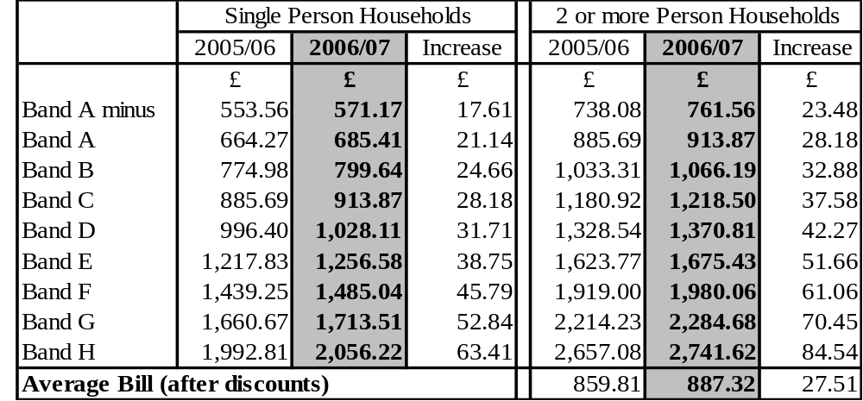

- BUDGET ASSUMPTIONS AND RISKS

Requirement of the Chief Financial Officer

- It is a requirement under Section 25 of the Local Government Act 2003 for the chief financial officer to report to the Council on the robustness of the estimates and the assumptions made in compiling it, and the adequacy of reserves.

- This section of the report seeks to fulfil that requirement.

Financial Health

- The financial health of the Council has now been restored through building up provisions against known future events, achieving a satisfactory level of general reserves, reducing outstanding debt, eliminating the deficit on the Collection Fund, and reducing the dependence on the capitalisation of revenue expenditure.

- Six years ago, the Council’s general reserves were eliminated by the call upon them to meet additional costs of looking after children, and a strategy was developed to restore general reserves to a healthy level, supported by the capitalisation of certain revenue expenditure. At the same time, deficits were being declared on the Collection Fund.

- Successive budgets since then have maintained a gradual improvement in the financial health of the Council to a point where it can justifiably be claimed that the financial health has been restored.

- Reserves are expected to reach £9.2m by 31st March 2006 as a result of an underspend of £2.4m in 2005/06. A risk assessment has been undertaken which identifies this level of reserves to be more than adequate to meet key risks and a strategy of controlled release of reserves back into supporting the budget has been developed. Comparison with authorities in the region show these levels of general reserves to be healthier than most neighbouring authorities.

- In addition, the provision for irrecoverable bad debts on sundry debtor accounts and Council Tax continues to improve.

- The level of outstanding sundry debtors is the lowest for several years, whilst the provision for bad debts is the highest for several years and therefore offers comfort that any debts identified as irrecoverable can be funded without a direct call upon the revenue budget. As a result, there is confidence that the annual contribution to the bad debts provision can remain at £0.2m.Over recent years the success of sundry debtor collection has enabled the provision to be reduced from £0.5m to £0.2m without increasing the risk of an under-provision.

- The deficit on the Collection Fund has been eliminated through improvements in the collection rate of Council Tax in recent years and a break-even position has been declared for 31st March 2006.

- The dependence on capitalising revenue expenditure is planned to be reduced further from £1m to £0.5m in 2006/07.

- Following a review of outstanding tripping claims, the level of claims now shows clear signs that they have peaked and are reducing. The Urban Vision joint venture with Capita and Morrisons which commenced on 1st February 2005 plans to invest £22m over the next 5 years in highway and footpath improvements to alleviate this issue and reduce tripping claims still further.

- The financial health of the Council has contributed towards a 3 star CPA rating for the use of resources in 2005.

- The medium-term financial strategy will continue to address these issues in a structured and considered manner.

Inflation

- Adequate allowance has been made for the impact of inflation.

- The pay increase in 2006/07 for administrative staff has already been agreed at 2.95% as the final year of an agreed 3-year pay settlement. The teachers pay increase will fall to be met from schools budgets which are now wholly funded by the Dedicated Schools Grant.
- Price inflation is limited to a 2.5% increase for charges which are determined outside of the control of the City Council, eg care charges by outside agencies, whilst no inflationary increase has been allowed for general supplies. An increase of 60% has been provided for a gas contract which is due to be renewed in 2006/07 on the basis of the current movement in commodity market prices and 12.5% for water costs to reflect the expected increase agreed by the water regulator. Increases in levies have been provided for at the level approved by the levying bodies, although it should be noted that the waste levy can vary up or down according to the level of waste tonnage disposed of. Any increases in costs above these assumptions must be absorbed within directorate budget allocations.

- Inflationary increases during 2006/07 will require close monitoring and scrutiny, and where they exceed the assumptions made will need to be contained within the budget allocations to directorates. The risk assessment of reserves makes allowance for the possibility of excessive inflationary costs being unable to be met by directorates.

Potential Spending Pressures

- The areas of greatest risk from spending pressures have been adequately addressed in the risk assessment of reserves.

- Key areas of spending pressure which are likely to be high risk have been identified in social care for adults and the elderly, and with children in care.

- New areas of potential risk have been identified with Supporting People and recycling.

- The risk assessment of reserves makes allowance for any potential breach of the assumptions built into these areas of the budget.

Use of Grant Funding

- Budget plans for 2006/07 have been affected by schemes coming out of grant-funding, notably SRB and HMRF. Where services rely upon specific grant support which are time-limited for future years' budgets beyond 2006/07, exit strategies are required.

- Budget plans are dependant upon a range of specific grants from the Government, some of which are time-limited, eg SRB, NRF, Children’s Fund, HMRF etc.

- Provision of £2.680m has been required in 2006/07 to provide for continuing funding of projects which have become time-expired and which are considered to be priority for continuing mainstream funding.

- It will be necessary for later years to have exit strategies in place to minimise any budgetary or service impact.

- The Government reduced the Supporting People grant by 5% nationally in 2005/06, and a one-off contingency of £0.5m was provided in the budget against reviews of supported schemes not achieving this saving in full in 2005/06. Reviews have successfully achieved this saving and the contingency funding has therefore been withdrawn for 2006/07. However, grant reductions of £233k in 2006/07 and a further £658k in 2007/08 have been made by the Government. No contingency against loss of grant has been made for 2006/07 on the basis that the financial strategy for the service should be to achieve the accumulated grant reduction of £891k for the 2007/08 baseline, and in so doing should be capable of achieving part year reductions of £233k in 2006/07. There is a risk of not achieving this strategy and this has been allowed for in the risk assessment of reserves.

Savings

- It is assumed that directorates will achieve their savings targets and have appropriately robust action plans in place to deliver them or can take alternative steps to achieve them. This will require rigorous monitoring during the year by Lead Members, Directors and Budget and Audit Scrutiny Committee.

- Total efficiency savings of £2.902m (including the full year effect of efficiencies in 2005/06) have been identified for 2006/07 in consultation with Lead Members and Strategic Directors.

- Budget and Audit Scrutiny Committee has examined the proposals and considers them to be achievable in principle, although wishes to examine the progress with their implementation during 2006/07 as part of the monitoring process.

- It is assumed that all directorates will meet their required savings targets by the means proposed in this report, but should it not prove possible by those means then alternative means will be identified to ensure that net expenditure is contained within directorate budget allocations.

Capitalisation of Revenue

- The revenue budget continues to be supported by the capitalisation of certain expenditure more normally chargeable to revenue. However, provision has been made in the 2006/07 revenue budget to unwind £0.5m of capitalised expenditure, with a further £0.5m to be unwound in the 2007/08 budget plans to eliminate the dependence on capitalisation altogether.

- It has been necessary to capitalise certain items of revenue expenditure for the past 6 years’ budgets, ranging from £13m in 2000/01 down to the planned level of £0.5m for 2006/07, to ensure a budget can be set at an affordable Council Tax.
- The medium-term financial strategy envisages eliminating this dependence on capital support by unwinding the capitalisation by 2007/08.

- The risk assessment of reserves now assumes that there is no longer a risk that insufficient revenue expenditure can be legitimately capitalised.

Capital Programme

- The revenue budget assumes that there will be no significant revenue implications arising from the preparation of the 2006/07 capital programme other than the assumptions over the capital financing costs which will be incurred on new borrowing (including the use of unsupported borrowing) and future annual maintenance costs from completed schemes.

Control of Risk

- Risk will be controlled through a combination of :-

- Monthly directorate level budget monitoring reports to Lead Members ;
- Meetings between the Lead Member for Customer and Support Services and other Lead Members as appropriate to agree action plans from issues arising from monthly budget monitoring and other developments not budgeted for ;
- Monthly corporate budget monitoring reports to Budget and Audit Scrutiny Committee to identify issues, agree appropriate action and call for special reports on issues of concern ;
- A quarterly update of risks which shall be incorporated into the reports to Budget and Audit Scrutiny Committee : and
- Reports from Budget and Audit Scrutiny Committee to Cabinet after each meeting on recommendations to be considered by Cabinet.

Budget Assumption Details

- A schedule of the key assumptions made in drawing up the 2006/07 revenue budget is contained at Appendix 10.

PART 2

THE HOUSING REVENUE ACCOUNT (HRA)

REVENUE BUDGET 2006/07

1. INTRODUCTION

1.1 This report is intended to inform members of the Housing Revenue Account (HRA) 2005/06 Approximate (the “expected” outturn) and the 2006/07 Budget

-incorporating

- effects of the government’s proposals on rent restructuring from April 2003, approved on the 6th February 2006
- the actual HRA subsidy determinations for 2006/07
- the actual Item 8 credit and Item 8 debit (general) determinations 2006/07
- previously approved service developments
- the effects of the 2005/06 outturn
- the relationship with New Prospect Housing Limited.

1.2 This report reviews the current year's plans and achievements in financial terms and also reflects aspirations for the coming year taking into account the wishes and needs of its tenants and available resources.

2. PUBLIC SECTOR HOUSING PRIORITIES

Housing Priorities

2.1 Although there were many notable achievements in 2005/06, and these are shown at Appendix 12, the main one was around all the initial preparatory work for determining options for the future management of the Council housing stock (“Stock Options”), which will continue into 2006/07 and beyond.

2.2 Consequently for ease of reference the priorities for 2006/07 and achievements for 2005/06 are not split between General Fund and HRA activities but shown for the Housing Service in its entirety.

2.3 All priorities for 2006/07 can be directly linked to the action plan arising from the Housing Strategy. It should be noted that the action plan is subject to regular monitoring and review.

Public Consultation

2.4 As part of the budget process there has been consultation with tenants through making a presentation to each of the five Local Boards and the Parent Board.

2.5 Tenants were asked for their views on the proposed increases to the rents and also their view on how the money was being allocated within the HRA. They were also consulted about the further de-pooling of service charges, which has to be implemented in relation to Stock Options.

2.6 A summary of the issues raised is shown at Appendix 13 and these have been taken into account when finalising the budget for the HRA for 2006/07.

3. REVIEW OF 2005/06

The 2005/06 Base Budget

3.1 The original approved budget for 2005/06 provided for gross expenditure of £85.141m, funded by matching income from rents, charges and subsidy.

3.2 At the time the budget was approved it was assumed there would be no contribution to or from reserves during 2005/06 and at 31st March 2006 reserves would be £2.838m or 3.3% of the budget which is slightly higher than the 3% Audit Commission guidelines.

The 2005/06 Approximate

- Following determination of the 2004/05 outturn, which was finalised after the 2005/06 base budget was set, the actual reserves at 31st March 2005 were £4.220m due mainly to a reduced call on reserves for repairs in 2004/05. The reasons for the increased surplus were reported to the Housing Lead Member on 30th June 2005.

- During 2005/06 the HRA budget has been continually monitored and in order to balance the budget it is forecast that a contribution from balances of £0.663m will be required, of which £0.531m was carried forward from 2004/05, to give outturn expenditure of £86.429m.

- The base data used and assumptions made in the calculations are highlighted in Appendix 15.

3.6 Brief details are also given at Appendix 15 of the variance between the original budget and the expected outturn for 2005/06.

4. HRA RESERVES 31st MARCH 2006

4.1 Members will note that as a consequence of the approved variations to the budget during 2005/06, the expected level of reserves at the 31st March 2006 is now forecast to be £3.557m or 4.1% of the budget, as follows :-
£m %
Opening Balance 1st April 2005 4.220 4.9

Less : Stock options appraisal costs 0.132
Earmarked repairs expenditure 0.531
------
Estimated Reserves 31st March 2006 3.557 4.1

5. THE 2006/07 ESTIMATE

Summary

5.1 The HRA gross revenue budget for 2006/07 is proposed at £89.432m.

5.2 The base data used and assumptions made in the calculations are highlighted in Appendix 15, which also compares the budget for the HRA for the 2006/07 Estimate with the 2005/06 Approximate, together with details of the major variances between the respective figures.

5.3 The following paragraphs consider the major issues which have arisen in consideration of the HRA revenue budget for 2006/07.

5.4 It should be noted that it is planned to use £1.193m from reserves, leaving a forecast balance in reserves of £2.364m or 2.6%, which will be slightly below the minimum 3% level prescribed by the Audit Commission, although it will be consistent with a risk assessment undertaken to determine the required minimum level of reserves. This is shown at Appendix 14.

Resources

Housing Rent Restructuring And Service Charges

5.5 Members will recall that Cabinet on the 16th July 2002 approved a revision to HRA rent review policy to align it with the HRA budget process with effect from 1st April 2003, and in order to align with Government proposals on rent restructuring.

5.6 The Government’s aim is that rents should reflect more closely the qualities which tenants value in properties, and that there should be no unwarranted differences between the rents set on similar properties by different local authorities or registered social landlords (RSLs). The key to achieving this is a common formula for both local authority and RSL rents to be based on.

- The size, condition and location of the property
- Local earnings

5.7 30% of the property’s rent will be based on relative property values, whilst 70% of the property’s rent will be based on relative county level earnings. A bedroom factor will be applied to reflect the size of the property.

5.8 The Government wants the transition from old rent to new rent to be completed within 10 years from 2002 to 2012.

5.9 All property rents have been recalculated and modelled over the remaining transition period in line with Government recommendations and included in the ‘Rent Restructuring Plan’

5.10 At the Council meeting of the 18th February 2004 approval was given to the rent restructuring plan for three years to ensure convergence and that any annual refinements during that period would be approved by the Lead Members for Housing and Customer and Support Services. A copy of the rent restructuring plan is shown at Appendix 16 for information.

5.11 Accordingly, at the Joint Lead Member meeting of the 6th February 2006 approval was given for an average rent increase of £2.41 per week for 2006/07 and an increase to service charges of inflation plus half a percent as permitted by Government. The average increase of £2.41 per week is based on 52 weeks. The £2.41 increase equates to an average increase of £2.61 per week on a 48 week basis due to the rent free weeks.

5.12 Additionally, approval was given for the introduction of two new service charges by taking them out of the rent calculation and charging them separately. This was an exercise that needed to be undertaken in preparation for Stock Options to ensure that charges were being recovered only from those tenants receiving specific services. It should be noted that as a result of introducing these new charges no tenant is detrimentally affected as a consequence.

5.13 This increase has been incorporated into the recommended budget for 2006/07 for the HRA. Any deviation from these figures will result in the HRA being out of balance for 2006/07.

Housing Subsidy

5.14 There were 2 important changes to housing subsidy in 2004/05, as follows :-

- removal of rent rebate subsidy (see paragraphs 5.31 to 5.32 below) ; and
- no longer subsidising the minimum revenue provision (MRP) required to be set aside for the repayment of HRA debt.

5.15 Local authorities have the discretion from 2004/05 to use part of their Major Repairs Allowance (MRA) to repay debt if they wish, but there is no compulsion so to do

5.16 On the basis that using part of the MRA for MRP purposes would provide less resource to maintain the current repair condition of the housing stock, the HRA revenue budget for 2006/07 makes no provision for the repayment of debt.

5.17 Details of the housing subsidy calculation are shown in Appendix 17.

Expenditure

New Prospect Housing Limited (NPHL) – Management Fee

5.18 On 16th September 2002, the Council established an arms length management company, New Prospect Housing Limited (NPHL), to manage and maintain its council housing stock

5.19 The HRA pays to NPHL a monthly management fee based on a jointly agreed annual budget between the Council and the Company.

5.20 A fee for 2006/07 of £21.083m was agreed at the Joint Lead Member meeting of Housing and Customer and Support Services on the 6th February 2006. This fee has been incorporated into the HRA budget for 2006/07.

5.21 It was also agreed at the meeting that the performance of NPHL would be subject to robust monitoring during 2006/07 in relation to the services to be provided and the performance levels expected for the fee paid. This will be undertaken through reviews of the Delivery Plan. It has also been agreed that the fee will be reviewed in relation to any changes arising during 2006/07 in planning for the effects and changes of Stock Options.

Repair/Maintenance/Improvement

5.22 Members will recall that Housing Committee, 18th December 1998, approved the creation of a separate Housing Repairs Account within the ring-fenced HRA under Section 77 of the 1989 Local Government and Housing Act to facilitate future budget management.

5.23 A Housing Repairs Account is used to keep a separate record of income and expenditure relating to the repair and maintenance of an authority’s HRA houses or other property. The main item of income within the Housing Repairs Account will be the contribution from the HRA.

5.24 The contribution from the HRA comprises a repairs element of £21m and an element of the NPHL management fee of £2.9m (this is included within the £21.083m referred to at paragraph 5.20 above). The repairs element has allowed for an increase for inflation. It should also be remembered that the level of the housing stock is also decreasing through right to buy disposals, thereby neutralising the effects of the inflation increase year on year.

5.25 Members are reminded that in addition to the above there is also a contribution from revenue to support the capital programme of £0.3m and whilst this may seem low compared to previous years it needs to be considered in conjunction with the 2006/07 capital programme later in this report.

Major Repairs Reserve

5.26 The Major Repairs Allowance (MRA) was introduced for the first time in 2001/2002 as part of the switch to Resource Accounting. It represents the estimated long term average amount of capital spending required to maintain the stock in its current condition.

5.27 The Local Authorities (Capital Finance and Accounts) (England) Regulations 2000 require authorities to set up a Major Repairs Reserve to facilitate the utilisation of the MRA.

5.28 The funds are an HRA capital resource and are paid to local authorities by Government via HRA subsidy.

5.29 The Item 8 Determination provides for the HRA to benefit from the potential for short-term investment of any unspent sums in the reserve each year.

5.30 The amount available for capital spend in 2005/06 is £15.9m and for 2006/07 is £16.270m. Full details of this and the overall Housing capital programme for 2006/07 are covered in Part 3 of this report. The formation of the capital programme for 2006/07 and the utilisation of resources in relation to the HRA have been formulated based on work programmes submitted by NPHL to achieve decent homes.

Rent Rebates

5.31 Changes in the Revenue Support Grant (RSG) settlement for 2004/05 for the General Fund revenue budget require rent rebates to be funded by the General Fund from 1st April, 2004.
5.32 The ODPM in their housing subsidy determination have allowed local authorities the discretion to transfer amounts from the HRA to the General Fund to compensate the General Fund for an overall loss of benefit subsidy brought about by the transfer of rent rebates and changes to subsidy rates for 2004/05 for all types of benefit payment (which includes Council Tax benefit and rent allowances). This transfer is based on 2001/02 audited subsidy data and amounts to £0.919m in Salford's case for 2004/05. In 2005/06, it reduces to 50% of this sum, ie £0.460m and in 2006/07 it ceases.
5.33 The proposed General Fund and HRA revenue budgets for 2006/07 have been drawn up on the basis of no transfer from the HRA to the General Fund being made and it will be noted that the transfer of £0.460m has been allowed for in 2005/06.

5.34 However, the Council does not need to commit itself to making the transfer until it closes its 2005/06 accounts during the summer of 2006. The situation with the General Fund and HRA revenue budgets will be kept under review and the implications for the housing service of making the above-mentioned transfer will be considered in the context of the priority budgetary demands of all services. The Council may therefore choose at a later date to reduce or eliminate this transfer if the financial circumstances of the 2 funds are appropriate.

Implementation Costs of Stock Options

5.35 A report was presented to the Joint Lead Member meeting for Customer and Support Services and Housing on the 28th November 2005 detailing the initial forecasted costs arising through the costs to be incurred in the preparation for Stock Options.

5.36 These costs cover staff seconded to work on the project from Housing, NPHL, Finance, Legal and Personnel, plus specialist consultants for Finance, Legal, Tenant Consultation, Stock Condition Surveys and Marketing. Whilst some of these costs particularly those associated with transfer will be recovered as shown within Appendix 15, the remainder have to be funded through the HRA.

5.37 Consequently within the report there was a funding proposal that would allow the costs to be met, which would require a contribution from balances, but this would not leave these in a precarious position. The effect upon balances at the end of 2006/07 is covered in the section below.

5.38 A separate monitoring report will be prepared on a monthly basis to Housing Lead Member on the budget for the implementation costs.

HRA Reserves

5.39 Members are reminded of the volatile nature of the HRA and the need, particularly under ringfencing, to maintain reserves to meet unforeseen circumstances which might arise and to minimise the effects of:-

- Right to buy applications
- Any possible adverse performance issues
- Budget variations identified during the year
- Decent homes investment requirements
- ODPM continually reviewing HRA subsidy
- Trends in void properties
- Rent restructuring and convergence
- Service charges
- New legislative requirements
- Homelessness and Supporting People changes
- Environmental and Estate investment

5.40 In an ideal situation reserves associated with an account of this size taking particular account of the comments in the previous paragraph would amount to approximately 3% of the gross budget as recommended by the Audit Commission. A formal risk assessment exercise has been undertaken similar to that for the General Fund to review risks in relation to reserves and this is shown at Appendix 14.

5.41 The HRA revenue budget for 2006/07 would normally aim to achieve a minimum level of reserves of 3%, or £2.682m on the gross budget of £89.432m.

  - Actual reserves at 31st March 2007 are expected to be £2.364m, or 2.6% as follows:

£m %
Opening Balance 1st April 2006 3.557 4.0

Less : Stock options appraisal costs 1.193

Estimated Reserves 31st March 2007 2.364 2.6

5.43 Although the level of reserves is slightly below the recommended amount this is justified through the investment required to fund the implementation costs of Stock Options. What the above demonstrates is that to keep the HRA in balance and fund the Stock Option costs of £4.820m in 2006/07 a contribution of only £1.193m is required from balances.

- CONCLUSION

- Members are reminded of:-

- The volatility of the HRA and potential effects of subsidy changes.

- The need to:-

- maintain reserves to provide adequate cover against anticipated risks

- sustain improvements to the housing stock and in housing management performance

- continually review service delivery within a rolling 5 year programme of Best Value reviews

- continually review the void property situation and the resultant impact on HRA income

- meet any further subsidy changes and inflationary factors that could affect the account during 2006/07 and beyond.

- RECOMMENDATION

- Being mindful that, under Section 76(3) of the Local Government and Housing Act 1989, on the basis of the best available information, the Housing Revenue Account will not be in deficit, members are requested to approve the proposed HRA budget and contribution from reserves for 2006/07.

PART 3

CAPITAL PROGRAMME 2006/07

- THE PRUDENTIAL CODE FOR CAPITAL FINANCE

- In considering the capital programme, due regard needs to be given to the implications of the new prudential capital finance system, which became operative on 1st April 2004 under the Local Government Act 2003, and is guided by CIPFA’s Prudential Code for Capital Finance.

- The key principle behind the new system is that any capital expenditure plans must be affordable. In particular, local authorities will have the freedom to determine the amount of new borrowing it will undertake, subject to the capital financing costs being affordable in the revenue budget.

- To reflect this freedom, the Government has abolished the system of credit approvals and replaced it with amounts of borrowing that it will support through RSG.

- Whilst this still imposes a form of constraint on borrowing, there is now more freedom for local authorities to determine their own borrowing, providing they can afford to meet the capital financing costs from their revenue budget.

- Also, capital planning over longer timescales is better facilitated as the timing of capital receipts is less critical and borrowing can be used to regulate any delays in completion of disposals at year-end, provided any resulting temporary extra debt is repaid from the capital receipt.

- Borrowing to fund invest to save proposals now also becomes a realistic proposition.

- As far as funding capital expenditure from borrowing is concerned, Council in February 2004 agreed the following principles :-

- Borrowing will only exceed the amount supported by Government in prescribed circumstances.

- The prescribed circumstances will be : - invest to save proposals where a business case has been approved by the Lead Member for Corporate Services (now Customer and Support Services) which provides for revenue savings at least equivalent to the capital financing costs of the borrowing ;
- where a capital receipt expected and built into financing plans in a financial year is delayed until the following financial year, provided the borrowing is repaid by the capital receipt in the following year ; - where Government grant is certain or expected with a high degree of confidence and it is essential that expenditure is committed ahead of the grant being approved or paid, in order to maximise the amount available.

- Other prescribed circumstances may be identified in due course as capital planning and operation of the prudential code become more mature.

- Furthermore, because the new prudential system requires a chief financial officer to recommend prudential borrowing indicators to the Council, the determination of the capital programme needs to be aligned with the revenue budget by considering and approving them at the same Council meeting.

- REVIEW OF 2005/06

- Based on the latest capital monitoring report to Budget and Audit Scrutiny Committee (February 2006) outturn capital expenditure is expected to be £112.950m.

- Available resources are expected to be £121.926m, giving a surplus of usable capital receipts to be carried forward of £8.976m.

- However, set against this surplus of available receipts is the need to earmark £9.101m for Educational use in 2006/07 through to 2008/09, thus leaving an effective shortfall of receipts of £0.125m. This shortfall will be made good by the temporary use of earmarked receipts.

- CAPITAL INVESTMENT PRIORITIES FOR 2006/07

  - The key spending priorities identified by strategic directors and lead members have been :-

Housing
- Private Sector – promoting regeneration through HMRF - disabled facilities grants
- Public Sector – meeting decent homes standards

Childrens’ Services
- Secondary school replacement and modernisation programme, ie BSF wave 3
- Primary school replacement and modernisation programme, with particular focus on replacement schools in Ordsall and Seedley/Langworthy
- Nursery provision via the Surestart programme

Planning
- Highways – fulfilling the local transport plan obligations and investment in footpath improvements
- Regeneration – supporting proposals for Central Salford and other key areas
- Disabled Access – to Council buildings

Community Health and Social Care
- Social Care – enhancing and maintaining assets and investment in ICT
- Leisure – refurbishment of Fit City Worsley, completion of Littleton Rd Sports Village
- Community – Higher Broughton Community Hub

Environment – maintaining the rolling programme of improvements in cemeteries and parks.

Chief Executive – regeneration of Central Salford, provision of Salford Innovation Park.

- Underpinning these priorities are the obligations to meet contractual commitments, support the revenue budget and maximise Government grants, borrowing approvals and other external funding.

- Of particular concern for the coming year has been the need to ensure that the Council's priorities in regeneration areas, including its commitment to the Housing Market Renewal Fund pathfinder, are fully met and therefore, after contractual commitments which must be funded are taken into account, proposals for capital investment in regeneration areas have been given highest priority in considering how resources should be allocated for 2006/07.

CAPITAL RESOURCES 2006/07

- The amount of resource expected to be available in 2006/07 is as follows :-

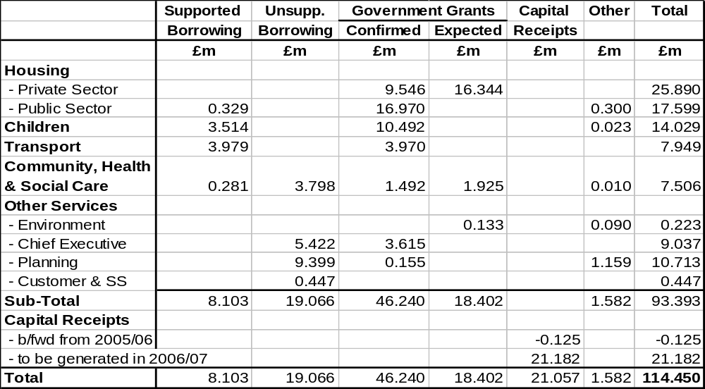
- It should be noted that, whilst there are some Government grants still to be confirmed, there is a high expectation that they will be confirmed in due course, where necessary following confirmation of proposed programmes, business plans or grant applications.
- The main Government grants awaiting confirmation are :-
£m
Housing – Private Sector
- HMRF 16.344

Environmental Services
  - Lottery – parks infrastructure 0.133

Community Health and Social Care
  - Lottery – Worsley Pool 1.925

- The critical figure within this table is the £21.057m of usable capital receipts. The extent to which this resource can support grant-funded proposals and its sufficiency to fund other non-grant-funded priorities, both national and local, is the key to determining a fully funded programme.

- A detailed breakdown of the list of assets for disposal which forms the estimate of usable capital receipts to be generated in 2006/07 is attached at Appendix 18.
- Members are requested to agree to the list of assets for disposal to allow the Director of Housing and Planning, through Urban Vision Partnership Ltd, to proceed to market those sites where a commitment to dispose has not already been made.

- Agreement to the list of assets for disposal will also allow a greater degree of predictability and certainty to be built into the forecast of available resources and hence better determine those proposals that are able to be funded.

- It should be noted that, where certain Government grants remain to be confirmed, estimates have been included on the basis of informal indications of grant amounts. It will be necessary in such instances to only commit related expenditure when the grant award is confirmed formally or there is a high degree of certainty that formal confirmation of grant will be made.

- CAPITAL EXPENDITURE PROPOSALS 2006/07

- On the basis of the Council’s priorities for capital investment, and having regard to the estimate of available resources, then a possible capital programme amounting to £107.325m could be determined as set out in the table below :-

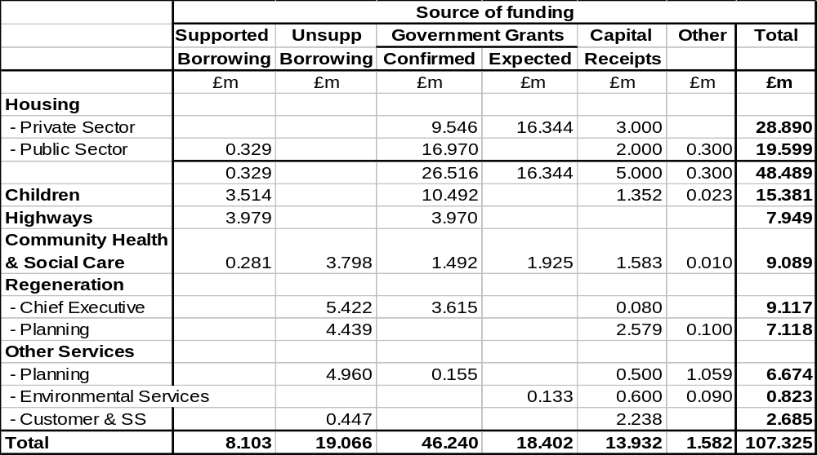

- It can be seen from the table above that the total proposed programme is approximately £7m less than the estimated available resource. This is mainly due to the need to earmark usable capital receipts from certain disposals of educational assets for future education capital expenditure.

- In addition to meeting the financial policy objectives set out above, a capital programme of £107.325m would enable the priorities outlined above to be met, focussing in particular on the following major proposals for each service :-

Housing

- To meet the requirements of the HMRF pathfinder
- To stimulate the regeneration of areas in Central Salford
- To support improvements to property occupied by disabled residents
- To maintain the condition of Council housing stock.

Education

- To remove surplus places
- To invest in improving the condition of primary schools
- To provide suitable nursery provision

Highways

- To maintain the fabric of the City’s highways
- To improve the condition of footpaths and thus reduce tripping claims

Social Services

- To modernise residential care facilities for older people and day care facilities for adults and older poeple
- To invest in ICT

Regeneration

- To invest in the regeneration of key areas of Central Salford, eg Charlestown/Kersal, Higher Broughton, Lower Broughton, Pendleton, Chapel St/Adelphi, Claremont/Weaste and Ordsall.
- To invest in certain outer areas of the City, eg Eccles Town Centre, Liverpool Rd, Eccles, Swinton Town Centre.

Other Services

- Improvements in parks and cemeteries
- Completion of the Littleton Rd Sports Village
- Making provision for the capitalisation of revenue expenditure in line with revenue plans.

- A schedule of the schemes contained in the proposed capital programme is included at Appendix 19.

- It should be noted that, in addition to the above-mentioned programme, which focuses on expenditure on assets in the ownership of the Council, major investment is planned for the future through other proposed public private partnership arrangements which will benefit the residents of Salford, as follows :-

- The replacement of 2 high schools – Buile Hill and Harrop Fold – via a PFI
- A new waste disposal PFI contract for Greater Manchester Waste Disposal Authority
- A new magistrates courts for Salford based in Eccles via a PFI contract to be let by the Courts Agency, which includes a similar facility in Bolton
- The replacement and refurbishment of secondary schools via Building Schools for the Future wave 3 funding
- Meeting decent homes standards through a review of the future investment options in Council housing.

- It should be noted at this stage that the capital programme can be subject to change as the year unfolds, with new schemes being introduced as funding sources are confirmed, schemes being removed if the expected funding proves not to be available, expenditure forecasts changing and the amount of usable capital receipts varying as marketing and disposal proceeds.

- Approval to the proposed capital programme at this stage should be seen as giving consent to an initial programme of those schemes that are at present contractually uncommitted proceeding to design and tender stage. Approval to commit capital expenditure on individual projects will continue to be referred to the Lead Member for Customer and Support Services, as at present, to ensure that projects will only be committed if funding is available or certain to become available.

- The capital programme will therefore need to be continuously reviewed during 2006/07 to reflect any significant variations that may arise, any new priorities that may emerge and certainly following the 2005/06 capital outturn.

- UNDERLYING ASSUMPTIONS

- Use of Borrowing

  - The use of supported borrowing will be maximised at £8.103m and a further £19.066m will be borrowed using unsupported borrowing powers.

  - The capital financing charges on unsupported borrowing can be met from the revenue budget. Appropriate provision has been made in the revenue budget to fund the unsupported borrowing to be used in funding of the capital programme.

    - Use of Capital Receipts

      - Capital receipts amounting to £21.057m are expected to be available from asset disposals.

        - Of this amount, some £10m needs to be earmarked for Childrens’ Services capital expenditure for educational purposes. An amount of £1.352m will be used out of this earmarked sum in 2006/07, leaving £8.648m to be carried forward for future educational use.

        - Of the remaining £11.057m available, £2.675m is earmarked for recycling into regeneration areas, and all this amount will be committed for use in such manner in 2006/07.

        - This leaves a balance of £8.382m available for general support of the capital programme.

        - After use of the earmarked sums for education and regeneration purposes, an amount of £9.905m is needed from unearmarked sources to fund the proposed capital programme, ie some £1.523m in excess of the amount expected to be available.

        - If this shortfall cannot be made good from additional receipts during the year it will be managed either by the slippage of expenditure into 2007/08 or by the temporary use of earmarked receipts provided such use is “repaid” from unearmarked receipts generated in 2007/08.

- RISKS

- The key risks are that :-

- The over-commitment of resources is not managed within the resources available. The management of individual service allocations allows for the natural tendency of capital programmes to underspend. Services are permitted to set over-programming levels to reflect this in the expectation that the outturn expenditure will be managed within the resource available. This approach runs the risk of expenditure over-shooting the resources available, but limits are applied to the over-programming that reflects the level of contractually committed expenditure and provision for new starts.

- Expected capital receipts will not be realised. Delayed receipts will be managed through unsupported borrowing or through the temporary use of earmarked receipts. Any substantial receipts from asset disposals which are critical to funding the capital programme and which cannot be realised, or realise less than expected, will be managed by adjusting the capital programme.

- Government grants not being realised. Capital projects which are dependant upon grant support will not be commissioned unless a grant approval has been received or is confidently expected. All proposed capital expenditure will be subject to the approval of the Lead Member for Customer and Support Services, who must be satisfied with the certainty of grant support.

- Cost overruns. Expenditure on capital schemes is monitored regularly and project managers are required to report any significant cost increase to their director and lead member. Where possible, cost overruns will be managed within resource allocations to services. Where an increase in resource is required this will be considered by the Lead Member for Customer and Support Services and, if necessary, Cabinet.

- Cost increases arising from outstanding Lands Tribunal hearings. The Council is currently involved with Lands Tribunal hearings yet to be held in respect of land acquisitions at Eccles Town Centre and the Manchester/Salford Inner Relief Route. Any additional costs over and above what has been provided in the capital programme and available by way of additional Government grant would fall to be met from the Council’s own resources.

PART 4

PRUDENTIAL INDICATORS
2006/07 TO 2008/09
- BACKGROUND

- The Local Government Act 2003 changed the system of capital finance with effect from 1st April, 2004 and one of the requirements of the Act (Section 3) is for each local authority to determine its own affordable borrowing limits and to have regard to specified codes of practice when determining these limits.

- Regulations issued pursuant to the Act endorsed a code of practice produced by CIPFA (the Prudential Code for Capital Finance) which local authorities should follow in determining its borrowing limits. The code advises local authorities to determine its limits for 3 years ahead.

- This report therefore sets out the limits for 2006/07 to comply with the requirements of the Code and to establish the affordability of the Council’s capital investment and treasury management plans.

- PRUDENTIAL LIMITS 2006/07 TO 2008/09

Prudential Limits for Capital Expenditure and Borrowing

Capital Expenditure

- The actual capital expenditure that was incurred in 2004/05 and the estimates of capital expenditure to be incurred for the current and next three years that are recommended for approval are :-

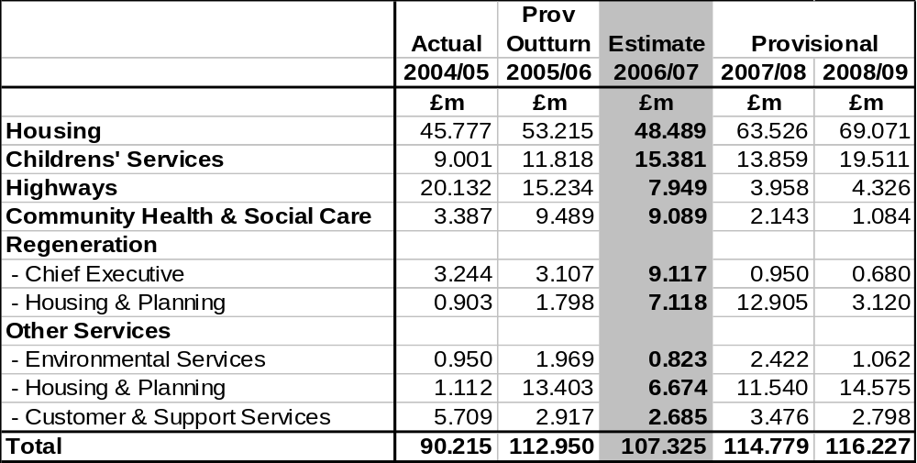

- The estimates of capital expenditure in 2007/08 and 2008/09 are provisional and are taken from the capital investment strategy approved by Council in February. They should only be considered as indicative at this stage as assumptions made may change in the light of future developments.

Ratio of Capital Financing Costs to Net Revenue Stream

- Ratios are required to be reported which identify the capital financing costs on the proposed capital expenditure shown in the previous table as a proportion of the net revenue stream for the same periods.

- The net revenue stream is defined as :-

- For General Fund - the total of income from NNDR, RSG and Council Tax
- For the HRA - total rent income (exclusive of service charges) and income from Government grants.

- The estimates of capital financing costs in 2007/08 and 2008/09 are provisional and are based on the cost of borrowing £20m each year to fund the capital investment strategy approved by Council last July. They should only be considered as indicative at this stage.

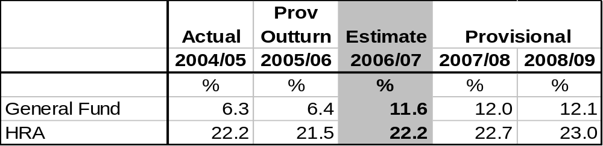

Incremental Impact of Capital Investment Decisions

- An estimate of the incremental impact is required to be made in Band D Council Tax and average weekly housing rent terms of the capital financing and other revenue costs of the proposed capital programme.

- As approval is being sought from the Council to the 2006/07 capital programme only, and the future contractual commitments that flow from that programme, the incremental impact does not reflect the full cost of the potential capital investment in 2007/08 and 2008/09.

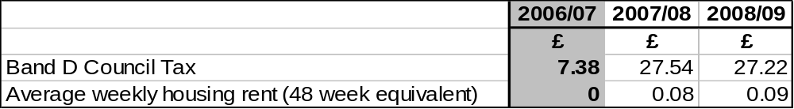

Capital Financing Requirement

- The capital financing requirement measures the Council's underlying need to borrow for a capital purpose and is measured net on investments held.

- Advice from CIPFA in their prudential code is that net external borrowing does not, except in the short term, exceed the total of the capital financing requirement in the preceding year plus the estimates of any additional capital financing requirement for the current and next two financial years. The figures in the following table make no allowance for new borrowing beyond that required in each year.

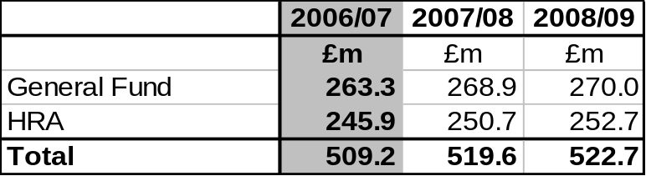

- The capital financing requirement represents a key benchmark and an early warning system of any potential breach of formal borrowing limits. As such, it is subject to continual detailed monitoring by the Strategic Director of Customer and Support Services and his treasury management staff.

- The maximum net debt held during 2005/06 has been £460.7m against a capital financing requirement of £462.3m.

Authorised Limit for External Debt

- This limit represents the total level of external debt the Council is likely to need in each year to meet all possible eventualities that may arise in its treasury management activities.

- These limits are required to show separately the Council's borrowing from its other long term liabilities, such as finance leases.

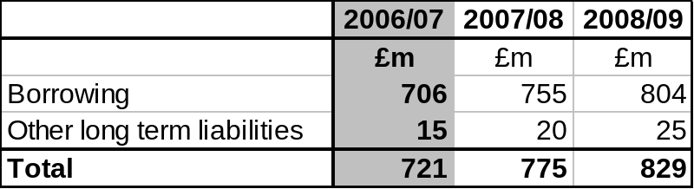

Operational Boundary for External Debt

- The operational boundary limits for external debt reflect the estimate of the most likely, prudent, but not worst case, scenario without the additional headroom included within the authorised limit.

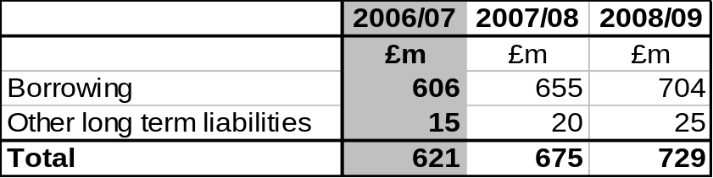

- It should be noted that the maximum actual level of debt held during the current financial year has been £521m.

- Members should note that the Council at its meeting in February 2004 delegated authority to the (now) Strategic Director of Customer and Support Services to effect movement between the separately agreed limits for borrowing and other long term liabilities, in urgent circumstances to exceed these limits without Council approval, and to report any such changes to the Council at its next meeting following the change. (NB. Such a course of action, if deemed necessary, is permitted within CIPFA's code).

- It has not been necessary to invoke this delegation since the inception of prudential borrowing on 1st April 2004. Accordingly, there have been no breaches of these limits in 2005/06.

Prudential Indicators for Treasury Management

- The following limits will be included in the annual Treasury Management Strategy for 2006/07 to be reported to the scheduled Council meeting in March.

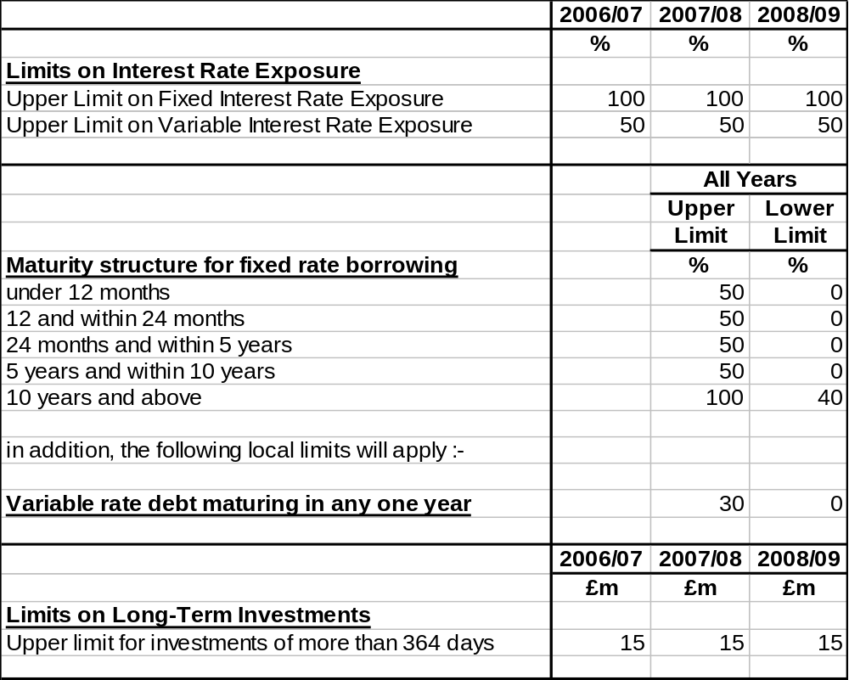

PART 5

ANNUAL EFFICIENCY STATEMENT
and VALUE FOR MONEY
- INTRODUCTION

  - At the same time as the announcement of the Comprehensive Spending Review (CSR) by the Chancellor of the Exchequer in July 2004, Sir Peter Gershon published his annual review of efficiency in the public sector.

  - The key conclusions from the review were :-

- £21.480bn efficiencies from the public sector are achievable in the CSR review period 2005-06 to 2007-08 ;
- Of this, £6.45bn is identified as coming from local government ;
- The efficiencies can be either cashable, ie result in cost reductions, or non-cashable, ie gains in productivity ;
- The efficiencies equate to 2.5% per annum, of which at least half of these savings will be expected to be cashable over the 3-year review period.

- The Gershon report identifies 6 broad areas for potential savings :-

- Back office – in effect support services
- Procurement – how goods and services are obtained, including both capital and revenue and commissioning of services such as social care
- Transactional services – benefits, pensions, collection of taxes, fees and charges and, the “collection and exchange of information”, e.g. registrars of births, deaths and marriages, and calculation of benefit entitlements
- Productive time of front-line staff
- Policy, funding and regulation for the public sector, eg Ofsted
- Policy, funding and regulation for the private sector

- The first 4 areas have a direct impact on Salford, the last two are mainly directed at central government and its agencies although there will be implications in areas such as licensing, trading standards and building control, etc., and in the role of LEA or Social Services.

- Efficiencies have been identified by Gershon as achievable in the following areas :-

  - 40% in schools through workforce reform, investment in ICT and reducing admin functions. There may also be savings through a “Procurement Centre of Excellence” (to be set up by April 2005) to strengthen practice across education and children’s services sectors
  - 10% through policing – 3% per annum for policing, by substantially increasing the proportion of officer time spent on front-line policing
  - 35% through procurement in other services, e.g., adult social care, social housing, children’s services, highway maintenance and waste

    - Further savings are anticipated through the rationalisation of back office functions and transactional services and improvements in productive time of staff.

    - Efficiencies in schools are to be separately identified and monitored by the DfES. They are therefore excluded from the 2.5% per annum target for local authorities.

    - Local authorities are required to provide an annual efficiency statement to demonstrate how they plan to make efficiency gains and to review their achievements against those plans. Forward looking statements for the year ahead are required to be produced in April each year, with backward looking statements reviewing the previous year required in June each year and a mid-year statement reviewing current year progress in November.

    - This report therefore provides a provisional indication of how, based upon the budget plans of the Council for 2005/06 and 2006/07, efficiencies will be achieved.

- PROVISIONAL EFFICIENCY PLANS FOR 2005/06 AND 2006/07

Cashable Savings

- The cashable savings are drawn from the mid-year efficiency return last November and the schedule of savings contained in Appendix 9. Some of the budget savings, eg debt rescheduling, increasing income, are not allowable under the ODPM’s definition, but most do count, as shown in Table 1 overleaf.

Non-Cashable Savings

- This element of efficiencies is one where further refinement may be most necessary before the final statement is provided to the ODPM, but some typical non-cashable efficiencies, or productivity improvements, are illustrated in Table 2 overleaf based upon service improvement plans, BVPI and local key PI targets for 2005/06 and 2006/07 :-

Table 1 – Cashable Efficiencies

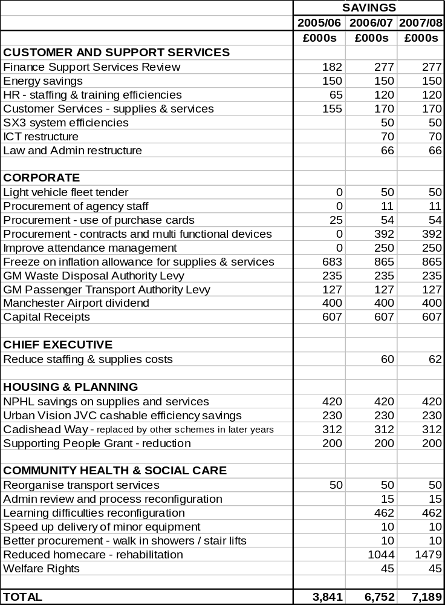

Table 2 – Non-Cashable Efficiencies

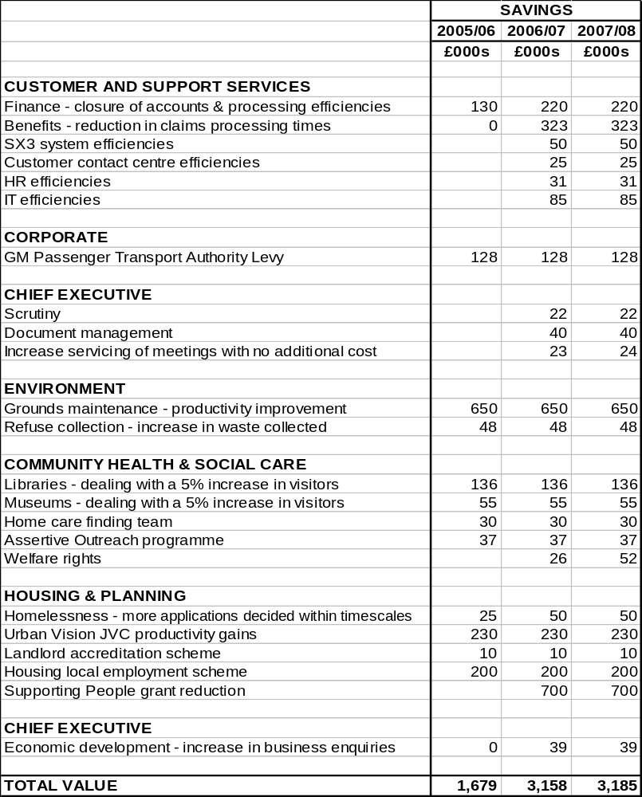

Total Efficiency Gains in Context

- Guidance from the ODPM requires the 2.5% annual efficiency target to be related to the 2004/05 baseline expenditure. The 2004/05 baseline uses total net expenditure, excluding schools expenditure and certain specific grants such as NRF, SRB and ERDF, but including capital expenditure other than education and use of capital receipts.
- Salford’s baseline expenditure is £272.3m based upon the ODPM’s definition and their most recent calculation made in February 2005, which gives a 2.5% efficiency savings target of £6.808m per annum, of which a minimum of 50%, ie £3.404m, should be cashable. The ODPM expects to issue a new baseline using 2004/05 outturn in the near future.

- Authorities will be allowed to count 2004/05 efficiency gains towards their 2005/06 target.

  - The combined total efficiencies based on 2006/07 plans will therefore be as follows :-

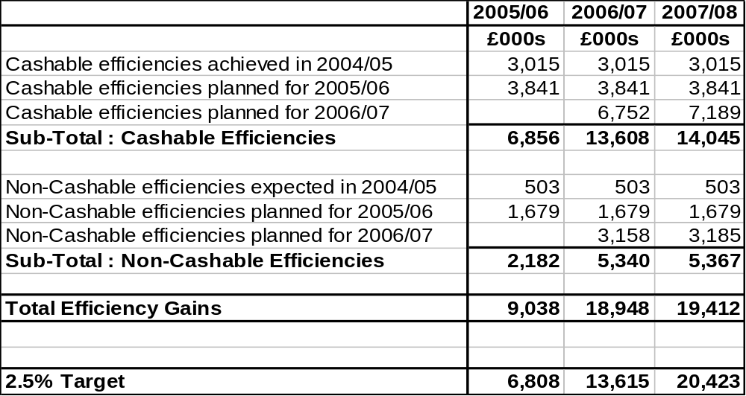

- The forecast above predicts that the minimum targets for 2005/06 and 2006/07 will be achieved in total and for the 50% cashable element. Work is required to identify further non-cashable efficiencies achieved in 2005/06 and expected for 2006/07.
- Further work is also required to establish the extent of efficiencies made on capital works which may be counted.

- The efficiencies achieved so far and planned for 2006/07 put the Council in a good position to exceed the 2007/08 target, as efficiencies identified to date stand only £1m short of achieving the 2007/08 target by the end of 2006/07.

- VALUE FOR MONEY

- The drive for value for money from services has taken on an increasing prominence from 2005 as it now features in the revised Audit Commission approach to the annual CPA assessment.

- Value for money is 1 of 5 themes to the “Use of Resources” CPA assessment block, along with financial reporting, financial management, financial standing and internal controls, as well as forming an element of individual service block assessments. The value for money assessment examines how current costs compare with other authorities, and how the Council is improving and managing value for money.

- Local authorities are required to undertake an annual self-assessment of value for money from its services, which the Audit Commission will evaluate for CPA purposes.

- The Audit Commission assessed Salford’s value for money element as 3 star, which contributed to the overall 3 star assessment for use of resources, with both scores being as good as any authority in the region.

- In 2005, a self-assessment template for assessing value for money from services was piloted against the Audit Commission’s key lines of enquiry, leading to a full self-assessment of all services. This approach has been put forward to the Audit Commission by the District Audit as an example of good practice that could be adopted by other authorities.

- The self-assessment has identified a number of areas for review in seeking service improvement, efficiencies and overall improvement in value for money and will continue to feature prominently in budget planning and also the drive for further efficiencies in the future.

PART 6

FUTURE PROSPECTS
- NATIONAL FACTORS AND INFLUENCES

There are a number of national factors and influences that will affect budget considerations in future years, and these are detailed below.

Issues for 2007/08

3-Year Revenue and Capital Settlements

The Government has issued a provisional RSG settlement for 2007/08 as part of its move to phase in the introduction of 3-year revenue and capital settlements. This should bring more stability and predictability into the RSG system, and facilitate better longer-term planning. It is therefore to be welcomed in principle.

The RSG Total Quantum

The Government has made it clear in its 2006/07 RSG settlement that the provisional grant settlement for 2007/08 will remain firm overall, apart from the updating of data for each authority, although Government has undertaken to discuss with local authorities the establishment of a formal mechanism for managing and fully funding new burdens and to explore ways that pressures can be reduced in 3 key areas : pay, waste and adult social care.

From the Government’s point of view, the substantial additional funding, efficiency gains and additional flexibilities provide no excuse to local authorities for excessive Council Tax increases and Council Tax capping will continue to apply in 2007/08 to prevent any excessive increase, with the level of capping being similar to that for 2006/07, ie 5%, although decisions on future capping principles will only be taken by the Government when budgets and Council Tax for 2006/07 have been set.

Single Status

The implementation of the job evaluation exercise under the Single Status agreement is due to be implemented by 1st April 2007 and the potential cost of this exercise could have a significant bearing upon the shape of the 2007/08 revenue budget. No estimates have been included in the forward projection for the cost of job evaluation because reliable estimates of cost are not yet available.

Issues for 2008/09 and beyond

Review of Local Authority Funding

The Lyons Inquiry was expected to report to the Deputy Prime Minister and the Chancellor of the Exchequer by the end of 2005 on recommendations for local authority funding, including :-

- the detailed case for changes to the present system of local government funding
- how best to reform Council Tax, taking into account the forthcoming revaluation of domestic property
- the case for providing local authorities with increased flexibility to raise additional revenue and for making a significant shift in the current balance of funding
- analysis of options other than Council Tax for local authorities to raise supplementary revenue, including a local income tax, reform of non-domestic rates and other possible local taxes and charges.

However, in September 2005 the Government announced an extension of the deadline for the Lyons Inquiry to report back in late 2006 and an extension of the remit of the inquiry to include a review of the role and functions of local government.

An interim report was published by the Lyons Inquiry in December 2005 which summarised the work to date, concluding that :-

- the public needs to better understand how local services are provided and paid for
- there is too much regulation, targets, inspection and specific grants which are complex and confuse
- increasing pressures on local government are becoming unsustainable
- the Council Tax base should be kept up to date
- Council Tax benefit should be reformed.

Further consultation is taking place on the interim findings and the extended remit, with a further interim report expected in June and the final report by December, feeding into the Comprehensive Spending Review in 2007.

Review of Council Tax Valuations

The values of domestic property for Council Tax purposes have remained unchanged since the tax was first implemented in 1993 and due to the movement in house prices since that time are clearly out of date. The Government had originally announced a revaluation to begin in 2005 by the Valuation Office Agency for new Council Tax bandings to be applied for bills from 2007/08, but when the Government announced the extension of the Lyons Inquiry it also cancelled the revaluation of Council Tax. A revised implementation date has yet to be set, but it is now unlikely to happen before 2009.

- LOCAL FACTORS AND INFLUENCES

The forward projections of expenditure and resources for 2007/08 and 2008/09 used for the medium-term financial strategy based around the 2006/07 budget, a continuation of service principle, and other principles and assumptions underlying the 2006/07 budget, indicate the following :-

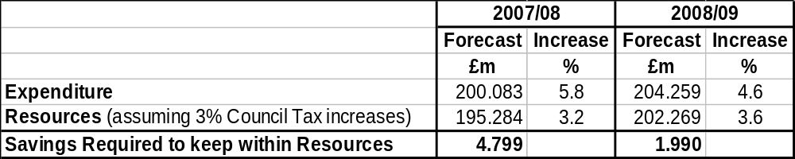

The medium-term financial forecast will need to be updated to take account of changes in circumstances as the year unfolds and strategy is developed. In particular, regard will need to be given to :-

- Inflation and other economic factors – in pay and prices and other external factors, eg interest rates

- Redistribution of resources – the desire to invest in the improvement of priority services

- Efficiencies – the drive for further efficiencies in service and in response to Gershon

- Single Status – the impact of the job evaluation exercise

- Time-expired Grant Funded Schemes – the need to determine exit strategies for schemes which come out of their grant funding

- Business Growth Incentive Scheme – whether any new income can be predicted from this source

- Regeneration – the impact upon the buoyancy of the Council Tax base as new property is built and becomes occupied

- Population – whether, or how quickly, the population decline of recent years will abate in the wake of regeneration activity.

Through the work of the Budget and Efficiency Group, these matters will be addressed in rolling forward the medium-term financial strategy.

A fundamental review of directorate budgets against priorities and pledges is already planned to take place early in 2006/07 looking ahead to 2007/08 and 2008/09, using the information gained from the value for money self-assessments and applying the decision conferencing technique as an aid to facilitating this review.

PART 7

SUMMARY OF RECOMMENDATIONS

RECOMMENDATIONS

Members are requested to :-

- Approve a revenue budget of £189.190m for 2006/07 ;

- Approve the Council Tax levy in accordance with the formal resolutions contained in Appendix 11 ;

  - Approve the HRA budget for 2006/07 as set out in Part 2 ;

  - Request each Lead Member and Strategic Director to monitor rigorously the implementation of the accepted savings and expenditure against budget on a regular basis, to identify and report to Budget and Audit Scrutiny Committee any alternative savings which may be necessary to compensate for any savings not achievable in full and to ensure that overall net expenditure is contained within budget, and for the Lead Member and Strategic Director of Customer and Support Services to report monthly to Budget and audit Scrutiny Committee on progress with the budget on a corporate basis ;

  - Approve a capital programme of £107.325m as set out in Part 3 and detailed in Appendix 19.

  - Agree to the list of assets for disposal in 2006/07 as set out in Appendix 18 to allow the Strategic Director of Housing and Planning, in conjunction with Urban Vision Partnership Ltd, to proceed to market those sites where a commitment to dispose has not already been made.

  - Approve the prudential indicators for 2006/07 to 2008/09 as set out in Part 4.

ALAN WESTWOOD COUNCILLOR BILL HINDS
Strategic Director of Customer and Lead Member for Customer and
Support Services Support Services

APPENDICES
Appendix Details

Part 1 -REVENUE BUDGET 2006/07 (Pink)

  - Directorate Profiles – 2005/06 Achievements ; 2006/07 Plans

- Public Consultation Responses

- 2005/06 Financial Performance

- Risk Assessment to Establish Level of General Reserves for 2006/07

- Details of the 2006/07 RSG settlement

- Comparison of Formula Grant across Greater Manchester

- Analysis of Council Tax Collection 1993/94 to 2005/06

- Summary of Directorate Outturn Revenue Budgets 2006/07

- Savings 2006/07

- 2006/07 Revenue Budget Assumptions

- Formal Resolutions - 2006/07 Council Tax

Part 2 - THE HRA REVENUE BUDGET 2006/07 (Green)
- HRA Profile – 2005/06 Achievements ; 2006/07 Plans

- Tenants Consultation Responses

- Risk Assessment of HRA Reserves for 2006/07

- Details of Major Variances between 2005/06 Budget and Expected
Outturn and 2006/07 Proposed Budget

- Rent Restructuring Plan

- General background to the HRA and HRA subsidy 2006/07

Part 3 - CAPITAL PROGRAMME 2006/07 (Yellow)

- Schedule of Assets for Disposal 2006/07

- Capital Programme 2006/07 - Proposed Programme

