SALFORD CITY COUNCIL - RECORD OF DECISION

I, Councillor Margaret Morris, Lead Member for Children’s Services, in exercise of the powers conferred on me by Paragraph D (4) (a) (cviii) of the Scheme of Delegation of the Council, do hereby authorise the appointment of Dr Becky Quicke, Chartered Clinical Psychologist, to the Fostering Panel with effect from August 2011.

The reasons are:

The Fostering Panel is required to meet the requirements of the Fostering Regulations 2002 and the National Minimum Standards for Fostering Services.

It is good practice for the Fostering Panel to include an Independent member among its membership.

Dr. Becky Quicke expressed an interest in becoming a panel member and is prepared to make the necessary commitment. She is a qualified Clinical Psychologist with extensive experience of working within the Looked After service providing therapy, training and support to Foster and Adoptive placements. She is currently employed by Manchester Childrens University NHS Foundation Trust, one of Salford Local Authority’s partnership agencies.

Members must be suitable for appointment with appropriate knowledge and experience and an up to date Criminal Records Bureau Disclosure. Personal references must also be taken up. A Criminal Records Bureau Disclosure has been obtained. Personal references will be taken up prior to appointment on the panel.

Dr Quicke will initially be appointed for a 3 year term until August 2013 and can serve a maximum of 3 x 3 year terms. She is required to sign a formal agreement in relation to her panel member responsibilities.
Options considered and rejected were:
This is a statutory requirement in order for the council to carry out its Fostering Agency functions. The Fostering Panel needs to meet the requirements for membership and quoracy.
The source of funding is:
No additional costs incurred. Dr Quicke will contribute to the panel as part of her job role.
Assessment of Risk: N/A

Legal advice obtained from: N/A

Financial advice obtained from: N/A

The following documents have been used to assist the decision process.
(If the documents disclose exempt or confidential information, they should not be listed, but the following wording shall be inserted :"(The relevant documents contain exempt or confidential information and are not available for public inspection)" : -
- Fostering Services Regulations 2002

Contact Officer Michael Kelly Tel. No 0161 779 7914

* This decision is not subject to consideration by another Lead Member/Director | ✓
* The appropriate Scrutiny Committee to call-in the decision is the Children Young People and Families Scrutiny Committee.

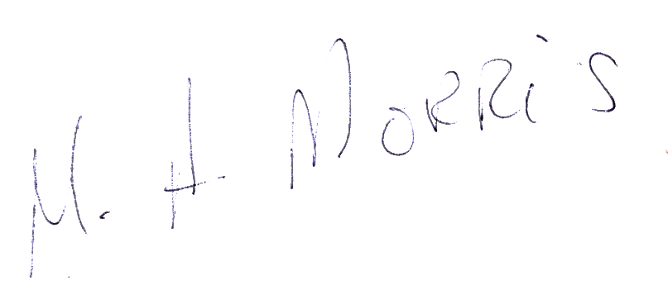

Signed Dated 1 August 2011

Lead Member

____________________________________________________________________________

FOR COMMITTEE SERVICES USE ONLY.

* This decision was published on 2 August, 2011

* This decision will come into force on # …………10 August, 2011 unless it is called-in in accordance with the Decision Making Process Rules

