 | Part 1 | ITEM NO.

REPORT OF THE DIRECTOR OF DEVELOPMENT

TO THE ASSISTANT MAYOR FOR FINANCE AND SUPPORT SERVICES FOR DECISION
ON 28th MARCH 2013

TITLE: Irwell River Park (IRP) – RIBA Design Competition / New Bridge Connection at The Meadows

RECOMMENDATIONS:

That the Assistant Mayor for Finance and Support Services, in line with the exceptions to Contractual Standing Orders, as set out in Part 4 of Section 3 (Para 2.1(a) of the Constitution:

1. Agrees to waive Contractual Standing Orders and appoint RIBA Competitions to manage an open design competition for The Meadows link project within a budget of £25,000 - £30,000. The waiver request is on the basis that RIBA Competitions is an exclusive provider of such services.

EXECUTIVE SUMMARY:

Irwell River Park (IRP) seeks to create new connections and enhance accessibility between spaces and key destinations along the 8km stretch of the River Irwell. One of the key future projects endorsed by the City Mayor is the creation of a new landmark bridge connection linking The Crescent with The Meadows. Local ward members have been made aware of the proposals through discussions at the Chapel Street Regeneration Forum.

To ensure the new bridge is of the highest quality and contributes to making the area more attractive to developers and also helps strengthen and accelerate existing private sector delivery programmes (particularly that led by English Cities Fund at Chapel Street), it is proposed that the bridge is procured through an international design competition run by the Royal Institute of British Architects (RIBA) which will require the waiving of Contractual Standing Orders.

1. Background

1.1 Irwell River Park (IRP) seeks to create new direct connections and enhance accessibility between spaces and key destinations along the 8km stretch of the River Irwell, with the ultimate aim of facilitating economic growth and competitiveness.

1.2 With over £660 million investment to date from a range of private and public sector regimes across the IRP planning guidance area, the IRP programme has delivered 3 new bridge connections at MediaCityUK, Spinningfields and Greengate, unlocking the economic potential of these key destinations and facilitating new linkages that would otherwise not exist.

2. Meadows Link

2.1 A key focus for IRP during the next three years is the creation of new direct pedestrian and cycle linkages between the new viaduct superstructure and cross river connections at Ordsall Chord - an £85 million new rail link between Piccadilly and Victoria Stations being delivered by Network Rail by early 2017 - through the major development sites at Salford Central Riverside, Middlewood, through to Chapel Street, The Crescent and onwards to The Meadows, the University of Salford and Peel Park (see attached connections plan at Annex 1).

2.2 Fundamental to this linkage is the potential construction of a new landmark bridge linking The Crescent and Chapel Street directly to The Meadows, one of the largest green spaces (7 hectares) in heart of the Regional Centre. An initial economic assessment indicates this new connection will strengthen and accelerate existing private sector delivery programmes – particularly that led by English Cities Fund at Chapel Street.

2.3 The City Mayor has indicated a desire to explore this connectivity in further detail to unlock the potential of The Meadows site and improve accessibility between key spaces, destinations and developments. In order to do so, and to raise the transformational profile of the area, it is proposed that an international design competition is undertaken and facilitated by the Royal Institute of Architects (RIBA) to develop outline bridge concepts that can be technically appraised in partnership with Urban Vision.

2.4 This process will enable the City Council to fully appraise the potential opportunity for a new landmark connection and the deliverability of the concept.

3. Design Competition facilitated by RIBA
3.1 The Royal Institute of British Architects is one of the most influential architectural institutions in the world. RIBA Competitions, established over 25 years ago, enables clients to select the best international designers for their particular project. RIBA’s international reputation for organising design competitions ensures they attract submissions from established national and international practices as well as emerging design talent. They are the only national architectural organisation with the knowledge and expertise to manage a design competition of this nature.

3.3 RIBA Competitions, as the recognised sole provider of such an acclaimed service, would:

- bring rigour, credibility and prestige to the selection process;
- ensure that the competition is managed to best practice standards with accurate documentation to ensure all decisions can be justified
- provide a dedicated architectural adviser to work with the council throughout the process, providing expertise and an independent view.
- add value to the competition by preparing a strong brief with an emphasis on deliverability that attracts design teams with the right set of skills to deliver the project, including a strong engineering input.
- give the council direct access to the RIBA’s 40,000+ global membership to promote the design competition. This, coupled with the RIBA’s ‘superbrand’ status enables RIBA to attract the highest quality design responses for clients.

3.4 In short, there is no other recognised project management practice that can demonstrate a comparable level of expertise or has the means to successfully access such a large target audience. RIBA Competitions is the sole provider of such a high quality service.

4.0 Urban Vision’s Role in the Project

4.1 The Council is keen to ensure that Urban Vision play a key role in the process. The design competition itself will be split into two stages. The first will be an open (international) and anonymous design competition. Anonymity will then be lifted for a second stage where a shortlist of up to 5 schemes will be asked to develop their design proposals further.

4.2 Deliverability of a new bridge in this location will be challenging and proposals will therefore require a strong engineering input to demonstrate constructability and deliverability. It has therefore been agreed that Urban Vision will be engaged in the design competition at the second (shortlist) stage.

4.3 Urban Vision will scrutinise the shortlisted proposals, using their extensive engineering knowledge to test the shortlisted proposals for constructability and deliverability, in addition to highlighting any potential engineering issues associated with the shortlisted designs. Following this process, they will report back on their findings to the design competition panel, which will include the City Mayor. Urban Vision will receive an appropriate fixed fee for this input, currently being negotiated with them.

4.4 Should the City Mayor endorse the progression to a delivery stage, Urban Vision will then act as the principal engineer for delivery of the scheme, working in partnership with the chosen design team to bring forward the winning proposals.

5.0 Recommendation

5.1 That the Assistant Mayor for Finance and Support Services, in line with the exceptions to Contractual Standing Orders, as set out in Part 4 of Section 3 (Para 2.1(a) of the Constitution:

- Agrees to waive Contractual Standing Orders and appoint RIBA Competitions to manage an open design competition for The Meadows link project within a budget of £25,000 - £30,000. The waiver request would be on the basis that RIBA Competitions is an exclusive provider of the service.

BACKGROUND DOCUMENTS: Irwell River Park Vision Brochure

KEY DECISION: NO

KEY COUNCIL POLICIES:

- Irwell River Park Planning Guidance
- Draft Crescent Development Framework
- Salford Central Planning Guidance and Development Framework

EQUALITY IMPACT ASSESSMENT AND IMPLICATIONS: A new DDA compliant bridge between The Crescent / Chapel Street and The Meadows and new connecting route to the existing Irwell Bridge will improve access to and across one of the largest green spaces in the Regional Centre, ensuring the space is better used for leisure, recreation, learning and active travel.

ASSESSMENT OF RISK:

Low - Appointing RIBA Competitions to run the open design competition will ensure the project is advertised as widely as possible and that submissions will be of a high calibre.

SOURCE OF FUNDING: Irwell River Park capital programme allocation for 2013/14

LEGAL IMPLICATIONS: Supplied by Juliet Mbam, Principal Solicitor, Ext 234 4489.
The Council’s Contractual Standing Orders apply to every contract for the procurement of supplies, services and works undertaken on behalf of the Council. There are certain circumstances where exceptions to the Standing Orders may be authorised by the Assistant Mayor for Finance and Support Services after consideration of a written report from the appropriate Director, in consultation with the Strategic Director of Customer and Support Services. One such circumstance is where the body to be appointed is an exclusive provider of the required service. RIBA Competitions have been identified as such a provider and in those circumstances it is considered that the proposal meets the requirements of the waiver to the Council’s Contractual Standing Orders.

FINANCIAL IMPLICATIONS: Supplied by Chris Mee, Group Accountant (Capital/PFI)
Ext 0434.

The Cost of this proposal can be met from within the 2013/14 Irwell River Capital Programme allocation.

PROCUREMENT IMPLICATIONS: Supplied by Andrew White, Category Manager, Ext 6295.

The Council’s Constitution permits certain exceptions where a waiver to Contractual Standing Orders maybe sought, one of which being where there is an exclusive provider of services. RIBA are the only national architectural organisation with the knowledge and expertise to manage a design competition of this nature. Therefore it is considered that the request to waive Contractual Standing Orders meets the criteria. The subsequent risk of challenge to the Council is considered to be low.

OTHER DIRECTORATES CONSULTED: Environmental Services Service Group, Customer and Support Services, Urban Vision

CONTACT OFFICER: Dan Welsh Tel. 2630
Catriona Swanson Tel. 3646

WARDS TO WHICH REPORT RELATES: Irwell Riverside, Broughton

ANNEX 1: Middlewood Loop Proposals
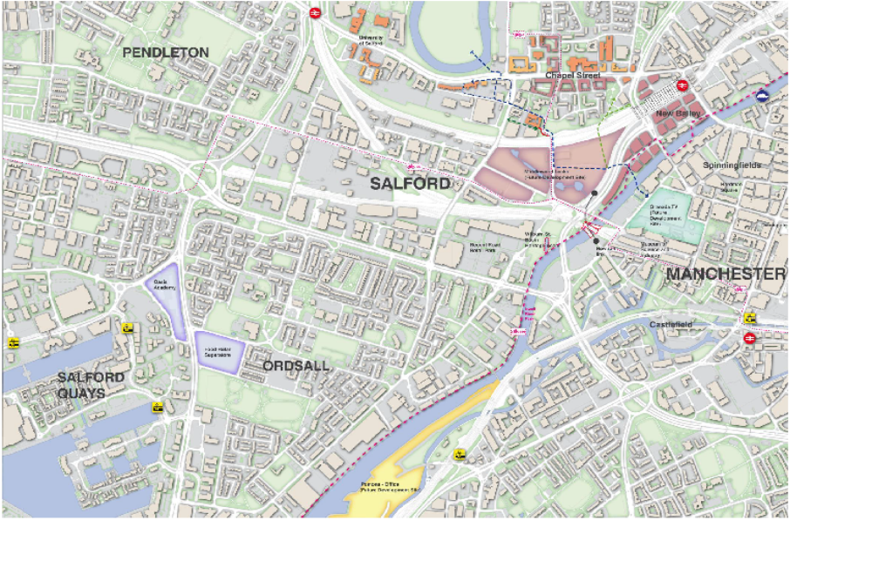

Annex 2: Meadows Link Connections


