Report of Assistant Director ICT & Transformation
To Corporate Issues Scrutiny Committee
22nd July 2013

Title: SAP Best Value Review

RECOMMENDATION: That the contents of this report be noted
EXECUTIVE SUMMARY: This report forms the initial basis of Best Value review of the corporate SAP Enterprise application product and service, and a wider review of the overall ICT application portfolio that serves and supports all the city councils functional services. The review is being phased in an approach that ‘discovers’ the current cost and value of the application, then considers options for a ‘market evaluation’ phase and exercise, followed finally by a ‘proposal and implementation’ phases. This report covers the ‘discover’ best and shows the background and benefits that the SAP product and service has brought to the council. It also provides high level details of the current costs and development plans associated with the service. Finally it suggests a number of options to consider in the next stage of the review.
CONTACT OFFICER; David Hunter – Assistant Director ICT & Transformation
- Introduction
In 1998 the Council, advised by consultants, developed and agreed a business case for investment in a modern integrated financial management system. Following a comprehensive procurement process, the Council, in July 1999, accepted the tender of PricewaterhouseCoopers (now IBM Business Consulting Services) to implement the SAP R/3 enterprise resource management system.
Closely related to the project was the reorganisation of financial support services across the Council to form the centralised Financial Support Group in Corporate Services to deliver the benefits set out in the business case.
The key features included in the business case were:-
- the need to replace outdated financial systems with an integrated resource management system
- benchmark-based study identifying the potential financial benefits of achieving upper quartile performance in the processing of financial transactions
- realising value for money savings by implementing a corporate approach to purchasing and maximising the Council’s buying power

The contract with IBM for the implementation of SAP was a major undertaking for the Council impacting on all Council directorates and a significant number of staff. The contract, with a value of £3.003m included the installation of dedicated Sun hardware, SAP R/3 software and the provision of implementation consultancy services.

SAP is a major business software application which is used by Salford City Council for the majority of all financial based activity, these include:
- General Ledger Accounting
- Accounts Payable
- Accounts Receivable
- Purchasing
- Sales and Works Order Management
- Human Resources (including payroll)

All payments and official purchase orders (with approvals where necessary) are created within SAP including a number of transactions which are transferred via interfaces from other corporate applications (mainly CareFirst).
Budget and control reports on financial/HR information are managed and distributed to nominated managers from within the SAP platform.
Income received is recorded in SAP at transaction level with the exception of Council Tax and Business Rates.
All employee pay and absence management is recorded in SAP. For example:
- Car Allowance/Mileage Claims
- Employee Lifecycle including Qualifications and Training
- Employee Expenses
- Production of Electronic P60/P11D/Pension Auto Enrolment Information
- Organisational Structures
- Reduction in paper payslips (Portal)
- Direct Electronic interaction with HMRC for e-filling/Leavers/Starters
SAP is also used to manage finance and human resources for the following organisations in addition to payroll processing for 5 school academies.
- Salford Community Leisure Trust
- Salix Homes Limited
- Office of the Police & Crime Commissioner
The core SAP system has the highest system availability record of all the corporate applications. There has been zero instances of software failure in 12 years and only one major hardware failure where system loss was greater than 1 day since 2000. Planned downtime is also scheduled during the night and weekends, so the system is always available through normal business hours.
- Achievements
As previously stated, the SAP Enterprise solution has been in place since 1999, and during this time it has witnessed a number of business and operational improvements as new functions and technologies have been added. The table below shows the history SAP changes

Year | Project | Details
1999 to 2000 | Initial Implementation | Financials, including Accountancy, Creditors, Debtors, Purchasing
1999 to 2000 | Initial Implementation | Human Resources, including Organisation Structures an Payroll
2001 to 2005 | Sales Orders | Phase 1 - Trade Waste Contracts
2001 to 2005 | New Companies | New Prospect Housing & Salford Community Leisure
2006 to 2010 | Major Upgrade | New SAP software engines, New Physical Server landscape
2006 to 2010 | SAP Support | Ended external consultancy support.
2006 to 2010 | New Company | Salix Homes
2006 to 2010 |  | Phase II - Supplier self-invoicing and e-remittances
2006 to 2010 | Employee Portal | Car mileage and expense claims
2006 to 2010 | Employee Portal | Purchase Orders with Budget Manager Authorisation
2011 to 2013 | New Companies | OPCC - Office of Police & Crime Commissioner
2011 to 2013 | New Companies | 5 school academy companies (basic payroll not full companies)
2011 to 2013 | Collaboration | Working relationship with Barnsley MDC SAP team
2011 to 2013 | e-Billing | Electronic Debtor invoicing
2011 to 2013 | New SAP Licence | Flex User Licence, Corporate Business Intelligence Dashboards, Interactive forms

The implementation of SAP has led to significant benefits to the organisation including:-

Financial Management
- The integrated financial, HR and resource management system, has lead to the consolidation of processing resources into small teams with reduced capacity.
- Immediate update of general ledger and budget monitoring reports as soon as transactions are entered, has improved our financial management, cash income and purchasing knowledge.
- Commitments are recorded against budgets as soon as orders are raised.
- SAP provides immediate online access to budget monitoring reports for accountants and budget managers.
- Reports provide drill-down functions to analyse expenditure to individual transaction level to control costs.
- Improved automated invoicing and reporting capabilities to improve performance e.g. prompt payment of invoices, debt recovery.
- Ability to upload financial and payroll data automatically reducing input time.
- Much Improved control over purchasing by the utilisation of corporate contracts, sourcing of supplies.
- Improved control and organisation of debtor billing and recovery.
- Increased focus on performance targets.
- Reduced the final accounts timetable by 5 months

Organisation Structures
Organisation structures held on SAP are now significantly more accurate than previously. SAP is now used as the single repository for all employee and organisational data and is accurately maintained through automated ‘starters & leavers’ processes.

The introduction of the online ‘Ask HR’ and Employee Portal has also improved the accuracy of data and improved the overall processing of a significant range of internal transactions, resulting in a reduction of support / administrative staff to operate these processes.

Transport

- Replaced stand alone Transport Management System with fully integrated works management system.
  - Reduced administration
Following the implementation of SAP and the creation of the single Finance Support Group and Employee Services group there have been significant reductions in the number of staff involved in business function services as follows :-

 | Prior to SAP/FSG | Current | Increase/Reduction
Accountancy  Payroll  Payments  Debtors  Purchasing | 77  41  35  22  16 | 55  13  8  7  4 | -  -  -  -  - | 22  28  27  15  12
Total | 191 | 87 |  | 104
These figures do not cover the reduction in administration staff that SAP automated processes has impacted on.

The financial benefits achieved through staff reduction compared to the target and based on an average salary of 22,500 in 2012/13 would be £2.5 million

Overall the efficiency improvements that have enabled staff resources to be reduced have been achieved. The anticipated benefits from a corporate purchasing approach have been accelerated following the Think Efficiency programme and a revised strategic approach to purchasing planning and controls, however work is still required on the corporate contracts register in order to fully realise significant procurement savings that can be attributed to the use of SAP.

- SAP Costs
The chart below shows the operational costs for SAP systems. Costs include implementation services, staffing and annual licence fees. Not shown are the initial purchase of software at £800,000 and the initial purchase of hardware also at £800,000.

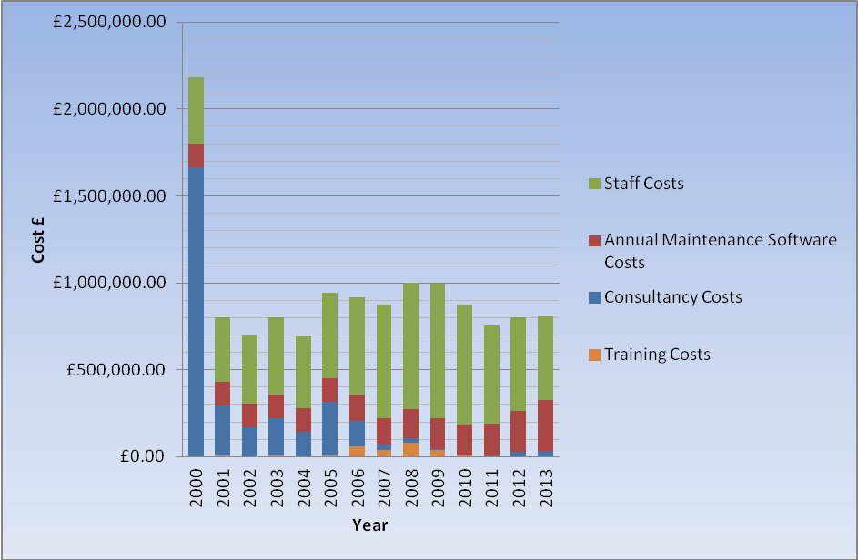

The cost mix to support the SAP environment has changed a number of times over the years. With significantly less reliance on expensive external consultants, followed by the consolidation of functional support teams into the SAP teams, and a more recent trend of reducing the staff support numbers even further.

However, to balance this and as a result of additional enterprise functionality being added to the solution, the annual maintenance costs have increased as more and more officers utilise the software.

The increase in operating cost in 2012 and 2013 are due to the following: -
  - investment in Business Intelligence for all corporate applications (i.e. Business Objects is now owned by SAP)
  - The purchase of the flexible license agreement which enables Salford to roll-out further self service functionality by replacing the more expensive SAP user licences
The combination of staffing and consultancy costs are now the lowest in the 13 year history of SAP in Salford.

Support Staff
The SAP system is managed by a team in the Corporate Applications division of Corporate ICT Services and comprises of 10 staff. The team is responsible for supporting current applications, providing help and training to users and developing new features and modules of the SAP system. They also provide technical support for the servers on which SAP is run, monitor performance, apply software upgrades, back-up the system, and running print jobs etc.

The table below shows the changes in the SAP support staff numbers and the cost of external consultancy over the last 3 years.
SAP Team Details 2011 to 2013
Year | Staff FTE | Staff Costs # | Consultancy Spend | Total
2011 | 15.5 | £632,126 | £0.00 | £632,126
2012 | 10.5 | £438,457 | £40,000 | £478,457
2013 | 10 | £369,471 | £45,000 | £414,471

These savings have contributed to the overall ICT savings targets, however the lack of resilience and specialist skills in the team is restricting the application development.

SAP Licensing
SAP licensing is a complex mix of named user and software engines. There are currently 5 layers of named user licence and these are allocated based on level and frequency of access required and portal self-service. New Council organisation structures, new technology, and recent reductions to employee headcount all have an impact on the type of SAP licences required, but do not have a direct impact on the annual licence payment to SAP.
The annual maintenance cost of a named user licence varies from £497 per annum for SAP technical developers to £10 for the basic self service licence. Ensuring the Council gain maximum value for money from licences within the set terms and conditions is a complex process.
Reducing headcount only reduces SAP licence requirements if processes are automated. Generally other officers will perform the SAP tasks.

SAP User Base
The chart below is a snap-shot of SAP customers as at 30th June 2013.

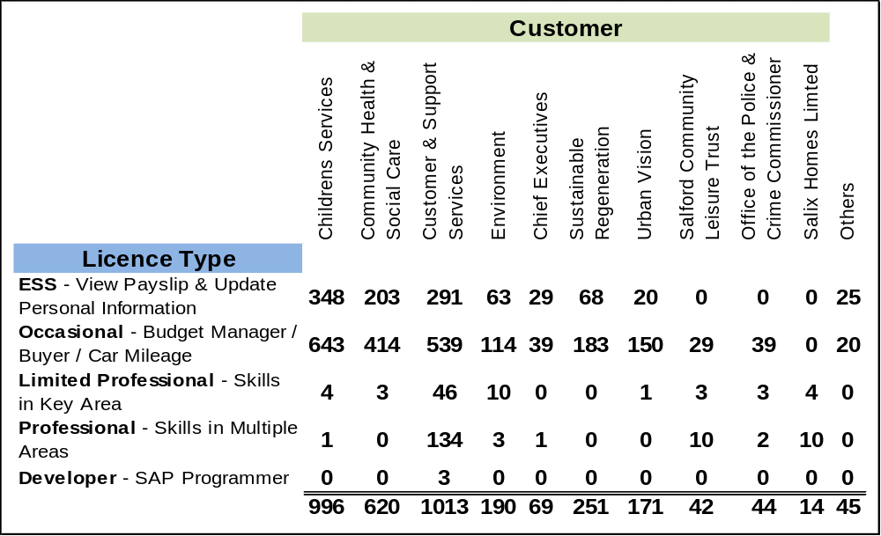

This equates to approx 3,455 users of the systems at varies levels of functionality, complexity and development. The SAP industry mean for support staff vs number of active users is 295 (IBM research 2012). Salford provides a support to user ratio of 1 support staff to 345 users, and suggests that support provide a lower than average cost of staff per user.

Net Costs
Salford’s SAP system also manages business processes for a number of external companies. The chart below shows the breakdown of the £93,780 contribution to Salford’s SAP running cost for financial year 2013/14.

Year | Source | SLA | Development | Total
2013 | SCL | £38,000.00 | £0.00 | £0.00
2013 | OPCC | £11,000.00 | £0.00 | £0.00
2013 | SALIX | £19,780.00 | £25,000.00 | £0.00

- Anticipated NET cost to Salford City Council for 2013/2014
  - Total expenditure £805,000 (staffing, consultancy and maintenance)
  - Less income £93,780
  - Net Expenditure £711,220
# Additional income is possible subject to development requests from external companies

The average annual cost per user for SAP support and maintenance is approx £205.85

- Product Development
The SAP development will be continuing with ongoing improvements to the functionality, the reliability and performance of the various modules. These include;

- New budgeting and financial planning processes
  - Barnsley and Salford are in advanced discussions regarding implementing a new budget monitoring add-on to the core SAP system, which will enable line managers to plan and monitor their budgets without requiring extensive SAP knowledge and with reduced accountancy support.
  - The processes also includes replacing existing static reports with new Business Intelligence
- Manager Self Service
  - The SAP upgrade planned for August 2013 will enable new functionality and improved portal performance. This will provide the ideal opportunity to launch a manager self service portal that will also include the visualisation of management information
  - Automated business intelligence reports will replace spreadsheet production
  - Assets assigned to employees
- Employee Self-Service
  - Automation of additional employee self-service features
    - Bank details
    - Timesheets
    - All attendance management
  - Mobile Working
- Corporate Asset Management
Asset management has a Council-wide impact. Multiple teams are responsible for inspections, scheduled maintenance, repairs and billing customers or occupiers as appropriate. Over many years the organisation has created numerous locally managed systems with no integration and little prospect of corporate asset intelligence, including performance monitoring within the Council and with suppliers and partners.
There is an opportunity to consolidate our entire asset data and related documents into the corporate ERP platform. This consolidation would enable full estates management of all Council property, land, fixed and circulating assets.
The consolidation will also enable the entire estate to benefit from future development and access to technologies such as mobile working and business intelligence. The corporate ERP platform now includes mapping and will support the visualisation strategy.

Corporate application portfolio rationalisation
SAP is rich in functionality and the SAP footprint at Salford has not reached its full potential. SAP is the single largest system within the Council’s Corporate ERP Platform, which also includes CRM, LLPG, GIS, Documentum and Mobile technology. This Corporate Platform is Salford’s wider Enterprise Resource Planning (ERP) system, containing all the functionality to manage every business process outside of Social Care.
As systems and process are moved into the corporate platform the Council increases the ROI and reduces the cost of managing the Council’s current system portfolio. The Corporate Platform guarantees resilience, integration and cost effectiveness. As the footprint of the Corporate platform is well established increasing the use of this ERP platform is often achieved with no increase in internal resources and little or no increase in licence costs (annual maintenance). Servers are also decommissioned realising further savings.
The following systems can be fully decommissioned by implementing all the business processes within the Corporate Platform.
- Civica APP (formerly known as Flare)
  - Savings to ICT would be in the region of £100,000 per annum
  - Future cost avoidance as we will restrict developing and integrating fewer applications.
  - Further administration and finance savings will also be realised due to the automation of processes within the fully integrated platform.
- Consolidation of Asset Management
  - Systems audit currently being undertaken by colleagues in Facilities Management
  - Future cost avoidance as application development outside of the Corporate Platform will be restricted.
Integrating SAP with the LLPG systems will also enable further rationalisation, as migrating master data from other applications will be both easier and accurate.

Management Information
Business Objects dashboards are currently being developed which will generate a new era of management information. As business objects is now a SAP product, any data held in SAP systems will automatically have SAP Business Intelligence tools available.
One example would be accurately monitoring the impact of the Council’s changing spend trends on the local and regional economies.

SAP Centre of Excellence
Salford City Council’s SAP services have been commended by the software provider and are working towards becoming a SAP Centre of Excellence; this will promote the solutions we have implemented in addition to providing a discount on the annual licence fee of a minimum of £40,000 per annum. This will be a joint project with Barnsley MBC who will realise a similar annual saving.
- Considerations and Next Steps
As a result of this initial discovery phase of the current service provision and use of the SAP Enterprise product, it is recommended that ICT move to an ‘evaluation’ phase that explores the current market and performs a more detailed analysis and product comparison with a view to the following options;
Option 1 - Replace SAP
A replacement strategy will need to consider the following: -
- Preparation of multi-functional and technical system specifications
- A full OJEU procurement process
  - A complex evaluation procedure
- Purchase of another ERP or several disparate systems (or a mixture of)
- Integration re-works with all other systems (CareFirst, Documentum. PARIS, LLPG, Ask HR, Active Directory and other online forms including sickness and holiday entitlement calculations).
- Training technical staff
- Re-training end users
- Development freeze for 18 – 24 months
  - Delaying or aborting current efficiencies
- Guarantee of any cost savings
Please not that under the terms of the SAP contract, replacing SAP will only realise savings if the entire system is fully decommissioned.

Option 2 - Retain SAP with 100% in-house support
- Continue with development programme
  - Accept long development timescales with the reduced resources
- Continue with the turnover risk
- Increase the SAP training budget
- Increase the SAP team
- Continuation of ICT Enablement and Transformation plans

Option 3 - Retain SAP with external support
- Continue with the collaborative working
  - Reducing consultancy support, turnover risk and development costs
  - Sharing infrastructure support and costs
  - Joint negotiations with SAP benefitting both organisations
  - Share training costs plus skills transfer across the two teams
- Commission specialist skills on a project basis

Each option should be considered though to fully evaluate option 1 may require external independent consultancy that the council would need to consider as part of an ‘invest to save’ proposition.
If it thought that continuing with SAP at the core of Salford’s Corporate ERP platform, a hybrid of options 2 and 3 may be the preferred model. This may will provide the best value for money regarding the retention of local expertise, the increased collaborative resource pool and the commissioning of specialist skills as appropriate, but this would need to be explored further as part of the next phase.

