


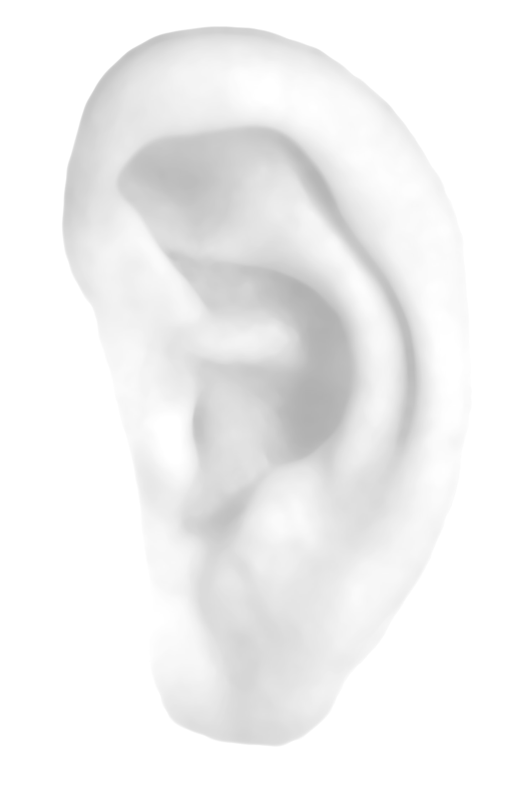


The big listening : 3
Will YOU help shape the future of Salford?

HELPFUL HINTS FOR COMPLETING THIS QUESTIONNAIRE

- The questionnaire should be completed by the Panel member – the addressee on the envelope.
- Answer the next question unless asked otherwise.
- In most cases, you will only have to tick one box but please read the questions carefully as sometimes you will need to tick more than one box.
- Once you have finished please take a minute to check you have answered all the questions that you should have answered.
- The survey consists of 12 pages and should take no longer than 15 minutes to complete.
- If you have any questions about this survey or you would like a copy in large print, Braille or another format, please contact Graham Runnymede on 0161 793 2686 or Saralyn Chaloner on 0161 240 2401
- Once you have completed the questionnaire please return in the pre-addressed envelope supplied. You do not need to add a stamp.

- If you cannot find or did not receive the pre-addressed envelope please send your completed questionnaire to Ipsos MORI North, Freepost xxx or call 0161 240 2401. You do not need to put a stamp on it.
Arabic

Chinese

Urdu

Gujarati

Bengali

Punjabi

COUNCIL SPENDING

Each year the council has to consider its spending plans for the following year to ensure that it is in line with its priorities and those of the community. As part of this process we would like to know your views about where you feel the council should be spending more or less money.

Q1 |  | From your point of view, would you like to see more money, less money or the same amount of money spent on each of the following services in the future?  PLEASE TICK () ONE BOX ON EACH ROW
 |  |  |  |  |  | More Money | Same Amount of Money | Less Money | Don’t Know
Education |  |  |  |  |  | 1 | 2 | 3 | 4 | (245)
Health and social care |  |  |  |  |  | 1 | 2 | 3 | 4 | (246)
Community committees |  |  |  |  |  | 1 | 2 | 3 | 4 | (247)
Crime and community safety |  |  |  |  |  | 1 | 2 | 3 | 4 | (248)
Youth services and facilities |  |  |  |  |  | 1 | 2 | 3 | 4 | (249)
Libraries, museums and art galleries |  |  |  |  |  | 1 | 2 | 3 | 4 | (250)
Parks and open spaces |  |  |  |  |  | 1 | 2 | 3 | 4 | (251)
Housing services |  |  |  |  |  | 1 | 2 | 3 | 4 | (252)
Refuse collection |  |  |  |  |  | 1 | 2 | 3 | 4 | (253)
Recycling |  |  |  |  |  | 1 | 2 | 3 | 4 | (253)
Traffic management and road safety |  |  |  |  |  | 1 | 2 | 3 | 4 | (254)
Street cleaning |  |  |  |  |  | 1 | 2 | 3 | 4 | (257)
Maintenance of roads and pavements |  |  |  |  |  | 1 | 2 | 3 | 4 | (258)
Economic development & regeneration |  |  |  |  |  | 1 | 2 | 3 | 4 | (260)
Street lighting |  |  |  |  |  | 1 | 2 | 3 | 4 | (261)
Sports centres and swimming pools |  |  |  |  |  | 1 | 2 | 3 | 4 | (262)

Q2 | In 2006/07 the average council tax paid in Salford was £905 per household. Please let us know your views on the level of spending and council tax. PLEASE TICK () ONE BOX ON EACH ROW
 |  | Definitely Yes | Probably Yes | Probably No | Definitely No
Would you support an increase in council tax of 3% to maintain council services at existing levels? |  | 1 | 2 | 3 | 4 | (267)
Would you support an increase in council tax above 3% in order to improve priority council services? |  | 1 | 2 | 3 | 4 | (268)
Would you support a decrease in council tax levels even if it meant a reduction in the level of services? |  | 1 | 2 | 3 | 4 | (269)

SATISFACTION WITH COUNCIL SERVICES

The Audit Commission (an independent body that monitors the performance of local government) says that Salford Council is “a council that is improving well”. We are interested to know your views about council services.

Q3 |  | Overall, how satisfied or dissatisfied are you with the services provided by Salford City Council?  PLEASE TICK () ONE BOX
 |  |  | Very  satisfied | Fairly  satisfied | Neither satisfied nor dissatisfied | Fairly  dissatisfied | Very dissatisfied
 |  |  | 1 | 2 | 3 | 4 | 6 | (244)

IF ANSWERED DISSATISFIED OR VERY DISSATISIFIED AT Q20 PLEASE ANSWER Q21, OTHERS GO TO Q22
Q4 | If you are dissatisfied or very dissatisfied, please can you briefly tell us your reasons for this.  PLEASE WRITE IN (263-266)

ABOUT YOU

To ensure that we are meeting the needs of all residents, it is important that we ask you a few questions about yourself. As with all the questions your answers will be completely confidential, however, if you do not wish to answer a question, please leave it blank and go on to the next one.

Q5 | Please could you tell us your date of birth?
 | PLEASE WRITE IN
 |  |  / |  / |  |  |  |  |  | (450)

Q6 | Are you…?
 | PLEASE TICK () ONE BOX ONLY | …male | 1 | …female | 2 | (451)

Q7 | What is your ethnic group?  PLEASE TICK () THE ONE APPROPRIATE BOX TO INDICATE YOUR CULTURAL BACKGROUND
 | White | (459) | Asian or Asian British | (460)
 | British | 1 | Indian | 1
Irish |  | 2 | Pakistani | 2
 | Other white background | 3 | Bangladesh | 3
 | Mixed |  | Other Asian | 4
 | White and Black Caribbean | 4 | Black or Black British
 | White and Black African | 5 | Caribbean | 5
 | White and Asian | 6 | African | 6
 | Other Mixed background | 7 | Other black background | 7
 | Chinese | 8 | Any other group (please write in) | (461)
 |  |  |  | 0

Thank you very much for taking part in this survey. Please return this questionnaire to Ipsos MORI North in the reply paid envelope provided.

