“Positive about young people and their potential”
Working together to improve Sexual Health and Wellbeing for young people in Salford 2010-2013

Salfords pledges on Teenage Pregnancy

As a result of working to make the changes outlined in this strategy, people in Salford can expect:

- Strategic Priority: Develop Contraception and Sexual Health Services
Young people will have easier access to contraceptive services and a greater choice of contraceptive methods across Salford
- Strategic Priority: Supporting young peoples sexual health and wellbeing through Primary Care
Improved support from General Practice for sexual health, increasing access and choices for young people in Salford
- Strategic Priority: Support for pregnant young women, young parents and their children
There will be better support for pregnant young women, young parents and their children enabling young people in Salford to continue their education and make healthier life choices for them and their children

Strategic Priority: Prevention and supportive environments
Support agencies and parents will have greater skills and confidence in dealing with and talking about young people’s sexual health and contraceptive needs
- Strategic Priority: Establish multi-agency service model
Young people in areas of greatest need in Salford will benefit from agencies working more closely and responsively to those needs
- Strategic Priority: Media and communications
Improved communication and use of the media will inform young people, parents, carers and professionals of the developments and actions being taken to reduce teenage pregnancy in Salford
- Strategic Priority: Relationship and Sex Education
Young people in Salford will benefit from improved Relationships and Sex Education in all schools in Salford giving them the information they need to negotiate and make choices about relationships and delaying parenthood
- Strategic Priority: Early Years Environment
Young parents in Salford will benefit from improved support in all Children’s Centres giving their children the best possible start in life and improving their future health and educational prospects
Foreword

Action to reduce teenage pregnancy has been a Governmental priority for the past 10 years. The health and socio-economic effects highlighted in the Social Exclusion Unit Report on Teenage Pregnancy (1999) and the high rates relative to the rest of Europe supported the launch of a national Teenage Pregnancy Strategy and the adoption of national targets to reduce teenage pregnancy by 50% by 2010. However, despite concerted efforts progress on this target nationally has been modest, with considerable variations between comparator local authorities.

The Department for Children, Schools and Families (DCSF) has issued guidance to accelerate the strategy to 2012 and areas where progress has been stalled (including Salford) have been visited by Teenage Pregnancy National Support Teams (TP NST). The recommendations from the NST visit have been used to inform this strategy. Teenage pregnancy is a priority for Salford City Council and Salford PCT. It is included in the Children and Young People’s Plan, Salford’s PCT Strategic Plan and Salford’s Local Area Agreement.

Past responses to impacting on teenage pregnancy in Salford have been insufficient to achieve sufficient progress swiftly enough to improve the sexual health and wellbeing of young people in the city. This document sets out a strategic vision which fits with other key priorities in Salford and identifies actions needed by partners to accelerate and industrialise delivery. It should be used to inform and prioritise the future commissioning for services for young people to reduce under–18 conceptions and support teenage parents.

Contents

- Introduction
- What Teenage Pregnancy means in Salford
- What we know works in tackling teenage pregnancy
- Current activity and gaps
- Delivery and Action Plan
- Governance
- Finance and Resources
- Appendix
- Further Reading
- Introduction

Summary

  - Aim

The aim of the Salford Teenage Pregnancy and Parenthood Strategy “Positive about young people and their potential” is to:

“Reduce the conception rate in those under-18 and reduce the impact of this on social exclusion, educational attainment, social aspiration and the health and wellbeing of the mothers and children”.

This is an ambitious strategy which will have a wide-ranging impact and will produce positive outcomes for Salford’s young people and contribute to achievement of a range of public service targets set for Salford. The strategy provides the vision and way forward with prioritisation of actions for short-term and medium-term outcomes. It will require translation into an action plan and commissioning plans.

  - Understanding Teenage Pregnancy and risk factors

The risk factors for teenage pregnancy show a relationship between deprivation and a range of related factors which increase the risk of teenage pregnancy. There are also a number of consequences of teenage pregnancy, which themselves increase the risk of poor outcomes, such as low educational attainment, poverty and worklessness, poor health and infant mortality. This is explored in further detail in Section 2.2.1.

Successful prevention of teenage pregnancy involves a wider range of prevention initiatives that include raising aspiration, educational attendance and attainment and will not be achieved through Relationships and Sex Education and the provision of contraception alone.

  - Process of Strategy Development in Salford

While preparing Salford Teenage Pregnancy and Parenthood Strategy “Positive about young people and their potential” young people, representatives from Education, Youth, Health and Social Services have been consulted and canvassed for opinions and thoughts on how to tackle Salford’s teenage pregnancy rates.

A nine month consultation and development process initiated by NHS Salford’s Director of Public Health has raised the profile for this NHS and Local Authority owned target. This strategy represents a significant shift in local thinking, seeking resources and interventions equal to the scale of the problem. The Teenage Pregnancy Executive provides strong senior level leadership across the NHS and Local Authority for implementation and governance of the Strategy.

  - Strategy ethos

The challenge to Salford and the ethos behind this strategy is to ensure that everyone including young people, parents, public, private and voluntary sector organisations recognise their role within Positive about young people and their potential. We wish to emphasise that everyone who comes into contact with young people in their everyday work can make a positive contribution to the future of young people in Salford and unless proven explicitly otherwise, you and your organisation are involved in preventing teenage pregnancy.

  - Recognition of competing priorities

Positive about young people and their potential also recognises that resources are finite in Salford and each organisation has delivery of core services that are equally essential. The strategic vision and intent of this document concerns adjustment to existing core services and identifies where additional resources are required. Teenage pregnancy is a multi-faceted issue that requires a multi-agency response. In understanding this and the connection of work between agencies, all partners will begin to shape an environment which promotes positive choices. All partners must commit to maximising the positive contribution of their work and ensure their actions do not have a negative impact.

  - Strategic alignment

Action to reduce teenage pregnancy has been a Governmental priority for the past 10 years. The health and socio-economic effects highlighted in the Social Exclusion Unit Report on Teenage Pregnancy (1999) and the high rates relative to the rest of Europe supported the launch of a national Teenage Pregnancy Strategy and the adoption of national targets to reduce teenage pregnancy by 50% by 2010.

This is an ambitious strategy which will have a wide-ranging impact and will produce positive outcomes for Salford’s young people and contribute to achievement of a range of public service targets set for Salford including: child health, healthy schools, obesity, physical activity, drugs and alcohol, mental health and social care outcomes.

The strategy provides the vision and way forward with prioritisation of actions for short and medium outcomes.

  - Strategic objectives

This Strategy operates alongside the delivery of and developments in children’s services, for example;

- The role of education to support children and young people to attend and achieve and to support and develop the health and well-being of children and young people
- Tackling child poverty
- The provision of support for looked after children, young people and care leavers
- Opportunities to work with young people in ways which are likely to impact positively on a wide range of outcomes.

The strategy takes a long term perspective changing behaviours and social norms in Salford that will reduce teenage pregnancy and support teenage parents. The Strategic Objectives of Positive about young people and their potential are:

- Place young people and young parents influence at the centre of the planning, delivery and monitoring of services.

- Commission and ensure delivery of accessible, high quality contraception and sexual health services for young people under-18 and teenage parents

- Ensure that young people, including those recognised as vulnerable or at risk, can easily access services, are assessed and, where appropriate, are able to progress to other services which support the reduction of risk factors and help increase protective factors

- Use community-based approaches to ensure that wider support to prevent teenage pregnancy and support for parenthood is available by working with parents/carers; siblings of pregnant young women and young fathers.

- Commission and ensure delivery of high quality support services for pregnant young women, young parents and their families including assertive outreach for those who don’t attend or engage.

- Devise and commission a workforce development programme to incrementally enhance the skills, specifically of the children and young people’s workforce on prevention of teenage pregnancy and support for young parents, having a wider impact on all services.

- Develop and deliver a media and communications policy and programme which are flexible to young people’s needs and provide relevant information via appropriate media and technology to a wide range of stakeholders, particularly young people and young parents.

- Ensure that You’re Welcome and young parent friendly standards are adopted by all services involved in implementing the Teenage Pregnancy strategy, monitored by The Local Authority, NHS Salford and young people.

- Develop and quality assure a Relationships and Sex Education programme within Personal, Social and Health Education in all schools and Pupil Referral Units and in other settings

  - Delivery arrangements and governance

Positive about young people and their potential is governed by the Health and Wellbeing Board and will be programme managed by the Teenage Pregnancy Executive. A supporting document Positive about young people and their potential: Action Plan 2009/12 provides details for each action that will be taken to deliver the strategic vision and objectives of Positive about young people and their potential. The Teenage Pregnancy Executive will use this document to oversee; support and performance manage the lead partner in delivery of each action. See Section 6.

The Teenage Pregnancy Executive will report to the Children and Young Persons Partnership Board, Think Healthy Living Board and ultimately to Salford Strategic Partnership. The action plan will be reviewed annually.

  - The vision that is Positive about young people and their potential

This is an ambitious strategy which will have a wide-ranging impact and will produce positive outcomes for Salford’s young people and contribute to achievement of a range of public service targets set for Salford.

Teenage pregnancy impacts on the health and wellbeing of young people and their children. It is both a cause and consequence of social exclusion and a continuing cycle of deprivation.

This Strategy seeks to promote a Salford where choice, opportunity and aspiration are first and foremost in the lives of young people. This Strategy is supported by the document “Working together to improve Sexual Health and Wellbeing for young people in Salford action plan 2010-2013” which contains eight strategic priorities:

- Develop Contraception and Sexual Health Services
- Supporting young peoples sexual health and wellbeing through Primary Care
- Support for pregnant young women, young parents and their children
- Prevention and supportive environments
- Establish multi-agency service model
- Media and Communications
- Sex and Relationship Education
- Early Years Environment

2 What Teenage Pregnancy means in Salford

Summary

Salford is not likely to meet the 2010 target to achieve a 50% reduction in under-18 conceptions, as measured from the 1998 baseline. The trend data shows that the rate of teenage conceptions is marginally increasing, following a reduction in 2001-2. Salford’s position for teenage pregnancy is linked to the levels of deprivation as there is a known correlation.

Table 1
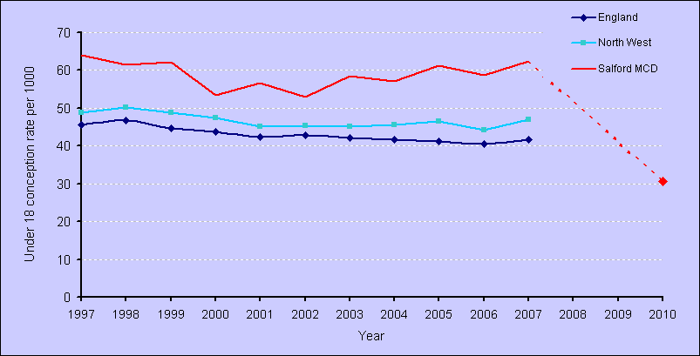

Performance required to meet 50% reduction target

However, other local authorities with similar deprivation indices have succeeded in making more significant improvements, for example; South Tyneside teenage pregnancy rates have fallen by 14.2% between 1998 and 2007.

The high levels of teenage pregnancy in Salford has significant implications for its young people and for future generation as is demonstrated through the evidence of the impact on young people, both through unwanted conceptions and teenage parenthood.

The levels of teenage pregnancy also have an impact on the wider community and the perception of very young parenthood as normal, along with the concurrent health and socio-economic impact.

Evidence shows that having children at a young age can damage young women’s health and wellbeing and severely limit their education and career prospects. Studies show that children born to teenagers are more likely to experience a range of negative outcomes in later life, and are up to three times more likely to become a teenage parent themselves.

Department for Education and Skills, 2007

The Government’s and local public sector’s recognition of the adverse impact of teenage pregnancy is demonstrated through national and local targets. This adverse impact needs to be translated to the wider Salford community to break the cycle of deprivation and meet the original objectives of reducing social exclusion.

2.1 National and local targets

- The Department for Children, Schools and Families and the Department of Health have shared responsibility for the target to halve under-18 conception rates by 2010 against a 1998 baseline.

- At a local level, the Primary Care Trust and local authority are jointly responsible for achieving this national indicator (NI 112) as part of Public Service Agreement 14 (Department for Communities and Local Government, 2007), through delivery of the local area agreement and NHS Operating Plan.

- The target for the under-16 conception rate is to reduce the rate per 1000 (based on female population aged 13-15).

- A further target relevant to teenage pregnancy is to increase to 60% the proportion of teenage mothers in education, training or employment to reduce their risk of long term social exclusion.

2.2.1 Identifying risk of teenage pregnancy or parenthood

There is strong evidence which identifies the individual risk factors that can increase the likelihood of teenage pregnancy and parenthood. These include:

- Being from an unskilled manual background (social class V)
- Living in an area with a high level of deprivation
- Having a mother who had no qualifications
- Having a mother who was a teenage mother
- Having low self-esteem
- Scoring below average on measures of educational achievement
- Leaving school at 16 without any qualifications
- Being in, or having been in, care
- Ethnicity which is ‘Black Caribbean’, ‘Mixed White and Black Caribbean’, ‘Other Black’ or ‘White British’ (categories from 2001 Census)
- Being a girl who is sexually active under 16
- Having poor use of contraceptives
- Having had a previous abortion or pregnancy
- Having a Mother with low educational aspirations for her daughter
(National Statistics (2004) Census 2001 table: C0069 Mothers under-19 at birth)

2.2.2 Impact on children of teenage mothers

Children of teenage mothers have a 63% increased risk of being born into poverty compared to babies born to mothers in their twenties.

Children of teenage mothers are more likely to have accidents and behavioural problems. However, the fact that teenage mothers were more likely to suffer from anxiety and depression seemed to be at the root of this, rather than teenage parenthood per se (Berrington et al, 2007).

Child benefit claimant data shows that 49% of teenage mothers live in the most deprived 20% of Super Output Areas.

2.2.3 Multiple risk factors

Young women experiencing five risk factors (daughter of a teenage mother; father’s unskilled social class; conduct disorder; social housing and poor reading ability at age 10) have a 31% probability of becoming a mother under-20 years of age, compared with a 1% probability for someone experiencing none of these risk factors.

Young men with the same risk factors had a 23% probability of becoming a young father (under age 23), compared to 2% for those not experiencing any of these risk factors.

2.2.4 Living in care

Research has shown that by the age of 20, 25% of young people who had been in care were young parents and 40% were mothers (Barn R, Andrew L, Mantovani N 2005).

- The prevalence of teenage motherhood among looked after young women under-18 is around three times higher than the prevalence among all girls under-18 in England (NHS Salford, 2009a)

2.2.5 Education

The likelihood of teenage pregnancy is far higher among those with poor educational attainment, even after adjusting for the effects of education. A survey of teenage mothers showed that disengagement from education often occurred prior to pregnancy, with less than half attending school regularly at the point of conception (Hosie and Dawson, 2005).

Among young women leaving school at 16 with no qualifications, 29% will have a birth under-18, and 12% an abortion under-18, compared with 1% and 4% respectively for young women leaving at 17 or over (Hosie and Dawson, 2005).

Teenage mothers are 20% more likely to have no qualifications at age 30 than mothers giving birth aged 24 or over. Overall, nearly 40% of teenage mothers leave school with no qualifications (Hosie and Dawson, 2005).

Poor attendance at school is also associated with higher teenage pregnancy rates (NHS Salford, 2009a). Dislike of school was also shown to have a strong independent effect on the risk of teenage pregnancy (Hosie and Dawson, 2005).

2.2.6 Worklessness

At aged 30 years, teenage mothers are 22% more likely to be living in poverty than mothers giving birth aged 24 or over, and are much less likely to be employed or living with a partner.

At age 30 men who became fathers in their early 20s, (under age 23) were twice as likely to be unemployed as those becoming fathers over 23 years, even after taking account of deprivation, (Berrington et al, 2007).

2.2.7 Health

The infant mortality rate for babies born to teenage mothers is 60% higher than for babies born to mothers aged 20-39 years, (Department of Health, 2007).

Teenage mothers are more likely to smoke during pregnancy and are less likely to breast feed, both of which have negative health consequences for the child.

Teenage mothers have 3 times the rate of post-natal depression of older mothers and are at a higher risk of post natal depression for 3 years after the birth.

2.2.8 Economic impact of teenage pregnancy and teenage parenting

There is a strong economic argument for investing in measures to reduce teenage pregnancy, which places significant burdens on the NHS and wider public services. In 2002, it was estimated that the cost to the NHS alone of pregnancy among under-18s was over £63 million pounds a year. (Teenage Pregnancy Strategy Evaluation Team, 2003)

Sources for the above: Department for Education and Skills 2007; Department for Education and Skills 2006; unless otherwise stated.

2.3 Current Statistics (Epidemiology)

- Salford’s under-18 conception rate remains high at 1.5% above baseline for figures reported in 2009 and Salford is not on target to achieve the 50% reduction in teenage conceptions by 2010
- Some statistical neighbours are achieving considerable reductions in their rate of under-18 conceptions, our most similar Local Authority South Tyneside a 14.2% reduction
- The positively rate for Chlamydia is higher than average
- The percentage of 16-19 year old mothers in education, employment or training is low, at 48%

2.4 Under-18 conceptions

Table 2 published February 2009:

 | 2007 |  | 1998 baseline |  | % change
 | Number | Rate | Number | Rate
Salford | 266 | 62.4 | 250 | 61.5 | +1.5%
North West  Region | 6,475 | 47.0 | 6,457 | 50.3 | -6.5%
England | 40,298 | 41.7 | 41,098 | 46.6 | -10.7%

In Salford, after a reduction in under – 18 conceptions in 2002, the rates have been increasing to a level of 62.4 per 1,000 under -18s in 2007. This compares to a North West rate of 47.0 and an England rate of 41.7. The latest data for Q2 2008 is 64 conceptions, for Q1 and Q2 2008 = 126 conceptions.

Salford’s under-18 conception rate (2007) has increased by 1.5% from the baseline in 1998, compared to a 10.7% reduction for England and a 6.5% reduction for the North West

2.5 Ward Level Data
The Teenage Pregnancy Unit has defined hotspot wards, as wards with teenage conception rates of 60 per thousand or higher of young women aged 15-17. This means with 2005-2007 data that Salford has thirteen hotspot wards, Langworthy, Ordsall, Winton, Blackfriars, Little Hulton, Pendleton, Walkden North, Barton, Eccles, Pendlebury, Broughton, Swinton North and Weaste and Seedley. Table 3 represents the post 2004 reorganisation of wards with 12/20 of Salford’s wards as hotpots.

Table 3
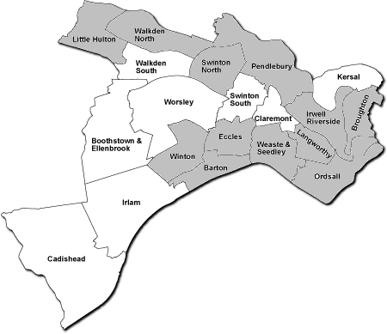

Teenage Pregnancy Hotspots 2005-2007
(data is supplied from ONS based on pre 2004 wards therefore map revised to account for post 2004 ward reorganisation)

2.6 Under-16 conceptions

The conception rate for those under-16 years is fairly static 10.5 rate per 1000, for 2005-2007 with 51.9% leading to abortion, a reduction from 61.5%. Nationally, the under-16 conception rate increased from 7.8 per 1,000 girls aged 13-15 in 2006 to 8.3 in 2007.

2.7 Abortions

Salford PCT commissions abortions from four providers; one NHS and three independent sector providers. The number of abortions in young women under-17 years from 2005 to 2008 shows that the figures for girls aged 15 and 16 years fell in 2008, but has remained relatively stable for 17 year olds.

2.8 Repeat terminations

Repeat termination data for Salford is calculated by the Department of Health and is calculated as age at termination rather than age at conception.

Table 4
 | No previous abortions | 1 or more previous abortions | Percentage of repeat abortions | Total under 19 abortions
2005 | 130 | 19 | 12.8% | 149
2006 | 122 | 21 | 14.7% | 143
2007 | 165 | 20 | 10.8% | 185
(Source: Department of Health, 2007)

2.9 Statistical neighbours

The percentage change in conception rates for Salford’s statistical neighbours show a wide variation, as follows:

Table 5
 | % change
South Tyneside | -14.2%
Hartlepool | -11.7%
Middlesbrough | +0.3%
Salford | +1.5%
Newcastle upon Tyne | +9.8%

3 What we know works in tackling Teenage Pregnancy

There is good evidence that including teenagers’ parents in information and prevention programmes is effective. Young people whose parents discuss sexual matters with them are more likely to use contraception at first intercourse (Swann et al, 2003; Stone and Ingham, 2002).

In 2002 a survey asked young people about their preferred sources of sex and relationships information. 40% of year 8 and 31% of year 10 girls said their preferred source was their parents. The corresponding figures for boys were 30% and 23% (Balding, 2003). Over half said they found it quite or very easy to talk to their mother about sex and relationships, 26% said the same for their father. 38% said they found it very difficult to talk to their father. One study with sisters of pregnant teenagers indicated that the programmes delayed sex and decreased reported pregnancy rates but did not increase use of contraception.

A survey in 2001 showed 86% of parents agreed that there would be fewer teenage pregnancies if more parents talked to their children about sex, relationships and contraception (BMRB, 2001). An established programme such as Speakeasy designed by the FPA has been used in Salford. Research shows that a mother with low educational aspirations for her daughter at age 10 is an important predictor of teenage motherhood (Department for Education and Skills, 2007).

The work already under way in education, to tackle absence, improves attendance; achievement and aspiration contribute to tackling the determinants of teenage pregnancy.

Schools, Pupil Referral Units, further education and sixth form colleges and training providers all have a role to play in the provision of high quality Relationships and Sex Education and to support the provision of easily accessible on-site services. The better equipped education providers are at dealing with school failure, antisocial behaviour and depression, the less likely young people are to have problematic health behaviours (Bremberg 2008, after Roe).

3.1 Evidence of Effectiveness

The Netherlands has the lowest teen pregnancy rate in Europe. Social attitudes to teenage sex and pregnancy are very different to those in the UK. In the Netherlands, there is social stigma attached to getting pregnant, while in some poor areas of the UK, pregnancy has become normalised.

Children are taught openly about sex both at home and at school - and they are expected to deal with sex responsibly.

Contraception is promoted for its health benefits by Dutch doctors. Many young women start using the pill before they begin having sex and abortion is considered a more acceptable option than in some parts of the UK.

The Netherlands defies theories that openness encourages sex. Surveys show that teenagers in the Netherlands are likely to start having sex on average a year later than their British counterparts. In the Netherlands, 58% of teenage girls discuss pregnancy with their partners, compared to 30% in the UK.

Across England there are many examples of areas that have successfully tackled teenage pregnancy through integrated programmes that address access to information, contraception and services, as well as wider factors such as young people’s aspirations and parental engagement. These integrated programmes have been shown to reduce teenage conceptions and support young parents to continue education and employment. They also have the potential to have a positive impact on wider key outcomes – particularly education and worklessness.

This finding is supported by research in the United States which found that 86 per cent of the recent decline in United States teenage pregnancy rates is the result of improved contraceptive use (Santelli et al, 2007). Among school-aged young people (aged 15-17) 77 per cent of the decline in pregnancy risk was attributable to improved contraceptive use.

Intensive reviews of statistically similar areas with contrasting rates of progress, carried out in 2005, identified the key factors for high impact changes:

- Active engagement of all the key mainstream delivery partners who have a role in reducing teenage pregnancies – Health, Education, Social Services and Youth Support Services – and the voluntary sector.
- A strong senior champion who is accountable for and takes the lead in driving the local strategy.
- The provision of a well publicised young people centred contraceptive and sexual health advice service, trusted by young people and known by professionals. There should be a range of service providers offering choice to young people but all working to same standards (You’re Welcome). Services should be both universal and targeted.
- A high priority given to PSHE in schools, with support from local authority to develop comprehensive programmes of Relationships and Sex Education in all schools. A strong focus on “healthy schools” as the vehicle for provision of Relationships and Sex Education, with school health services providing the link between schools and young peoples sexual health services.
- A strong focus on targeted interventions with young people at greatest risk of teenage pregnancy, in particular with Looked After Children, with Relationships and Sex Education training for all services working with vulnerable young people.
- Workforce training on Relationships and Sex Education for professionals in partner organisations.
- A well resourced Youth Service, with a clear focus on addressing key social issues affecting young people
(Department for Education and Skills, Teenage Pregnancy Nest Steps 2006)
4 Current Activity and Gaps
4.1 Young Peoples’ Contraception and Sexual Health Services

4.1.1 Summary

Evidence shows that early access to contraception services and contraceptive use has a significant impact on reducing teenage conception rates. There is clear evidence about the characteristics of services required by young people. Service redesign of young people’s sexual health services in Salford has been started with a clear model of provision being put in place, with defined outcomes and pathways. Service delivery is through a range of providers across four tiers of increasing intensity and intervention, including school and further education settings, however further developments are needed, including management of service interfaces so that young people can get the same quality of service, whichever provider they choose to go to services which provide interventions to prevent pregnancy and sexually transmitted infections. There is potential to further develop services in conjunction with primary care and the third sector.

National levels for sexual health services outlined in the National Strategy for Sexual Health and HIV, (Department of Health 2001) are not directly appropriate for young people’s sexual health services. Salford PCT has therefore devised 4 tiers of service to describe the interventions aimed at young people which are in line with the tiers for young people’s substance misuse services.

4.1.2 Service redesign to improve access and extend services at Tiers 1 and 3

The most significant strategic and operational change being implemented in Salford is a process of service redesign, with a new contraceptive and sexual health service for young people being commissioned from December 2009.

This represents the culmination of a significant amount of work to assess local need, involve and listen to young people, consider the current evidence base, and make explicit the way in which the commissioners want services to be provided. Salford PCT has made additional investment in this new service which will significantly increase the potential for young people to access services.

Transition arrangements have been put in place with the current providers to ensure minimal disruption for clients. NHS Salford has made significant investment of £376,000 to ensure adequate and equitable service delivery across Salford.

4.2 Support for Young People including Vulnerable Young People

4.2.1 Summary

As outlined in the Salford Teenage Pregnancy Health Needs Assessment those with the greatest risk factors will require the greatest support. Current provision of support for young people in Salford is through the delivery of Integrated and Targeted Youth Support, the “Team around the School” model, and a range of community-based activities.

Further work is needed to evaluate current provision, described below, and to build on current programmes and moving towards a holistic and integrated package of provision for young people, provided within youth development models.
Although there are a wide range of interventions being provided for young people, the way they are planned and delivered is fragmented across different services and there is a lack of coordination and resources are thinly spread.

No formal mapping has been done of current provision against what is available to young people through a youth development model. Consideration of a health component will be a useful starting point. Current universal provision needs strengthening, enabling the delivery of a universal/progressive model which supports young people’s engagement.

Outreach provision for young people is not integrated but focuses separately on risky behaviour or health needs, causing prevention work to focus on the symptoms, rather than the underlying cause. There are no shared tools or procedures in place to support assessment of risk of teenage pregnancy; also there is no shared guidance on parental involvement/consent in working with young people.

The link between young people’s alcohol use and teenage pregnancy prevention and/or teenage parenthood has not been fully explored locally.

4.2.2 Targeted Youth Support

Current Provision: Targeted Youth Support is a model which makes services more accessible, attractive and relevant for vulnerable young people. Through the use of the Common Assessment Framework (CAF), needs are identified early, enabling personalised packages of support, information, advice and guidance, provided early and co-ordinated by a lead professional. This support can be provided in universal settings and across transitions.

Gap Analysis: Although the Common Assessment Framework, (CAF) as a tool, helps to identify general risk factors, it does not identify all factors which are known to lead to teenage conception, which itself carries elements of risk. The Teenage Pregnancy Risk Assessment toolkit developed by Manchester and Stoke Teenage Pregnancy Workers provides an additional tool for identifying risk factors which relate to teenage pregnancy.

Future Provision: Introduce the Teenage Pregnancy Risk Assessment Toolkit to all formal and informal education settings.

4.2.3 Team around the School

Current Provision: Salford City Council’s targeted youth support model is the “Team around the School” these are co-located multi-disciplinary teams, which are being well received by Head Teachers in High Schools and Pupil Referral Units.

The “Team around the School” model of provision builds on current practice and provides systematic and joined up prevention, early intervention and support arrangements for young people and ensures close links with universal services within individual schools.

Gap Analysis: The “Team around the School” programme is new and has yet to be evaluated fully and is not yet at full capacity. Current provision will be evaluated to support future developments.

Future Provision: Evaluate and regularise the provision of the “Team around the School” programme in Salford to maximise impact.

4.2.4 Localities and neighbourhoods

Current Provision: Locality managers have an important co-ordination function, working with a wide range of practitioners and services, including those relating to safeguarding. Their engagement in implementation on a local basis is fundamental, particularly in those areas with very high rates of teenage pregnancy.

Gap Analysis: Mapping is under way to demonstrate need and current provision and identify areas where new provision is needed. Langworthy and Winton for instance have very limited youth provision and are hot spot areas.

Future Provision: All hot spot areas will be supported to understand and develop co-ordinated responses to Teenage Pregnancy.

4.2.5 Promoting the health of young people – a holistic, multi-agency model

Current Provision: Existing Young Persons Sexual Health services are being transferred to a new provider on the 1st of January 2010.

Gap Analysis: Existing services required great expansion to meet potential need and the opportunity was taken to put the service out to competitive tender.

Future Provision: The model for the provision and the implementation of young people’s contraception and sexual health services provides a potential base for the development of a wide range of preventative interventions and services described as part of the co-location of services. This is integral to linking this strategy with others for example; smoking and alcohol.

4.3 Support for vulnerable young people

4.3.1 Looked after children / young people

Current Provision: The looked after children’s nurse, employed by the Local Authority, is sexual health trained to provide advice and prescribe contraception. The educational outcomes and other needs of looked after children and young people are taken into account within the virtual school model.

Gap Analysis: There is a need for all social workers to be included in tier 1 training ensuring access to basic sexual health information for all young people who come into contact with Social Services.

Future Provision: Universal Tier 1 training to be rolled out for all social workers and staff working with young people.

4.3.2 Young offenders

Current Provision: There is good integration of health provision through a specialist nurse role within the Youth Offending Service. Most of the clients are male, although a few are young mothers.

Gap Analysis: Contraception can be accessed by clients of this service, although there still remains the need for wider sexual health training for all staff.

Future Provision: Universal Tier 1 training to be rolled out for all staff working with young people in the Youth Offending Service.

4.3.3 Homeless young people

Current Provision: All staff at the two single people’s hostels and at Salford Foyer have been trained to provide basic contraception and sexual health services. The impact is noticeable as measured by uptake of the Chlamydia Screening Programme;

Gap Analysis: Further basic training is required and links to young people’s sexual health services.

Future Provision: Universal Tier 1 training to be rolled out for all staff working with young people in the single people’s hostels and Salford Foyer.

4.3.4 Alcohol and drugs

Current Provision: Salford has significant issues with alcohol use by young people. Locally young people are known to “binge" drink and drink outside. This puts them at higher risk sexual activity they might later regret, unprotected sex and possibly sexual exploitation.

Gap Analysis: There has been no reliable self-reporting survey of young people’s drug use.

Future Provision: Commission a survey through the Drug and Alcohol Team to determine the link with Sexual Health. Tier 1 training and increased partnership working with young people’s sexual health services to be established.

4.3.5 Safeguarding and Prevention of under-18 conceptions

Current Provision: The delivery of a programme for prevention requires good functioning of the mechanics of a safeguarding system. During the delivery of relationships and sex education, within primary, secondary or special school, within Pupil Referral Units, colleges and alongside training provision, a dialogue with a young person can trigger a child protection concern.

Gap Analysis: It is essential then that the different levels of safeguarding process work well with delivering prevention activity.

Future Provision: Develop robust links with services providing support to young people experiencing sexual exploitation and abuse.

4.3.6 Relationships and Sex Education (RSE)

Current Provision: Given the resource available, there is a considerable amount of activity across primary, secondary and special schools and within Pupil Referral Units to support the delivery of Relationships and Sex Education, through the provision of advice, guidance and the development of capacity in Personal, Social and Health Education leads, pastoral leads in conjunction with Senior Management Teams. A review process is also under way. There is good joint working across a range of related areas, for example; Personal, Social and Health Education, Healthy Schools, alcohol and drug education, Social and Emotional Aspects of Learning and this joint working needs to continue, in support of the wider young people’s wellbeing agenda. There has also been a good uptake of Continuing Professional Development for Personal, Social and Health Education, and within that Relationships and Sex Education, though there has been greater success within primary than secondary schools.

Gap Analysis: In partnership with Government Office North West, a resource has drawn together good practice from across the region and aims to promote effective Relationships and Sex Education to meet the needs of young people and teachers and to support schools to provide good quality Relationships and Sex Education.

Future Provision: Implement the best practice from across the region incorporating:

- the Department for Education and Skills Sex and Relationships Guidance (2000)
- Every Child Matters outcomes
- the revised Personal and Social Health and Economic Education requirements of the Qualifications Curriculum Authority
- the Social and Emotional Aspects of Learning (SEAL) Programme.

Effective Relationships and Sex Education:

- Is developmental, spiralling and appropriate to the age, ability and maturity level of children and young people
- Provides accurate information
- Includes details of local services
- Provides the opportunity for visits, either actual or virtual, to local young people’s contraception and sexual health clinics
- Promotes self esteem, assertiveness and builds confidence
- Is sensitive to the needs of children and young people, including those with learning and physical disabilities
- Promotes and develops respect for self and others
- Encourages young people to reflect and analyse their own role in developing negotiation skills
- Contributes to positive, responsible and caring relationships
- Allows young people to reflect and analyse their own role in developing negotiation skills
- Enables young people to develop and practice communication and decision making
- Enables young people to understand difference
- Develops skills and gives the correct information to make informed choices
- Promotes the spiritual, moral, cultural, mental and physical development of pupils at school and in society
- Teaches a pupil to understand human sexuality
- Offers single gender sessions if appropriate
- Supports parental involvement
- Links to other themes in local Healthy Schools delivery
- Is delivered by trained professionals

The list above outlines how Relationships and Sex Education, delivered to a gold standard, will look. The delivery model will be flexible according to identified needs and available resources.
4.3.7 Communications and Media

Current provision: There has been some interim service publicity with the short-term changes to services over the last year.

Gap Analysis: Young people’s involvement in development and design of publicity is limited and information about services doesn’t always emphasise that they’re free and confidential and when they are available to young people under 16. There is currently no directory of services and specific publicity for vulnerable groups has not been developed. It is not clear whether young people are able to access straightforward information on avoiding pregnancy, sexually transmitted infections and choice of services available

There is no up-to-date policy to support media and communications activity in relation to prevention and support and no clear objectives, shared standard messages or framework for mapping out required media and communications activity

There is no clear plan for long term service publicity as new services embed and there is no plan for the communication of the strategy within partner organisations

Future Provision: Develop and implement a robust communications strategy for Teenage Pregnancy and Salford.

4.3.8 Work with Parents/Carers

Current provision: Although some work has been done with parents/carers, it has been limited in scope and patchy in terms of delivery geographically or in relation to certain vulnerable groups.

Gaps Analysis: There is no community-wide approach to working with adults/parents to raise awareness and develop skills in Relationships and Sex Education, sexual health promotion and in the determinants and negative outcomes of teenage pregnancy.

Future Provision: New models for working with parents need to be identified and developed, including models for incorporation into early year’s provision. Specific provision needs to be made available for parents to discuss concerns in confidence.

4.3.9 Raising Aspiration and Absenteeism

Current Provision: Underpinning teenage pregnancy are low aspirations, poor attendance or achievement at school, poor potential for employment and poor role models. The likelihood of teenage pregnancy is far higher among those with poor educational attainment, even after adjusting for the effects of education.

A survey of teenage mothers showed that disengagement from education often occurred prior to pregnancy, with less than half attending school regularly at the point of conception. Poor attendance at school is also associated with higher teenage pregnancy rates (Salford Primary Care Trust, 2009a). Dislike of school was also shown to have a strong independent effect on the risk of teenage pregnancy.
(Hosie and Dawson, 2005)

Gap Analysis: Across England there are many examples of areas that have successfully tacked teenage pregnancy through integrated programmes that address access to information, contraception and services, as well as wider factors such as aspiration and parental engagement. These integrated programmes have been shown to reduce teenage conceptions and support young parents to continue education and employment. They also have the potential to have a positive impact on wider key outcomes – particularly education and worklessness.

Future Provision: Develop and commission programmes that build aspiration and tackle absenteeism from the early years through to young adulthood.

4.3.10 Salford and Other Countries

Current Provision: Research by the Alan Guttmacher institute compared rates of teenage pregnancy in five developed nations, and their approaches to this issue. It concluded that comprehensive and balanced information about sexuality is one of the hallmarks of countries with lower levels of adolescent pregnancy. Easy access to contraceptives and other reproductive health services were seen to contribute to lower rates (Darroch et al, 2001).

As stated in Section 3.1 The Netherlands has the lowest teen pregnancy rate in Europe. Social attitudes to teenage sex and pregnancy are very different to those in the UK. In the Netherlands, there is social stigma attached to getting pregnant, while in some poor areas of the UK, pregnancy has become normalised.

Gap Analysis: A UNICEF report compared teenage birth and termination rates in 28 countries and concluded that provision of quality sex education, building incentives to avoid early parenthood and improving access to contraception, are the main characteristics of countries with lower rates (UNICEF, 2001).

Future Provision: Successful implementation of this strategy will start to address shortcomings in current provision and shift the social norms that have previously failed to raise aspiration, educational attendance and attainment and establish a healthy dialogue concerning relationships and sex.
5 Delivery and Action Plan

The accompanying document “Working together to improve Sexual Health and Wellbeing for young people in Salford action plan 2010-2013” contains eight strategic priorities and should be read in conjunction with this strategy. These priorities are supported by a number of actions which will deliver a reduction in Teenage Pregnancy in Salford.

The strategy will deliver:

- Improved access to contraception across Salford
- Improved support from primary care for young people’s sexual health
- Improved support for pregnant young women, young parents and their children
- Improved support services and primary prevention of pregnancy and infection
- Improved multi-agency working
- Improved communication and use of the media
- Improved Relationships and Sex Education in all schools in Salford
- Improved support in all Children’s Centres in Salford

  - Priority 1: Develop Contraception and Sexual Health Services

Evidence shows that early access to contraception services and contraceptive use has a significant impact on reducing teenage conception rates. There is clear evidence about the characteristics of services required by young people. Service redesign of young people’s sexual health services in Salford has been started with a clear model of provision being put in place, with defined outcomes and pathways.

Table 6
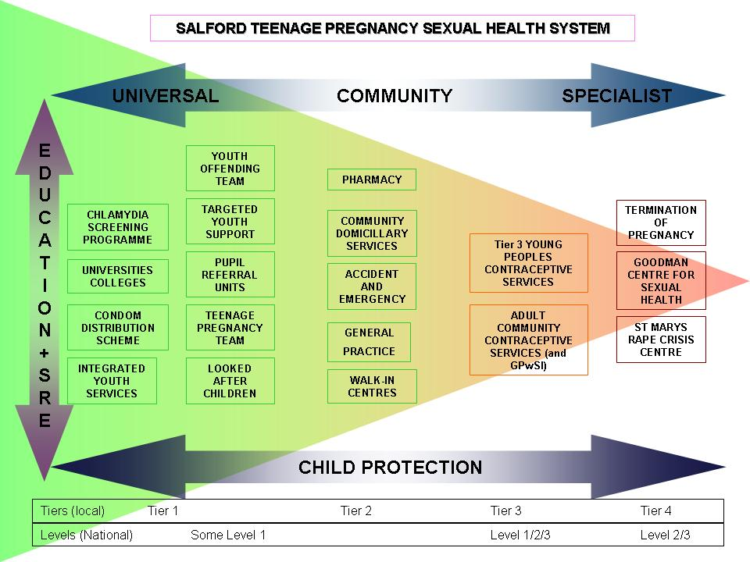
The most significant strategic and operational change being implemented in Salford is a process of service redesign, with a new contraceptive and sexual health service for young people being commissioned from December 2009.

Actions to deliver the objective – commissioning and developing services that will improve access to contraception across Salford

- Develop Tier 2 sexual health services in five schools with the highest conception rates
- All high schools to establish a drop in contraception and sexual session
- All Salford City College sites to deliver tier 3 contraception and sexual health services
- All providers of work-based training for young people, commissioned through the city council and the PCT, to provide tier one sexual health interventions

  - Priority 2: Supporting young peoples sexual health and wellbeing through Primary Care

A survey in 2003 demonstrated that among both 16-17 and 18-19 year old young women, the most popular source of contraception services or supplies was their own GP or practice nurse (21% and 55% respectively), followed by community contraceptive services (17% and 25% respectively) (ONS, 2003). A survey in 2003 showed that general practice (doctor or practice nurse) was young people’s second choice in a list of providers of contraceptive advice (22%), (BMRB International, 2003). However, general practitioners are perceived by young people as being less confidential than other settings (Peckham et al, 1996).
Actions to deliver the objective – commissioning and developing services that will improve support from primary care for young people’s sexual health

- Recruitment of a GP champion for young people’s sexual health to lead in primary care development and implementation
- Implement the Local Enhanced Service contract with GPs for Chlamydia screening and young people’s sexual health services
- Complete a sexual health skills audit across Primary Care and make recommendations for training and development to PBC
- Include Tier one sexual health interventions into all frontline staff job descriptions

  - through Primary Care

5.3 Priority 3: Support for pregnant young women, young parents and their children

A significant proportion of teenage mothers have more than one child when still a teenager. Nationally, around 20% of births conceived under-18 are second or subsequent births. Whilst most births to under-18s are the first birth, around 5% each year are the patient’s second child (NHS Salford, 2009a)

Table 7

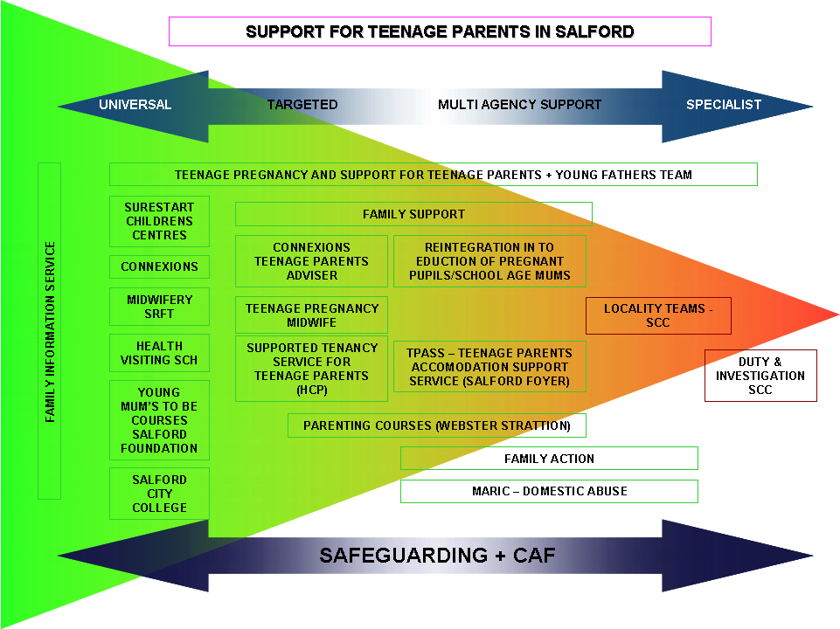
Actions to deliver the objective – commissioning and developing services that will improve support for pregnant young women, young parents and their children

- Establish a post in Maternity Services to support Teenage parents and to develop the skills of the maternity services
- Develop personalised education programmes for all individual school age parents

5.4 Priority 4: Prevention and supportive environments

The factors that have the most impact on teenage pregnancy are those which also impact on other health and wellbeing outcomes for children, young people and families. Tackling these factors requires a shared strategic approach across agencies, including the voluntary and third sector, to ensure an integrated and coherent approach with the best use being made of available resources. The implementation of the strategy is an integral part of the broader safeguarding agenda.
Actions to deliver the objective – commissioning and developing services that will improve support services and primary prevention of pregnancy and infection

- All services to achieve the standards for You’re Welcome and Getting it Right
- Deliver courses in the community for parents to develop their skills and confidence around sexual health and relationships
- Complete a skills audit across frontline staff (PCT and CC) to assess development needs
- Evaluate the targeted youth support scheme around the school to assess the impact on young people’s sexual health

5.5 Priority 5: Establish multi-agency service model

There is a need for joint working between practitioners within services to ensure young people can access a number of workers, according to the service needed. There is the potential for provision of multi disciplinary teams which would integrate young people’s sexual health with other risk factors.

Actions to deliver the objective – commissioning and developing services that will improve multi-agency working

- Set up a task and finish group to develop a young people’s healthy lifestyle model
- Pilot in one of the hot spot areas, the integrated youth development model through an identified team
- Evaluate and deliver on a city wide basis

5.6 Priority 6: Media and Communications

A strategically co-ordinated programme on media and communications which provides clear information in a range of formats to young people, young parents or to services is crucial to both provision of consistent information to young people about sexual health and also providing information about services.
Actions to deliver the objective – commissioning and developing services that will improve communication and use of the media

- Develop and implement a media communications strategy
- Develop and implement a Social Marketing campaign that targets those most at risk of early pregnancy

5.7 Priority 7: Sex and Relationship Education

The delivery of Relationships and Sex Education in schools within Personal, Social and Health Education will become compulsory in 2011. This will support schools to deliver high quality Relationships and Sex Education, building on good work that has gone before but with a clear project management approach, a clear core offer, gold standard and targets to aim for, with a timeframe for delivery, quality assurance and reporting programme.

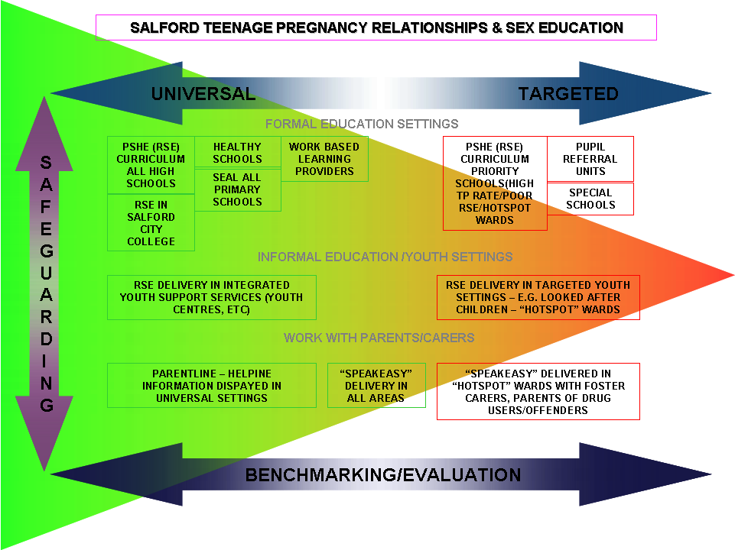
Table 8

Actions to deliver the objective – commissioning and developing services that will improve Relationships and Sex Education in all schools in Salford

- All schools and Pupil Referral Units to achieve the Healthy Schools Status
- All schools to have an accredited PSHE teacher
- Implement RSE leadership scheme for all school governors and all Head Teachers
- All schools to include RSE as part of the School Improvement Assessment

5.8 Priority 8: Early Years Environment

Though there is considerable support for early year’s activity in Salford, there are no broad, evidence-based programmes of intervention in place to support young parents and their children from pregnancy through to primary school.

Actions to deliver the objective – commissioning and developing services that will improve support in all Children’s Centres in Salford

- Develop young parents support service in all Children’s Centres

6 Governance

6.1 Summary

The current Teenage Pregnancy Executive provides strong senior level leadership for implementation of the Strategy. A revised sub-structure is proposed with clear governance and accountability, to create greater flexibility and wider engagement. Further consideration is needed regarding the engagement of young people and young parents with the work of the Executive and within the sub-structure.

6.2 Teenage Pregnancy Executive

On recommendation from the Teenage Pregnancy National Support Team visit (2008) a revised Teenage Pregnancy Executive meets monthly and is chaired by Salford City Council, Assistant Director Children’s Services. The progress made over 2008/9 demonstrates good joint working across PCT and local authority and incorporates voluntary sector representation.

The strength of the working relationship has been evidenced by a recent series of joint visits to secondary school heads and pupil referral units to explore the potential of school-based CASH services and the further development of Relationships and Sex Education across Salford.

Table 9

Teenage Pregnancy Executive Reporting Structure

Teenage Pregnancy Executive
Salford Strategic Partnership
Health and Wellbeing Board
Children and Young Peoples Partnership Board
Task and Finish Group
Task and Finish Group
Task and Finish Group
Task and Finish Group
Salford City Council Cabinet
Think Healthy Living Board
NHS Salford Board
Young People, Parents and The Wider Community
NHS Salford Commissioning
Board

7. Finance / Resources

7.1 Summary

Investment in tackling teenage pregnancy and parenthood comes from a range of sources and historically some resources have been embedded in block contracts or have become part of core provision with a number of service providers. This makes it difficult to extrapolate and provide a baseline figure of investment. Other investment has been short term and used to pump prime innovation or fill service gaps.
The main investment sources have either been from central Government via regional allocation: through Area Based Grant; through local authority allocations or through PCT allocations.

7.2 Current Position

Historically Salford PCT has invested in a limited sexual health service for young people, indirectly through maternity and abortion services, GUM services, school health programme, school nurse and health visitor services. There has also been a significant level of funding is on a non – recurrent basis, e.g. media campaigns such as the Taxi “Wrapping”, “Headliners” within Buses and support to related targets such as chlamydia screening.
More recently there have been developments in resourcing the local Chlamydia screening programme and the R.U.Clear Manchester wide component of the programme; pharmacy provision of emergency hormonal contraception and through commissioning contracts with Salford Acute Foundation Trust and Salford Community Health activity by maternity, abortion and GUM services and the school health service, community contraceptive service and a specialist young people’s sexual health sessions.

The local authority has received resources for teenage pregnancy through the Area Based Grant which is on a 3 year cycle. The Area Based Grant is currently used for a mix of core functions and support for schemes for young mothers (see below).
A number of options are being considered for the future of Area Based Grant funded initiatives. Options include mainstreaming immediately, mainstreaming on a tapered basis, or decommissioning the activity. Given the importance of the Teenage Pregnancy Strategy to the Local Area Agreement, a proposal has been put forward to mainstream the Teenage Pregnancy funding that lies within the Area Based Grant with a recommendation the Grant should be used for innovation and pump priming teenage pregnancy initiatives.

The City Council provides mainstream funding in the region of £60,000 which part funds one SRE post and the Teenage Pregnancy Operation Manager. In addition, the City Council contributes support to the Teenage Pregnancy strategy through the use of sessional youth workers and other Children’s Services staff.

7.3 PCT Current Investment in Specialist Young People’s Sexual Health services

The PCT, through Salford Community Health has funded four KISS clinics per week and has a contract with Brook (Salford) who provide 6 clinics per week. The combined funding for these services is estimated at £210,000.
The level of funding for the KISS clinics is held within the budget for the overall funding of Sexual Health Services provided by the PCTs Provider Directorate and so is not readily identifiable.
A significant number of Young People attend Provider Directorate Sexual Health clinics not specifically for Young People; therefore monies over and above that noted are spent on Young People’s Sexual Health services. The total recurrent investment in Young People’s Sexual Health services in 2008/09 was in the region of £300k to £350k.

  - PCT additional investment

The PCT identified the need to further invest in specialist Young People’s Sexual Health Services and identified recurrent funding to support this. The extended service will be established early in the financial year 2009/10.

The additional monies available for investment are £376,000 – which includes the PCTs allocation from the new funding announced by the Department of Health in February 2008 of £68,000 (this is only 3 years funding from 2008/09). Further monies may be available from funding allocated to SHAs, also announced in February 2008 by the Department of Health (and again only 3 years from 2008/09).
This additional investment has been combined with the monies currently used to fund the KISS and Brook clinics to fund an expanded service, which was procured through a tendering process and will launch December 2009.

The new Tier 3 Contraceptive and Sexual Health Service is being commissioned from West Pennine Brook, part of national Brook Young People’s Sexual Health Services and will start delivering services in December 2009 with a managed handover from Salford Community Health.

The PCT has also provided additional investment in senior management for sexual health and operational management for the Chlamydia screening programme and shared capacity in SRFT Midwifery (see table 10).

Further investment is also being made into training and development of Tier 2 service provision with a specific focus on primary care, including a GP champion for young people’s sexual health. This investment is £145,000 for three years. (See table 10)

7.5 Area Based Grant

Two grants 31otalling £185,000 fund a range of Young Person’s services. This is non-recurrent funding, and is dependent on the negotiation of the Area Based Grant for continued support. The main use of the grants are to fund one Youth Service post, the Teenage Pregnancy Strategy Manager, 0.5 SRE post, 3 Brook clinics (one Tier 3 and two Tier 2) and a number of support schemes to young mothers and mothers to be.

7.6 Salford Council Current Investment

There is mainstream funding in the region of £60,000 which part funds one SRE post and the Teenage Pregnancy Operation Manager. In addition, the City Council contributes support to the Teenage Pregnancy strategy through the use of sessional youth workers and other Children’s Services staff.

Table 10
 | 2009/10 | 2010/11 | 2011/12
Head of Sexual Health and Teenage Pregnancy (Band 8a) (0.5) (match funded by Local Authority for 2009/10/11) | £25,844 | £26,425 | £27,020
Sexual Health and Wellbeing Officer (AfC Band 6) | £34,970 | £35,757 | £36,561
Midwife (0.5) (AfC Band 7) match funded by SRFT | £20,653 | £21,398 | £21,593
Training budget | £53,533 | £51,420 | £49,826
Contraceptive Supplies LARCS, Condoms, etc | £10,000 | £10,000 | £10,000
Totals | £145,000 | £145,000 | £145,000

Table 11 below summarises the current agreed funding streams for specialist Young Persons’ Sexual Health Services. It does not include funding for general sexual health services which young people also access.
Table 11
Source of funding | Recurrent funding 2008/09 | Non – recurrent funding 2008/09 | Additional Interim Funding 2008/09 | Additional recurrent funding from 2009/10
Salford PCT | 210,000 |  | 60,000 | 376,000 + 145,000 YP SH Business Case
Area Based Grant |  | 185,000
Salford Council | 60,000

8 Appendices

Appendix 1

Every Child Matters themes for teenage pregnancy

Being Healthy
- Access to appropriate health and relationships advice
- Support and contraceptive services
- Good quality Personal, Social and Health Education
- Dedicated antenatal and post natal services for younger mothers

Enjoy and Achieve
- Improving access to education, employment and training for young parents
- Dedicated support for young parents from Connexions and Youth Service

Make a Positive Contribution
- Involving young people in the planning, delivery and evaluation of services and health improvement campaigns

Staying Safe
- Protecting confidentiality
- Safe guarding vulnerable young people
- Offering supported accommodation
- Supporting Looked After Children

Social and Economic Wellbeing
Reducing the teenage conception rate in “hotspot” wards by means of embedding preventative interventions within local Regeneration and Area Improvement/Health Plans

9 Further Reading

Social Exclusion Unit (1999). Teenage Pregnancy Report by the Social Exclusion Unit, HMSO, London

Health Development Agency (2004) Teenage pregnancy: an overview of the research evidence

Hosie A and Dawson N (2005) The Education of Pregnant Young Women and Young Mothers in England. Bristol: University of Newcastle and University of Bristol

NHS Salford (2009a) Salford Teenage Pregnancy Needs Assessment

Berrington A, Diamond I, Ingham R, Stevenson J et al (2007) Consequences of teenage parenthood: pathways which minimise the long term impacts of teenage childbearing. University of Southampton

Department for Education and Skills (2006b) Teenage Pregnancy Next Steps: Guidance for local authorities and primary care trusts on effective delivery of local strategies. London: Department for Education and Skills

Santelli J et al (2007) Explaining recent declines in adolescent pregnancy in the United States: The contribution of abstinence and improved contraceptive use American Journal of Public Health January, 97, 1, 150-56

Tackling Health Inequalities: What Works (2005) Department of Health, Health Inequalities Unit

Teenage Pregnancy Strategy Evaluation Final Report (2005) Synthesis Summary: Department for Education and Skills

Department of Health, Department for Education and Skills (2004) National Service Framework for Children, Young People and Maternity Services

Department of Health (2009) The strategy for children and young people’s health - “Healthy Lives, Brighter Futures”

Department for Children, Schools and Families (2007) The Children’s Plan: Building brighter futures. London: Department for Children, Schools and Families

Department for Children Schools and Families (2003) Building a Culture of Participation – Every Child Matters

Swann C, Bowe K, McCormick G and Kosmin M (2003) Teenage pregnancy and parenthood: a review of reviews. Evidence briefing. London: Health Development Agency.

Department for Children, Schools and Families (2008b) Participation in education, training and employment by 16-18 year olds in England. Statistical first release (June 2008)

Department for Children, Schools and Families (2006) Teenage Pregnancy Next steps: Guidance for Local Authorities and Primary Care Trusts on Effective Delivery of Local Strategies

Kirby D (2001) Emerging answers: research findings on programs to reduce unwanted teenage pregnancy. Washington, DC, USA: National Campaign to Prevent Teen Pregnancy.

Department for Education and Skills (2006a) Teenage pregnancy: Accelerating the Strategy to 2010

Department for Education and Skills (2006b) Teenage Pregnancy Next Steps: Guidance for local authorities and primary care trusts on effective delivery of local strategies. London: Department for Education and Skills

Office for National Statistics (2003) Contraception and sexual health, 2002. National statistics. London: Office for National Statistics.

BMRB International (2003) Evaluation of the Teenage Pregnancy Strategy. Tracking survey. Report of results of nine waves of research. October 2003: London. BMRB International.

Peckham S, Ingham R, Diamond I (1996) Teenage pregnancy, prevention and programmes. Southampton: Institute for Health Policy Studies, University of Southampton

Churchill D (2000) Consultation patterns and provision of contraception in general practice before teenage pregnancy: case control study. British Medical Journal 321:486-9

Department for Education and Skills (2007a) Extended schools: Building on experience. London: Department for Education and Skills

Department for Education and Skills (2007b) Teenage Pregnancy Next Steps: Guidance for local authorities and primary care trusts on effective delivery of local strategies. London: Department for Education and Skills

Department for Education and Skills (2007c) Common themes: Local Strategic Partnerships and Teenage Pregnancy Department for Communities and Local Government: London

Balding J (2003) Young people in 2002. Exeter: Schools Health Education Unit, University of Exeter

Speakeasy offers a non-threatening group based opportunity for parents to learn together and acquire the confidence and skills they need to talk to their children about sex, relationships and growing up. It is designed to be fun and relaxed, providing an atmosphere where parents can learn together from their personal experiences. It is locally organised and can link with educational, community and/or health provisions in a particular area.

