Sustainable Transport IN Salford

Draft

March 2007

Introduction.

- Our quality of life depends on transport for easy access to the everday services that we now take for granted. A safe, efficient and integrated transport system is a pre-requisite for a strong and prosperous economy. But the way in which we travel and the continued growth in road traffic is already damaging our towns, harming our countryside and contributing to global warming.

- The car engine emits many types of pollutants including nitrogen oxides, carbon monoxide, particulates, sulphur dioxide, carbon dioxide and noise. Individually, one car is not a particularly important source of pollution. However, collectively they represent a major source of air pollution which in turn has consequential effects on climate change.

- As well as affecting our environment, the way that we travel can also affect our health. The growth in car ownership has led to a more sedentary lifestyle with people taking less physical exercise. The Royal Commission on Environmental Pollution has previously reported that obesity, air pollution and traffic accidents all contribute to lower life expectancy and the 2004 Government white paper: ‘Choosing Health: Making Healthier Choices Easier’ firmly put obesity on the agenda. This highlighted the need to promote healthier communities and envisaged a transformation of the local environment with ‘whole town’ approaches to walking, cycling and public transport. Higher levels of walking and cycling would reduce heart disease, respiratory disease and obesity with consequent savings for the national health service.

- Unless we make fundamental changes to the travel choices that we make, the damage that we cause to the planet and society as a whole will become irreversible. This document aims to show the ways in which Salford City Council and its partners are trying to improve this future by providing sustainable travel choices.
  - Context.

  - Current economic strategies within the conurbation aim to make it substantially wealthier by the end of 2011. However, without significant interventions the potential increase in cars seeking to enter the Regional Centre via the limited number of radial routes will cause:

  - the rate of economic growth and inward investment to slow or disappear altogether,
  - the environmental quality of the region to be adversely affected, and,
  - the benefits of economic growth to be fettered by social exclusion, brought about by a lack of sustainable accessibility.

  - Increased activity elsewhere in the conurbation will also bring similar problems and in Salfords case, given its proximity to the Regional Centre, these problems could be considerably worse which demonstrates why Salford must be at the forefront of the development of sustainable transport systems.

  - In response to these challenges the Government has produced a series of documents outlining the need for more sustainable travel choices to be made available and describing ways in which we can minimise the overall need to travel. The Government bases its vision of sustainable development on four broad objectives:

  - Social progress which recognises the needs of everyone;
  - Effective protection of the environment and public health;
  - Prudent use of natural resources; and
  - Maintenance of high and stable levels of economic growth and employment.

  - These can also be applied to transport systems and as the sustainable development policy also recognises the right to a healthy, clean and safe environment immediate action must be taken to:

  - control traffic growth,
  - improve the performance of vehicles
  - make the public more aware about the environmnetal impact of the pollution created by the private car,
  - Make businesses more aware of greener transport and logistical solutions and,
  - create conditions wherby people feel motivated and compelled to use alternatives to the car.

Sustainable transport policies involve more than just traffic reduction. They also require new technology for increased vehicle efficiency and further investment in other modes of transport. They need to address what journeys are necessary, with the development of the Internet, for example, many people can now work from home.
  - In 1998, the Government White Paper "A New Deal for Transport: Better for Everyone" outlined their overall vision for the future of transport. The purpose of the document was to extend travel choice and secure mobility in a such a way as to support sustainable development. This was quickly followed by the 2001 Transport Act, which gave each Local Transport Authority a statutory duty to develop policies “for the promotion and encouragement of safe, integrated, efficient and economic transport facilities” and to describe them in a document known as The Local Transport Plan. (In Metropolitan areas such as Salford this duty is shared between the Passenger Transport Executive and the Metropolitan District Councils.)

  - Also in 2001 PPG13 was published, which gave further advice on:

  - the development of sustainable transport choices, both for people and freight, and,
  - the creation of easy accessibility to jobs, shopping, leisure facilities and services by public transport, walking and cycling.

It also aimed to reduce the need to travel, especially by car.

  - PPG13 made it mandatory for local authorities, such as Salford, to ensure that their own planning and transportation policies aligned themselves with the policies contained within the Regional Spatial Strategy (RSS), a document aimed specifically at ensuring that development across the North West takes place in the most sustainable and joined up way.

  - In 2003, the sub-regional policy document “Sharing the Vision, A Strategy for Greater Manchester”, outlined a vision that by 2020 Greater Manchester would be recognised as:

  - a creative and successful European Regional Centre with a strong knowledge driven economy
  - a great place to build a business, to live in and to visit a conurbation which is leading the wider north west region to greater levels of prosperity and which is helping to close the gap in prosperity between the north and the south
  - a place with a quality of environment, both built and natural, second to none.

and the important role that sustainable transport policies would play in achieving that aim.

  - More recently, The Greater Manchester Integrated Transport Strategy (GMITS), published in April 2005, set out a fifteen year perspective of how a transport system might develop in order to ensure that economic growth can take place in the most sustainable manner. Fundamental to the strategy is the need to bring about a step change in the quality and quantity of public transport, the need for a progressive approach to demand management and the recognition that future land use planning will have to direct certain activities to those areas best served by a range of transport modes.

  - The main elements of the strategy are:

  - The development of corridor partnerships with a range of organisations working together to implement an agreed range of transport measures.
  - Bus improvements, including both network enhancements and service improvements, to improve both journey quality and reliability.
  - The delivery of an expanded Metrolink network.
  - The development of rapid transit systems including busways and tram-train for those corridors where Metrolink is not economically viable.
  - Improvements to the rail networks, especially in relation to increasing capacity.
  - Greater investment in cycling and walking infrastructure to make it more safe, secure and convenient.
  - The introduction of network management measures to make best use of the existing infrastructure.
  - The development of a toolkit of demand management measures which underpin economic growth rather than harm it.
  - Better integration of modes including smarter travel, better ticketing and park and ride opportunities
  - Targeted investment in major highway schemes.
  - Better highway maintenance.

  - At the more detailed level, the policies and strategies outlined above educate the Greater Manchester Local Transport Plan (GMLTP), a document that ensures that the strategic requirements of transport infrastructure are not governed by local authority boundaries. Within this context, the overarching aim of GMLTP2 is to deliver:

  - An increase of 4 percentage points in the proportion of peak hour trips to the regional centre made by modes other than the private car.
  - No significant worsening in congestion and area wide traffic flow growth on local roads of no more than 2%.
  - A 50% reduction in the number of people killed and seriously injured on our roads by 2010 compared with the 1994 to 1998 average and a 55% reduction in the number of children killed and seriously injured.
  - A 39% reduction in the level of nitrogen oxide emissions from traffic on local roads and a 1% reduction in Co2 emissions compared with the “do nothing” scenario.

  - In order to ensure that we achieve the final bullet point, the Council's Air Quality Action Plan action plan is specifically aimed at meeting the national health based emission standards contained within the Governments National Air Quality.

  - Also at the local level the policies and procedures contained within Salford City Councils own Unitary Development Plan (UDP) also explain how the City Council is ensuring that sustainable development will take place and how it will support sustainable travel. The aims of the UDP are as follows:

  - Aim 1 – To Meet the City’s Housing Needs
  - Aim 2 - To Maximise Employment Opportunities for Local People
  - Aim 3 - To Minimise the Need to Travel and Develop a Sustainable and Integrated Transport Network
  - Aim 4 - To Improve Environmental Quality and Community Safety
  - Aim 5 - To Provide a Comprehensive Range of Accessible Local Facilities
  - Aim 6 - To Protect and Enhance Natural and Historic Environmental Assets
  - Aim 7 - To Secure Sustainable Resource Management

and from the table below it can be seen that they in turn help to deliver the 7 themes of Salfords Community Action Plan and the “Magnificent 7” pledges of the Cabinet:

Community Plan | Seven Pledges | Aim 1 | Aim 2 | Aim 3 | Aim 4 | Aim 5 | Aim 6 | Aim 7
Theme 1 A Healthy City | Pledge 1 Improving health in Salford | x |  | x | x | x | x | x
Theme 2 A Safe City | Pledge 2 Reducing crime in Salford |  |  | x | x |  |  | x
Theme 3 A Learning and Creative City | Pledge 3 Encouraging learning leisure and creativity in Salford |  |  |  |  | x
Theme 4 A City where Young People Are Valued | Pledge 4 Investing in young people in Salford |  | x |  |  | x
Theme 5 An Inclusive City | Pledge 5 Promoting inclusion in Salford | x | x | x | x | x | x | x
Theme 6 An Economically Prosperous City | Pledge 6 Creating prosperity in Salford | x | x | x | x | x | x | x
Theme 7 A City That’s Good To Live In | Pledge 7 Enhancing life in Salford | x | x | x | x | x | x | x

  - Thus it can be seen, via the mechanism outlined above, that the development of sustainable travel within Salford has a direct bearing on both the prosperity of the nation and the environmental well being of the planet.

- How The City Council and its Partners Are Working Towards Sustainable Travel Within Salford.

Public Transport

- Public transport offers an alternative to the private car and can both relieve traffic congestion and reduce air pollution. Therefore the use of public transport must be encouraged if a truly sustainable transport policy is to be developed. However, before public transport can reach its maximum potential a number of things need to happen i.e.:

  - The available journey coverage and hours of operation need to be increased in order to maximise journey opportunity.
  - Confidence, in terms of journey time reliability and vehicles actually turning up must improve.
  - Either the cost of trips must reduce or the true cost of trips made by the private car must become more transparent.
  - There must be improvements to the overall pedestrian environment especially in terms of perceived safety and also improvements to the safety and comfort of passengers.
  - There must be improvements to ticketing, information, interchange (including cycle facilities) and vehicle quality,
  - An effective package of demand management measures must be introduced, and,
  - There must be significant additional investment.

Buses

- Buses are generally recognised as an environmentally friendly form of transport, particularly in relation to the number of car journeys needed to carry the same number of passengers. A bus uses less fuel per person carried, and hence less fuel than the number of cars it replaces. However, buses in the UK are still mainly powered by diesel engines and in order to maximise their sustainability it is essential that the use of alternative fuels becomes more widespread. New technology also has a role to play, around half the current fleet currently operating in Greater Manchester have engines which at least meet the Euro 2 standard (generally taken by the industry as the watershed between buses that are polluting and those that are more acceptable) and from October 2006 it will not be legal to buy a new bus anywhere in Britain that does not meet Euro 4. Emissions for older buses also can be reduced significantly if particulate traps are fitted and GMPTE is making this a requirement for GMPTE subsidised services.

- In recognition of the part that buses play in the delivery of sustainable transport systems GMLTP2 seeks the following:

  - An increase in bus patronage of 4% against the background of a historically declining trend.
  - An increase in bus punctuality of 12 percentage points to 85% of all journeys, and,
  - A five percentage points increase in satisfaction with local bus services amongst all residents.

- Within Greater Manchester bus priority measures are delivered on a corridor basis (QBCs) by a partnership consisting of the ten district Councils and GMPTE. These corridors encourage travellers to utilise public transport by ensuring that the bus stop environment is of an extremely high quality and that there is adequate information to give passengers the confidence that a bus will actually arrive. Real Time Passenger Information has already been installed on the A666 and will soon be rolled out to other corridors so that travellers will know exactly when the next bus will arrive. Disabled access, through the introduction of bus boarders, to complement low floor buses, and bus stop clearway orders is also a major feature. As noted above, one of the main contributory factors to a successful public transport network is journey time reliability and most corridors contribute to reliability through the installation of bus priority measures. Salford City Council was the first Council in Greater Manchester to fully complete a QBC, which not only seeks to improve facilities for buses but also cyclists and pedestrians. Major operators such as First and Stagecoach recognise the importance of these corridors and as part of their on-going partnership work support them by enhanced frequency levels, modern fleets and high levels of driver training.

- In recognition of the importance that buses have to play in the delivery of a sustainable transport network Salfords UDP seeks:

“To improve their operating environment through measures such as the reallocation of road space or the use of bus priority schemes at busy road junctions.”

with Policy A5 gives further detail of how this will be achieved i.e.

“Improvements to the quality of bus services, facilities and associated highway infrastructure will also be secured through:

  - The provision of new interchange facilities;
  - The improvement of existing bus stations and bus stops, including improved standards of security, pedestrian and disabled access and improvements in the waiting environment; and
  - New forms of bus provision, such as flexible and demand responsive services, minibuses, and school buses.”

- To date, however, the majority of these QBCs are radial and the City Council recognises that if travel by bus is to become a viable option for many of its residents, problems of orbital connectivity must also be addressed. Plan one shows the main routes upon which the City Council would like to make travel by bus more attractive.

- However, the Council does not only influence the infrastructure, in certain circumstances they can also influence the services themselves. In the past, the Chief Executives team have made successful bids for Urban Bus Grant which has helped to establish subsidised services within underprivileged areas the City, The Childrens Services team arrange school transport and The Community, Health and Social Care Directorate also help to operate Community Transport (Salford). The GMPTE address more specific travel needs with their Ring and Ride service.

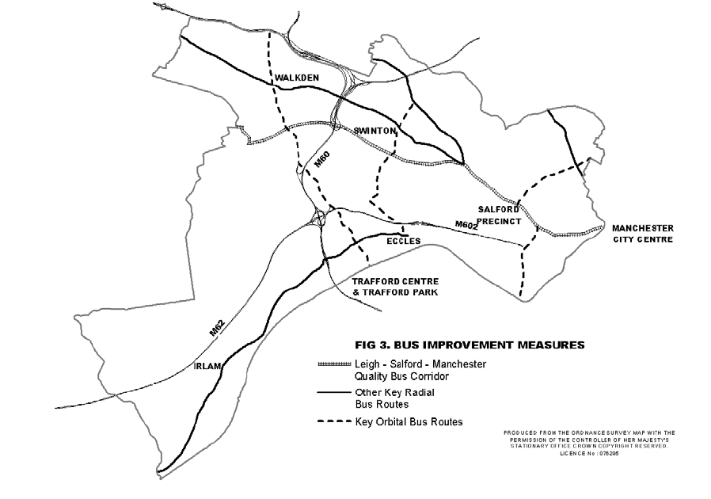

Plan 1 – Bus Improvement Measures

Rail Travel

- Railways are sustainable in two ways:

  - They use less land than roads, and,
  - They can carry large numbers of passengers.

However, they still contribute to air pollution by producing large amounts of diesel particulates and via the electricity generated “upstream” at power stations and eventually used to power electric trains (although this is small in comparison to that created by road transport). Within Greater Manchester positive actions are being taken to increase rail patronage by 12% between 2003/04 and 2010/11

- Although many Salford residents already rely upon the rail network for longer journeys around or beyond the Greater Manchester conurbation the City Council recognises that a number of relatively small improvements could still make a major contribution towards their goal of achieving a significant modal shift away from the car to public transport.

- Many existing railway stations offer little in the way of passenger comforts and are often difficult to access, especially for the disabled or others with mobility difficulties. The City Council is therefore working in partnership with the GMPTE in order to identify and prioritise a programme of station improvements designed to render the stations more accessible, safer and generally more inviting.

- Salford Central Station is of particular importance to the network, being one of five railway stations serving Manchester City Centre and monies are currently being sought in order to carry out a major upgrade of its facilities, including the provision of a pedestrian access from Trinity Way. Given its prominent location adjacent to the University and the Chapel Street Corridor, Salford Crescent has also been identified for improvement as an interchange facility.
- The City Council is also seeking to introduce new railway stations in order to benefit those large communities within Salford which do not have direct access to exiting ones eg Little Hulton.

- Against this background Policy A4 of the UDP makes this commitment to railways:

“Improvements to the City’s railway stations, rail infrastructure and rail services will be secured through:

- The continued development and improvement of Salford Central Station as a major publc transport facility serving Manchester City Centre, and Salford Crescent Station as an interchange;
- The refurbishment of the City’s other existing railway stations, including improvements to the waiting environment; the improvement of access arrangements for pedestrians, cyclists and the disabled; provision of secure cycle parking facilities; provision of transport interchanges, bus and taxi waiting areas, and where appropriate park and ride facilities; and measures designed to improve safety and security for all rail users;
- The provision of new railway stations that will serve the needs of existing communities;
- The provision of new railway stations that will serve major new development that would be likely to generate significant levels of traffic; and
- Measures that would improve the safety, speed and capacity of the rail network or relieve congestion upon it, whilst maintaining local services.”

Trams

- There has recently been a resurgence in the use of light rapid transit systems which have a lower environmental impact than buses. Trams use smaller vehicles and tighter rail tracks than conventional trains, which enables them to be more easily constructed within built-up areas. They also run at a lower cost than trains, and they can easily be expanded to accommodate increases in passengers. However, they are also expensive, and given that they utilise fixed track systems, can only form part of an integrated transport network. Never the less it is recognised that the development of the Metrolink system has an essential role to play in the creation of a high quality, fully integrated public transport network across Greater Manchester. Consequently, GMLTP2 seeks to deliver an increase in patronage of 11% between 2003/04 and 2010/11 by enhancing the existing network.

- Within Salford the Metrolink network already stretches to Salford Quays and Eccles and provision for the Lowry Spur is made with the existing Transport and Works Act although future developments will eventually assist the expansion of the system into Dock 9. The City Council also considers that further extensions to the Metrolink system are a very important part of the City’s regeneration and future success and it would like to see the extension of the existing Eccles line along the A57 to the Barton and across the Manchester Ship
Canal into Trafford as shown in Plan two.

- Policy A3 of the UDP also requires Salford City Council to work closely with GMPTE and Wigan Metropolitan Borough Council in pursuit of the conversion of the Manchester to Wigan railway line to Metrolink. This would link Little Hulton, Walkden, Swinton and Pendleton directly to Chapel Street and Manchester City Centre, thus enabling significantly more people in the City to access a fast, rail-based public transport system. In the longer term this could then be connected via the Eccles line into the former loop-line network running from Monton to Little Hulton creating much greater accessibility. Finally, Regional Spatial Strategy for the North West states that the potential for track share between heavy and light rail services should also be investigated and consequent studies are now underway into the potential for Tram Trains links between various railway stations in Salford and Manchester.

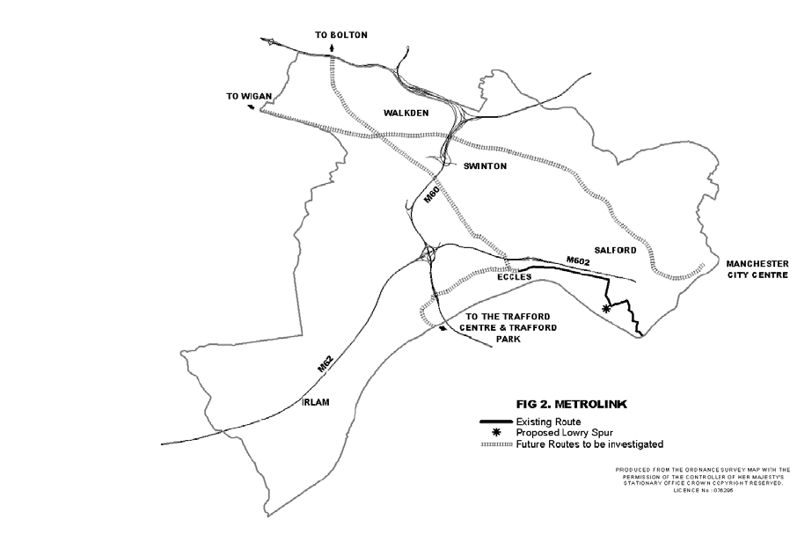

Plan Two – Metrolink (existing and proposed)

Taxis

- Hackney carriages and private hire taxis perform a useful public transport function and it is therefore important that they should be adequately catered for within town centres, and at other locations likely to generate significant numbers of trips. In recognising the part they have to play in the provision of an integrated and sustainable transport strategy Policy A6 of the UDP requires major trip generating developments to make satisfactory provision for them.

- The City Council recognises that many vehicles within the existing fleet are quite old and consequently their emissions are higher than those put out be new vehicles. In consequence of this the Council is considering using the Licensing system to encourage the provision of cleaner vehicles (in relation to the engines and fuels used). The outcome of these discussions will be fed into the AQAP

Walking

- Walking is a sustainable mode of travel that is available at no cost with many associated benefits e.g.

  - It makes you feel good
  - It gives you more energy
  - It helps you to sleep better
  - It helps to reduce stress
  - It keeps your heart healthy and strong
  - It can help to reduce blood pressure
  - It helps you to manage your weight

- In general, the safer the walking environment the better and in Salford we have actively tried to encourage pedestrian movements in the following ways.

  - Highway Improvements.
Working with its delivery partner, Urban Vision, the City Council has recently identified a way of investing £22M into highway improvements at no extra cost to the Council. The expectation is, that by improving the footway network, and reducing the possibility of trips and falls, more people will be encouraged to walk.
  - Pedestrian Crossings.
Each Community Committee within the City (8 in total) was recently given £100k to invest in their own area transport infrastructure improvements. Many are choosing to spend some of this money on additional pedestrian crossing facilities.
  - Streetlighting.
The City Council are constantly seeking ways in which to improve their street lighting stock. As well as identifying highway monies for this aim, they also seek additional grant funding such as crime reduction etc. Recently they instructed Urban Vision to devise an overall renewal strategy and also the means by which they might fund it.
  - Chapel Street Walking Strategy.
The City Council have recently introduced this in an attempt to improve connectivity between the University and the Regional Centre.
  - Walking For All IN Salford.
There are currently 10, one hour, Health Walks in Salford, stewarded by Leisure Services and aimed at people who do little or no exercise. Currently they cover Irlam, Cadishead, Lower Kersal, Clifton, Walkden, Buile Hill, Worsley, Ordsall and Weaste and are part of a national initiative called ‘Walking the Way’ to Health.
  - Walking Bus Initiative.
Four primary schools across the City are currently operating a walking bus.

See also The Road Safety Plan and Rights of Way Improvement Plan

Cycling

- In the UK cycling has declined in popularity over the last 20 years and now accounts for only 1% of all distance travelled by road users. However, as well as being healthy and cheap, cycling is often the quickest way to make short journeys, the energy used in one litre of petrol is enough to power a bicycle over 1000 miles.

- There are often cultural difficulties associated with cycling, for example the following concerns were raised at a recent consultation exercise:

  - I have to wear a suit
  - I don’t want to arrive hot and sweaty
  - I don’t have a bike.
  - I can’t ride a bike.
  - I have to travel a long way between meetings.
  - I work a long distance from home.
  - Cycling isn’t safe.
  - I have too many things to carry.

- Nevertheless, in a demonstration of its commitment to cycling the City Council already hosts a cycle forum which allows Members, Officers and other stakeholders to meet in order to discuss ways in which cycling within the City can be improved and encouraged. To this end, the City Council has already adopted a cycle strategy outlining how it will achieve these aims and plan three shows how the Council intends to ensure how the ability to move about by bicycle quickly and safety is to become a reality.

See also Cycling IN Salford.

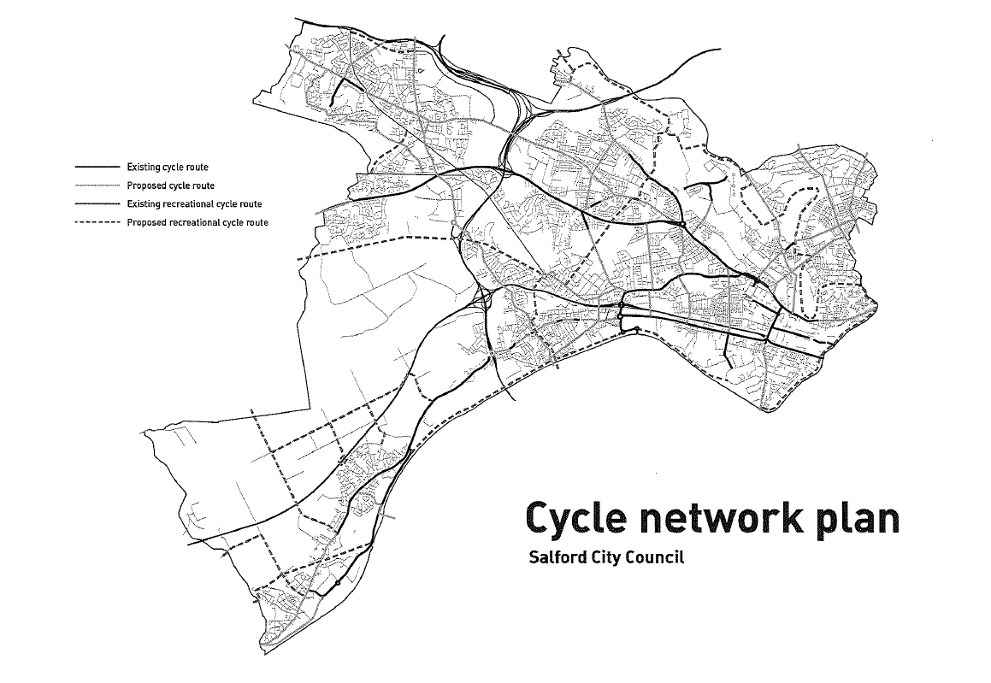

Plan 3 – The Cycle Nework

Waterways

- With over 30 miles of river and canal in Salford there really is the potential to make waterborne travel a reality. Water taxis already exist throughout the summer months and the expectation is that these could be made a permanent feature of Quays life. Discussions are also on-going about the possibilities of developing a freight interchange at Barton. This would enable freight to be brought up the ship canal from Liverpool, thus reducing HGVs and the environmental issues that accompany them.

Air Quality

- The Council has recently replaced its aging fleet of vehicles with a new fleet meeting the latest Euro standards for engines. This has achieved a significant reduction in emissions whilst improving fuel efficiency. The Council always takes advantage of new fuels and has now moved on from ultra low sulphur diesel to a blend with Bio diesel. In addition all Council HGV vehicles are fitted with CRT (catalytic regenerative traps) which significantly reduce the emissions of particulates.

- Sustainable Travel Issues Across Salford

- In order to maximise the appeal of sustainable transport it has to be considered as an essential element of land use planning. Within this context some of the key themes that major planning applications need to address are:

  - The need to ensure good access to public transport (both in terms of the location and the design of the site) from new development.
  - The need to ensure that developer contributions are used to mitigate against the impact of congestion by promoting sustainable travel.
  - The need to take an holistic approach to the transport implications of regeneration rather than rely on Transport Assessments for individual sites. This means that developer contributions can be used on an area basis to provide agreed sustainable transport improvements, rather than piecemeal (in which case the funding may not be sufficient to bring about improvements of real value).
  - The need for pedestrian/cyclist friendly layouts in new developments.
  - The need to protect routes for future sustainable transport schemes.
  - The need for parking standards to reflect the availability of public transport at different locations.

- With those points in mind, this section describes some of the improvements that will be needed in order to address many of the accessibility issues currently being experienced across Salford. Their overall effect, in terms of spatial strategy, can be seen on the pull out plan that accompanies this document.

Kersal, Broughton, Ordsall, Irwell Riverside, Langworthy, Weaste and Seedley.

- These wards are recognised as some of the most deprived wards within Salford and their relatively low levels of car ownership and makes all forms of sustainable transport essential if these communities are to thrive and develop. However, the disproportionate effect that the car has on these communities is demonstrated by the fact that all of the radial routes serving the north and west of the Greater Manchester conurbation, and beyond (eg A6 / A56 / A57 leading to A580 / M61 / M602 / M62) converge here.

- At its eastern extremity, the area abuts Manchester City Centre and has typical city centre issues (office blocks; inner city apartments etc). Further out there are the usual mix of edge of centre business and related uses. Beyond this lies a ring of post war municipal housing, much of which is high rise and high density. Salford University also lies within the area and although a major generator of trips, (particularly pedestrian and cycle) is effectively severed by the A6. Further out there are areas of terraced housing and later interwar housing interspersed with a number of industrial areas, district shopping centres, schools, parks etc..

- Within the area it would be advantageous to improve the pedestrian linkages within, across and without in order to assist accessibility. Of particular importance will be the development of safe attractive and convenient routes supported, where possible, by external sources such National Road Safety Initiative funding and New Deal for Communities. Much good work is already taking place with pedestrian kerbcraft training established in the following schools:

- Brentnall | - Lark Hill | - Lower Kersal
- All Souls RC | - St Georges CE | - St Pauls CE
- Langworthy Road | - St Sebastians RC | - Tootal Drive
- Seedley | - Charlestown | - The Friars
- St James RC | - St Boniface RC

and safe walking routes linking the University with the Regional Centre.

- In tandem with this exercise, the following schools have introduced a travel plan:

- Tootal Drive | - Lower Kersal | - St Georges CE
- The Friars

This is worth noting as schools with an authorised travel plan are entitled to grant aid (approximately £10,000 for a typical secondary school and £5,000 for a typical primary school) in order to support sustainable school travel initiatives. Typical spends include the following:

- Cycle shelters and cycle storage. changing facilities. | - New paths for pedestrians and cyclists.
- Improving access on school land | - Wider paths in the school grounds.
- Improved Drainage | - Improved lighting in school grounds
- CCTV | - New signing
- Traffic calming on school access roads in school grounds | - New or improving car drop zones/turning circles.
- Waiting shelters for pedestrians (e.g. parents waiting, pupils waiting for school buses) | - Bus turning circles on school grounds.

In the case of secondary schools these monies are then further supplemented by the funding of cycle shelters, actions which also contribute to the Councils Local (air quality) Action Plan.

- As would be expected the area is also criss-crossed by the City’s cycle network and is one of the few instances where good orbital links are displayed (although these are often severed by the main routes into Manchester and the waterways). Wider connectivity is also evidenced by the fact that the National Sustrans Cycle Routes 55 and 6 converge here. It should be remembered that as well as reducing traffic, walking and cycling strategies, such as those noted above, also have a role to play in improving air quality.

- Although there are a number of quality (bus) corridors within this zone, on the whole these radiate out from the central core meaning that orbital bus connectivity is somewhat lacking. The lack of connectivity with the Quays and Trafford Park is also of major concern, although it is hoped that joint work currently being carried out by Salford, Trafford and the GMPTE will go some way to improve this. As well as improving public transport links, quality corridors are also an essential element of the Salford City Council Local (air quality) Action Plan.

- One major area of opportunity is the A6 corridor where plans are currently being developed to improve the travelling experience between the University and Regional Centre. Although arguably, this is one of the most architecturally interesting corridors within the City, the potential enjoyment of the area is tarnished by the volume of traffic using the route (somewhere in excess of 50,000 vehicles per day) and the canyon effect created by the height of the buildings along it. Consequently, the URC are undertaking studies to test if this traffic can be diverted onto other routes, which will in turn allow a number of pedestrian friendly environmental improvements to be introduced.

- In addition to improvements detailed above, proposals are also being developed to improve pedestrian connectivity across the A6 to Salford Shopping City where it is anticipated that future development will allow a rationalisation of all the sustainable modes centred around enhanced bus facilities.

- One potential barrier to sustainable transport within the area is the current number of (often temporary) car parking spaces. Conventional wisdom suggests that a reduction in the use of the private car and greater use of public transport will be achieved by reducing the number of long stay parking places within and adjacent to the regional centre. However, this must be balanced against the needs of the road user in general and therefore an efficient parking strategy should seek to:

- Promote pedestrian safety.
- Reduce car crime.
- Influence travel demand and promote the increased use of public transport.
- Promote accessibility by effectively managing the parking of cars on the footway.
- Allow the local economy to function,
- Promote the safe free flow of traffic in order to maximise the reduction of emissions, and also,
- Raise revenue to cover the costs of parking provision and enforcement.

- As noted above, a large percentage of land within the Chapel Street area is given over to car parking, much of which is of a temporary nature. Given the ambition of the Council around the Greengate area and the potential for regeneration on the former Exchange Station site it is likely that some replacement car parking will need to be identified (although the expectation is that the area will primarily be served by sustainable transport). Replacement car parking could take either of two forms:

  - Increased on street provision, or,
  - Further multi storey provision.

- In order to minimise the opportunity for vehicle crime, on street provision should only be introduced on well trafficked streets and opportunities for this will arise in the wake of regeneration. Overall provision within the area must also be balanced against future traffic flows along the A6, as given the current studies, it is possible that the majority of traffic may be re-routed away from the area.

- Parking problems are also evident in the vicinity of Hope Hospital and it should be an essential condition of the current redevelopment plans that an effective, deliverable and measurable travel plan must be developed.

- Finally, it should be noted that the extent of the existing Metrolink sits within this area and although, in the past, there has been an aspiration to take the line out to the Quays, rather than the previously suggested spur, the advent of the Media City development has made it essential to introduce a new line through Pier 8 and into Dock 9.

Future Priorities Across The Area (Kersal, Broughton, Ordsall, Irwell, Riverside, Langworthy, Weaste and Seedley).

- Within these wards it is recommended that the following should form the basis for future priorities:

  - Pedestrian and cycling connectivity
  - Connectivity to the Quays / Trafford Park
  - The A6 Corridor
  - Bus facilities
  - Car parking provision
  - Extension of Metrolink into Dock 9

Eccles, Winton, Worsley, Swinton North, Swinton South, Claremont, Pendlebury and Barton.

- Within this area the lack of orbital bus routes becomes more apparent and it is essential that every effort is made to improve connectivity if employment opportunities at the Quays and Trafford Park are to be exploited by the residents within these wards. On the positive side, however, the radial routes do support a number of quality corridors and cycle routes (either existing or proposed).

- Much good work has already taken place at a local level, within schools, which has resulted in the successful introduction of a number travel plans i.e.:

- Broadoak Primary | - St Charles RC | - Barton Moss Primary
- Christ Church CE | - Beech Street Primary | - St Andrews CE
- St Marks RC | - Clifton Primary | - Swinton High
- Mossfield Primary | - Moorside Primary | - Wentworth High
- Clarendon Road Primary | - Monton Green Primary | - Godfrey Ermen Memorial CE
- Holy Cross and All Saints RC | - St Marys RC

- As with other areas pedestrian kerbcraft training is also taking place in various primary schools within the area and to date has been completed in:

- Light Oaks Infants | - St. Marys RC | - St Lukes CE
- Godfrey Ermen Memorial CE | - Lewis Street

- Within Eccles itself, the construction of the bypass has allowed much of the extraneous traffic to be removed from the Town Centre which has in turn enabled its semi-pedestrianisation. The area would probably benefit from further study to secure greater improvements.

- Capacity problems at the Peel Green Roundabout are also evident as in the peak hour traffic queues back towards Irlam causing delays to both public transport and the private car alike. Although it is anticipated that this problem will be resolved by the signalisation of the roundabout (funded through developer contributions) the length of the A57 would benefit from further study.

- Although Swinton is well served by public transport, as with the Regional Core, car parking provision should also be considered. Currently, there are competing demands between the residents, the long stay needs of the local workforce and the short stay requirements of the shoppers. Consequently, it is considered essential that major trip generators, such as the Civic Centre, should introduce sustainable transport plans, which, as well as reducing congestion will also improve air quality.

Future Priorities Across The Area (Eccles, Winton, Worsley, Swinton North, Swinton South, Claremont, Pendlebury and Barton.)

- Within these wards it is recommended that the following should form the basis for future priorities:

  - The provision of orbital bus routes.
  - Connectivity to the Quays / Trafford Park.
  - Eccles pedestrianisation.
  - Car parking provision within Swinton.
  - The introduction of sustainable travel plans.
  - The capacity of Peel Green roundabout.
  - The Liverpool Road corridor.

Irlam, Cadishead, Boothstown and Ellenbrook.

- Although the completion of the award winning Cadishead Way Bypass has done much to improve traffic conditions across the area, congestion is still being caused by capacity problems at Peel Green roundabout which leads to long queues being generated in the morning peak back towards Irlam.

- The completion of the bypass, however, will allow environmental improvements to be introduced along the existing Liverpool Road corridor which will, in the main, favour more sustainable modes of transport such as bicycles and buses. It is anticipated that the completion of the bypass will, by removing extraneous traffic from the centre of Cadishead, also improve air quality in the area. (Similar results can also be expected from the previous completion of the Eccles bypass and the Manchester Salford Inner Relief Route).

- It should also be possible to accelerate and enlarge sustainable transport provision within these wards by making it an integral feature of the major planning applications currently being drawn up for the Barton area eg the Port Salford freight interchange facility and the Salford Reds stadium development. These applications might will also allow connectivity with Trafford to be improved and every opportunity should be taken to make the most of this.

- In common with the inner wards much good work is also taking place within schools and pedestrian Kerbcraft training has been completed in:

- Fiddlers Lane Primary | - Mossfield Primary | - St. Teresas RC

With approved travel plans in the following:

- Cadishead Primary | - Ellenbrook Primary | - Irlam Primary
- St Joseph The Worker RC | - St Marys CE | - St Teresas RC
- Irlam and Cadishead High | - Boothstown Methodist Primary | - Fiddlers Lane Primary

Future Priorities Across The Area (Irlam, Cadishead, Boothstown and Ellenbrook.)

- Within the South West it is recommended that the following should form the basis for future priorities:

  - The capacity of Peel Green roundabout.
  - The Liverpool Road corridor.
  - Connectivity with Trafford.

Walkden South, Walkden North and Little Hulton.

- Within this area, Little Hulton, one of the most deprived wards in the City, stands out as having poor connectivity with the rest of the City and the provision of such connections (with Manchester, Salford and Bolton) must therefore be recognised as a high priority.

- As with the majority of the City, the bus priority routes (many of which are proposed rather than established) radiate out along the major routes and a lack of orbital public transport links is again evident. This lack of orbital connectivity needs to be addressed if the residents of these areas are ever to take advantage of the availability of employment within the Quays / Trafford Park.

- In common with the South West and Central Belt a number of schools have already introduced travel plans:

- Bridgewater | - St Edmunds RC | - Wharton
- Christ the King RC | - St Pauls CE | - Walkden High
- St Andrews Methodist | - St Georges RC High

and given the fact that Little Hulton is recognised as a deprived ward, but was not within the original kerbcraft project the road safety team are looking at introducing their own form of pedestrian training in the area.

- The cycle network across the area is, on the whole, good, but perhaps it would be useful to ask the Cycle Forum what further developments could be introduced. Once these are known it would be a relatively simple matter to make these the subject of S106 conditions should the appropriate planning applications come forward.

- Finally, it should be remembered that the guided busway will shortly be introduced along the A580 which should allow greater pedestrian connectivity across the road to be introduced whilst at the same time allowing greater cycle and bus connectivity with the regional centre.

Future Priorities Across The Area (Walkden South, Walkden North and Little Hulton.)

- Within the North West it is recommended that the following should form the basis for future priorities:

  - All forms of connectivity with Little Hulton.
  - Orbital bus connectivity (especially with The Quays and Trafford Park).
  - Improvements to the cycle network.
  - Child pedestrian training.

- The Action Plans

- The following tables show the way in which we will ensure that sustainable travel choices become a reality within Salford.

Theme 1 – Travel Awareness, Travel Planning and Managing Travel Demand
Strategic Aims  To reduce the need to travel in order to:  - Reduce pollution  - Reduce congestion  - Improve health and well being |  | Likely Measures of Success:  - Successful development of local facilities.  - Appropriate use of the land use planning system.  - Flexibility of work patterns.  - A healthy workforce.
Proposals | Actions |  | Targets | Timing / Programme | Champion
Promote home working, video conferencing etc. | Salford City Council and Urban Vision to adopt and promote flexible working policies through development of the Agile Working Strategy. |  | Delivery of Agile Working Strategy | May 2007 | Martin Vickers
Promote home working, video conferencing etc. |  |  | Develop and launch Sustainable Travel Plan. | Achieved | Steve Glazebrook
Promote home working, video conferencing etc. | Increase the amount of car sharing by Salford City Council / Urban Vision staff. |  | 125 members on car sharing database. | December 2007 | Steve Glazebrook
Adopt appropriate planning policies. | Ensure that spatial plans encourage development in appropriate areas. |  | Submit Core Strategy document to Secretary of State. | July 2008 | Chris Findley
Adopt appropriate planning policies. | Require travel plans on all new major developments. |  | 100% compliance. | On – going | Trupti Patel
Increase access to travel, transport and all Council services through the Councils web site. | Improve the Councils web content and provide online transactions that will subsequently reduce the need for citizens and employees to travel for direct services. |  | 100% access to services. | Achieved | David Hunter
 |  |  | Develop and launch a Council web site improvement plan alongside a customer contact strategy. | July 2007 | John Fox / David Hunter
 | Increase service usage through the web. |  | Increase take up of online transactions by 10%. | March 2008 | David Hunter

Education and Promotion. | Promote all of the above amongst local businesses. | Approach 95% of all organisations with >200 employees. | December 2007 | Steve Glazebrook
Education and Promotion. | Improve travel awareness amongst local businesses. | Carry out recruitment campaign with local businesses to encourage them to join Salford Travel Partnership. 3 new businesses to join Partnership. | December 2007 | Salford Travel Partnership
Education and Promotion. | Disseminate sustainable travel information to local businesses. | Delivery of two working lunches with guest speakers. | April 2008 | Salford Travel Partnership.
Education and Promotion. | Educate and encourage existing businesses and schools to introduce travel plans that will:  - Promote sustainable modes of transport.  - Reduce the need to travel.  - Reduce environmental decay.  - Reduce the number of road accidents. | 100% schools with adopted travel plan. | By 2010 | Steve Glazebrook
Better travel planning. | Ensure comprehensive, affordable alternative travel supply available. | Develop 5 new travel plans within business community. | December 2007 | Steve Glazebrook
Wider use of demand management techniques. | Identify appropriate county wide measures. | Submit TIF bid to Central Government. | Summer 2007 | AGMA

Theme 2 – Public Transport
Strategic Aims  To improve public transport network in order to:  - Reduce pollution  - Reduce congestion  - Reduce social exclusion  - Improve accessibilty  - Create further improvements through economies of scale |  | Likely Measures of Success:  - Level of partnership working with GMPTE, operators and other districts.  - Higher usage.
Proposals | Actions |  | Targets | Timing / Programme | Champion
Improvements to bus infrastructure including the creation of better orbital bus connections. | Proactive work on the 4 corridor partnerships. |  | Creation of steering group with clear action planning arrangements. | December 2007 | Steven Lee
 | Proactive work on the remaining QBCs. |  | Agree completion of Eccles Old Road link. | December 2006. | Maurice Kean
 | The adoption of area specific public transport strategies. |  | Ensure public transport needs analysis included in all area action plans. | On – going. | Darren Findley
Improvements to the rail network. | Pursue improvements to Salford Central and Salford Crescent Stations. |  | Salford Central – Improvements to booking office and platforms | December 2007 | Northern Rail
Improvements to the rail network. |  |  | Complete study to determine future position of station. | Summer 2007 | URC
Metrolink. | Ensure Metrolink access into Dock 9 as part as an overall package of sustainable transport measures. |  | Deliver Metrolink extension. | December 2010 | Malcolm Sykes
Metrolink. | Ensure completion of feasibility study on tram train proposals. |  | Complete study to determine future form and usage of the Crescent. | Summer 2007 | URC

Improve access to Salford Quays / Trafford Park | Work to implement the recommendations of the Trafford Park and Salford Quays study. | Complete feasibility study. | Achieved. | Darren Findley

Theme 3 - Walking
Strategic Aims  To increase the amount of walking throughout the City in order to:  - Improve health  - Reduce social exclusion  - Reduce pollution  - Reduce congestion |  | Likely Measures of Success:  - Amount of trips carried out on foot.  - Reduction of accidents to pedestrians.
Proposals | Actions |  | Targets | Timing / Programme | Champion
Create better walking routes. | Improve route signage and accesibility. |  | Increase BVPI 178 compliance to 80% | April 2008 | Stephanie Thomasson
Create better walking routes. | Increase CCTV coverage. |  | Delivery of single Salford CCTV facility | To be adivised | Don Brown
Create better walking routes. | Improve streetlighting. |  | Approval for renewal investment business case. | December 2007. | Steven Lee
Create better walking routes. | Improve footpaths. |  | Invest over £4M in footway improvements. | Annual target | Paul Garret
Create better walking routes. | Improve pedestrian crossing facilities. |  | Increase BVPI 165 compliance to 60%.  (Further programme of improvements under development) | April 2007 | Maurice Kean
Create better walking routes. |  |  | Introduce 1 new crossing facility per year. | Annual target | Andy Devine
Create better walking routes. | Increase the number of dropped crossings. |  | Install 30 new facilities per year. | Annual target | Gail MacFarlane.
Create better walking routes. | Walking bus initiative. |  | Introduce 4 new walking bus schemes. | April 2008 | Steve Glazebrook
Training. | Increase availability of Kerbcraft training in primary schools. |  | Deliver 20 courses per year. | Annual target | Sarah Grattage
Training. | Promote “Streets Ahead” project. |  | Make resources available to 100% of out of school clubs. | Annual target | Sarah Grattage

Hearts and Minds. | Develop and introduce school travel plans. | 100% schools with adopted travel plan. | By 2010 | Steve Glazebrook
Hearts and Minds. | Develop and introduce workplace travel plans. | Develop 5 new travel plans within business community. | December 2007 | Steve Glazebrook
Hearts and Minds. | Require travel plans on all new major developments. | 100% compliance. | Annual target | Trupti Patel
Hearts and Minds. | Promote healthy walks initiative. | 50 people to participate in the healthy walks initiative. | December 2007 | Jo Bennet
Education. | Promote greater driver awareness. | 2 publicity campaigns per year. | Annual target (report required) | Don Isherwood
Education. | Promote greater pedestrian awareness amongst all age groups. | Pilot “Healthy Living” initiative amongst 10 senior citizen groups. | April 2008 | Don Isherwood
Education. | Promote greater pedestrian awareness amongst all age groups. | Deliver “Crucial Crew” to 100% Yr 6 pupils. | Annual target | Don Isherwood
Education. | Promote greater pedestrian awareness amongst all age groups. | Make the following DVDs available to appropriate age groups (100% coverage):  - Safe and Sound (12 yr olds)  - Time Out (12 – 14 yr olds)  - Streetmoves (10/11 yr olds) | Complete | Don Isherwood
Education. | Promote greater pedestrian awareness amongst all age groups. | Carry out pedestrian theory courses in 100% primary schools annually. | Annual target | Don Isherwood
Education. | Promote greater pedestrian awareness amongst all age groups. | Make “Get Across Road Safety” parent guide available to 100% new pupil intake annually. | Annual target | Jill Winstone
Education. | Promote greater pedestrian awareness amongst all age groups. | Enrol 100% 3 year olds into Salford Childrens Traffic Club. | By 2010 | Sarah Brabban
Improve access to the countryside. | Development and adoption of Public Right of Way Improvement Plan. | Adoption of Plan. | November 2007 | Nigel Openshaw

Theme 4 - Cycling
Strategic Aims  To increase the amount of walking throughout the City in order to:  - Improve health  - Reduce social exclusion  - Reduce pollution  - Reduce congestion |  | Likely Measures of Success:  - Amount of trips carried out by bicycle.  - Reduction of accidents to cyclists.
Proposals | Actions | Targets | Timing / Programme | Champion
Better cycle parking provision. | Provision of more cycle parking facilities across the City. | 20 per year. | On – going. | Lee Evans
Better cycle parking provision. | Provision of secure cycling facilities at public buildings, transport interchanges and educational establishments. | I trial scheme | April 2008 | Lee Evans
Education. | Promote greater driver awareness. | Carry out 4 publicity campaigns | April 2008 | Don Isherwood
Education. | Promote greater cyclist awareness. | Carry out one event to celebrate Bikeweek | June 2007 | Lee Evans
Training. | Increase accessibility to “Safer Cycling” / “Bikeability” training scheme. | Train 50% of all year 6 pupils annually | By 2009 | Don Isherwood
Improve access to the countryside. | Increase number of cycle pods. | 2 more pods | April 2008 | Lee Evans
Provision of a safe cycle network. | Support the Bridgewater Way project which will create an extra 8 km of cycle path within Salford and 40 km overall. | 8 km of new cycle path. | By 2009 | John Pedder.
Provision of a safe cycle network. | Carry out improvements to the looplines. | Improve 1km loopline surface. | Achieved | Gail MacFarlane
Provision of a safe cycle network. | Carry out improvements to the looplines. | Improve access at 22 loopline sites (Roe Green and Tyldsley). | Achieved | Gail MacFarlane
Provision of a safe cycle network. | Work with Sustrans and the cycle forum in order to identify the most appropriate routes and measures to encourage cycling. | Complete signage of Route 55 | April 2008 | Cycle Forum
Provision of a safe cycle network. | Ensure that all new developments adhere to COPECAT guidelines. | 100% compliance. | Annual target | Trupti Patel

Hearts and Minds. | Develop and introduce school travel plans. | 100% schools with adopted travel plan. | By 2010 | Steve Glazebrook
Hearts and Minds. | Develop “feeder school” cycle club project. | 50% of high schools to have cycle clubs and shelters. | By 2008 | Steve Glazebrook / Don Isherwood
Hearts and Minds. | Develop and introduce workplace travel plans. | Develop 5 new travel plans within business community. | December 2007 | Steve Glazebrook
Hearts and Minds. | Require travel plans on all new major developments. | 100% compliance. | Annual target | Trupti Patel
Hearts and Minds. | Continue to promote membership of the Cycle Forum. | Increase regular attendance by 2 new members. | December 2007 | Peter Kidd
Hearts and Minds. | Publicise the cycle strategy and the existing routes. | Ensure strategy and plans available on-line. | Achieved | Lee Evans
Hearts and Minds. | Publicise the cycle strategy and the existing routes. | Service usage to be monitored on an annual basis. | Annual target | Lee Evans
Hearts and Minds. | Publicise the cycle strategy and the existing routes. | Make plans and strategies available to all libraries and schools. | December 2007 | Lee Evans
Hearts and Minds. | Conduct awareness campaign during National Bike Week. | 1 campaign to be determined. | June 2007. | Geoff Dean.

Theme 5 – The Environment
Strategic Aims  To reduce the negative impacts of transport in order to:  - Improve health  - Reduce pollution  - Protect and improve the environment |  | Likely Measures of Success:  - Air quality.  - Percentage of vehicles using environmentally friendly fuel / technology.
Proposals | Actions |  | Targets | Timing / Programme | Champion
Improve air quality. | Develop and introduce school travel plans. |  | 100% schools with adopted travel plan. | By 2010 | Steve Glazebrook
Improve air quality. | Develop and introduce workplace travel plans. |  | Develop 5 new travel plans within business community. | December 2007 | Steve Glazebrook
Improve air quality. | Require travel plans on all new major developments. |  | 100% compliance. | Annual target | Trupti Patel
Improve air quality. | Promote “Dirty Diesel” reporting campaign. |  | Publish details on Council website. | September 2007 | Ged Steadman
Improve air quality. | Greater usage of new technology. |  | Increase the percentage of bio diesel in the blend used by the Council fleet from 5% to 20%. | December 2008 | Terry Dixie
Improve air quality. |  |  | Ensure all Council HGV’s fitted with CRT exhaust systems. | December 2007 | Terry Dixie
Improve air quality. | Use licensing system to encourage cleaner taxis. |  | Introduce scheme. | December 2007 | Ged Steadman / Terry Dixie / Jane Nugent
Improve air quality. | Carry out vehicle emissions testing. |  | Carry out 3 days testing. | September 2007 | Ged Steadman
Reduce noise pollution. | Ensure that new roads and developments are adequately screened by landscaping. |  | 100% compliance. | Annual target | Alex Shaw

Reduce severance by radial routes. | Improve orbital connectivity. | Include orbital connectivity as a priority within GMLTP 2 | Achieved | Darren Findley
Hearts and Minds. | Refresh and renew interest in Council travel plan. | Continue to promote Council travel plan on website. Service usage to be monitored on an annual basis. | Annual target | Steve Glazebrook
Hearts and Minds. | Continue to promote and encourage the use of sustainable travel modes. | Increase the number of travel plans overall by 5% per annum. | Annual target | Steve Glazebrook

