City of Salford

REPORT OF THE SCRUTINY COMMISSION

Asylum Seekers and Refugees
IN Salford

“We aim to create the best possible

quality of life for the people of Salford”

Salford City Council Overall Mission



Contents

Page

Chair’s Foreword 3

Executive Summary, conclusions & recommendations 4

The Scrutiny Commission 10

- Approach
- Background
- The National Picture and Definitions

What did we find? 15

Recommendations Explained 30

Appendices 1 Members of the Commission 36
- Advisors and Witnesses 37
- Glossary of terms 38
- Facts and Figures 39

To the Council of the City of Salford

CHAIR’S FOREWORD



This report represents the culmination of six months’ deliberation by the Scrutiny Commission. It makes recommendations aimed at trying to improve services to asylum seekers and refugees and to build on the historically good record that Salford has for community cohesion and inclusivity.

The Scrutiny Commission is proof of the City Council’s commitment to a real and meaningful partnership with all communities that make up our City.

I want personally to thank all the members of the Scrutiny Commission for their time and commitment. I also want to thank the many local people who submitted evidence whether in writing, by phone or by personal appearance before the Commission, the expert witnesses and officers of the City Council. They have all contributed to a successful outcome.

I commend this report to the City Council, our partners and the people of the City of Salford.

Councillor Andy Salmon

EXECUTIVE SUMMARY AND CONCLUSIONS

Summary

The Scrutiny Commission met over a period of six months from December 2002 to June 2003; they held several meetings in order to speak to service providers, service users, voluntary groups, partner agencies, the general public and other interested parties. They made visits to the sites of service provision and other relevant organisations as well as a visit to gather evidence from the Minister of State for Citizenship, Immigration and Community Cohesion Beverley Hughes MP.

The Commission has challenged the way that services are provided, compared the services with alternatives and been involved in a large exercise in consultation. The commission asked witnesses to identify problems or gaps that they think there are in service provision and suggest possible improvements that can be made to the current system.

After careful consideration of the evidence presented, the commission has produced this report containing 26 recommendations aimed at a number of organisations including Central Government, the City Council and local agencies about the system of dispersal of asylum seekers to the City of Salford together with other issues of concern to those trying to escape from tyranny and war; those trying to provide services to them; and people generally in Salford.

Recommendations are summarised below:

That

- The Leader of the City Council establishes and allocates the asylum seeker portfolio to a single Cabinet member.

- A senior officer within the City Council and Local Strategic Partnership is given overall responsibility for the coordination of strategy in relation to asylum seekers.

- The City Council should join the Refugee Action ‘Refugees Welcome Here’ campaign which aims to promote and highlight the Council’s support and commitment to welcoming asylum seekers and refugees to our City.

- The asylum seeker steering group be dissolved and formally reconstituted as a Multi-Agency Forum (MAF), chaired by the appropriate Lead Member and coordinated by the senior officer with overall responsibility for asylum seeker issues and that the groups’ terms of reference focus on coordination of activity and provision of leadership.

- The MAF have the involvement of all of the relevant statutory and non-statutory agencies in the City and regionally including NASS.

- An audit be carried out to establish a list of all organisations in the City that are currently working with asylum seekers, in order to identify possible duplication of activity or opportunities for the sharing of work load or resources.

- The Lead Officer with responsibility for asylum seeker issues and the MAF prepare an ‘Asylum Seekers Strategy’ for the City for production by the end of 2003.

- The MAF produce a ‘Welcome and Induction Pack – for Salford’ for all newly dispersed asylum seekers to the City.

- The MAF carry out an analysis of all interpretation and translation services available to public and voluntary sector organisations in the City, with a view to establishing whether the current provision is giving the best and most appropriate service to all agencies, with a view to improvement.

- The MAF work to produce a publicity strategy for asylum seekers which looks to respond to negative and misleading press reporting on this issue and also to promote and publicise the facts about asylum and more positive representations of asylum seekers.

- The MAF develops a policy to assist equal dispersal of asylum seekers throughout the City, and that NASS and other relevant agencies be invited to be involved in this work.

- The MAF and representatives from NASS establish a sub group to consult with contracted private housing providers in the City to ensure that good practice is shared and that there is a consistent approach to service provision.

- An analysis in cooperation with the Council’s Peer Review Group 4, be carried out as to the level and types of Diversity and Cultural awareness training that is carried out in the City, both within the voluntary and public sector including schools.

- A process is developed with NASS to ensure that officers working within the community are kept informed of the proposed dispersal of asylum seekers. This should be done prior to dispersal in order to make available the fullest level of information and support for asylum seekers and local residents.

- An audit of the support and training available to officers working with asylum seekers is carried out with a view to ensuring that adequate support is provided.

- The Greater Manchester Police provide information in respect of the ‘hot spots’ in the City in relation to race crime, in order to assist the MAF in future appropriate dispersal.

- The Strategic Health Authority give consideration to the format and translation of the initial correspondence sent to asylum seekers allocating them a local GP.

- The MAF consider the issue of ‘move on’ after an asylum seeker has been given a positive decision, with a view to ascertaining best practice in other authorities and ensuring the future sustainability of our communities.

- The Government ensure that the dispersal figure for Salford (1130) is not exceeded in future and that the current figure be brought down to that level as soon as is possible.

- The Government ensure that there is a more equal dispersal of asylum seekers across the northwest region.

- The Government is asked to consider new legislation that would allow asylum seekers to work whilst their claim is being considered.

- The Commission note and welcome the regionalisation of NASS, and that the Government be asked to carry out the process as quickly as is possible to enable local support on dispersal and policy making as well as support to individual asylum seekers.

- NASS start to work with the City Council to ensure a more equal procurement of property and dispersal of asylum seekers across the city.

- NASS redress the balance of public against private sector housing dispersal in the city and bring the figures back to a more equal split as originally envisaged.

- The Post Office is asked to change the current process of a separate queue being used for asylum seekers at its office on Salford Precinct.

- The Local Strategic Partnership and the MAF carry out an audit of the training available to refugees in the City, with a view to ensuring that there is an appropriate range available for those who choose to stay in Salford.

CONCLUSION

Community Integration, Community Cohesion and Good Service Provision are the key themes in this report. The commission welcomed the commitment and hard work of all of the agencies both in the public and voluntary sectors currently working with asylum seekers in the City.

It was clear that a lot of good work was currently ongoing in this area and that the issue has had a tremendous impact on some already busy services.

The commission felt strongly that a strong central coordination of all activity was required so as to enable better joint working and communication across agencies and the community.

The dispersal of asylum seekers is one of the most high profile issues currently concerning both Government and the public at large.

Much of the information available to the general public is misrepresented in the national press and sometimes serves to confuse rather than clarify public awareness of this issue. In spite of this representation of the issue it is also clear that the dispersal of asylum seekers to certain areas can have a detrimental effect, not only on service provision and planned regeneration, but also on asylum seekers themselves who may find themselves isolated or victims of harassment.

The Commission believe that the City of Salford is a place that welcomes and encourages the diversity of our communities and wishes to see equal levels of and access to services for all, including our indigenous population and our new and old communities.

The commission would also point out Salford is a City currently going through a great amount of change and regeneration and that public services across the City are already stretched in some areas. The City has a dispersal number for asylum seekers, which has been set in agreement with Central Government. This target has been consistently broken over the last six months with the City taking more than its agreed allocation and more than that of other similar local authorities.

The commission would urge Government to consider the impact of over dispersal on the City and act accordingly.

THE SCRUTINY COMMISSION

Approach

The aim of the Scrutiny Commission

The Scrutiny Commission looking into the issue of dispersal of asylum seekers across the City was the first of its kind under new decision making arrangements although the City Council had some previous experience of Scrutiny Commissions.

The aim was to meet in a similar way to a Parliamentary Select Committee. It therefore heard evidence and representations from a wide range of citizens, organisations and agencies with an interest in the asylum issue. It also spoke to organisations that were able to share best practice. The commission has considered (a) Who does what? (b) What the situation is? (c) What peoples views are on the main issues and (d) What recommendations should be made to improve on current practice?

The aim of this evidence and analysis was to develop a clear overview of the situation and offer some direction for the City Council and it’s partners on the issue. From this work it would then be possible to identify and put forward a series of realistic recommendations, which would help to deal with the concerns identified.

The meetings of the commission were held at various locations but mainly at the Civic Centre in Swinton, interviews were held involving commission members and a scrutiny support officer at locations around the City and nationally. Visits were also arranged for members to see service providers and service users and question them. Members of the commission also visited Beverley Hughes MP, in her Ministerial capacity, and NASS officials at the Houses of Parliament to discuss issues.

The commission met on 10 occasions beginning with an initial meeting in November 2002 and a press launch in December 2002, with the final meeting being held on 18th July 2003.

The representations to the commission

A list of interviewees and meeting dates are contained within this report in the appendix.

BACKGROUND

The City Council has an agreement, with the National Asylum Seeker Service (NASS) to have a number of asylum seekers dispersed to the City.

The council has a dual role as both a Social Landlord and Regulator for Private Sector Housing in the City together with its roles in respect of Social Services, Education, Community Cohesion and Community Safety issues.

Asylum Seekers are housed in both council and private sector accommodation. Under the agreement the City is expected to take 1130 individual asylum seekers for dispersal within all housing providers. Currently the split is 71.4% private sector and 28.6% public sector.

The council coordinates asylum seeker issues primarily through the Housing Services Division and the New Prospect Housing Limited Asylum Team based at Halton House, Salford, they resettle and support people and liase with NASS. Other Directorates in City Council also provide services for asylum seekers especially Education and Leisure and Community and Social Services. The private sector is coordinated by NASS. There are a number of private sector providers locally.

Where are asylum seekers resettled?

The City has a dispersal figure of 1130. As at 31st July 2003 there was a total of 1214 currently dispersed. Dispersal is currently not evenly distributed, the City wards breakdown as follows.

Breakdown by ward

Ward | Total | Percentage
Barton | 0 | 0
Blackfriars | 25 | 2.05
Broughton | 544 | 44.8
Cadishead | 0 | 0
Claremont | 32 | 2.6
Eccles | 57 | 4.7
Irlam | 0 | 0
Kersal | 99 | 8.1
Langworthy | 95 | 7.8
Little Hulton | 0 | 0
Ordsall | 6 | 0.5
Pendlebury | 16 | 1.3
Pendleton | 216 | 17.8
Swinton North | 8 | 0.7
Swinton South | 0 | 0
Walkden North | 0 | 0
Walkden South | 0 | 0
Weaste and Seedley | 110 | 9.06
Winton | 6 | 0.5
Worsley and Boothstown | 0 | 0
Total | 1214 | 100

Figures at 31/07/2003

See appendix 4 for other statistics.

How long are asylum seekers staying for?

It varies for each individual, but the National Asylum Seeker Service now appears to be processing claims more quickly. If a claim is refused many people do lodge appeals so the process can go on for some time, therefore increasing pressure on services.

The figure for the total number of asylum seekers in the City is changing everyday as decisions are made and people choose to stay in Salford or move to somewhere else or until a person refused asylum is sent to their country of origin or to another country.

THE NATIONAL PICTURE AND DEFINITIONS

Who is an asylum seeker/refugee?

An asylum seeker/refugee is someone who is fleeing serious danger back home; the types of danger can range from war, political persecution, famine, economic crisis or natural disasters.

Under international law, however, the word refugee has a very precise meaning. It describes someone who is forced to flee home and country, escapes to another country and is recognised as a refugee under international law by the government of the new country. The government of the new country has to decide whether the person has fled or is unable to return home ‘owing to a well founded fear of being persecuted for reasons of race, religion, nationality, membership of a particular social group or political opinion’.

A person who has fled in this way and is seeking to be recognised as a refugee under the asylum laws in the new country is called an asylum seeker.

Where does this definition come from?

The definition comes from the 1951 United Nations Convention relating to the status of and treatment of refugees and the 1967 protocol relating to the status of refugees.

What are the criteria that refugees have to meet?

The refugee definition is very strict, and asylum seekers have to prove that they meet all of the following criteria in order to be given refugee status. They must:

- Be outside their country of origin, or outside of the country where they usually live.
- Be at genuine risk and in fear of serious harm.
- Prove their own government does not want or is failing to protect them from harm.
- Prove that their fear is linked to their civil, political, or social status.
- Need and deserve protection.

Refugees: Facts and Figures

According to the United Nations Commissioner for Refugees (UNHCR), the largest international refugee organisation responsible for the protection of refugees worldwide, there were 20million people in the world in need of protection in 2001, including 6.3million who were displaced in their own countries. Of the 20million of concern to UNHCR, about 12million are refugees as defined by the UN convention. About 2.2million, or 11% of those, are refugees in Europe.

In 2001, the UK received 71,365 new asylum applications – less than 0.35% of the global refugee population and 3.24% of the refugee population in Europe. The UK has signed both the 1951 convention and the 1967 protocol. This means that the UK recognises that people whose applications for asylum are found to meet the convention definition are refugees.

WHAT DID THE COMMISSION FIND?

Evidence and Commentary

Service Provision

One of the first pieces of work that was carried out by the commission was to understand the support services available to asylum seekers in the voluntary, statutory and private sector and to consider if they meet asylum needs.

The commission interviewed a number of representatives from a selection of agencies and organisations. These included the Police, the Primary Care Trust, the National Asylum Seekers Service (NASS), members of the NPHL Asylum Team (housing and social services), Citizens Advice Bureau, CVS, Voluntary agencies, other Local Authorities, Refugee Action, various local authority officers, training providers, and the North West Consortium. The commission also interviewed asylum seekers themselves and carried out consultation with local communities, which was dealt with in both focus groups and written evidence.

The Greater Manchester Police (GMP)

The Police are involved in multi-agency cooperation and discussions, which address issues arising from dispersal. The commission invited the Divisional Commander for Salford together with his representatives to give their views.

The police see the issue of asylum seekers as becoming quite serious and having an impact on the well being of some of our neighbourhoods. There has been an increase in racist incidents, verbal abuse and vandalism in some of our black and minority ethnic communities, there has also been a perception that there has been an increase of crime, which might involve asylum seekers. A lot of good work is currently being developed across agencies but it needs to be carried out in a much more coordinated way.

GMP and the police nationally have developed some good practice in respect of diversity training and reference was made to recently produced ACPO guidance on policing areas containing asylum seekers and refugees.

The police are concerned about the over dispersal of asylum seekers into the City and the uneven split that exists across areas.

The Police stated that there have been some problems with NASS and it is felt that they need to be more aware of the concerns of the local police; there have also been difficulties in communication with NASS.

The police are more than willing to be involved in any joint working on asylum seekers with other agencies.

The Primary Care Trust (PCT)

The commission interviewed a representative from the PCT who worked, at an operational level, with asylum seekers in the City.

An explanation was given as to health service provision for asylum seekers in the City and the processes that are followed in relation to access to health providers and support and funding arrangements with NASS.

Some of the issues discussed are highlighted below:

- Private landlords do not always pass on proper information to asylum seekers about the services they can access.
- There are some GP surgeries in Salford that are nearly full.
- Regarding the physical health of asylum seekers it was noted that, it was generally good. Some of the main problems are untreated war wounds, childhood injuries, scabies and dental problems.
- There are continuing concerns about availability and access to interpretation services much of the information about health services is currently sent out in the English language.
- There has been an increase in the pressure on mental health service provision.

Concern was again expressed about NASS in relation to over dispersal in some areas of the City, which is having an impact on services in those areas, also some of the private landlord provision in the City is inadequate with health workers having been involved in complaints to NASS about hygiene standards.

The National Asylum Seeker Support – Stuart Dandy, North West Regional Manager

How the dispersal scheme works?

The dispersal of asylum seekers was started in April 2000 when NASS was established and assumed responsibility. When a person enters the Country they are processed through the Home Office to NASS who manage contracts with Regional Consortia, Refugee Action, Private Landlords and individual Local Authorities to house asylum seekers across the Country.

The minimum standards an asylum seeker can expect.

The standard should be the same whether in council or private sector accommodation. Complaints can currently be referred through the asylum team or the Housing Services Division. If problems continue then the accommodation provider will be reported to NASS.

How does NASS monitor private providers?

NASS have a contract manager in each region that will report problems to the regional manager. In the case of breaches of contract NASS have the power to terminate the contract.

The impact of the dispersal scheme.

Prior to NASS being formed parts of the South East were flooded with asylum seekers and it was felt that a more equitable dispersal was required, at that stage it was stated that it would be difficult to assess the impact of dispersal on the North West region.

NASS stated its intention to work closely with police and local authorities and share information as to where dispersals are taking place.

How can the impact to a community be improved?

Central and Local Government have been concerned recently about the problems that have come about as a result of the increase of asylum seekers and the growth of far right politics in some of our towns.

Each local authority needs to develop its own multi agency forum (MAF) which would bring together all of the relevant partners who could identify local community needs and look for local solutions.

Members raised their concerns about the over dispersal to Salford and highlighted a number of occasions when there had been incidents of harassment and violence towards asylum seekers.

REFUGEE ACTION

Refugee Action is a charity, which was set up in 1979 to help support Vietnam refugees. They provide reception facilities and community development work and are funded by the Home Office.

They also provide a “one stop shop” drop-in centre, which provides general advice and acts as a signposting facility for other agencies.

Over 70% of asylum seekers make their way to Refugee Action. New clients may come directly from Immigration services. When the asylum seeker first arrives the dispersal process is explained and the process of dispersal begins.

Refugee Action also runs an advice line and provides help on ‘voluntary return’ and community based project work.

The organisation continues to be involved in a number of national campaigns, working with local authorities and lobbying central government on its policy and legislation. They are happy to work with the City Council in activity in relation to dispersal.

THE NEW PROSPECT HOUSING LIMITED ASYLUM TEAM

The commission gathered information from officers in the New Prospect Housing Limited asylum team and officers from housing services with some strategic responsibility for asylum seeker issues and private landlord liaison. Members undertook a visit to the asylum team officers and met staff to discuss issues.

The team described how they carry out their work and the processes in place for dispersal to their properties. They discussed their relationship with other agencies locally as well as their experience in dealing with NASS.

A number of issues were raised as follows:

- There are robust processes in place for the team to properly deal with clients. The team make sure that all of the relevant information is given to asylum seekers in respect of local amenities and support.
- The team help to signpost other organisations for clients.
- The team has to work on quite difficult issues and members of the team often become involved in work which is outside their contractual remit in supporting clients.
- There is very little counselling support available to some members of the team.
- The team have consistently encountered problems with NASS in regard to the lateness of information and the inability to contact relevant officers when required.
- There is increasing concern about the over reliance on private sector providers to the detriment of the asylum team, NASS originally envisaged a 50/50 split between social and private providers, this figure is now more like 70/30 in favour of private providers.

NORTH WEST CONSORTIUM

The manager of the northwest consortium attended the commission and gave an overview of the work of the consortium in coordinating the dispersal contract for the northwest region.

Information was given as to how the asylum function was being dealt with in other northwest local authorities and where there were examples of good practice.

The consortium shares the concerns of the City Council in regard to the current breach of the cluster limit and have made the point to NASS.
The consortium has recently expressed concerns about the accuracy of current NASS information and are, at present, unable to ascertain NASS figures of new property procurement.

EDUCATION

ETHNIC MINORITY AND TRAVELLER ACHIEVEMENT SERVICE (EMTAS) TEAM

Representatives from the Council’s EMTAS team gave evidence to the commission and members visited the EMTAS team office to ask staff questions and receive a presentation on the work of the team.

The EMTAS team give support to schools who have children from asylum seeker families or children who have language barriers to their education. (See appendices for current figures).

Concern was expressed about the workload of the team, which has had to respond to the recent influx of asylum seeker children into the City. We now have children from over 80 different countries in our schools with some schools having to support several different languages. The EMTAS team now spends most of its time dealing with asylum seeker families and has over 350 children as clients.

The team were currently putting together bids for future funding of development work and had previously encountered difficulties in receiving NASS funding at the right times.

BROUGHTON EARLY LEARNING CENTRE

An informal interview took place with the Head-teacher of the abovementioned early learning centre, which had been affected by the number of asylum seeker families that had moved into the Broughton area of the City.

There had been a large influx into the centre and there were currently 13 children in the nursery class who did not have English as a first language.

The centre has some difficulties accessing translation services and sometimes has to rely on young family members to explain things to parents.

The EMTAS team do not currently have any remit for under 5 provision.

LOCAL RESIDENTS

The commission carried out consultation with local residents and community representatives in order to ascertain their views about the asylum issue and dispersal to the City.

When the commission was launched in December 2002, representations were invited from anyone who wished to comment, in the first two weeks after the press launch the commission received over 30 phone calls and 10 letters from members of the public.

Following the initial launch the commission has worked to publicise its continuing work and has also sent out publicity material to local groups and public buildings to gain further commentary.

As part of the formal consultation the commission went on to organise focus groups both with local residents, neighbourhood coordinators and service users.

COMMENTARY

A range of views came forward from our local communities, many of which were positive and referred to people’s experiences with their neighbours, other comments reflected peoples growing concerns about the over dispersal of asylum seekers to the City and the detrimental effect that this was having on areas of the City that were already seen to have problems in relation to service provision and community safety.

Some of the negative commentary was based on issues that had been highlighted in the National and Local press and peoples understanding of the asylum process and the benefits available to asylum seekers, it was some peoples view that asylum seekers were getting ‘better treatment’ than many established residents in the City.

Some of the types of comments made are listed below:

“Asylum Seekers are mainly being moved into areas of the City where problems already exist and have already been named as regeneration areas”

Broughton Resident

“There seems to be a lack of support for asylum seekers who just seem to be dumped into communities”

Chair of a residents steering group

“Asylum Seekers are seen as a drain on our community as they are unable to work”

Member of a residents group

“The police are not taking action against Asylum Seekers who are committing offences”
Local Resident

“We feel that we are not consulted about the dispersal of Asylum Seekers into our area. We are not against Asylum Seekers moving into our area, as long as the process is managed properly and that the full support and information is given to the existing community”

Broughton Resident

“Local services can’t cope, I have been waiting for an operation but have been told that I will have to wait because Asylum Seekers are being seen first”

Swinton Resident

“Some people are concerned about raising complaints about Asylum Seekers as they do not want to branded as racist”

Swinton Resident

“There is no communication with local communities before Asylum Seekers are moved in”

Broughton resident

“Why are other local authorities not taking as many Asylum Seekers as Salford?”

Resident

“It is far too easy for people to get into this Country”

Eccles Resident

“There are always going to be tensions when new people come into a community, we need to all learn to live together”

Eccles Resident

ASYLUM SEEKERS AND REFUGEES

As part of the consultation process the commission also spoke to a number of refugees and asylum seekers themselves in order to understand their circumstances and experiences with the asylum process.

The following issues were raised:

“I feel that I have been treated fairly and made welcome by the people of Salford”

Kurdish Refugee

“Some of my friends have had bad experiences and been attacked by teenagers in their neighbourhood”

Kurdish Refugee

“As an Asylum Seeker I am not allowed to work, I would like to work to pay my own way”

Iraqi Asylum Seeker

“If a person is refused asylum but is not able to return home, they no longer have access to any services or support and have to rely on friends or charity or live on the streets”

Iraqi Refugee

“It would be better If I was placed nearer to other people from my own country”

Kurdish Asylum Seeker

“I encountered numbers of problems with NASS, I was often sent letters late and sometimes they went, to the wrong address”

Somali Refugee

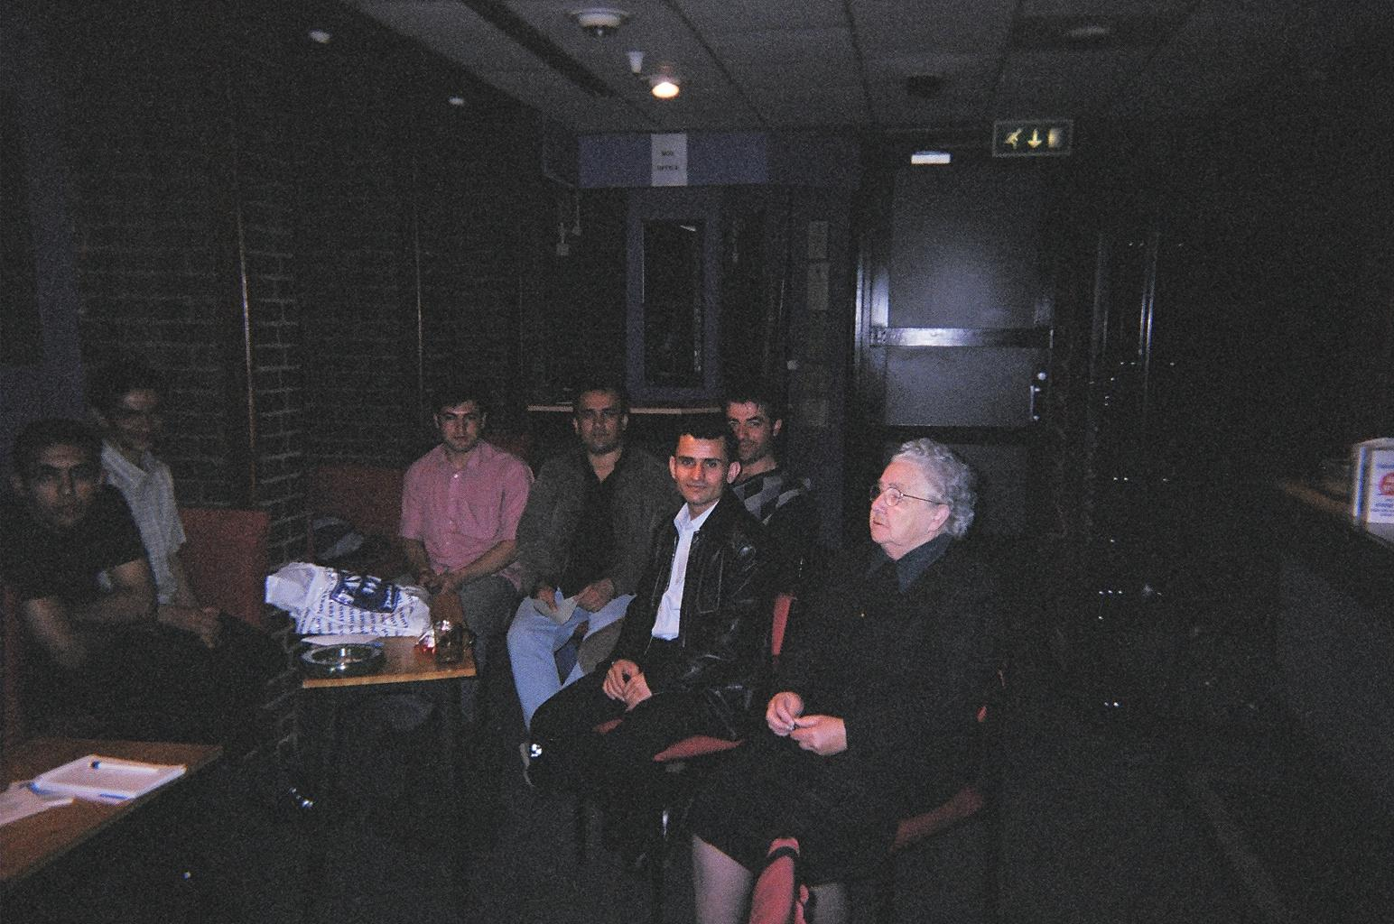
Mrs Margaret Dixon, Commission Member, with a group of Refugees/Asylum Seekers
CITIZENS ADVICE BUREAU (CAB)

The Salford CAB has seen a significant increase in the number of asylum seekers looking for advice from 107 in 2001/2002 to 313 in 2002/2003. This has had a large impact on the time that is now spent dealing with usual inquiries.

The increase has been of concern to the CAB and there have been incidences of racial harassment towards asylum seekers in their central Salford office on Salford Precinct.

The CAB also complain of difficulties in contacting NASS on behalf of their clients and the need for the City to adopt a coordinated approach to dealing with asylum issues.

OTHER COMMENTARY

As well as speaking to service providers and service users the commission took time to speak to other partners in the City including the Voluntary Sector and other agencies working with asylum seekers a number of issues were raised.

- There is a need for the City to coordinate all activity and work with asylum seekers and to articulate its overall policy.
- There is a need for public bodies in the City to promote positive messages about asylum seekers.
- There needs to be much better communication between agencies.
- Much more information should be available for newly dispersed asylum seekers.
- There was concern about the practice at the Post Office on Salford Precinct whereby a separate queue is established for asylum seekers to pick up their benefits. It was felt that this could cause tension for people waiting in the Post Office as they were easily identified as asylum seekers.

LEADER, DEPUTY LEADER AND CHIEF EXECUTIVE of SALFORD CITY COUNCIL

On the 8th February 2003 the commission invited the then Leader and Deputy Leader of the City Council, together with the Chief Executive to give evidence and their opinions on the issue.

The following issues were discussed: -

- It was recognised that the dispersal of asylum seekers to the City was causing some problems in respect of community cohesion and that there had been some incidents of harassment to asylum seekers and other ethnic minority members of the community.
- A discussion took place on recently introduced Government legislation and the possible impact that this could have on homelessness in the City.
- It was acknowledged that there was a perception that asylum seekers were getting ‘special treatment’ over and above that which could be expected by our indigenous population.
- It was agreed that the City Council needs to take a ‘political’ lead on the matter.
- It was noted that certain areas of the City were being affected more than others and that this was having a detrimental affect on areas of regeneration.
- It was noted that the City Council is committed to working closely with other agencies and our communities to develop a future strategy for asylum seekers.

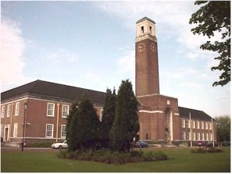

BEVERLEY HUGHES MP, MINISTER FOR STATE FOR CITIZENSHIP, IMMIGRATION AND COMMUNITY COHESION



In June 2003, 3 members of the commission visited Beverley Hughes MP who is the Minister of State responsible for immigration and asylum issues.

The members met with the Minister and NASS officials to discuss the work of the Commission, the work of NASS and central Government policy in relation to asylum seekers.

The commission members were extremely grateful for the opportunity given by the Minister to discuss these issues and wish to pass on their thanks to her for the time given.

The following questions were discussed:

- The Minister expressed her support for the work that was going on in Salford in respect of asylum seekers and was positive about the decision to establish a commission looking at the matter.
- Members expressed their concerns about the fact that Salford’s cluster limit had been exceeded and that the City was taking more asylum seekers than other authorities in the region.
- Concern was also expressed about the over reliance on private sector landlords as opposed to the city’s public sector provision.
- Members asked what the government was doing to alter the public perception of the asylum issue and counter some of the negative national press reports that had been published.
- The Minister was also asked to comment on the views of some service providers as to the performance of NASS, particularly in relation to the ability to contact the organisation.

Ministers Response:

- The Minister acknowledged that there had been some problems with procurement which came about when NASS was first established and needed to procure property at the most efficient cost. She stated that this could have had an effect on regeneration in some Local Authorities.
- New legislation in respect of the asylum process would now mean that there would be fewer applications, which will reduce the number of asylum seekers being dispersed to Salford.
- The new legislation is also bringing about the regionalisation of NASS, which will mean more joint working with Local Authorities and the ability to contact NASS in the regions. The Minister stated that NASS is more than willing to be involved in any Multi-Agency Forums, so as to bring about better communication at a local level.
- The Government is continuing to work with the National Press regarding their portrayal of asylum issues and would encourage local authorities to work at a local level to influence their partners to help promote and publicise more positive information.

The Minister suggested that senior NASS officials would be more than willing to visit the City to be shown the reality of the situation in Salford.

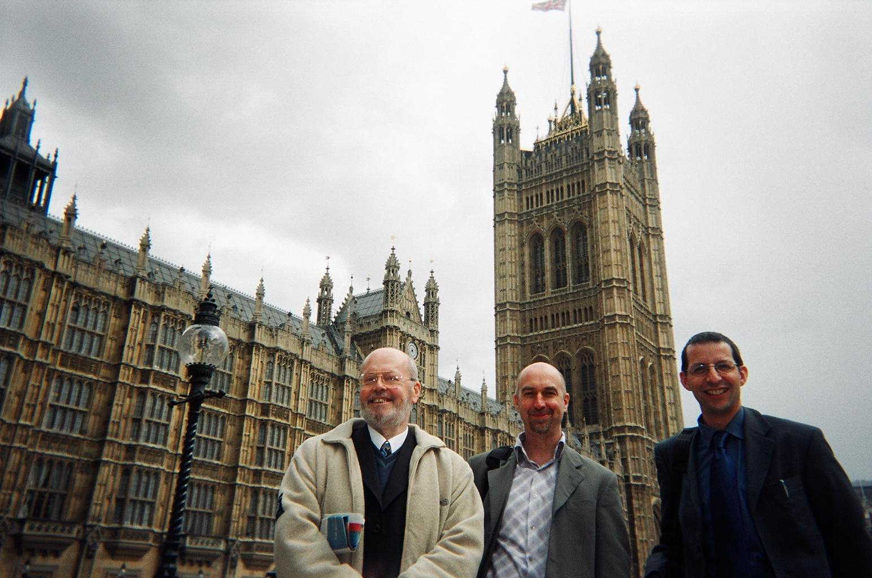
Councillors Bernard Murphy, Andy Salmon (Chair) and Tony Ullman, at the Houses of Parliament
OTHER LOCAL AUTHORITIES

The commission talked to a number of other local authorities who were involved in the dispersal of asylum seekers to their areas. The following areas of good practice were highlighted:

Wigan Metropolitan Borough Council

The Council had carried out a review of dispersal 2 years ago which lead to the publication of a ‘Policy Framework’ and the establishment of a MAF. The MAF is working well and has the involvement of all of the relevant agencies working towards an established strategy.

The Council had appointed a Lead Member with responsibility for asylum issues.

The local police were working closely with the Council and had helped to develop a protocol for appropriate dispersal in partnership with NASS, this had begun to ensure a more ‘equal split’ of asylum seekers across the borough.

The Council had also developed a ‘myth busting’ leaflet and were working with the local press to promote more positive information about asylum seekers.

Bury Metropolitan Borough Council

The North West Consortium reported that Bury Council had established a useful system for partnership working with the Private Sector Housing Landlords in the Borough. They had developed a forum whereby service provision and consistency were considered and future dispersal could be monitored.

They now have a formal agreement with landlords and NASS not to procure properties in certain areas of the borough.

Kent County Council

Kent was one of the first Council’s affected by dispersal and has had a formally published strategy since 2001.

RECOMMENDATIONS – EXPLAINED

From the presentations, visits and deliberations received, made and undertaken by the scrutiny commission, a series of recommendations have now been reached. It is hoped that these recommendations will be accepted by the Council in order that the work on asylum seekers in the City can continue to progress and improve.

The recommendations are as follows: -

- The Leader of the City Council establishes and allocates the asylum seeker portfolio to a single cabinet member.

Most of the agencies and service providers interviewed emphasised the importance of the political lead that is required in order that the issue is given the correct level of recognition and importance by the City Council.

- A senior officer within the City Council and Local Strategic Partnership is given overall responsibility for the coordination of strategy in relation to asylum seekers.

Given the number of agencies involved in working with asylum seekers it is appropriate that a senior officer from the city council is appointed or identified to coordinate all joint working and strategy on asylum seeker issues.

- The City Council should join the Refugee Action ‘Refugees Welcome Here’ campaign which aims to promote and highlight the Councils’ support and commitment to welcoming asylum seekers and refugees to our City.

The commission felt that it was important that the City Council and other agencies expressed their commitment to the positive impact that the welcoming of asylum seekers and refugees can have on a community like Salford.

- The asylum seeker steering group be dissolved and formally reconstituted as a Multi-Agency Forum (MAF), chaired by the appropriate Lead Member and coordinated by the senior officer with overall responsibility for asylum seeker issues and that the groups terms of reference focus on coordination of activity and provision of leadership.

The current arrangements for the asylum seeker steering group need to be strengthened and include representation from all groups concerned. The group needs to consider its future terms of reference and involvement of NASS.
- The MAF have the involvement of all of the relevant statutory and non-statutory agencies in the City and regionally including NASS.

See recommendation three above.

- An audit be carried out to establish a list of all organisations in the City that are currently working with asylum seekers, in order to identify possible duplication of activity or opportunities for the sharing of work load or resources.

Some organisations in the city are carrying out similar work in supporting asylum seekers and there is potential for duplication of activity. Opportunities exist for sharing or joining up of workload together with better sharing of information or good practice.

- The Lead Officer with responsibility for asylum seeker issues and the MAF work to prepare an ‘Asylum Seekers Strategy’ for the City for production by the end of 2003.

A number of local authorities have in place Asylum Seekers Strategies or Policy Frameworks, which look to plan activity and future strategy for all of the areas of work involved in dispersal of asylum seekers including accommodation, dispersal, communication, community cohesion, community safety and promotion and publicity.

- The MAF produce a ‘Welcome and Induction Pack – for Salford’ for all newly dispersed asylum seekers to the City.

Service users and providers commented about the lack of information available to asylum seekers about service providers and appropriate agencies. It was felt that a welcome and induction pack was required for circulation to all new asylum seekers so that they are aware of all necessary contacts and amenities within the City.

- The MAF carries out an analysis of all interpretation and translation services available to public and voluntary sector organisations in the City, with a view to establishing whether the current provision is giving the best and most appropriate service to all agencies, with a view to improvement.

A number of agencies raised concerns about the availability and appropriateness of translation and interpretation services available to them and the level to which their own organisation translates public documents.

- The MAF work to produce a publicity strategy for asylum seekers which looks to respond to negative and misleading press reporting on this issue and also to promote and publicise the facts about asylum and more positive representations of asylum seekers.

Concern was expressed about the amount of inaccurate information published about the asylum issues. It was felt that more work was required to develop a strategy to assist in publicising the facts about asylum seekers and the asylum process.

- The MAF develops a policy to assist equitable dispersal of asylum seekers throughout the City, and that NASS and other relevant agencies be invited to be involved in this work.

There is a concern that nearly 90% of the asylum seeker population are located in 5 inner city areas with 44% in just one ward - Broughton and that dispersal needs to be more equal in future. The commission would like the MAF to work closely with NASS prior to dispersal in order to ensure that dispersal is more evenly spread across the City.

- The MAF and representatives from NASS establish a sub group to consult with contracted private housing providers in the City to ensure that good practice is shared and that there is a consistent approach to service provision.

Concern was expressed regarding the activities of some private landlords in the City and the level of support and information that is given to asylum seekers in their properties. The commission would like the MAF to establish a forum with NASS contracted landlords to ensure that consistent support is given across the City.

- An analysis, in cooperation with the Councils’ Peer Review Group 4, be carried out as to the level and types of Diversity and Cultural awareness training that is carried out in the City, within both the voluntary and public sector including schools.

Given the influx of people from a number of countries to the City it was felt that the Council and other agencies should investigate this issue in order to ascertain if there was any good practice in the City that could be shared across agencies.

- A process is developed with NASS to ensure that officers working within the community are kept informed of the proposed dispersal of asylum seekers. This should be done prior to dispersal in order to make available the fullest level of information and support for asylum seekers and local residents.

The City Council and other agencies have officers working within our communities who, given timely information, could help the induction of asylum seekers into those areas and assist in the preparation of local communities to receive asylum seekers.

- An audit of the support and training available to officers working with asylum seekers is carried out with a view to ensuring that adequate support is provided.

Many of the officers working with and supporting asylum seekers are having to deal with some very difficult and often upsetting casework. The commission felt that there was a need to identify whether relevant training and support was available for them.

- The Greater Manchester Police provide information in respect of the ‘hot spots’ in the City in relation to race crime, in order to assist the MAF in future appropriate dispersal.

There have been a number of reported incidents of harassment and violence against asylum seekers and refugees in the City. Information on the areas that these incidents are occurring in could be used to plan future dispersal.

- The Strategic Health Authority give consideration to the format and translation of the initial correspondence sent to asylum seekers allocating them a local GP.

It was reported that the initial letter sent by the Strategic Health Authority to asylum seekers is currently only produced in the English Language. The commission noted that the letter is relatively short and of a standard wording so could easily include a translation into the commonest 5 or 6 languages.

- The MAF consider the issue of ‘move on’ after an asylum seeker has been given a positive decision, with a view to ascertaining best practice in other authorities and ensuring the future sustainability of our communities.

The commission were very concerned about the current process for ‘move-on’ and the unrealistic timescales given. The commission ask that the MAF and NASS consider other schemes across the Country where different contractual arrangements exist and work is being carried out in partnership with the private sector to ensure that accommodation is available for refugees who would potentially be homeless.

- The Government ensure that the dispersal figure for Salford (1130) is not exceeded in future and that the current figure be brought down to that level as soon as is possible.

The Commission do not think that it is fair for Salford to be taking over its originally agreed dispersal figure.

- The Government ensure that there is a more equal dispersal of asylum seekers across the northwest region.

Salford is the only City in the northwest region that is currently taking over its dispersal figure. The commission would ask government to look at the situation across the northwest with a view to more equity.

- The Government is asked to consider new legislation that would allow asylum seekers to work whilst their claim is being considered.

A common complaint for asylum seekers was the restriction on them working. This concern was mirrored by some longer established Salford residents. Whilst the commission recognised the governments’ concerns that ‘economic migrants’ should not get mixed up with genuine asylum seekers it would also seem counter productive not to make better use of this often very able potential workforce

- The Commission note and welcome the regionalisation of NASS, and that the Government is asked to carry out the process as quickly as is possible to enable local support on dispersal and policy making as well as support to individual asylum seekers.

The commission felt that the regionalisation of NASS could only have a positive impact on the way that services are delivered at a more local level. The commission would encourage Government to speed up the process of regionalisation that officers could be appointed as soon as is possible.

- NASS start to work with the City Council to ensure a more equal procurement of property and dispersal of asylum seekers across the city.

The City does not currently have information regarding the ongoing procurement of property by NASS.The commission would like NASS to consider future procurement so that it does not impact on just a few areas of the City.

- NASS redress the balance of public against private sector housing dispersal in the city and bring the figures back to a more equal split as originally envisaged.

Almost 70% of the City asylum seeker population is now in the private sector. The commission would now like NASS to ensure that a higher percentage of dispersals are to the public sector as originally envisaged when the contract was first established.

- The Post Office is asked to change the current process of a separate queue being used for asylum seekers at its office on Salford Precinct.

The commission felt that the practice of separating asylum seekers from other customers at the Post Office could have a detrimental effect and heighten community tensions.

- The Local Strategic Partnership and the MAF carry out an audit of the training available to refugees in the City, with a view to ensuring that there is an appropriate range available for those who choose to stay in Salford.

There are a number of agencies in the City involved in training for refugees or residents who do not have English as their first language. The commission felt that it should be clear which agencies were working with refugees on training issues so that the most appropriate training could be provided in order for the skills of refugees to be utilised as soon as is possible.

APPENDIX ONE

Members of the Scrutiny Commission

Councillor Andy Salmon (Chairman)

Councillor Bob Boyd
Councillor Val Burgoyne
Councillor Jim Dawson
Councillor Roger Jones
Councillor Bernard Murphy
Councillor Tony Ullman

Mrs. Margaret Dixon – Co-opted member, British Red Cross

Advisor to the Scrutiny Commission

David McGovern, Principal Scrutiny Support Officer

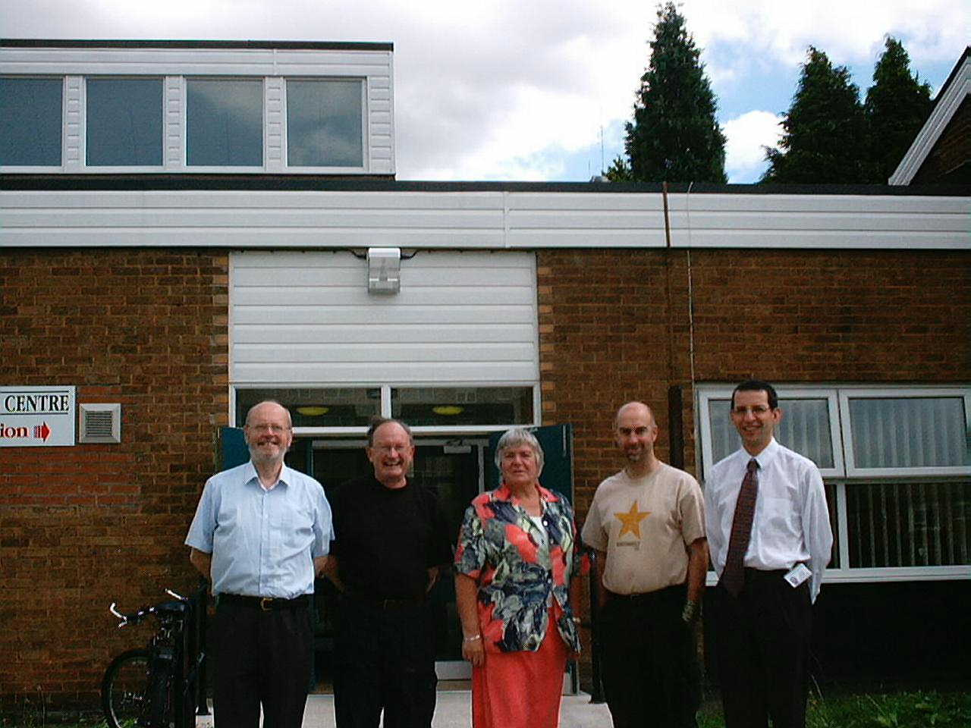
Commission Members, Councillors Bernard Murphy, Bob Boyd, Val Burgoyne, Andy Salmon and Tony Ullman

APPENDIX 2

The commission acknowledge with thanks the contribution made to the commission by the organisations and witnesses outlined below.

Salford City Council

Councillor Bill Hinds and Councillor John Merry
John Willis, Chief Executive
Harry Seaton, Anne Williams, Jill Baker, Bob Osborne, Jane Anderson, Rachel Shaw, Lynne Wallwork, The New Prospect Housing Limited Asylum Team, John Wooderson, Steve Thompson, Maggie Maudsley, Wayne Logan, Sheila Murtagh, Linda Corfield and the EMTAS team, Roselyn Baker, Scott Durairaj, Tom MacDonald, Mick Walbank, Chris Skinkis, Angela Every, Fred Prest and Jean Coward

Other

Dr. Rhetta Moran – The Revans Institute, Salford University
Chief Superintendent Brian Wroe – GMP
Krishna Cour – GMP
Chris White – GMP
Cath Maffia – Salford PCT
Nigel Rose and Tim Hilton – Refugee Action
Anne-Marie and Peter Fell – REVIVE
Chris Storab – Salford CAB
Jules Harrison – North West Regional Consortium
Graham Sutch – Wigan MBC
Nicky Vincer – Pendleton College
David Mottram and Team – Salford CVS
Louise Kay/Eddie Eden – Salford IAG
Amanda Jones-Said – British Red Cross
Karen Young – Bury MBC
Donna Hewitt – Salford RAPAR
Mohammed H. Khan – British Red Cross

Beverley Hughes MP
NASS

APPENDIX 3

GLOSSARY OF TERMS

LSP - LOCAL STRATEGIC PARTNERSHIP

MAF - MULTI-AGENCY FORUM

NASS - NATIONAL ASYLUM SUPPORT SERVICE

GMP - GREATER MANCHESTER POLICE

UNHCR - UNITED NATIONS COMMISSIONER FOR REFUGEES

PCT - PRIMARY CARE TRUST

NPHL - NEW PROSPECT HOUSING LIMITED

CAB - CITIZENS ADVICE BUREAUX

CVS - COUNCIL FOR VOLUNTARY SERVICE

ACPO - ASSOCIATION OF CHIEF POLICE OFFICERS

EMPTAS
ETHNIC MINORITY AND TRAVELLER ACHIEVEMENT SERVICE TEAM

PEER GROUP 4
THE COUNCIL’S WORKING GROUP EXAMINING COMMUNITY ENGAGEMENT AS PART OF THE REVIEW CARRIED OUT BY THE IMPROVEMENT AND DEVELOPMENT AGENCY

DISPERSAL/CLUSTER LIMIT
THE FIGURE FORMALLY AGREED FOR THE NUMBER OF ASYLUM SEEKERS TO BE IN SALFORD AT ANY ONE TIME, BASED ON 1 IN 200 OF THE CITY POPULATION

MOVE-ON
THE PROCESS FOR MOVING ASYLUM SEEKERS ON TO APPROPRIATE ACCOMODATION ONCE THEIR CLAIM HAS BEEN DEALT WITH AND A DECISION HAS BEEN MADE

APPENDIX 4

FACTS AND FIGURES

- Education

Pupils Supported with English as an additional language who are not asylum seekers
Pupils | 286
Primary School | 263 in 35 schools
Secondary School | 23 in 6 schools
Number of Languages | 29

Pupils Supported with English as an additional language who are asylum seekers
Pupils | 422
Primary School | 321 in 38 schools
Secondary School | 161 in 9 schools
Number of Languages | 35

Examples of Languages

Arabic, Albanian, Amharac, Creole, Dari, Kinyarwanda, Romany, Somali, Swahili, Urdu and Xhosa

- Dispersal in Salford and the Region

Public/Private housing Sector split

 | Total | %
Public | 347 | 28.6
Private | 867 | 71.4
Total | 1214 | 100

Regional Split

Area | Number
East Region | 7,715
West Region (Merseyside) | 2,012
Total | 9,727

Comparison by Council

NORTH WEST CONSORTIUM - EAST REGION - SUMMARY
Authority | No. Applicants | Cluster
Blackburn | 435 | 700
Bolton | 1020 | 1338
Burnley | 42 | -
Bury | 591 | 914
Manchester | 1630 | 2149
Nelson | 58 | -
Oldham | 671 | 1096
Rochdale | 466 | 1041
Salford | 1215 | 1130
Stockport | 254 | 1464
Tameside | 302 | 1102
Trafford | 129 | 1102
Wigan | 921 | 1553
NWC Total | 7734

Percentage by Ward

NB: All figures correct at 31/07/03

Published by the Scrutiny Support Team
Personnel and Performance Division
Chief Executive’s Directorate
Salford City Council
If you have any comments or observations pleas contact
0161 793 2513
scrutiny.support@salford.gov.uk

