Report to Cabinet
50 day report Think Customer-A review of front line services

1. Background

  - The Cabinet of Salford City Council formally approved the launch of the Think Customer strategy at the beginning of February 2004. A subsequent Programme Board meeting held on 6/02/04 agreed to the delivery of seven broad pilot projects, each with a specific theme and a long-term vision. All of the pilot projects are to deliver specific objectives over the course of a 100-day period. At the end of this time-scale each project will be reviewed and measured against deliverables, and the lessons learnt from the various schemes will then be utilised to formulate a broader Think Customer strategy.

1.2 The pilot work programme is aimed at direct customer facing front line services engaged in providing the first point of contact to Citizens using telephone, face to face, Internet and paper channels, and from there examining how back office services should also be re-engineered. The scope of the programme embodies the development and implementation of the new service model and also addresses the key enablers which will be fundamental in bringing about and supporting transformation including:

- Design develop and implement pilot collaborative services
- Evaluate the pilot services to inform wider rollout
- Develop underlying access strategy
- Develop early proposals on governance and decision making arrangements
- Develop early proposals on budget allocation process
- Develop early proposals related to future organisational structure
- Identify gaps in enabling HR and ICT services and products

1.3 The Think Customer strategy is closely aligned to other key strategic developments within Salford at the present time such as the Neighbourhood Management Strategy and the development of the Salford brand. Strong relationships exist between programme managers for all such developments to ensure that a consistent approach is taken, service improvements are shared across all developments and all such initiatives are working towards the shared goals of delivering the leadership priorities

- Service improvement
- Improving public participation
- Improving the image of the City

1.4 Each of the seven themes features a broad long-term vision specifically focussed on delivering collaborative working models which will provide more customer focussed, high quality services. Whilst it is not envisaged that in all cases the model itself will be delivered in the 100-day time-scale (Day 100 is 18th June 2004), it is expected that within this period we will have built up an understanding of what the future collaborative working model will look like. It is also expected that certain services relating to each theme will have been implemented into a single point of customer contact, via the following channels: telephony, web, face to face and written. Each project will be measured against its specific objectives, and the outcomes in terms of what was achieved, what was not achieved, what was done well, what could have been improved upon will be used to formulate the broader strategy moving forward.

1.5 Members will find overleaf progress reports in respect of each of the seven pilot themes.

2. Theme 1: Providing joined up health and benefits advice IN Salford

2.1 Aspiration
Provision of a one-stop shop for benefits/health and financial advice specifically in the area of home visits, advice surgeries and benefits take-up campaigns/health promotional work.

2.2 Progress Against Plan:

Whilst there have been several positive developments within this particular theme, perhaps the most significant flowed out of a workshop (April 2004) with several local agencies who are responsible for giving financial, benefits and health advice to vulnerable pensioners across the City. The workshop has concluded that through a joint Agency team, an exercise will shortly commence whereby all such Agencies will track approximately 500 vulnerable pensioners through their daily lives. It is envisaged that this tracking exercise will assist in developing
- joint intervention procedures to avoid such persons falling into further difficulties
- consistent service standards across all partner Agencies
- improved referral protocols for transferring information across partner Agencies in respect of vulnerable pensioners

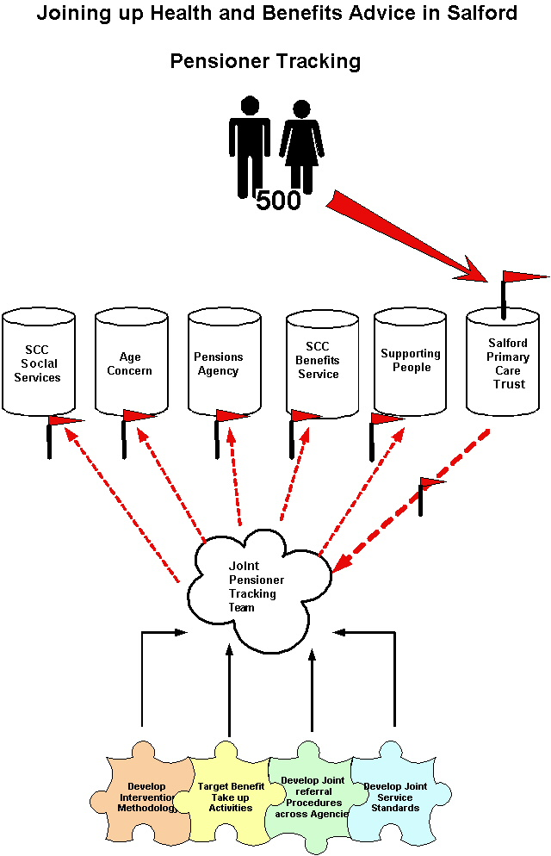

2.3 It is hoped that the pensioner tracking process will revolve around the tracking of pensioners who have recently been admitted/discharged into/from Hope Hospital where such persons are at their most vulnerable and are more likely to encounter difficulties in dealing with partner Agencies. Whilst this issue is still under discussion in terms of the sensitivity of data sharing, you will note from the model below the number of interactions such persons face at this time in their lives, many of which are not currently referred to interested parties at this time.

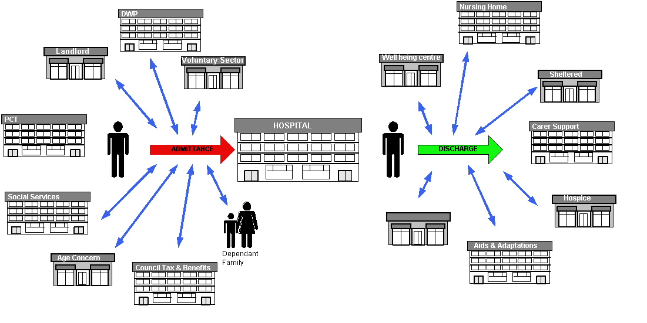

2.4 Key developments within 0-50 days

- Creation of Project Documentation following workshop with all key stakeholders (March, 2004, initial planning meeting held 9th February, 2004)
- Implementation of joint advice surgeries at Hope Hospital (Salford Direct, Welfare Rights, CAB, Pensions Service) (February, 2004),
- Further development of such outreach work within the Health Promotion sessions currently planned (Smoking cessation, male/female screening)
- Implementation of benefits verification services across the whole of the Libraries network (April, 2004)
- Workshop held 19th April 2004, facilitated by Manchester Business School and attended by
  - Salford Primary Care Trust
  - Age Concern
  - Supporting People
  - Housing Advice
  - Welfare Rights and Fairer Charging
  - Stockport Pensions Agency
  - Blackpool Pensions Agency
  - SCC Benefits Service

- Discussions with Mary Murphy (Joint appointment with SCC/PCT) 8th April, 2004, with a view to joining up across both Agencies valuable information for vulnerable pensioners through all existing communication channels, issue has been raised at Salford Older Peoples Partnership about how this may be achieved.

2.5 Next Steps:

Use of joint visiting protocols across all Benefits Advice Agencies (June 2004)
- Delegation of benefits verification responsibilities to external organisations such as Irwell Valley Housing Association (July 2004)
- To deliver pensioner tracking system across all service areas including all Agencies who attended workshop
- To develop intervention procedures to ensure vulnerable pensioner groups are given the best opportunity to maximise incomes/improve quality of life/avoid difficult engagements with Agencies
- To examine in particular the issues affecting older people in respect of admissions/discharge from to hospital
- To develop consistent service standards for across Agencies for dealing with vulnerable pensioners
- To develop more effective referral protocols between all Agencies dealing with vulnerable pensioners
- To create a multi-Agency working model to undertake the pensioner tracing exercise (June 2004)

3. Theme 2: A safer place for all to live IN Salford

3.1 Aspiration

The provision of one point of access to the Anti-Social Behaviour Referral process including the review of all associated “back-office” procedures within the City Council and the organisational structure and location of those arrangements. This will include considerations of a whole system approach that enables better integration and improved service access in ways that make sense to the customer, as well as making a difference to outcomes on the ground.

3.2 Progress Against Plan:

Several meetings have been held with appropriate service partners with a view to achieving the stated aspiration. Work is well underway in terms of delivering the single point of access to Anti-Social Behaviour reporting, Hate Crime reporting during the pilot period but more comprehensive analysis of operational protocols is now being undertaken with a view to developing consistent working practices across Anti-Social Behaviour teams currently located within Community Safety and New Prospect Housing Ltd. Further workshops are to be held shortly to consider the prospect of these two units integrating to a much greater degree.

3.3 Key developments within 0-50 days

- Relevant information re nature and number of hate crime incidents reported has been sourced
- Developed understanding of processes within the Crime and Disorder Partnership
- Developed understanding of number of incidents reported
- Reached consensus with key partners of need for single system

The Working Group has
  - looked at the development of a single “definition” of anti-social behaviour
  - mapped sources of complaint
  - commenced BPR analysis of current practices

3.4 Next Steps:

- Programming development day for action planning
- Sourcing possible IT solutions/ presentations
- identify the resources that will be required to implement the system
- looking at a report that identifies the current position and the “ideal system” then mapping progress towards that single system.

4. Theme 3: Joining up access to bereavement services IN Salford

4.1 Aspiration

Provision of a single point of contact to facilitate the prompt and effective delivery of all multiple agency services (Health, Social Care, Benefits, Voluntary Sector, Spiritual, Operational and Legal) to those who are either anticipating or undergoing a bereavement.

4.2 Progress Against Plan:

The most highly developed collaborative model to date where following a series of successful workshops with partner agencies, the working model below has been agreed in principle as a means of testing the concept of a single point of contact for people suffering bereavement. The working group have discussed all aspects of bereavement including dealing with people with terminal illness, unforeseen death etc and includes a diverse range of organisations such as District Nurses, Police Officers and members of the faith sector. It is anticipated that during the 100 day period, the following working model will be adopted initially within the City Council at the point of contact between the customer and the Registrars Service and with a view to developing a roll out programme across partner Agencies beyond the 100 day period.

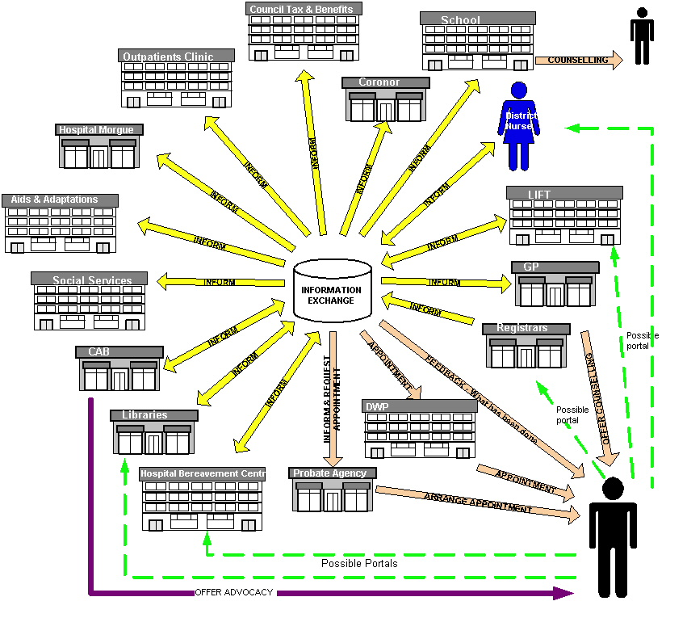

4.3 Key developments within 0-50 days

- Agreement reached on the preferred service delivery model. The working group felt that the information “hub” concept was the way forward. The idea being that wherever a contact is made the information is fed into the central hub and shared amongst those who have an interest
- Agreed that over the next 50 days the model will be tested internally across City Council Departments. The delivery model pilot will involve customers who make contact to register a death. This information, should the customer consent, will be entered into the Citizen system and automatically distributed across those departments who have an interest

4.4 Next Steps:

- Design Citizen (Customer Relationship Management system) scripts
- Train front line staff in delivering the model
- Implementation of the preferred service delivery model
- Scope the information sharing protocols both internally and externally
- Continue to work on the content of an information pack where all stakeholders within the process will be providing the same consistent information whenever they are faced with bereavement situations

5. Theme 4: Improving Children and Young People’s lives IN Salford

5.1 Aspiration

To develop improved access to Salford City Council and other partner services to support all of Salford’s children and young people. To contribute to a whole systems approach to the planning, and modernisation, of all children and young people’s services within the City.

5.2 Progress Against Plan:

There is a longstanding view that the needs of the most vulnerable children and young people can be best met through a holistic approach within a multi-disciplinary framework. This view is reflected in a range of national policies and legislation, most recently the Green Paper, Every child Matters. This strategic approach will be translated into the Children’s Bill which is likely to become statutory in November 2004.
Salford’s own drive to improve services reflects this national approach and elected members have been proactive in appointing a consultancy to lead on the development of a Children and Young People policy/strategy, establishing a Children and Young People Services Planning Forum and agreeing to the establishment of a Children and Young People Trust. The Trust includes the cohesive partnership of the authority, the PCT and other partners and will reflect the following features:
- Integrated governance and performance management
- Joint commissioning and an integrated funding framework
- A common assent framework
- Co-ordinated information sharing and
- Integrated service delivery – disability, CAMH, Public Care, Child Protection, Medical/Sick children and young people, families.
From within the total task of integrating children’s services this exercise will focus on three particular aspects:
- Implementing Information Sharing and Assessment
- Implementing Common Assessment Framework
- Implementation of integrated commissioning

5.3 Key developments within 0-50 days

- An inter-agency group is working with a facilitator on integrated commissioning. This has been through a 4-day action learning set and the final day will be 27 May after which recommendations for a way forward will be produced.
- Work is in hand on looking at integration of services for children with disabilities. Much work has been done on this area but there is a space problem which is being explored. The Working Group will be using the consultant who helped on the Adult Learning Disability Service to help with this.
- A Children's Trust Project Manager has been appointed and should take up post in June. This is a joint E&L, CSSD, PCT appointment.
- Interviews will shortly be held for a Child and Adolescent Mental Health Coordinator who will take the lead on integration of this area of service.
- The Family Action Coordination Unit (an inter-agency team), which will spearhead the coordination of responses to children and families with low-level needs and which will link to sector teams becomes operational in June. This will also mark the introduction of an agreed cross-agency hierarchy of needs which will assist in achieving appropriate responses. This is central to our implementation of Identification Referral and Tracking (Information Sharing and Assessment).
- A joint working group is now in place with the PCT to work on involving children and young people in designing joint services.
- The Tri-partite funding panel for children with exceptionally complex needs has now been operating for a year and has just reviewed its operation.

5.4 Next Steps:

- A further series of inter-agency staff briefings will occur in June and July 2004 to ensure we share our thinking with staff and listen to their views.
- All service partners are about to begin work on the common assessment model which means all agencies will use the same assessment processes for children. This is scheduled for implementation by December 2004. Aspects of this are already being piloted by social services staff, the PCT and schools.
- Salford CC are about to advertise for a Principal Manager Family Services who will manage an inter-agency team providing support to families with higher level needs.
- Proposals for integrated commissioning will be brought forward by late Summer 2004.
- The LIBRA report will also inform the development of the Trust
- Family Action service goes live June 2004 with support for children and families.
Single information system for children and parents summer 2004.
Information sharing protocol June 2004.
Child-friendly privacy and information sharing statements September 2004.

6. Theme 5: Improving access to applications for licence or permits IN Salford

6.1 Aspiration

To provide a single point of access for customers to obtain any type of licence or permit for as broad a range of social, business or pleasure activity.

6.2 Progress Against Plan:

Much progress has been made within the 50 days in terms of understanding the wide range of licence applications handled by the Authority. When examining this issue, a broad definition of the term “licence” has been deployed so that we can bring together many similar services across the Authority and develop a truly collaborative front line service. Within the 100 days it is expected that several licence application processes will be made more accessible through being made available through the Corporate Contact Centre and the Council’s website with services such as free school meal/blue badge applications some of the first services to be implemented through these new communication channels. Preparatory work is also being undertaken to understand the implications of future legislative change in this area.

6.3 Key developments within 0-50 days

- The review of past activity in relation to this theme
- Meeting core staff who have had a lead role to play in the roll out
- Input of new impetus in the delivery of new ways of working
- Identification of deliverables and barriers to deliver e.g. there are no statutory instruments in place and the guidance received from Government is in draft form at present in relation to the Licensing Act 2003.
- Identification of core processes within each licence / permit activity
- Prioritisation of activity to incorporate licence / permit applications through the call centre.

6.4 Next Steps:

  - Private Hire and Hackney Taxi licences are scheduled to go live 1st August.
- To roll out licence applications through the Call Centre. There have been 2 phase reports with regards to this activity, the first of which was written on the 16th December 2002. The scheduled programme, which currently relates to 10500 applications a year, is:
  - Free School Meals – Target date 31st May 2004
  - Chaperone Licence / Work Permits – Target date 18th June 2004
  - Blue Badges / Concessionary Bus Passes / Car Boot Sales – Target date 18th June 2004

- Meeting partners where appropriate
- Map out potential partners / collaborators with regards to the additional responsibilities under the Licensing Act 2003.

7. Theme 6: Joining up Street Scene Services IN Salford

7.1 Aspiration

To provide a single point of access for customers wishing to access the services provided by both
- Environmental and Development Services - Street Scene
- Development Services Directorate - Highways Service first point of contact, and, in either case,
- To report faults, progress chase enquiries, complete transactions

To establish collaborative working, both internal to the Council, and with external partners, to deliver more efficient and effective resolution of street scene issues, and multi agency shared enforcement.

7.2 Progress Against Plan:

As described above work is progressing, within this particular theme, as detailed above, with anticipated delivery of highways/street lighting service requests within the Corporate Contact Centre within the 100 day period to create a single point of customer access and continued work to facilitate joint working on operational activities internally within the City Council, primarily between Environmental and Development Services but also with external partners, and New Prospect Housing Limited. Such development work includes joint training and development programmes for key staff, sharing of information between appropriate parties, the development of referral protocols/systems between such bodies, the creation of service standards and pledges, to the community, from all service partners, and the expansion and enhancement of the enforcement of street scene legislation through increased capacity.

7.3 Key developments within 0-50 days

- Transfer of Development Services call handling to the Call Centre almost completed.

- Decision to design and adopt pledges and standards, against which Street Scene services will be measured, has been taken.
- Partnership working with the Environment Agency already underway to deal with fly tipping and relevant enforcement.
- Confirmation that the proposed JVC will not affect the future continuity of the collaborative model has been received.
- Project documentation completed.
- Joint working report on transfer and sharing of Street Scene data is completed and technical implementation underway.
- Meeting held with external partner representatives and internal training programmes designed to raise joint awareness of Street Scene issues. Inter Agency meeting refined and agreed the Terms of Reference for the representative parties involvement. Interim work being undertaken as regards improved partnership working between Environment Agency, United Utilities, and the Council. Transco to be co-opted to the group to replicate arrangements with United Utilities.

7.4 Next Steps:

- Meetings being scheduled between Development Services and utilities to consider enhanced integration of Street Scene operations and communications, with early emphasis on demolitions and street lighting.
- Building on developing partnership with Environment Agency, to address areas of joint enforcement through current operational partnership and local meetings.
- Incorporating the Street Scene approach into the Neighbourhood Management concept to maximise outcomes for both.
- Use of compatible electronic data transfer, between Environmental and Development Services, is progressing.
- Reciprocal training programmes to be undertaken between Environmental and Development Services Street Inspectors.
- Determine extent of Street Scene services to be covered by this theme.
- Identify all current Street Scene legislation and realistic capacity for expanding enforcement of relevant legislation.
- Progress working relationships and opportunities with NPHL Patch Officers to address anti-social behaviour, through collaborative resource input, such as overt and covert surveillance.
- Development of customer pledges and service standards, from consultation with community representatives.

8. Theme 7: Tackling Health Inequalities IN SALFORD

8.1 Aspiration
Improving access and quality of life, health and social well being through access to joint service provision. Key developments within the project will include;
- Health promotion
- Raising awareness of the Patient Advisory Liaison Service (PALS)
- Integration of procedures in respect of complaint handling
- Joint training and development of staff
- Pilot integration work between City Council and a GP surgery
- Provision of health/benefits advice outreach work in Health/City Council premises
- Examine possibilities for integration/sharing of key customer contact computerised systems
- Service design in respect of the new LIFT Customer Service Centres
- Joint marketing and publicity programme specifically in respect of collaborative working initiatives

8.2 Progress Against Plan:

This Think Customer Theme was borne out of the future prospect of a collaborative working model primarily between Salford PCT and the City Council in terms of the provision of integrated front line services across both organisations through the LIFT Centres (January 2006). It was evident from the early work on these developments that whilst the buildings had been the catalyst for development of joint service redesign work, that it wasn’t necessary for delivery of various joint working initiatives to be constrained by LIFT timescales and much positive work has therefore already commenced.

8.3 Key developments within 0-50 days

- Presentation to Local Strategic Partnership 24th March, 2004 where commitment was received from all partner Agencies to the Think Customer strategy
- Presentation to Senior Joint PCT/SCC Working Group 25th March, 2004
- Presentation to PCT Locality Managers 26th April, 2004
- Joint Staff Development workshop (SCC Customer Services/SCC Libraries/PCT) 27th April 2004, which focussed on analysing potential front line services and the development of joint service standards across partner Agencies.
- Smoking cessation campaign (March 2004) including joint marketing, joint advice sessions and joint training and development where 3 SCC members of staff gained accreditation for giving formal advice on smoking cessations
- Discussions close to finalisation about development of flu jab vaccine opportunity for all SCC staff for 2004

Meeting with Skills Solutions 24th March, 2004, to seek 3rd party support for development of the joint training and development programme for SCC/PCT staff focussed around Customer Service NVQ/European Computer Driving Licence programme
- Joint exchange of SCC/PCT staff on respective IIE/ECDL training programmes

Joint marketing campaigns currently being undertaken in respect of all joint health promotional work

8.4 Next Steps:

Patient Advice and Liaison Service (PALS) awareness session at Staff Development workshop 27th April, 2004 followed by formal PALS accreditation training with front line SCC staff (June 2004)

Public Patient Involvement (PPI) forum promotion to commence at Swinton Civic Centre (May 2004)
- Councillor Murphy to formally raise the profile of the issue of GP involvement with the service redesign work and seek support from the Professional Executive Committee on this issue
- BPR analysis work to commence in respect of LIFT front line services (Within libraries, clinics, Customer Services) led by SCC (June 2004)
- Joint LIFT website hosted by SCC continues to be maintained and a source of great interest locally/nationally. Content to be revised and updated by day 75
- Meeting to be held 12th May, 2004, to determine joint working/joint consultation developments with Geraldine Murphy, Alison Dalley Salford PCT where it is intended to utilise SCC’s Customer Services front line staff to consult with customers about Health and City Council services

Various health promotion activities including;

      - 2004/05 health promotion marketing programme currently being finalised including October 2004 flu jab campaign
- Joint men’s screening/benefits awareness at Forest Hill Prison (May 2004)
      - Joint family planning/benefits awareness at various family planning clinic (May/June 2004)
      - Implementation of joint advice surgeries at Hope Hospital (Salford Direct, Welfare Rights, CAB, Pensions Service) (February, 2004)

9. Conclusion

9.1 The positive analysis of progress to date within the Think Customer programme represents an exciting move forward for the Authority and its partners in achieving its goal of developing high quality, customer focussed front line services, services which maximise the resource of all appropriate Agencies in delivering truly collaborative working solutions.

9.2 These developments are proving critical in helping formulate proposals on the following measures

- Organisation Development… The implications of the collaborative model on the organisational structure of the Council, relating to both the pilot areas and the possible wider impacts of a rollout of the model in other service areas. This will also need to cover organisational preparedness for change, skills and cultural change.
- IT Systems… Develop the specification for the underlying ICT products, facilities and infrastructure to facilitate the collaborative model, any gaps in current provision and recommended solutions to address the gaps. This will cover investment, implementation and business case

Governance and Decision-making…Understand the implications of the collaborative model upon the council’s governance arrangements and decision- making process in light of the cross-service nature of the initiative.

Budget allocation… The implications of the collaborative model upon the council’s budget allocation process in light of the cross-service nature of the initiative will need to be understood.
- Customer Care standards… Corporate customer care standards need to be adopted to underpin the new service model including standards of responsiveness, accessibility and communication

9.3 The pilot themes are also contributing to the development of a “Think Customer” toolkit which will incorporate lessons learned from the projects and a guide on how to develop such working models so that the pilots provide transferable tools which can be deployed elsewhere across the Local Strategic Partnership. It is clear from our efforts to date that translating good intent from agencies into service transformation can provide considerable challenges and it is vital that good practices established within the pilot projects can be shared with others.

9.4 Members are asked to note the report.

