Part 1 | ITEM NO.

REPORT OF THE STRATEGIC DIRECTOR FOR CUSTOMER AND SUPPORT SERVICES

TO THE LEAD MEMBER FOR CUSTOMER AND SUPPORT SERVICES
ON 7TH MARCH 2011

TITLE: IRWELL RIVER PARK – IRWELL LITTER BOAT

RECOMMENDATION:

That the Lead Member for Customer and Support Services:

1. Approve the appointment of APEM Aquatic Scientists Ltd as preferred supplier and delivery agent of the proposed Irwell Litter Boat.
2. Approve the appointment as a departure from Contractual Standing Orders under Part 4, Section 7 of the Council Constitution, subsection 2.1(a)

EXECUTIVE SUMMARY:

Lead Member approval was granted on 8 February 2011 (Lead Member Planning) and 14 February 2011 (Lead Member Customer and Support Services) for the commitment of £20,000 from the secured Irwell River Park capital allocation towards the Irwell Litter Boat. Healthy Waterways Trust will also contribute £20,000.

Approval is sought to pay the secured and approved £20,000 Salford City Council contribution to APEM, which would be a single tender action and would be a departure from Standing Orders under Part 4, Section 7 of the Council Constitution, subsection 2.1(a), the reasons for which are set out in the report.

A joint proposal with APEM Aquatic Scientists and the Healthy Waterways Trust has been developed to operate a new litter boat facility for the stretch of river between Clippers Quay and the City Centre. The collection of litter from the river and its banks is a vital element of Irwell River Park’s maintenance strategy, and will bring significant benefits to users of the waterway and the areas adjoining the river.

APEM will own, operate, store, maintain, insure and license the vessel on a voluntary basis. They will run the boat at least once per month for a period of at least five years. All revenue and running costs will be covered by APEM, and there are no further funding commitments required from the City Council. A legal agreement will be secured between the City Council, APEM and Healthy Waterways Trust stipulating the scope and extent of the operation use of the Litter Boat.

BACKGROUND DOCUMENTS:
(Available for public inspection)

None.

KEY DECISION: NO

DETAILS:

1.0 Introduction

1.1 Lead Member approval was granted on 8 February 2011 (Lead Member Planning) and 14 February 2011 (Lead Member Customer and Support Services) for the commitment of £20,000 from the secured Irwell River Park capital allocation towards a £40,000 project to support the maintenance strategy for Irwell River Park, that will see a new Litter Boat operation commence during Spring 2011.

2.0 Delivery

2.1 A joint proposal with APEM Aquatic Scientists and the Healthy Waterways Trust has been developed to operate a new litter boat facility for the stretch of river between Clippers Quay and the City Centre.

2.2 The proposed litter boat is shown in the images below:

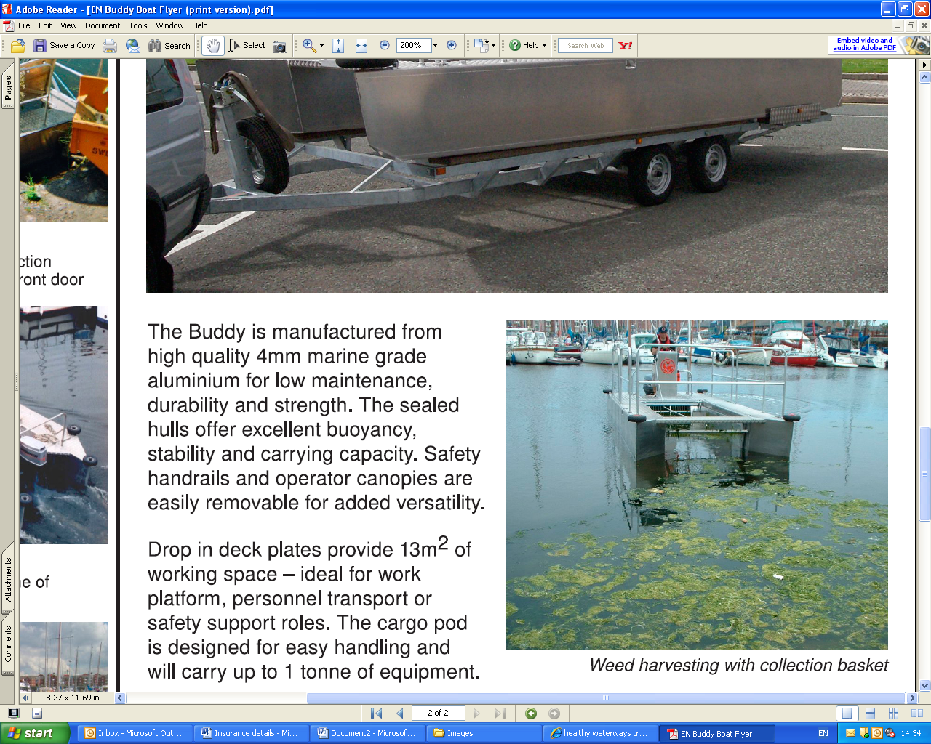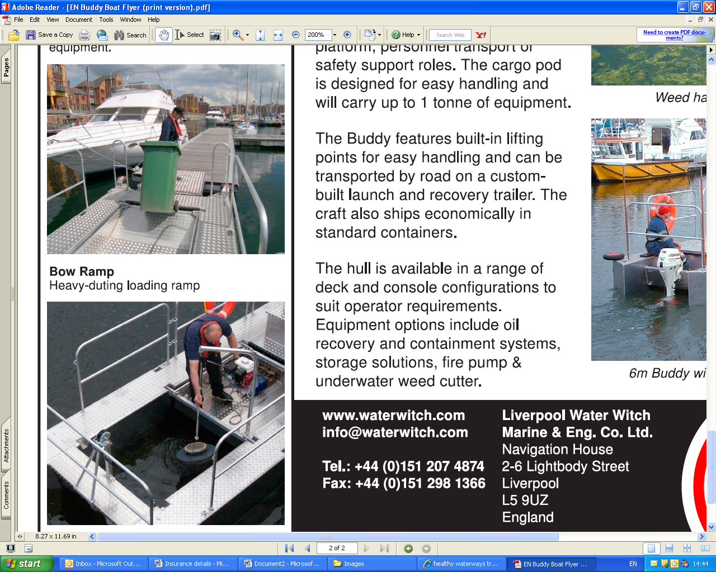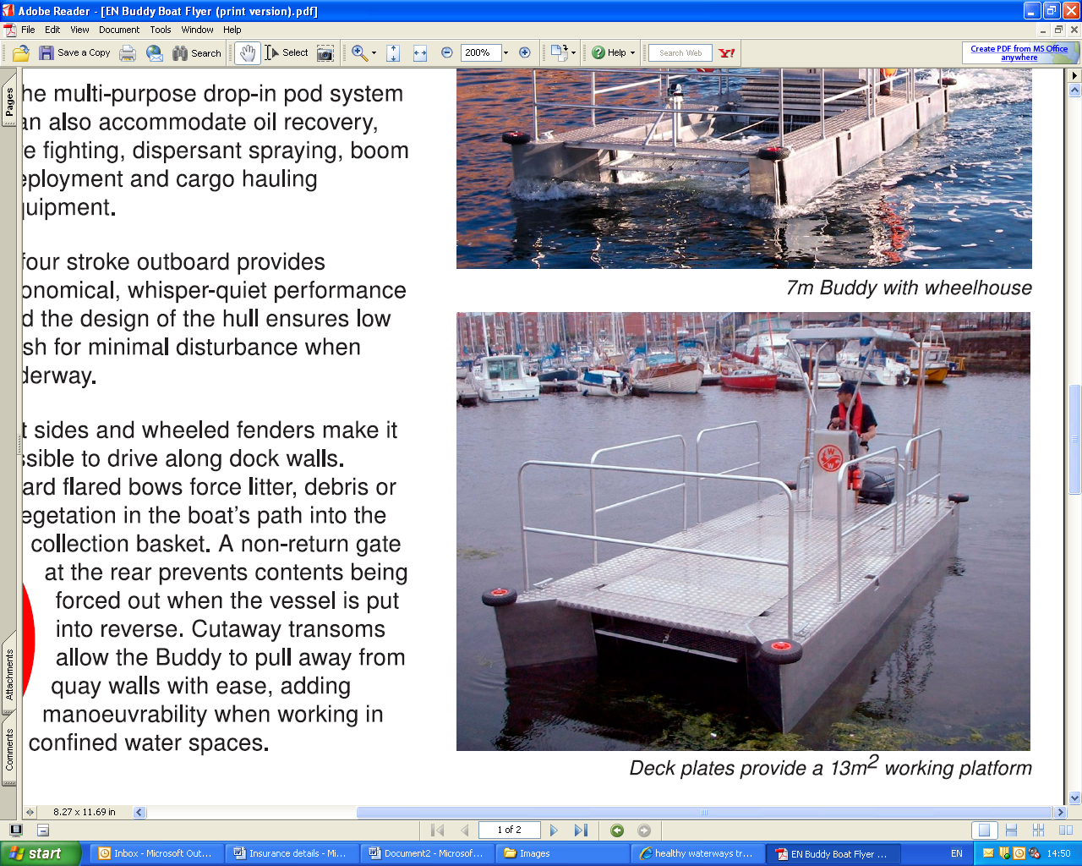

2.3 The project will cost a total of £40,000 to establish. Capital funding to launch the project will come from a secured contribution from the Healthy Waterways Trust of £20,000 with the balance of £20,000 sought from Salford City Council.

2.4 The £40,000 funding secured will allow the purchase of the boat and its operation for one day per month for a period of five years. APEM are in advanced discussions with large corporate bodies to provide the revenue sponsorship required to run the boat on a more regular basis and for a longer period than five years. The capital investment by Salford City Council and Healthy Waterways Trust has guaranteed the funds to enable the project to commence as soon as possible in 2011/12.

2.5 It has been agreed with Healthy Waterways Trust and APEM that APEM will own and operate the vessel. They will also store, maintain, insure and license the vessel on a voluntary basis. All revenue and running costs will be covered by APEM, and there are no further funding commitments required from the City Council. A legal agreement is being drawn up for agreement by Salford City Council, Healthy Waterways Trust and APEM to establish a formal funding agreement and operational scope of the service. The legal agreement is proposed to include clauses which would ensure that Salford (and Healthy Waterways Trust) would have a “stake” in the boat and would recover a pro-rata sum of approximately £4,000 per year of operation should the service not be provided for the minimum five years. For example, if after 12 months the service is regarded as unworkable and the asset (the boat and associated equipment) is disposed of, a proportion of the Council’s stake should be returned. In the above example therefore if after 12 months of operation the boat was sold, four fifths of the money given by the Council should be recoverable (£16,000).

2.6 Manchester Ship Canal Company and Environment Agency are members of Healthy Waterways Trust and have confirmed in writing that they support the proposal.

3.0 Procurement

3.1 A departure from the City Council’s Contractual Standing Orders is requested to pursue through single tender action the appointment of APEM as the preferred delivery agent for the new Litter Boat service. This preference is based on the following factors:

- APEM are specialist aquatic scientists who have been involved with the River Irwell for over twenty years, including leading on the Ship Canal Aeration scheme and working with the Mersey Basin Campaign. Through these projects APEM have gained unrivalled experience of the River/Ship Canal and therefore would provide the best value for money and quality of service.

- Since 2005 APEM have promoted the need for a long term strategy of waterway maintenance. During the last six months APEM have worked alongside the Irwell River Park team and Healthy Waterways Trust to develop a detailed and viable proposal to resolve the longstanding issue of litter within the waterway. This has included the selection of vessel type and specification, liaison with the Manchester Ship Canal Company regarding insurances and licenses, agreement to provide volunteers and all project logistics. The proposal would not have reached a deliverable stage without the expert advice, knowledge and commitment over the longer term, with all necessary statutory and legal requirements met by APEM as delivery agent.

- The project cannot be delivered by anyone else, due to APEM’s long established relationships with Salford City Council, Healthy Waterways Trust and Manchester Ship Canal. They have the specialist expertise to provide the service, which could not be provided by either Salford City Council or Healthy Waterways Trust.

3.2 In order to progress this essential project, the proposal is to engage APEM directly rather than through a competitive procurement exercise. This would avoid delays incurred through the tender process as Salford staff do not have the specialist expertise to ensure that the appropriate technical specification is provided by the potential tenderer to the same specification provided by APEM.

3.3 It will be important to get the vessel operational immediately so that the waterway is as clear of litter as possible before the arrival of BBC staff at MediaCityUK from May 2011.

3.4 For the reasons set out above, the Strategic Director is asked to approve a departure from Standing Orders to facilitate immediate delivery of this project.

Martin Vickers
Strategic Director for Customer and Support Services

KEY COUNCIL POLICIES: None

EQUALITY IMPACT ASSESSMENT AND IMPLICATIONS:

The one-off payment of a preferred service provider supplier has no direct equality impacts. The removal of litter from within the waterway will improve the quality of environment for all those living and working in the areas close to the River Irwell such as the City Centre, Ordsall and Castlefield. The project will also importantly improve the setting for investment along the river corridor between the City Centre and Salford Quays.

ASSESSMENT OF RISK: Low

This is a one-off payment of secured capital to allow the purchase of the litter boat. APEM will own, operate, store, maintain, insure and license the vessel on a voluntary basis. All revenue and running costs will be covered by APEM, and there are no further funding commitments required from the City Council or the Healthy Waterways Trust.

Manchester Ship Canal Company and Environment Agency are members of Healthy Waterways Trust and have confirmed their support for the proposal in writing.

SOURCE OF FUNDING:

£20,000 will be provided from the secured Irwell River Park capital allocation for 2010/11 as approved by Lead Members on 8 February 2011 (Lead Member Planning) and 14 February 2011 (Lead Member Customer and Support Services).

£20,000 will be provided by the Healthy Waterways Trust, as agreed by the Healthy Waterways Trust Board on 9 February 2011.

LEGAL IMPLICATIONS:

Supplied by: Norman Perry
Date Consulted: 2 March 2011

Unfortunately the proposed agreement is not available for comment. On the assumption that it is drawn along the lines outlined in this report, Salford would have a stake in the boat and would recover a pro-rata sum per year of operation if the service is discontinued before the five year minimum period has ended.

FINANCIAL IMPLICATIONS:

Supplied by: Alison Swinnerton
Date Consulted: 2 March 2011

There is provision for the £20,000 contribution from SCC within the agreed Irwell River Park allocation for 2010/11. Minutes of the Healthy Waterways Trust Board meeting show their commitment to their £20,000 contribution.

There are no revenue implication to this decision as it relates to a contribution to a third party.

OTHER DIRECTORATES CONSULTED:

Environment Directorate are supportive of the proposed method of litter collection from the Salford Quays Watersports Centre by the usual Salford collection contractor.

CONTACT OFFICER: Tim Hewitt TEL. NO.: 0161 686 7416

WARD(S) TO WHICH REPORT RELATE(S): Ordsall

