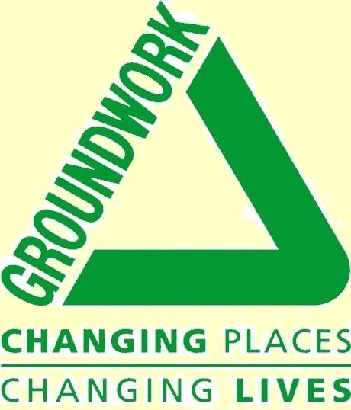
Groundwork Presentation

Background:-

Groundwork
- Groundwork was formed in 1981
- There are 51 Trusts
- Building sustainable communities through joint community action
- Involved in 5000 projects

Groundwork Manchester, Salford and Trafford
- Merger of two Trusts in 2003
- 60 staff
- £5 million turnover
- Project in Salford
- Dedicated Salford Team

Approach
Examples:
Social – Intergenerational Projects
Youth Media Project
Youth offending teams
Neighbourhood wardens

Environmental - Alleygating
Community Gardens
Anti joyriding
Streetlighting
CCTV

Economic - New Deal
ILM
Recycling
Ironworks

Each of these aspects are interlinking and overlapping.

Community Environment Programme:
Within each area, projects are developed to deliver sustainable improvements based around the themes of living environment and social inclusion. They aim to:

• Build community capacity
•
• Enhance and maintain the physical fabric
• Create clean, safe and healthy local environments
In practice this is achieved through the thematic programme, the Community Environment Programme

The Community Environment Programme can incorporate a range of projects including:
- Community gardens
- Alleyway closures
- Gable ends
- Open green spaces
- Parks and play areas
- Education campaigns
- Art Projects
- Environment campaigns e.g. Green Streets, In Bloom

Build Community Capacity:

Capacity building is integral to the projects
Employ qualified trainers, moving towards being an accredited centre
As the physical project develops the group work through the project training file learning and developing skills on
• Project Development,
• Project Management
• Sustainability.
Accredited through LSC Pilot Project

Enhance and Maintain the physical fabric:
- Creative yet locally appropriate designs
- Facilities that meet local needs
- In accordance with area development strategies
- High quality durable materials
- Sustainable sources

- Low maintenance

Create clean, safe and healthy local environments:

- Improving security e.g. alleygating
- Reducing flytipping
- Creating spaces and facilities for play
- Improving perceptions of areas and reducing fear of crime
- Creating a sense of ownership and opportunities for social interaction

Project Example: Cromwell Community Garden
Community garden or crofts can transform a derelict wasteland into a community space that everyone can enjoy.

They provide a safe and secure area for relaxation and play particularly where open space is limited, fear of street crime is prevalent and houses have minimal gardens.

Identified by residents as a solution to environmental, crime and community safety issues in their area.

• Contribute to the Living Environment by creating clean, safe and healthy local environments
• Contribute to Social Inclusion by building community capacity as groups form or develop new skills to take forward and manage the project. They increase cohesion by providing a strong local network as neighbours come together and support each other to create positive local solutions.

Residents receive training on
• Project Development,
• Project Management
• Garden Maintenance
• Fund Raising

Over the next year residents are benefiting from on site garden maintenance training from experienced contractors

Layout designed through consultation workshops and meetings.

Artwork for the gateways and imprinted tiles for the paved areas designed by pupils from Charlestown Primary School

Maintained by a partnership of local residents, St George’s Day Centre and Petrie Court.

Good communication is important

Good quality designs meeting local needs and aspirations using high quality materials

A key aspect of the success of the Community Environment Programme is working in partnership with the residents, the City Council, Regeneration Partnerships, Housing Associations and other local groups.

To contact the team:
•Neil Hewertson - Programme Manager
•Helen Barker - Programme Co-ordinator
•Jonathan Long - Clifton/Newlands
•Pam Anderson - Brown- LIVIA Support Officer
•Katy Hughes - Charlestown/Lower Kersal
•Rob Fulton - Charlestown/Lower Kersal
•Michael Connaughton - Broughton/Blackfriars

Contact: Tel: 873 7182
Phoenix House, 61 Spear Street, Manchester M1 1DF

