ITEM 11

Central Salford
Urban Regeneration Company
Digital World Centre
1 Lowry Plaza
Salford Quays
M50 3UB

Tel: +44 (0) 161 601 7736
www.centralsalford.com

6th July 2005

Dear all,

Salford – The Northwest’s Secret Garden

The more we have delved into the area which we call Central Salford, the more we have come to realise how many hidden assets there are in this part of the world. For the past eight months the Consortium commissioned by Central Salford Urban Regeneration Company (URC) has immersed itself in the area, talking and listening to huge numbers of people who live and work here, walking mile after mile, and in the process discovering what has come to be referred to as this ‘secret garden.’ That will sound fanciful and perhaps cause some wry laughter, but when you look as closely as we have at the waterways, the green spaces, the historic buildings as well as some of the more recent initiatives like the two Lowrys, Salford Quays and Caltrava’s bridge, you begin to see that there really is a secret garden full of potential delights - its just that at present you seldom see it because much is obscured by dereliction and other problems.

On July 14th an 8 page supplement in the Salford Advertiser will unveil the draft Vision and Strategic Regeneration Framework which we will spend the rest of the summer sharing with local people, businesses and other stakeholders and asking for their opinions. As someone who has already been involved, I wanted you to have early notification of these next steps.

A team of local voluntary organisations, community groups and individual residents will be organising events, meetings, presentations and discussions throughout the summer to ensure that as many people as possible in the area know what is being proposed and have the opportunity to give their opinion. With the help of Partners IN Salford’s Good Practice in Community Involvement project and the University of Salford, all that information will be pulled together and used to help shape the eventual framework which will be published in the autumn. The University of Salford are also working closely with the URC to organise a business forum for the local business community, a stakeholder forum aimed at public agencies and a drop-in event open to everyone.

If you would like more information or to get involved in the discussions over the summer, please visit www.centralsalford.com from 14th July onwards, or contact Sarah Darch by telephone or email on 0161 601 7736 / sarahdarch@centralsalford.com.

Thank you for your support to date. You have already helped to shape the draft Vision and Framework which we are about to share with the wider public. Our aim is to transform Central Salford. When you see the proposals we suspect you will say that, like all the very best ideas, ‘Why that’s obvious!’ Then it will be time to start ‘doing’.

Kind regards
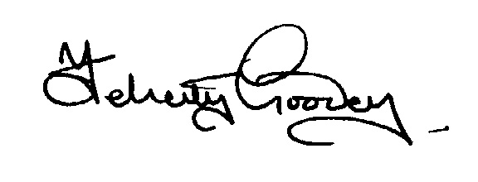
Felicity Goodey
Chair of the Central Salford Urban Regeneration Company

