Part 1 | ITEM NO.

REPORT OF THE STRATEGIC DIRECTOR OF HOUSING AND PLANNING

TO THE LEAD MEMBER FOR HOUSING SERVICES

ON 30th November 2006

TO THE LEAD MEMBER FOR THE ENVIRONMENT

ON 13th November 2006

TITLE: Langholm Place, Winton.

RECOMMENDATIONS:

That the Lead Member for housing:-

- Notes the contents of the report;
- Together with the Lead Member for Environment, approves appropriation and maintenance of land (edged blue, Appendix 2) from the Housing Directorate to the Environment Directorate;
- Approves an additional small adjoining piece of land (edged red, Appendix 2) being appropriated and maintained by the Environment Directorate, subject to the area being handed over in a manageable standard by Housing;
- Approves of the proposed play area for 0-8 year olds.
- Notes that the appropriation will guarantee and secure the maintenance funding of the area by the Environment Directorate.

EXECUTIVE SUMMARY:

This report requests authority to progress with the appropriation of an area of land around Langholm Place, Winton, from the Housing Directorate to the Environment Directorate for the purpose of acquiring revenue funding to install a children’s play area and maintain it and the surrounding appropriated land.

The proposal is to be funded by the Neighbourhood Road Safety Initiative (NRSI) who agreed to adopt the funding role to the value of £46,500 and confirmed this in writing (appendix 1) subject to completion of the project by March 06, subsequently extended to March 07.

The site is immediately surrounded by four popular blocks of 2 bed low-rise flats:

- 2-12 Langholm Place
- 1-11 Langholm Place
- 13-23 Langholm Place
- 63-73 Worsley Road

A presentation to the New Lane Residents association was given in June and the proposal was well received. Further consultations with local residents have since taken place resulting in overall support for the proposal.

The grass area of land edged blue (appendix 2) is currently owned and maintained by Housing and, in isolation, is considered in its current position not to have any infill development potential due to its location on the estate and its close proximity to the railway. Urban Vision has advised that any developer is unlikely to receive planning permission as a result of this.

In addition Housing and Planning Directorate have requested that the area edged red in appendix 2 is also appropriated by the Environment Directorate on the condition that it is handed over in a manageable condition at the expense of the Housing and Planning Directorate. The Liveability Manager for the Environment Directorate has agreed to fund the annual maintenance from existing revenue budgets.

BACKGROUND DOCUMENTS:

Small scale stock option appraisal procedure approved by Lead member 21st April 2005.

Audit Commission Key Lines of Enquiry (KLOE 3) http://www.audit-commission.gov.uk/products/guidance/0CD68C37-776C-4C8B-ACAE-133F5A1F727C/KLOE3.pdf

ASSESSMENT OF RISK: Low

There is no real physical risk, however the proposals have received a lot of support from tenants, residents and local councillors. The proposals also relieve Housing of future maintenance costs on the site. As stated in appendix 4, (subject to the successful appropriation of the land) the Environment Directorate has secured funding to maintain the area shown in appendix 1, thus releasing the Housing and Planning Directorate of future responsibility for the area.

SOURCE OF FUNDING:

The Environment Directorate approached the Neighbourhood Road Safety Initiative (NRSI) who agreed to adopt the funding role to the value of £46,500 and confirmed this in writing (appendix 1) subject to completion of the project by March 06, subsequently extended to March 07.

The annual cost to maintain the proposed play area and the grass plot within the land edged blue is £4,200. The Head of Finance has agreed to fund this from the Revenue Funding for New Capital Schemes on the understanding that the land edged blue becomes the responsibility of the Environment Directorate. (appendix 4)

COMMENTS OF THE STRATEGIC DIRECTOR OF CUSTOMER AND SUPPORT SERVICES (or his representative):

LEGAL IMPLICATIONS:
The Principal Legal Assistant for the Housing and Planning directorate has approved the report.

FINANCIAL IMPLICATIONS:
See ‘Source of Funding’. The Principal Group Accountant for Housing has confirmed this will have no adverse financial implications for the Housing Directorate.

PROPERTY:
The plot of land does not directly affect any of the properties, but is immediately surrounded by four popular blocks of 2 bed low-rise flats:

- 2-12 Langholm Place
- 1-11 Langholm Place
- 13-23 Langholm Place
- 63-73 Worsley Road

HUMAN RESOURCES:

CONTACT OFFICER:

Steve Jones, Development Officer, The Environment Directorate,
Telephone/ email: 0161 793 1016/ steve.jones@salford.gov.uk

James Allan, Principal Strategy Officer, Asset Managerment
Telephone/ email: 0161 793 2881 / james.allan@salford.gov.uk

WARD(S) TO WHICH REPORT RELATE(S): Winton

KEY COUNCIL POLICIES:

The proposal works in line with three of the seven key council pledges:

Pledge Three: Encouraging learning, leisure and creativity in Salford.

Pledge Four: Investing in people in Salford.

Pledge Seven: Enhancing life in Salford.

DETAILS

- Background
  - The purpose of the report is to inform Lead Members of the Environment Directorate and Housing Directorate of the necessity for the Environment Directorate to appropriate an area of land within the control of the Housing Directorate in order to acquire revenue funding for the purpose of installing a children’s play area.

  - In May 2004 Sure Start (part of the NHS) approached Salford City Council with a proposal and funding of £50,000 to build a play area for 0-5yrs in the Brookhouse estate area. A suitable site in the estate could not be found and Athol Street, Winton was proposed as an alternative. Sure Start carried out limited consultations with the residents of Athol Street and a favourable response to the proposal was given. In February 2005 Sure Start withdrew the offer of funding and re-directed the £50k to ‘the Children’s Centre’.

  - The Environment Directorate subsequently approached the Neighbourhood Road Safety Initiative (NRSI) who agreed to adopt the funding role to the value of £46,500 and confirmed this in writing (appendix 1) subject to completion of the project by March 06, subsequently extended to March 07.

  - In order to satisfy the NRSI’s requirements and the City Council’s accepted procedure, regarding siting of a new play facility, a wider consultation exercise took place in August 2005, engaging the local residents who would be affected by the proposal. The result of this consultation was inconclusive and at a public meeting held in Jan 06, local residents decided against the proposal.

  - Other sites around the locale were considered, but due to either a lack of space or proximity of residential property all sites, with the exception of one, had to be discounted.

  - A site (Langholme Place, appendix 2 edged blue) near to the original location was considered as the only appropriate area within the locale that could accommodate a formal play facility. The site is immediately surrounded by four popular blocks of 2 bed low-rise flats:

- 2-12 Langholm Place
- 1-11 Langholm Place
- 13-23 Langholm Place
- 63-73 Worsley Road

A presentation to the New Lane Residents association was given in June and the proposal was well received. Further consultations with local residents have since taken place resulting in overall support for the proposal.

  - Due to the presence of adjacent residential properties and allowance for noise separation, the proposed play area would be limited in size. Two 30 metre buffer zones (coloured red appendix 3) have been positioned around properties 1 to 11, 13 to 23 and 2 to 12 Langholme Place. The buffer zones represent the 30 metre separation distance. The area shaded grey represents the available position for the play area, but due to the adjacent trees, negotiations will take place with Pollution Control with a view to agreeing a reasonable and sensible encroachment within the 30 metre separation distance.

  - The grass area of land edged blue is 2,611 m2 and is currently owned and maintained by Housing and, in isolation, is considered in its current position not to have any infill development potential due to its location on the estate and its close proximity to the railway. Urban Vision has advised that any developer is unlikely to receive planning permission as a result of this.

  - Negotiations have been ongoing with the Housing and Planning Directorate for the appropriation of the land edged blue to the Environment Directorate. The responsibility will include the play area, the grass and 12 trees within the land edged blue, subsequently relinquishing Housing and the new Local Housing Company of any maintenance liability or cost.

  - An in principal agreement to fund the annual maintenance cost was given by the Head of Finance on the understanding that the land edged blue becomes the responsibility of the Environment Directorate. The Head of Finance has now confirmed that the annual maintenance costs will be met by the ‘Revenue Funding for New Capital Schemes’ subject to successful appropriation. (appendix 4)

  - In addition to the land edged blue, Housing and Planning Directorate have requested that the area edged red in appendix 2 (approximately 300m2) is also appropriated to this Directorate on the condition that it is handed over in a manageable condition at the expense of the Housing and Planning Directorate. The Liveability Manager has agreed to fund the annual maintenance which equates to £34.50 from existing revenue budgets. This Environment Directorate is able to absorb this cost (appendix 6).

- Summary of Financial Information:
  - The Neighbourhood Road Safety Initiative (NRSI) is to fund the capital for the scheme, to the sum of ₤46,500.

  - The site will then be maintained by the Environment Directorate at a cost of ₤4,200 per annum, funded through the Revenue Funding for New Capital Schemes.

  - The additional piece of land (the old drying area) would be maintained and funded by the Environment Directorate, through their annual maintenance at a cost of ₤34.50 per annum.

- Marketing and Promotion:
  - The proposed play area will be promoted via the City Council’s web site and an article in the Advertiser. As is the Environment Directorate’s usual custom when developing a new play area, a official opening ceremony will take place shortly after completion.

- Press Release:
  - See point 3.1

- Other Action Proposed Following Approval of This Report:
  - If approved by both Lead Members, further action will be sought by the NPHL area office to clear the area edged red, the old drying area (area edged red, appendix 2) to a manageable standard for the Environment Directorate to subsequently maintain. For confirmation of this, see appendices 5 and 6.

- Recommendations:
  - Notes the contents of the report;

  - Together with the Lead Member for Environment, approves appropriation and maintenance of land (edged blue, Appendix 2) from the Housing directorate to the Environment Directorate;

  - Approves an additional small adjoining piece of land (edged red, Appendix 2) being appropriated and maintained by the Environment Directorate, subject to the area being handed over in a manageable standard by Housing;

  - Approves of the proposed play area for 0-8year olds.

  - Notes that the appropriation will guarantee and secure the maintenance funding of the area by the Environment Directorate.

- Conclusion:
  - The proposed scheme has received significant support from the surrounding tenants, residents and councillors through the work conducted by the Environment Directorate. As well as improving the aesthetics of the estate, the scheme will provide a children’s play area: a facility which is notably lacking in the surrounding area. Further to this, through the appropriation the site, which in isolation holds little development potential or value, will secure the maintenance funding and relinquish the Housing directorate of any maintenance costs. It is therefore recommended to Lead Member that the land is appropriated to the Environment Directorate.

Background Documents

Appendix 1 Letter from NRSI
Appendix 2 Plan showing area of land to be appropriated
Appendix 3 plan showing location of proposed play area
Appendix 4 Confirmation from Head of Finance for maintenance funding

Appendix 1
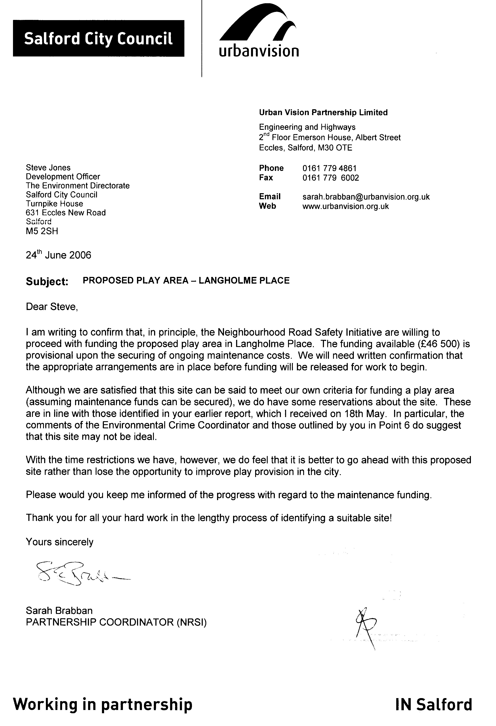
Appendix 2

