Part 1

______________________________________________________________

REPORT OF THE DEPUTY DIRECTOR OF HOUSING AND PLANNING
______________________________________________________________

TO THE LEAD MEMBER FOR HOUSING
FOR INFORMAL ON 20th MAY 2008
______________________________________________________________

TITLE: Salford’s National Affordable Housing Programme (NAHP) 2008 – 2011 allocation and approach to Regular Market Engagement (RME)
______________________________________________________________

RECOMMENDATIONS: That Lead Member for Housing:

- Note the Housing Corporation’s National Affordable Housing Programme (NAHP) 2008 – 2011
- Approve the monitoring of this programme and the approach to Regular market Engagement (RME).
______________________________________________________________

1. EXECUTIVE SUMMARY

  - This report notes Salford’s NAHP for 2008-2011 Housing Corporation allocation of £13.3m, and seeks approval of Lead Member to the reporting on the progress of implementing 262 units under the 08-11 programme.

  - This report also notes the proposed process for appraising and supporting Housing Corporation RME bids; and the proposed bids recommended for re-submission as part of the Housing Corporation RME.
____________________________________________

BACKGROUND DOCUMENTS:
Lead Member for Housing Report 13th December 2007: Bids to be supported for Salford’s National Affordable Housing Programme (NAHP) 2008 – 2011.
Lead Member For Housing Report, On 21st June 2007: Review of Salford’s Affordable Housing Programme 2004 - 2008 and planning for the 2008 - 2011 bidding round.
Interim Statement of Priorities for the Affordable Homes Programme 08-11.
Scheme Viability Checklist (SVC)
___________________________________________________________

ASSESSMENT OF RISK:
The principal risk is not delivering the programme. To mitigate this regular meetings: between the lead and support RSL and SCC staff; Affordable Housing Programme Working Group Meeting (AHPWG); and Liaison meetings with the Housing Corporation. Furthermore, SCC is working with all partners to ensure robust and appropriate community engagement activities are developed and delivered, that will ensure community support for any developments.
___________________________________________________________

SOURCE OF FUNDING:
Housing Corporation grant from their NAHP 2008-2011.
______________________________________________________________

LEGAL IMPLICATIONS:
Ian Sheard
Ext: 3084

confirms that there are no comments from the legal viewpoint

FINANCIAL IMPLICATIONS:
Nigel Dickens
Ext: 2585

confirms that there are no financial implications

COMMUNICATION IMPLICATIONS:

Councillors, staff and partner organisations need to be informed about which bids have been successful for 2008-2011. Furthermore, the Housing Corporation will need to be kept informed about progress in implementing the successful schemes.

VALUE FOR MONEY IMPLICATIONS:
By working pro-actively with partners and assessing which affordable housing bids / schemes take priority, we would seek to obtain best value for money from the grant allocation received from the Housing Corporation.

CLIENT IMPLICATIONS:
Many of submitted schemes are to be developed on Council owned land and / or within development agreements that the Council has with its private developer partners. Securing the grant allocated is intrinsically linked with the progress of master planning, site assembly and planning applications being delivered by the Council’s private developer partners or Urban Vision on behalf of the Council. Therefore, it is imperative that partners are proactive in ensuring that plans / applications move forward at the agreed pace and specification, otherwise there is a risk of losing funding.

PROPERTY:
Proposed new developments are on land owned by, SCC, RSLs or in private ownership. Details of this are presented within the scheme summary information.

HUMAN RESOURCES:
Whilst delivery of schemes rests with the RSLs, Salford City Council is responsible for co-coordinating the preparation for the 2008-2011 NAHP bidding round and monitoring outcomes.

CONTACT OFFICER:
Mark Hart:
Strategy and Partnerships Team
0161 793 2039
mark.hart@salford.gov.uk
______________________________________________________________

WARD(S) TO WHICH REPORT RELATE(S):
Broughton
Langworthy
Ordsall
Swinton South
Claremont
Weaste and Seedley
____________________________________________________________

KEY COUNCIL POLICIES:
The Salford Agreement (LAA), 2007-10
Housing Market Renewal Update 08
(Draft) Housing Strategy 2008-2011
City of Salford Unitary Development Plan (UDP) 2004-16 (adopted June 2006)
Salford Supporting People Strategy 2005-2010
______________________________________________________________
DETAILS:

- Salford nahp 08-11 ALLOCATION

2.1 Salford has successfully received an allocation of 262 units and £13.3m from the Housing Corporation. In line with the Council’s Interim Housing Priorities Statement, our successful allocation consists of: 5% (13 units) of supported housing, 146 (52%) are 3 beds or more, 235 (90%) are for rent, with a substantial majority located in strategic housing priority areas in Broughton, Langworthy and Weaste and Seedley. The average grant per unit is £50,768. The successful schemes are shown in detail below. A summary table showing all these schemes is shown in Appendix 1, with their geographic location shown in Appendix 2.

2.2 Countryside Properties : Broughton Phase 2a, 2b and 3
Phase 2a - A development of 42 homes for rent (8 x 2 bed houses, 26 x 3 bed houses, 8 x 4 bed houses) . A site has been identified which is predominantly owned by SCC. Total capital cost is £5,685,695, with a grant allocation of £2,394,000 (£57,000 per unit). The anticipated Start On Site (SOS) date is September 08 with a completion date of September 09.

2.2.1 Phase 2b - A development of 128 homes for rent, (15 x 2 bed houses, 28 x 3 bed houses, 3 x 4 bed houses, 82 x 2 bed apartments). A site has been identified which is predominantly owned by SCC. Total capital cost is £16,809,958, with a grant allocation of £7,040,000 (£55,000 per unit). Anticipated SOS date is September ‘09 with a completion date of September 10.

2.2.2 Phase 3 - A development of 41 homes all for rent (8 x 2 bed houses, 18 x 3 bed houses, 15 x 4 bed houses). A site has been identified which is predominantly owned by SCC. Total capital cost is £5,685,695 with a grant allocation of £2,173,000 (£53,000 per unit). Anticipated SOS date is September 10 with a completion date of September 11.

2.3 Great Places: Fitzwarren Street Phase 1, Seedley Village
A development of 24 homes as New Build HomeBuy (22 x 3 bed houses and 2 x 4 bed houses). Planning permission is being sought by June 08, with purchase of the SCC owned land to follow. Total capital cost is £3,236,146, with a grant allocation of £747,000 (£31,125 per unit). Expected SOS is August 08, with expected completion August 09.

2.4 Great Places: Lilac Court, Pendleton
A development of 14 homes for rent (11 x 3 bed houses and 3 x 4 bed houses). Plans and designs to be submitted in July ‘08, with acquisition of the SCC owned site is expected in October ‘08. Total capital cost is £2,122,300 with a grant allocation of £812,000 (£58,000 per unit). Estimated start on site date is November 08, with completion November 09.

2.5 Adactus: HOLD
This scheme promotes Home Ownership for people with Long term Disabilities (HOLD), through the acquisition of properties by the RSL, who then sell to purchasers applicable for the HOLD scheme. The properties are yet to be identified but will include 3 x 2 bed houses. This scheme fits with Salford’s Learning Difficulties Strategy and is expected to be implemented in liaison with the Learning Difficulties Team. A total capital cost of £567,465 has been identified with a grant allocation of £116,571 (£38,857 per unit).

2.6 Carr Gomm: Swinton South
This Housing Corporation funding as part of the NAHP 08-11 is for replacement and maintenance projects, including but not exclusively: replacement fire alarm system. They have been allocated £18,750.

- PROPOSED Approach for appraising and supporting HOUSING CORPORATION Regular market engagement (RME) bids

  - The Housing Corporation has only allocated 55% of the NAHP allocation of regional figure for 2008-11. The remainder of this funding is to be provided through Regular Market Engagement (RME) bids, which will provide Salford the opportunity to seek additional funding for affordable units.

  - The Housing Corporation has indicated that RME will be undertaken on a quarterly basis, although not necessarily every quarter. The usual priorities will apply as well as the Housing Corporation taking into account their targets.

  - The timescales indicated by the Housing Corporation, will require streamlined, but robust Council appraisal and support processes in order to maximise RME bidding rounds. As a result this paper proposes that the Deputy Director for Housing and Planning will scrutinise the RME proposals, and support the submission of RME bids that successfully meet the Council’s strategic housing priorities and Housing Corporation guidelines. It is proposed that reports to Lead Member on the RME and progress of the NAHP 08-11 are provided on a bi annual basis and monitored through the LSP’s Salford Strategic Housing Partnership (SSHP).

4. PROPOSED bids RECOMMENDED FOR RE-SUBMISSION AS PART OF THE HOUSING CORPORATION’S (RME)

4.1 Table 1 overleaf indicates potential “in year” bids presented in the December 07 Lead Member for Housing Report. The table shows: the scheme; location; estimated costs; and progress / start on site times. The timing of any bids for RME will depend upon the issues identified being resolved to ensure that the schemes are deliverable.

  - This table isn’t exhaustive and other schemes may come to light that could be considered for RME. Some of these are small schemes such as Kersal Heights and St Marks (referenced in May’s Lead Member Update of Salford’s Affordable Housing Programmes 2004-06 and 2006-08) whilst others are large strategic sites, such as Pendleton that may require Housing Corporation funding to provide appropriate re-housing options for residents. These schemes are less detailed at present.

4.3 Furthermore, please note that the following schemes referenced as potential “in year” bids in the December Lead Member report, will not be pursued for RME at present owing to further scrutiny and initial appraisal work with partners.

Great Places – Fitzwarren Street Phase 2 – Broughton
Great Places – Reprovision supported Housing unit
Contour - Poets Site NDC
Salvation Army Hostel currently on Chapel St
Contour – Salford Supported Families Scheme

Table 1 Potential RME for 08-11 (identified in December’s Lead Member Report)

Location | RSL | Scheme | Output | Capital | Issues / Progress
Ordsall | Great Places | Radcliffe School | 57 affordable units (TBC) | TBC | Type, size and tenure to be identified, but Development Plan Notice (DPN) submitted. Deigns are agreed and developer secured with a anticipated start on site date of October 08, and completion October 09.
Langworthy | Great Places | Langworthy  Gateway | NBHB  12 x 2 bed aparts  Rent  12 x 2 bed aparts 8 x 3 bed houses | Total £14,139,206  H.C grant £1,496,000 | A site has been identified and the land is owned by SCC, Great Places and Langworthy Road Surgery. Demolition is due to start in April 08, and once the land has been purchased from SCC, Great Places will approach the surgery to assemble the site.
Weaste / Claremont | Great Places | Meadow Gate | 5 houses  3 x 3 bed house  1 x 4 bed house  1 x 2 bed house | Total £617,000  H.C grant £140,000 | Site investigation started end of March 08. Great Places have submitted a bid for the site (owned by SCC). If successful, planning permission, designs etc.. will be sought, with a view to start on site January 09, with completion January 10.
Charlestown Riverside | Contour | NDC | At lease 90-100 units TBC | TBC | No of units, type and size is to be identified. A master plan is being developed and will be submitted in June ‘08, with outline planning permission sought by in September ‘08 and an anticipated start on site date of September ’09 for early phases.

5.0 CONCLUSION

5.1 The Lead Member for Housing is asked to note the NAHP 08-11 allocation shown below:

- Great Places – Fitzwarren Street Phase 1 – Seedley Village
- Great Places – Lilac Court – Pendleton
- Countryside Properties – Lower Broughton Phase 2a, 2b and 3
- Adactus – HOLD scheme
- Carr Gomm – Swinton South

5.2 This report notes that due to the timescales of RME a streamlined, but robust Council appraisal and support processes will be required. As a result the report proposes that the Deputy Director for Housing and Planning will scrutinise RME proposals based upon strategic housing priorities, and Housing Corporation guidelines. It is proposed that Report to the Lead Member on the progress of the NAHP 08-11 and RME are provided on a bi annual basis.

5.3 This report also recommends that the following potential schemes should be investigated further and appraised by SCC. If they meet the strategic housing priorities and the Housing Corporation criteria, then it is recommended that they should be resubmitted to the Housing Corporation as RME.

- Great Places – 96 New Lane – Site not yet confirmed
- Great Places – Langworthy Gateway NBHB – Seedley Village
- Great Places – Langworthy Gateway Rent – Seedley Village
- Great Places – Meadowgate – Weaste/Claremont
- Great Places – Radcliffe High School, Ordsall
- Contour – Charlestown Riverside

5.4 The following schemes referenced as potential “in year” bids in December’s Lead Member report will not be pursued for RME at present owing to other funding secured, further scrutiny and initial appraisal work with partners.

Great Places – Fitzwarren Street Phase 2 – Broughton
Great Places – Reprovision supported Housing unit
Contour - Poets Site NDC
Salvation Army Hostel currently on Chapel St
Contour – Salford Supported Families Scheme

Bob Osborne,
Deputy Director of Housing and Planning
Appendix 1

NAHP 08-11 Allocation

Location | Association | Scheme | Output | Capital
Seedley Village  (Langworthy) | Great Places | Fitzwarren St Phase 1 – | 24 homes (LCHO)  22 x 3 bed houses  2 x 4 bed houses | Total = £3,236,146 H.C grant = £747,000
Broughton | Countryside Properties | Phase 2a | 42 homes  8 x 2 bed houses  26 x 3 bed houses  8 x 4 bed house | Total = £5,685,695  H.C. grant =£2,394,000
Broughton | Countryside Properties | Phase 2b | 128 homes  15 x 2 bed houses  28 x 3 bed houses  3 x 4 bed houses  82 x 2 bed apartments | Total = £16,809,958  H.C. grant = £7,040,000
Broughton | Countryside Properties | Phase 3 | 41 homes  8 x 2 bed houses  18 x 3 bed houses  15 x 4 bed houses | Total = £5,685,695  H.C. grant = £2,173,000
Pendleton  (Langworthy) | Great Places | Lilac Court | 14 homes  11 x 3 bed houses  3 x 4 bed houses | Total = £2,122,300 H.C grant = £812,000
To be identified | Adactus | Home Ownership for Long term Learning Disability (HOLD | 3 x 2 bed houses (LCHO) | Total = £567,465 H.C grant = £116,571
Swinton South | Carr Gomm | Refurbishment and maintenance | Replacement fire alarm (classed as 10 units by Housing Corporation). | H.C grant = £18,750
 |  |  | 262 units | Total Costs = £34.1m  Total Grant = £13.3m

Appendix 2

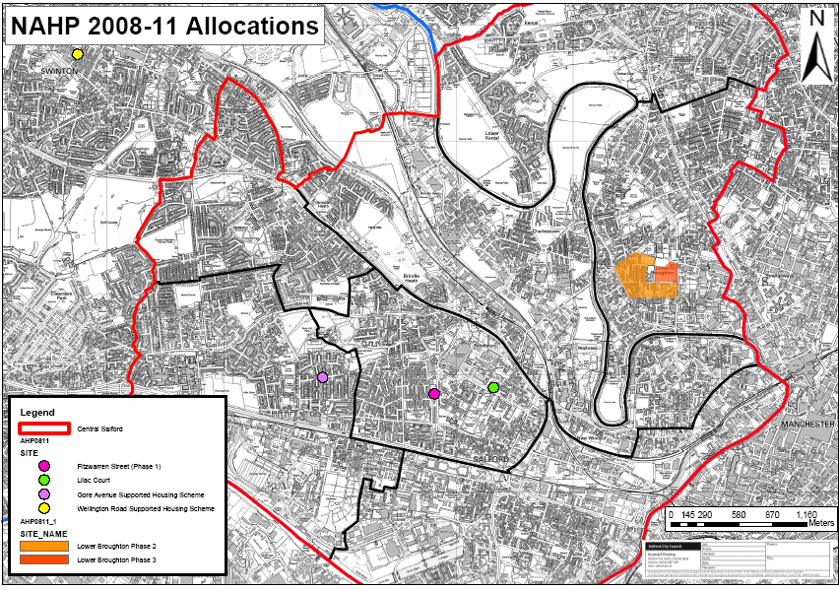

The secured Lower Broughton Phase 4 allocation of 2.3m and 40 units, has been transferred to the 06-08 programme
Countryside have secured Housing Corporation funding for this, but will transfer the stock to an RSL upon satisfactory completion. Negotiations are advanced, and it is likely that the stock will be transferred to Great Places.
Unless LCHO (Low Cost Home Ownership and products including New Build Homebuy, NBHB) is stipulated, all units are for social rent

