APPENDIX 1 – Map of properties 10-16 Duchy Road

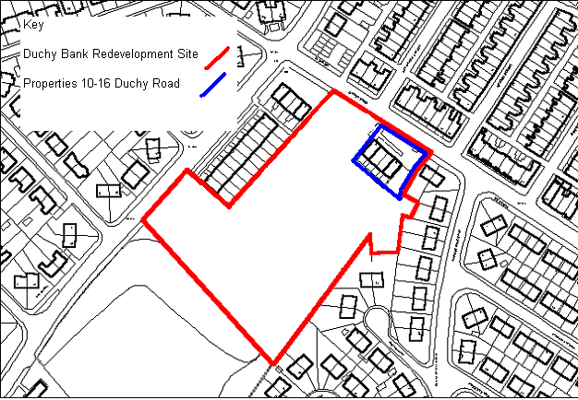

APPENDIX 2 – Photograph of Properties at 10-16 Duchy Road

