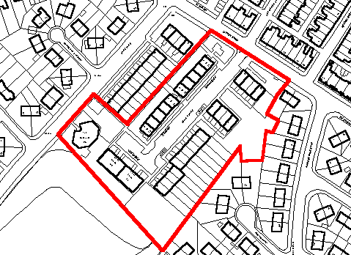
PROPOSED DUCHY BANK RE-DEVELOPMENT SITE

