SALFORD CITY COUNCIL - RECORD OF DECISION

I Harry Seaton Director of Housing Services in exercise of the powers conferred on me by Paragraph 6(a) (ii) of Section F of the Scheme of Delegation of the Council, and following consultation with Councillors Warmisham and Hunt being the Lead and the Deputy Lead Member, respectively, for the Housing Service function, do hereby authorise

In regard to the following dwellings in the Pendleton Area:

The low-rise block on Eagle Drive, on the Whit Lane estate, comprising 12 one-bedroom dwellings (one tenanted).

The dwellings on Mark Avenue, on the London Street estate, comprising of 5 shop units and 5 three bedroom maisonettes above. (two tenanted)

The dwellings on St. Bernard’s Close on the Albion/Dogtrack estate comprising of a block of 4 one bedroom cottage flats (all void).

That the most appropriate course of action in respect of the dwellings is to re-house the existing tenants and to demolish the dwellings. The sites will be cleared temporarily treated and included as part of a package of sites within the New Deal for Community Initiative (NDFC), which may assist potential re-development and re-investment.

The reasons are

The fabric of the stock is in reasonable condition, however the design along with the immediate area surrounding the blocks contributes to their unpopularity. The blocks have a significant amount of insecure open space around the dwellings, which is not appropriate for present day vehicle use/ownership/security.

The source of funding is HRA Home Loss and Disturbance Budget 2001/2 and Housing Capital Programme
The following documents have been used to assist the decision process:-

None applicable

Signed ............................................... Dated ................................................
Director

Signed ............................................... Dated ................................................
Lead Member

Signed ............................................... Dated ................................................
Deputy Lead Member

Contact Officer Alan Lunt Tel. No. 925-1311

* This decision is not subject to consideration by another Director

Report to Lead Member and Deputy – Housing

Report for Decision / Information

Date Of Meeting

Subject: Options Paper - 1 – 9 Mark Avenue/Cumbria Walk, 2-24 Eagle Drive and 1 – 4 St. Bernard’s Close: Pendleton

- Purpose of the report

The purpose of the report is to investigate future options that are currently available in regard to 1-9 Mark Avenue/Cumbria Walk, 1-4 St. Bernard's Close and 2-24 Eagle Drive all located within the Kersal, Pendleton and Charlestown Community Committee Area.

The dwellings and the shops have for some time been unpopular. The immediate surrounding area along with the appearance of the blocks is causing a further blight to the respective estates.

Recommendations

That members note, that due to the number of void dwellings and their unpopularity, a detailed Option Appraisal is not essential in this case.

It is recommended that the most appropriate course of action in respect of the dwellings is to re-house the existing tenants and to demolish the dwellings. The sites will be cleared temporarily treated and included as part of a package of sites within the New Deal for Community Initiative (NDFC), which may assist potential re-development and re-investment.

Background

Scheme Location and Size

The dwellings are located in the Kersal, Pendleton and Charlestown Community Committee Area of the City. The dwellings were constructed in the Mid - 1970’s.

The low-rise block on Eagle Drive, on the Whit Lane estate, comprises 12 one-bedroom dwellings (one tenanted).

The dwellings on Mark Avenue, on the London Street estate, comprise of 5 shop units and 5 three bedroom maisonettes above. (two tenanted)

The dwellings on St. Bernard’s Close on the Albion/Dogtrack estate comprise of a block of 4 one bedroom cottage flats (all void).
The fabric of the stock is in reasonable condition, however the design along with the immediate area surrounding the blocks contributes to their unpopularity. The blocks have a significant amount of insecure open space around the dwellings, which is not appropriate for present day vehicle use/ownership/security.

Background to the current position

Vacant dwellings have recently been classified as ‘B’ voids Since May 2000.

The shops on Cumbria Walk/Mark Avenue and form part of the joint Housing and Development Services shop review, which is still ongoing.
All of the shop units on Mark Avenue have been vacant for a number of years. Two of the shop units have never been fitted out since construction. The last shop unit to be vacated has been void since September 1998.

The shop units have been unpopular since construction. The design of the building is dated. There is very little passing trade, no traffic through routes and a lack of adequate parking, all coupled with changing retail trends, has contributed to a loss of viability. There are more popular shops of this type within the area on Gerald, Littleton & Seaford Roads.

Previous traders have had difficulties to maintain any profit. Development Services have not had any interest for some time

Current Demand

The housing register and anecdotal evidence from the Area Housing Team indicates that there is no current demand for these dwellings. Salford Housing Services has recently undertaken a detailed study of projected future demand for housing across all tenures within the city up to 2004. The study clearly indicated that there is a lack of demand for flats above the ground floor in the Urban North and Inner City Areas.

Relet strategy – property letting

A range of initiatives have been used in order to boost demand for the dwellings. Some relatively minor improvements were made. Eagle Drive, internals painting, palisade fence to the rear of the flats and an upgrade to the door entry system. St. Bernards Close, palisade fence was erected to the rear.

All of the flats were included in the marketing exercise for Whit Lane and included in other Pendleton adverts for flatted accommodation. Three adverts were placed in local papers for the years 99/00 & 00/01. In total, these general adverts generated 9 tenancies as a result of the marketing exercises. This amounted to an advertising cost of approximately (£)347.00 per let, which is above the city average.

It is difficult to effectively interrogate our current rehousing system database. Therefore the actual number lets for the dwellings on Eagle Drive, Mark Avenue and St. Bernard’s, may well be less.

Stock Condition

The fabric of the housing stock is in relatively good condition, however, its overall appearance and design is poor. The properties have a Radburn footprint with a significant amount of insecure open spaces around the dwellings.

In recent years, the only major maintenance programmes to have been undertaken was an estate Prior to Paint taken scheme in 1997/98. The Maintenance Division have do not have specific records which itemises how much was spent on the units. However they estimate that approximately no more than (£) 31,500.00 will have been spent (unit costs of £1500.00).

Programmed repairs are at planning stage for the London Street estate in 2001/2002. This will include at central heating conversion from district to individual. Therefore, if the dwellings on Mark Avenue were cleared there will be a potential saving of (£) 14,000. 00

Options currently under review: -

Retain and do nothing

Total costs for security panels and safety checks to the void properties so far are (£) 3,300.00. Additionally, we have close boarded the properties on Eagle Drive. To do nothing would represent a failure to manage the estate and would probably result in further decline.

Retain the properties in City Council ownership refurbish void properties as existing.

A outlined estimate on the unit costs associated with relet repairs of the current voids will be (£)2500.00. This is based on the improvement costs of the Little Hulton team which follows the current citywide void letting standard model (May 2001).

It would be reasonable to assume that the shops would need substantial improvement. An outlined estimate to bring the units to a good condition would be (£) 30,000.00

Rehouse and Demolish

The demolition of the block would avoid ongoing management costs and improve the environment at this part of the Salford Central North. The cost of demolition is estimated to be (£)68,000.00 which would also temporary treat the cleared sites to help to prevent fly tipping or unauthorised use.

The rehousing of the remaining tenants could be completed and Home Loss and Disturbance costs would be in the region of approximately (£) 10, 000.00

The sites could be cleared to create possible package of re-development sites which could link into the forthcoming NDFC regeneration scheme. It would be reasonable to assume that the site of Eagle Drive has greater development potential due to the surrounding vacant land. Any development on the Mark Avenue site would be restricted as this is within the London Street estate, however, their may be potential to link the site with the new secondary school development. There is an opportunity to link the land on St. Bernard’s drive to the adjacent Poets site. However, consideration needs to be given to the possible relocation of a United Utilities substation that does not form part of the building but may have costs implications with any future development.

Consideration needs to be given to the possibility of contaminated land issues, which may increase demolition costs. Reclamation costs will be dependent on the condition, which is currently unknown, therefore we may have to consider site investigation.

Revenue Implications

This estimated cost would be funded from the HRA Compensation and Demolition budget.

- Rent Income

It is anticipated that remaining tenants will be rehoused in void dwellings elsewhere and so there will be no actual current rent loss to the City Council. The annual rental charge for all the shop units is approximately (£) 10,500.00

- HRA Subsidy

HRA stock numbers for subsidy purposes are now fixed at 1st April prior to the subsidy year. It is assumed that the demolition will ultimately have a benefit through the dwelling count.

Management 21 x (£)315.92 = - 6634
Maintenance 21 x (£)667.77 = - 14,023
Guideline Rent 21x (£)36.70 x 52 x 98% = +39, 245

= + 18,558.00

(2001/2002 Allowances)

- Management Costs

There will be a reduction relating to the direct expenditure of the stock therefore there may need to be possible savings in Area Office costs. There will be no direct savings on the repair and maintenance budget although there will be less dwellings to maintain.

Conclusions

This report is in accordance with the main principles of Housing Revenue Account Business Planning. Therefore, it would be difficult to justify additional and substantial further capital investment on dwellings that clearly may not be sustainable, especially when alternative accommodation which is more popular throughout the City is also in need of capital investment.

The results of the Market Demand Study, especially for one bedroom accommodation, together with the experience the tried marketing methods and the current demand issues suggest that it will be questionable whether demand can be created. This is of major concern given the fact that indications suggest that the problem associated with demand will become worse into the medium term.

All the sites are within the NDFC boundary, if cleared they could link into create possible re-development sites.

This option should eventually generate a land receipt however it will be difficult to forecast the future value of the cleared site (which could offset and rehousing / compensation costs).

Stock Option Appraisal - Financial Implications review

1 - 4 St Bernard’s Close

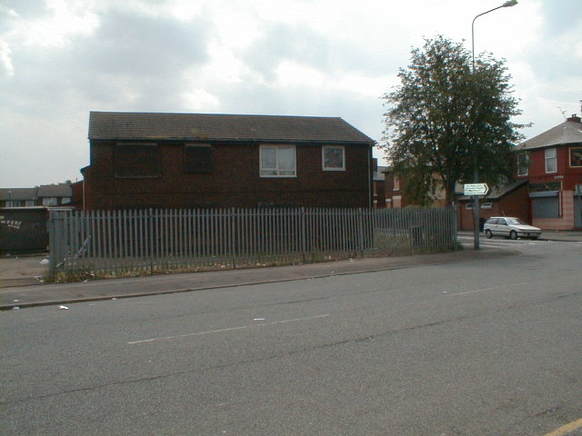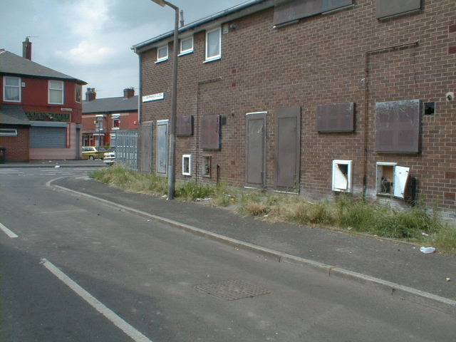
View from Seaford Road View from St Bernards

1- 9 Mark Avenue

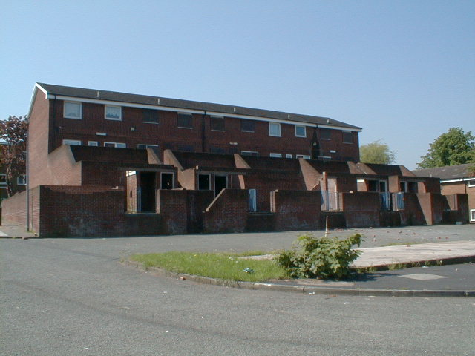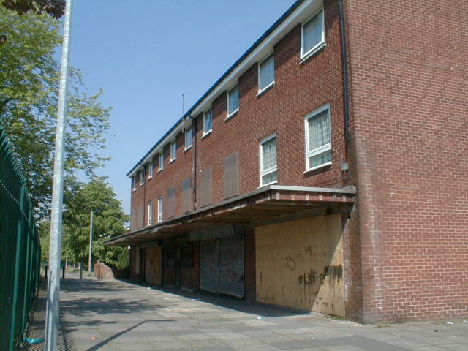
View from Mark Avenue Shop at Cumbria Walk

Eagle Drive – front and rear

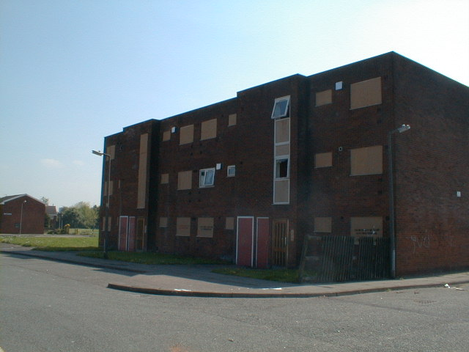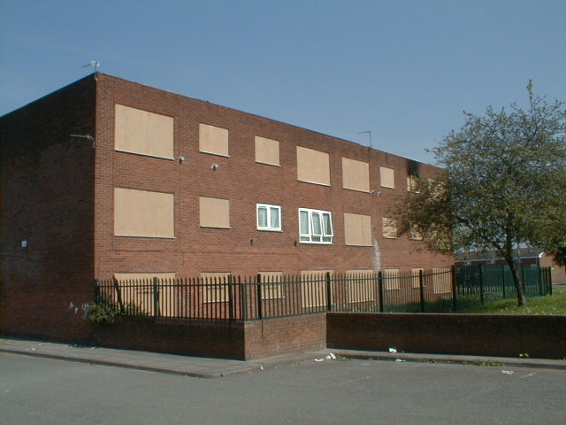

Whit Lane Estate Poets and The Dogtrack Estates London Street Estate

