APPENDIX 5

MANCHESTER CITY COUNCIL
SALFORD CITY COUNCIL
TRAFFORD METROPOLITAN BOROUGH COUNCIL

IRWELL CITY PARK
PLANNING GUIDANCE

CONSULTATION STATEMENT
MARCH 2008

1 | BACKGROUND
1.1 | Planning Guidance for the Irwell City Park has been prepared to facilitate the delivery of the Irwell City Park as an exciting and unique waterfront location within the Manchester Regional Centre.
1.2 | The transformation will create dramatic public spaces, new waterside environments and new connections between the riverside and local neighbourhoods and businesses. New high quality commercial and residential developments and leisure uses along the riverside will provide attractions and activity.
1.3 | The Guidance has been prepared jointly by Manchester City Council, Salford City Council and Trafford Metropolitan Borough Council to set out the guidelines which the Councils as Local Planning Authorities will use as a material consideration in determining applications for planning permission and other matters in the Irwell City Park area.
1.4 | The Guidance aims to ensure that new public realm and development in the Irwell City Park is not only of exceptional design quality but also that it is integrated with the surrounding area and that linkages between other regeneration initiatives in the Regional Centre are successfully achieved.
2 | INTRODUCTION
2.1 | The Planning Guidance has been prepared as a non-statutory document and therefore will not form part of the three authorities’ Local Development Frameworks. Whilst there were therefore no statutory requirements for public involvement during the production of the Planning Guidance, the approach sought to closely parallel the process for producing a Supplementary Planning Document. The purpose for taking this comprehensive approach to consultation was to engage a wide range of stakeholders in the development of the Irwell City Park project, and to support the weight that can be accorded to the Planning Guidance as a material consideration in planning decisions.
2.2 | The approach to consultation and participation set out in this Consultation Statement has been developed in accordance with:  - Manchester’s Statement of Community Involvement (adopted January 2007)  - Salford’s Statement of Community Involvement (adopted March 2008)  - Trafford’s Statement of Community Involvement (adopted July 2006)  and in broad compliance with the requirements of the Town and Country Planning Regulations relating to the production of Supplementary Planning Documents.
3 | GOLD STANDARDS IN COMMUNITY INVOLVEMENT
3.1 | Partners IN Salford (Salford’s Local Strategic Partnership) have developed eight aspirational standards for community involvement. All partners are signed up to delivering community involvement in this way and the approach to consultation has sought to embrace these principles. The Gold Standards are:  - Check if anyone else has done consultation work with results you can share.  - Ensure that consultation can affect change. It should be a dialogue that leads to decisions, so consult BEFORE decisions are made.  - Make sure that you allow adequate time for your consultation project. You need to consider time for planning, conducting, collecting and responding to your activities.  - Try to use methods of consultation that will be the best use of your resources and give the best results from your target audience.  - Try to make your consultation as inclusive as possible but be aware of over-consulting certain groups.  - Always give feedback to those who have participated in your consultation exercises.  - Turn your consultation into action. Don’t leave consultation work ‘on the shelf’.  - Share the results of your work with others.
4 | PRE-PRODUCTION STAGE
4.1 | A comprehensive communication and engagement programme was delivered in order to engage a wide range of stakeholder groups and local communities in the development of the Irwell City Park proposals. This consultation was undertaken to inform the preparation of the Irwell City Park Development Framework.
4.2 | The Planning Guidance has been developed to embed the Development Framework in the planning policy framework of the three partner local authorities of Manchester, Salford, and Trafford. The consultation undertaken to inform the preparation of the Development Framework is therefore taken to constitute the pre-production stage of the Planning Guidance.
4.3 | The Irwell City Park communication and engagement programme was divided into four key phases:  - Phase 1 – September to December 2006: Planning, awareness raising, and strategic stakeholder consultation phase  - Phase 2 – January to February 2007: Main consultation phase  - Phase 3 – March to May 2007: Analysis, evaluation and feedback phase  - Phase 4 – June 2007 onwards: Long term engagement plan
4.4 | Phase 1: September - December 2006, Planning, awareness raising and Strategic Stakeholder consultation phase  The first stage of the engagement programme was initiated by awareness raising through articles in written, internet and broadcast media, distribution of marketing materials through outlets and groups across the three local authority areas and launch of the ICP website. A stakeholder mapping exercise was undertaken to identify and understand the project’s stakeholders, and early consultation activities took place through specially arranged events for strategic community stakeholders, and for developers. A schedule of stakeholders identified via the stakeholder mapping exercise is listed at Appendix 1. The area of focus for resident and community consultation is identified at Appendix 2. The Mersey Basin Campaign Conference also took place in December, so information was distributed and feedback gained from special interest groups at this event.
4.5 | Phase 2: January - February 2007, Main consultation phase  During this phase a series of events and activities took place across Salford, Trafford and Manchester to raise awareness about Irwell City Park and gain feedback and comments from a variety of stakeholder groups, including residents, community groups, businesses and those with a special interest in the river. Working with local community and voluntary groups, activities included street theatre, door to door interviews and specially arranged events to target businesses, public agencies and residents. Community radio provided an alternative avenue to encourage meaningful debate about the park concept. Additional activities were held to target specific groups such as children and young people, and people with disabilities. The Community Networks for Manchester and Salford  were key partners in disseminating information to communities of identity such as BME groups and targeted activities were conducted within neighbourhoods immediately adjacent to the river.
4.6 | Phase 3: March - May 2007, Analysis, evaluation & initial feedback  Information was collated and analysed throughout this phase, and fed into the designs for Irwell City Park. Quantitative data was analysed by type of person to gain an understanding of the needs of different stakeholder groups, for example businesses, residents or those attending schools and  colleges. Qualitative data from events and other activities was grouped into key themes and priorities for different groups. The engagement methods used were evaluated by those who delivered the consultation, as well as the Stakeholder Engagement working group, and this fed into the  development of the future engagement strategy. A newsletter providing initial feedback and next steps for the project was produced and distributed to all those who provided their contact details throughout the engagement programme.
4.7 | Phase 4: June 2007 onwards, Main feedback and future engagement  A feedback document was distributed in June to launch the designs and to outline how people’s thoughts and comments shaped the proposals. The feedback document was distributed to all those who provided their contact details throughout the Stage 2 engagement programme, through various public outlets across Manchester, Salford and Trafford, through the Irwell City Park website and through the various community networks. A series of exhibitions will take place at local museums during summer 2007, to be promoted through the feedback document and through other methods such as community newsletters and local press. This will give all stakeholders an opportunity to view the proposals for Irwell City Park.
4.8 | The Irwell City Park communication and engagement programme was developed by a working group which included local residents and community and voluntary sector representatives. Local community and voluntary groups delivered many of the consultation events and activities, supported by a wider facilitation team.
 | Summary of communication and engagement activity
4.9 | Through the communication and engagement programme 50 events and activities were held and over 40,000 leaflets, postcards and brochures were distributed through consultation events and various public outlets including schools, community centres, libraries and museums. In addition, several thousand people received information about the project through presentations, the ICP website, discussions with the project team and other methods. The comprehensiveness of the approach to communication and engagement enabled over 1500 people to contribute their ideas to help shape the proposals for Irwell City Park.
4.10 | Key activities included:  - Around 70 strategic community stakeholders from across the three local authority areas contributed to a workshop event in December 2006.  - Local community and voluntary groups led a range of activities throughout January and February 2007, including street theatre, broadcasting, vox pops, focus groups, doorstep interviews and workshop sessions. Almost 900 people were engaged through these methods, including residents living in the immediate Irwell City Park area and further afield, as well as communities of identity such as people with disabilities, BME groups, LGBT groups, older people and faith groups.  - Presentations were made to heads of local schools to seek feedback, and further activities were arranged to capture the views of children and young people. Working with Urbis museum and the University of Manchester, five workshops took place involving over 150 school children and students.  - Other activities included a roadshow that took place in a main shopping centre in Manchester, staffed stands at existing events in local neighbourhoods, and questionnaires that were made available online and at local community centres. Around 300 people gave their feedback through these methods.  - In addition to the community engagement programme, developers were consulted on an ongoing basis through group sessions and one to one meetings, and businesses were engaged through a business event as well as individual meetings. Organisations and individuals with a special interest in the river gave feedback through a specially arranged question and answer session for Action Irwell and Action Manchester Waterways organisations, as well as through individual meetings, emails and letters and at the Mersey Basin annual conference.
 | Summary of feedback from communication and engagement activities
4.11 | Over 1500 people gave their views and opinions to help shape the proposals for Irwell City Park. Over half of those consulted (775) gave their feedback through completing questionnaires. This provided good quality quantitative data, enabling conclusions to be drawn about levels of support for the project and what different types of stakeholders wanted from the project. The remaining data gathered through workshop sessions and events was qualitative in nature, so that more detailed opinions and comments could be captured, and so that people could enter into meaningful debate.
 | Questionnaire responses
4.12 | Key findings from the questionnaire responses were:  - 84% of respondents overall felt that it was extremely important (67%) or important (17%) to improve the river and surrounding area. The most enthusiastic groups were business owners (95% feeling it was extremely important or important), residents and leisure users (both 87%) and those working in the area (86%).  - The top priorities for all consultees to encourage them to visit the river and the riverside more was good ongoing maintenance (57.2%), better access onto the river and along the river route (52.6%) and places for people to gather/seating and shelter (52.4%).  - In terms of what events and activities would attract people to the Irwell City Park, The most popular were places to eat and drink (60.7% for all groups). The second most popular choice for all consultees was wildlife and nature areas/green space (57.5%) followed by festivals/fun days and grand events (55%) as the third priority.
 | Qualitative feedback
4.13 | Community cohesion and local pride - this was particularly important and consultees wanted Irwell City Park to become an area which they can have pride in and feel a sense of ownership over. The park was also seen by consultees as a tool for linking communities in the area and creating greater community cohesion.
4.14 | Safe, well maintained welcoming green environment - throughout the consultation stakeholders identified that people will be attracted to Irwell City Park if it is a place in which everybody feels safe and welcome. It was felt that the River Irwell suffered from a poor image currently, and that this image had been compounded by safety and access issues. Many considered the area to be a lost opportunity, with the potential to become a valuable resource.
4.15 | New activities - the provision of activities proved an important priority to the majority of those consulted and it was considered that activities would be very important in animating Irwell City Park, bringing the river back to life. A wide range of activities were identified that would encourage people to visit and use the area, and most of these fell into the following categories; places to eat and drink, wildlife and nature areas, festivals and fun days, music, dance, theatre, sports and leisure activities, and shops and markets.
4.16 | Health and wellbeing - the future health and wellbeing of the community was identified by community stakeholders as an important benefit that Irwell City Park should provide to the local community and the surrounding area. The project was identified as a possible vehicle for improving the health of the community, by providing a pleasant place for local people to walk to, relax in and use as part of their daily activities.
4.17 | Education - education was another important benefit that was identified throughout the consultation by a variety of stakeholder groups, including local residents, leisure users, public agencies and local school teachers. Consultation with schools and universities identified a number of ways in which the project could enhance the education offer in the area, particularly when working closely with the environment and wildlife conservation.
4.18 | Accessibility - accessibility was a strong theme that emerged from the consultation, and improvements in this area were seen to be a key factor in encouraging people to visit the River. It was felt the access could be improved through better parking facilities nearby and better public transport links, as well as additional bridges so that people could reach the area and equally leave the area at key locations. Access along the river was also important to many people, with requests for high quality pathways, wide where possible, with clear signage making it easy to join and leave the river.
4.19 | Facilities - facilities were important to many consultees, particularly basic facilities such as public conveniences, litter bins, seating and shelter. Many respondents noted that the provision of meeting and seating areas would encourage them to visit and use the park.
4.20 | Environment and wildlife - environment and wildlife conservation were identified as issues by a number of those consulted. It was felt that the project should contribute to the improvement of the environment and river quality and should conserve existing wildlife, as well as encouraging additional wildlife, for example through the creation of specific ‘safe havens’ along the river.
 | Stakeholder support and involvement
4.21 | Large numbers of participants offered their feedback through events and activities, and the vast majority were extremely supportive of the project. Many organisations and individuals offered additional support for the Irwell City Park project and in total just under 700 people requested to be kept informed about the project, with over 100 people expressing the desire to play a more active role and be involved in the project as it develops. An extensive database now exists in order to ensure continuing involvement as the Irwell City Park proposals move forward.

5 | DRAFT PLANNING GUIDANCE CONSULTATION
5.1 | There was a formal 6-week period of consultation on the Draft Planning Guidance from 17th August 2007 to 27th September 2007.
5.2 | Whilst there were no statutory requirements for the consultation as the Planning Guidance was prepared outside of the three authorities’ Local Development Frameworks, the approach sought to closely parallel the process for producing a Supplementary Planning Document (SPD). The approach to consultation was therefore developed with regard to Part 5, Regulation 16 of the Town and Country Planning (Local Development) (England) Regulations 2004 which establishes the arrangements for public participation in the production of an SPD.
5.3 | In accordance with this, the following approach to consultation was undertaken:
 | Copies available for inspection
5.4 | Copies of the Draft Planning Guidance and supporting documents were available for inspection at the following locations:  Manchester  - Via the website www.manchester.gov.uk/planning  - At public libraries in the City of Manchester during normal opening hours  - At the Planning Reception, in the Town Hall Extension, Albert Square, Manchester  Salford  - Via the website www.salford.gov.uk/planguidance  - At public libraries in the City of Salford during normal opening hours  - At the main reception, Salford Civic Centre, Chorley Road, Swinton  Trafford  - Via the website www.trafford.gov.uk/planning  - At public libraries and Trafford Direct offices in the Metropolitan Borough of Trafford during normal opening hours
 | Notification sent to relevant consultees
5.5 | Letters were sent out to specific and general consultees together with other relevant consultation bodies, groups, and individuals identified by the three partner authorities to advise them of the period of consultation and where the Draft Planning Guidance and supporting documents could be viewed. Letters were sent to 1002 consultees in total. A full list of consultees is set out at Appendix 3.
 | Press Notice
5.6 | A statement was published in the Manchester Evening News on the first day of consultation - 17th August 2007 to identify the period of consultation and where the Draft Planning Guidance and supporting documents could be viewed.
 | Additional consultation
5.7 | Given the extensive range of consultation and involvement in the development of the Irwell City Park proposals, additional engagement activity on the Draft Planning Guidance document further to that set out above was not considered necessary as it may have resulted in confusion and consultation fatigue.
 | Representations submitted
5.8 | All consultation responses made by 4:30pm on 27th September 2007 were fully considered and appropriate changes were made to the Planning Guidance prior to its adoption. In total, representations were submitted from 32 organisations / individuals. These organizations are listed below:  - ASK Property Developments Ltd  - Bellway Homes Ltd  - Charlestown and Lower Kersal New Deal for Communities  - Countryside Properties  - Emerson Group  - English Heritage  - Environment Agency  - Friends of the Fallowfield Loop  - Government Office North West  - Greater Manchester Ecology Unit  - Greater Manchester Passenger Transport Executive  - Greater Manchester Police (Architectural Liason Unit)  - Heritage Recording UK  - Highways Agency  - Individual (Nigel Holmes)  - Magnesium Elektron  - Manchester Ship Canal Company  - Manchester, Bolton and Bury Canal Society  - Natural England  - North West Regional Assembly  - Northwest Regional Development Agency  - Peel Holdings Ltd  - Rambler’s Association (Manchester and High Peak)  - Red Rose Forest Team  - Regent Park Surgery  - Salford Cycle Forum  - Salford Primary Care Trust  - SHA Estates  - Sustrans  - The Theatres Trust  - Turley Associates  - United Utilities
5.9 | A statement setting out all representations submitted during the consultation period and the council’s response to these, is available via the city council’s website at www.salford.gov.uk/icp-planguidance

APPENDIX 1 – STAKEHOLDERS IDENTIFIED THROUGH STAKEHOLDER MAPPING EXERCISE

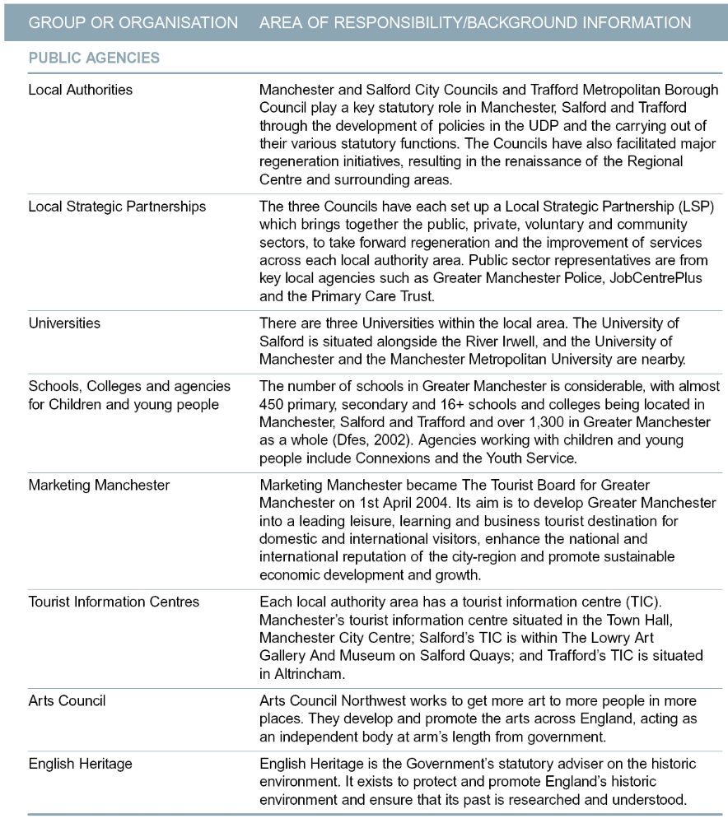

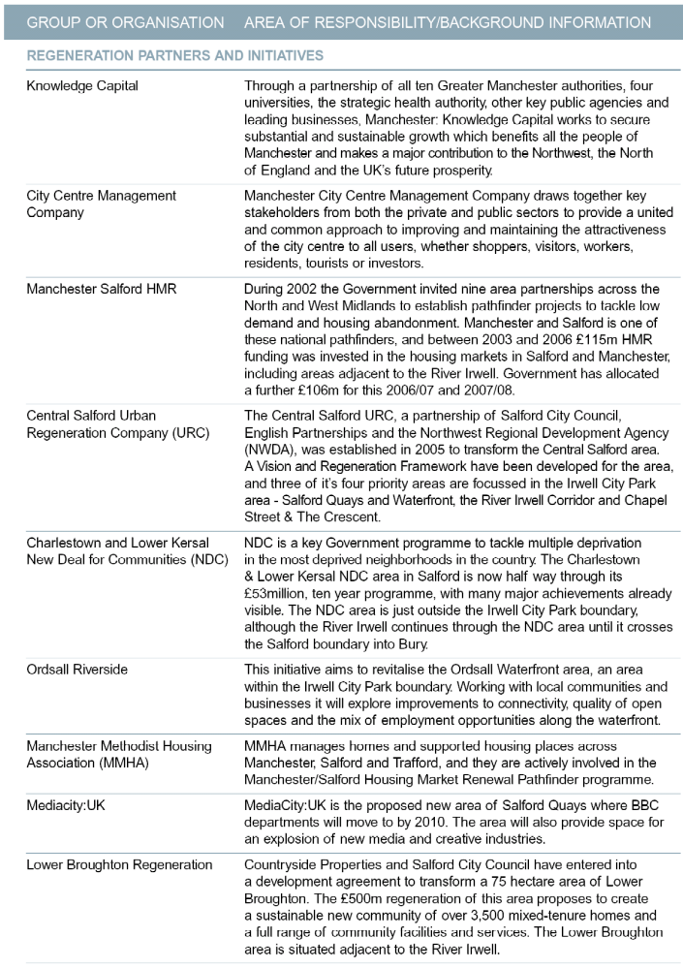
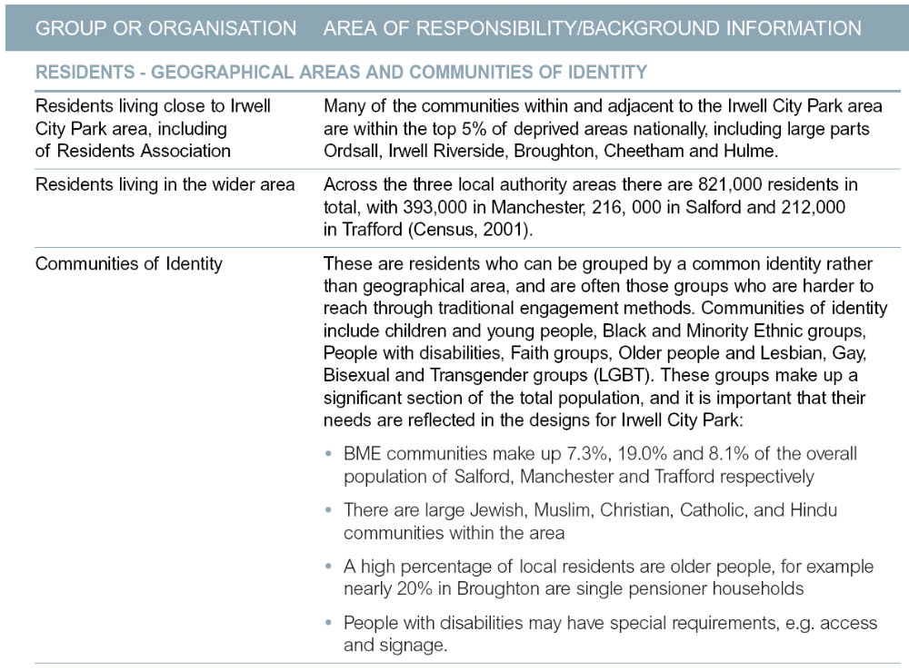
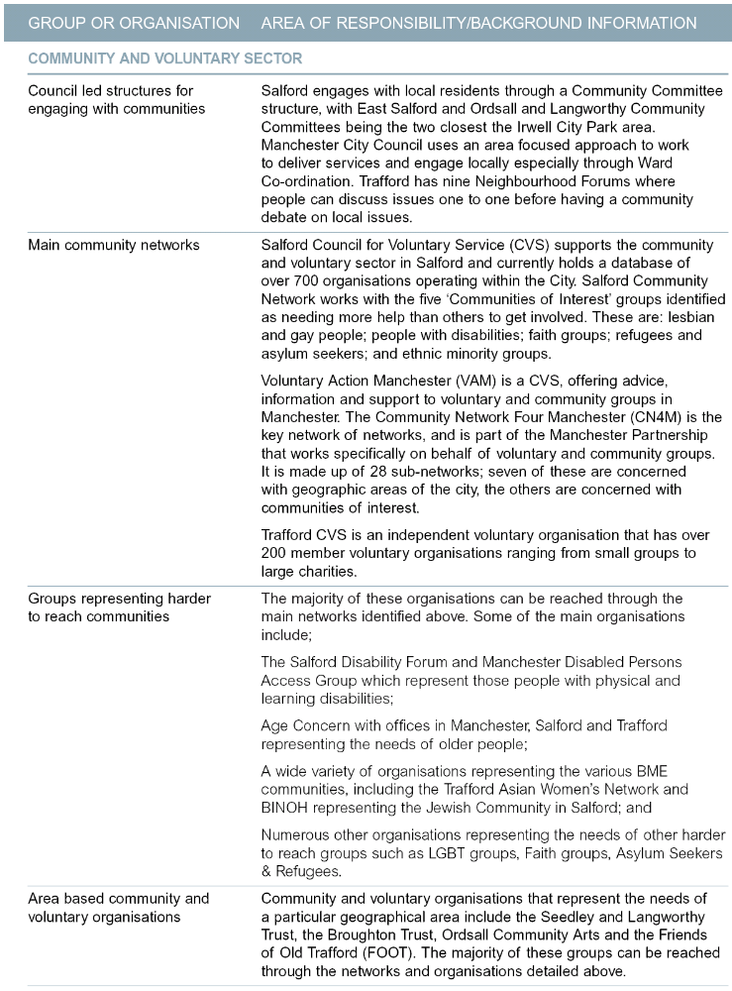
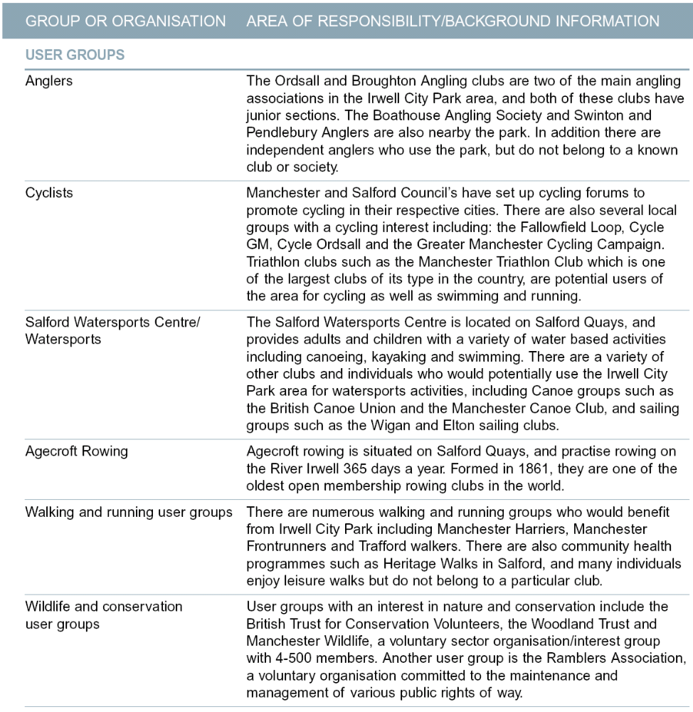
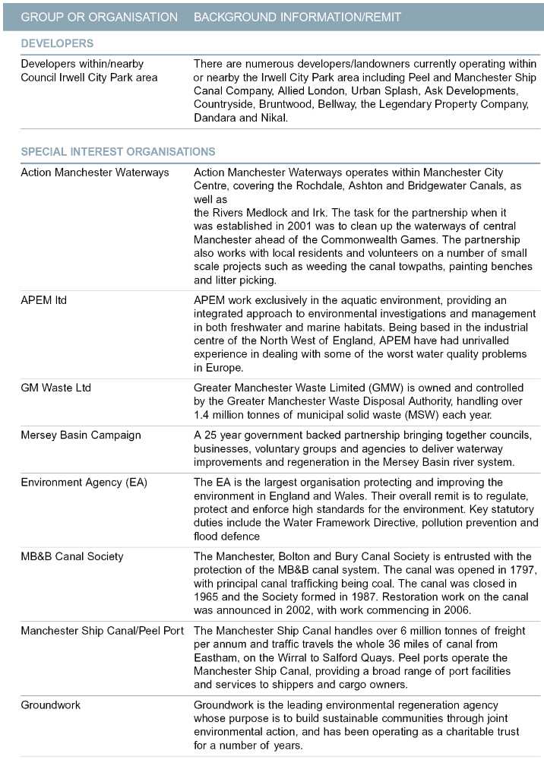
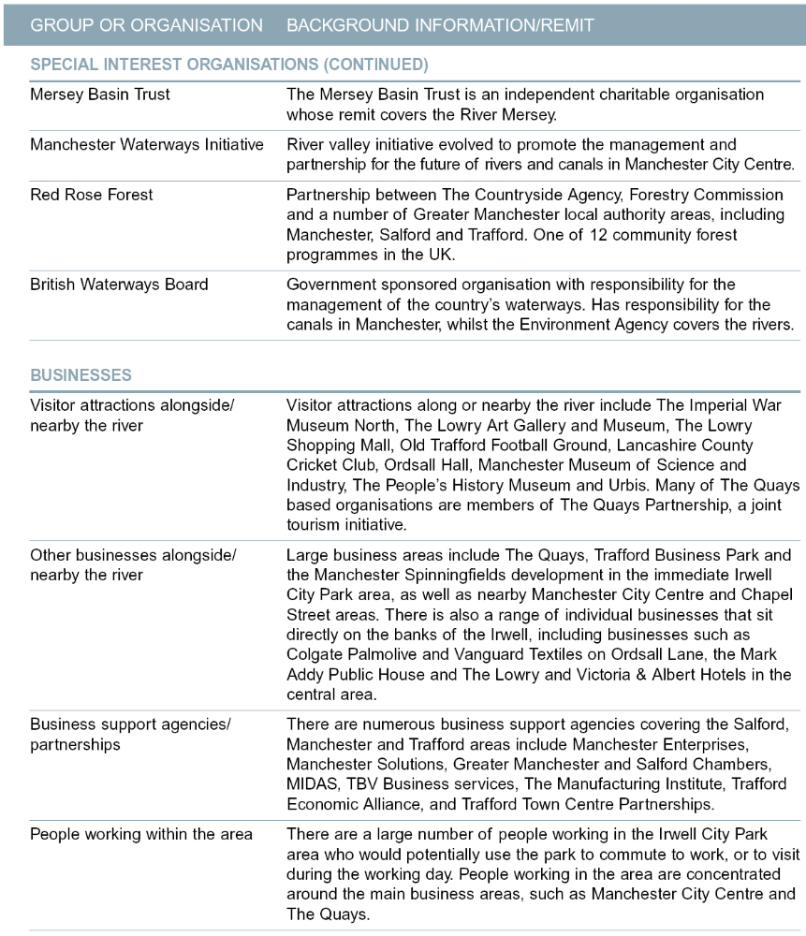
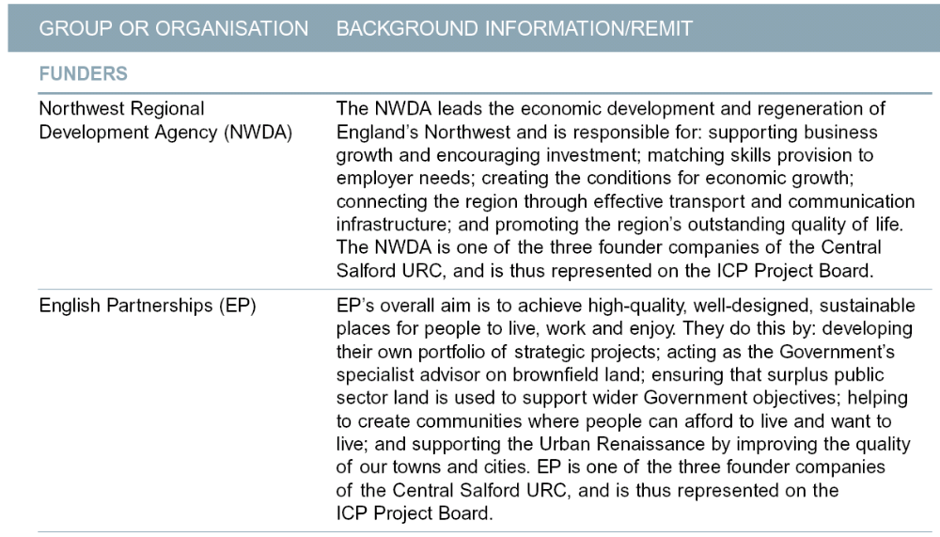
APPENDIX 2 – RESIDENT AND COMMUNITY MAPPING

Research was undertaken to understand more about resident stakeholders, both those adjacent to the Irwell City Park area and those in the wider area so that appropriate engagement activities could be developed.

Wider population - there are 821,000 residents in total across the three local authority areas, with 393,000 in Manchester, 216,000 in Salford and 212,000 in Trafford (Census 2001). This was selected by the Stakeholder Engagement group as the target area for informing residents about the project (see map below).

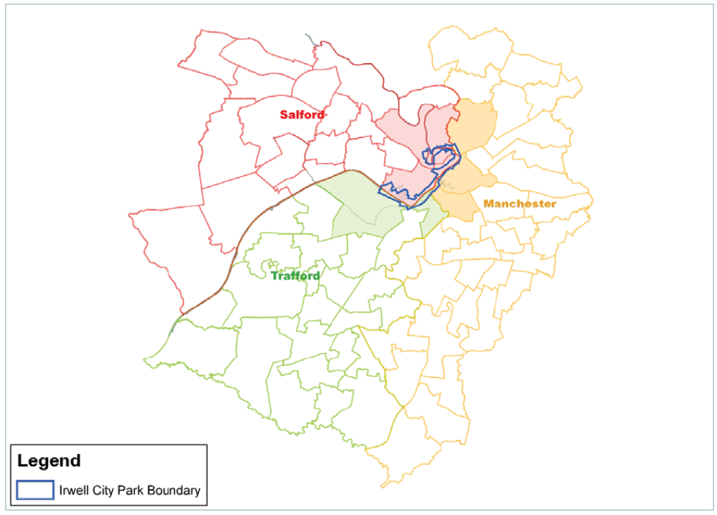

Areas adjacent to Irwell City Park - there are over 75,000 residents living within the eight wards closest to the Irwell City Park area. The largest residential communities situated on and adjacent to the river are in Salford within Ordsall, Broughton and Irwell Riverside wards, home to just under 30,000 people. Around 27,000 people live in the wards nearby the river in Manchester (Cheetham, City Centre and Hulme wards), and nearby wards in Trafford (Gorse Hill and Clifford) are home to just over 20,000 people. These eight wards were selected as the target areas for consultation and involvement activities (see map below).

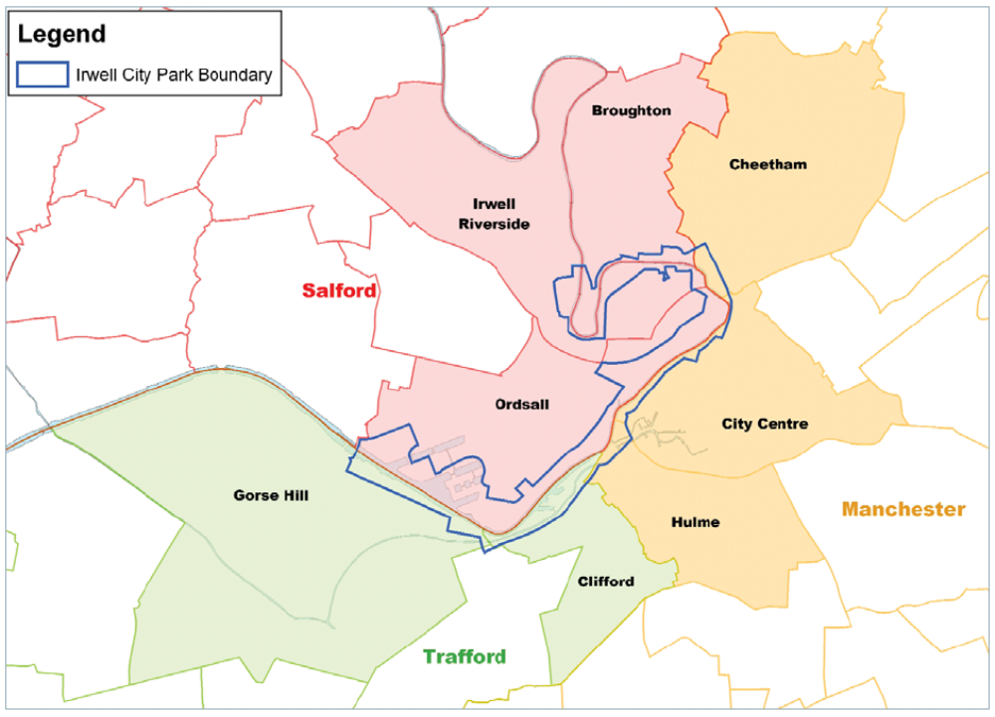
APPENDIX 3 – LIST OF CONSULTEES FORMALLY NOTIFIED OF CONSULTATION ON DRAFT PLANNING GUIDANCE

ORGANISATION
1st Asian Support | B.E.S.S.A.R.A
Abasindi | BANGLADESH ASSOCIATION
Abito | Bangladeshi Women's Organisation
ACADEMY FOR RABBINICAL RESEARCH | BAO LTD
Action Irwell | BARRATT MANCHESTER LTD
Action Manchester Waterways | BARTON WILLMORE PARTNERSHIP
Adactus Housing Group | BBC GMR
AEW Architects | BE GROUP
African Caribbean Care Group for the Elderly | BEECH FARM RESIDENTS ASSOCIATION
African Women's Health Forum | Bellway Homes Ltd
Afro-African Council of Immigrants Welfare Service | Bett Homes
Age Concern | Better Transport Partnership
AGGREGATE INDUSTRIES | Bidwells
AGMA | Black Health Agency
ALDER KING | BLACKLEACH COUNTRY PARK & OPEN SPACE COMMITTEE
ALDERBROOK INVESTMENTS LTD | BOLTON METROPOLITAN BOROUGH COUNCIL
All Saints CE Primary School | Bovis Homes Ltd
Allied London Properties Ltd | BRAND PACKAGING
Alyn Nicholls & Associates | Bridgewater Canal Trust
AMEC Plc | Bridgewater Meeting Room Trust
AMERICHEM | British Geological Survey
ANCIENT MONUMENTS SOCIETY | British Telecom
Andrew Martin Associates | British Waterways
Arawak Walton Housing Association | BRITISH WIND ENERGY ASSOCIATION
Arcon Housing Association | Broad African Representative Council
Arcus Consulting | Broadmoss Tenant's Association
Arena Housing Association | BROADWAY MALYAN PLANNING
Arley Homes | BROCK CARMICHAEL ASSOCIATES (LIVERPOOL)
ARMITAGE RESIDENTS ASSOC. | Brookdale Park User Group
ARRIVA NORTH WEST LTD | Brookhouse Group
ARUP | Bruntwood Ltd
Arup North West | BSC Group
ASDA STORES LTD | B-Serv Ltd
Ashiana Housing Association | BTCV
Ashley Parish Council | BUCKINGHAM BINGO
Ashton New Road and District Residents Association | BURY MBC
Asian Welfare & Advice Centre | Business Consultative Forum
Ask Developments | CABE
ASK Property Development | CALM Co-ordinator
Assael Architecture | Camberwell Park School
Association of Manchester Allotment Societies | CAMPAIGN FOR REAL ALE CAMRA
Atmospheric Research & Information Centre | CARRINGTON PARISH COUNCIL
Awaaz | Castlemore
 | CB RICHARD ELLIS LTD
CDS Development Services Ltd | Community Cohesion Community Forum
Central Manchester PCT | Connexions
CENTRAL SALFORD URC | CONTOUR HOMES
Centre for Ecology and Hydrology | COOPERATIVE GROUP PROPERTY DIVISION
CENTRE FOR LOCAL ECONOMIC STRATEGIES | COPTHORNE HOTEL
Chain Bar Tenants Association | Council for British Archaeology
Charles Green Regeneration | Council for the Protection of Rural England
Charles Topham | Countryscape
Charlestown and Lower Kersal NDC | Countryside Properties Ltd
Cheetham Al-Halil Community Project | County Palatine Housing Association
Chemical Building Association | CRAUNTON HOUSE ASSOCIATION OF TENANTS
Cheshire County Council | CREAM LINE DAIRIES
CHESHIRE COUNTY COUNCIL | Crosby Homes (NW) Ltd
Cheshire Wildlife Trust | Crown Estate Commissioners
Children, Families and Social Care | Cruden Construction
Chorlton Civic Society | CTAC
Chorlton Park Ward Co-ordinator | CTL ESTATES
CHRIS THOMAS LTD | CULCETH AND GLAZEBROOK PARISH COUNCIL
Chris Thomas Ltd Outdoor Advertising Consultants | Cultural Centre for Diversity, Arts and Education
Church Commissioners c/o Smiths Gore | Culture Partnership
Church Commissioners for England | Cunnane Town Planning LLP
Church Lane and District Residents Association | Cushman and Wakefield
CHURCH OF ENGLAND | CUSSONS TECHNOLOGY
Cirkadia | CWS Property Group
CITY CENTRE CRUISES | Cycling Project North West
City Centre Management Company | Cyclist Touring Club
City Centre Project | DANDARA
Civic Trust | DAVID L WALKER
CIVIL AVIATION AUTHORITY | David Lock Associates
CLAREMONT COMMUNITY ASSOCIATION | DAVID MCLEAN HOMES LIMITED
Claremont Road Neighbourhood Care Group | DAVID WILSON HOMES
Clean and Green Partnership | Davis Langdon
Clicks and Links Ltd | De Pol Associates
CLIFF WALSINGHAM AND CO. | DE TRAFFORDS RESIDENT ASSOC.
CLIFTON HAMLET | DEGINSSA CC UK LTD
CLIFTON OVER 60 | Denis Wilson Partnership
CN4M | Denton Hall
CN4M, BME People Network | Denton Wilde SAPTE
CN4M, Faith Communities Network | Department for Constitutional Affairs
Coal Authority | Department for Culture,Media and Sport
Colin Buchanan & Partners | Department for Environment, Food and Rural Affairs
Colliers CRE | Department of Transport
Collingwood Housing Association | DEV PLAN UK
Commission for Racial Equality | DEVELOPMENT PLANNING PARTNERSHIP
Community Arts North West | Didsbury Civic Society
 | Didsbury East Ward Co-ordinator
Diocesan Board of Finance | FRAMPTONS
Director of Public Health | Frank Marshall & Co.
Disability Rights Commission | Freight Transport Association
Diversity Plus | Freightliner Ltd
DOCTORS SURGERY | Friends of Cringle
Donaldsons | Friends of Old Trafford
DORRIBO T/A REGIONAL MAP DISTRIBUTERS | Friends of the Earth NW
DPDS Consulting Group | Friends, Families and Travellers
DRIVERS JONAS | Frogmore Northern
DTZ PIEDA CONSULTING | Fusion Online Ltd
Dunlop Haywards Lorenz | G.E. ROBINSON
East Manchester Community | Galliard Homes
East Manchester Over Fifties Forum | General Aviation Awareness Council
ECCLES MOSQUE | GEORGE WIMPEY MANCHESTER LTD
ECCLES SAVINGS AND LOANS CLUB | Gerald Eve
ECHG Tenancy Support | Gerald Knight Associates
Economic Development Unit | Ghana Cultural Heritage
Edmund Kirby | GL Hearn
Elder Grove Area Residents | Gleeson Homes
Elite Homes | GM ARCHAEOLOGICAL UNIT
ELLESMERE PARK RESIDENTS ASSOCIATION | GM CENTRE FOR VOLUNTARY ORGANISATION
Emery Planning Partnership | GM County Fire Service
ENERSYS MANCHESTER | GM Pedestrian Asssociation
English Churches Housing Group | GM PEDESTRIANS ASSOCIATION
ENGLISH HERITAGE | GMAU
English Partnerships | GMGU
English Welsh & Scottish Railway Ltd | GMPTA
ENVIRONMENT AGENCY | GMPTE
Environment Network for Manchester | GMTU
Equal Opportunities Commission | GONW (Sustainability Section)
Equity Housing Group | Gough Planning Services
Erinaceous Planning | GOVERNMENT OFFICE NORTH WEST
Ethnic Health Forum | GRAHAM BOLTON PLANNING
Ethnic Minority Outreach Project | Grangefield Estates
Eversheds | GREAT MINSTER HOUSE
Everyone & Everywhere Matters Partnership | Great Places Housing Group
Exchange Quay Management | Greater Manchester Bangladesh Association
F E BARBOR LTD | Greater Manchester Bat Group
FAIRBRIDGE | Greater Manchester Black and Jewish Forum
Fairfield Composting | Greater Manchester Centre for Volunteers
Fairfield Materials Management | GREATER MANCHESTER CHAMBER OF COMMERCE
First Manchester Limited | Greater Manchester Coalition of Disabled People
First North Western | Greater Manchester Cycling Campaign
FORDHAM RESEARCH LTD | GREATER MANCHESTER ECOLOGY UNIT
FOREST SOFA LTD | GREATER MANCHESTER FIRE AND RESCUE
Forestry Commission | Greater Manchester Jewish Housing Association
Greater Manchester Learning and Skills  Council | Individual
Greater Manchester Police | Individual
Greater Manchester Trust for Recreation | INLAND WATERWAYS ASSOCIATION
GREATER MANCHESTER WASTE DISPOSAL AUTHORITY | Irish Community Care
GREENOAKS LTD | IRLAM AND CADISHEAD COMMUNITY CENTRE
GROUNDWORK MANCHESTER SALFORD AND TRAFFORD | IRLAM MEDICAL CENTRE
Grovebank Properties | Irwell Valley Housing Association
GVA GRIMLEY | ITV plc
Halcrow Group Transport | J. FLETCHER (ENGINEERS) LTD
Hallam Land Management Ltd | J10 Planning
HARLAND MACHINE SYSTEMS LTD | JEWISH REPRESENTATIVE COUNCIL OF GTR MANCHESTER
Harvest Housing Association | JMP Consulting
Health & Safety Executive NW | JOHN ROSE ASSOCIATES
Healthy Living Partnership | Joint Health Unit
Help the Aged | Jones Day
Higham and Co | Jones Lang Lasalle
HIGHER CRUMPSALL & BROUGHTON HEBREW CONGREGATION | Jordan Hayes Ltd
Higher Openshaw Neighbourhood Association | JWPC LTD
HIGHWAYS AGENCY | Kelloggs
HILL STREET RESIDENTS ASSOCIATION | KENYON RESIDENTS
Hillcrest Homes Ltd | KEPPIE DESIGN
HJ BANKS & COMPANY LIMITED | Kerry James Planning
HOLM COURT TENANTS ASSOCIATION | KING STURGE
HOME BUILDERS FEDERATION | Kingsfold Developments
HOME START SALFORD | Knight & Sons
Homewatch | Knight Frank
Hour Car | Lambert Smith Hampton
House of Commons | LANCASHIRE AERO CLUB
Housing Corporation | Lancashire County Cricket Club
HOW Planning LLP | LANCASHIRE WILDLIFE TRUST
Ibstock | LANCS CIRCUIT OF JEHOVAH'S WITNESSES
ICHI | Landmark Information Group
Indigo Planning Ltd | Langtree Group
Individual | Leach Rhodes Walker
Individual | Leaf Centre
Individual | Legendary Property Company (LPC)
Individual | Lexstorer Ltd
Individual | LIDL UK PROPERTIES
Individual | Life Begins at 50 & Over Partnership
Individual | Lightbowne Residents Association
Individual | Link-Age
Individual | Littman & Robeson
Individual | Liverpool City Council
Individual | Longford Conservationists
Individual | Longsight / Moss Side Community Project
Individual | Loreto College
Ludlam Associates | Manchester Salford Pathfinder
LVMH UK LTD | Manchester Ship Canal Company
M/CR DIOCESAN BOARD FOR SOCIAL RESPONSIBILITY | Manchester Social Enterprise Forum
Macclesfield Borough Council | Manchester United Football Club
MAGNESIUM ELEKTRON LTD | Manchester University
MAKRO SELF-SERVICE WHOLESALERS LTD. | Manchester Vietnamese Refugee Community Association
Malcolm Judd & Partners | Manchester Wildlife
Malcolm Scott Consultants | Manchester Women's Network
MANCAT | Maritime Housing Association
MANCHESTER & DISTRICT HOUSING ASSOCIATION | Matthews and Goodman
Manchester Airport | MAWDSLEY BROOKS CO
Manchester Alliance Community Care | MCIN
Manchester Asian Care Ltd | MCP PLANNING
Manchester Black Health Forum | MCR Property Group
Manchester Black led Council of Churches | Merci
MANCHESTER BOLTON AND BURY CANAL SOCIETY | Mersey Basin Campaign
Manchester Care Limited | Mersey Basin Trust
Manchester Carers Forum | MIDDLE VICTORIA RD HOME WATCH
Manchester Chamber of Commerce & Industry | MILLER HOMES
Manchester City Centre Management Company | MILLER METCALFE
Manchester City Centre Resident's Forum | MISTER BLISTER LTD
Manchester City Council ward co-ordination | Mobberley Parish Council
Manchester Civic Society | MOBILE OPERATORS ASSOCIATION
Manchester Council for Community Relations | Mobile Operators Association
Manchester DDA | Morris Homes (North) Limited
Manchester Deaf Centre | Mosscare Housing Association
MANCHESTER DIOCESAN BOARD OF FINANCE | Moston Meadows Residents Association
Manchester Disabled People's Access Group | MOUCHEL PARKMAN
MANCHESTER DOORS & CUBICALS | MultiEcommerce Int Ltd
Manchester Enterprises | MVA LTD
MANCHESTER FRIENDS OF THE EARTH | MVM Planning
Manchester Geomatics | NAI Fuller Peiser
Manchester Jewish Community Care | NATHANIEL LICHFIELD AND PARTNERS
Manchester Jewish Federation | National Farmers Union
Manchester Jewish Museum | NATIONAL GRID PROPERTY LTD
Manchester Joint Health Unit | National Grid Property Ltd
Manchester Leisure Services | National Grid, Land & Development Team
Manchester Methodist Housing Group | National Playing Fields Association
Manchester Metropolitan University | National Travellers Action Group
Manchester Partnership | National Trust
Manchester Progressive Enterprise Network | NATURAL ENGLAND (NW REGION)
Manchester Race and Health Forum | NDC
Manchester Refugee Support Network | Neesa Well Women Drop In Project
Manchester Residents' Association | Network Rail
 | New Earth Solutions Ltd
 | New East Manchester Ltd
 | NEW PROSPECT
NG Bailey & Co Ltd | Peel Holdings Ltd
Nigeria Community Manchester | Peel Investments (North) Limited
Nigerian Women's Group | PENDLETON COLLEGE
Nikal | People First
NIMANS LTD | Persimmon Homes
NJL CONSULTING | Peter Cunliffe Chartered Surveyors
North Cheshire Equity Housing Association | Petros / CIS
North Country Homes Group | Phoenix Club
North District EPS | Piccadilly Village Residents Association
North Manchester Law Centre | Pickard Finlason Partnership
North Manchester Partnership Team | Planning & Environmental Services Limited
North Manchester PCT | Planning Aid
North Manchester Primary Care Group | Planning, School of Environment & Development
North Trafford College | PLUSWORK LTD
North West Ambulance Service | Portico Housing Association
North West Regional Housing Board | Post Office Property Holdings
NORTHBANK MANAGEMENT COMPANY | Powergen c/o E.ON
Northenden Civic Society | PRDS
Northenden Rectory | Precinct Women's Group
Northern Counties Housing Association | PRIMARY CARE TRUST
Northwards Housing | Prime Pizza
NORTHWEST REGIONAL DEVELOPMENT AGENCY | PROBUS CLUB IRLAM
NOVEMBRE PROPERTIES LTD. | Programme Manager
NOVOTEL MANCHESTER WEST | ProManchester
Npower Renewables Limited | PRP Architects
NW ENGLAND CONSERVANCY | PZ CUSSONS
NW STRATEGIC HEALTH AUTHORITY | Quality Homes For All Partnership
NWRA | Rail Freight Group
OFF THE RAILS LTD | Rambler's Association (Manchester & High Peak)
Old Trafford and Gorse Hill Partnership Board | RANDALL THORP
Old Trafford Liaison Group | Rank Group plc
OLDHAM MBC | RAPLEYS
Omi Architects | Ravenblack Developments Ltd
OPCS | Red Rose Forest
OPEN SPACES SOCIETY | REDROW HOMES (NORTH WEST) LTD.
ORANGE PERSONAL COMMUNICATIONS SERVICES LTD | Reece Employment Law Limited
Outlook East Manchester | Renewables Northwest
Outlook Homes Ltd | Residents of Belthorne Avenue
Pakistan Resource Centre | RIBA North West
Pakistani Longsight United Association | RIVERSIDE ISLAND TENANTS ASSOC
Parish Church of St John the Evangelist | RIXTON WITH GLAZEBROOK PARISH COUNCIL
PARTINGTON TOWN COUNCIL | RMS INTERNATIONAL
PARTNERS IN SALFORD | Road Haulage Association
Paul Butler Associates | Road Haulage Association Ltd
PEACOCK & SMITH | Road Safety and Development Control
Peak & Northern Footpaths Society | ROC
 | ROCHDALE MBC
Roger Hannah & Company | St George's Youth and Community Association
ROGER TYM & PARTNERS | St James with St Clement Moss Side Pastoral Centre
ROLAND BARDSLEY (BUILDERS LTD) | St Modwen
RPS Planning | St Vincent's Housing Association
RSPB | St Wilfrid's CE Primary School
RTS PLC | Stagecoach Manchester
Rusholme & Fallowfield Civic Society | STANDISH
Safer Trafford Partnership | Stephenson Bell
SAFETY SYSTEMS UK LTD | STEVEN ABBOTT ASSOCIATES
Salford & Trafford Health Authority | Stevens Assoc
SALFORD CITY REDS | Stewart Ross Associates
SALFORD COLLEGE | STOCKPORT MBC
SALFORD COMMUNITY LEISURE | STOREYS:SSP
SALFORD COUNCIL FOR VOLUNTARY SERVICE | Strategic Planning Advice Ltd
SALFORD DISABILITY FORUM | Stretford Town Centre Partnership
SALFORD DISABLED MOTORISTS ASS. | Strutt & Parker
SALFORD ELIM CHURCH | Styal Village Association
SALFORD HINDROD VENTURE LTD | Sunshine Crew
SALFORD LIDS | Sure Start Benchill
SALFORD LINK PROJECT | Sustainability Northwest
SALFORD PRIMARY CARE TRUST | Sustrans
SALFORD RANGER TEAM | SW Foulkes Architects
SALFORD YOUTH SERVICE | SWINTON COMMUNITY COMMITTEE
SALVATION ARMY | SWINTON JUDO CLUB
Sanderson Weatherall | Symond Road Tenants and Residents Association
SAVILLS | TAMESIDE MBC
SCOTT WILSON | TARMAC CENTRAL LIMITED
Sedi | Taylor Woodrow Developments Limited
SEEDLEY AND LANGWORTHY PARTNERSHIP | TAYLOR YOUNG
Sevenoaks District Council | Templar Housing Association
Shell Chemicals UK Ltd | TESCO
Shell UK Pipelines | Texaco Ltd
SHELTER (LONDON) | THE BANK
Sheppard Robson Architects | The Berkeley Group Plc
SHO in Intensive Care | The British Wind Energy Association
Society for the Protection of Ancient Buildings | The Church of England Diocese of Manchester
Somali Bravenese Community of Manchester | THE COAL AUTHORITY
South Central Community Network | The Confederation of British Industry
South Manchester PCT | The Crown Estate Office
South Manchester Regeneration Team | THE DEVELOPMENT PLANNING PARTNERSHIP
SOUTHGARTH RESIDENTS ASSOC. | THE EMERSON GROUP
SPACE NEW LIVING LTD | The Garden History Society
Sport Action Zone | The Georgian Group
Sport England | The Guinness Trust
Sprocket | The Gypsy and Traveller Law Reform Coalition
Sri Lanka UK Friendship Association | The Gypsy Council
St Augustine's CE Primary School | The Jewish Youth Project
 | The Pankhurst Centre
The Planning Bureau Limited | VINCENT AND GORBING
The Post Office | Virgin Mobile Telecoms Ltd
The Ramblers Association | Viridor Waste Management
THE SEEDLEY AND LANGWORTHY TRUST | Vishwa Hindu Parishad (UK)
The Showmen's Guild of Great Britain | VITA SALFORD
THE SPAB | Voice of BME Trafford
THE STABLES | Voluntary & Community Action Trafford
THE TERIAN ENGINEERING SERVICES LTD | Wai Yin Chinese Women Society
The Theatres Trust | WAINHOMES (NW) LTD
The Twentieth Century Society | Wainhomes NW Ltd
The University of Manchester | WALTON & CO
The Womens National Commission | Wardell Armstrong
THE WOODLAND TRUST | WARDLEY TP
THORN COURT TENANTS ASSOC. | WARRINGTON BOROUGH COUNCIL
Town Planning Consultancy Ltd | Warwick Road Residents Association
Towpath Action Group | WEASTE COMMUNITY WATCH
Trafford Access Group | Weatherall, Green and Smith
Trafford CVS | WELLINGTON STREET WEST RESIDENTS ASSOC.
Trafford Disability Advisory Group | West Didsbury Resident's Association
Trafford Economic Alliance Partnership | West Properties
Trafford Healthcare NHS Trust | WESTHOUGHTON TOWN COUNCIL
Trafford Housing Trust | Whalley Range Forum
Trafford Leisure Trust | WHITE YOUNG GREEN PLANNING
Trafford MBC | WIGAN METROPOLITAN BOROUGH COUNCIL
Trafford North Primary Care Trust | Wilberton Properties Ltd
Trafford Park Business Forum | WILLIAM SUTTON HA LTD
Trafford Tenants & Residents Fedn | Willowbank Resident's Association
Trafford Together Partnership | Winston Road District Tenants' and Residents' Association
Trans-Pennine Trail | Women's National Commission
Traveller Law Reform Project | WOODFORD LAND
Tree Aid New Sudan | Worker's Educational Association
Tribal MJP | WORSLEY AND SWINTON RESIDENT ASSOCIATION
Trimdon Residents Association | WORSLEY RD NORTH SENIOR CITIZENS
Tung Sing Housing Association | Wythenshawe Regeneration Team
Turley Associates
UNITED COOPERATIVES LTD
UNITED UTILITIES
University of Manchester
Urban Splash
Urbanistics
VALLEY TARA
Valuing Older People
Vanguard Textiles Ltd
Vermont Developments Ltd
Victoria Baths Trust

Town and Country Planning (Local Development) (England) Regulations 2004, Part 5.

