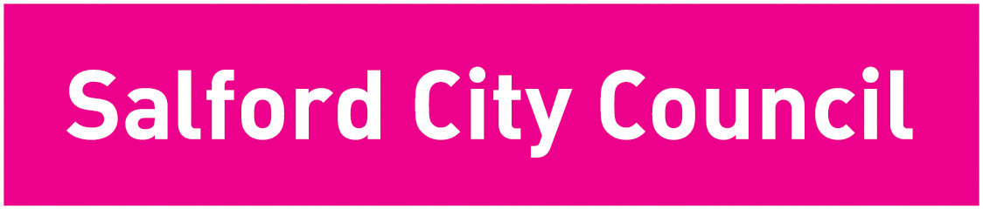

BUDGET CONSULTATION QUESTIONNAIRE

2005/06

The Council is currently developing its spending plans for the financial year April 2005 to March 2006. It is likely that the increase in our spending requirements in 2005/06 will exceed the increase in the Government financial support and therefore some difficult decisions will have to be made.

Please help us to make the right choices by answering the following questions:

Q1 When making its expenditure plans for 2005/06 the City Councils priority should be to (please tick one box) :

maintain current levels of service even if it means an increase in Council Tax
improve current levels of service even if it means a greater increase in Council Tax
reduce the levels of some services to keep any Council Tax increase to a minimum
improve some levels of services at the expense of others to keep any Council Tax increase to a minimum

Q2 Please tell us which three City Council service areas should receive more money and which three should receive less money (please tick no more than 3 boxes in each column):

More Money | Less Money | Service Area
 |  | Education
 |  | Health and Social Care
 |  | Community Committees
 |  | Crime and Community Safety
 |  | Youth Services and facilities
 |  | Leisure Facilities
 |  | Libraries, Museums and Art Galleries
 |  | Parks and Open Spaces
 |  | Housing
 |  | Refuse Collection and Recycling
 |  | Traffic Management and Road Safety
 |  | Support to Voluntary Organisations
 |  | Consumer advice and protection
 |  | Providing electronic access to services
 |  | Planning and Development Control
 |  | Street Cleaning
 |  | Maintenance of roads and pavements
 |  | Parking enforcement and car parks
 |  | Economic Development and Regeneration

Q3 The City Council’s seven pledges are shown below. Please can you number them 1 to 7 in order of priority (1 being your highest priority) based on the changes you would most like to see in Salford.

Please enter number 1 to 7 in order of priority | CITY COUNCIL PLEDGES
 | Pledge 1 – Improving health in Salford – we will improve the health, well-being and social care of the people in Salford
 | Pledge 2 – Reducing Crime in Salford – we will reduce crime and disorder and improve community safety
 | Pledge 3 – Encouraging learning, leisure and creativity in Salford – we will raise educational and skill levels and further enhance cultural and leisure opportunities in the City
 | Pledge 4 – Investing in young people in Salford – we will focus on services, activities and opportunities to support children and young people in order to achieve their full potential.
 | Pledge 5 – Promoting inclusion in Salford – we will tackle poverty and social inequalities and increase the involvement of local communities in shaping the future of the city.
 | Pledge 6 – Creating prosperity in Salford – we will ensure an economically prosperous city with good jobs and a thriving economy.
 | Pledge 7 – Enhancing Life in Salford – we will ensure that Salford is a city that’s good to live in with a quality environment and decent, affordable homes which meet the needs of local people

Q4 If you were the leader of the City Council, what would be your very top priority?

Q5 If you had between £5m to £10m to spend on improving City Council services what would you spend it on?

Q6 Where do you think the City Council could improve efficiency and /or make savings?

Q7 What is your age?

Under 25
25 – 44
45 – 64
65 +

Q8 Are you Male/Female?

Male Female

Thank you for taking the time to complete this questionnaire.

You can also let us have your comments or request further information by:

- email: budgetconsultaiton@salford.gov.uk
- writing to: Budget Consultation, Freepost NWW1358, Swinton M27 7BD
- telephoning: 0161 793 3057

If you have any special requirements such as access or languages please contact Carolyn Haslam on 0161 793 3057

More details of the budget proposals for next year can be found at www.salford.gov.uk/budget-consultation

