PLANNING AND TRANSPORTATION REGULATORY PANEL | DATE:  7 May  2009 | PART 1  (OPEN TO PUBLIC)
SUBJECT: CONFIRMATION OF THE SALFORD CITY COUNCIL TREE PRESERVATION ORDER (No.391) 2008 |  | OPERATIONAL MATTERS
REPORT OF: DIRECTOR OF SUSTAINABLE REGENERATION DIRECTORATE. |  | FOR DECISION

1. Purpose of Report / Summary:

To confirm the Salford City Council Tree Preservation Order (TPO) (No.391) 2008, at the land to the rear of Hazlehurst Road and Chapel Road, Swinton.

- Recommendations

It has been considered that the TPO be confirmed.

- Routing:

To the Planning and Transport Regulatory Panel for confirmation.

- Implications:

  - Resources (Finance/Staffing) No implications

  - Performance Review No implications

  - Environmental Maintenance and tree cover in the City

  - Equal Opportunities No implications

  - Community Strategy No implications

- Background:

This site occupies an area bordered by the rear gardens of properties on Chapel Road, Ringlow Park Road, 1 to 17 Hazelhurst Road and Aldergate Court flats. The Arboricultural consultant has visited the site. He was of the opinion that as a group value the trees enhance the area and are worthy of the protection of a TPO.

IF YOU HAVE ANY QUERIES PLEASE CONTACT  Mrs P Harrison on  0161 779 4838 | BACKGROUND DOCUMENT  (Available for Public Inspection)  Pictures of the trees & Plan of the site  Schedule 1 of original and varied Tree Preservation Order (No.88) 2008.  Copy of TPO (No.391) 2008.
QUALITY CONTROL | Report Prepared by: P. Harrison  Checked by: S. Key
Sustainable Regeneration Directorate (Planning and Building Control)
Emerson House, Albert Street, Eccles, M30 OTE

- Details:

The Salford City Council Tree Preservation Order (TPO) (No.88) 1986 originally protected the majority of the trees on this site. This TPO was confirmed by the council on the 26th April 1988.

An application was submitted Ref:08/55955/TPO proposing to fell seventeen trees on the land to the rear of Hazlehurst Road and Chapel Road, Swinton. The Arboricultural Consultant visited the site and it became apparent that although the majority of the trees were currently protected by TPO (No.88). Not all of the trees on the site were protected by the existing TPO and some of the original trees protected were missing.

An evaluation of the trees was carried out using the Tree Evaluation Methodology for Preservation Orders (TEMPO), which is designed to address the considerations of TPO suitability. The result indicated that the trees merit the protection of a TPO. It was recommended that the original TPO should be varied to protect the trees as a group (G1) to include all the twenty-one mature trees on the site.

One letter of objection was received in relation to the variation of TPO (No.88) 2008. On the 18th September 2008, the confirmation of the variation of TPO (No.88) 2008 was considered at the Planning and Transport Regulatory Panel. It was decided by the panel members that the variation of the TPO should be confirmed.

However it became apparent that due to a legal administration error the existing TPO was not varied as requested but a new TPO was created TPO (No.88) 2008. Therefore two TPO’s existed on the same site. However the TPO (No.88) 2008 was void, as authorisation to create a new TPO was never obtained.

Consequently TPO No.88 (1986) was revoked and this TPO (No.391) 2008 was created on the 3rd December 2008 to ensure that the trees are adequately protected and that the TPO is legally binding to include all the mature trees on site.

One letter of objection has been received in respect of this TPO, from the occupier of 13 Hazelhurst Road, Worsley, adjacent to the site. The issues raised are summarised as follows:

- The title address on the TPO is technically incorrect; the land is to the rear of Hazelhurst Road, Worsley and not Swinton as referred to.
- The site has never and is not one common area. The land is sub divided into private plots and currently has six owners. The primary function of the land is to provide space for garages.
- Salford City Council has never approached any of the adjacent owners/occupiers prior to the extension of the TPO and the change to the existing TPO (No.88) 1986.
- It is my opinion that certain owners consider my first two trees to be detrimental to the well being of their properties and would prefer them to be cut down.
- In 1986 Salford City Council did not see any reason to include my three trees within the original order.
- One sycamore is located nearest to my house No.13 Hazelhurst, Road. This tree in particular darkens my house, blocks out sunlight and creates unacceptable levels of moss and dampness to the rear yard.
- I have to leave the kitchen light on, which wastes energy and increases electricity bills.
- The leaf fall has dramatically increased, causing blockages, which have twice had to be professionally unblocked, adding further to my expenses. These points raised may also apply to my immediate neighbours.
- The main sewer pipe for properties 1-17 Hazelhurst Road runs along the back of the houses. If Sycamore A is left standing the roots will have a detrimental effect on the function of the pipe. Potentially I could be embroiled in a difficult expensive legal argument with the neighbours as to the responsibility of repairing the sewer pipe. This could be avoided if I had the freedom to remove this tree.
- Sycamore trees A&B offer no significant screening purpose for the properties that border the land. Therefore the removal of these trees would have a minimal impact upon the environment and the neighbours.
- My current garage is too small to accommodate a vehicle, however it would be impossible to build a double length garage due to the trees. This is an unfair imposition as my neighbours have been able to do this; the value and desirability of my house would also suffer. I will soon have to consider building a garage to free up car parking spaces for my neighbours at the front of my property. Also to reduce the risks and costs of damage to my vehicle.
- The definition of amenity is a “pleasant or useful feature”. Taking account all of the above points to include sycamore trees A and B fails to meet this criteria.
- I am convinced that my neighbours are also of the opinion that the removal of sycamore trees A and B would improve the outlook of the whole area. Which would also allow extra sunshine and daylight to benefit their properties.
- The restrictions contained within TPO No.391 (2008) will hinder me and my fellow residents in improving the site and to create a ‘ local amenity’ that will benefit those that really matter, the people who live at Hazelhurst Road and Chapel Road.
- I urge the council to adjust TPO (No. 391) 2008 by removing sycamore trees A and B from the plans, thereby giving me the freedom to improve my particular plot of land to the satisfaction of both myself and neighbours.

Below is a response to the points raised:

- Both Ringlow Park Road and Chapel Road are in Swinton, which is why the TPO is referred to as Swinton.
- The trees have grown as a group on the land to the rear of Hazelhurst Road. It is irrelevant how many landowners or plots the land has or the current primary function of the land.
- Application Ref:08/55955/TPO proposing the felling of seventeen trees on the land and prompted the re assessment of the trees and the TPO.
- Appraisals of the trees were undertaken, they are considered to be in an acceptable condition. As a group they provide amenity to the area and are worthy of a TPO.
- The trees have grown to form a cohesive canopy structure and, as such, have a collective impact as a group, which is considered to merit preservation. This may differ from when the existing TPO was created twenty-one years ago.
- An application to carry out remedial pruning operations in the future can be submitted and will be assessed at that time.
- Pruning could be carried out to alleviate light issues, an application would be assessed on it’s own merits.
- A crown reduction or a crown thin may help alleviate some of these problems; therefore a discussion with a tree surgeon may be beneficial. Clearing gutters on a regular basis is considered a normal maintenance activity.
- If issues arise regarding roots affecting drains then independent, expert advice should be sought and the council should be informed of the outcome.
- The group does not rely on one or two principle trees. The trees suitability for a TPO has been considered from a group perspective, as this is believed to provide the greatest amenity.
- A TPO may not prevent development or planning permission being granted. The Local Planning Authority would consider the merits of any future planning application.
- If trees merit protection in their own right, they should be specified as individual trees. The group category should in general terms be used for trees whose overall impact and quality merit protection. In this case the group classification was used as the trees have a greater collective impact.
- The trees are clearly visible from Ringlow Park Road and Hazelhurst Road. As a group they provide the area with a prominent amenity. Tree retention is considered beneficial and valuable to the environment. No objections have been received in respect of this TPO from neighbouring residents.
- It has been recognized that trees within the group do have defects and may not reach their maximum age or height. However if any trees in the future fulfil the criteria of dead, dying or dangerous they would be exempt from the TPO regulations. The TPO allows the Local Planning Authority to assess the appropriateness of the remedial works and prevents poor pruning or tree removal, retaining the amenity value they provide.
- A group classification was used as the trees have a greater collective impact as a group. The trees are clearly visible from Ringlow Park Road and Hazelhurst Road. As a group these trees provide a significant, valuable amenity in terms of their visibility to the surrounding neighbourhood. It is considered that these two trees add to the value of the group.

The majority of the neighbour’s objections refer to the sycamore trees A, B and C
The two photographs below indicate these trees, which are highly visible and contribute to the value of the group.

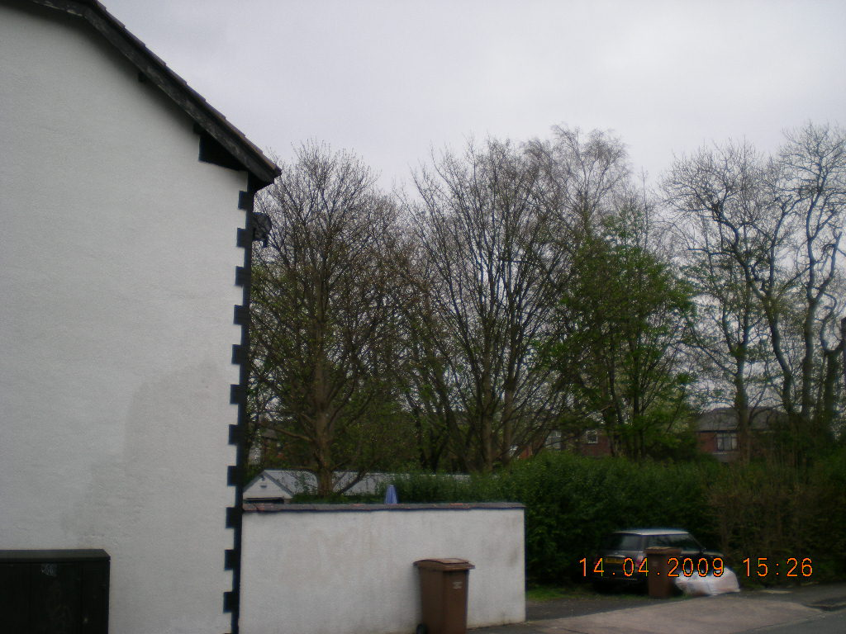
Photograph taken from adjacent to 19 Hazelhurst Road

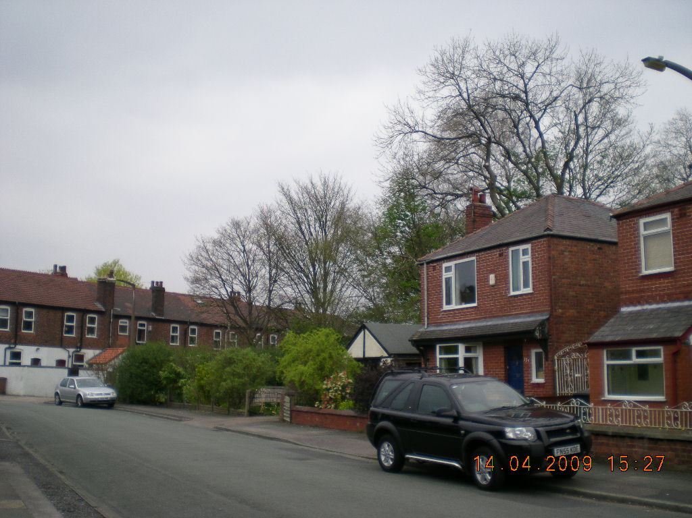
Photograph taken from 126 Ringlow Park Road, Swinton.

The photograph below shows the group of trees that are included in group G1 of TPO (No.391). This photograph has been taken from Ringlow Park Road, looking south-east.

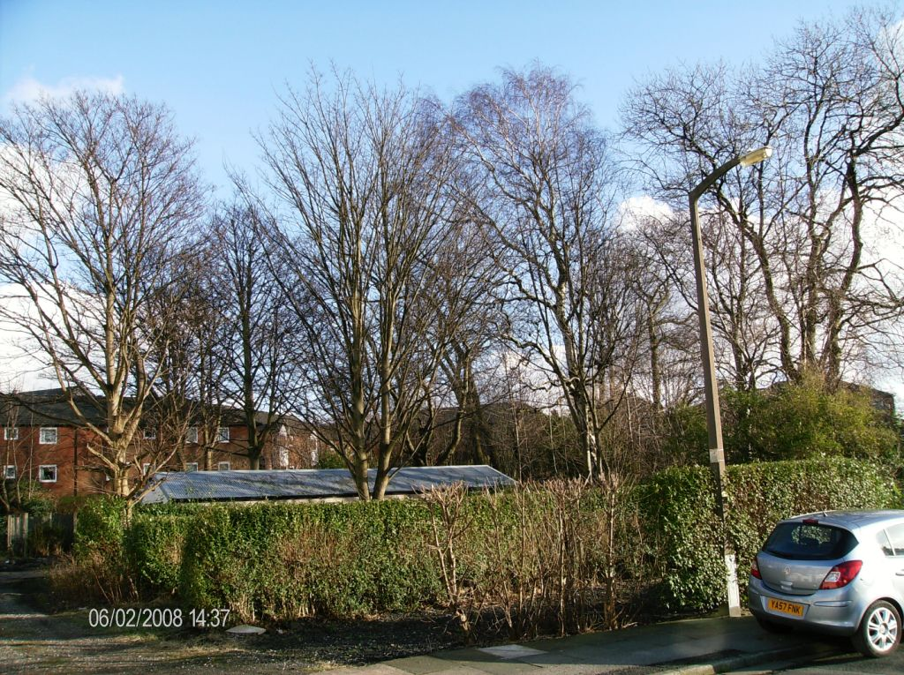

An evaluation of the trees was carried out using the Tree Evaluation Methodology for Preservation Orders (TEMPO), which is designed to address the considerations of TPO suitability. The TEMPO system considers the relevant factors in the TPO decision making process. The areas of evaluation are listed below, along with a justification for each section:

Part 1: Amenity Assessment

1a.) Condition and suitability for TPO – Range 0 – 5 (unsuitable – highly suitable). These trees scored a 3, which is considered suitable for a TPO.

Reasoning: The condition and suitability of the trees has been considered as a group, as the cohesiveness of the group does not rely on one or two principal trees. It is recognised that trees within the group do have defects, and expected that the majority will not reach their maximum age or height. The present health of the trees is considered to be in a satisfactory condition, although it is accepted that intervention is likely in the future. It is considered that the trees can be retained in a safe condition for a reasonable number of years without excessive expenditure.

1b.) Retention span (in years) and suitability for TPO – Range 0 – 5
(Unsuitable – Highly suitable). These trees scored a 2, which is considered suitable for a TPO

Reasoning: This group is made up of sycamore, ash, birch and a poplar tree. It is recognised that birch trees have a life span of up to 70 years, ash and poplar up to 150 years and sycamores up to 300 years. When considering the situation of this group of trees, it is expected that principally, these trees are capable of surviving in a reasonable condition for a further 40 years.

1c.) Relative public visibility and suitability for TPO – Range 1 – 5
(Probably Unsuitable – Highly Suitable) These trees scored a 4, which is considered suitable.

Reasoning: The upper canopy of the tree group is approximately 12 to 15m in height, with the crowns developing a dominant shape. The trees are considered to be of a medium size, but clearly visible to the surrounding area. The surrounding area is a developed residential area with a sparse treescape. The retention of a cohesive group of trees in this area is an important factor in the local tree scene.

Subtotal No.1 = 9

In this next section the trees must have already scored 7 or more points (with no zero score) to qualify.

1d.) Other factors – Range 1 – 5 (trees with none of the above additional redeeming features - Principal components of arboricultural features or veteran trees). These trees scored a 1, as they have none of the other redeeming features.

Reasoning: It is considered that these trees do not have any outstanding features, be they historical or arboricultural; but they do contribute to, and help to diversify the neighbourhood. The group does add a tree scene to this otherwise urban landscape that is lacking in mature tree cover.

Subtotal No.2 = 10.

Part 2: Expediency assessment – Range 1 – 5 (Precautionary only – Immediate threat to the tree). These trees scored a 3, which means a foreseeable threat to the trees.

Reasoning: The submitted application Ref:(08/55955/TPO) proposed to fell all the trees on this site. The reasoning given for the removal of the trees was because anti-social behaviour had been taking place within the site, and that in the interests of neighbouring resident’s safety the trees should be felled and a fence erected. This proposal was considered to be extreme and unwarranted.

As was stated in the application assessment, there is no evidence of anti-social behaviour on the site; however rubbish and garden waste has been tipped on the site over a period of years. The boundary of the site is secured by garden fencing to the east, south and west; with only the northern boundary unfenced to the gardens of the Hazelhurst Road properties. The existing trees on the site do not prevent the erection of a security fence.

Part 3: Decision Guide – Range 0 – 15 + (Do not apply TPO – Definitely merits a TPO) these trees as a group scored a total score of 13, which means a TPO is justifiable.

Reasoning: The trees detailed in this variation TPO have grown as a group, and as such have a considerable collective impact. An abundance of self-seeded saplings are starting to populate the under-storey area creating a mixed canopy layer improving the wildlife habitat value of the site.

- Appraisal Summary

The trees as a group are clearly visible from the surrounding public highways. It is expected that these trees are capable of surviving for a further forty years. This group adds a tree scene to this urban landscape, which is currently lacking in mature tree cover. In conclusion the trees on this site, provide the neighbourhood with a significant visual amenity and contribute significantly to the environment. As a group these trees merit the protection of a TPO. It is considered important to confirm this TPO to preserve the public amenity, the environment and the general treescape within the area.

