Research and information IN Salford

Produced by Information Group, Development Planning, Development Services Report No. 2004/EWS-09-04

Salford’s Early Warning System (EWS)

January 2005

For further information please contact:

Neighbourhood Statistics Analyst, Planning Information Group

Early Warning System – Introduction & Methodology

Background
The Early Warning System was a concept developed as part of the Neighbourhood Renewal Strategy to help the LSP stay abreast of local trends within Salford. The rationale behind the system is that through regular, extensive monitoring in local areas, changes that could lead to deprivation can be identified in enough time to take preventative action.

Definitions
The Early Warning System (EWS) will highlight at post code unit level any area that has been triggered by any one of the following three triggers, across more than half (i.e. 4+) of the seven domains (Turnover, Vacancy, Benefits, House Prices, Domestic Burglary, Vehicle Crime, Juvenile Nuisance).

Trigger One
If an area falls within a percentile of the Maximum rate over the last twelve months;
This trigger will highlight those areas that have the most severe problems, as the rates for each of the domains are close to or above the 12 month average for that area of the city.

Trigger Two
If an area falls above a percentile of the Minimum rate over the last 12 months; AND it has experienced a quarterly change that is less than the Minimum Median change over the last 12 months;

This trigger will highlight those areas that have experienced excessive / severe change. As although the overall rates might not be the highest for that area, the quarterly rate of change is above the minimum median change rate over the last 12 months for that area of the city.

Trigger Three
If an area experiences a negative change over three consecutive quarters or months (dependant on data frequency).
This trigger will highlight those areas that may be creeping towards a poorer position.

The above triggers will be assessed against two area levels:
- The first will assess each area against City based averages / triggers – this will inform us of those areas that are of most concern relative to the city as a whole.
- The second will assess each area against Ward based averages / triggers – this will inform us of areas of concern at a more localised level, as the change will be relative to each ward (in contrast to the city average model which will by definition be weighted towards the poorest performing areas of the whole city).

The above methodology will highlight all aspects of possible decline. In that the areas of most / immediate concern will be highlighted through trigger one; then those areas where the problems may not necessarily be the worst but where there has been a rapid decline will be highlighted through trigger two, and finally those areas that are steadily / slowly declining will be highlighted through trigger three.

NB. It is important to note that the EWS is designed to look at changes within areas rather than absolute values. Therefore the areas identified may not be the poorest in the city, but they will be the poorest performing over the last quarter, relative to the city and ward averages.

Early Warning System – Exception Report

City Based Assessment
The plan below demonstrates those areas of the city that have been highlighted against the city level triggers. This plan therefore provides us with Early Warning of those areas that are currently performing poorly against city averages.

As we may have expected there have been areas highlighted within Central Salford (around Broughton, Irwell Riverside, Langworthy, Ordsall) and within Little Hulton; where a number of programmes are already underway in recognition of these issues.

However, there is also a significant concentration of areas highlighted within Barton, Eccles and Winton, plus to a smaller extent within Irlam.

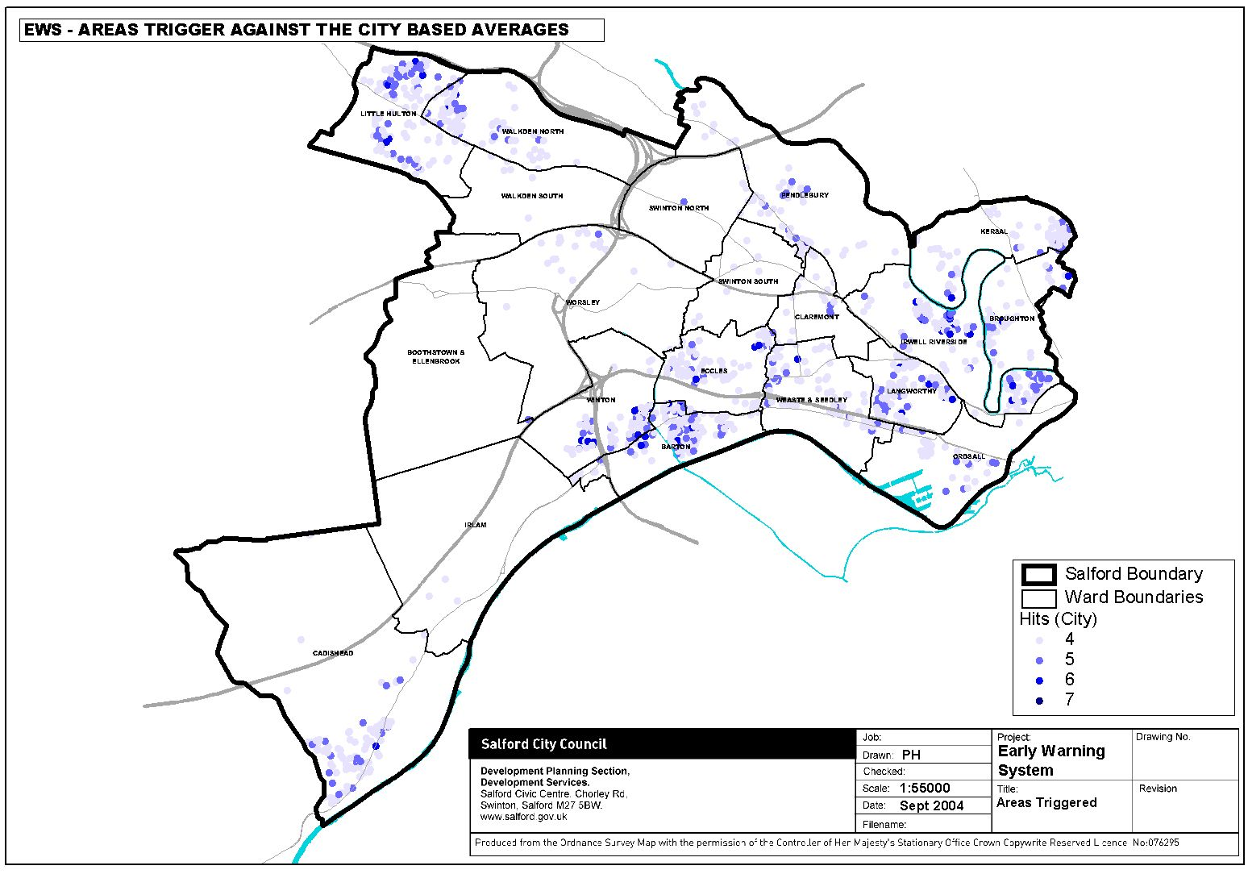
1
4
3
2
5
8
7
6
9

Overview of highlighted areas
- The main issue across most of the highlighted areas of the city relates overwhelmingly to the crime triggers.
- A high level of Benefit claimants are also significant areas for concern.
- Areas ‘1 – Little Hulton’; ‘2 – Winton’; ‘3 – Barton’; ‘6 – Broughton’; ‘7 – Pendleton’ and ‘9 – Kersal’ all have these same issues around Crime and Benefits. However, there are slight differences in some of the other areas as highlighted below.

Area 4 - Eccles
- Additionally to the common issues around crime, over a three quarters of this area has issues relating to high vacancy.

Area 5 - Langworthy
- Although there are still significant issues surrounding the common crime issues, the main issues that have been highlighted here relate to high benefit claimant rates and high levels of vacancy.

Area 8 - Ordsall
- Although there are still significant issues surrounding the common crime issues, more so in the vehicle crime and juvenile nuisance areas. The main issues that have been highlighted here relate to high benefit claimant rates.

Local Based Assessment
The plan below demonstrates those areas of the city that have been highlighted against the ward level triggers. This plan therefore provides us with more localised Early Warning of those areas that are currently performing poorly against local averages.

When considering the concentration of areas on this plan it is interesting to note that there are more areas highlighted in Salford West than within Central Salford, which is against what might have been expected. This therefore demonstrates that although Central Salford may perform poorly against a city average, the issues are fairly uniform across the whole area and subsequently there are only a couple of localised areas of greater concern. In contrast, Salford West (with the exception of Little Hulton & Eccles) generally performs okay in the city context, and therefore the areas highlighted here represent localised pockets of poorer performance.

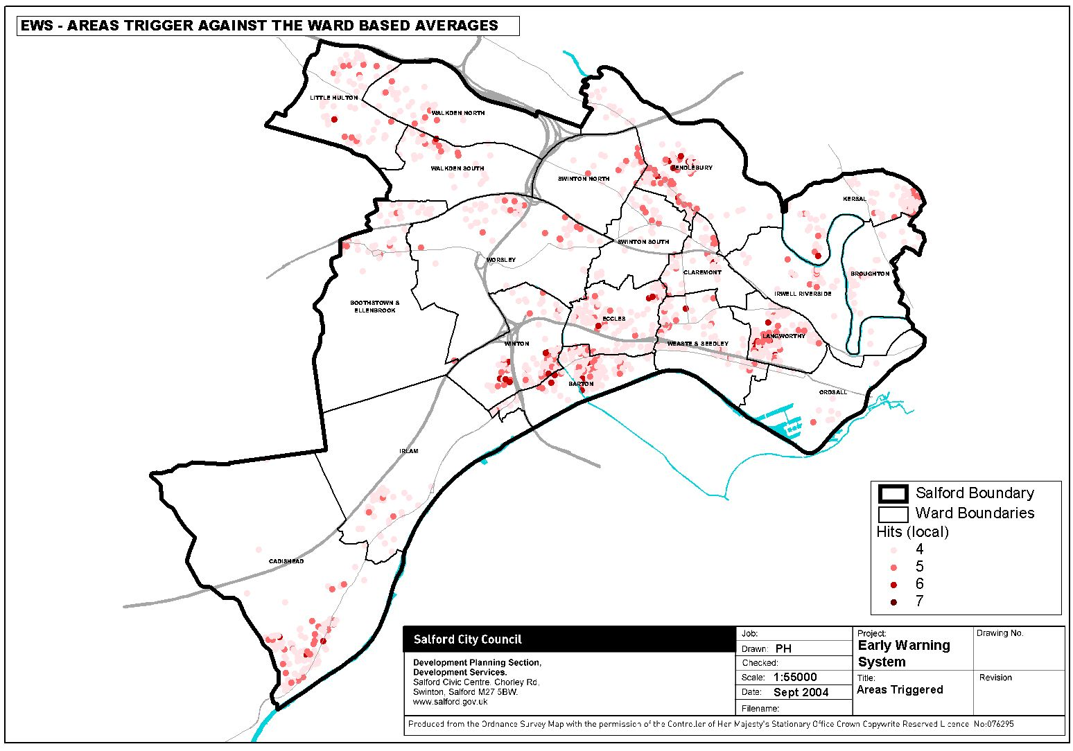
1
4
3
2
5
8
7
6
9

Area 1 – Little Hulton
- The main issues within this highlighted area of the city relates overwhelmingly to the benefits and juvenile nuisance triggers.
- There are also significant issues surrounding high vacancy and turnover rates, where half of the area has been highlighted as poorly performing against the local average.

- The main focus for the areas that have been triggered is around the north of Manchester Road in Little Hulton.

Implications - (To be completed by neighbourhood managers)
1. …
2. etc…

Implications

Further investigation is needed in order to explain the changing situation in this area.

Area 2 – Irlam
- The main issues within this highlighted area of the city relates overwhelmingly to the vehicle crime and juvenile nuisance triggers, which affects almost all of the triggered areas.
- There are also significant issues surrounding average benefits and vacancy where over half of the area has been highlighted as poorly performing against the local average.

- The main focus for the areas that have been triggered is around south-west corner of the city along Liverpool Road in Cadishead.

Implications

The report seems to suggest a shift of concentration from Irlam to Cadishead. Main focus Main concentration area between Moss Road and Fir Street (Cadishead) need further investigation.

Meetings have been arranged with the Crime and Disorder Partnership to ensure that further analysis of the vehicle crime and juvenile nuisance triggers.

A possible link between an increase in juvenile nuisance in Culcheth is also being looked into further.

Area 3 – Brookhouse, Winton
- The main issue within this highlighted area of the city relates overwhelmingly to the crime triggers, where all of the areas have been triggered.
- There are also significant issues surrounding the benefits trigger, where over three quarters of the area has been highlighted as poorly performing against the local averages.
- Vacancy is also higher than the local trends in around half of the area.

- The main focus for the areas that have been triggered is around Brookhouse estate in Winton.

Implications
An issue had been previously identified with a series of racists attacks which will have had an impact on the crime figures.
In terms of vacancy issues are explained to a certain extend in terms of low demand for parts of Brookhouse estate associated with perception of crime for example but some further investigation may be useful to explain the further change which has occurred.

Area 4 – Peel Green, Barton
- The main issue within this highlighted area of the city relates overwhelmingly to the juvenile nuisance.
- There are also significant issues surrounding average vacancy, benefits and vehicle crime, where over half of the area has been highlighted as poorly performing against the local average.

- The main focus for the areas that have been triggered is around the Peel Green area within Barton.

Implications
The significant increase in crime over this period can be partially explained prolific offender who was operating in the area. Action has now been taken against this individual.

Further investigation is required however, as Barton appears to becoming a particular hotspot for vehicle crime

Area 5 – Monton, Eccles
- The main issues within this highlighted area of the city relate overwhelmingly to the crime triggers, where almost all of the areas have been affected.
- There are also issues surrounding high vacancy, where two thirds of the area has been highlighted as poorly performing against the local average.

- The main focus for the areas that have been triggered is around the south side of Monton Road in Eccles.

Implications
There has been a prolific offender committing burglaries in the Monton area over the summer months which may go part way to explaining the crime figures
The vacancy rate definitely requires further investigation as this has tended to be an area where both public and private accommodation has been in high demand

Area 6 – Langworthy Road, Langworthy
- The main issue within this highlighted area of the city relates overwhelmingly to the juvenile nuisance and vehicle crime triggers.
- There are also significant issues surrounding benefits and burglary, where two thirds of the area has been highlighted as poorly performing against the local average.

- The main focus for the areas that have been triggered is based around the east and west sides of Langworthy Road.

Implications

Some action has been taken in relation to vehicle crime.

The increase in the level of juvenile nuisance can be partially explained because work by nuisance link staff has led to increased community confidence in reporting in relation to one hot-spot in particular.

Area 7 – Bury Old Road, Kersal
- The main issue within this highlighted area of the city relates overwhelmingly to the benefits trigger.
- There are also significant issues surrounding juvenile nuisance and vacancy, where almost two thirds of the area has been highlighted as poorly performing against the local average.
- There are also some issues around the other crime triggers, which is affecting almost half of the highlighted area.

- The main focus for the areas that have been triggered is based between Leicester Road and Bury Old Road, Kersal.

Implications

Further investigation is needed in order to explain the changing situation in this area.

Area 8 – East side of Trafford Road, Ordsall
- The main issue within this highlighted area of the city relates overwhelmingly to the vehicle crime trigger.
- There are however also significant issues surrounding benefits and vacancy, where over three quarters of the area has been highlighted as poorly performing against the local average.
- It is also interesting to note that this areas is the only triggered area in the city to have a significant issue surrounding the house prices trigger, which effects a quarter of the highlighted area. This may be due to huge disparity between the house prices on the East and West sides of Trafford Road.

- The main focus for the areas that have been triggered is based around the east side of Trafford Road.

Implications

Further investigation is needed in order to explain the changing situation in this area.

Area 9 – Bolton Road, Pendlebury
- The main issue within this highlighted area of the city relates overwhelmingly to the juvenile nuisance and vehicle crime triggers.
- There are also significant issues surrounding benefits and vacancy, where over two thirds of the area has been highlighted as poorly performing against the local average.
- The main focus for the areas that have been triggered is based along the Bolton Road corridor between Irlam’s of the Height and Clifton, in Pendlebury.

Implications
Further work is being undertaken to establish why there seems to be a particular pattern in terms of juvenile nuisance and vehicle crime around the Bolton Road area.
The installation of CCTV at Station Road/Bolton Rd junction and Clifton Green in the new year may make a difference. Several projects are also being run in clifton to try and engage the youths i.e. angling club. The Swinton Youth Partnership is also trying to engage with youths in hotspot areas to try and engage them in activities.

