SALFORD CITY COUNCIL - RECORD OF DECISION

I , Councillor John Warmisham, Lead Member, Children’s Services
in exercise of the powers conferred on me by Paragraph D 4 (a) (cx) of the Scheme of Delegation of the Council do hereby approve the attached Fostering Service Statement of Purpose 2006 - 7.
The reasons are:
- The Fostering Service Regulations 2002 and the National Minimum Standards for Fostering Services require each local authority Fostering Service to have a written Statement of Purpose, formally approved by elected members, and updated annually.

- This is an update of the Statement of Purpose previously approved in January 2006.

- The Fostering Service Regulations 2002 require the Statement of Purpose to include:
    - A statement of the aims and objectives of the fostering service
    - A statement as to the services and facilities provided by the fostering service

      - The National Minimum Standards for Fostering services require that the Statement of Purpose includes details of:
    - The management structure of the Fostering Service
    - The services it provides
    - Its aims and objectives, principles and standards of care

Numbers, relevant qualifications and experience of staff
    - Numbers of foster carers
    - Numbers of children placed
    - Numbers of complaints and their outcome
    - The procedures for recruiting, approving, training, supporting and reviewing carers
      - I am satisfied that the document produced covers all the requirements of both The Fostering Service Regulations 2002 and the National Minimum Standards for Fostering Services.
Options considered and rejected were: (a) Not updating the Statement of Purpose. The information has changed and would be inaccurate; and (b) Not having a Statement of Purpose. The local authority cannot operate a Fostering Service that does not have a Statement of Purpose and would be criticised in the CSCI Fostering Inspection process.
The source of funding is:N/A
Assessment of Risk:This is a legal requirement that would affect the local authority’s ability to provide a Fostering Service.
Legal advice obtained from:N/A
Financial advice obtained from:N/A
The following documents have been used to assist the decision process.
- The Fostering Service Regulations 2002
- The National Minimum Standards for Fostering Services
- Fostering Service Statement of Purpose 2006 –7

Contact Officer: Carolyn Williams Tel. No 0161 603 4300

* This decision is not subject to consideration by another Lead Member/Director | ✓
* This decision is urgent and is not subject to call-in, in accordance with paragraph 5
of the Decision Making Procedure Rules.
* The appropriate Scrutiny Committee to call-in the decision is the Children’s services Scrutiny Committee.

Signed Dated 5 January 2007 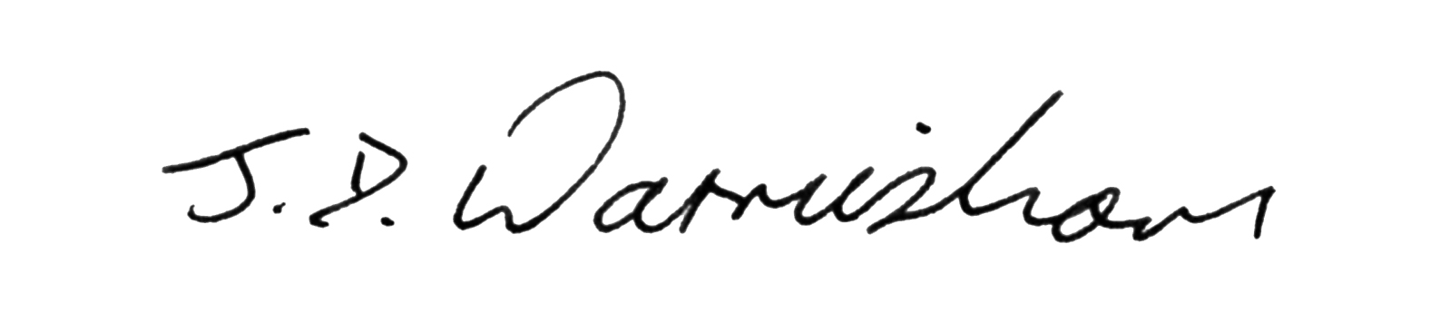 Lead Member
_______________________________________________________________________________
This decision was published on 5th January , 2007
* This decision will come into force on 15th January , 2007
unless it is called-in in accordance with the Decision Making Process Rules

