Salford City Council - Record of Decision

I, Cllr John Warmisham, Lead Member for Children’s Services, in accordance with the authority delegated to me under the provisions of Paragraph J(a)(v) authorise the
Play Strategy
The Reasons are that : The Play Strategy is a five year plan which must be authorised in order that funds can be applied for in September
Assessment of Risk : Low
The source of funding is: Bid to Big Lottery Fund. Sure Start and Extended Schools budget
Legal Advice obtained : No
Financial Advice obtained: No
The following documents have been used to assist the decision process.
Play Strategy
Contact Officer: Jane Middleton Tel No 0161 778 0397

* This decision is not subject to consideration by another Lead Member/Director
* This document records a key decision, but the matter was not included in the Council's Forward Plan and it has been dealt with under the emergency procedure.
* The appropriate Scrutiny Committee to call-in the decision is the Children’s Services Scrutiny Committee.
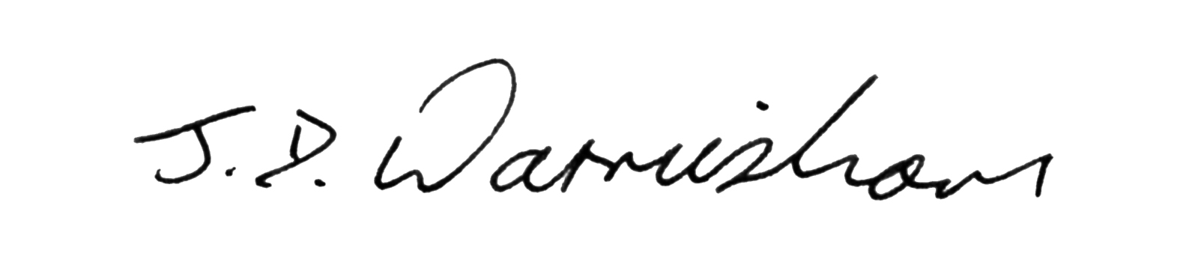
Signed: Cllr John Warmisham Dated: 17 October 2007 Lead Member
* This decision was published on 17th October , 2007
* This decision will come in force on 25th October , 2007, unless it is called-in in accordance with the Decision Making Process Rules.

