SALFORD CITY COUNCIL - RECORD OF DECISION

I Councillor Bill Hinds Lead Member for Customer and Support Services
in exercise of the powers in Paragraph 20.1b of Section 7, Part 4 of Contractual Standing orders authorise an exception to Contractual Standing orders in respect of the procurement of the following works:

Proposed installation of a Multi Use Games Area at Patricroft Recreation Ground.

The reasons are

The Council has entered into a partnership agreement in accordance with the principles of Re-thinking Construction as detailed in paragraph 20. 1b of Section 7, Part 4 of Contractual Standing Orders.

Options considered and rejected are: Not applicable

Assessment of Risk : Low

The source of funding is:
£130,000 The Fair Share Trust &
£8,000 Eccles Community Committee
Legal advice obtained Yes………………………………………………………………………

Financial advice obtained Yes…………………………………………………………….

The following documents have been used to assist the decision process.
Exception to Standing Orders – Proposed installation of a Multi Use Games Area at Patricroft Recreation Ground

Contact Officer Steve Jones. Tel. No. 925 1016.

* This matter is also subject to consideration by the Lead Member for Environment
and, accordingly, has been referred to that Lead Member/Director for a decision

* This decision is not subject to consideration by another Lead Member/Director
* This document records a key decision, but the matter was not included in the Council's
Forward Plan and it has been dealt with under the emergency procedure

* This decision is urgent and is not subject to call-in, in accordance with paragraph 5
of the Decision Making Procedure Rules.
- The appropriate Scrutiny Committee to call-in the decision is the
Environment Housing and Planning Scrutiny Committee.

Signed Councillor Bill Hinds Dated 24th November 2008
Lead Member for Customer and Support Services

_________________________________________________________________________________

FOR COMMITTEE SERVICES USE ONLY.

* This decision was published on 24th November 2008

* This decision will come into force on 2nd December 2008
unless it is called-in in accordance with the Decision Making Process Rules

 | PART 1  (OPEN TO THE PUBLIC) | ITEM NO.
___________________________________________________________________

REPORT OF DEPUTY DIRECTOR ENVIRONMENT
___________________________________________________________________

TO THE LEAD MEMBER FOR CUSTOMER AND SUPPORT SERVICES

ON 17th November 2008
___________________________________________________________________

TITLE:
The installation of a Multi Use Games Area at Patricroft Recreation Ground

___________________________________________________________________

RECOMMENDATIONS:

That authorisation to expend capital be approved ___________________________________________________________________

EXECUTIVE SUMMARY:
___________________________________________________________________

BACKGROUND DOCUMENTS: (available for public inspection)
Report of Director to Lead Member Environment
Record of Key Decision made by Lead Member Environment
___________________________________________________________________

ASSESSMENT OF RISK:

Low
___________________________________________________________________

THE SOURCE OF FUNDING IS:
- The Fair Share Trust
- Eccles Community Committee __________________________________________________________________

LEGAL ADVICE OBTAINED:

YES the council has agreed to exclusively purchase Works from Urban Vision. Urban Vision is to be offered the work on the basis of first refusal.
_________________________________________________________________________

FINANCIAL ADVICE OBTAINED:

Yes Environment Directorates Group accountant
____________________________________________________________
CONTACT OFFICER:
Steve Jones
___________________________________________________________________
WARD(S) TO WHICH REPORT RELATE(S)
Eccles
___________________________________________________________________

KEY COUNCIL POLICIES: please delete those not appropriate
Budget Monitoring
Community Strategy
Cultural Strategy
Environmental Strategy
Equalities
Health
Planning Strategy
Procurement Policies
Regeneration
___________________________________________________________________

DETAILS:

  - The Park Residents Association has been awarded £130,000 by the Fair Share Trust towards the installation of a Multi Use Games area (MUGA) at Patricroft Recreation Ground. This offer was confirmed by letter in August 08 (appendix 1)
In addition to this the group has also secured an additional £8,000 from Eccles Community Committee towards this scheme.

  - The Association was established in 1995 in response to domestic criminality in the area and operated for many years as a Home Watch Scheme. The aim of the group today is to promote safety, well- being and to keep residents involved and informed regarding issues affecting their lives. The group is represented on the local Community Committee and associated sub-groups e.g. Budget Group, Children and Young Peoples Task Group and the Environmental Task Group.

  - The association considers that Patricroft Recreation Ground is at the hub of the community and has the potential to provide the area with a vibrant community space to be enjoyed by all residents. One of the aims of the group is to enhance the park and the group submitted an application to Barton Fairshare for a new MUGA, Lighting and CCTV. The panel agreed to fund the capital element of the MUGA (£130K).

1.4 The award offer letter states that “payment for the capital part of the project will only be released upon satisfactory completion of the upgrading of the games area”. In order to address this issue, a request was made to the City Treasurer to underwrite this scheme. The City Treasurer has agreed to this request.

  - Affirmation has also been received from the City Treasurer to support the annual maintenance of £5,500 for the MUGA. Although this will provide the routine maintenance it would not be sufficient to cover serious vandalism, however unlike previous sport area projects carried out in the past there is no mention within the award offer letter that the funding will be requested back from the council if in the event the facility is unusable due to vandalism.

1.6 In accordance with the partnership arrangement Urban Vision will be delivering the scheme.

1.7 Once approval has been granted a proposed time frame can be formulated, it is anticipated that this project will be completed within the next financial year.

Appendix 1

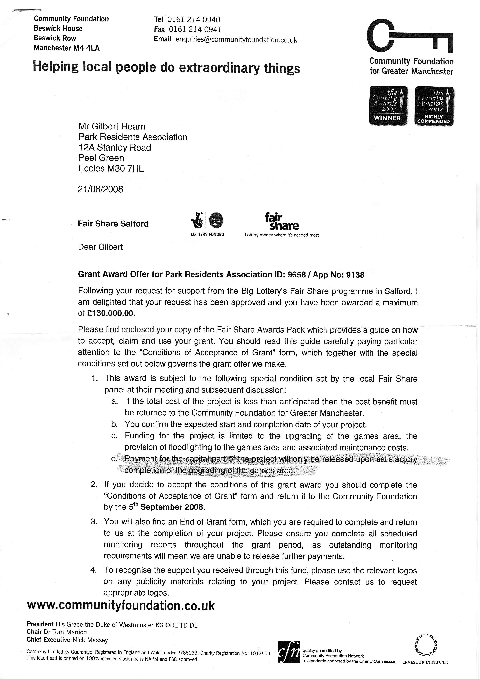



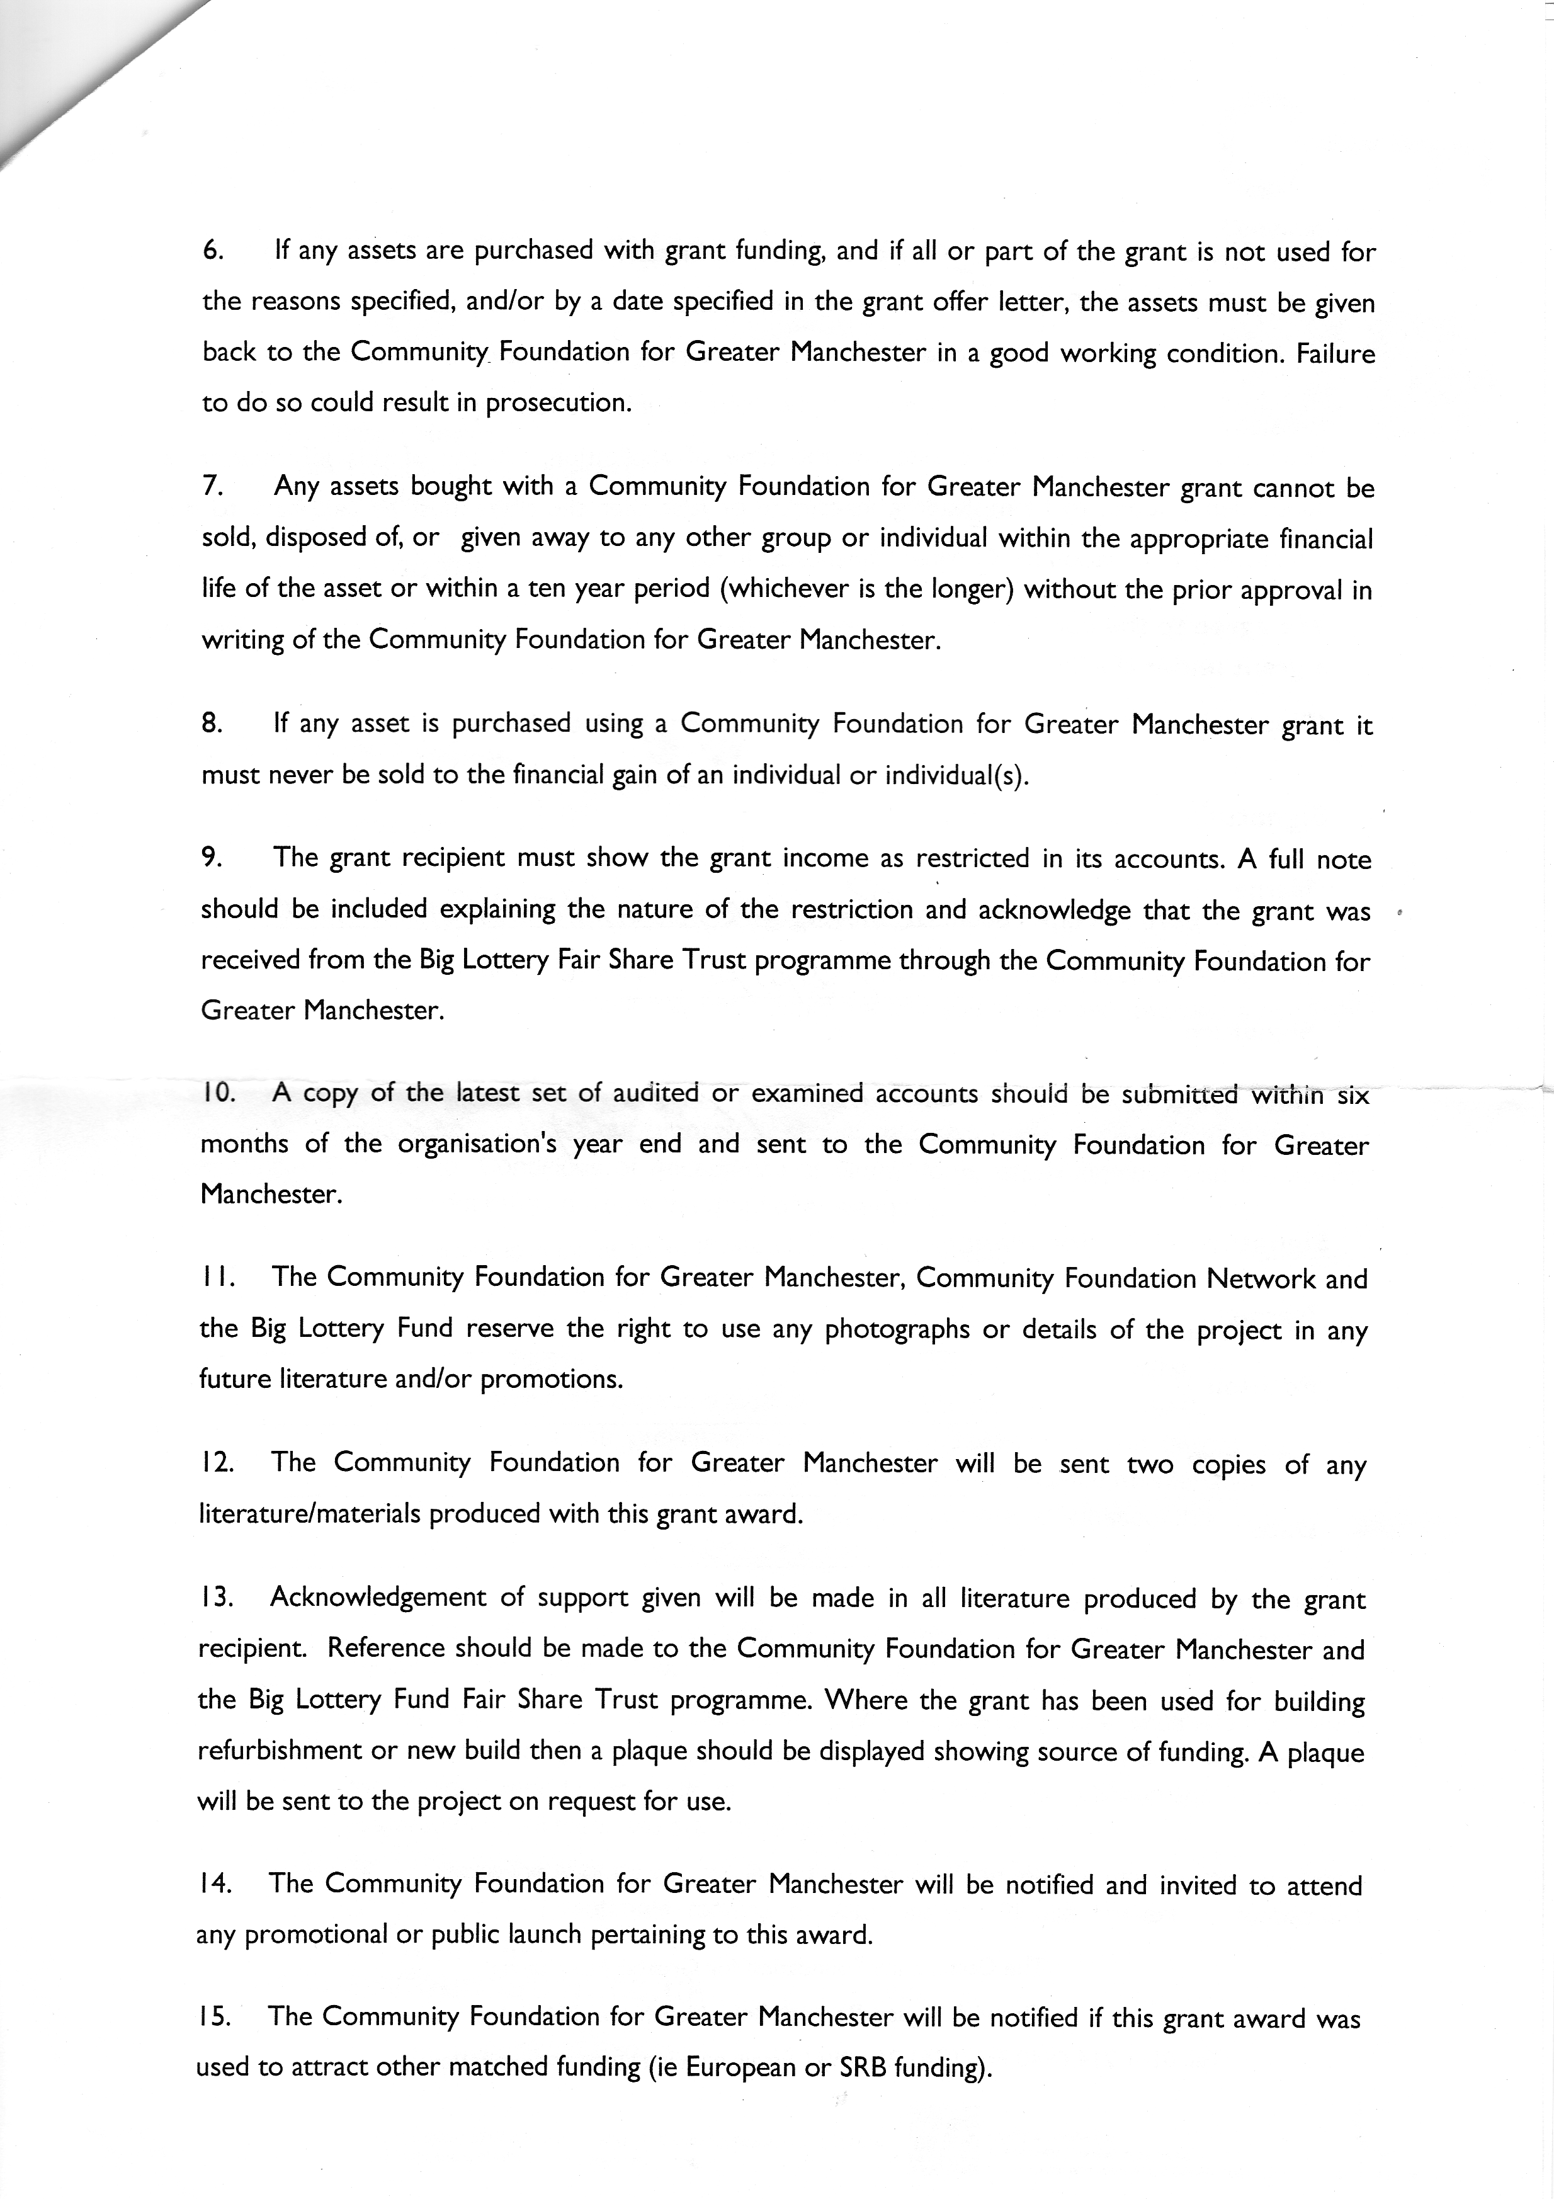

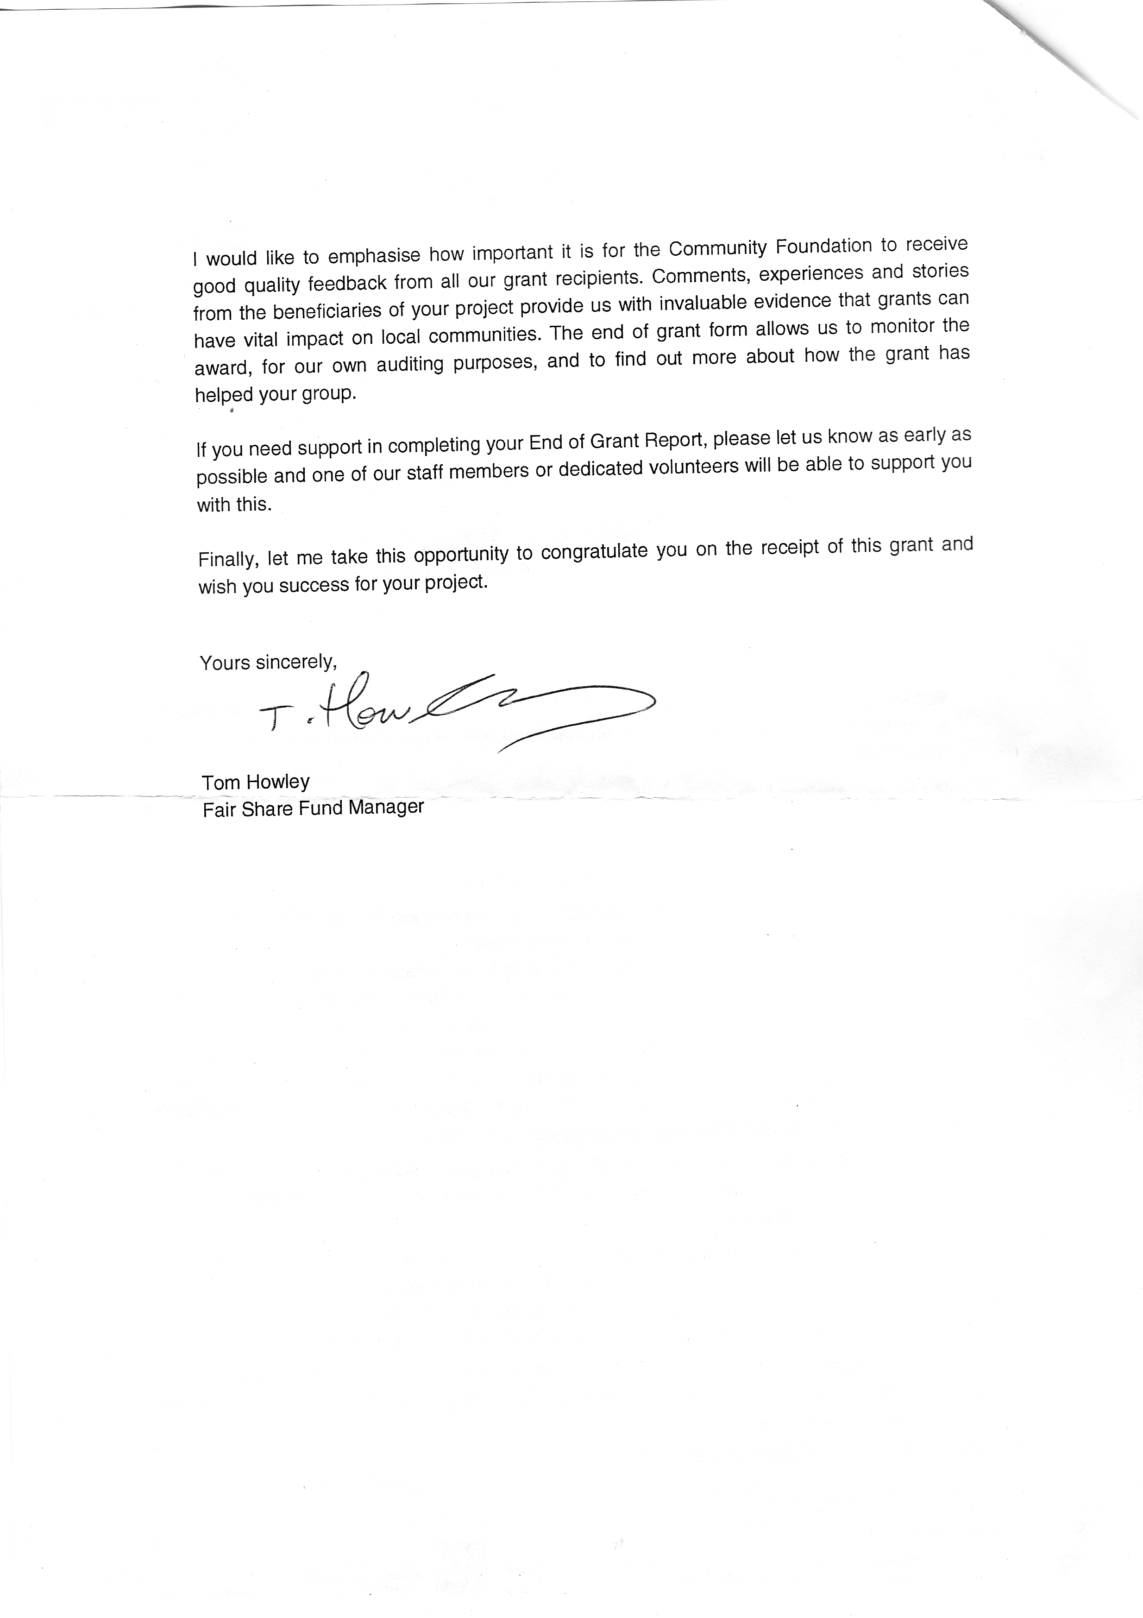
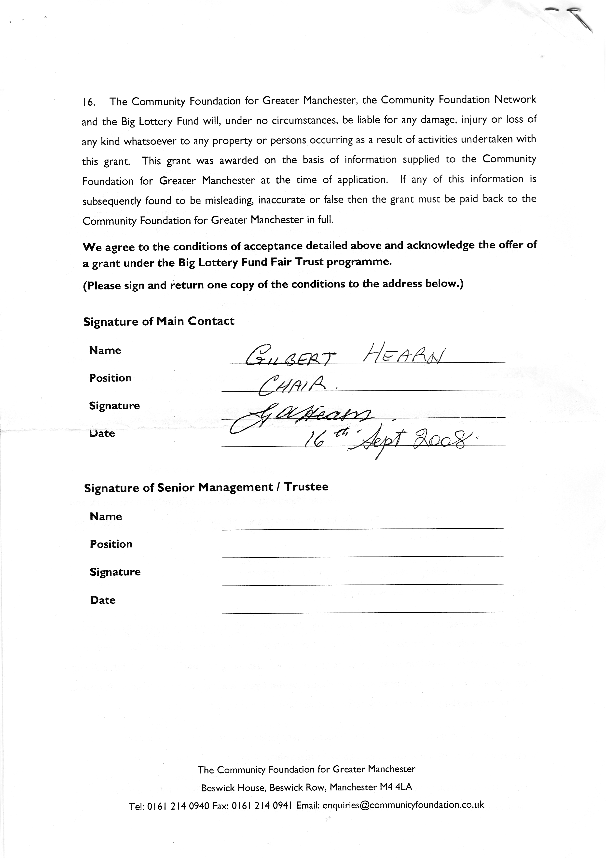

TENDER APPROVAL – PROFORMA
For use in seeking the approval of the Lead Member for Customer and Support services to proceed with a capital proposal
Title of scheme: The installation of a Multi Use Games Area at Patricroft Recreation Ground

Recommendations (please append report to Lead Member for Directorate only if preferred)
Approval is given to proceed with the above.

Scheme Details (please append report to Lead Member for Directorate only if preferred)
Please see attached report
Tender details (please append report to Lead Member for Directorate only if preferred)
To be undertaken in partnership with Urban Vision. Total capital cost £138,000
Estimated - start Date January 09 Estimated – End Date July 09
FINANCIAL DETAILS
Breakdown of scheme cost |  |  |  |  | 07/08  £000’s |  |  | 08/09  £000’s |  | 09/10  £000’s |  |  |  | Total  £000’s
Contract (construction costs) |  |  |  |  |  |  |  |  |  | 110 |  |  |  | 110
Fees |  |  |  |  |  |  |  | 6 |  | 22 |  |  |  | 28
Other (specify) revenue
2008/09 only – phasing of capital Expenditure (£000’s)
Apr | May | June | July | Aug | Sept |  | Oct |  | Nov |  | Dec |  | Jan |  | Feb | Mar
 |  |  |  |  |  |  |  |  |  |  |  |  |  |  | 3 | 3
Note: The monthly cash flow above should be consistent with the contract start and end dates shown above and should allow for normal time lapses which will occur between work being done, claimed for, certified and paid, as well as retentions. Please consult your Capital Accountant if you need assistance with this or any other part of this proforma.
Is scheme in the Current Approved Capital programme? Yes
Funding identified |  |  |  |  |  | 07/08  £000’s |  |  | 08/09  £000’s |  |  | 09/10  £000’s |  |  | Total  £000’s
Supported Borrowing
Unsupported Borrowing
Grant - The Fair Share Trust |  |  |  |  |  |  |  |  | 6 |  |  | 124 |  |  | 130
Capital Receipts - Eccles Community Committee |  |  |  |  |  |  |  |  |  |  |  | 8 |  |  | 8
Other Revenue
Total |  |  |  |  |  |  |  |  | 6 |  |  | 132 |  |  | 138
Other financial implications
Decision Lead Member Customer and Support services Approved/not Approved

