Salford City Council - Record of Decision

I, Councillor Morris, Lead Member for Children’s Services
in exercise of the powers conferred on me by Paragraph J (a) (I), of the Scheme of Delegation of the Council do hereby approve:

- the extension to the contract between Salford City Council Children’s Services Directorate and Salford Royal NHS Foundation Trust for a Special Education Needs Speech, Language and Communication Service from 1st September 2011 until 31st July 2012 for £45, 354..

- That the Lead Member for Customer Support Service is requested to approve the exception of Standing Orders to enable the extension of the contracts referred to above

The Reasons are
- To allow for a statutory service to be delivered in the academic year 2011/12 to ensure that children who have a specified special educational need to be given a speech and language service do receive this provision in the next academic year.
- to allow for a service specification to be finalised to bring together other existing contracts to address the delayed development of children and young people’s speech, language and communication skills.
- to allow sufficient time for a full tender process to be undertaken.
- to allow sufficient time for a safe transfer of service to another provider if necessary

Options considered and rejected were:
- Relying on the NHS funded service. This has been rejected as it is unable to meet the specified need.
- Collating the current service specifications into one contract and continuing with the current provider

Assessment of Risk: Low

The Source of Funding is:

CSD: Complex Needs: Special Education Needs £ 45,354

Legal Advice obtained: Yes from Tony Hatton & Chidi Ebizie

Financial Advice obtained . Yes from Paula Summersfield

Procurement Advice obtained: Yes from Sharon Robson

The following documents have been used to assist the decision process.
- Report to the Children’s Services Contract Overview Group
- Lead Member briefing report

Contact Officer: Maggie Maudsley TEL NO: 0161 212 5680

* This matter is also subject to consideration by the Lead Member for Director of Customer and Support Services and, accordingly, has been referred to that Lead Member for a decision. | x
* This decision is not subject to consideration by another Lead Member/Director
* This document records a key decision, but the matter was not included in the Council's Forward Plan and it has been dealt with under the emergency procedure.
* This decision is urgent and is not subject to call-in, in accordance with paragraph 5 of the Decision Making Procedure Rules
* The appropriate Scrutiny Committee to call-in the decision is the Scrutiny Committee.
Key:
Tick boxes at the end of these lines, as appropriate.
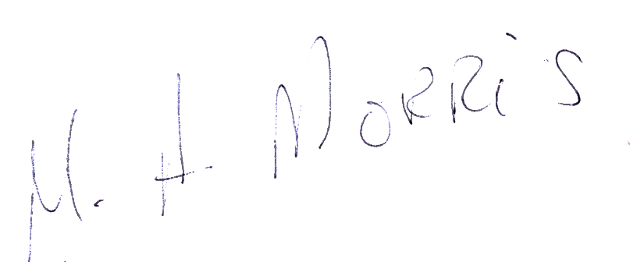

Signed: Dated: 1 August, 2011 .
Lead Member

FOR DEMOCRATIC SERVICES USE ONLY

* This decision was published on 2 August, 2011.
* This decision will come in force on 10 August, 2011 unless it is called-in in accordance with the Decision Making Process Rules.

Key:
# Insert date five days after decision notice is to be published.

