Salford’s Joint Health and Wellbeing Strategy

2012-2015
Draft 1.10
Date 28/11/12
Author David Herne/Alistair Fisher/Melanie Sirotkin

Executive Summary – 1 page

Our vision for a healthier Salford in 2015
Figure 1 Salford’s joint health and wellbeing strategy:
Opening statement from City Mayor
Foreword - joint statement from Assistant Mayor for Health and Wellbeing and Chair of NHS Salford Clinical Commissioning Group.

vision, priorities and guiding principles
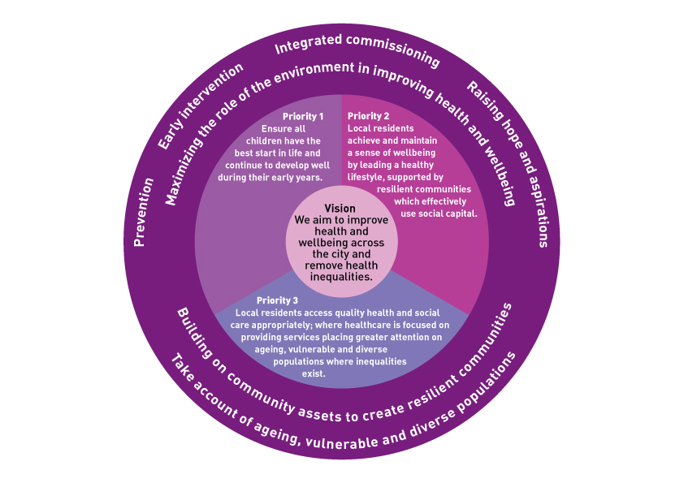

- Background
This strategy is built on a rich history of partnership working and strategic responses to addressing health and wellbeing in the city which has included work through a partnership Health and Wellbeing Board since 2009. The new Pathfinder Health and Wellbeing Board has been in place since October 2011 in preparation for the requirements of the Health and Social Care Act for an established statutory Board from April 2013.
The Health and Wellbeing Board is the principal structure in Salford responsible for improving the health and wellbeing of the people of the city through partnership working. The Board is a partnership between Local Government, the NHS and the people of Salford. Members include senior local GPs, members of the Mayoral team, the Local Involvement Network (LINk) and senior officers from the City Council.
The Board will make a measurable difference to the health and wellbeing of the people of Salford. We will use the national requirement of a Joint Health and Wellbeing Strategy to enable us to steer the major strategic work on health and wellbeing in the city.
2.0 What is the Joint Health and Wellbeing Strategy?
Many predictors of health and wellbeing fall outside of the health care setting. Social, economic, and environmental factors all influence health. People benefiting from good education, stable employment, safe homes and neighborhoods, and access to high quality preventive services tend to be healthier throughout their lives and live longer.
Our strategy focuses on prevention and the wider predictors of health. It identifies the top priorities for the Health and Wellbeing Board over the next three years where we can work together to make a difference in promoting the health and wellbeing of the people of Salford.
This strategy identifies proposed priorities and associated targets to tackle the most pressing health and wellbeing issues our city faces today.

3.0 Stakeholder engagement
The strategy has been developed through board discussions, current Salford partnership strategies and informed by data in the current and previous JSNA and the Annual Report of the Director of public health.
These local priorities have been developed through an extensive consultation with local partners and the public; they will continue to be shaped and defined further as the strategy is refined and refreshed. The Health and Wellbeing Board has used its development sessions to craft a set of agreed priorities based on the evidence from key policy documents including the Marmot review and the Joint Strategic Needs Assessment; this initially produced a long list of seven emerging priorities. Following briefing sessions with the newly elected City Mayor and the Assistant Mayor for Health and Wellbeing, the emerging priorities have been taken out to the public for consultation using a range of methods (including social networks, web media and face-to-face discussions) to give people the widest opportunity to air their views on the long list of priorities. Further consultation has also taken place with new partners such as the Clinical Commissioning Group and the Local Healthwatch citizen’s transition group. Salford LINk has also undertaken a review of its recent consultations to support the consultation process by identifying themes which have been expressed through those consultations which can inform the priority setting. By April 2013 Salford Healthwatch will be established to replace LINk and act as the main channel into the Health and Wellbeing Board for Salford children, young people and adults to contribute their voice and influence the future re-shaping of the strategy. We also plan to engage with providers to ensure that the board’s work is informed by best practice in service delivery.
4.0 Why better health and wellbeing is important
Preventing disease and improving wellbeing is vital to Salford. When we invest in prevention, the benefits are shared across the city and across the life cycle. A healthy start in life means that our children grow up in communities, homes, and families that nurture them. Supporting healthy lifestyles means people can be productive and healthy. This brings wider business benefit because a healthier workforce is a more productive one and reduces healthcare cost to the city. A healthy workforce increases stability and productivity. Communities that offer a healthy, productive, stable workforce are attractive places for both people and businesses.

The Marmot review “Fair society healthy lives: strategic review of health inequalities in England (2010)” has strongly influenced the development of this local strategy. The review highlights that reducing health inequalities is an issue of fairness and social justice. Many people die prematurely each year as a result of health inequalities and the lower a person’s social position, the worse his or her health. The review advocates that actions must be universal, but with a scale and intensity that is proportionate to the level of disadvantage (proportionate universalism). Six policy objectives set the broad scope of the report and a call to action for central and local government and the NHS in partnership with wider agencies and local communities:
- Give every child the best start in life
- Enable all children, young people and adults to maximise their capabilities and have control over their lives
- Create fair employment and good work for all
- Ensure healthy standard of living for all
- Create and develop healthy and sustainable places and communities
- Strengthen the role and impact of ill health prevention
The full Marmot Review can be accessed at http://www.instituteofhealthequity.org/projects/fair-society-healthy-lives-the-marmot-review/fair-society-healthy-lives-full-report
Achieving the goal of improved health and wellbeing depends on a range of actions including health improvement and public health services, clinical prevention, health protection, support for healthy lifestyles and action that addresses social justice and health inequalities. Improving health and wellbeing in Salford will not only reduce the burden of ill health but will also help achieve sustainable, affordable health care. The health and wellbeing of our citizens is a key driver of economic growth.
We are building on strong foundations. These include the Sustainable Community Strategy which sets an ambitious vision to transform Salford into a thriving city, driving investment and developing the potential of the city as a place to work and live. In 2011 Salford launched Better off in Salford: A strategy to end family poverty and improve life chances which takes a life cycle approach and proposes a set of major changes to improve the way partners work together, as well as with local communities, to tackle family poverty. These focus on: neighbourhood early intervention and prevention; employer engagement; joining up investment; skills and adult learning; and financial inclusion. There are also a number of health and wellbeing focused strategies:
- Working together for a change for life: Salford’s Healthy Weight Strategy 2009-12
- A Good Life with Alcohol in Salford: An Alcohol Harm Reduction Strategy For 2010-2020
- Salford’s tobacco control strategy 2010-15
- Breastfeeding and healthy weaning: an infant feeding strategy for Salford 2010-13
- Salford’s Immunisation strategy 2008-13
- Salford infection control strategy 2008-13, Salford’s Oral Health Strategy 2007-12
- Salford Sexual Health strategy 2006-10
- Positive about young people and their potential: Working together to improve Sexual Health and Wellbeing for young people in Salford 2010-2013
- Growing older in Salford a ‘refreshed’ strategy for wellbeing March 2009
- Salford Mental Wellbeing Strategy 2011-15
- Improving the life chances of disabled citizens In Salford: A well-being strategy for people with physical and/or sensory impairments 2009-2013
5.0 The Vision
- We aim to improve health and wellbeing across the city and remove health inequalities. We will create an integrated system that responds to local needs and gains public confidence.
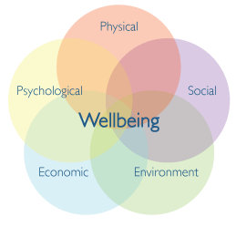
- We believe that prevention is better than cure and that by empowering people we can improve quality of life, improve the long-term health of communities in the city and promote individual responsibility and behavioural change.
Figure 2
This is a holistic view of health and wellbeing. It reflects our understanding of the links between physical, social and psychological health, the environment in which people live and their economic circumstances. To achieve it we will need to think differently about where and what we spend our money on and how we shape and buy services in a more integrated way. We will need to use our collective leadership and influence to improve the things that have the biggest impact on health and wellbeing – poverty, housing, early years and community infrastructure. It will also be important to develop a healthcare system that can support people with chronic ill health better in the community and by integrating services to meet their needs. We also want to support our local communities to engage through the voluntary sector in the planning and delivery of health interventions and to ensure all services are effective. In short, we want to empower people to be healthier throughout their lives; to control their own health; provide more community-based services to help people stay at or close to home when they do need help; and improve people’s experience of specialist services.

6.0 Salford: opportunities and challenges for a healthy and successful future

Situated at the heart of the Greater Manchester City Region, Salford is well placed to be a city of international significance, a place where people and businesses are successful, and where people feel included and enjoy the highest quality of life. Salford’s seven ambitions set out within the Sustainable Community Strategy underpin the ambition to make Salford a prosperous and welcoming city, driven by energetic and engaged communities.

Salford already has much to be proud of in striving to deliver these ambitions. 60% of the city is green space, including two Green Flag award winning parks. It has cutting edge urban developments, including Media City UK, Chapel Street, and Port Salford. It is a regional tourist destination with award-winning cultural venues, it has world-class sporting venues and an extensive network of community facilities. It has a rich heritage and is acknowledged to be the birthplace of the Industrial and transport revolutions.

In recent years Salford has undergone an economic renaissance. Even in the midst of recession steady growth and development have continued. The successful Salford economy is providing people with jobs, income, and skills which improve their quality of life but equally, the economy needs healthy, productive, well-trained employees for it to grow - health and wellbeing going hand in hand with economic prosperity. In terms of health and wellbeing sustainable paid employment is one of the best health improvement measures we can support.

The city’s population is growing with an increasing number of children and young people mirroring the change seen across the country. This is a major opportunity for the city’s future with the prospect of more aspirational and skilled young people contributing to our communities and economy. It also presents a challenge for us to ensure that Salford’s young people get the best start in life and have the things they need to make the most of their talents.

Salford is also growing older: over the last 10 years, the number of people aged over 65 has increased. By 2015 it is projected that 35,624 people living in Salford will be aged 65 and over. Whilst this is a success we want to ensure that life expectancy, and in particular healthy life expectancy, continues to increase.

As more people live longer it is inevitable that the numbers living with long-term conditions will rise also. For example it is estimated that 2,451 people currently live with dementia in Salford, and that this is set to rise to 3,488 by 2030. We need to take steps now to reduce the need for hospital and residential care by keeping people healthier and safer for longer, because the current level of support for the elderly will not be possible as the older population grows. Salford is already working to redesign its services to meet this challenge through its Integrated Care Programme for the elderly population.

Whilst we see some improvements in health and people in Salford are living longer than ever before, the significant health inequalities within the city remain a major challenge. Inequalities persist between neighbourhoods and in the health of some groups who experience discrimination, social exclusion and the effects of social and economic deprivation. The variation in Life Expectancy between the best and poorest wards is unacceptable at 12.1 years for men and 8.2 years for women. There is also a growing and significant threat to health from the way we live our lives, in particular through smoking, alcohol and overweight and obesity. People in Salford smoke and drink to excess more than most other districts in the country, causing higher death rates of related conditions like cancers of lung and liver.

These are difficult times with rising unemployment, incomes falling in real terms and increases in the cost of food, fuel and services posing additional challenges to people’s health and wellbeing. We need to recognise this and support people to weather the recession and maintain and support individual and community mental wellbeing. We also need to keep a close check on the major challenge that welfare reform will present to many adults and families living on low incomes.

Like household budgets, the money available to public services and local councils is also reducing and the Government has introduced reforms to public services to reduce public spending. This means we need to take a new approach. We know that doing the things we have always done in the way we have always done will not help us to tackle both the short- and long-term challenges facing Salford. We have to make changes now. We need to focus on promoting health and wellbeing throughout the life course to improve the prospect of people retaining good health in later years; intervene early to stop problems getting worse; ensure our services focus on stability and recovery as well as value for money; and make the most of the assets in our communities. Salford is committed to the implementation of the Marmot Review’s life course approach to tackle health inequalities. This will enable us to re-balance our expenditure to make it sustainable for the long term.

We are confident we can achieve the aspiration set out here because Salford has a long history of working in partnership to make a real difference to people’s lives. Health and wellbeing has long been seen as central to the future success of our city. This is because we know that health and wellbeing affects and is affected by all areas of life: better health and wellbeing often means people are able to learn, work, earn and be socially active; and unemployment, low educational attainment and isolation can damage people’s health and wellbeing. We want people in Salford to be successful in everything they do but we know we have to address some of the underlying problems in the city to improve wellbeing and give everyone a chance to succeed.
Headline Health Facts
- 236,597 people live in Salford. By 2015 this will be 246,400.
- There are currently 45,705 children aged 16 and under living in Salford, this will reach 49,069 by 2015, an increase of 7.4%.
- Deprivation is higher than average and about 13,100 children live in poverty.
- Currently 34,220 adults living in Salford are aged 65 and over. By 2015 this will reach 35,624, an increase of 4.1%.
- The health of people in Salford is generally not as good as the England average.
- Life expectancy for both men and women is about 3 years less than the England average.
- The difference in life expectancy between least and most deprived wards is 12.1 years for men and 8.2 years for women.
- Over the last ten years, rates of early deaths under the age of 75 have fallen BUT:
- Early death rates from cancer, heart disease and stroke remain higher than the England average.
- The rate of infant death under the age of 1 in Salford has not shown the same downward trend as England and the figure for 2008-2010 stands at 6 deaths per 1000 live births (compared to 4.6 in England).
- Levels of hospital stays among those under 18, teenage pregnancy, alcohol-specific admissions and smoking in pregnancy are all higher than the England average.
- Levels of breast feeding initiation and GCSE attainment are lower than the England average.

6.1 Salford at a glance
Figure 3
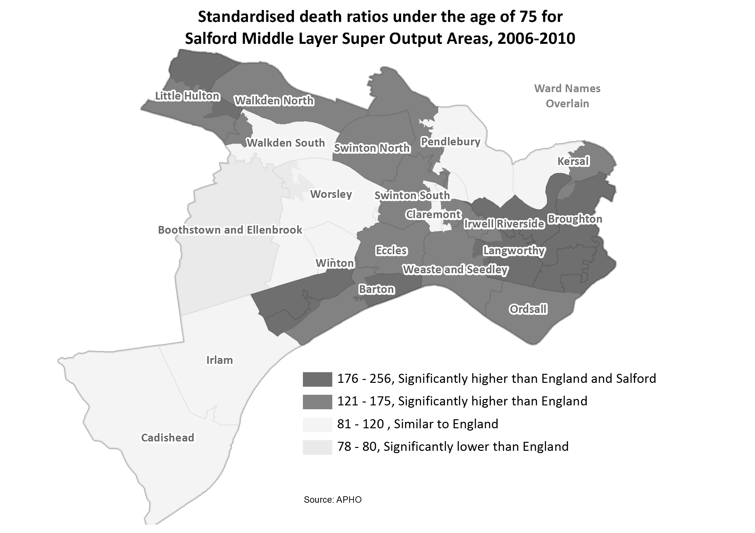

7.0 The scale of our ambition
We want to know your views
- The Health and Wellbeing Board cannot stretch its role to cover all areas of health related policy – how do you think it should reflect other fields of work, for example, work on Family Poverty, in this strategy?

- To close the life expectancy gap between Salford and the UK average by 25% over
the next three years.
- To improve health and wellbeing at every stage of life.
8.0 Our Priorities
- Ensure all children have the best start in life and continue to develop well during their early years

- Local residents achieve and maintain a sense of wellbeing by leading a healthy lifestyle, supported by resilient communities which effectively use social capital

- Local residents access quality health and social care appropriately; where care is focused on providing services placing greater attention on ageing, vulnerable and diverse populations where inequalities exist

Note: The following section is shown as a worked-up example of how this section of the final strategy will look.

- Ensure all children have the best start in life and continue to develop well during their early years

The Marmot review emphasized the importance of giving every child the best start in life as being crucial to reducing health inequalities across the life course. The foundations for virtually every aspect of human development, physical, intellectual and emotional, are laid in early childhood. What happens during these early years (starting in the womb) has lifelong effects on many aspects of health and wellbeing from obesity, heart disease and mental health, to educational achievement and economic status. To have an impact on health inequalities we need to address the social gradient in children’s access to positive early experiences. Salford has significant challenges to overcome if it is to give its children the best possible start they can have, for example we know that:
- Smoking at time of delivery has decreased in Salford over the past 3 years to 16% but remains 2% above the current average for England, and 5% above the 2015 target set by the Department of Health.
- 30% of children in Salford live in poverty. In real terms, this means that in 2008 more than 7,500 families and around 14,750 Salford children were living in poverty.
- Breast feeding initiation in 2011 was 60% which is 20% below the average for England. By week six 36% of all mothers are still 10% below the average for England.

Figure 4 Distribution of child poverty in Salford
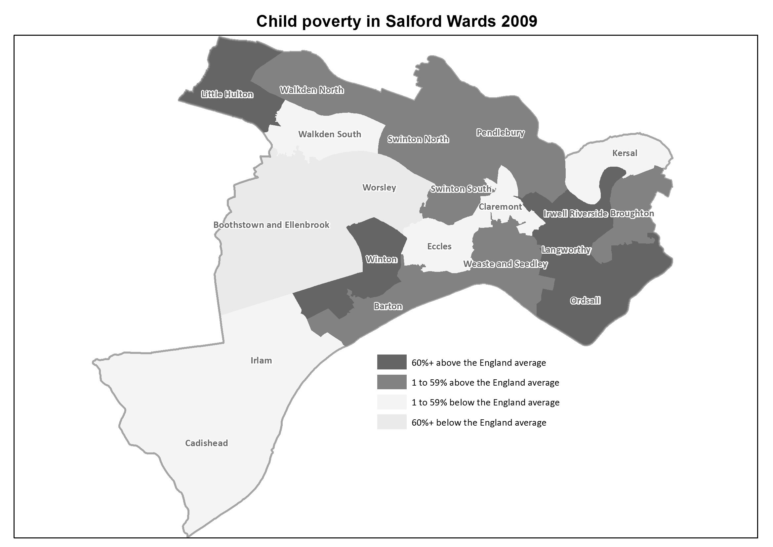

9.0 What will Salford look like if we achieve our ambition?

Our aspiration is great, to see Salford people have as healthy and happy lives as the best parts of the UK, but to achieve that will take time. This strategy sets out our ambition for the first step on a longer journey. However even this first step to 2015 will require significant improvements across the entire Salford system. Our calculations show that to achieve a 25% reduction in the Life Expectancy gap between Salford and the UK average by 2015 will require us to deliver changes across a wide range of issues (a sample of which are shown below but shown more fully in the later section on how we intend to track our improvements):
Increase | BY | From | TO | Baseline Measure
Healthy Eating in adults | 16% | 23.8 | 27.6 | % adults, modeled estimate using Health Survey for England 2006-2008
GCSE attainment | 10% | 49.7 | 55.0 | % at Key Stage 4 2009/10
Breastfeeding initiation | 10% | 63.3 | 69.6 | % of mothers initiating breastfeeding where status is known 2009/10
The proportion of adults who are active | 15% | 10.2 | 11.7 | % aged 16+ 2009/10

Decrease | BY | From | TO | Baseline Measure
Smoking in pregnancy | 17% | 19.5 | 16.1 | % of mothers smoking in pregnancy where status is known 2009/10
Numbers of adults who smoke | 15% | 28.4 | 24.1 | % adults aged 18+, 2009/10
The numbers of adults who are obese | 7% | 23.5 | 21.8 | % adults, modelled estimate using Health Survey for England 2006-2008 (revised)
The numbers of children who are obese | 13% | 19.7 | 17.1 | % of school children in Year 6, 2009/10
Drug Misuse | 27% | 11.6 | 8.4 | Estimated problem drug users using crack and/or opiates aged 15-64 per 1,000 resident population, 2008/09
Teenage pregnancy | 22% | 58.7 | 45.3 | Under-18 conception rate per 1,000 females aged 15-17 (crude rate) 2007-2009 (provisional)
Numbers of people with diabetes | 9% | 5.65 | 5.1 | % of people on GP registers with a recorded diagnosis of diabetes 2009/10
Child poverty | 26% | 29.4 | 21.7 | % children in families receiving means-tested benefits and low income 2008
Child tooth decay | 19% | 1.2 | 1.0 | Weighted mean number of decayed, missing or filled teeth in 12-year-olds, 2008/09
Violent crime | 21% | 17.7 | 13.9 | Recorded violence against the person crimes crude rate per 1,000 population 2009/10
Alcohol related admissions | 18% | 2967 | 2433 | Directly age and sex standardised rate per 100,000 population, 2009/10
Unemployment | 29% | 8.4 | 6.0 | Crude rate per 1,000 population aged16-64, 2010
Accidental dwelling fires | 10% |  |  | By 2015 a 10% reduction in the number of accidental dwelling fires starting from a baseline of 264 (2010-11).

The table above shows the scale of impact needed to make even a relatively small reduction in the gap in life expectancy. These are indicative figures that show the breadth of interventions needed across the partners on the Health and Wellbeing board if we were to make a 25% reduction in life expectancy. As we develop our strategy and goals we will be able to assess the impact of our work on our ambition for Salford.

10.0 How we will achieve our ambition
These are the new ways in which we will all work together and which will guide our approach to health and wellbeing in Salford. This means that all the decisions we make be shaped by the key principles below:

- Valuing the assets the people of Salford bring - Salford people will be at the heart of everything we do. People will be able to make informed choices about their health and wellbeing, be supported to take charge of their lives, support themselves, their friends and families and to share decisions about the services they need.

- Supporting strong and vibrant neighbourhoods that promote health and wellbeing - we will increase individual and community resilience and enable people to maintain and improve their quality of life throughout their lives. We will deliver health, social care, children’s, housing and other services which are co-produced and delivered with local people, service users and their carers to ensure that local people are not passive recipients of care but actively delivering and designing the services in the future.

- Social Justice and tackling inequality - everyone should get a fair chance to succeed in Salford and have access to the services they need. We know that some people and families need extra help to reach their full potential, particularly when they face multiple challenges; so tackling the inequality and injustice this can lead to will underpin all that we do.

- Health and wellbeing will be everyone’s responsibility - health services alone cannot improve health and wellbeing, we will make health and wellbeing a part of everything the city does, make it everyone’s job.

- Partnership and integration of provision - we will work in partnership with our local communities, the public, private and voluntary, community and faith sector organisations to improve the health and wellbeing of people in Salford. We will join up health, social care, education, children’s services, housing and other local services. Where people need support from health and social care services, those services will be tailored to individual needs and help people and their support networks to maintain or regain the greatest level of independence for their personal circumstances.

- Prevention and early intervention throughout life - we will stop problems occurring in the first place wherever we can and where they cannot be prevented we will respond efficiently to enable people to be independent again as quickly as possible. It is in everyone’s best interests to tackle the root causes of ill-health, it is the only way we can make Salford’s health and social care system sustainable and affordable for future generations.

- Quality, Innovation and Evidence-based - we will ensure that the health, social care, children’s and housing services provided in Salford are high quality and innovative in meeting the needs of service users. We will use research expertise and national and local intelligence to ensure Salford’s services are efficient, effective and meet the needs of people based on evidence of what works.
11.0 How we will show we are on course to
deliver our ambition
Ensure all children have the best start in life…
Priority 2
Priority 3
Critical priorities
Low birth weight of full term babies
Prevalence of exclusive breastfeeding at 4 months
Child development at 2 to 2.5 years.
School readiness: foundation stage profile attainment for children starting Key stage 1

Headline outcomes
Outcome1
Outcome 2
Outcome 3

Outcome1
Outcome 2
Outcome 3

Guiding principles:
Valuing the assets the people of Salford bring
Supporting strong and vibrant neighbourhoods that promote health and wellbeing
Social Justice and tackling inequality
Health and wellbeing will be everyone’s responsibility
Partnership and integration of provision
Prevention and early intervention throughout life
Quality, Innovation and Evidence-based

Our Vision
The people of Salford will have healthy happy lives on a par with the best districts in the UK
By 2015 we will have the narrowed the Life Expectancy gap by 25% as a first step on that path
We want to know your views
We want to show how our vision links to the priorities and our selected outcomes – how well does this diagram achieve that?

The Health and Wellbeing Board has made a firm commitment to achieving the ambition it has set for 2015; it will rigorously monitor progress in the delivery of the outcomes in the Joint Health and Wellbeing Strategy.

Each one of the priorities has a set of measures or indicators which will tell us how we are doing in our efforts to improve health and wellbeing in Salford. To ensure we are on course this strategy will be supported by a strong performance management approach which will demonstrate the progress we are making and quickly identify any areas where we are not making sufficient progress to enable the board to provide the leadership required to turn it around.

These are indicators drawn from the major national frameworks which will be used to provide this picture and samples of the indicators are shown below against the priorities we have agreed. We will publish at least on an annual basis our performance against all the measures to ensure that everyone can chart our progress towards the outcomes.

Priority 1 – Ensure all children have the best start in life and continue to develop well during their early years

What we plan to do
- Ensure expenditure on early years development is focused progressively across the social gradient
- Reduction in the number of children and families living on the threshold of poverty or in poverty
- Giving priority to pre- and post-natal interventions that reduce adverse outcomes of pregnancy and infancy
- Providing routine support to families through parenting programmes, children’s centres and key workers, delivered to meet social need via outreach to families
- Developing programmes for the transition to school
- Provide good quality early years education and childcare proportionately across the gradient. This provision should be:
  - Combined with outreach to increase the take-up by children from disadvantaged families
  - Provided on the basis of evaluated models and to meet quality standards.
We want to know your views
This section is trying to give a high level sense of what we will focus on and how we will know if we are on track to achieve the required change - how well does it achieve this? How else might we set it out?
We know we will have made a positive difference when we have:

- Rreduced smoking in pregnancy by 17%
- Reduced the numbers of deaths to infants in their first year of life by 18%
- Reduced the level of tooth decay by 20%
- Increased the numbers of mothers who breastfeed by 10%
- Reduced the numbers of teenage pregnancies by 23%
- Reduced child poverty by 26%

12.0 How we will ensure people are accountable for delivering their part of the ambition
Where we have evidence that outcomes are not being achieved, the Health and Wellbeing Board will hold commissioners and providers to account. The Health Scrutiny Committee of Salford City Council will also be able to hold service providers to account and challenge them to improve.
It is also vital that, as the Health and Wellbeing Board, we regularly assess whether we are focusing, commissioning and delivering the right things.

Note - The board is about to undertake a review of its Terms of Reference which will include a review of its governance lines and accountabilities. The output of this review will be reflected more fully in the final document – it will also need to build in the comments from the development session about being resilient and ambitious, not being afraid to take risks, holding each other to account and getting value for money from our investments.

The Joint Strategic Needs Assessment has informed this strategy and will provide a regular overview of the health and wellbeing issues in Salford, highlighting where new health challenges occur and where health and wellbeing is either improving or worsening. Whilst we are confident that the Health and Wellbeing Strategy addresses the main health and wellbeing opportunities and challenges for the next 3 years, we intend to review the Strategy in 2013. This is because in April 2013, the Government’s health reforms become law and Salford’s Health and Wellbeing Board will be a statutory body. We will have had the opportunity to plan out the work programmes and any gaps and will be clearer about how we involve the public and service providers in the work of the board.

13.0 Glossary of terms
MSOA A Middle Layer Super Output Area is a geographic area designed to improve the reporting of small area statistics in England and Wales. The minimum population is 5000 and the mean is 7200.

Vision and approach were established by Partners in Salford in the Community Strategy under “A Healthy City” theme; refreshed by HWB Board August 2012.
Non I-HIT target, suggested by GM Fire and Rescue

